Republic of Zambia
GSB e-Services

Application for Water Permit
Service documentation
Owner: Water Resources Management Authority
Service key: WARMA/water-permit
Version: service v1, platform 9e8768d3
Date: 2026-10-15
Generated automatically by the service's end-to-end test run. Every screenshot shows synthetic test data on a local test installation, never real personal data.

Contents
- 1. Service summary
- 2. Application process, step by step
- 3. Payment
- 4. Output documents
- 5. Notifications
- 6. Legacy mapping
- 7. Version and date
This document describes the Application for Water Permit service of Water Resources Management Authority as the platform runs it today. It is generated by the service's end-to-end test: every step was performed by the test and every screenshot was taken during that run, with synthetic data. Regenerate it with "npm run docs:services" in the e2e suite; do not edit it by hand.

1. Service summary
Service | Application for Water Permit
Owner (MDA) | Water Resources Management Authority (WARMA)
Purpose | Service offered to Individuals and Organizations allowing them to use public water for various purposes in Zambia.
Who can apply | Individual; Organization
How to apply | Online on the national e-Services portal, signed in with ZamPass; pay with ZamPay.
Fees | Temporary Fee: ZMW 0.00  Temporary Fee: ZMW 0.00  Application for a permit or renewal of a permit for usage up to 10 Megawatts (MW): ZMW 6666.67  Annual access charges per kilowatt of installed capacity: ZMW 1.01  Usage per kilowatt/hour(kWh) generated: ZMW 0.01  In a cascade of any installed capacity per kWh generated: ZMW 0.00  Application for a permit or renewal of a permit for usage up to 10 Megawatts (MW): ZMW 6666.67  Annual access charges per kilowatt of installed capacity: ZMW 1.01  Usage per kilowatt/hour(kWh) generated: ZMW 0.01  In a cascade of any installed capacity per kWh generated: ZMW 0.00  Application for a permit or renewal of a permit up to 100m3 per day: ZMW 668.67  Application for a permit or renewal of a permit above 100m3 per day: ZMW 6666.67  Usage tariff up to 100 m3 per day: ZMW 6.67  Usage tariff above 100 m3 per day: ZMW 0.01  Application for a permit or renewal of a permit up to 100m3 per day: ZMW 668.67  Application for a permit or renewal of a permit above 100m3 per day: ZMW 6666.67  Usage tariff up to 100 m3 per day: ZMW 6.67  Usage tariff above 100 m3 per day: ZMW 0.01  Application for a permit or renewal of a permit: ZMW 13333.33  Annual access charge per m3 per day of permitted volume: ZMW 0.00  Usage tariff per m3 per day: ZMW 0.01  Application for a permit or renewal of a permit: ZMW 13333.33  Annual access charge per m3 per day of permitted volume: ZMW 0.00  Usage tariff per m3 per day: ZMW 0.01  Application for a permit or renewal of a permit: ZMW 10000.00  Annual access charge per m3 per year of permitted volume: ZMW 0.00  Usage tariff per m3 per day: ZMW 0.01  Application for a permit or renewal of a permit: ZMW 13333.33  Annual access charge per m3 per year of permitted volume: ZMW 0.00  Usage tariff per m3 per day: ZMW 0.01  Application for a permit or renewal of a permit: ZMW 668.67  Annual access charge per m3 per year of permitted volume: ZMW 0.00  Usage tariff per m3 per day: ZMW 0.00  Application for a permit or renewal of a permit: ZMW 668.67  Annual access charge per m3 per year of permitted volume: ZMW 0.00  Usage tariff per m3 per day: ZMW 0.00  Application for a permit or renewal of a permit: ZMW 3933.33  Application for a permit or renewal of a permit: ZMW 3933.33  Application and renewal for permit for storage (chargeable on fifty percent of storage volume per m3): ZMW 0.01  Application and renewal for permit for storage (chargeable on fifty percent of storage volume per m3): ZMW 0.01  Application for a permit or renewal of a permit for volume between 75-149m3 per day: ZMW 33333.32  Application for a permit or renewal of a permit for volume between 150-199m3 per day: ZMW 66666.67  Application for a permit or renewal of a permit for volume in excess of 200m3 per day: ZMW 133333.33  Application for a permit or renewal of a permit for volume between 75-149m3 per day: ZMW 33333.32  Application for a permit or renewal of a permit for volume between 150-199m3 per day: ZMW 66666.67  Application for a permit or renewal of a permit for volume in excess of 200m3 per day: ZMW 133333.33  Application for an annual permit: ZMW 202666.67  Application for an annual permit: ZMW 202666.67  Application for an annual permit: ZMW 66666.67  Application for an annual permit: ZMW 66666.67  Application for construction of a dam with storage capacity of up to 200,000 m3: ZMW 1333.33  Application for construction of a dam with storage capacity of up to 200,001 - 500,000 m3: ZMW 4666.67  Application for construction of a dam with storage capacity of up to 500,001 – 1,000,000 m3: ZMW 13333.33  Application for construction of a dam with storage capacity above 1,000,000 m3: ZMW 26666.67  Application for construction of a dam with storage capacity of up to 200,000 m3: ZMW 1333.33  Application for construction of a dam with storage capacity of up to 200,001 - 500,000 m3: ZMW 4666.67  Application for construction of a dam with storage capacity of up to 500,001 – 1,000,000 m3: ZMW 13333.33  Application for construction of a dam with storage capacity above 1,000,000 m3: ZMW 26666.67  Application for construction of a weir: ZMW 2666.67  Application for construction of a weir: ZMW 2666.67  Application for construction of a diversion of canal: ZMW 13333.33  Application for construction of a diversion of canal: ZMW 13333.33
Turnaround | 60 days
Validity of the output | Validity depends on the purpose of the permit.
Required documents | National Registration Card (NRC) (required)  Company Registration Certificate (required)  Proof of land ownership (Title deed/Lease/Traditional Authority Consent Letter) (required)  Borehole completion Report. (optional)  Hydraulic Infrastructure design drawings and report. (optional)  Environmental impact assessment. (optional)  ZEMA Decision Letter. (optional)  Approval letter from National Heritage Conservation Commission. (optional)  Implementation Agreement from Ministry of Energy. (optional)
Output documents | Notice of Action  Application form  GF-1 Treasury Invoice  GF-2 Treasury Receipt
Legal basis | The Water Resources Management Act, No. 21 of 2011 (http://extwprlegs1.fao.org/docs/pdf/zam117433.pdf)  SI No. 18 Charges and Fees Regulations, 2018 (https://www.enotices.co.zm/download/statutory-instrument-no-18-of-2018-the-water-resources-management-charges-and-fees-regulations-pdf/)

2. Application process, step by step

The process as configured
Step | Role | Task | Type
1 | Applicant | Apply | form
2 | Case Officer | Review | review
3 | Case Officer | Generate Payment | generate-payment
4 | Applicant | Payment | payment
5 | Case Officer | Verify Payment | verify-payment
6 | Supervisor | Review | review
7 | Executive | Decision | decision
8 | System | Generate Document | generate-document
9 | System | Notify Client | notify

Step by step
Who takes part in this journey: Citizen, Case Officer, Supervisor, Executive, Anyone (public). Citizen steps are shown on a desktop and on a 375 px phone; back-office steps on a desktop.

Step 1. Find the service and read its page
Citizen · National e-Services portal
The citizen finds "Application for Water Permit" in the national directory and opens its page: the authority, the fees by use, the documents to have ready (proof of land ownership, the hydraulic design).
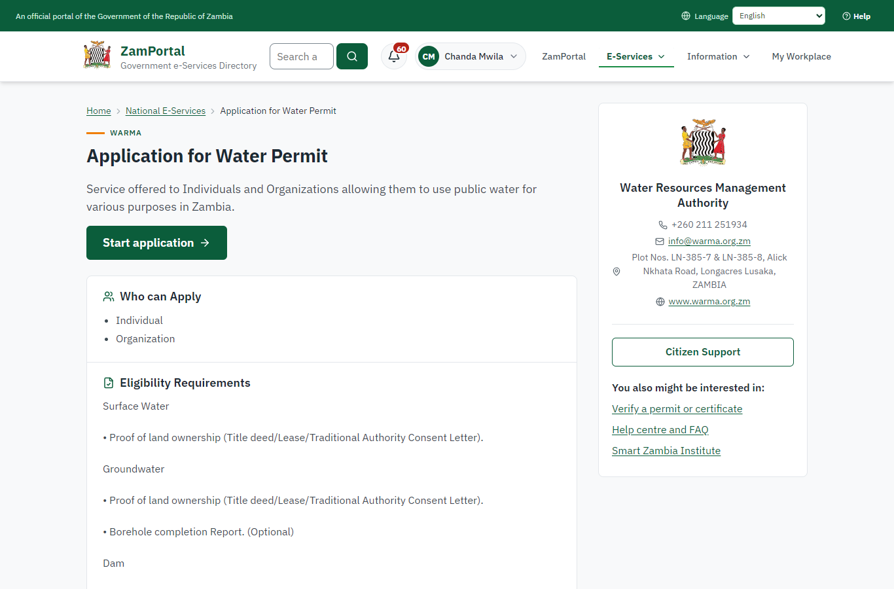 | 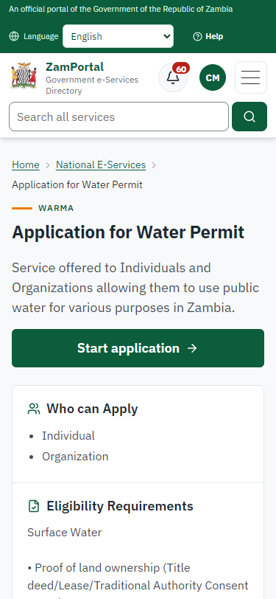
Step 1: Find the service and read its page - desktop (left) and a 375 px phone (right).

Step 2. Take the application on
Case Officer · Back office (done through its case API in the test run: no screenshot)
The Case Officer takes the new application on (assigned to them). The case moves from "Submitted" to "CO Review".

Step 3. Record the catchment and the permitted volume
Case Officer · Back office
After the physical inspection the officer opens the application in the water permit register (Ministry functions -> Water resources -> Water permits) and records the catchment, the sub-catchment and the volume to permit. Every correction needs a reason and is kept with the old values. The location came from the application (latitude and longitude).
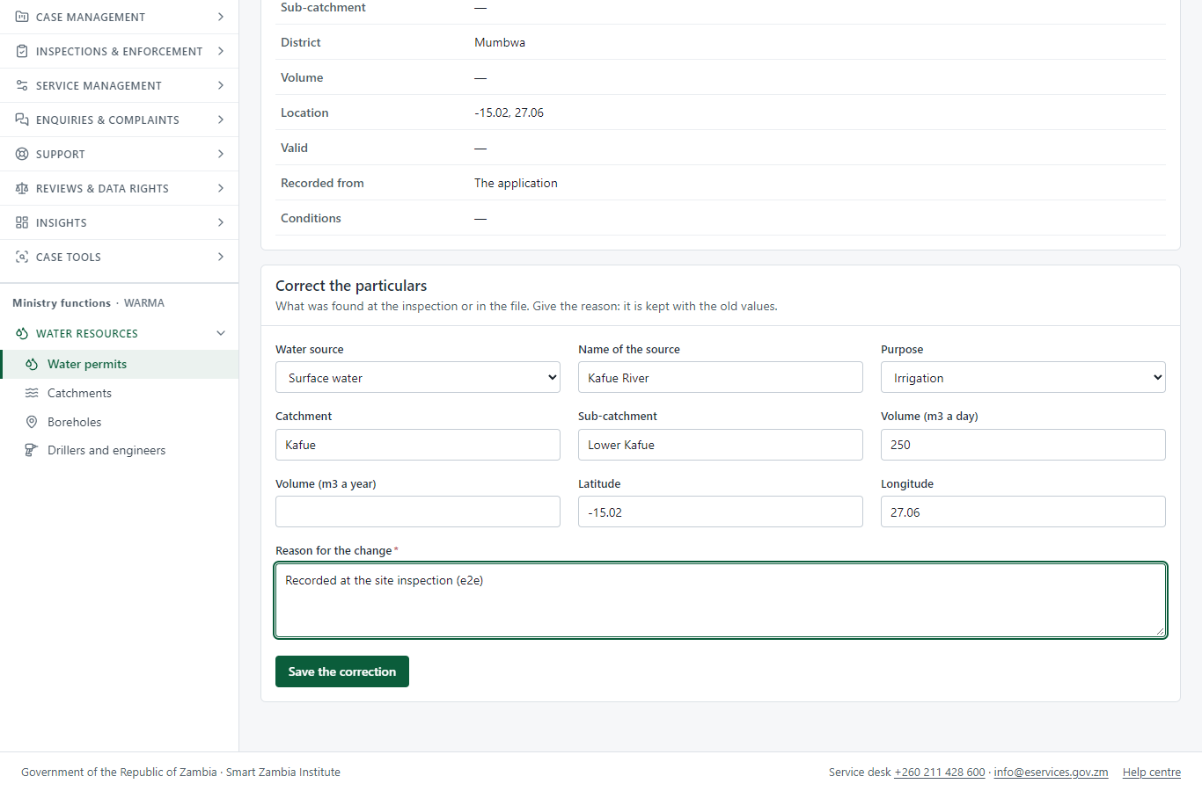
Step 3: Record the catchment and the permitted volume.

Step 4. Receive, Inspect, Report Findings
Case Officer · Back office (done through its case API in the test run: no screenshot)
The Case Officer completes "Receive, Inspect, Report Findings". The case moves from "CO Review" to "CO Generate Payment".

Step 5. Set the permit fee
Case Officer · Back office (done through its case API in the test run: no screenshot)
After the inspection the officer sets the fee from the schedule for the use applied for (ZMW 6666.67 in this run: a permit for usage up to 10 MW); the citizen is invoiced.

Step 6. Pay the permit fee
Citizen · National e-Services portal
The application waits for the citizen’s payment in My Workplace, with a Pay button (ZamPay: mobile money or bank card).
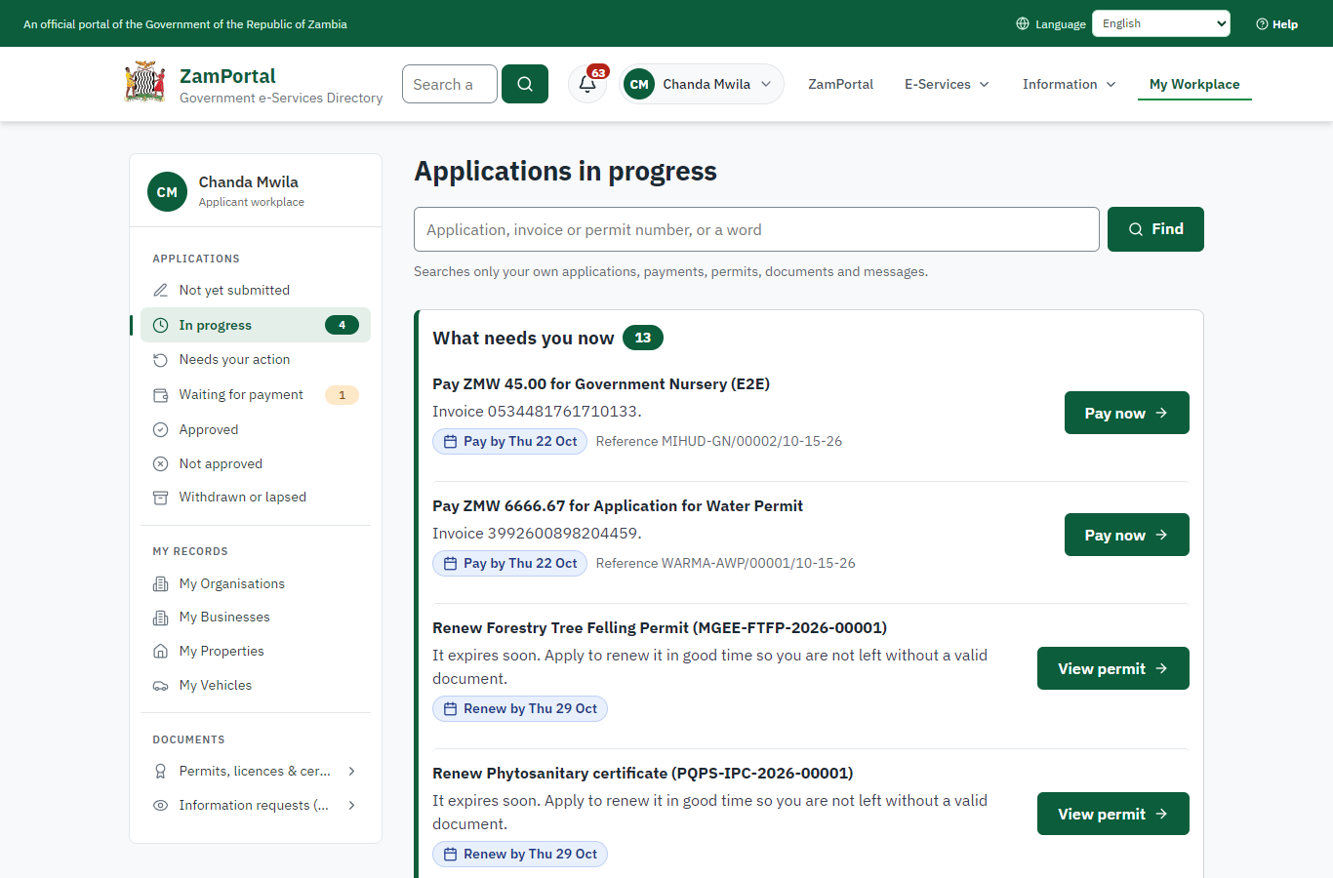 | 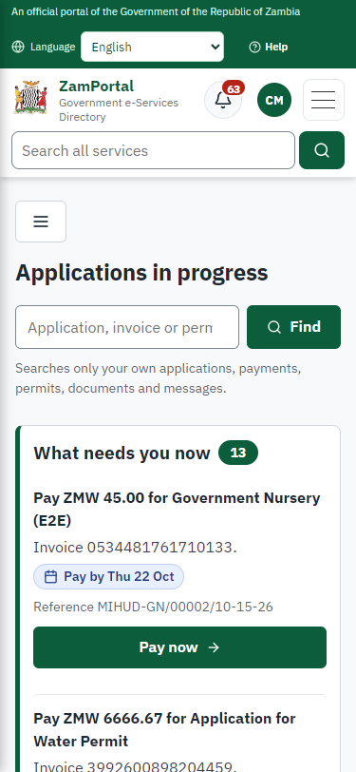
Step 6: Pay the permit fee - desktop (left) and a 375 px phone (right).

Step 7. Payment
Case Officer · Back office (done through its case API in the test run: no screenshot)
The Case Officer completes "Payment". The case moves from "CO Verify Payment" to "SV Review".

Step 8. Review, Add Comments, Send for Signature
Supervisor · Back office (done through its case API in the test run: no screenshot)
The Supervisor completes "Review, Add Comments, Send for Signature". The case moves from "SV Review" to "EX Decision".

Step 9. Review, Inspect, e-Sign
Executive · Back office (done through its case API in the test run: no screenshot)
The Executive decides: approve ("Review, Inspect, e-Sign"). The case moves from "EX Decision" to "Completed".

Step 10. The permit in the water permit register
Supervisor · Back office
The register shows the new permit as Active, with its source, purpose, catchment and volume. Its status is read from the permit itself, so a renewal, suspension or revocation shows here at once.
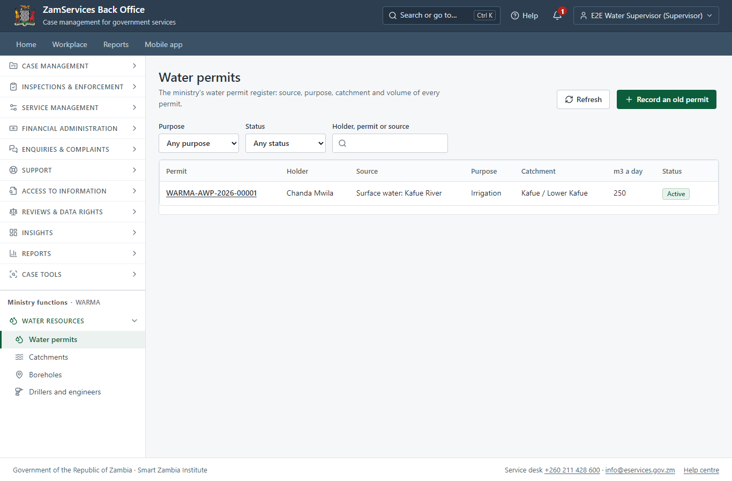
Step 10: The permit in the water permit register.

Step 11. Permitted volumes by catchment
Supervisor · Back office
Catchments adds up the volumes of the permits in force. It is a register figure: there is no catchment allocation pool (input.md F90).
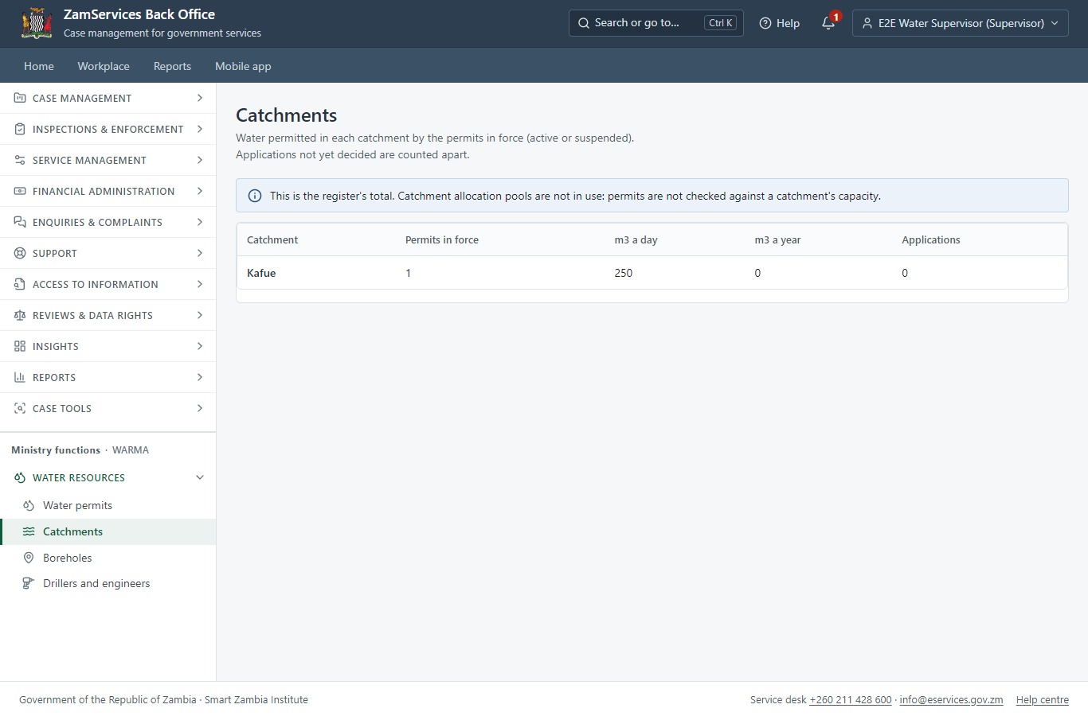
Step 11: Permitted volumes by catchment.

Step 12. The permit in My permits
Citizen · National e-Services portal
The permit is listed in "My permits and licences" with its validity, the water source, purpose, catchment and volume (a generic block: any permit can show its particulars), and a download of the sealed PDF.
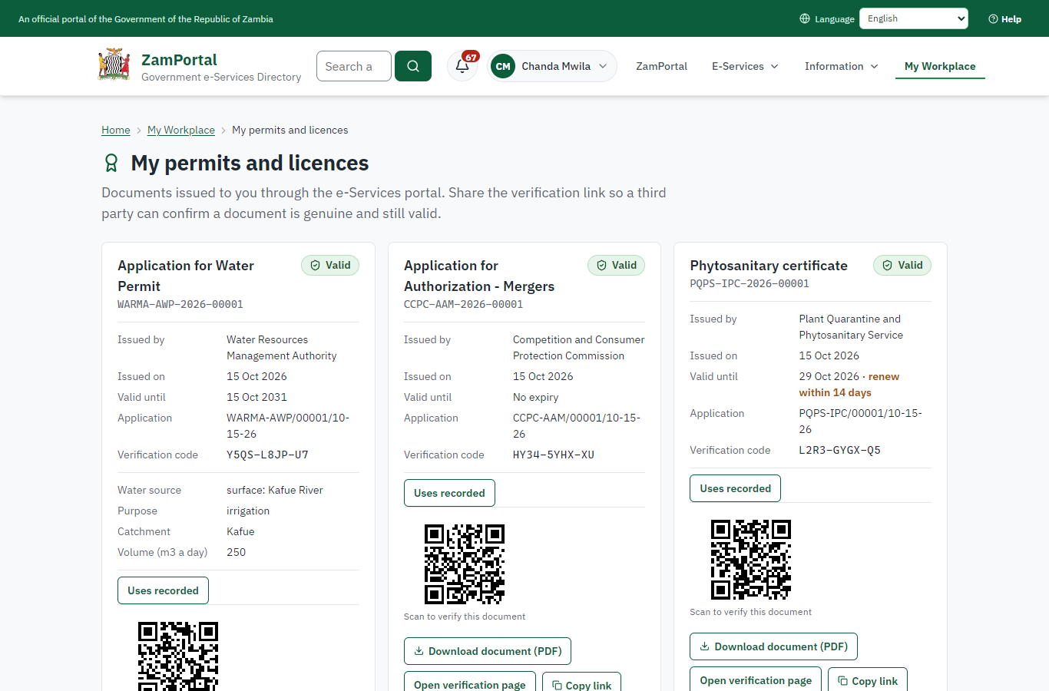 | 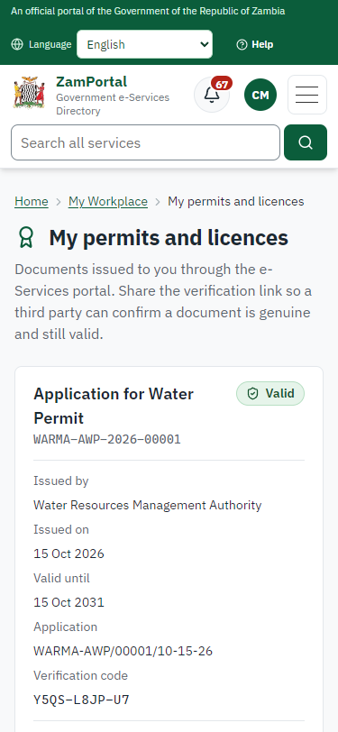
Step 12: The permit in My permits - desktop (left) and a 375 px phone (right).

Step 13. Verify the permit
Anyone (public) · Public verification page
The QR code on the permit opens the public verification page: genuine and current, and whether the electronic seal is valid. No sign-in is needed.
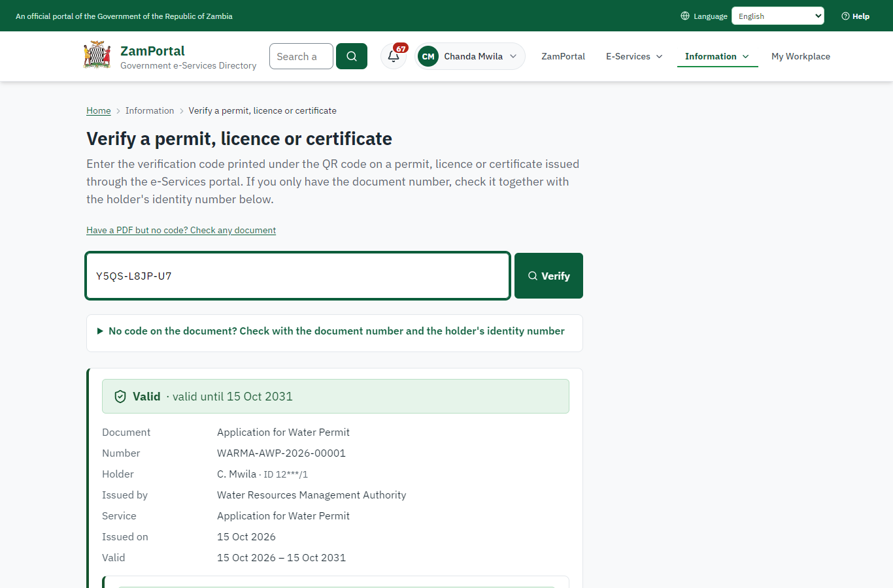 | 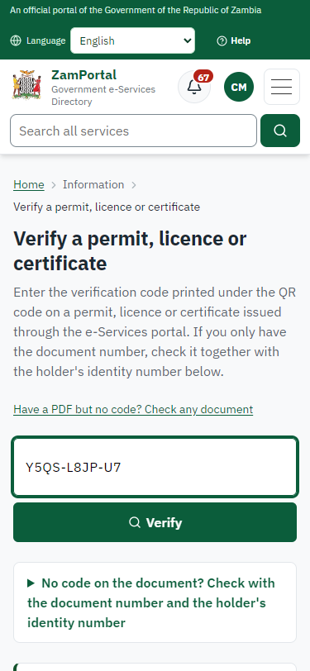
Step 13: Verify the permit - desktop (left) and a 375 px phone (right).

3. Payment
Item | In the test run
Fee | ZMW 6666.67: set by the officer from the imported fee schedule (the legacy fee is "Dynamic": by use and capacity)
When it is paid | After the inspection, before the decision
Invoice number | 3992600898204459
Paid through | ZamPay (the ZamPay test double in this run)
On screen: step 5 (Set the permit fee), step 6 (Pay the permit fee) in section 2.

4. Output documents

Application for Water Permit (sealed PDF)
The water permit issued when the Executive decides, with the abstraction particulars from the register as its conditions, sealed with the platform's electronic seal.
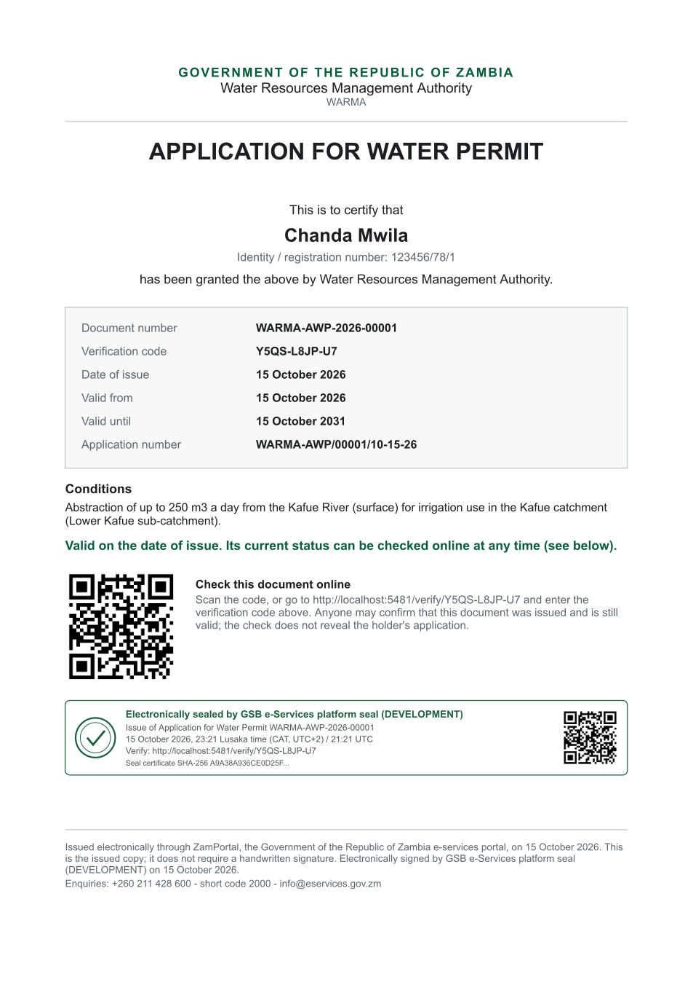
Application for Water Permit (sealed PDF) - first of 1 page, as issued in the test run.

Fields
Field | Value in the test run
Document title | Application for Water Permit
Permit / licence number | WARMA-AWP-2026-00001
Holder | Chanda Mwila
Valid from | 2026-10-15
Valid until | 2031-10-15
Status | active
Verification code (printed with a QR code) | Y5QS-L8JP-U7

Seal
Seal status | sealed
Signature level | PAdES-B-T
Sealed by | the platform seal (development key in the test run)
Signed at | 2026-10-15T21:21:02.643Z
Trusted time-stamp | 2026-10-15T21:21:02.993Z (time-stamping authority)
Document fingerprint (SHA-256) | dde37215e18df414...

Verification
Where | The public verification page of the national portal, <portal>/verify/<verification code>, opened by scanning the QR code on the document.
What it shows | Whether the document is genuine and current, its holder and validity, and whether the electronic seal is valid and who sealed it.
Checking a copy | Anyone can upload a PDF they were given; the page says whether it is exactly the document that was issued. A changed copy is reported as not matching.
On screen: step 10 (The permit in the water permit register), step 11 (Permitted volumes by catchment), step 12 (The permit in My permits), step 13 (Verify the permit) in section 2.

5. Notifications
When | Channel | To | Message | Delivery
Application received | in-app (portal bell) | the applicant | Application WARMA-AWP/00001/10-15-26 received - Your application WARMA-AWP/00001/10-15-26 for Application for Water Permit has been received by Water Resources Management Authority. | shown
Status changed | in-app (portal bell) | the applicant | Update on application WARMA-AWP/00001/10-15-26 - WARMA-AWP/00001/10-15-26 (Application for Water Permit) is now: With the office - being reviewed. | shown
Payment due (invoice raised) | in-app (portal bell) | the applicant | Payment due for application WARMA-AWP/00001/10-15-26 - The fee of ZMW 6666.67 for Application for Water Permit (WARMA-AWP/00001/10-15-26) is now due. Invoice 3992600898204459. | shown
Payment received | in-app (portal bell) | the applicant | Payment received for WARMA-AWP/00001/10-15-26 - Your payment of ZMW 6666.67 for WARMA-AWP/00001/10-15-26 (Application for Water Permit) has been received. Receipt: <ZamPay>/pdf?documentType=receipt&invoiceNumber=3992600898204459 | shown
Licence / permit issued | in-app (portal bell) | the applicant | Your Application for Water Permit document has been issued - WARMA-AWP-2026-00001 has been issued for Application for Water Permit and is valid until 15/10/2031. | shown
Invitation to rate the service | in-app (portal bell) | the applicant | How was Application for Water Permit? - How was Application for Water Permit? Tell us in about a minute. | shown
Decision: approved | in-app (portal bell) | the applicant | Application WARMA-AWP/00001/10-15-26 completed - WARMA-AWP/00001/10-15-26 (Application for Water Permit) is complete. Your documents are ready. | shown
permit.status_changed | in-app (portal bell) | the applicant | Your Application for Water Permit (WARMA-AWP-2026-00001) is now suspended - WARMA-AWP-2026-00001 (Application for Water Permit) is now suspended. Abstraction above the permitted volume at the follow-up inspection (e2e) | shown
permit.status_changed | in-app (portal bell) | the applicant | Your Application for Water Permit (WARMA-AWP-2026-00001) is now active - WARMA-AWP-2026-00001 (Application for Water Permit) is now active. Complied (e2e) | shown
Application received | email | e2e.c***@example.test | Application WARMA-AWP/00001/10-15-26 received | skipped
Application received | sms | +260 97* *** 567 | Application WARMA-AWP/00001/10-15-26 for Application for Water Permit has been received. Track it: <portal>/my-workplace | delivered
Status changed | sms | +260 97* *** 567 |  | delivered
Payment due (invoice raised) | sms | +260 97* *** 567 | Fee of ZMW 6666.67 due for WARMA-AWP/00001/10-15-26. Invoice 3992600898204459. Pay: <ZamPay>/pay-for-service/get-invoice/3992600898204459 | delivered
Payment due (invoice raised) | email | e2e.c***@example.test | Payment due for application WARMA-AWP/00001/10-15-26 | skipped
Payment received | sms | +260 97* *** 567 |  | delivered
Invitation to rate the service | sms | +260 97* *** 567 |  | skipped
Invitation to rate the service | email | e2e.c***@example.test | How was Application for Water Permit? | skipped
Licence / permit issued | email | e2e.c***@example.test | Your Application for Water Permit document has been issued | skipped
Decision: approved | email | e2e.c***@example.test | Application WARMA-AWP/00001/10-15-26 completed | skipped
Licence / permit issued | sms | +260 97* *** 567 |  | delivered
Decision: approved | sms | +260 97* *** 567 |  | delivered
permit.status_changed | email | e2e.c***@example.test | Your Application for Water Permit (WARMA-AWP-2026-00001) is now suspended | skipped
permit.status_changed | sms | +260 97* *** 567 |  | delivered
permit.status_changed | email | e2e.c***@example.test | Your Application for Water Permit (WARMA-AWP-2026-00001) is now active | skipped
Delivery: shown = in the portal's notification bell; delivered = the SMS gateway (a test double in this run) reported the text delivered; skipped = not sent on that channel (e-mail is not configured on the test installation, and some notices go out on one channel only); sent by the national portal = a ministry node handed the notice to the national portal, which texts and e-mails the citizen under its own name and the citizen's preferences. Addresses written <portal>, <ZamPay> stand for the national portal and ZamPay.

6. Legacy mapping
Replaces | Application for Water Permit in the legacy ZIGS e-Services directory (ZIGS_Services)
Legacy service id | 327
Legacy provider | Water Resources Management Authority (WARMA) under Ministry of Water Development and Sanitation
Legacy process | Standard.Review_4Step (process 104)
Fee in the legacy system | Application for a permit or renewal of a permit for usage up to 10 Megawatts (MW): ZMW 6666.668 (New)  Annual access charges per kilowatt of installed capacity: ZMW 1.0119 (New)  Usage per kilowatt/hour(kWh) generated: ZMW 0.0122 (New)  In a cascade of any installed capacity per kWh generated: ZMW 0.001 (New)  Application for a permit or renewal of a permit up to 100m3 per day: ZMW 668.668 (New)  Application for a permit or renewal of a permit above 100m3 per day: ZMW 6666.668 (New)  Usage tariff up to 100 m3 per day: ZMW 6.668 (New)  Usage tariff above 100 m3 per day: ZMW 0.0063 (New)  Application for a permit or renewal of a permit: ZMW 13333.332 (New)  Annual access charge per m3 per day of permitted volume: ZMW 0.0031 (New)  Usage tariff per m3 per day: ZMW 0.0127 (New)  Application for a permit or renewal of a permit: ZMW 10000 (New)  Annual access charge per m3 per year of permitted volume: ZMW 0.0015 (New)  Usage tariff per m3 per day: ZMW 0.0063 (New)  Application for a permit or renewal of a permit: ZMW 668.668 (New)  Annual access charge per m3 per year of permitted volume: ZMW 0.001 (New)  Application for a permit or renewal of a permit: ZMW 3933.332 (New)  Usage tariff per m3 per day: ZMW 0.0041 (New)  Application and renewal for permit for storage (chargeable on fifty percent of storage volume per m3): ZMW 0.0066 (New)  Application for a permit or renewal of a permit for volume between 75-149m3 per day: ZMW 33333.32 (New)  Application for a permit or renewal of a permit for volume between 150-199m3 per day: ZMW 66666.668 (New)  Application for a permit or renewal of a permit for volume in excess of 200m3 per day: ZMW 133333.332 (New)  Application for an annual permit: ZMW 202666.668 (New)  Application for an annual permit: ZMW 66666.668 (New)  Application for construction of a dam with storage capacity of up to 200,000 m3: ZMW 1333.332 (New)  Application for construction of a dam with storage capacity of up to 200,001 - 500,000 m3: ZMW 4666.668 (New)  Application for construction of a dam with storage capacity of up to 500,001 – 1,000,000 m3: ZMW 13333.332 (New)  Application for construction of a dam with storage capacity above 1,000,000 m3: ZMW 26666.668 (New)  Application for construction of a weir: ZMW 2666.668 (New)  Application for construction of a diversion of canal: ZMW 13333.332 (New)  Application for a permit or renewal of a permit for usage up to 10 Megawatts (MW): ZMW 6666.668 (Renewal)  Annual access charges per kilowatt of installed capacity: ZMW 1.0119 (Renewal)  Usage per kilowatt/hour(kWh) generated: ZMW 0.0122 (Renewal)  In a cascade of any installed capacity per kWh generated: ZMW 0.001 (Renewal)  Application for a permit or renewal of a permit up to 100m3 per day: ZMW 668.668 (Renewal)  Application for a permit or renewal of a permit above 100m3 per day: ZMW 6666.668 (Renewal)  Usage tariff up to 100 m3 per day: ZMW 6.668 (Renewal)  Usage tariff above 100 m3 per day: ZMW 0.0063 (Renewal)  Application for a permit or renewal of a permit: ZMW 13333.332 (Renewal)  Annual access charge per m3 per day of permitted volume: ZMW 0.0031 (Renewal)  Usage tariff per m3 per day: ZMW 0.0127 (Renewal)  Application for a permit or renewal of a permit: ZMW 13333.332 (Renewal)  Annual access charge per m3 per year of permitted volume: ZMW 0.0015 (Renewal)  Usage tariff per m3 per day: ZMW 0.0063 (Renewal)  Application for a permit or renewal of a permit: ZMW 668.668 (Renewal)  Annual access charge per m3 per year of permitted volume: ZMW 0.001 (Renewal)  Application for a permit or renewal of a permit: ZMW 3933.332 (Renewal)  Usage tariff per m3 per day: ZMW 0.0041 (Renewal)  Application and renewal for permit for storage (chargeable on fifty percent of storage volume per m3): ZMW 0.0066 (Renewal)  Application for a permit or renewal of a permit for volume between 75-149m3 per day: ZMW 33333.32 (Renewal)  Application for a permit or renewal of a permit for volume between 150-199m3 per day: ZMW 66666.668 (Renewal)  Application for a permit or renewal of a permit for volume in excess of 200m3 per day: ZMW 133333.332 (Renewal)  Application for an annual permit: ZMW 202666.668 (Renewal)  Application for an annual permit: ZMW 66666.668 (Renewal)  Application for construction of a dam with storage capacity of up to 200,000 m3: ZMW 1333.332 (Renewal)  Application for construction of a dam with storage capacity of up to 200,001 - 500,000 m3: ZMW 4666.668 (Renewal)  Application for construction of a dam with storage capacity of up to 500,001 – 1,000,000 m3: ZMW 13333.332 (Renewal)  Application for construction of a dam with storage capacity above 1,000,000 m3: ZMW 26666.668 (Renewal)  Application for construction of a weir: ZMW 2666.668 (Renewal)  Application for construction of a diversion of canal: ZMW 13333.332 (Renewal)  Temporary Fee: ZMW 0.0048 (New)  Temporary Fee: ZMW 0.0048 (Renewal)
Fee taken before submission | yes (as in ZIGS)
Time to issue (legacy) | New: 60 calendar days  Renewal: 60 calendar days
Legacy output templates | Notice of Action: ZIGS_Forms_Notices / GS-2.NoticeOfAction  Application form: ZIGS_Forms_WARMA / WARMA_WaterPermit.Application  GF-1 Treasury Invoice: ZIGS_CustomForms / GF-1 Invoice  GF-2 Treasury Receipt: ZIGS_CustomForms / GF-2 Receipt
Legacy address | none recorded
How it was brought over | Imported by the platform's legacy catalogue importer (zcm-backend scripts/zigs/importLegacy.js) from the ZIGS snapshot: form, case types, fees, documents, process and output templates, then served by the new platform.

7. Version and date
Document version | service v1, platform 9e8768d3
Generated | 2026-10-15T21:21:11Z (by the end-to-end run, not edited by hand)
Service version | not versioned (configured directly)
Platform snapshot | backend 9e8768d3  portal b47ff71  back office 548d2d6
Test suite | e2e ca5e2ed; one installation (combined); seed profile mihud
Journeys | 23-water-permit.spec.js: citizen: finds the service and applies - passed  23-water-permit.spec.js: officer: takes it on, inspects and records the catchment and volume in the register - passed  23-water-permit.spec.js: the officer sets the fee; the citizen pays; supervisor reviews, executive decides: the permit is issued - passed  23-water-permit.spec.js: citizen: the permit in My permits with its water particulars; sealed; verifies - passed  23-water-permit.spec.js: lifecycle: a suspension on the permit shows in the register - passed
Result | 5 of 5 journey tests passed
Data | Synthetic test data on a local test installation; provider test doubles for ZamPass, ZamPay, SMS and signing.

