Republic of Zambia
GSB e-Services

Vessel’s Registration Certificate
Service documentation
Owner: Department of Maritime and Inland Waterways
Service key: miwd/vessels-registration-certificate
Version: service v1, platform 47fe6fa7
Date: 2026-10-22
Generated automatically by the service's end-to-end test run. Every screenshot shows synthetic test data on a local test installation, never real personal data.

Contents
- 1. Service summary
- 2. Application process, step by step
- 3. Payment
- 4. Output documents
- 5. Notifications
- 6. Legacy mapping
- 7. Version and date
This document describes the Vessel’s Registration Certificate service of Department of Maritime and Inland Waterways as the platform runs it today. It is generated by the service's end-to-end test: every step was performed by the test and every screenshot was taken during that run, with synthetic data. Regenerate it with "npm run docs:services" in the e2e suite; do not edit it by hand.

1. Service summary
Service | Vessel’s Registration Certificate
Owner (MDA) | Department of Maritime and Inland Waterways (MIWD)
Purpose | This is a certificate to allow a vessel to be used in inland waters of Zambia to ensure that she determines compliance with The Inland Waters Shipping Act.
Who can apply | Individual; Organization
How to apply | Online on the national e-Services portal, signed in with ZamPass; pay with ZamPay.
Fees | First Registration Fee: ZMW 120.00  Subsequent Registration Fee: ZMW 90.00  Renewal Application Fee: ZMW 684.00
Turnaround | 14 days.
Validity of the output | 12 months.
Required documents | National Identity Card (NRC) (required)  Company Registration Certificate (required)  Customs Duty certificate (required), New applications only  Certificate of Vessel's Ownership (required), Renewal applications only  Proof of Residence (required)
Output documents | Notice of Action  Application form (New)  Application form (Renewal)  GF-1 Treasury Invoice  GF-2 Treasury Receipt  Certificate of registration
Legal basis | The Inland-Waters-Shipping-Act Chapter 466 of the Laws of Zambia (http://www.parliament.gov.zm/sites/default/files/documents/acts/Inland%20Waters%20Shipping%20Act.pdf)  Merchant Shipping (Temporary Provisions) Act Chapter 468 of the Laws of Zambia (https://zambialaws.com/principal-legislation/chapter-468merchant-shipping-temporary-provisions-act)

2. Application process, step by step

The process as configured
Step | Role | Task | Type
1 | Applicant | Apply | form
2 | Case Officer | Review | review
3 | Case Officer | Survey of the vessel | vessels-survey
4 | Case Officer | Generate Payment | generate-payment
5 | Applicant | Payment | payment
6 | Case Officer | Verify Payment | verify-payment
7 | Supervisor | Decision | decision
8 | System | Generate Document | generate-document
9 | System | Notify Client | notify

Step by step
Who takes part in this journey: Citizen, Case Officer, Surveyor, Supervisor, Registrar (Supervisor), Anyone (public). Citizen steps are shown on a desktop and on a 375 px phone; back-office steps on a desktop.

Step 1. Find the service and read its page
Citizen · National e-Services portal
The citizen finds "Vessel's Registration Certificate" in the national directory and opens its page: the authority, the documents to have ready, the fees (first registration, subsequent registration, renewal) and the time it takes.
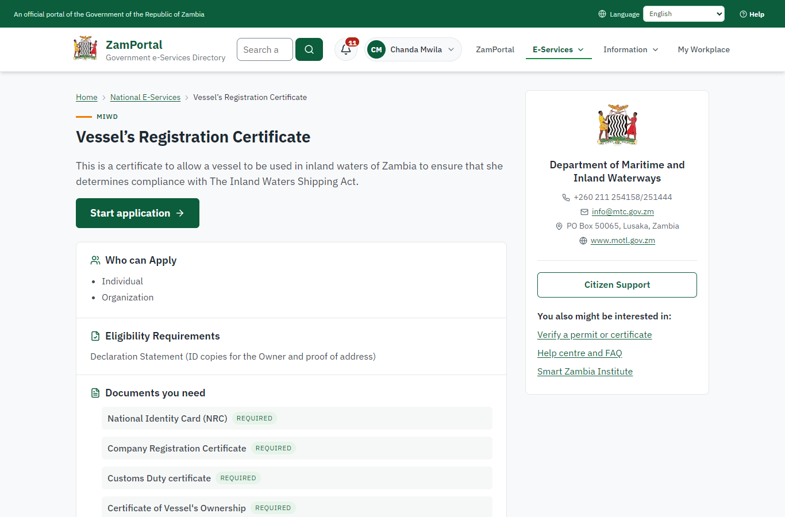 | 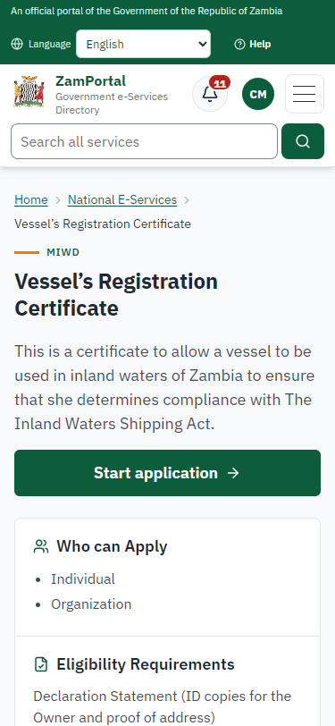
Step 1: Find the service and read its page - desktop (left) and a 375 px phone (right).

Step 2. Apply for the first registration
Citizen · National e-Services portal (sent through the API the portal uses in the test run: no screenshot)
The citizen chooses "the first registration of a vessel", names the vessel and its port of registry (Siavonga, on Lake Kariba), the owner (a company), its construction (steel, motorised), builder and date, its tonnage and dimensions, its use (passenger ferry), crew and passengers, and uploads the required documents. The vessel is recorded on the register as file VR-2026-00001; its identity mark is assigned when the registration is approved.

Step 3. Take the application on
Case Officer · Back office (done through its case API in the test run: no screenshot)
The Case Officer takes the new application on (assigned to them). The case moves from "Submitted" to "CO Review".

Step 4. Check the application against the register
Case Officer · Back office (done through its case API in the test run: no screenshot)
The Case Officer completes "Check the application against the register". The case moves from "CO Review" to "CO Review".

Step 5. Survey of the vessel by a licensed surveyor
Surveyor · Back office
A surveyor licensed on the surveyor register (Ministry functions -> Vessels -> Surveyors; proposed by a supervisor, approved by another senior officer) surveys the vessel and records it on the vessel's page: the place, the findings of the legacy Form 2 (hull, freeboard, life jackets, fire extinguishers, lights), the passengers allowed and the outcome - here seaworthy with a condition. The survey is valid for three months. An officer who is not on the register is refused.
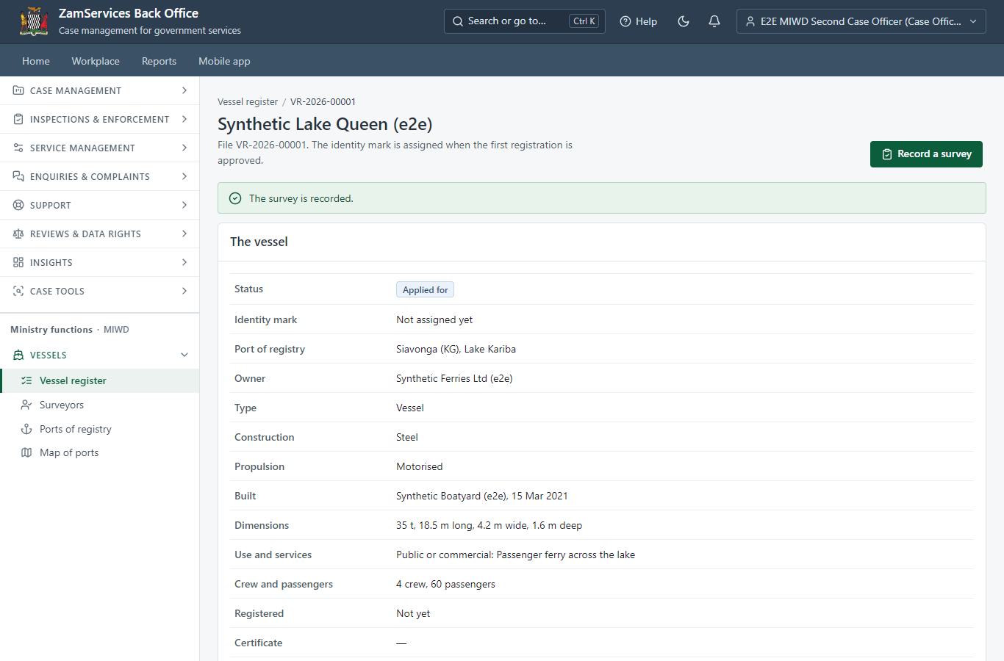
Step 5: Survey of the vessel by a licensed surveyor.

Step 6. Set the fee
Case Officer · Back office (done through its case API in the test run: no screenshot)
The officer sets the fee from the service's fee schedule: First Registration Fee, ZMW 120.00. The applicant is invoiced.

Step 7. Pay the registration fee
Citizen · National e-Services portal
The application waits for the payment in My Workplace, with a Pay button (ZamPay: mobile money or bank card).
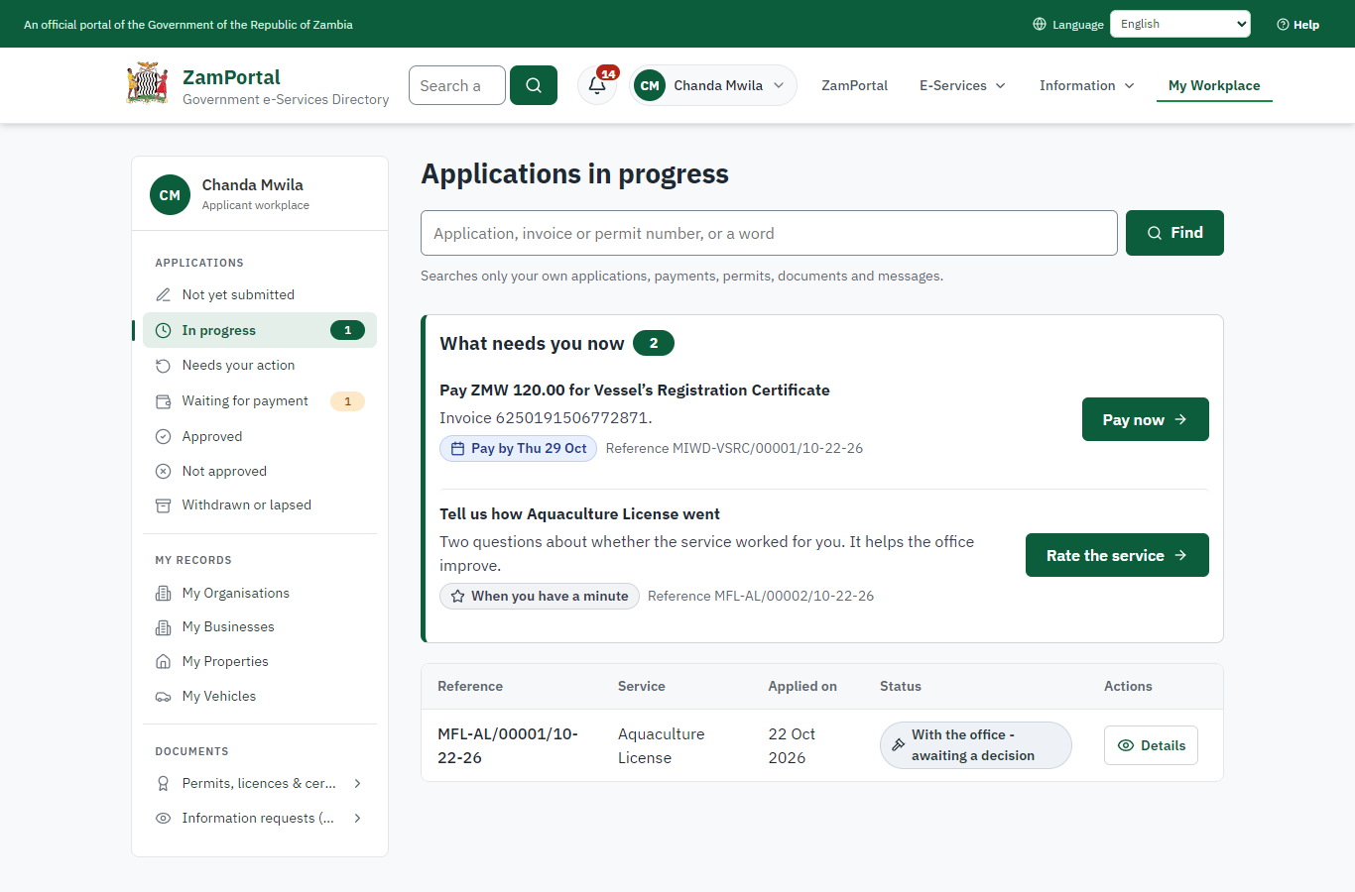 | 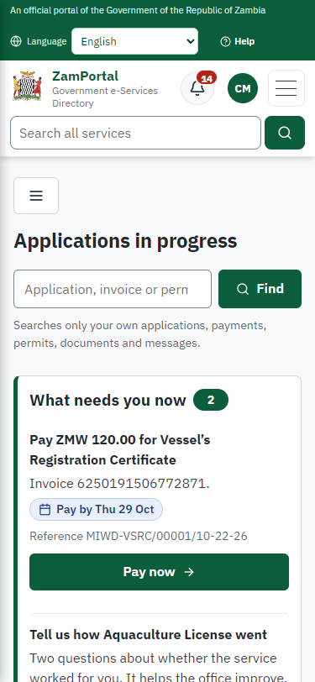
Step 7: Pay the registration fee - desktop (left) and a 375 px phone (right).

Step 8. Verify Payment
Case Officer · Back office (done through its case API in the test run: no screenshot)
The Case Officer completes "Verify Payment". The case moves from "CO Verify Payment" to "SV Decision".

Step 9. The registrar's decision and signature
Supervisor · Back office (done through its case API in the test run: no screenshot)
The Supervisor decides: approve ("The registrar's decision and signature"). The case moves from "SV Decision" to "Completed".

Step 10. The vessel registered with its identity mark
Registrar (Supervisor) · Back office
The registrar - a supervisor, never the surveyor who surveyed the vessel - approved the registration. The module assigned the identity mark KG-001: the code of the port of registry (KG) and the next number of that code, unique on the register. The vessel is registered for 12 months; its page shows the survey it rests on and its history.
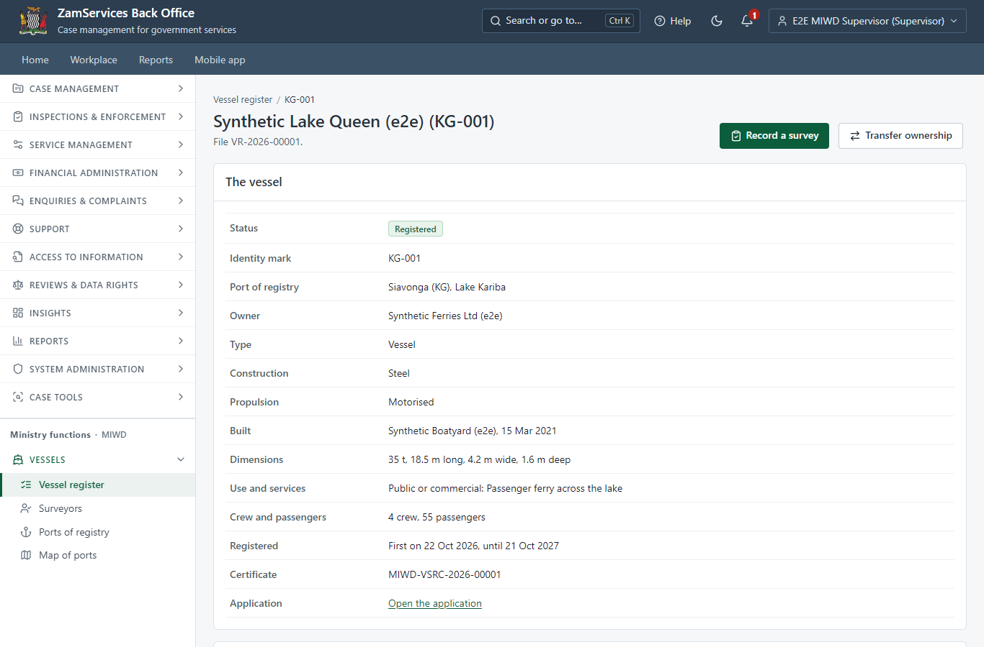
Step 10: The vessel registered with its identity mark.

Step 11. The certificate in My permits
Citizen · National e-Services portal
The certificate of registration is listed in "My permits and licences" with its validity, the vessel, its identity mark and port of registry, and a download of the sealed certificate.
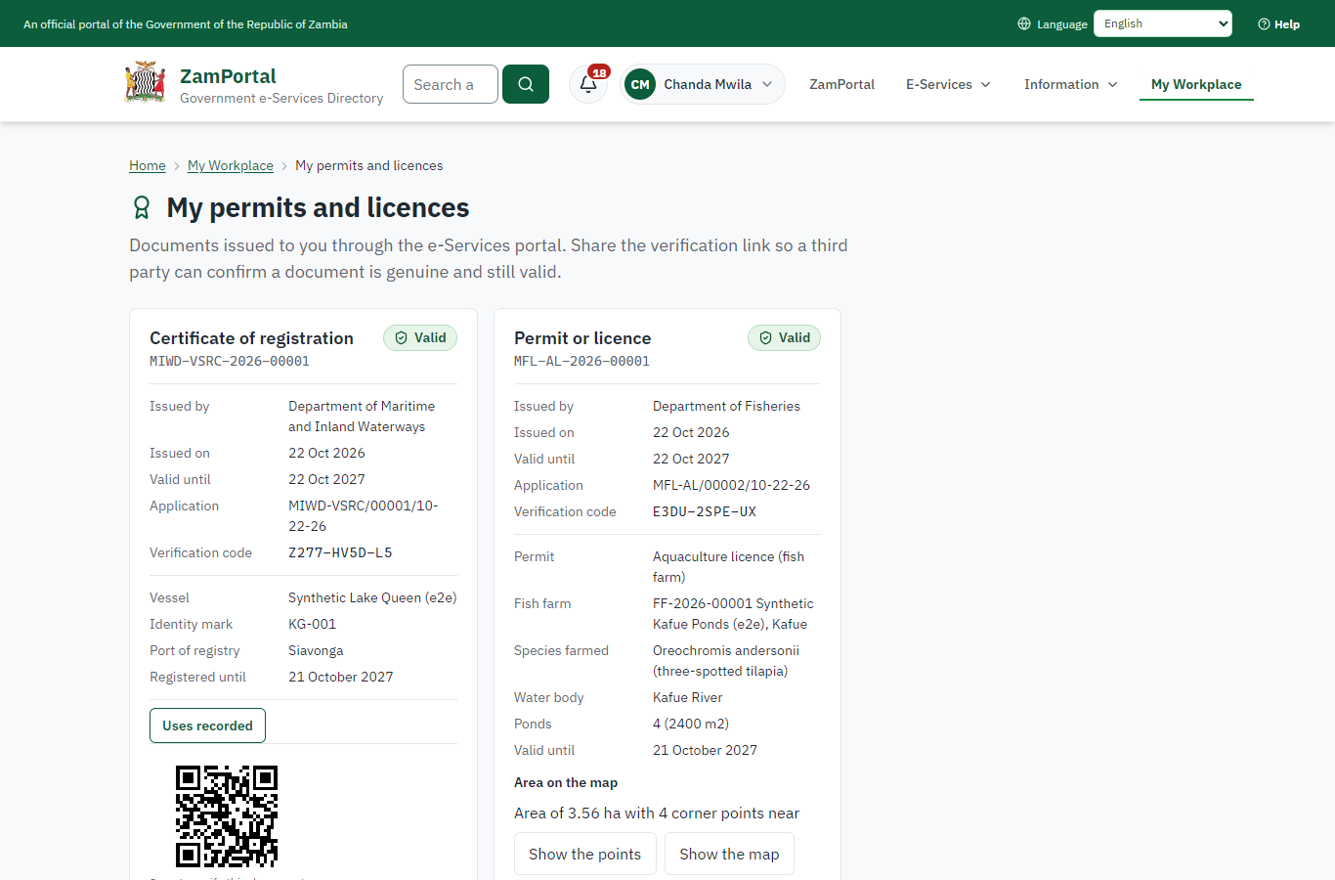 | 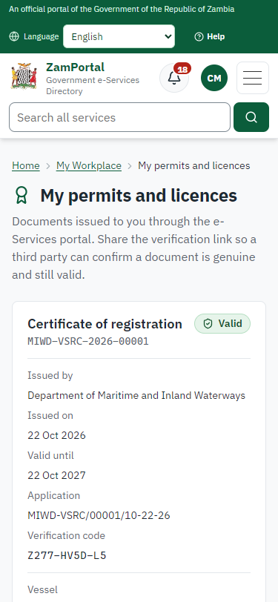
Step 11: The certificate in My permits - desktop (left) and a 375 px phone (right).

Step 12. Verify the certificate
Anyone (public) · Public verification page
The QR code on the certificate opens the public verification page: genuine and current, and whether the electronic seal is valid. No personal details are shown.
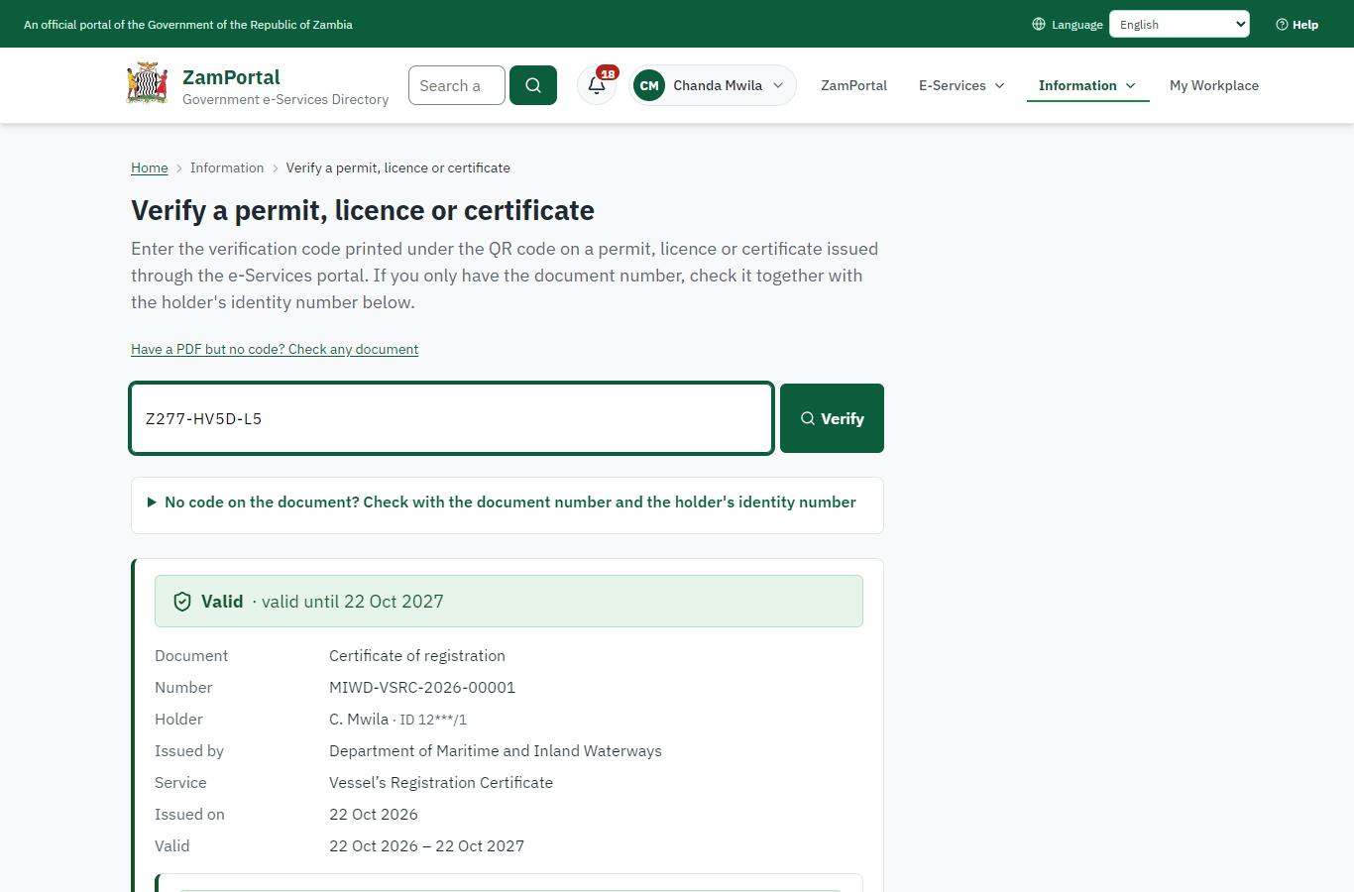 | 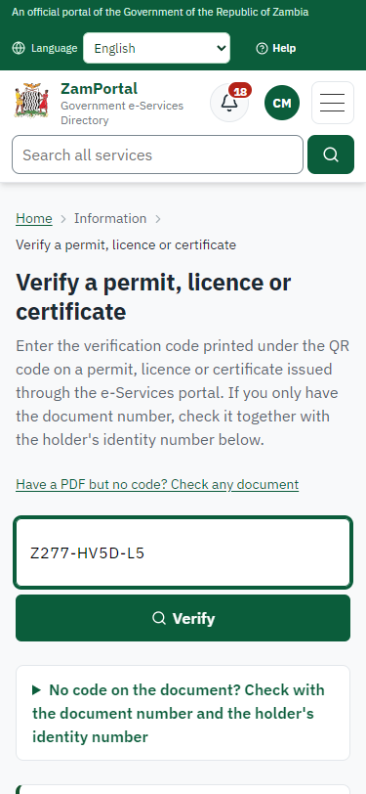
Step 12: Verify the certificate - desktop (left) and a 375 px phone (right).

3. Payment
Item | In the test run
Fee | ZMW 120.00: first registration fee (the service's fee schedule)
When it is paid | After the survey, before the registrar's decision
Invoice number | 6250191506772871
Paid through | ZamPay (the ZamPay test double in this run)
On screen: step 7 (Pay the registration fee) in section 2.

4. Output documents

Certificate of registration (sealed PDF)
The certificate of registration issued when the registrar decides: its number, the vessel's name, its identity mark, the port of registry and water body, the owner, the nature of services, type, construction and dimensions, crew and passengers, the survey it rests on and its condition, the validity (12 months), sealed with the platform's electronic seal and a QR code for verification.
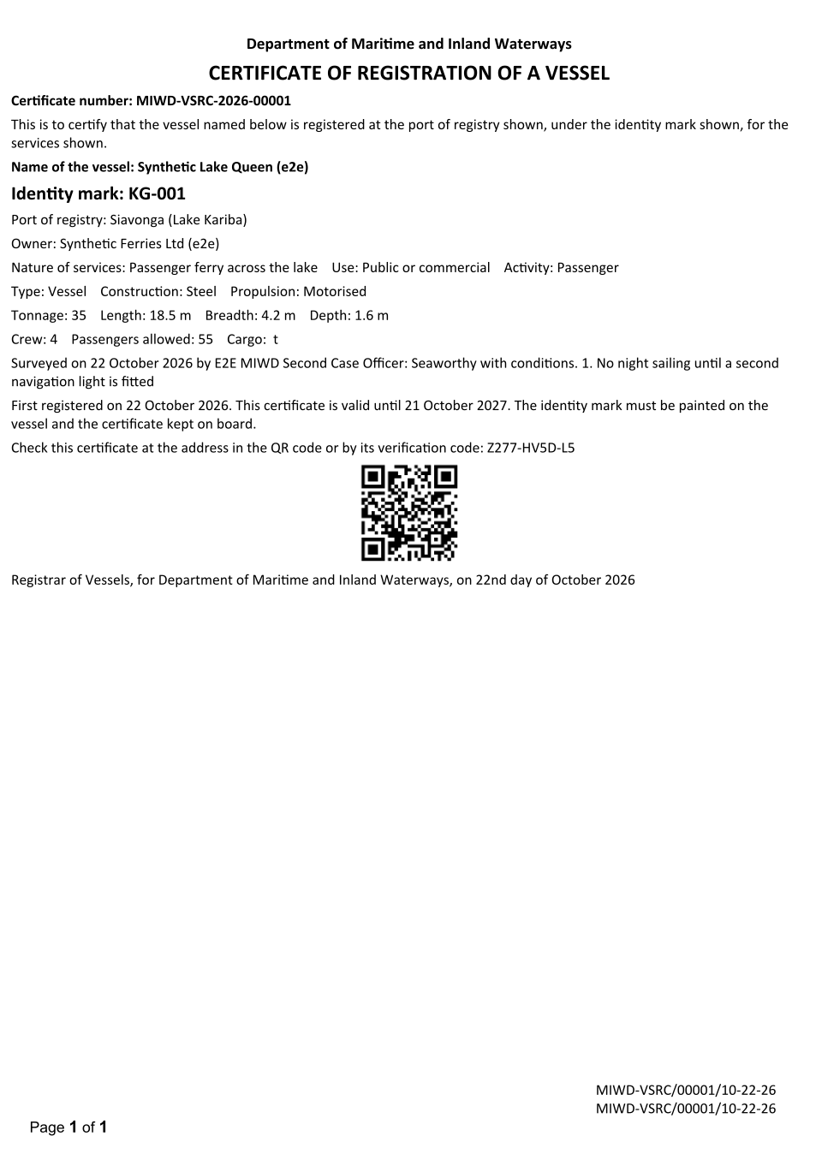
Certificate of registration (sealed PDF) - first of 1 page, as issued in the test run.

Fields
Field | Value in the test run
Document title | Certificate of registration
Permit / licence number | MIWD-VSRC-2026-00001
Holder | Chanda Mwila
Valid from | 2026-10-22
Valid until | 2027-10-21
Status | active
Verification code (printed with a QR code) | Z277-HV5D-L5

Seal
Seal status | sealed
Signature level | PAdES-B-T
Sealed by | the platform seal (development key in the test run)
Signed at | 2026-10-22T04:42:27.650Z
Trusted time-stamp | 2026-10-22T04:42:27.635Z (time-stamping authority)
Document fingerprint (SHA-256) | d1ceccbb7ca5ff53...

Verification
Where | The public verification page of the national portal, <portal>/verify/<verification code>, opened by scanning the QR code on the document.
What it shows | Whether the document is genuine and current, its holder and validity, and whether the electronic seal is valid and who sealed it.
Checking a copy | Anyone can upload a PDF they were given; the page says whether it is exactly the document that was issued. A changed copy is reported as not matching.
On screen: step 10 (The vessel registered with its identity mark), step 11 (The certificate in My permits), step 12 (Verify the certificate) in section 2.

5. Notifications
When | Channel | To | Message | Delivery
Application received | in-app (portal bell) | the applicant | Application MIWD-VSRC/00001/10-22-26 received - Your application MIWD-VSRC/00001/10-22-26 for Vessel’s Registration Certificate has been received by Department of Maritime and Inland Waterways. | shown
Status changed | in-app (portal bell) | the applicant | Update on application MIWD-VSRC/00001/10-22-26 - MIWD-VSRC/00001/10-22-26 (Vessel’s Registration Certificate) is now: With the office - being reviewed. | shown
Payment due (invoice raised) | in-app (portal bell) | the applicant | Payment due for application MIWD-VSRC/00001/10-22-26 - The fee of ZMW 120.00 for Vessel’s Registration Certificate (MIWD-VSRC/00001/10-22-26) is now due. Invoice 6250191506772871. | shown
Payment received | in-app (portal bell) | the applicant | Payment received for MIWD-VSRC/00001/10-22-26 - Your payment of ZMW 120.00 for MIWD-VSRC/00001/10-22-26 (Vessel’s Registration Certificate) has been received. Receipt: <ZamPay>/pdf?documentType=receipt&invoiceNumber=6250191506772871 | shown
Licence / permit issued | in-app (portal bell) | the applicant | Your Vessel’s Registration Certificate document has been issued - MIWD-VSRC-2026-00001 has been issued for Vessel’s Registration Certificate and is valid until 22/10/2027. | shown
Invitation to rate the service | in-app (portal bell) | the applicant | How was Vessel’s Registration Certificate? - How was Vessel’s Registration Certificate? Tell us in about a minute. | shown
Decision: approved | in-app (portal bell) | the applicant | Application MIWD-VSRC/00001/10-22-26 completed - MIWD-VSRC/00001/10-22-26 (Vessel’s Registration Certificate) is complete. Your documents are ready. | shown
Application received | email | e2e.c***@example.test | Application MIWD-VSRC/00001/10-22-26 received | skipped
Application received | sms | +260 97* *** 567 | Application MIWD-VSRC/00001/10-22-26 for Vessel’s Registration Certificate has been received. Track it: <portal>/my-workplace | delivered
Status changed | sms | +260 97* *** 567 |  | delivered
Payment due (invoice raised) | email | e2e.c***@example.test | Payment due for application MIWD-VSRC/00001/10-22-26 | skipped
Payment due (invoice raised) | sms | +260 97* *** 567 | Fee of ZMW 120.00 due for MIWD-VSRC/00001/10-22-26. Invoice 6250191506772871. Pay: <ZamPay>/pay-for-service/get-invoice/6250191506772871 | delivered
Payment received | sms | +260 97* *** 567 |  | delivered
Invitation to rate the service | sms | +260 97* *** 567 |  | skipped
Licence / permit issued | email | e2e.c***@example.test | Your Vessel’s Registration Certificate document has been issued | skipped
Invitation to rate the service | email | e2e.c***@example.test | How was Vessel’s Registration Certificate? | skipped
Licence / permit issued | sms | +260 97* *** 567 |  | delivered
Decision: approved | email | e2e.c***@example.test | Application MIWD-VSRC/00001/10-22-26 completed | skipped
Decision: approved | sms | +260 97* *** 567 |  | delivered
Delivery: shown = in the portal's notification bell; delivered = the SMS gateway (a test double in this run) reported the text delivered; skipped = not sent on that channel (e-mail is not configured on the test installation, and some notices go out on one channel only); sent by the national portal = a ministry node handed the notice to the national portal, which texts and e-mails the citizen under its own name and the citizen's preferences. Addresses written <portal>, <ZamPay> stand for the national portal and ZamPay.

6. Legacy mapping
Replaces | Vessel’s Registration Certificate in the legacy ZIGS e-Services directory (ZIGS_Services)
Legacy service id | 102
Legacy provider | Department of Maritime and Inland Waterways (MIWD) under Ministry of Transport and Logistics
Legacy process | CaseOfficerReview (process 6)
Fee in the legacy system | First Registration Fee: ZMW 120 (New)  Subsequent Registration Fee: ZMW 90 (New)  Renewal Application Fee: ZMW 684 (Renewal)
Fee taken before submission | yes (as in ZIGS)
Time to issue (legacy) | New: 30 calendar days  Renewal: 30 calendar days
Legacy output templates | Notice of Action: ZIGS_Forms_Notices / GS-2.NoticeOfAction  Application form (New): ZIGS_Forms_MIWD / MIWD_CertificateOfRegistration.Application  Application form (Renewal): ZIGS_Forms_MIWD / MIWD_CertificateOfRegistration_Renewal.Application  GF-1 Treasury Invoice: ZIGS_CustomForms / GF-1 Invoice  GF-2 Treasury Receipt: ZIGS_CustomForms / GF-2 Receipt
Legacy address | none recorded
How it was brought over | Imported by the platform's legacy catalogue importer (zcm-backend scripts/zigs/importLegacy.js) from the ZIGS snapshot: form, case types, fees, documents, process and output templates, then served by the new platform.

7. Version and date
Document version | service v1, platform 47fe6fa7
Generated | 2026-10-22T04:42:30Z (by the end-to-end run, not edited by hand)
Service version | not versioned (configured directly)
Platform snapshot | backend 47fe6fa7  portal 9dadc82  back office f75e95d
Test suite | e2e e42f7f1; one installation (combined); seed profile mihud
Journeys | 45-vessel-registration-survey-certificate.spec.js: citizen: finds the service and applies for the first registration of a vessel - passed  45-vessel-registration-survey-certificate.spec.js: officer and surveyor: the survey step waits for a survey by a licensed surveyor - passed  45-vessel-registration-survey-certificate.spec.js: citizen pays; the registrar decides; the identity mark is assigned and the certificate issued - passed  45-vessel-registration-survey-certificate.spec.js: citizen: the certificate in My permits with the vessel and its mark; sealed; verifies - passed
Result | 4 of 4 journey tests passed
Data | Synthetic test data on a local test installation; provider test doubles for ZamPass, ZamPay, SMS and signing.

