Republic of Zambia
GSB e-Services

Variety Testing (Pre-Release)
Service documentation
Owner: Seed Control and Certification Institute
Service key: scci/variety-testing-pre-release
Version: service v1, platform 9e8768d3
Date: 2026-10-15
Generated automatically by the service's end-to-end test run. Every screenshot shows synthetic test data on a local test installation, never real personal data.

Contents
- 1. Service summary
- 2. Application process, step by step
- 3. Payment
- 4. Output documents
- 5. Notifications
- 6. Legacy mapping
- 7. Version and date
This document describes the Variety Testing (Pre-Release) service of Seed Control and Certification Institute as the platform runs it today. It is generated by the service's end-to-end test: every step was performed by the test and every screenshot was taken during that run, with synthetic data. Regenerate it with "npm run docs:services" in the e2e suite; do not edit it by hand.

1. Service summary
Service | Variety Testing (Pre-Release)
Owner (MDA) | Seed Control and Certification Institute (SCCI)
Purpose | Service offered to Variety Owners or their Representatives to assess the value for cultivation and use of a new variety.
Who can apply | Organization; Individual
How to apply | Online on the national e-Services portal, signed in with ZamPass; pay with ZamPay.
Fees | Pre-Release fee per Application (if the case is for first season of testing only): USD 20.00  DUS Testing fee per variety per year: USD 150.00  National Variety Release Trials fee per variety per site per year: USD 150.00
Turnaround | Minimum two (2) years - from application to Variety Release
Validity of the output | One (1) year
Required documents | National Identity Card (NRC) (required)  Certificate of Incorporation / ZDA (if company, church, society) (required)  Botanical Information (that is, a Completed Crop Specific Technical Questionnaire) (required)  Descriptors for the Parents to the new variety (as per OECD requirements) (required)
Output documents | Notice of Action  Application form  GF-1 Treasury Invoice  GF-2 Treasury Receipt
Legal basis | Plant Variety and Seeds Act (Laws, Volume XIV, Cap. 236) (https://www.parliament.gov.zm/sites/default/files/documents/acts/Plant%20Variety%20and%20Seeds%20Act.pdf)  Plant Variety and Seeds Regulation (SI No. 23 of 2018) (https://www.parliament.gov.zm/sites/default/files/documents/acts/Plant%20Variety%20and%20Seeds%20Act.pdf)

2. Application process, step by step

The process as configured
Step | Role | Task | Type
1 | Applicant | Apply | form
2 | Case Officer | Generate Payment | generate-payment
3 | Applicant | Payment | payment
4 | System | Generate Document | generate-document
5 | Case Officer | Review | review
6 | Supervisor | Review | review
7 | Case Officer | Verify Payment | verify-payment
8 | Case Officer | Laboratory | samples-laboratory
9 | Supervisor | Committee decision | approve
10 | System | Generate Document | generate-document
11 | System | Notify Client | notify

Step by step
Who takes part in this journey: Citizen, Case Officer, Accountant, Supervisor, Laboratory technician, Laboratory head (Supervisor), Committee secretary (Supervisor). Citizen steps are shown on a desktop and on a 375 px phone; back-office steps on a desktop.

Step 1. Find the service
Citizen · National e-Services portal
On the national e-Services portal the citizen opens All Services and searches for the service by name ("Variety Testing"). Each result names the service and the ministry that provides it.
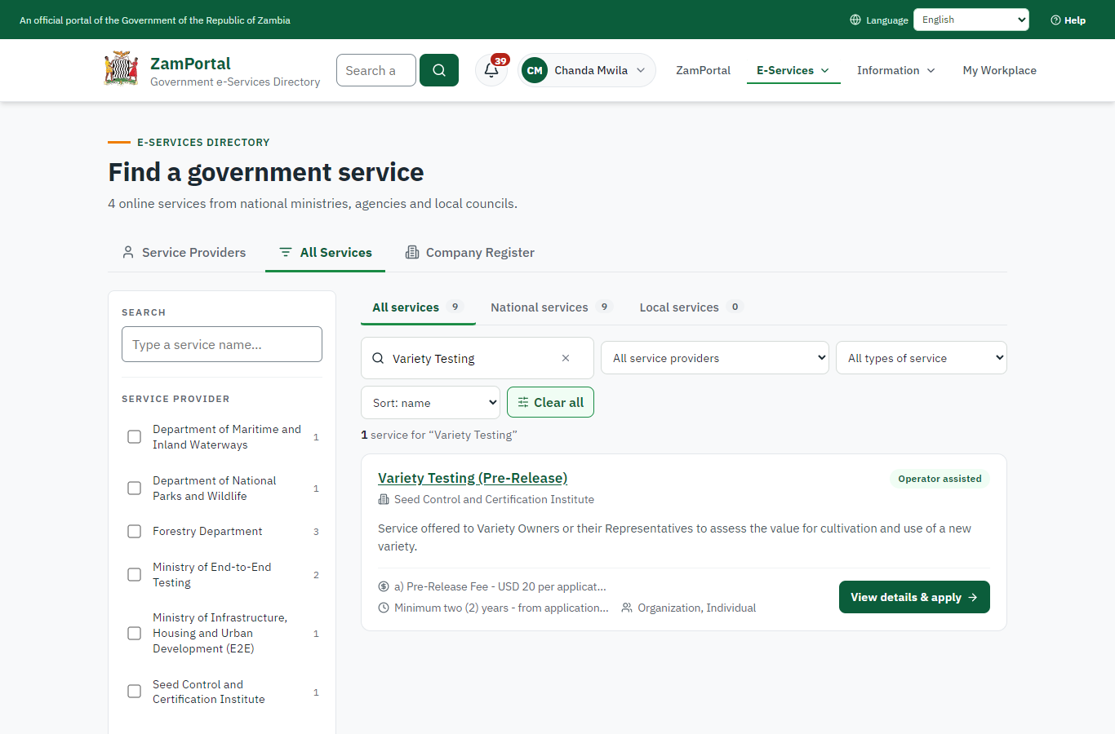 | 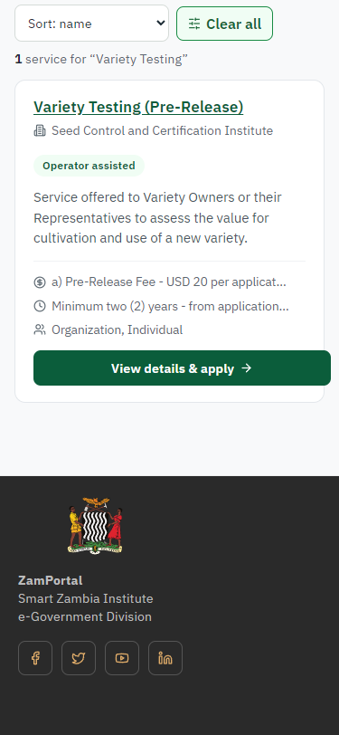
Step 1: Find the service - desktop (left) and a 375 px phone (right).

Step 2. Read the service page
Citizen · National e-Services portal
The service page sets out what the service is for, who provides it, the fee, how long it takes and the documents to have ready. "Start application" begins an application (the citizen is signed in with ZamPass).
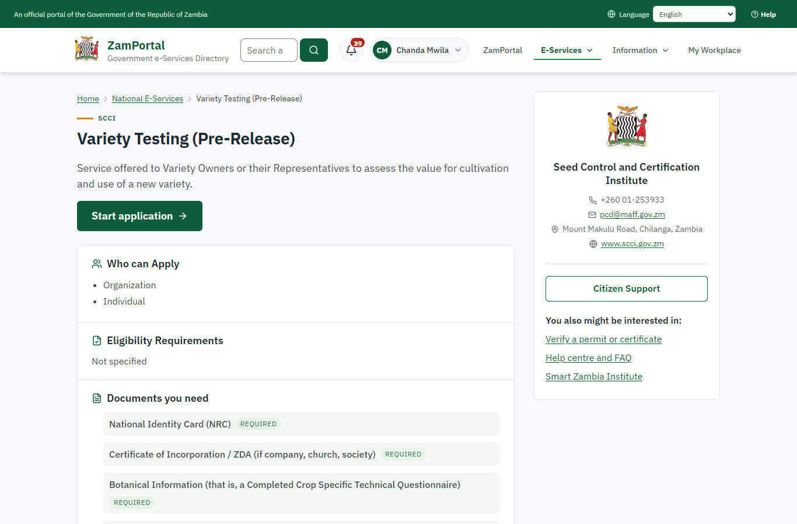 | 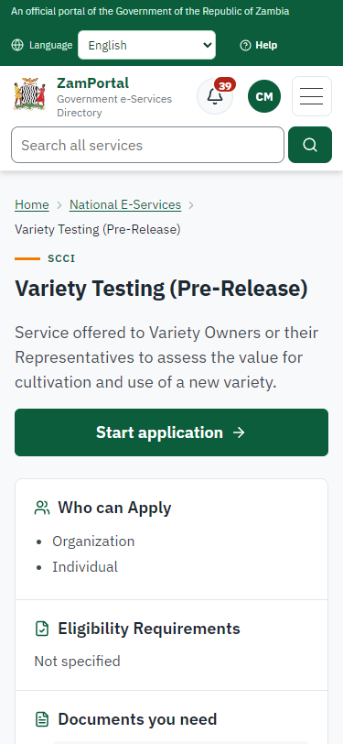
Step 2: Read the service page - desktop (left) and a 375 px phone (right).

Step 3. Confirm the applicant details
Citizen · National e-Services portal
The applicant details are filled in from the citizen's ZamPass account. The citizen says whom they are applying for (themself here) and continues with "Proceed to Application".
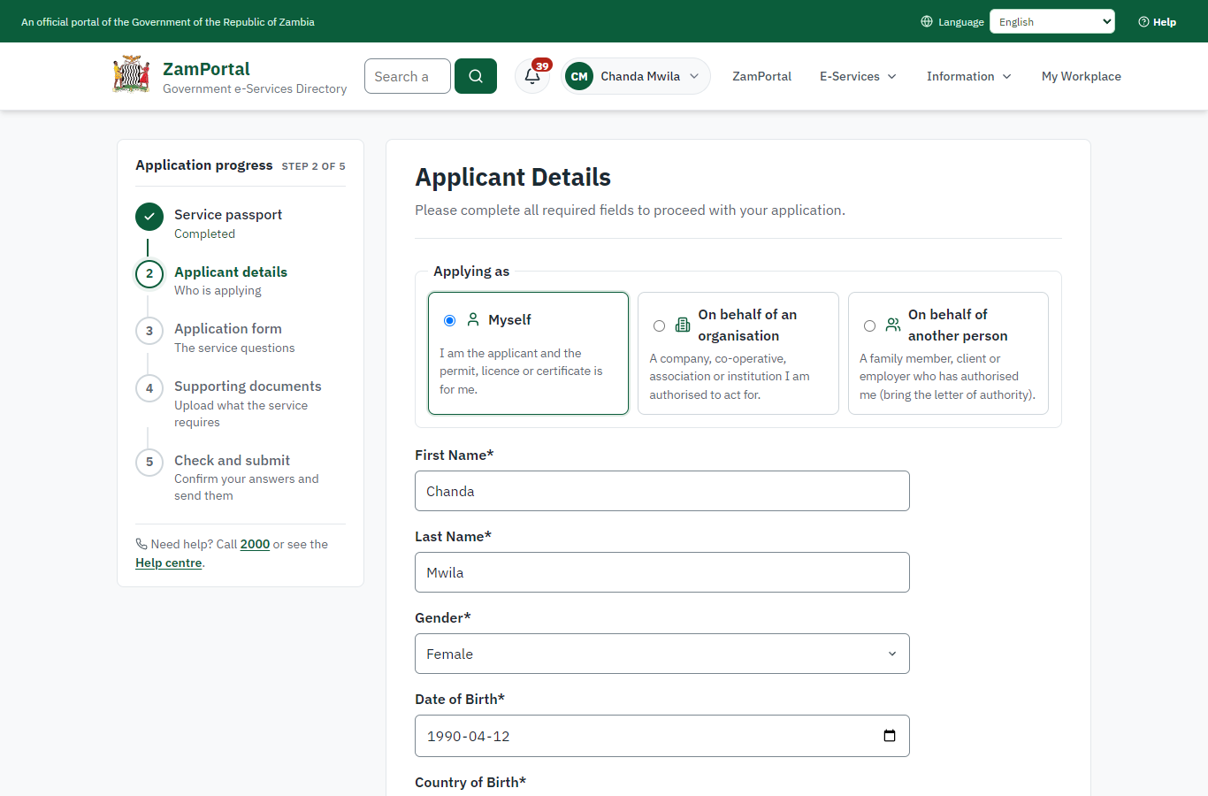 | 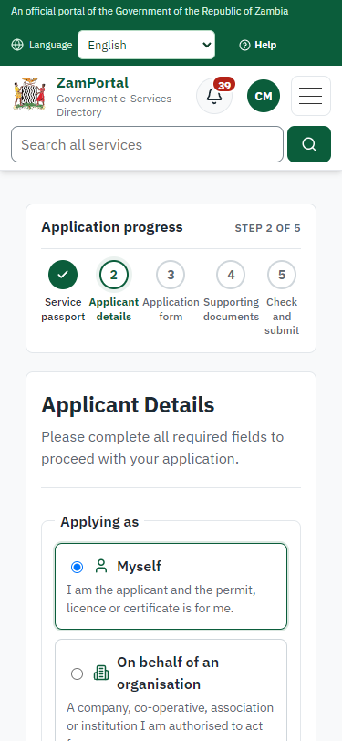
Step 3: Confirm the applicant details - desktop (left) and a 375 px phone (right).

Step 4. Give the particulars of the variety
Citizen · National e-Services portal
The form is the legacy service's own, imported: species, the preliminary designation and the proposed name of the new variety, its parental lines, parentage, origin, breeding method, maturity group, type of release, botanical characteristics, the quantity of seed supplied for testing and the grain type. The legacy service lists three fees for a new application (pre-release, DUS per year, national variety release trials per site and year); the fee that applies is priced on the server.
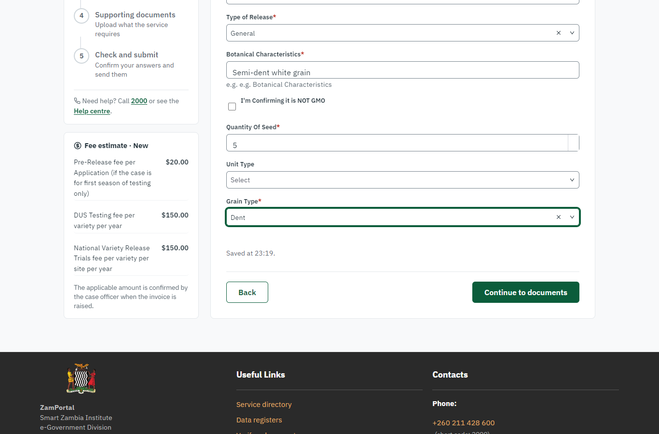 | 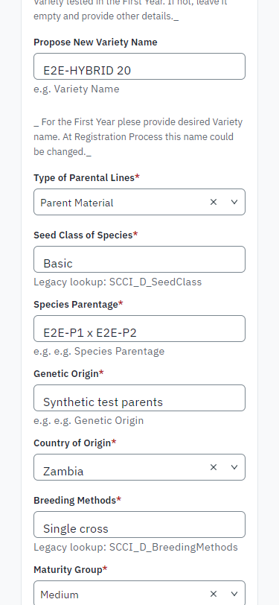
Step 4: Give the particulars of the variety - desktop (left) and a 375 px phone (right).

Step 5. Upload the documents
Citizen · National e-Services portal
The documents the legacy service asked for: the NRC, the botanical information (the crop-specific technical questionnaire), the descriptors of the parents (OECD) and the others listed. Synthetic files in this run.
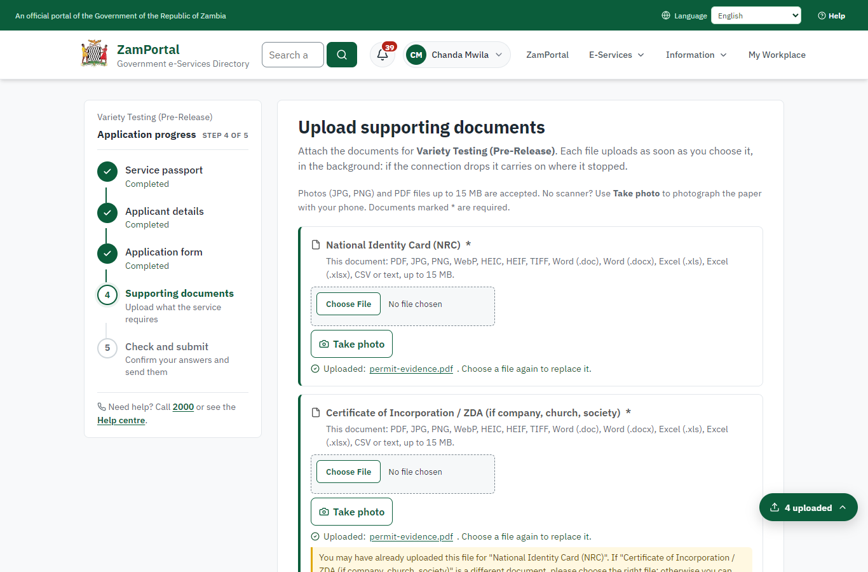 | 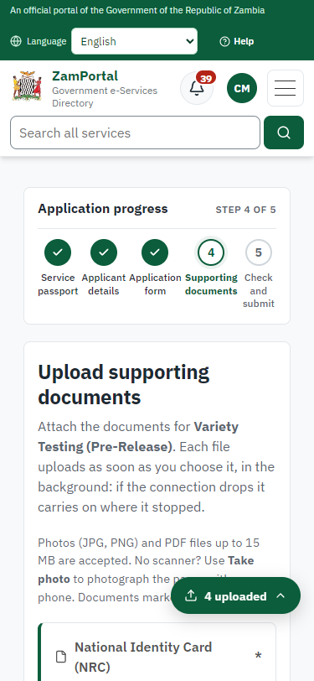
Step 5: Upload the documents - desktop (left) and a 375 px phone (right).

Step 6. Application sent
Citizen · National e-Services portal
The portal confirms the application with SCCI's reference number (SCCI-VT/00001/10-15-26 in this run). The legacy service lists three possible fees; SCCI works out which apply and the citizen is then invoiced.
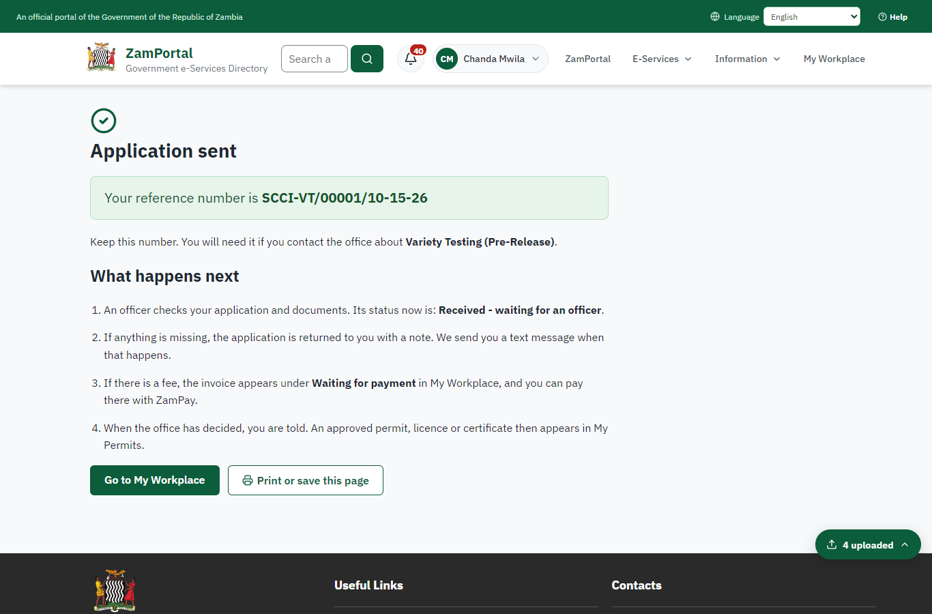 | 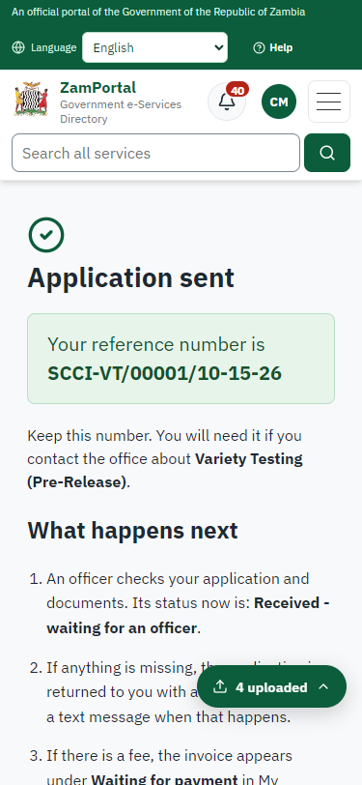
Step 6: Application sent - desktop (left) and a 375 px phone (right).

Step 7. Take the application on
Case Officer · Back office
The paid application arrives in SCCI's case list (only SCCI's staff see it). The officer assigns it to themself.
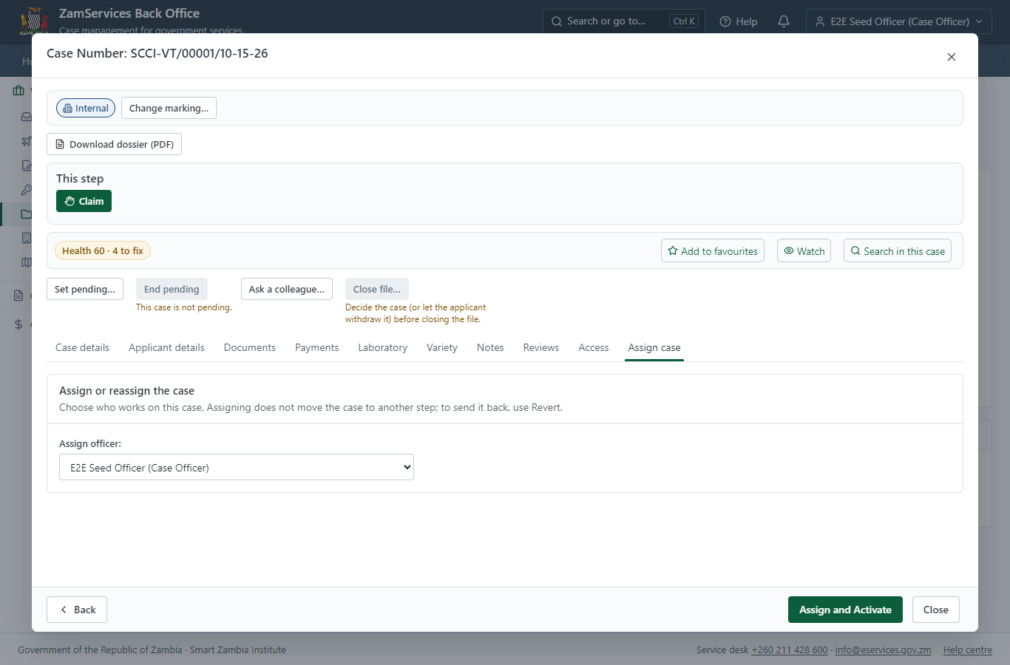
Step 7: Take the application on.

Step 8. Work out the application fee
Case Officer · Back office
The legacy service lists three fees for a new application: the pre-release fee (K20.00 for the first season of testing), the DUS testing fee and the national variety release trial fee per site and year. The officer sets the fee that applies now - the pre-release fee; the tests are charged on the laboratory quotation later - and "Submit Fees and Advance" raises the invoice for the applicant.
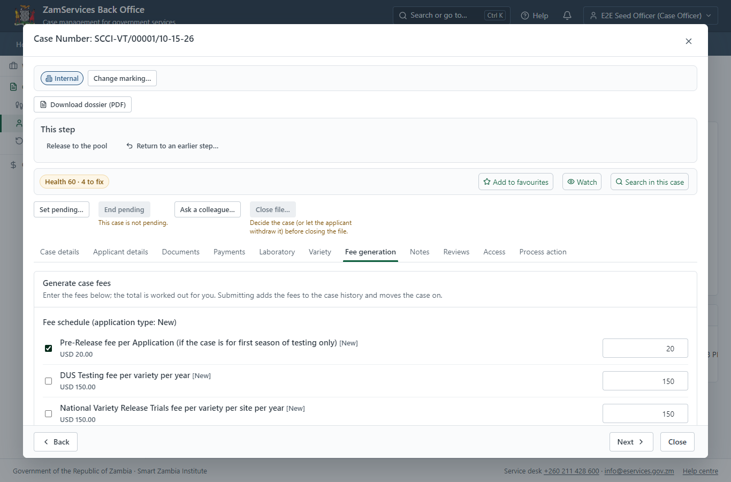
Step 8: Work out the application fee.

Step 9. Pay the application fee
Citizen · National e-Services portal
The application shows "Waiting for your payment" in My Workplace. Pay opens the invoice (K20.00, the pre-release fee); the citizen pays at ZamPay by mobile money or card.
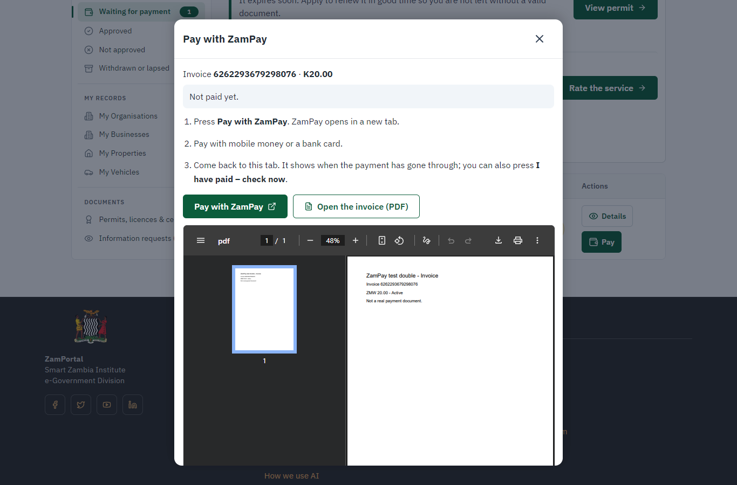 | 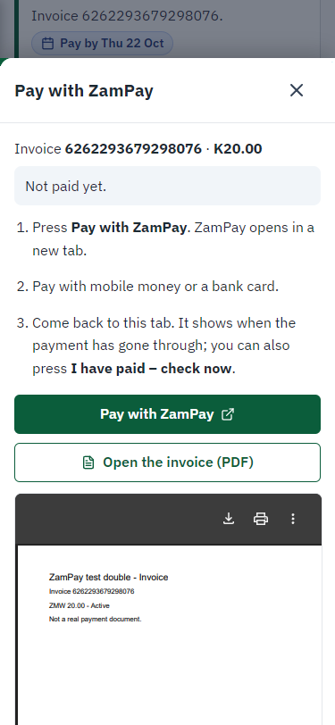
Step 9: Pay the application fee - desktop (left) and a 375 px phone (right).

Step 10. Register the seed sample
Case Officer · Back office
On the case's Laboratory tab the officer registers what the applicant supplied: species, variety, quantity (5 kg) and the date the laboratory received it. The banner at the top is the server's own verdict on the Laboratory step: it holds until every sample has a signed report.
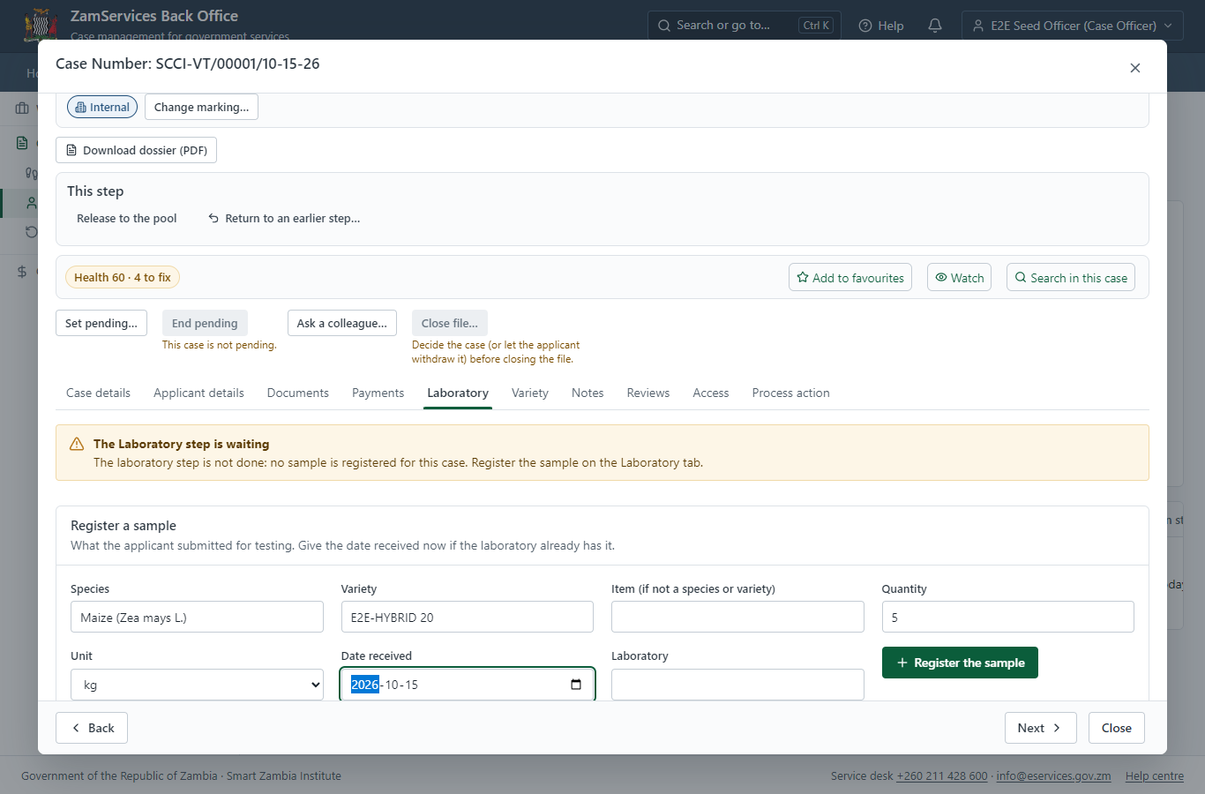
Step 10: Register the seed sample.

Step 11. Plan the DUS and VCU tests
Case Officer · Back office
The officer plans the tests from the laboratory's list of test types: the DUS test (distinctness, uniformity, stability) and the national variety release trial (VCU), each with its method and fee.
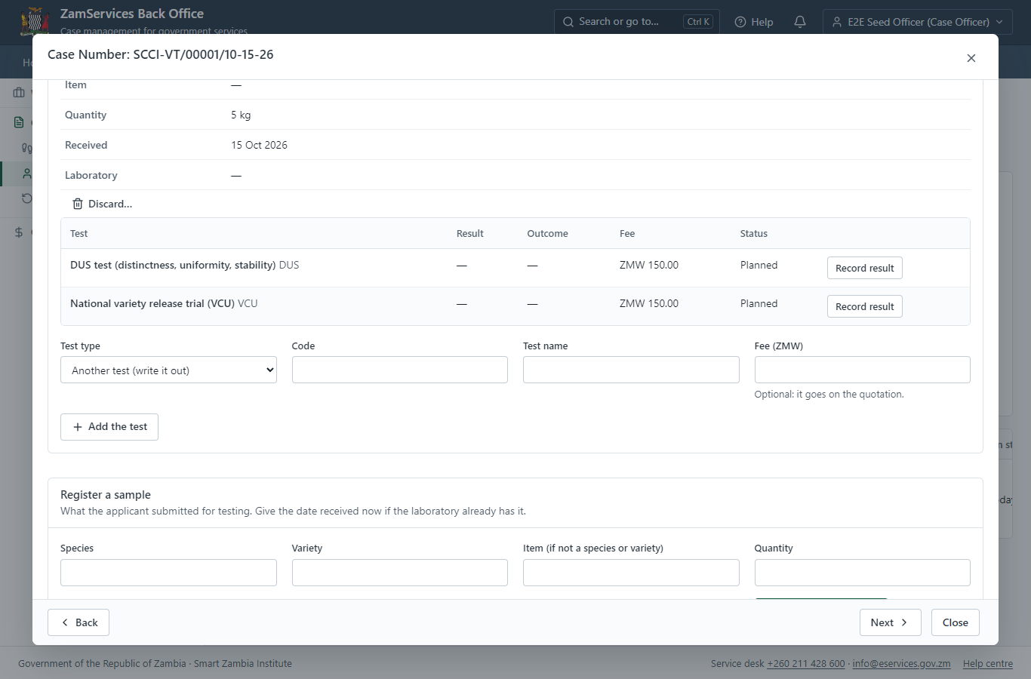
Step 11: Plan the DUS and VCU tests.

Step 12. Ask finance for the quotation
Case Officer · Back office
The fees of the planned tests (ZMW 300.00 in this run) go to finance as a charge on the application. The applicant sees nothing until an Accountant approves it; the officer who proposed it cannot approve it.
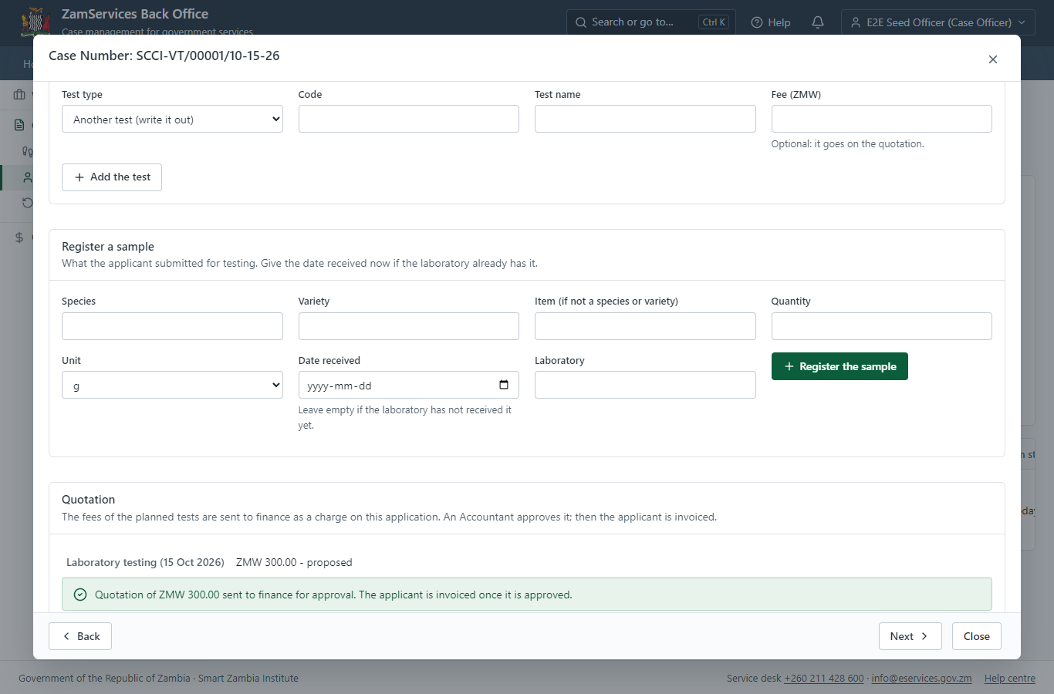
Step 12: Ask finance for the quotation.

Step 13. Approve the laboratory quotation
Accountant · Back office (done through its case API in the test run: no screenshot)
An Accountant of SCCI checks the quotation (the planned tests and their fees) and approves it. The charge is added to the application and invoiced to the applicant at once.

Step 14. Approve and sign the quotation step
Supervisor · Back office (done through its case API in the test run: no screenshot)
The supervisor completes the legacy "Approve and Sign Quotation" step. The next step - checking that the quotation is paid - holds while an invoice of the application is unpaid.

Step 15. Record the test results
Laboratory technician · Back office (done through its case API in the test run: no screenshot)
The technician records the result of each test: the DUS test (distinct, uniform, stable) and the VCU trial (8.4 t/ha). A result can be corrected until the report is signed - never after.

Step 16. Sign the DUS report
Laboratory head (Supervisor) · Back office
A lead officer of the laboratory who recorded no result checks and signs the report (LR-SCCI-2026-1 in this run). The results are frozen into it, the PDF is sealed with the platform's electronic seal when the installation has one - and says plainly when it is not - and it is added to the case documents for the deciding officers. The Laboratory step can now be completed.
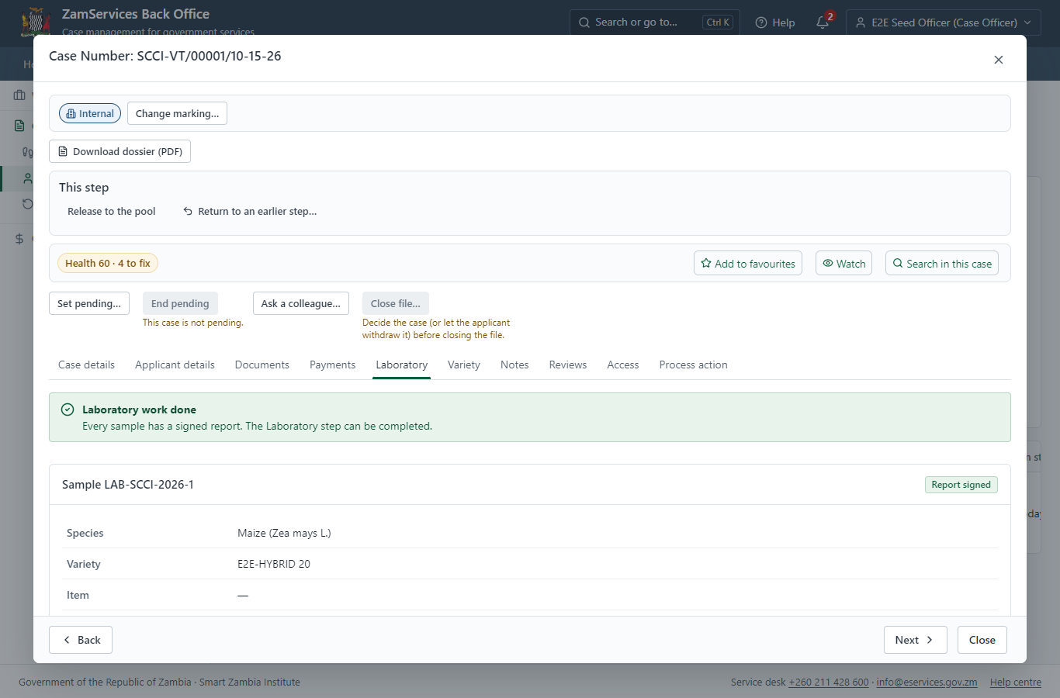
Step 16: Sign the DUS report.

Step 17. The variety committee decides
Committee secretary (Supervisor) · Back office (done through its case API in the test run: no screenshot)
The secretary puts the application on the agenda of a meeting of the Variety Release Committee (VRC/2026/1 in this run), records who attended (the quorum is checked) and the resolution "approve" with its reasons, and closes the meeting. Closing it decides the application; the minutes are kept with the meeting.

Step 18. The varieties register
Case Officer · Back office
Ministry functions -> Seed control -> Varieties register: the variety is now "Recommended for release". The release application, the protection (with its gazette notice) and the seed growers who multiply it are recorded against it in the same register.
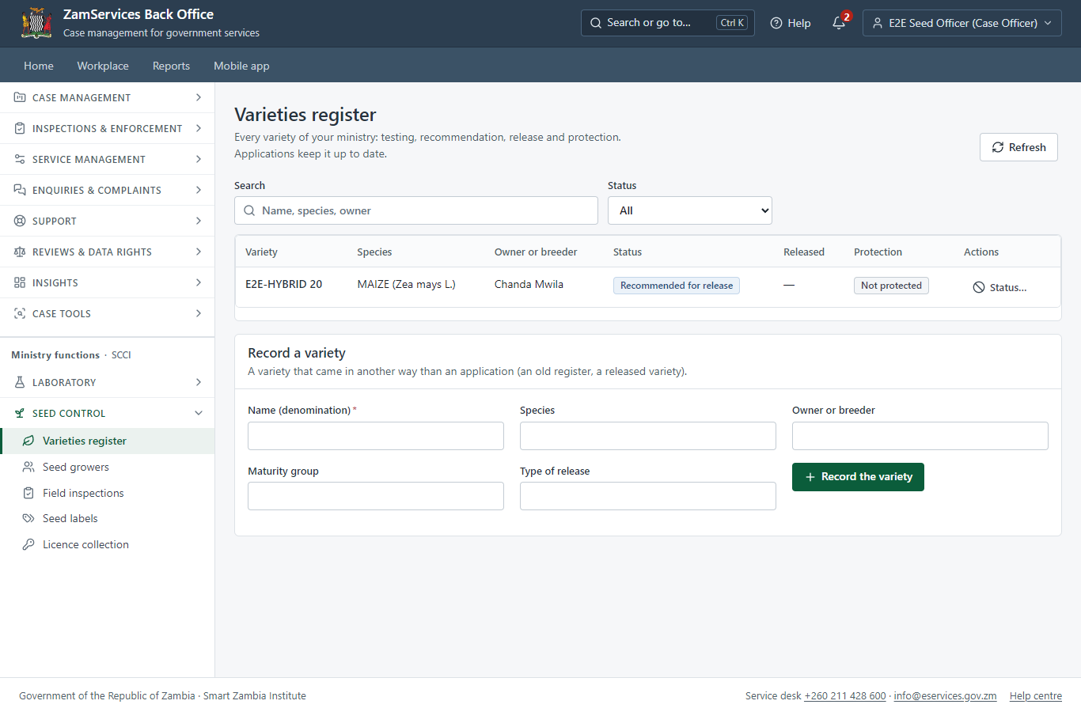
Step 18: The varieties register.

3. Payment
Item | In the test run
Application fee | ZMW 20.00, invoice 6262293679298076, paid with the application (as the legacy service did)
Laboratory quotation | ZMW 300.00: the fees of the planned DUS (150.00) and VCU (150.00) tests, proposed by the officer, approved by an Accountant, invoice 6306355005375890
Paid through | ZamPay (the ZamPay test double in this run)
Rule | The quotation is never approved by the officer who proposed it; the case waits at "Check the laboratory quotation is paid" until every invoice is paid
On screen: step 9 (Pay the application fee), step 13 (Approve the laboratory quotation) in section 2.

4. Output documents

DUS report LR-SCCI-2026-1 (laboratory report, PDF)
The laboratory report signed by a lead officer of the laboratory: the sample, the results of each test frozen as they were signed, the conclusion, who signed and when, and the seal. It is a case document for the deciding officers (internal; an officer may release it to the applicant). The download is checked against the hash recorded when it was signed.
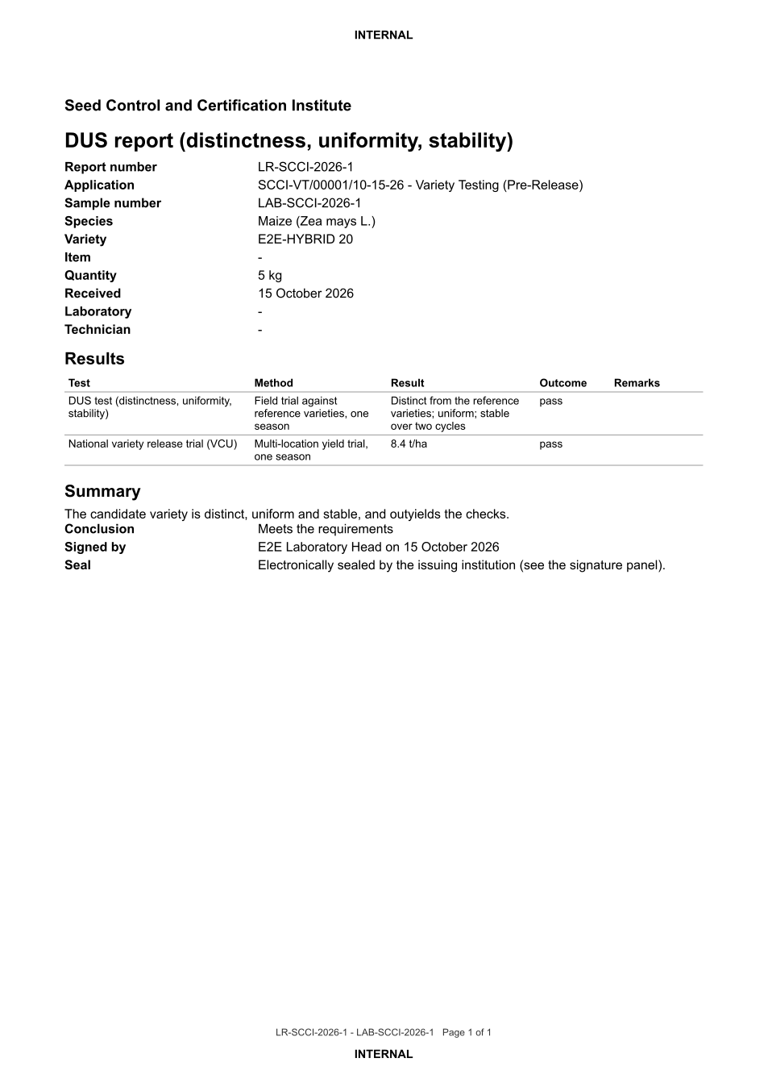
DUS report LR-SCCI-2026-1 (laboratory report, PDF) - first of 1 page, as issued in the test run.

Fields
Field | Value in the test run
Report number | LR-SCCI-2026-1
Sample | LAB-SCCI-2026-1
Variety | E2E-HYBRID 20
Tests | DUS: distinct, uniform, stable (pass); VCU: 8.4 t/ha (pass)
Conclusion | Meets the requirements

Seal
Seal | Electronically sealed (PAdES) by the platform's signing service

Verification
Integrity | SHA-256 recorded at signing; the download is refused if the stored file does not match
On screen: step 18 (The varieties register) in section 2.

5. Notifications
When | Channel | To | Message | Delivery
Application received | in-app (portal bell) | the applicant | Application SCCI-VT/00001/10-15-26 received - Your application SCCI-VT/00001/10-15-26 for Variety Testing (Pre-Release) has been received by Seed Control and Certification Institute. | shown
Status changed | in-app (portal bell) | the applicant | Update on application SCCI-VT/00001/10-15-26 - SCCI-VT/00001/10-15-26 (Variety Testing (Pre-Release)) is now: With the office - fees being worked out. | shown
Payment due (invoice raised) | in-app (portal bell) | the applicant | Payment due for application SCCI-VT/00001/10-15-26 - The fee of ZMW 20.00 for Variety Testing (Pre-Release) (SCCI-VT/00001/10-15-26) is now due. Invoice 6262293679298076. | shown
Payment received | in-app (portal bell) | the applicant | Payment received for SCCI-VT/00001/10-15-26 - Your payment of ZMW 20.00 for SCCI-VT/00001/10-15-26 (Variety Testing (Pre-Release)) has been received. Receipt: <ZamPay>/pdf?documentType=receipt&invoiceNumber=6262293679298076 | shown
fee.approval_requested | in-app (portal bell) | the applicant | Fee to approve on SCCI-VT/00001/10-15-26 - Hello E2E Seed Accountant, E2E Seed Officer proposed a fee of ZMW 300.00 on case SCCI-VT/00001/10-15-26 (Variety Testing (Pre-Release)). Approve or refuse it in the back office: <back office>/finance/fee-approvals | shown
fee.decided | in-app (portal bell) | the applicant | Fee on SCCI-VT/00001/10-15-26 approved - Hello E2E Seed Officer, the fee of ZMW 300.00 you proposed on case SCCI-VT/00001/10-15-26 (Variety Testing (Pre-Release)) was approved. Note: Fees as per the test types Open the case: <back office>/cases/baa8e331-1fc5-4750-8851-a0e54d1f64fb | shown
Payment received | in-app (portal bell) | the applicant | Payment received for SCCI-VT/00001/10-15-26 - Your payment of ZMW 300.00 for SCCI-VT/00001/10-15-26 (Variety Testing (Pre-Release)) has been received. Receipt: <ZamPay>/pdf?documentType=receipt&invoiceNumber=6306355005375890 | shown
Licence / permit issued | in-app (portal bell) | the applicant | Your Variety Testing (Pre-Release) document has been issued - SCCI-VTPR-2026-00001 has been issued for Variety Testing (Pre-Release) and is valid until 15/10/2027. | shown
Invitation to rate the service | in-app (portal bell) | the applicant | How was Variety Testing (Pre-Release)? - How was Variety Testing (Pre-Release)? Tell us in about a minute. | shown
Decision: approved | in-app (portal bell) | the applicant | Application SCCI-VT/00001/10-15-26 completed - SCCI-VT/00001/10-15-26 (Variety Testing (Pre-Release)) is complete. Your documents are ready. | shown
Application received | sms | +260 97* *** 567 | Application SCCI-VT/00001/10-15-26 for Variety Testing (Pre-Release) has been received. Track it: <portal>/my-workplace | delivered
Application received | email | e2e.c***@example.test | Application SCCI-VT/00001/10-15-26 received | skipped
Status changed | sms | +260 97* *** 567 |  | delivered
Payment due (invoice raised) | sms | +260 97* *** 567 | Fee of ZMW 20.00 due for SCCI-VT/00001/10-15-26. Invoice 6262293679298076. Pay: <ZamPay>/pay-for-service/get-invoice/6262293679298076 | delivered
Payment due (invoice raised) | email | e2e.c***@example.test | Payment due for application SCCI-VT/00001/10-15-26 | skipped
Payment received | sms | +260 97* *** 567 |  | delivered
fee.approval_requested | email | e2e.s***@example.test | Fee to approve on SCCI-VT/00001/10-15-26 | skipped
Payment due (invoice raised) | sms | +260 97* *** 567 | Your payment of ZMW 20.00 for application SCCI-VT/00001/10-15-26 (Variety Testing (Pre-Release)) has been received. Receipt: <ZamPay>/pdf?documentType=receipt&invoiceNumber=6262293679298076 Processing continues. | delivered
fee.decided | email | e2e.s***@example.test | Fee on SCCI-VT/00001/10-15-26 approved | skipped
Invitation to rate the service | sms | +260 97* *** 567 |  | skipped
Invitation to rate the service | email | e2e.c***@example.test | How was Variety Testing (Pre-Release)? | skipped
Decision: approved | email | e2e.c***@example.test | Application SCCI-VT/00001/10-15-26 completed | skipped
Licence / permit issued | sms | +260 97* *** 567 |  | delivered
Licence / permit issued | email | e2e.c***@example.test | Your Variety Testing (Pre-Release) document has been issued | skipped
Decision: approved | sms | +260 97* *** 567 |  | delivered
Delivery: shown = in the portal's notification bell; delivered = the SMS gateway (a test double in this run) reported the text delivered; skipped = not sent on that channel (e-mail is not configured on the test installation, and some notices go out on one channel only); sent by the national portal = a ministry node handed the notice to the national portal, which texts and e-mails the citizen under its own name and the citizen's preferences. Addresses written <portal>, <ZamPay> stand for the national portal and ZamPay.

6. Legacy mapping
Replaces | Variety Testing (Pre-Release) in the legacy ZIGS e-Services directory (ZIGS_Services)
Legacy service id | 250
Legacy provider | Seed Control and Certification Institute (SCCI) under Ministry of Agriculture
Legacy process | VarietyTesting (process 128)
Fee in the legacy system | Pre-Release fee per Application (if the case is for first season of testing only): USD 20 (New)  DUS Testing fee per variety per year: USD 150 (New)  National Variety Release Trials fee per variety per site per year: USD 150 (New)
Fee taken before submission | yes (as in ZIGS)
Time to issue (legacy) | New: 24 months
Legacy output templates | Notice of Action: ZIGS_Forms_Notices / GS-2.NoticeOfAction  Application form: ZIGS_Forms_SCCI / SCCI_VarietyTesting.Application  GF-1 Treasury Invoice: ZIGS_CustomForms / GF-1 Invoice  GF-2 Treasury Receipt: ZIGS_CustomForms / GF-2 Receipt
Legacy address | none recorded
How it was brought over | Imported by the platform's legacy catalogue importer (zcm-backend scripts/zigs/importLegacy.js) from the ZIGS snapshot: form, case types, fees, documents, process and output templates, then served by the new platform.

7. Version and date
Document version | service v1, platform 9e8768d3
Generated | 2026-10-15T21:19:50Z (by the end-to-end run, not edited by hand)
Service version | not versioned (configured directly)
Platform snapshot | backend 9e8768d3  portal b47ff71  back office 548d2d6
Test suite | e2e ca5e2ed; one installation (combined); seed profile mihud
Journeys | 20-seed-variety-samples.spec.js: citizen finds the service and applies for a variety test - passed  20-seed-variety-samples.spec.js: the SCCI officer takes it on and works out the application fee - passed  20-seed-variety-samples.spec.js: citizen pays the application fee - passed  20-seed-variety-samples.spec.js: the officer registers the sample, plans the tests and asks finance for the quotation - passed  20-seed-variety-samples.spec.js: the quotation: approved by an Accountant (not by its proposer), the step approved, the citizen pays - passed  20-seed-variety-samples.spec.js: the Laboratory step holds until the report is signed; results, then the signature of an officer who recorded none - passed  20-seed-variety-samples.spec.js: the variety committee meets and approves; the case is completed and the variety recommended for release - passed  20-seed-variety-samples.spec.js: the signed laboratory report: downloaded, its fields and seal - passed
Result | 8 of 8 journey tests passed
Data | Synthetic test data on a local test installation; provider test doubles for ZamPass, ZamPay, SMS and signing.

