Republic of Zambia
GSB e-Services

Subdivision of Land
Service documentation
Owner: Department of Local Government
Service key: LGD/subdivision-of-land
Version: service v1, platform 39fb88e4
Date: 2026-10-21
Generated automatically by the service's end-to-end test run. Every screenshot shows synthetic test data on a local test installation, never real personal data.

Contents
- 1. Service summary
- 2. Application process, step by step
- 3. Payment
- 4. Output documents
- 5. Notifications
- 6. Legacy mapping
- 7. Version and date
This document describes the Subdivision of Land service of Department of Local Government as the platform runs it today. It is generated by the service's end-to-end test: every step was performed by the test and every screenshot was taken during that run, with synthetic data. Regenerate it with "npm run docs:services" in the e2e suite; do not edit it by hand.

1. Service summary
Service | Subdivision of Land
Owner (MDA) | Department of Local Government (LGD)
Purpose | Service authorizes property owners or their authorized representatives to lawfully subdivide land into two or more plots, subject to compliance with approved zoning regulations, planning standards, infrastructure requirements, and any conditions imposed by the Planning Authority. Outstanding Property Rates arrears must be paid before applying for this service.
Who can apply | Not set in the service configuration.
How to apply | Online on the national e-Services portal, signed in with ZamPass; pay with ZamPay.
Fees | Subdivision fee: (table)  Application and inspection fees: (table)  Minutes extracts fee: (table)
Turnaround | Not set in the service configuration.
Validity of the output | Not applicable
Required documents | Applicant/Representative Identity Document (required) - Taken from the applicant's verified identity / registration where available (legacy automatic document).  Applicant/Representative Certificate of Registration (required) - Taken from the applicant's verified identity / registration where available (legacy automatic document).  Certificate of Title (required)  Site Plan endorsed by registered planner or planning firm (required)  Letter of Consent from property owner (optional)
Output documents | GS-1 Application for a Government Service  GS-2 Notice of Government Action  Subdivision Memo  Subdivision Recommendation Letter

2. Application process, step by step

The process as configured
Step | Role | Task | Type
1 | Applicant | Apply | form
2 | System | Generate Document | generate-document
3 | Case Officer | Generate Payment | generate-payment
4 | Applicant | Payment | payment
5 | Case Officer | Review | review
6 | Case Officer | Inspect Site | inspection
7 | Supervisor | Approve | parallel-approval
8 | Supervisor | Review | review
9 | System | Generate Document | generate-document
10 | Executive | Decision | decision
11 | System | Generate Document | generate-document
12 | System | Notify Client | notify

Step by step
Who takes part in this journey: Citizen, Case Officer, Supervisor, Executive, Anyone (public). Citizen steps are shown on a desktop and on a 375 px phone; back-office steps on a desktop.

Step 1. Find the service at the council
Citizen · National e-Services portal
The service is delivered by the local authorities: on the national e-Services portal the citizen opens Councils, chooses their council (Lusaka City Council in this run) and searches its services ("Subdivision of Land"). The application is then registered with that council and priced with its own fees.
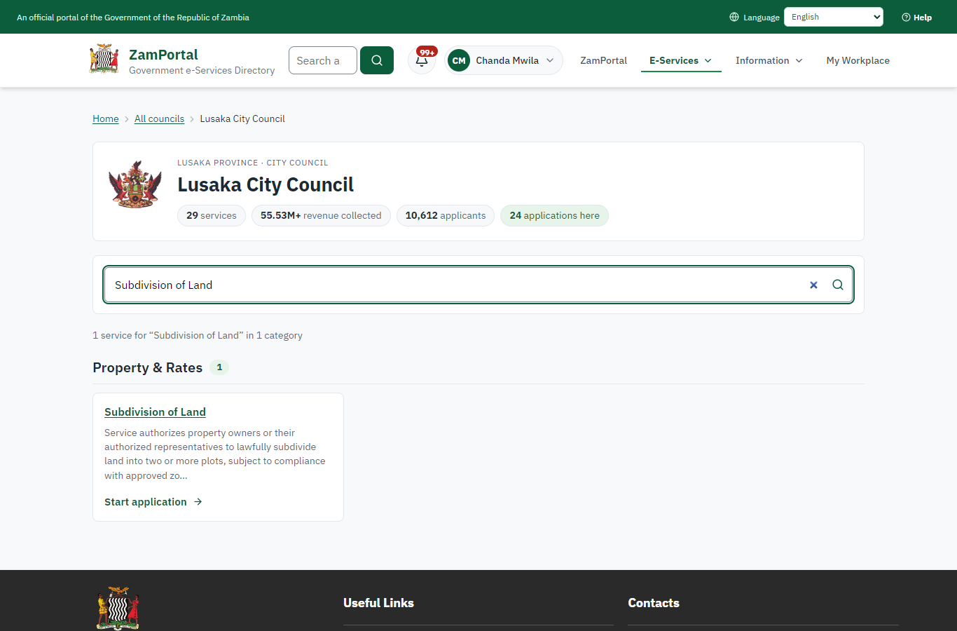 | 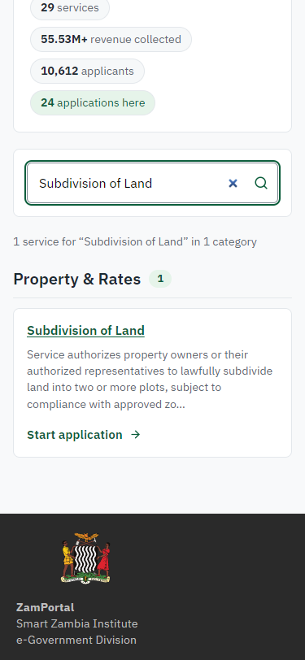
Step 1: Find the service at the council - desktop (left) and a 375 px phone (right).

Step 2. Read the service page
Citizen · National e-Services portal
The service page sets out what the service is for, the fee, how long it takes and the documents to have ready, and names the council the application goes to. "Start application" begins an application at Lusaka City Council (the citizen is signed in with ZamPass).
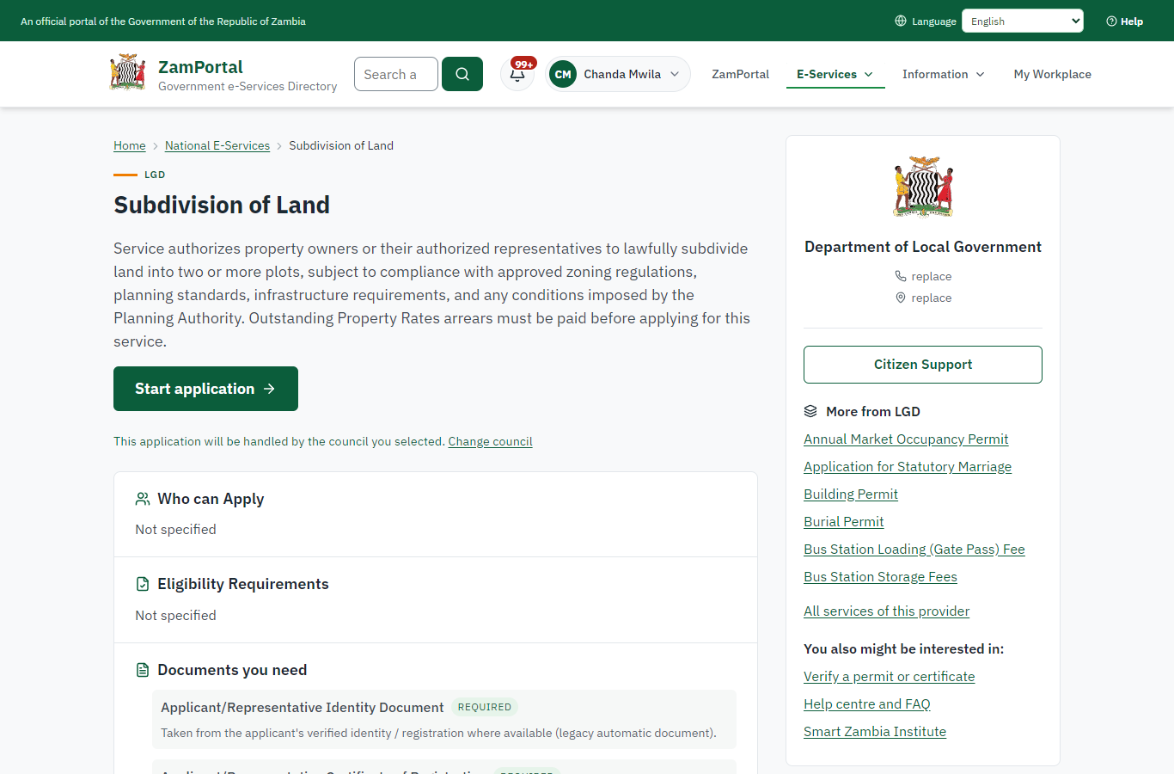 | 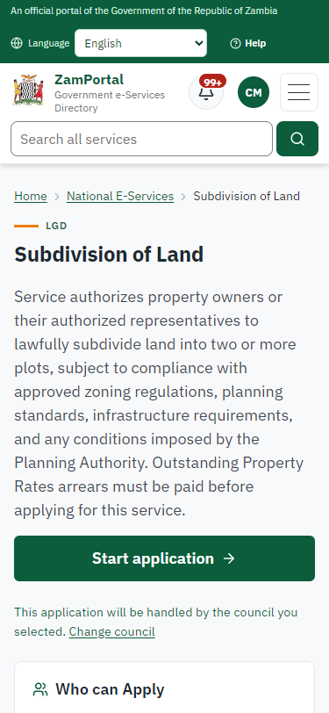
Step 2: Read the service page - desktop (left) and a 375 px phone (right).

Step 3. Confirm the applicant details
Citizen · National e-Services portal
The applicant details are filled in from the citizen's ZamPass account. The citizen says whom they are applying for (themself) and continues with "Proceed to Application".
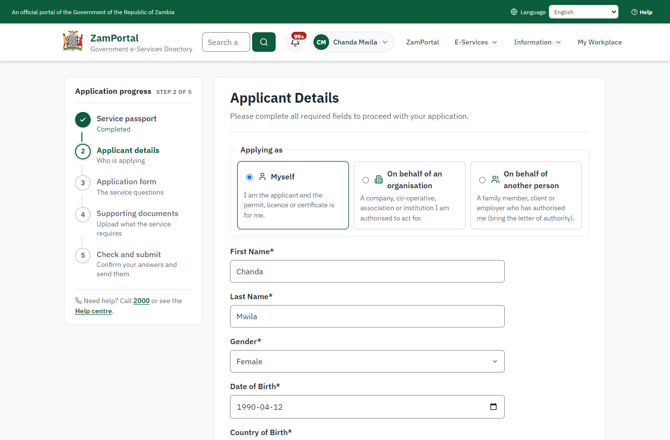 | 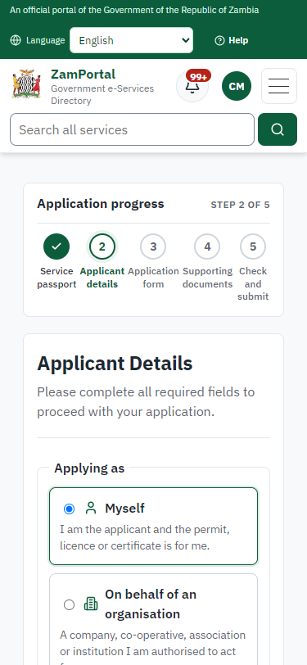
Step 3: Confirm the applicant details - desktop (left) and a 375 px phone (right).

Step 4. Fill in the application form
Citizen · National e-Services portal
The citizen answers the service's own application form, converted from the legacy system (10 answers in this run, all synthetic), for the type of application "New". Questions marked * must be answered; some appear only after an earlier answer. Answers are saved as the citizen types, so an unfinished application can be reopened from My Workplace.
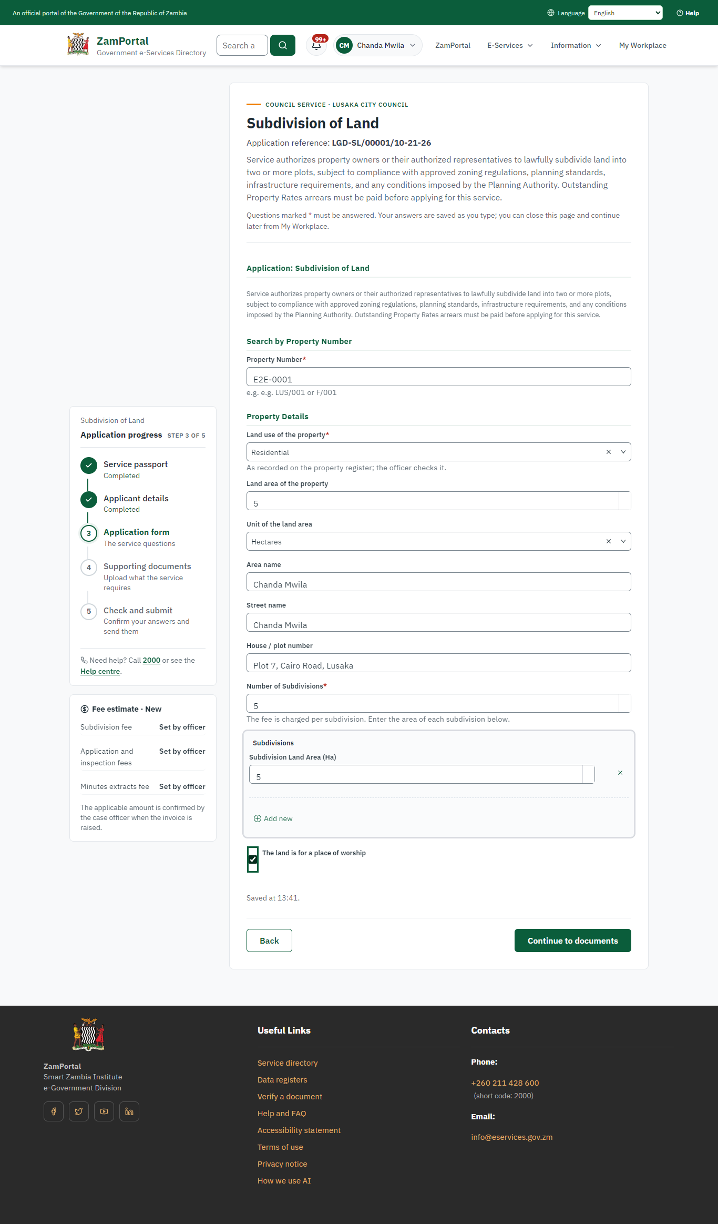 | 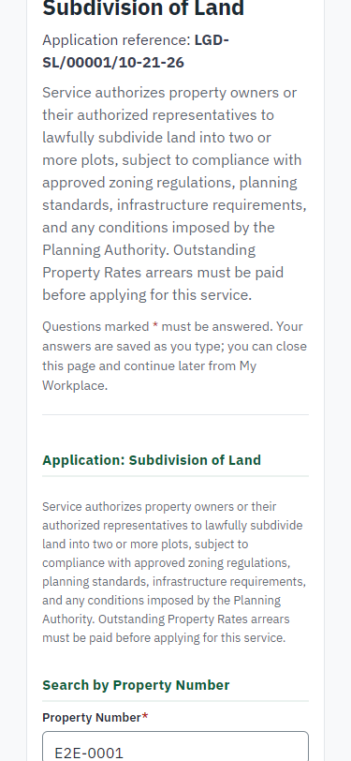
Step 4: Fill in the application form - desktop (left) and a 375 px phone (right).

Step 5. Upload the supporting documents
Citizen · National e-Services portal
Each document the service asks for has its own upload (5 in this run: Applicant/Representative Identity Document, Applicant/Representative Certificate of Registration, Certificate of Title, Site Plan endorsed by registered planner or planning firm, Letter of Consent from property owner). The files are checked and stored with the application; the page confirms each upload.
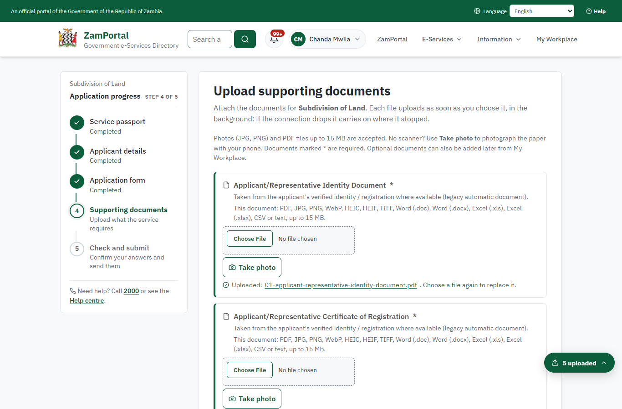 | 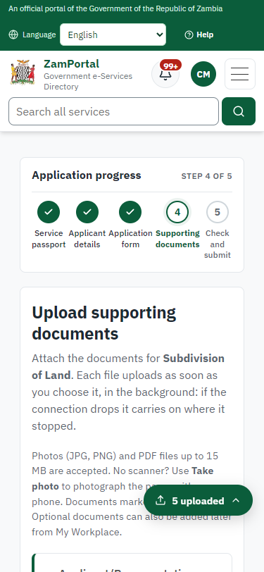
Step 5: Upload the supporting documents - desktop (left) and a 375 px phone (right).

Step 6. Check the answers and confirm the declaration
Citizen · National e-Services portal
Before sending, the citizen sees every answer and document on one page and can go back to change them. The declaration that the information is true and complete must be ticked.
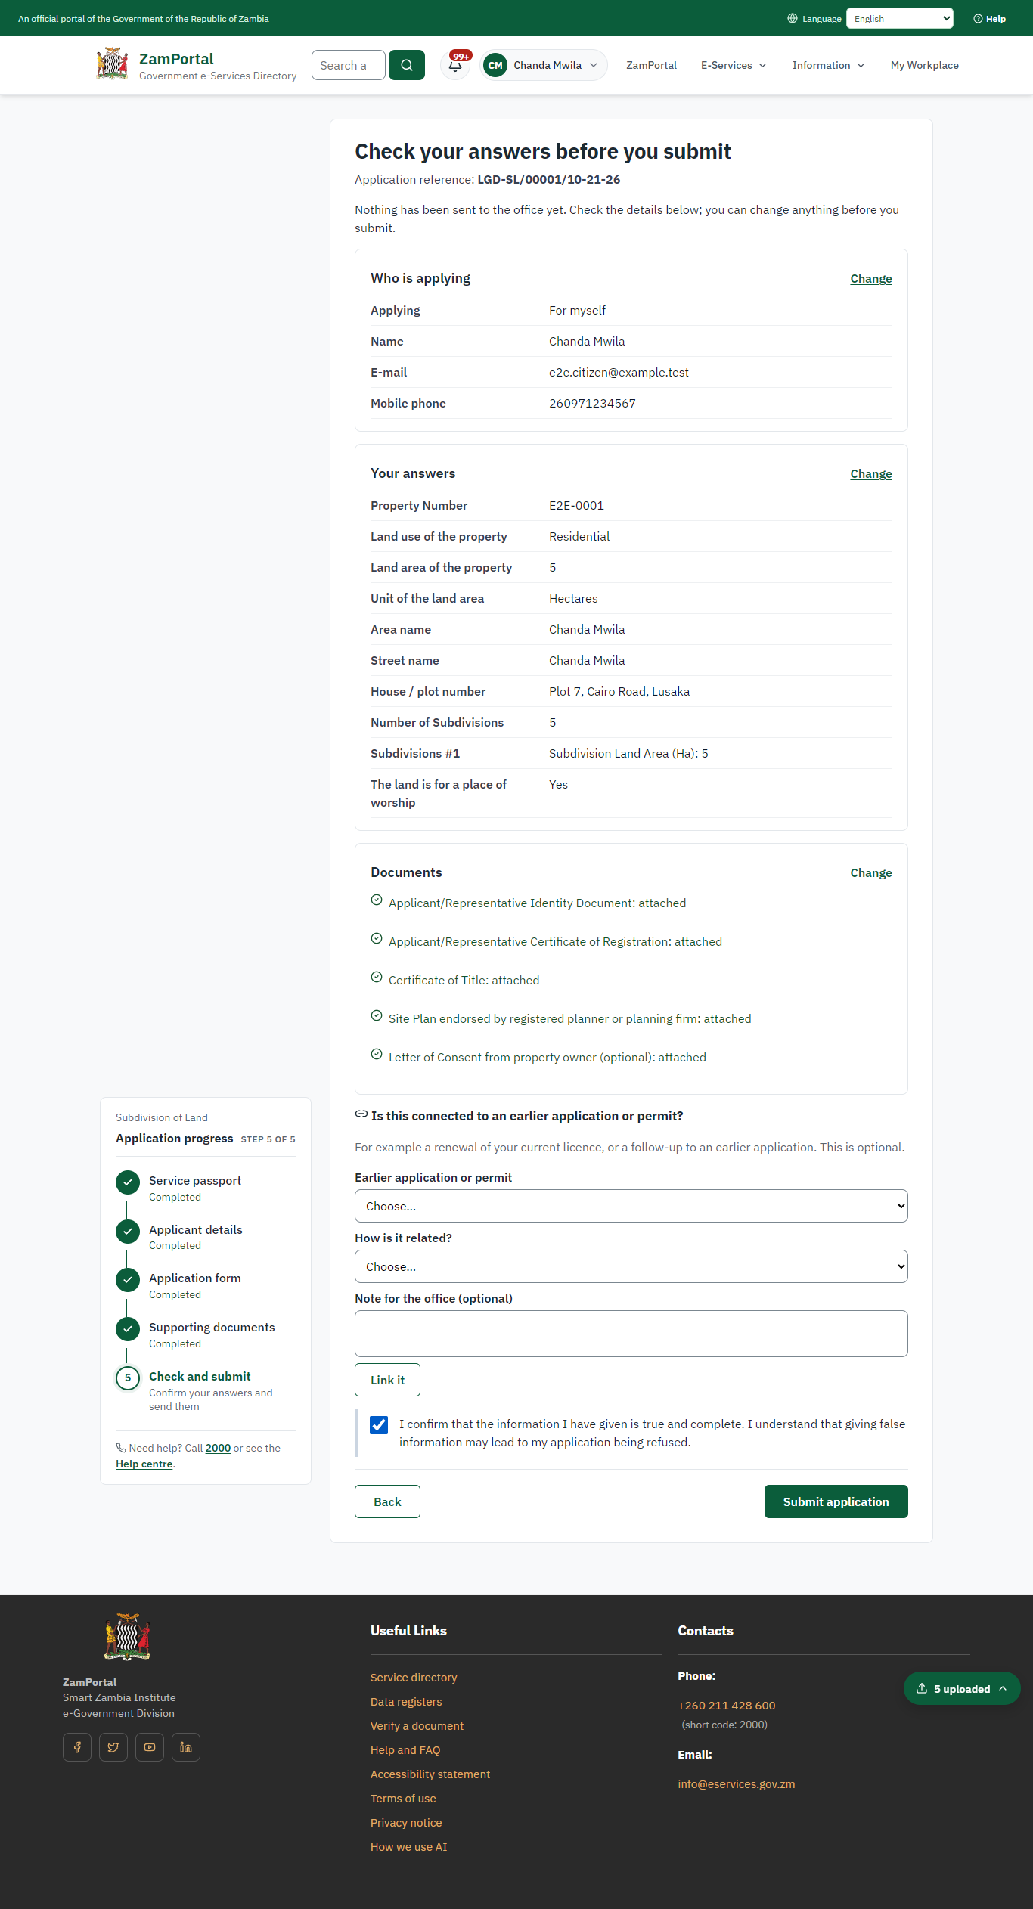 | 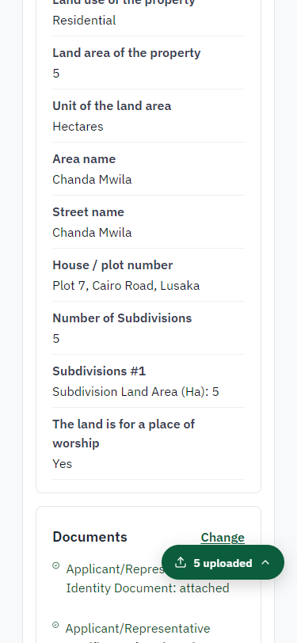
Step 6: Check the answers and confirm the declaration - desktop (left) and a 375 px phone (right).

Step 7. Application sent
Citizen · National e-Services portal
The portal confirms the application with the ministry's reference number (LGD-SL/00001/10-21-26 in this run). The fee is due now: it is taken with the application, so the invoice was raised when the application was sent.
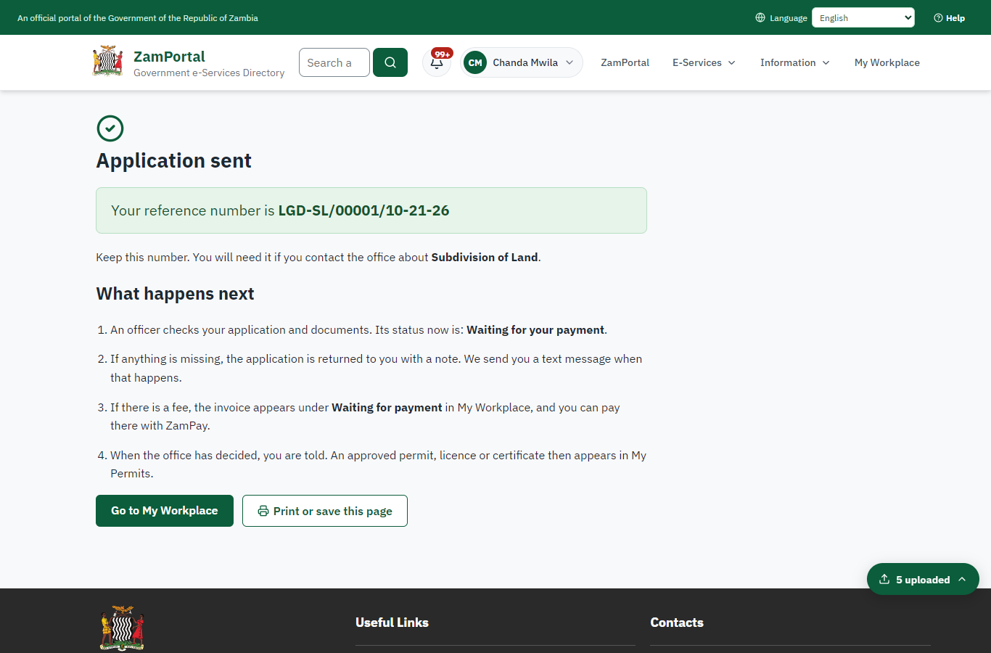 | 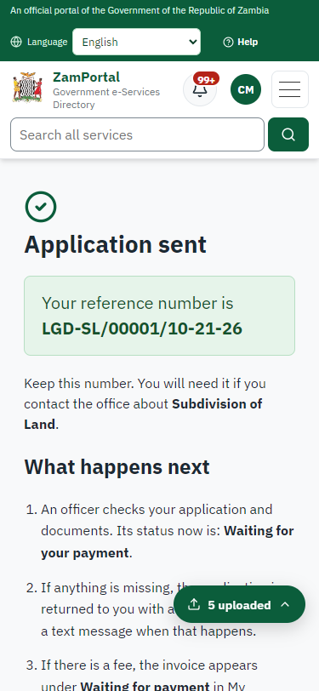
Step 7: Application sent - desktop (left) and a 375 px phone (right).

Step 8. See that the fee is due
Citizen · National e-Services portal
The application shows "Waiting for your payment" in My Workplace with a Pay button (K33,050.00). The fee is taken with the application; the invoice was raised on ZamPay.
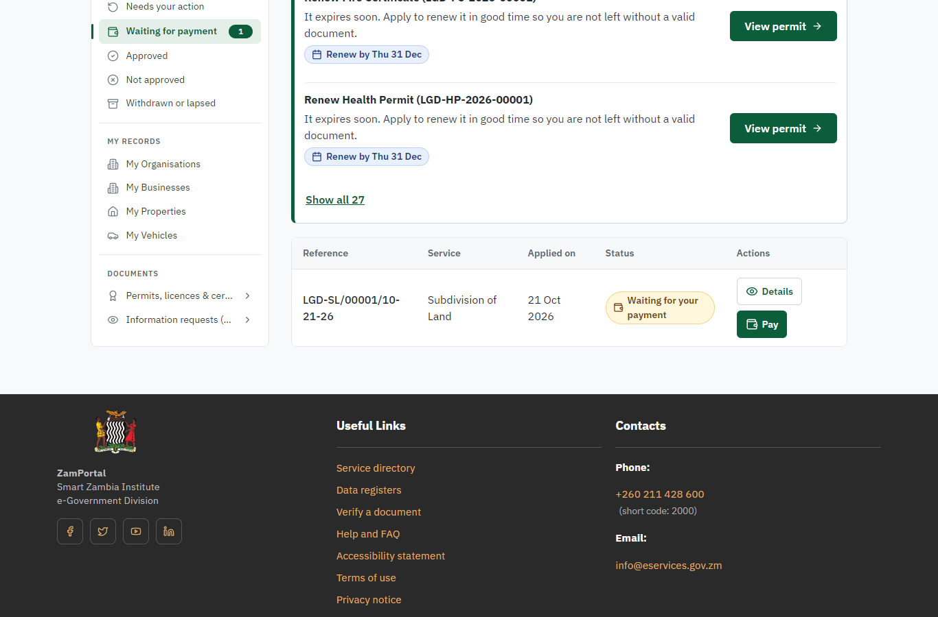 | 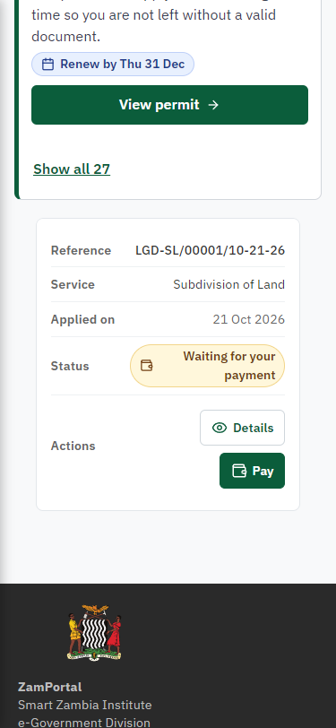
Step 8: See that the fee is due - desktop (left) and a 375 px phone (right).

Step 9. Pay with ZamPay
Citizen · National e-Services portal
Pay opens the invoice (K33,050.00, the amount set by the platform, never by the page) with its PDF preview; the citizen pays at ZamPay by mobile money or bank card.
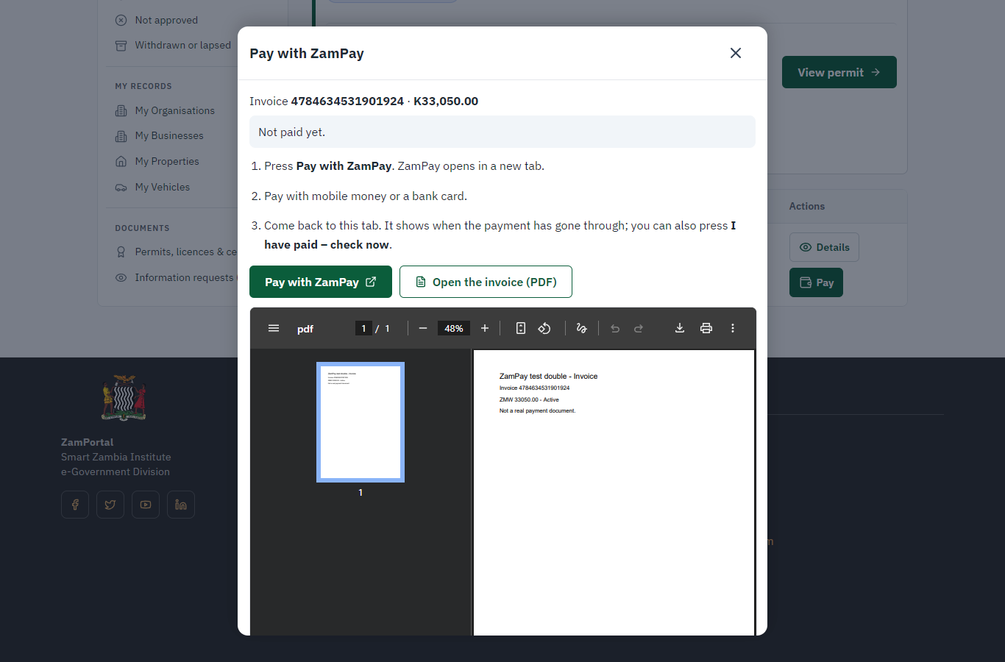 | 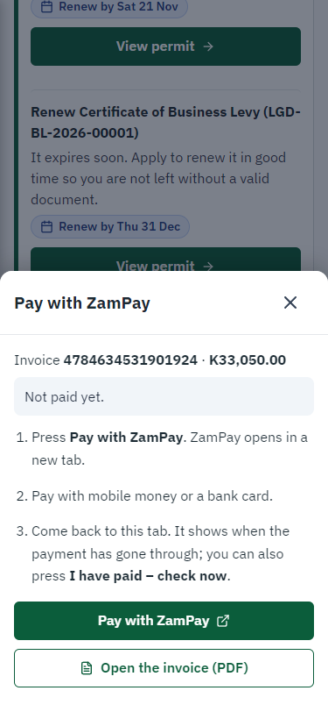
Step 9: Pay with ZamPay - desktop (left) and a 375 px phone (right).

Step 10. Payment received
Citizen · National e-Services portal
ZamPay reports the payment; the dialog says "Paid. Thank you" and the application moves on to the ministry's officers.
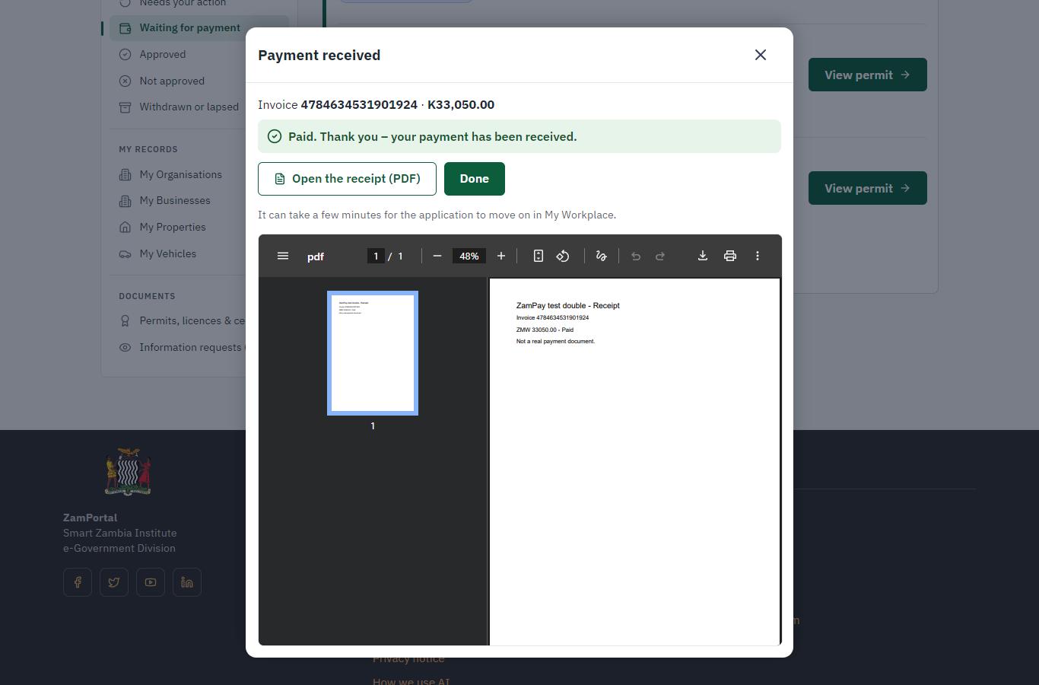 | 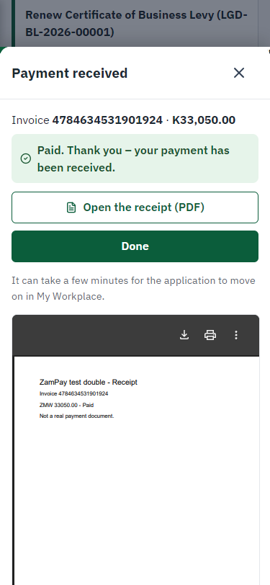
Step 10: Payment received - desktop (left) and a 375 px phone (right).

Step 11. Take the new application on
Case Officer · Back office
The application arrives in the case queue of the ministry that owns the service (Department of Local Government); only its staff see it. The officer opens it by its reference number - answers, documents and process are on the case - assigns it to themself and takes it on.
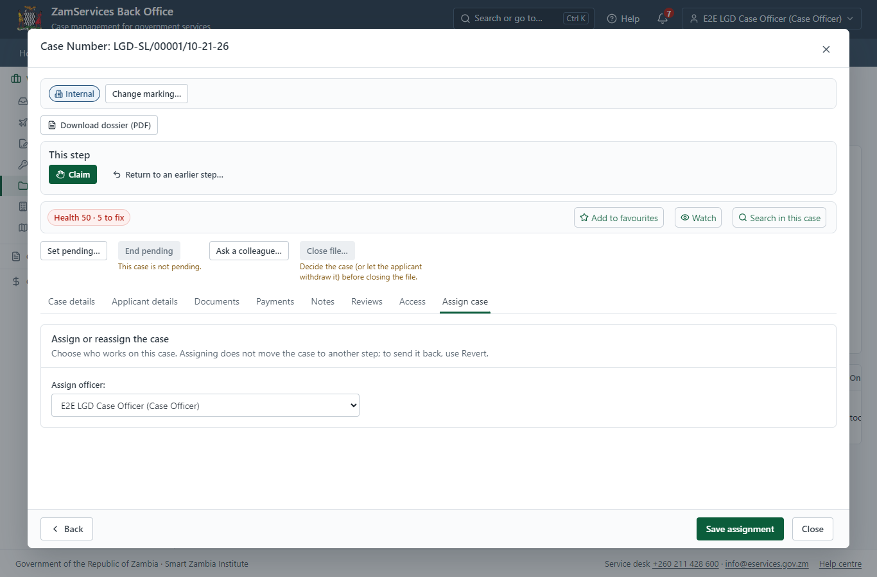
Step 11: Take the new application on.

Step 12. Verify case eligibility / compliance
Case Officer · Back office
The Case Officer works on "Verify case eligibility / compliance" (review in the imported process), checks the application and its documents, and completes the step.
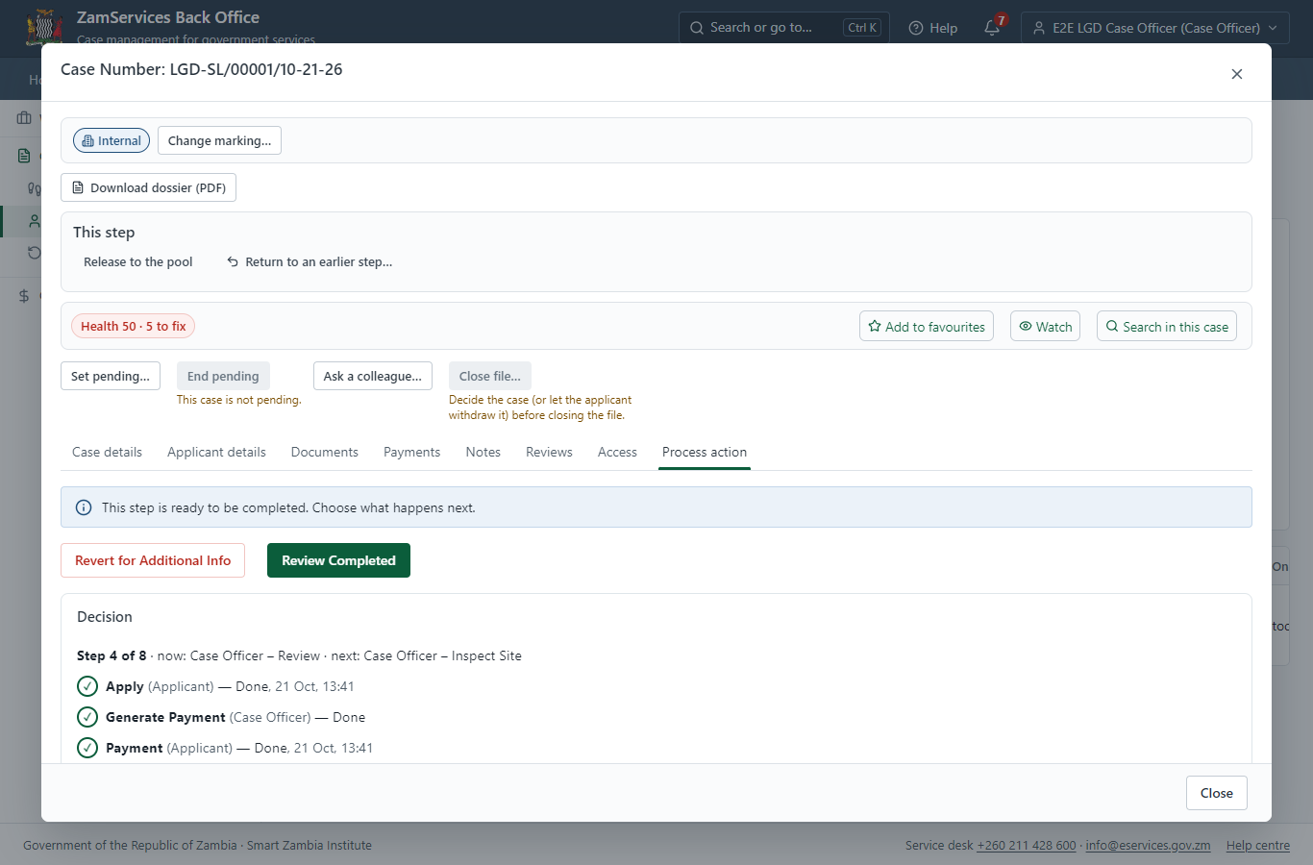
Step 12: Verify case eligibility / compliance.

Step 13. Inspect the land and the proposed subdivisions
Case Officer · Back office
The Case Officer works on "Inspect the land and the proposed subdivisions" (inspection in the imported process), checks the application and its documents, and completes the step.
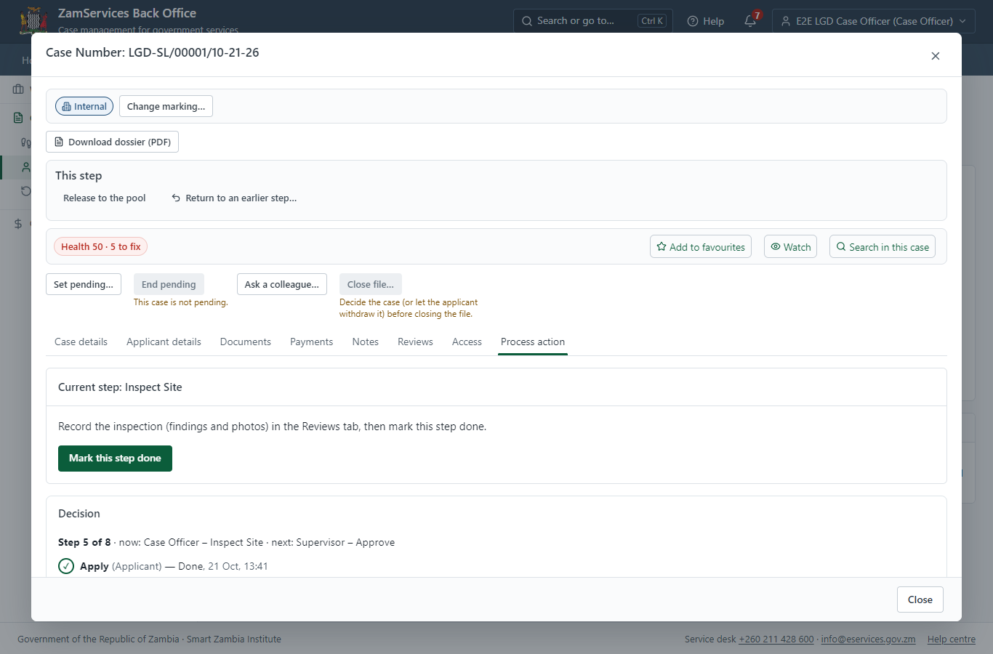
Step 13: Inspect the land and the proposed subdivisions.

Step 14. Inspection: Inspect the land and the proposed subdivisions
Case Officer · Back office
"Inspect the land and the proposed subdivisions" is a site inspection: the case cannot move on until the findings are recorded. The officer assigns the inspection (to themself here) on the case's Reviews tab, visits the place and records each checklist item, the visit and the outcome ("passed" in this run); then completes the step.
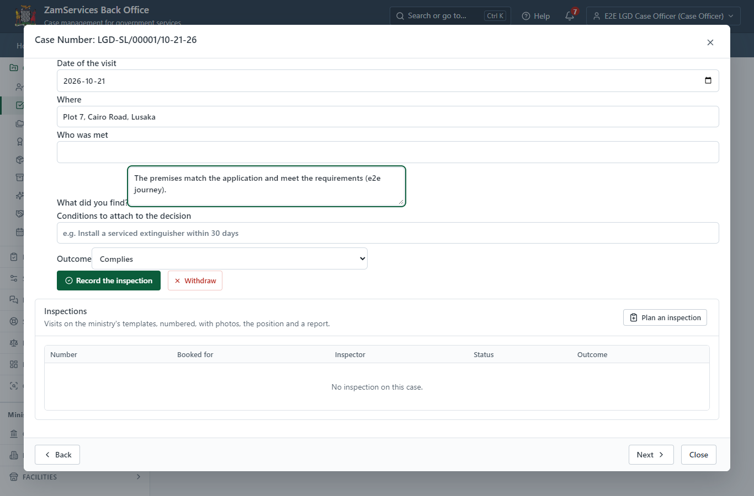
Step 14: Inspection: Inspect the land and the proposed subdivisions.

Step 15. Committee: Planning committee decision
Supervisor · Back office
"Planning committee decision" is a committee step: the members named by the process (Planning committee member 1, Planning committee member 2, Planning committee member 3) each record a vote on their own task under "This step"; the step completes when its rule (quorum, quorum 2) is met. Each member is a different officer.
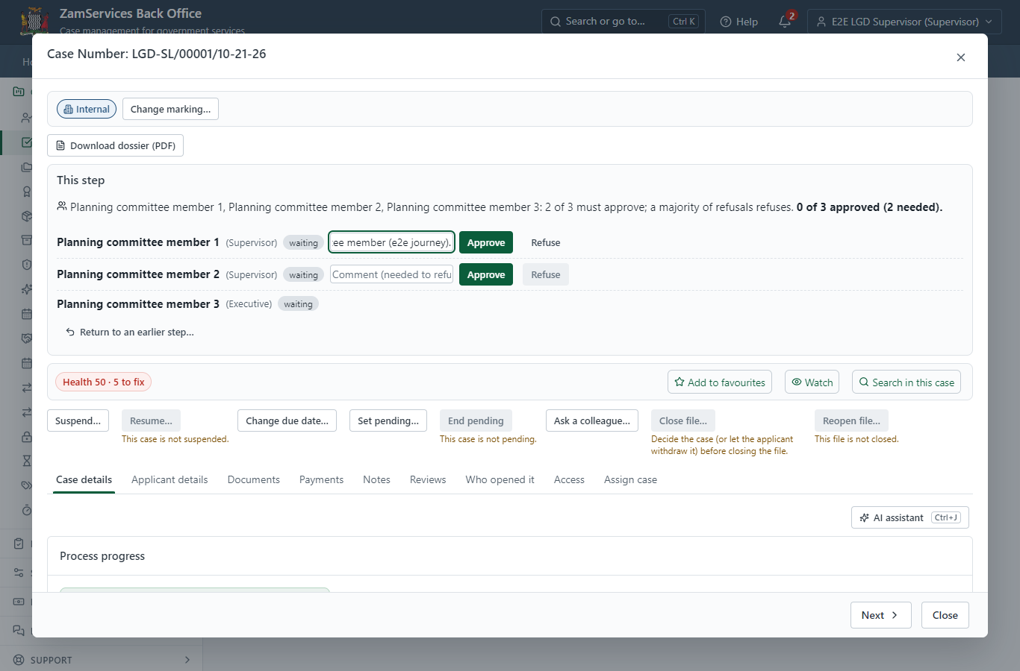
Step 15: Committee: Planning committee decision.

Step 16. Review, draft decision, send to the executive
Supervisor · Back office
The Supervisor works on "Review, draft decision, send to the executive" (review in the imported process), checks the application and its documents, and completes the step.
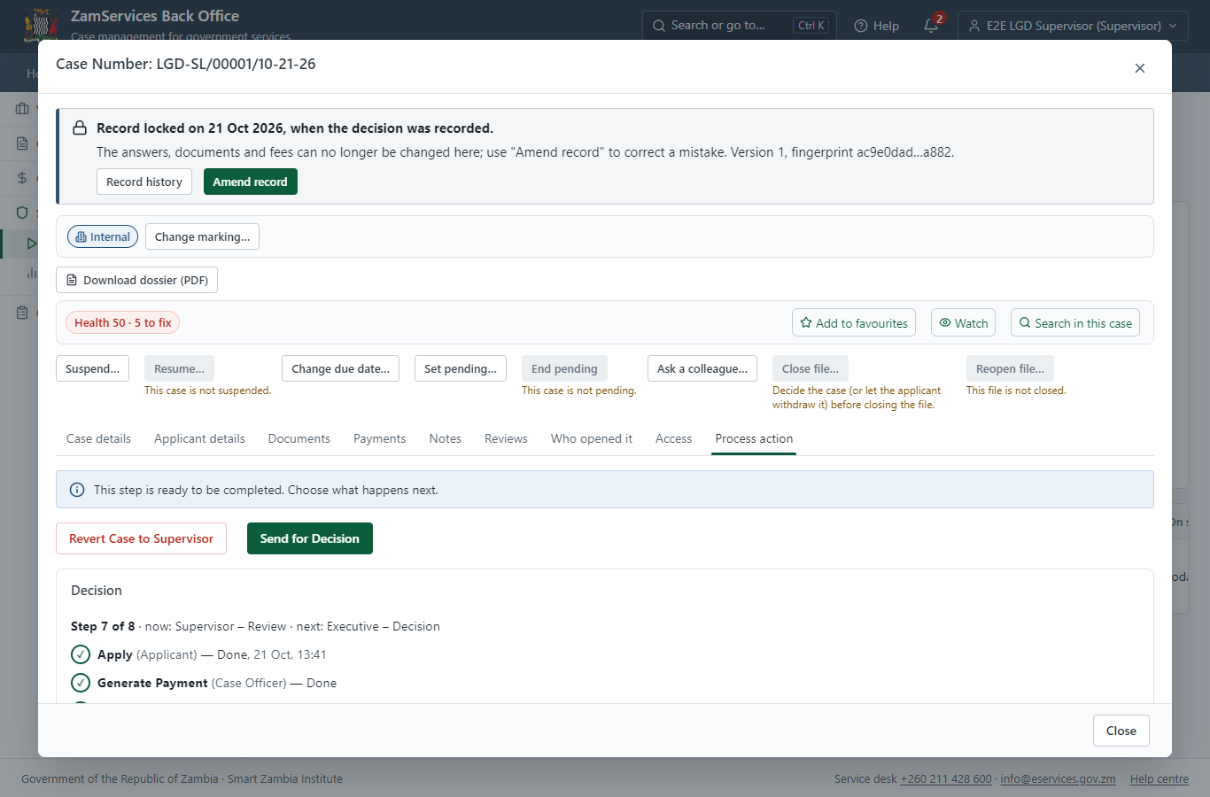
Step 16: Review, draft decision, send to the executive.

Step 17. Decide: Review final decision, e-sign
Executive · Back office
At "Review final decision, e-sign" the Executive records the decision: approve, with a comment kept in the case history. Approving moves the case on; the last decision completes it and issues the document.
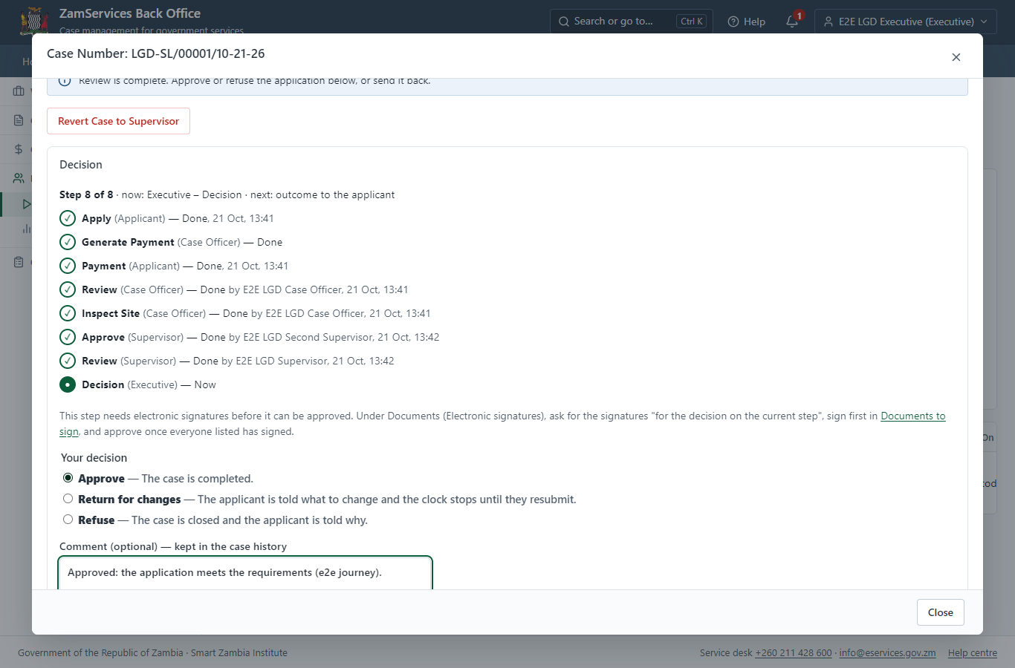
Step 17: Decide: Review final decision, e-sign.

Step 18. Issue the document
Case Officer · Back office
The service's validity ("not stated") is not a fixed period, so completing the case does not issue the document by itself: the officer issues it from the completed case ("Issue / check permit"). It is generated from the service's output configuration and sealed.
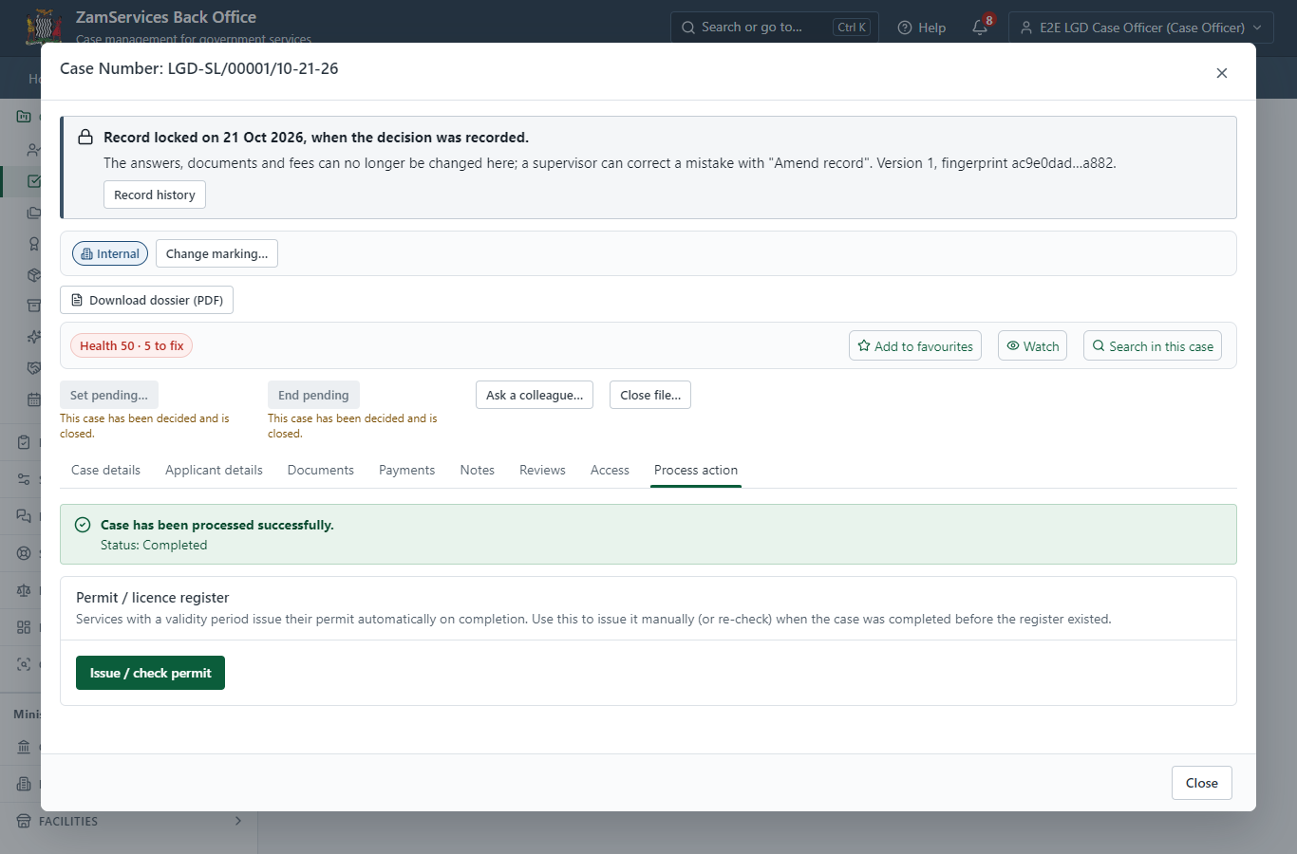
Step 18: Issue the document.

Step 19. The document in My permits
Citizen · National e-Services portal
The issued document (LGD-SL-2026-00001 in this run: "Subdivision Memo") is listed in "My permits and licences" with its validity and a download of the sealed PDF.
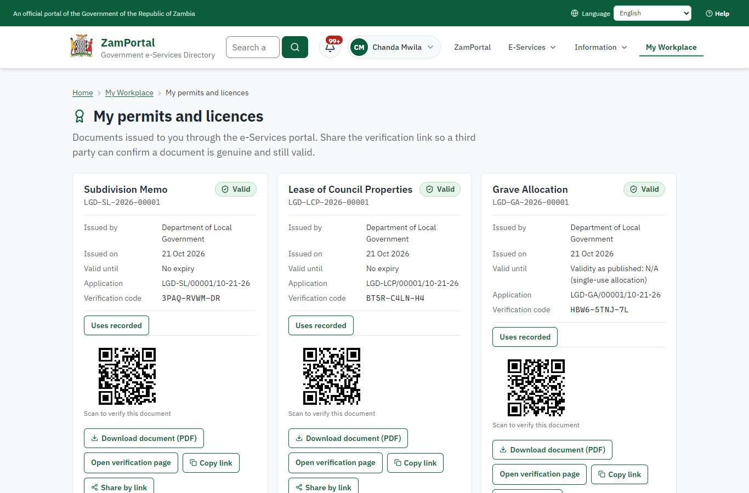 | 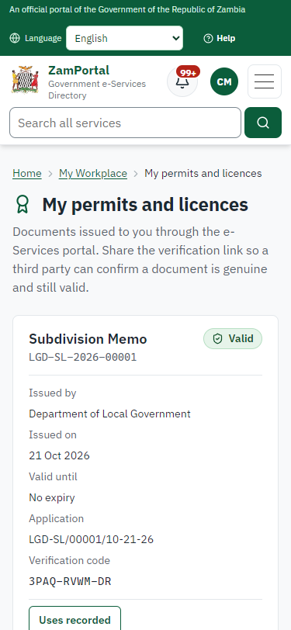
Step 19: The document in My permits - desktop (left) and a 375 px phone (right).

Step 20. Verify the document
Anyone (public) · Public verification page
The QR code on the document opens the public verification page: genuine and current, to whom it was issued, and whether the electronic seal is valid. No sign-in is needed.
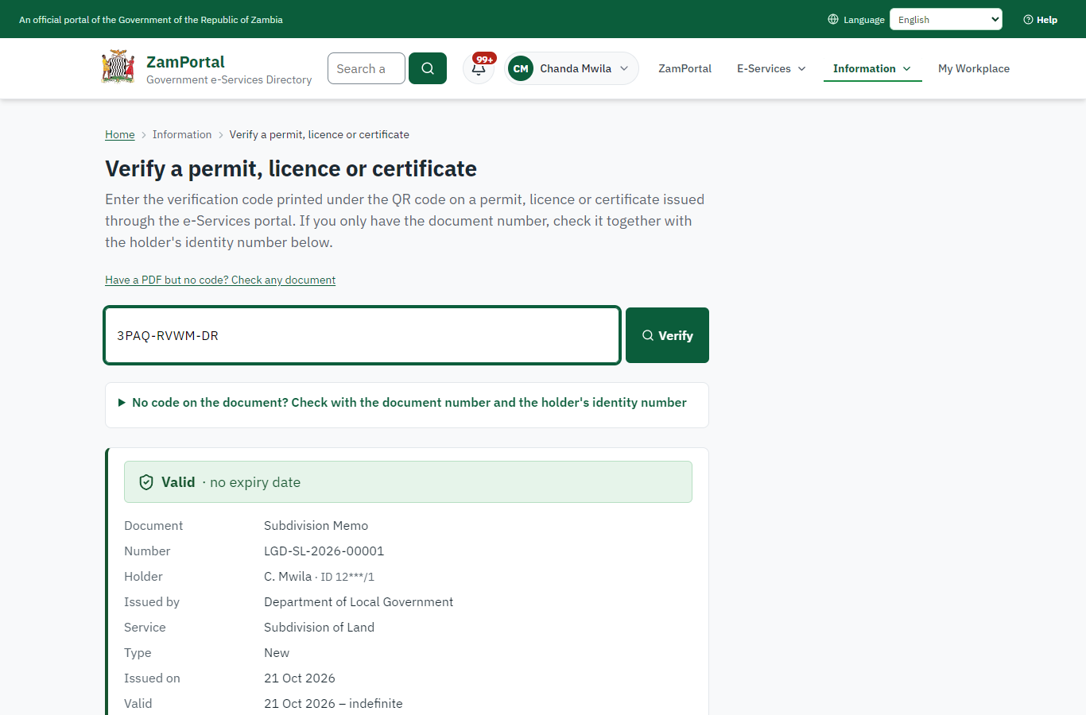 | 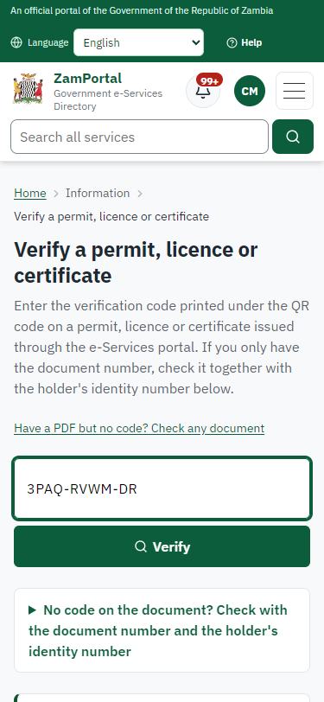
Step 20: Verify the document - desktop (left) and a 375 px phone (right).

3. Payment
Item | In the test run
Fee (as published) | none
Invoice 1 | 4784634531901924
Amount 1 | ZMW 33050.00
Paid at 1 | with the application
On screen: step 8 (See that the fee is due), step 9 (Pay with ZamPay), step 10 (Payment received) in section 2.

4. Output documents

Subdivision Memo (sealed PDF)
Issued when the case was approved, from the service's output configuration (permitDocument/issued@1), filled from the application and the decision, sealed with the platform's electronic seal and stored as the issued version. The holder downloads it from My permits; the verification page checks it.
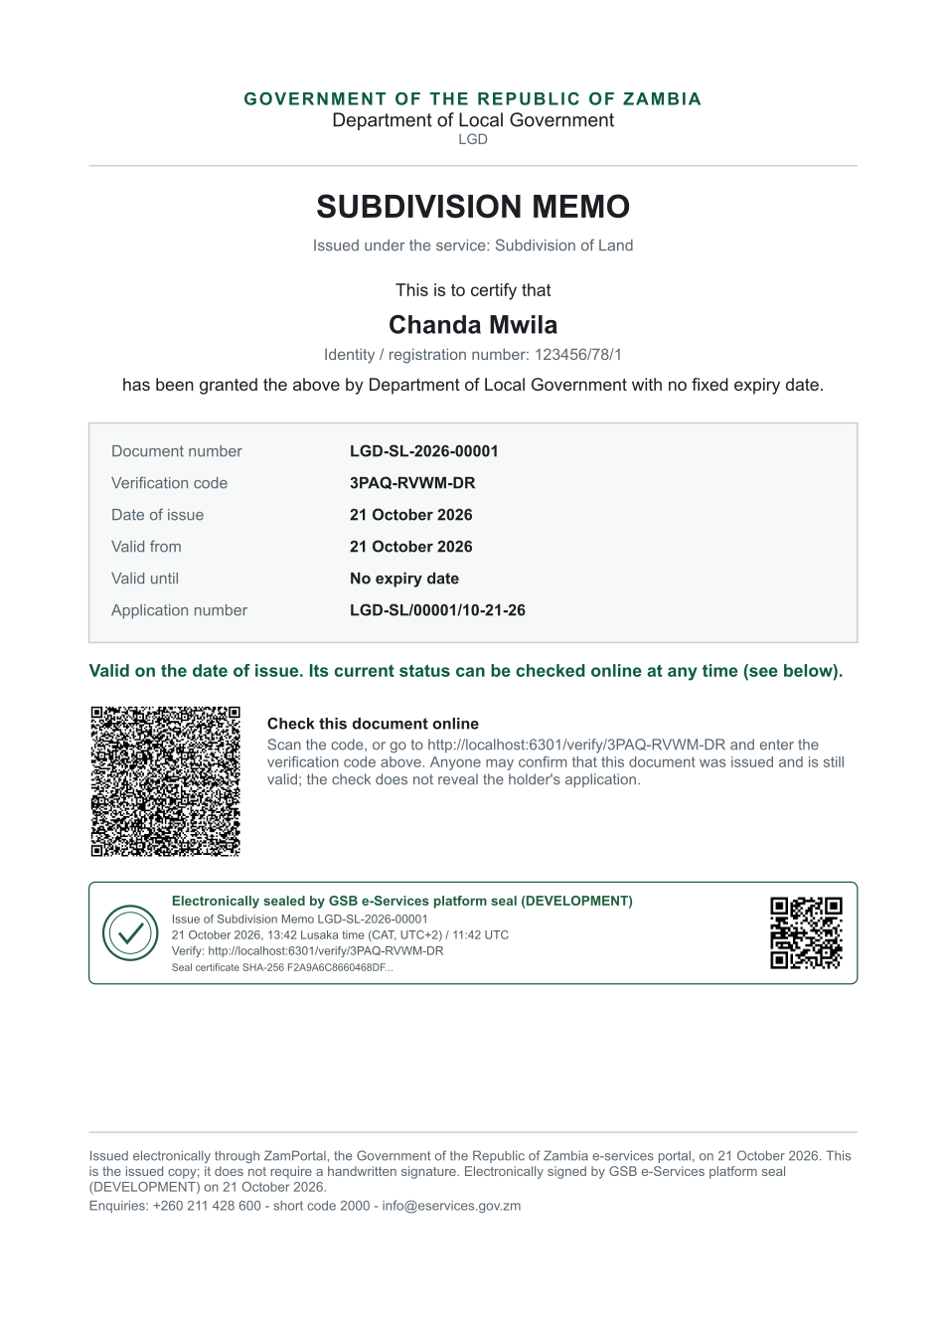
Subdivision Memo (sealed PDF) - first of 1 page, as issued in the test run.

Fields
Field | Value in the test run
Document title | Subdivision Memo
Permit / licence number | LGD-SL-2026-00001
Holder | Chanda Mwila
Valid from | 2026-10-21
Valid until
Status | active
Verification code (printed with a QR code) | 3PAQ-RVWM-DR

Seal
Seal status | sealed
Signature level | PAdES-B-T
Sealed by | the platform seal (development key in the test run)
Signed at | 2026-10-21T11:42:11.060Z
Trusted time-stamp | 2026-10-21T11:42:11.578Z (time-stamping authority)
Document fingerprint (SHA-256) | 451fdd6e1081e190...

Verification
Where | The public verification page of the national portal, <portal>/verify/<verification code>, opened by scanning the QR code on the document.
What it shows | Whether the document is genuine and current, its holder and validity, and whether the electronic seal is valid and who sealed it.
Checking a copy | Anyone can upload a PDF they were given; the page says whether it is exactly the document that was issued. A changed copy is reported as not matching.
On screen: step 18 (Issue the document), step 19 (The document in My permits), step 20 (Verify the document) in section 2.

5. Notifications
When | Channel | To | Message | Delivery
Payment due (invoice raised) | in-app (portal bell) | the applicant | Payment due for application LGD-SL/00001/10-21-26 - The fee of ZMW 33050.00 for Subdivision of Land (LGD-SL/00001/10-21-26) is now due. Invoice 4784634531901924. | shown
Application received | in-app (portal bell) | the applicant | Application LGD-SL/00001/10-21-26 received - Your application LGD-SL/00001/10-21-26 for Subdivision of Land has been received by Department of Local Government. | shown
Payment received | in-app (portal bell) | the applicant | Payment received for LGD-SL/00001/10-21-26 - Your payment of ZMW 33050.00 for LGD-SL/00001/10-21-26 (Subdivision of Land) has been received. Receipt: <ZamPay>/pdf?documentType=receipt&invoiceNumber=4784634531901924 | shown
case.inspection_scheduled | in-app (portal bell) | the applicant | Inspection for application LGD-SL/00001/10-21-26 on Wednesday 21 October 2026 - Inspection for LGD-SL/00001/10-21-26 (Subdivision of Land) on Wednesday 21 October 2026. | shown
review.submitted | in-app (portal bell) | the applicant | Opinion received on case LGD-SL/00001/10-21-26 - E2E LGD Case Officer recorded an opinion on case LGD-SL/00001/10-21-26: passed. | shown
Invitation to rate the service | in-app (portal bell) | the applicant | How was Subdivision of Land? - How was Subdivision of Land? Tell us in about a minute. | shown
Decision: approved | in-app (portal bell) | the applicant | Application LGD-SL/00001/10-21-26 completed - LGD-SL/00001/10-21-26 (Subdivision of Land) is complete. Your documents are ready. | shown
Licence / permit issued | in-app (portal bell) | the applicant | Your Subdivision of Land document has been issued - LGD-SL-2026-00001 has been issued for Subdivision of Land. | shown
Payment due (invoice raised) | email | e2e.c***@example.test | Payment due for application LGD-SL/00001/10-21-26 | skipped
Payment due (invoice raised) | sms | +260 97* *** 567 | Fee of ZMW 33050.00 due for LGD-SL/00001/10-21-26. Invoice 4784634531901924. Pay: <ZamPay>/pay-for-service/get-invoice/4784634531901924 | delivered
Application received | email | e2e.c***@example.test | Application LGD-SL/00001/10-21-26 received | skipped
Application received | sms | +260 97* *** 567 | Application LGD-SL/00001/10-21-26 for Subdivision of Land has been received. Track it: <portal>/my-workplace | delivered
Payment received | sms | +260 97* *** 567 |  | delivered
review.requested | email | e2e.c***@example.test | Your opinion is requested on application LGD-SL/00001/10-21-26 | skipped
case.inspection_scheduled | email | e2e.c***@example.test | Inspection for application LGD-SL/00001/10-21-26 on Wednesday 21 October 2026 | skipped
case.inspection_scheduled | sms | +260 97* *** 567 |  | delivered
review.submitted | email | e2e.c***@example.test | Opinion received on case LGD-SL/00001/10-21-26 | skipped
Invitation to rate the service | sms | +260 97* *** 567 |  | skipped
Invitation to rate the service | email | e2e.c***@example.test | How was Subdivision of Land? | skipped
Decision: approved | email | e2e.c***@example.test | Application LGD-SL/00001/10-21-26 completed | skipped
Decision: approved | sms | +260 97* *** 567 |  | delivered
Licence / permit issued | email | e2e.c***@example.test | Your Subdivision of Land document has been issued | skipped
Licence / permit issued | sms | +260 97* *** 567 |  | delivered
Delivery: shown = in the portal's notification bell; delivered = the SMS gateway (a test double in this run) reported the text delivered; skipped = not sent on that channel (e-mail is not configured on the test installation, and some notices go out on one channel only); sent by the national portal = a ministry node handed the notice to the national portal, which texts and e-mails the citizen under its own name and the citizen's preferences. Addresses written <portal>, <ZamPay> stand for the national portal and ZamPay.

6. Legacy mapping
Replaces | Subdivision of Land in the legacy ZIGS e-Services directory (ZIGS_Services)
Legacy service id | 663
Legacy provider | Department of Local Government (LGD) under Ministry of Local Government and Rural Development
Legacy process | not recorded
Fee in the legacy system | none
Fee taken before submission | yes (as in ZIGS)
Time to issue (legacy) | not recorded
Legacy output templates | GS-1 Application for a Government Service: ZIGS_Forms_ZDA / GS1  GS-2 Notice of Government Action: ZIGS_Forms_Notices / GS-2.NoticeOfAction  Subdivision Memo: / Subdivision.Memo  Subdivision Recommendation Letter: / Subdivision.RecommendationLetter
Legacy address | https://ecouncils.gsb.gov.zm
How it was brought over | Imported by the platform's legacy catalogue importer (zcm-backend scripts/zigs/importLegacy.js) from the ZIGS snapshot: form, case types, fees, documents, process and output templates, then served by the new platform.

7. Version and date
Document version | service v1, platform 39fb88e4
Generated | 2026-10-21T11:42:17Z (by the end-to-end run, not edited by hand)
Service version | not versioned (configured directly)
Platform snapshot | backend 39fb88e4  portal 72805f0  back office 58e5946
Test suite | e2e 2f82c10; one installation (combined); seed profile mihud
Journeys | 30-catalogue-service.spec.js: citizen finds the service, answers its form, uploads its documents and sends the application - passed  30-catalogue-service.spec.js: the case goes through every step of its process: payments by the citizen, each officer step by its role - passed  30-catalogue-service.spec.js: the grant document is issued, sealed, filled in and verifiable; the citizen has it in My permits - passed
Result | 3 of 3 journey tests passed
Data | Synthetic test data on a local test installation; provider test doubles for ZamPass, ZamPay, SMS and signing.

