Republic of Zambia
GSB e-Services

Short-Term Road Service Licence
Service documentation
Owner: Road Transport and Safety Agency
Service key: RTSA/short-term-road-service-licence
Version: service v1, platform 9b8a591f
Date: 2026-10-17
Generated automatically by the service's end-to-end test run. Every screenshot shows synthetic test data on a local test installation, never real personal data.

Contents
- 1. Service summary
- 2. Application process, step by step
- 3. Payment
- 4. Output documents
- 5. Notifications
- 6. Legacy mapping
- 7. Version and date
This document describes the Short-Term Road Service Licence service of Road Transport and Safety Agency as the platform runs it today. It is generated by the service's end-to-end test: every step was performed by the test and every screenshot was taken during that run, with synthetic data. Regenerate it with "npm run docs:services" in the e2e suite; do not edit it by hand.

1. Service summary
Service | Short-Term Road Service Licence
Owner (MDA) | Road Transport and Safety Agency (RTSA)
Purpose | The Short Term RSL is a license granted to allow individuals, on a temporary basis, to utilize public service vehicles for seasonal business or the execution of specific work.
Who can apply | Individual; Organization
How to apply | Online on the national e-Services portal, signed in with ZamPass; pay with ZamPay.
Fees | Application Fee for Short Term RSL: ZMW 80.00  Short Term RSL: ZMW 173.00  Identity Certificate: ZMW 185.00  Vehicle Authorized in RSL: ZMW 80.00
Turnaround | One (1) day
Validity of the output | 90 days for RSL and Identity Certificate
Required documents | Personal ID (required)  Certificate of Incorporation (Obtained from PACRA) (required)  Valid ZRA Tax Clearance Certificate (required)  An Investment Licence in transport for applicants with less than 75% Zambian Shareholding in the business (required)
Output documents | Short-Term Road Service Licence  Denial of Service  Notice of Approval  Notice of Action  Application form  GF-1 Treasury Invoice  GF-2 Treasury Receipt
Legal basis | Road Traffic Act 11 of 2002 (https://www.rtsa.org.zm/wp-content/uploads/2019/09/The-Road-Traffic-Act-No-11-of-2002.pdf)  Statutory Instrument No. 41 of 2015 (Fee & Penalty Unit Value) (http://www.seczambia.org.zm/wp-content/uploads/2018/08/SI-No-41-of-2015-Fees-and-Fines-Act.pdf)  Statutory Instrument No. 63 of 2013 (Public Service Vehicles) (https://www.pmrczambia.com/wp-content/uploads/2015/08/The-Road-Traffic-Public-Service-Vehicles-Regulations-Statutory-Instrument-No.-63-of-2013.pdf)  Road Traffic (Fees) Regulation, 2021, Statutory Instrument No. 112 of 2021 (https://zambialii.org/akn/zm/act/si/2021/112/eng@2021-12-31/source.pdf)  Road Traffic (Amendment) Act No. 8 of 2022 (https://www.rtsa.org.zm/wp-content/uploads/2022/09/Road-Traffic-Amendment-Act-No-8-of-2022.pdf)

2. Application process, step by step

The process as configured
Step | Role | Task | Type
1 | Applicant | Apply | form
2 | Case Officer | Generate Payment | generate-payment
3 | Applicant | Payment | payment
4 | System | Generate Document | generate-document
5 | Case Officer | Approve | approve
6 | Case Officer | Verify Payment | verify-payment
7 | System | Generate Document | generate-document
8 | System | Generate Document | generate-document
9 | System | Notify Client | notify

Step by step
Who takes part in this journey: Citizen, Case Officer, Anyone (public). Citizen steps are shown on a desktop and on a 375 px phone; back-office steps on a desktop.

Step 1. Find the service
Citizen · National e-Services portal
On the national e-Services portal the citizen opens All Services and searches for the service by name ("Short-Term Road Service Licence"). Each result names the service and the ministry that provides it.
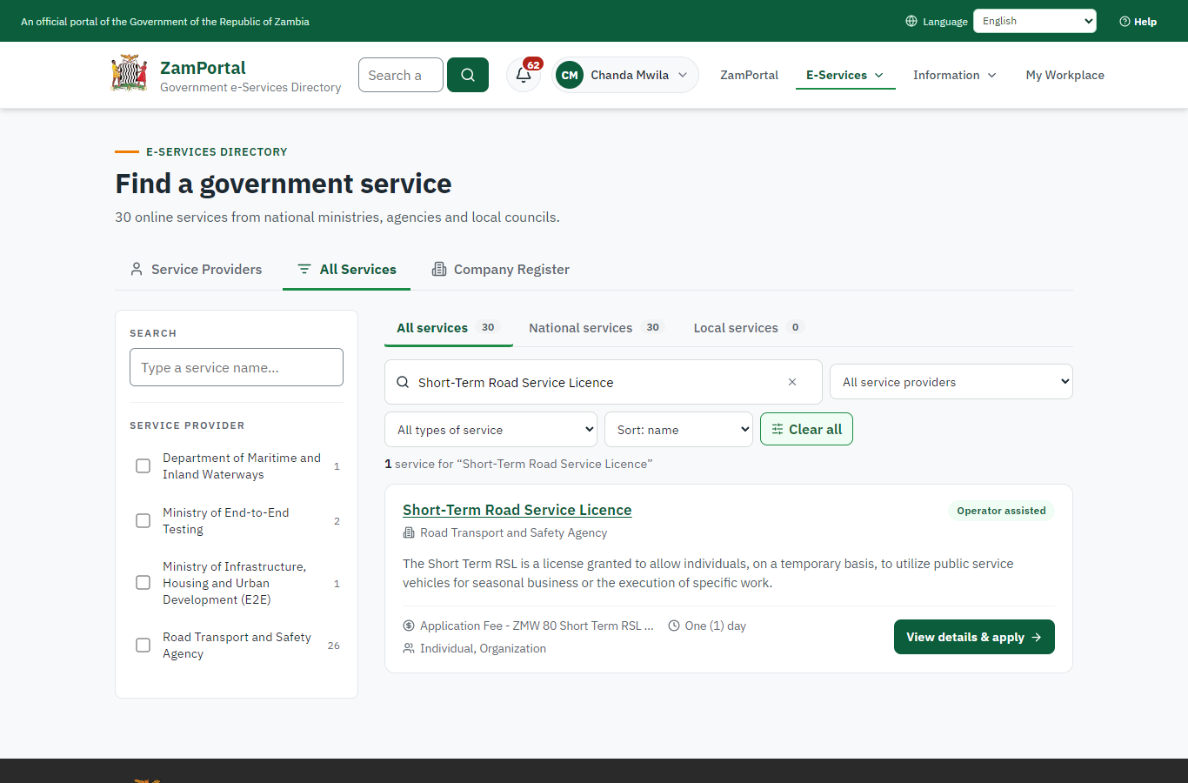 | 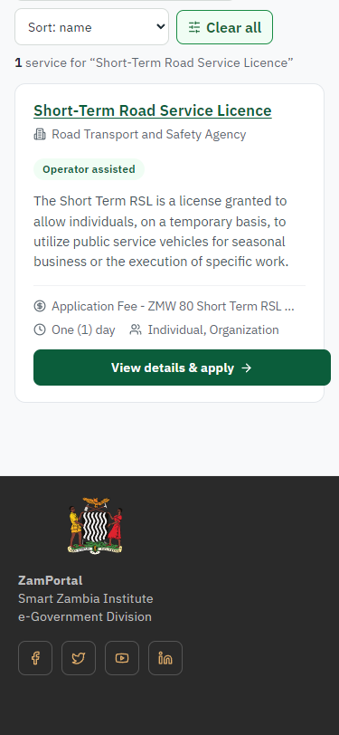
Step 1: Find the service - desktop (left) and a 375 px phone (right).

Step 2. Read the service page
Citizen · National e-Services portal
The service page sets out what the service is for, who provides it, the fee, how long it takes and the documents to have ready. "Start application" begins an application (the citizen is signed in with ZamPass).
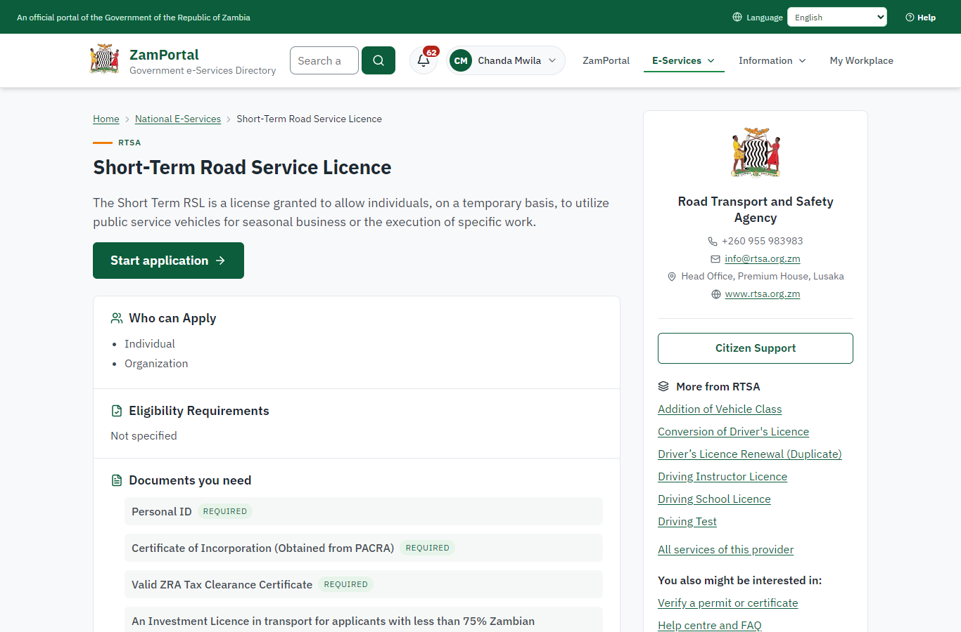 | 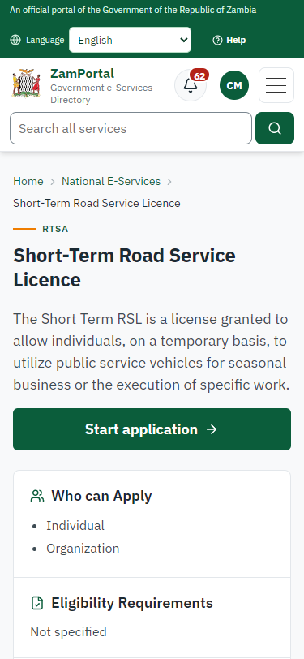
Step 2: Read the service page - desktop (left) and a 375 px phone (right).

Step 3. Confirm the applicant details
Citizen · National e-Services portal
The applicant details are filled in from the citizen's ZamPass account. The citizen says whom they are applying for (themself) and continues with "Proceed to Application".
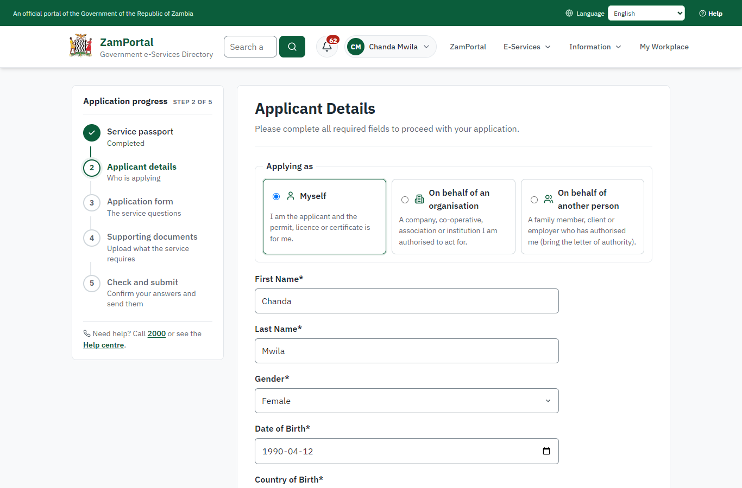 | 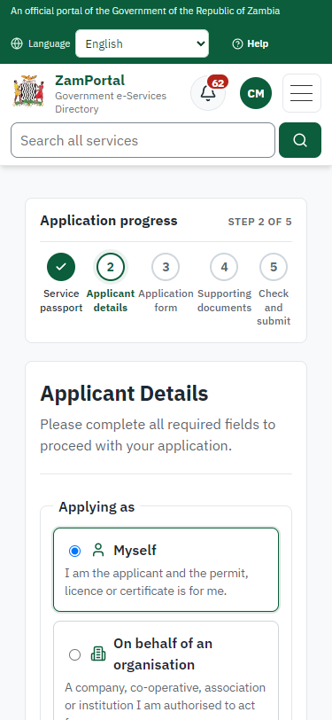
Step 3: Confirm the applicant details - desktop (left) and a 375 px phone (right).

Step 4. Fill in the application form
Citizen · National e-Services portal
The citizen answers the service's own application form, converted from the legacy system (12 answers in this run, all synthetic), for the type of application "New". Questions marked * must be answered; some appear only after an earlier answer. Answers are saved as the citizen types, so an unfinished application can be reopened from My Workplace.
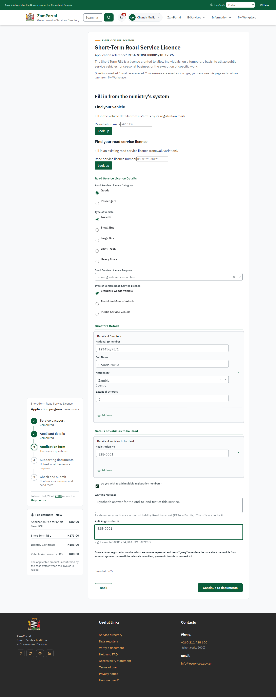 | 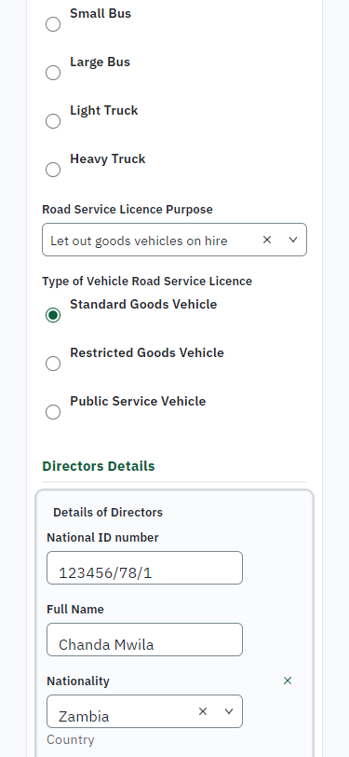
Step 4: Fill in the application form - desktop (left) and a 375 px phone (right).

Step 5. Upload the supporting documents
Citizen · National e-Services portal
Each document the service asks for has its own upload (4 in this run: Personal ID, Certificate of Incorporation (Obtained from PACRA), Valid ZRA Tax Clearance Certificate, An Investment Licence in transport for applicants with less than 75% Zambian Shareholding in the business). The files are checked and stored with the application; the page confirms each upload.
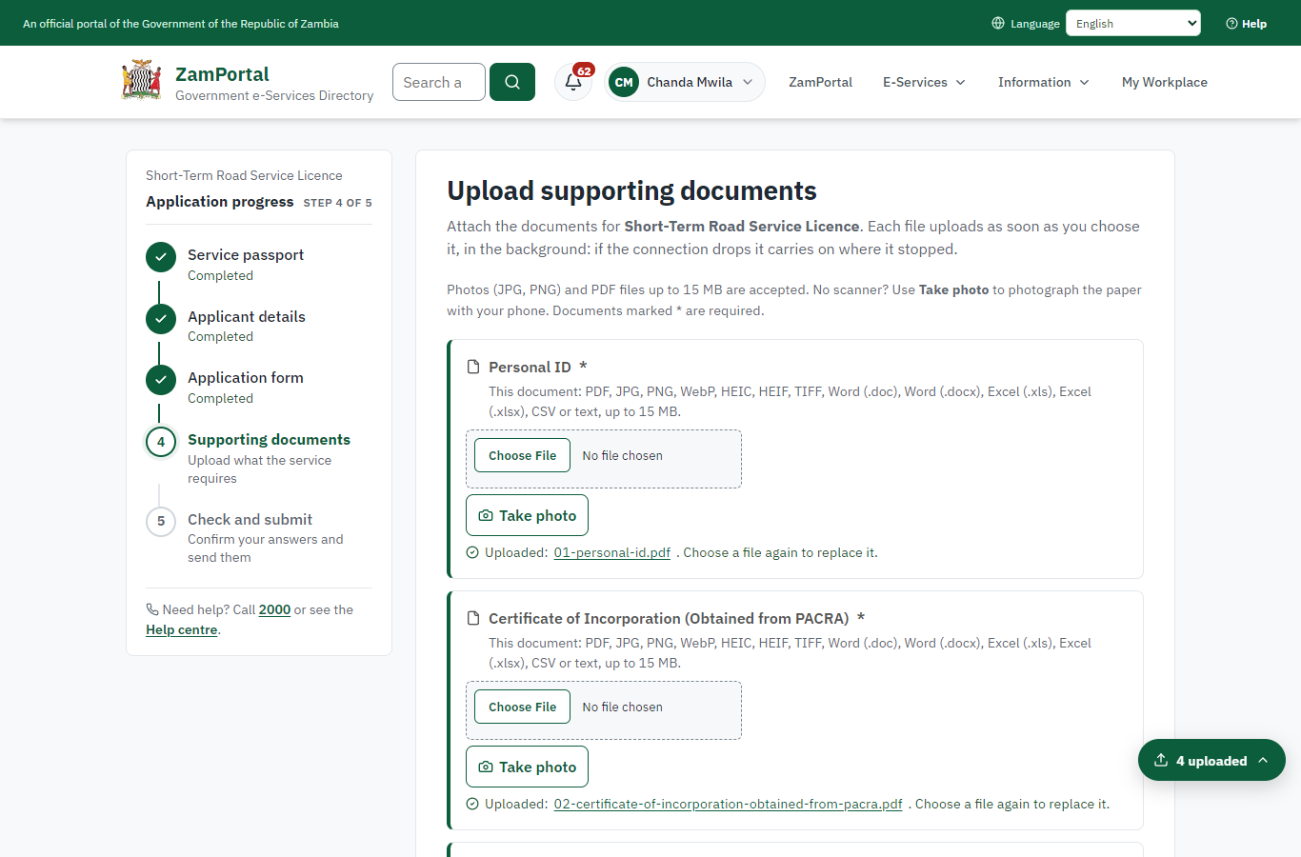 | 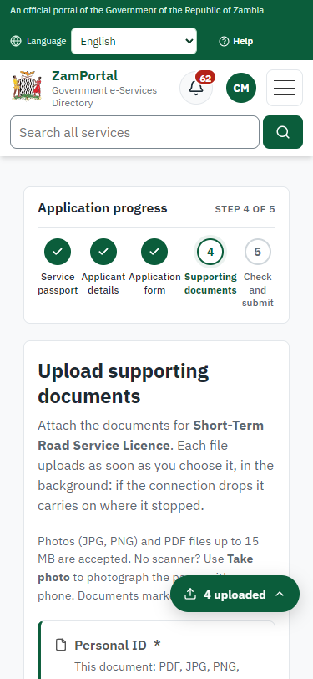
Step 5: Upload the supporting documents - desktop (left) and a 375 px phone (right).

Step 6. Check the answers and confirm the declaration
Citizen · National e-Services portal
Before sending, the citizen sees every answer and document on one page and can go back to change them. The declaration that the information is true and complete must be ticked.
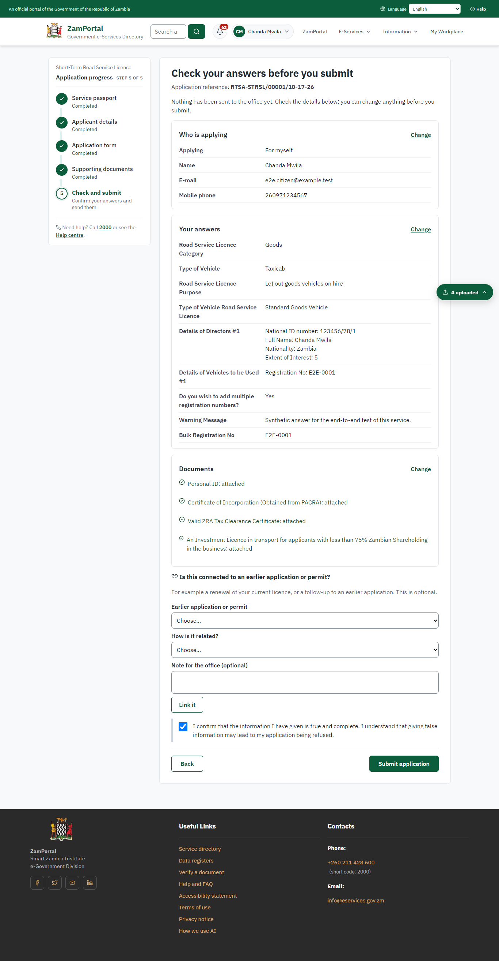 | 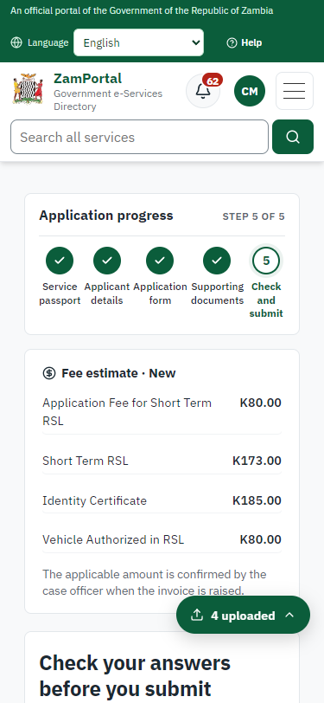
Step 6: Check the answers and confirm the declaration - desktop (left) and a 375 px phone (right).

Step 7. Application sent
Citizen · National e-Services portal
The portal confirms the application with the ministry's reference number (RTSA-STRSL/00001/10-17-26 in this run). The application goes to the ministry's officers; the citizen follows it in My Workplace.
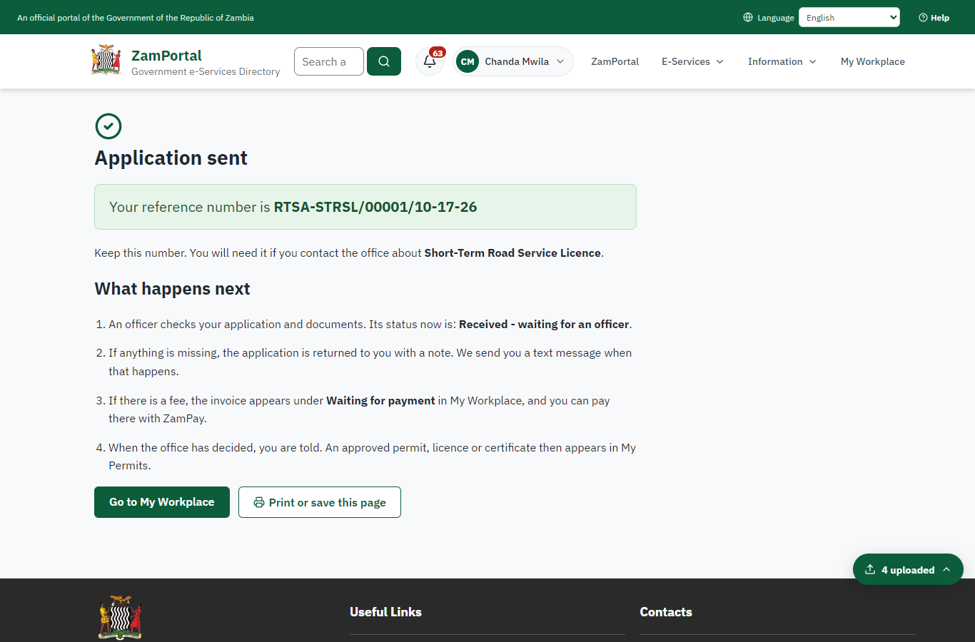 | 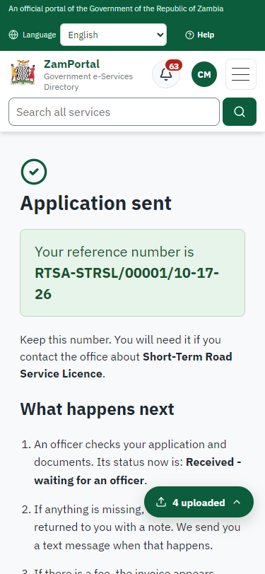
Step 7: Application sent - desktop (left) and a 375 px phone (right).

Step 8. Take the new application on
Case Officer · Back office
The application arrives in the case queue of the ministry that owns the service (Road Transport and Safety Agency); only its staff see it. The officer opens it by its reference number - answers, documents and process are on the case - assigns it to themself and takes it on.
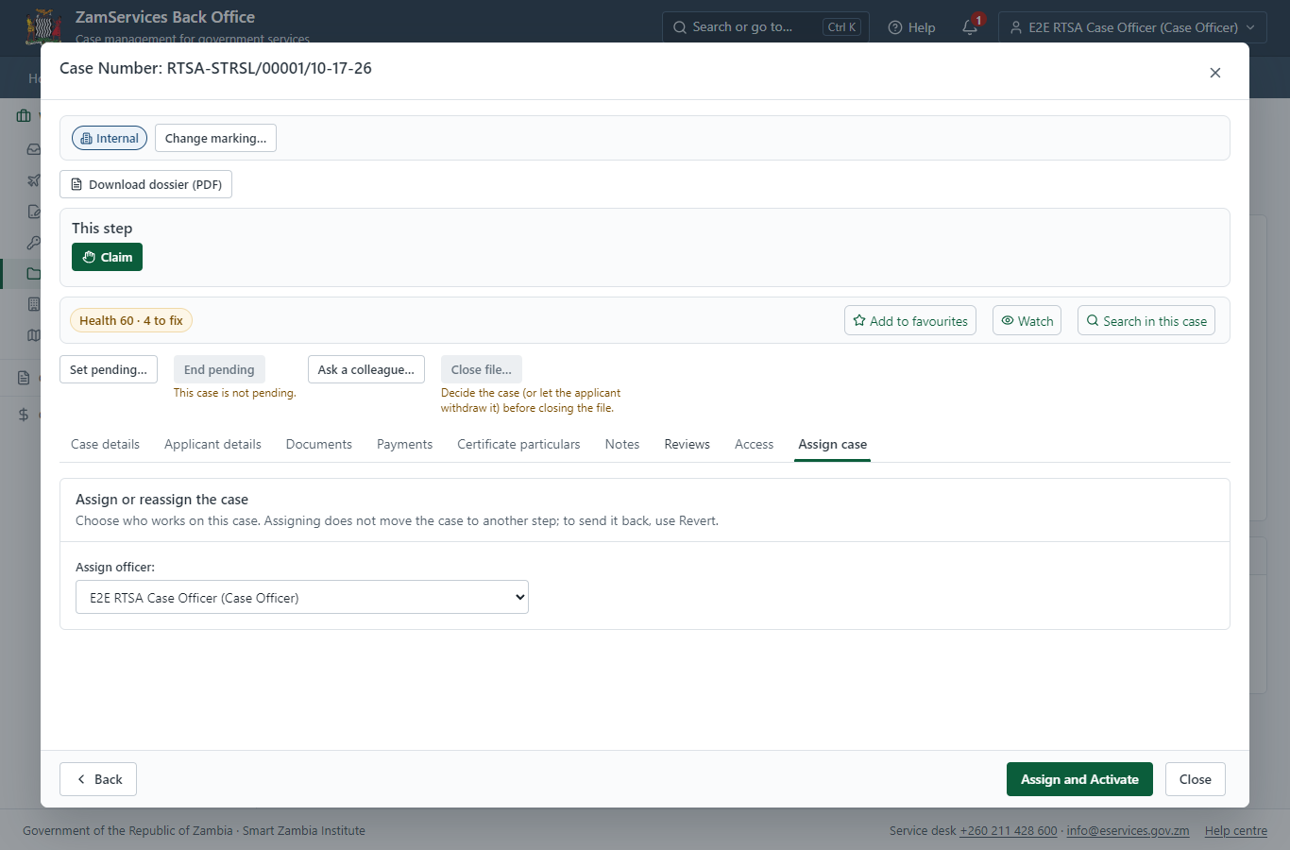
Step 8: Take the new application on.

Step 9. Fill in the certificate particulars
Case Officer · Back office
The issued document prints 3 fields that come from the office rather than from the application (Station, Authorised cc, Num vehicles authorized). The officer fills them in on the case's "Certificate particulars" tab before the document is issued (synthetic values in this run) and saves; once the document is issued they can no longer change.
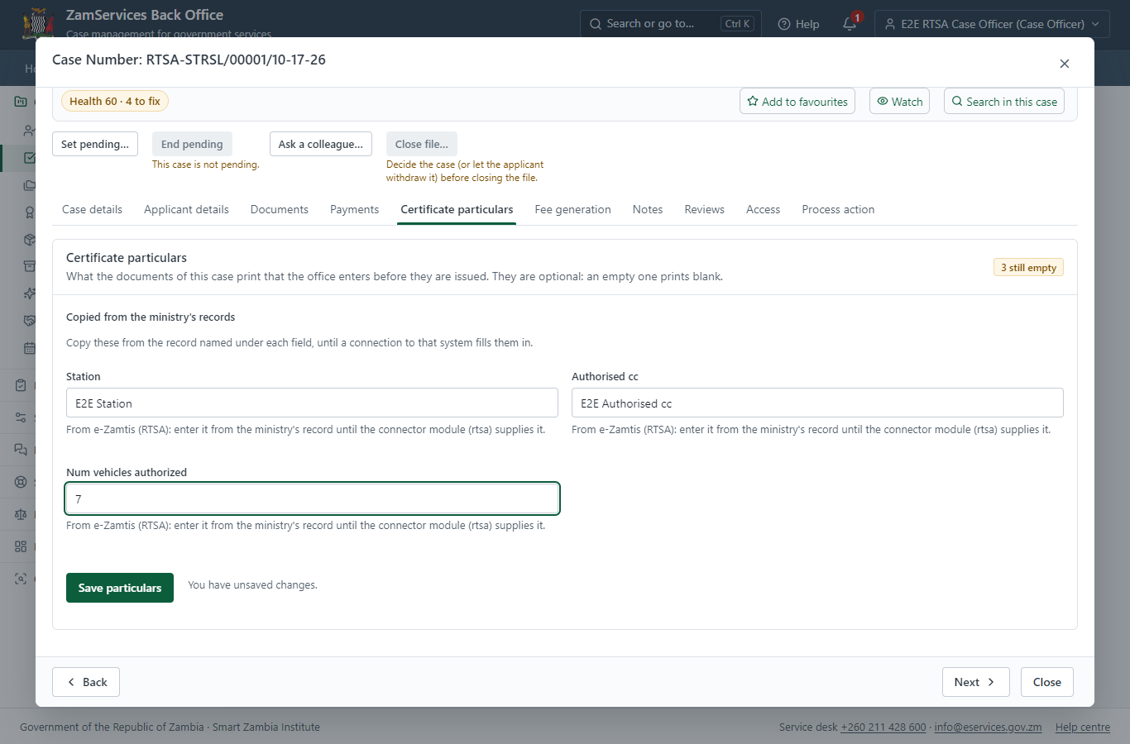
Step 9: Fill in the certificate particulars.

Step 10. Work out the fee
Case Officer · Back office
The Case Officer works out the fee from the service's imported fee schedule ("Application Fee - ZMW 80 Short Term RSL - ZMW 173 Identity certificate - ZMW 185 Vehicle authorized in road service license ZMW 80.00 per vehicle"). "Submit Fees and Advance" records it, raises a ZamPay invoice for the applicant and moves the case to payment.
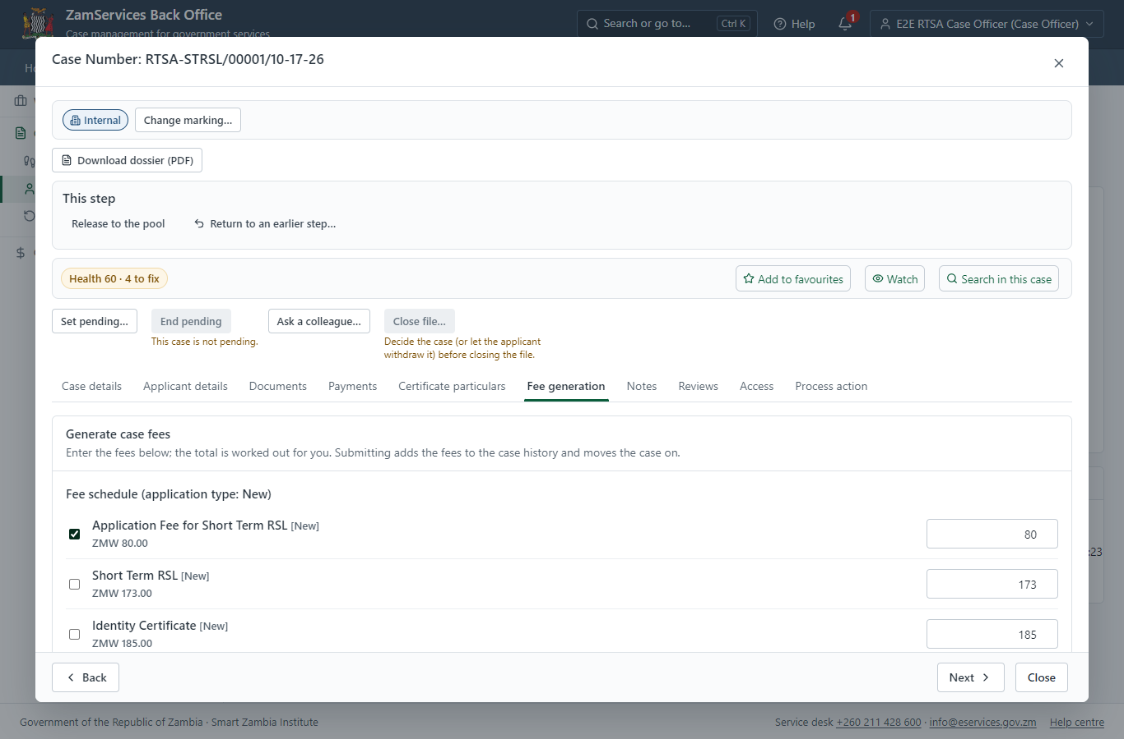
Step 10: Work out the fee.

Step 11. See that the fee is due
Citizen · National e-Services portal
The application shows "Waiting for your payment" in My Workplace with a Pay button (K80.00). The office priced the case; the invoice was raised on ZamPay.
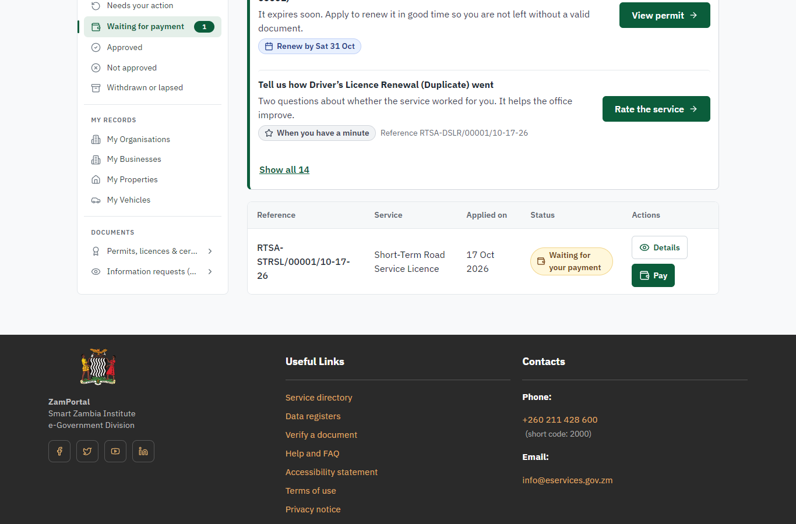 | 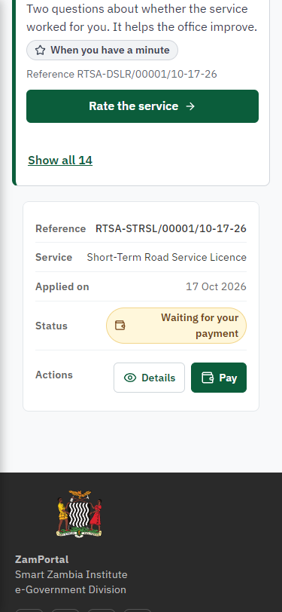
Step 11: See that the fee is due - desktop (left) and a 375 px phone (right).

Step 12. Pay with ZamPay
Citizen · National e-Services portal
Pay opens the invoice (K80.00, the amount set by the platform, never by the page) with its PDF preview; the citizen pays at ZamPay by mobile money or bank card.
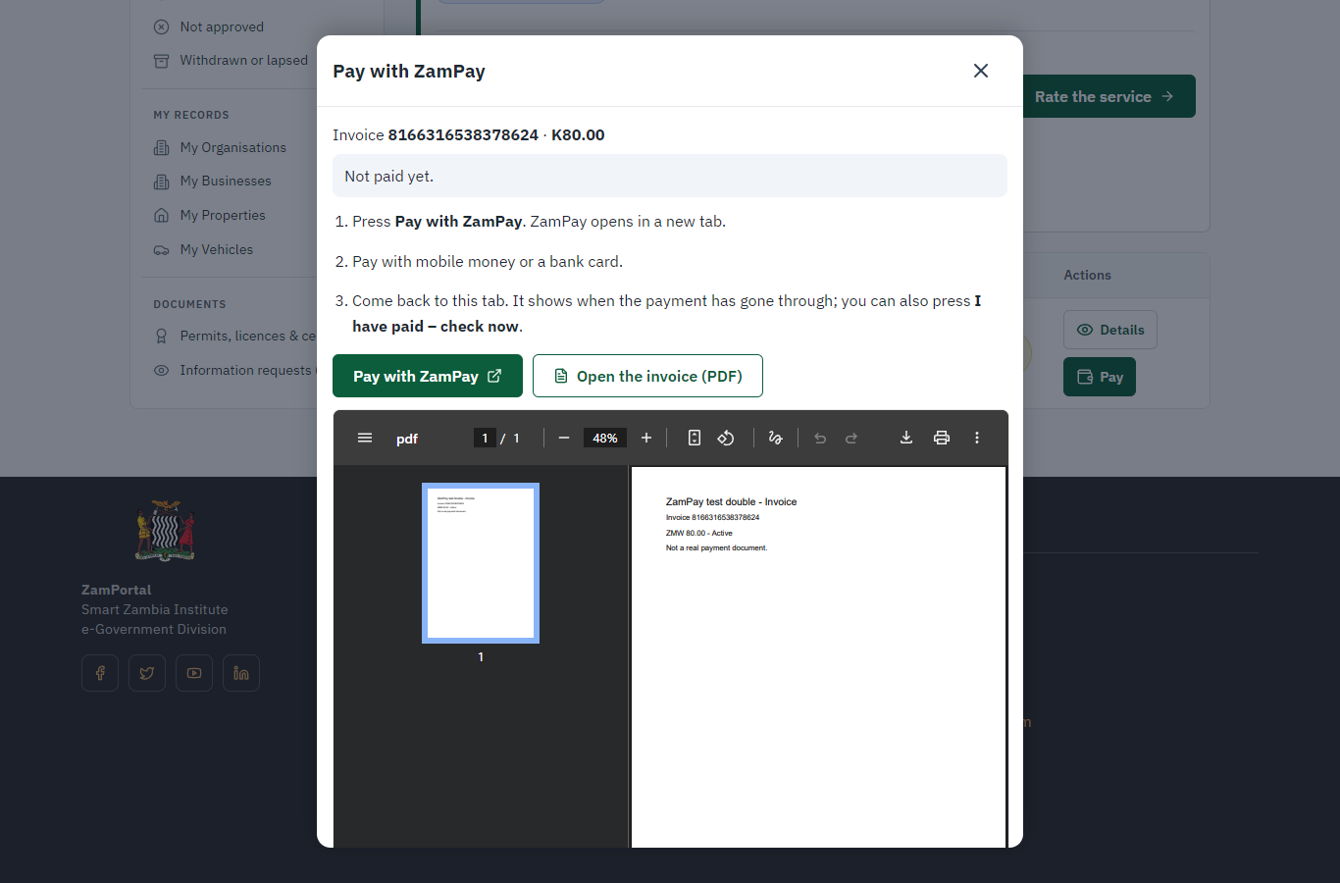 | 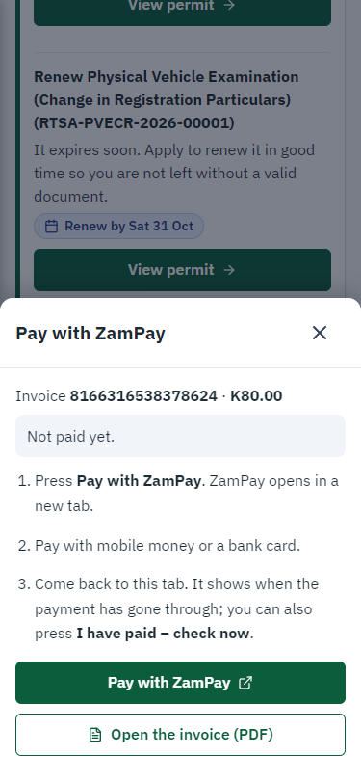
Step 12: Pay with ZamPay - desktop (left) and a 375 px phone (right).

Step 13. Payment received
Citizen · National e-Services portal
ZamPay reports the payment; the dialog says "Paid. Thank you" and the application moves on to the ministry's officers.
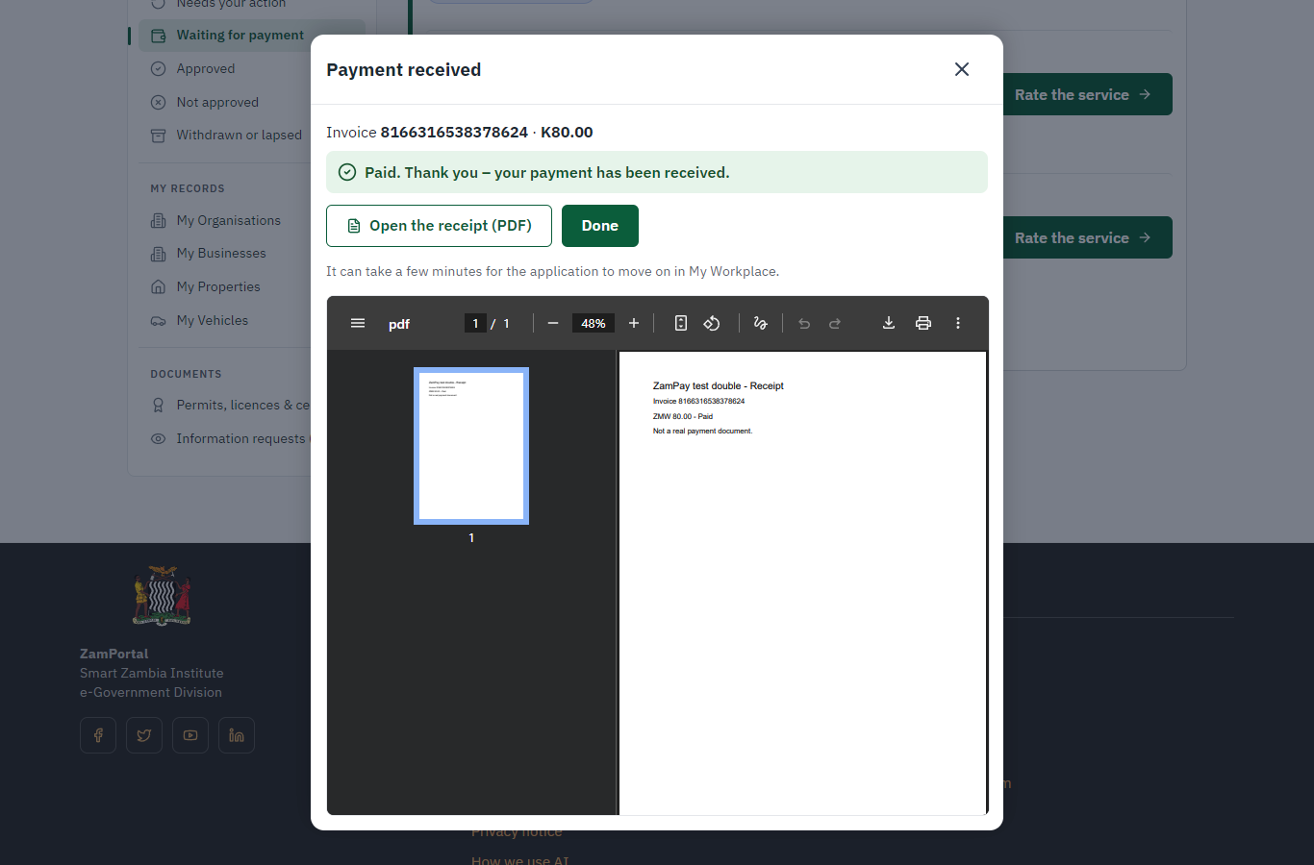 | 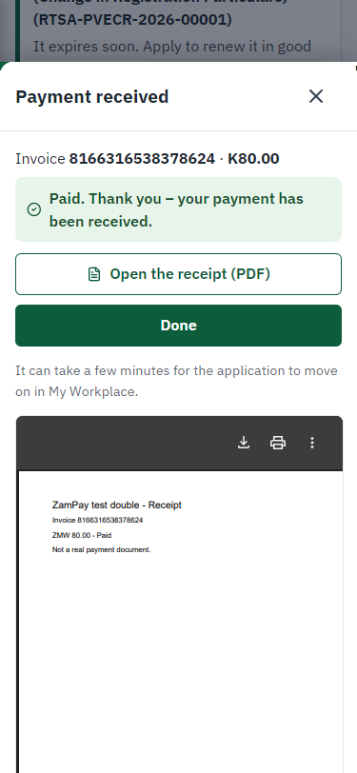
Step 13: Payment received - desktop (left) and a 375 px phone (right).

Step 14. Decide: Record the decision of RTSA (processed in its own system)
Case Officer · Back office
At "Record the decision of RTSA (processed in its own system)" the Case Officer records the decision: approve, with a comment kept in the case history. Approving moves the case on; the last decision completes it and issues the document.
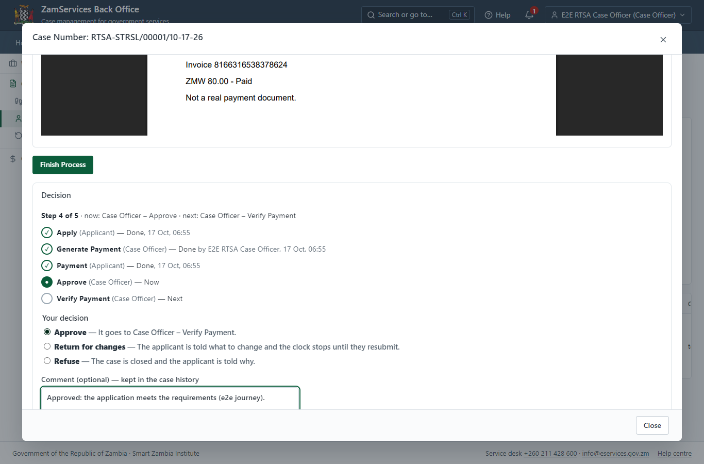
Step 14: Decide: Record the decision of RTSA (processed in its own system).

Step 15. Verify payment of the fees RTSA set
Case Officer · Back office
The Case Officer works on "Verify payment of the fees RTSA set" (verify-payment in the imported process), checks the application and its documents, and completes the step.
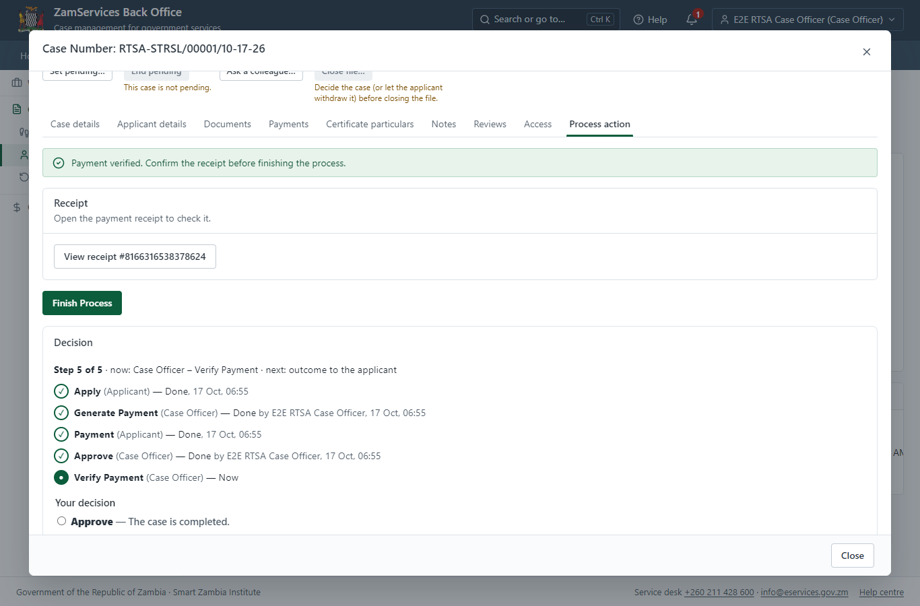
Step 15: Verify payment of the fees RTSA set.

Step 16. The document in My permits
Citizen · National e-Services portal
The issued document (RTSA-STRSL-2026-00001 in this run: "Short-Term Road Service Licence") is listed in "My permits and licences" with its validity and a download of the sealed PDF.
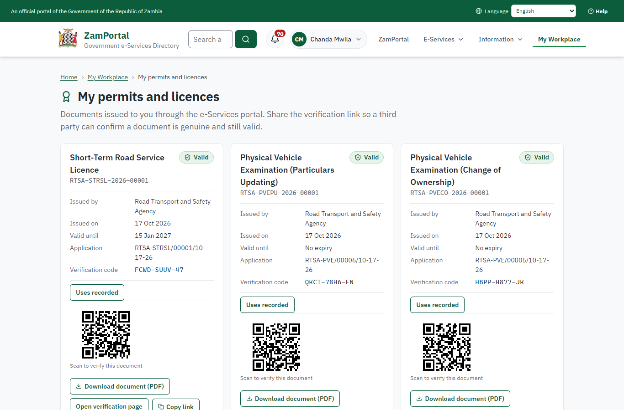 | 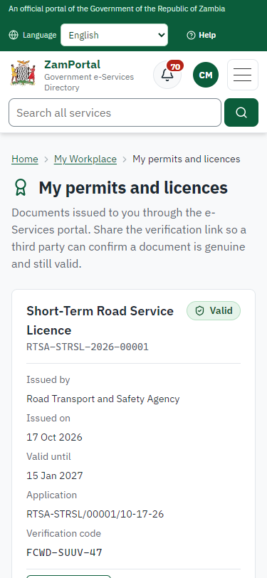
Step 16: The document in My permits - desktop (left) and a 375 px phone (right).

Step 17. Verify the document
Anyone (public) · Public verification page
The QR code on the document opens the public verification page: genuine and current, to whom it was issued, and whether the electronic seal is valid. No sign-in is needed.
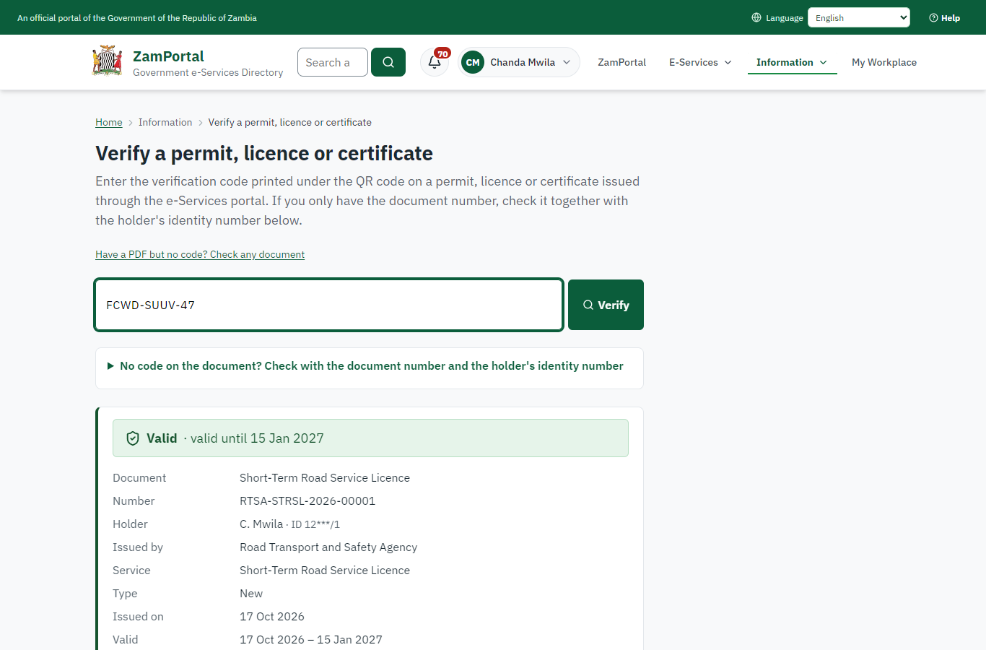 | 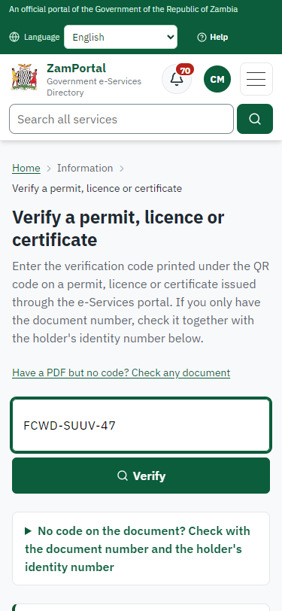
Step 17: Verify the document - desktop (left) and a 375 px phone (right).

3. Payment
Item | In the test run
Fee (as published) | Application Fee - ZMW 80 Short Term RSL - ZMW 173 Identity certificate - ZMW 185 Vehicle authorized in road service license ZMW 80.00 per vehicle
Invoice 1 | 8166316538378624
Amount 1 | ZMW 80.00
Paid at 1 | after "Work out the fee"
On screen: step 10 (Work out the fee), step 11 (See that the fee is due), step 12 (Pay with ZamPay), step 13 (Payment received) in section 2.

4. Output documents

Short-Term Road Service Licence (sealed PDF)
Issued when the case was approved, from the service's output configuration (service template RTSA_ShortTermRoadService.Certificate.docx), filled from the application and the decision, sealed with the platform's electronic seal and stored as the issued version. The holder downloads it from My permits; the verification page checks it.
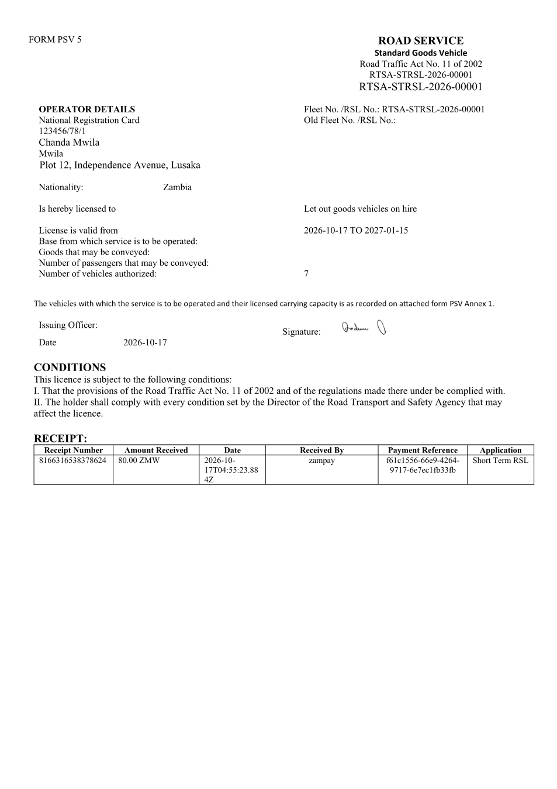
Short-Term Road Service Licence (sealed PDF) - first of 2 pages, as issued in the test run.

Fields
Field | Value in the test run
Document title | Short-Term Road Service Licence
Permit / licence number | RTSA-STRSL-2026-00001
Holder | Chanda Mwila
Valid from | 2026-10-17
Valid until | 2027-01-15
Status | active
Verification code (printed with a QR code) | FCWD-SUUV-47

Seal
Seal status | sealed
Signature level | PAdES-B-T
Sealed by | the platform seal (development key in the test run)
Signed at | 2026-10-17T04:55:53.537Z
Trusted time-stamp | 2026-10-17T04:55:53.526Z (time-stamping authority)
Document fingerprint (SHA-256) | d5239f77a3776eb5...

Verification
Where | The public verification page of the national portal, <portal>/verify/<verification code>, opened by scanning the QR code on the document.
What it shows | Whether the document is genuine and current, its holder and validity, and whether the electronic seal is valid and who sealed it.
Checking a copy | Anyone can upload a PDF they were given; the page says whether it is exactly the document that was issued. A changed copy is reported as not matching.
On screen: step 16 (The document in My permits), step 17 (Verify the document) in section 2.

5. Notifications
When | Channel | To | Message | Delivery
Application received | in-app (portal bell) | the applicant | Application RTSA-STRSL/00001/10-17-26 received - Your application RTSA-STRSL/00001/10-17-26 for Short-Term Road Service Licence has been received by Road Transport and Safety Agency. | shown
Status changed | in-app (portal bell) | the applicant | Update on application RTSA-STRSL/00001/10-17-26 - RTSA-STRSL/00001/10-17-26 (Short-Term Road Service Licence) is now: With the office - fees being worked out. | shown
Payment due (invoice raised) | in-app (portal bell) | the applicant | Payment due for application RTSA-STRSL/00001/10-17-26 - The fee of ZMW 80.00 for Short-Term Road Service Licence (RTSA-STRSL/00001/10-17-26) is now due. Invoice 8166316538378624. | shown
Payment received | in-app (portal bell) | the applicant | Payment received for RTSA-STRSL/00001/10-17-26 - Your payment of ZMW 80.00 for RTSA-STRSL/00001/10-17-26 (Short-Term Road Service Licence) has been received. Receipt: <ZamPay>/pdf?documentType=receipt&invoiceNumber=8166316538378624 | shown
case.approved | in-app (portal bell) | the applicant | Application RTSA-STRSL/00001/10-17-26 approved - RTSA-STRSL/00001/10-17-26 (Short-Term Road Service Licence) has been approved. | shown
Licence / permit issued | in-app (portal bell) | the applicant | Your Short-Term Road Service Licence document has been issued - RTSA-STRSL-2026-00001 has been issued for Short-Term Road Service Licence and is valid until 15/01/2027. | shown
Decision: approved | in-app (portal bell) | the applicant | Application RTSA-STRSL/00001/10-17-26 completed - RTSA-STRSL/00001/10-17-26 (Short-Term Road Service Licence) is complete. Your documents are ready. | shown
Invitation to rate the service | in-app (portal bell) | the applicant | How was Short-Term Road Service Licence? - How was Short-Term Road Service Licence? Tell us in about a minute. | shown
Application received | sms | +260 97* *** 567 | Application RTSA-STRSL/00001/10-17-26 for Short-Term Road Service Licence has been received. Track it: <portal>/my-workplace | delivered
Application received | email | e2e.c***@example.test | Application RTSA-STRSL/00001/10-17-26 received | skipped
Status changed | sms | +260 97* *** 567 |  | delivered
Payment due (invoice raised) | sms | +260 97* *** 567 | Fee of ZMW 80.00 due for RTSA-STRSL/00001/10-17-26. Invoice 8166316538378624. Pay: <ZamPay>/pay-for-service/get-invoice/8166316538378624 | delivered
Payment due (invoice raised) | email | e2e.c***@example.test | Payment due for application RTSA-STRSL/00001/10-17-26 | skipped
Payment received | sms | +260 97* *** 567 |  | delivered
case.approved | sms | +260 97* *** 567 |  | delivered
case.approved | email | e2e.c***@example.test | Application RTSA-STRSL/00001/10-17-26 approved | skipped
Invitation to rate the service | sms | +260 97* *** 567 |  | skipped
Invitation to rate the service | email | e2e.c***@example.test | How was Short-Term Road Service Licence? | skipped
Licence / permit issued | email | e2e.c***@example.test | Your Short-Term Road Service Licence document has been issued | skipped
Decision: approved | email | e2e.c***@example.test | Application RTSA-STRSL/00001/10-17-26 completed | skipped
Licence / permit issued | sms | +260 97* *** 567 |  | delivered
Decision: approved | sms | +260 97* *** 567 |  | delivered
Delivery: shown = in the portal's notification bell; delivered = the SMS gateway (a test double in this run) reported the text delivered; skipped = not sent on that channel (e-mail is not configured on the test installation, and some notices go out on one channel only); sent by the national portal = a ministry node handed the notice to the national portal, which texts and e-mails the citizen under its own name and the citizen's preferences. Addresses written <portal>, <ZamPay> stand for the national portal and ZamPay.

6. Legacy mapping
Replaces | Short-Term Road Service Licence in the legacy ZIGS e-Services directory (ZIGS_Services)
Legacy service id | 92
Legacy provider | Road Transport and Safety Agency (RTSA) under Ministry of Transport and Logistics
Legacy process | RoadServiceLicence (process 132)
Fee in the legacy system | Application Fee for Short Term RSL: ZMW 80 (New)  Short Term RSL: ZMW 173 (New)  Identity Certificate: ZMW 185 (New)  Vehicle Authorized in RSL: ZMW 80 (New)
Fee taken before submission | yes (as in ZIGS)
Time to issue (legacy) | New: 24 hours
Legacy output templates | Short-Term Road Service Licence: ZIGS_Forms_RTSA / RTSA_ShortTermRoadService.Certificate  Denial of Service: ZIGS_Forms_RTSA / RTSA_ShortTermRoadService.DenialService  Notice of Approval: ZIGS_Forms_RTSA / RTSA_ShortTermRoadService.NoticeApproval  Notice of Action: ZIGS_Forms_Notices / GS-2.NoticeOfAction  Application form: ZIGS_Forms_RTSA / RTSA_ShortTermRoadService.Application  GF-1 Treasury Invoice: ZIGS_CustomForms / GF-1 Invoice  GF-2 Treasury Receipt: ZIGS_CustomForms / GF-2 Receipt
Legacy address | none recorded
How it was brought over | Imported by the platform's legacy catalogue importer (zcm-backend scripts/zigs/importLegacy.js) from the ZIGS snapshot: form, case types, fees, documents, process and output templates, then served by the new platform.

7. Version and date
Document version | service v1, platform 9b8a591f
Generated | 2026-10-17T04:55:58Z (by the end-to-end run, not edited by hand)
Service version | not versioned (configured directly)
Platform snapshot | backend 9b8a591f  portal dfd4933  back office a975a2c
Test suite | e2e 2b037bb; one installation (combined); seed profile mihud
Journeys | 30-catalogue-service.spec.js: citizen finds the service, answers its form, uploads its documents and sends the application - passed  30-catalogue-service.spec.js: the case goes through every step of its process: payments by the citizen, each officer step by its role - passed  30-catalogue-service.spec.js: the grant document is issued, sealed, filled in and verifiable; the citizen has it in My permits - passed
Result | 3 of 3 journey tests passed
Data | Synthetic test data on a local test installation; provider test doubles for ZamPass, ZamPay, SMS and signing.

