Republic of Zambia
GSB e-Services

Reserved Parking Permit (CBD)
Service documentation
Owner: Department of Local Government
Service key: LGD/reserved-parking-permit-cbd
Version: service v1, platform 39fb88e4
Date: 2026-10-21
Generated automatically by the service's end-to-end test run. Every screenshot shows synthetic test data on a local test installation, never real personal data.

Contents
- 1. Service summary
- 2. Application process, step by step
- 3. Payment
- 4. Output documents
- 5. Notifications
- 6. Legacy mapping
- 7. Version and date
This document describes the Reserved Parking Permit (CBD) service of Department of Local Government as the platform runs it today. It is generated by the service's end-to-end test: every step was performed by the test and every screenshot was taken during that run, with synthetic data. Regenerate it with "npm run docs:services" in the e2e suite; do not edit it by hand.

1. Service summary
Service | Reserved Parking Permit (CBD)
Owner (MDA) | Department of Local Government (LGD)
Purpose | This service enables eligible individuals and organizations to request, reserve, and pay prescribed fees for selected parking slots within Council-managed parking areas in the Central Business District (CBD).
Who can apply | Individual; Organization
How to apply | Online on the national e-Services portal, signed in with ZamPass; pay with ZamPay.
Fees | per month per parking slot: ZMW 500.00
Turnaround | Within one (1) day.
Validity of the output | The permit is valid for one (1) year by default, or for the specific number of months paid for.
Required documents | Applicant/Representative Identity Document (required)  Applicant/Representative Registration Number (required)  Trading Permit (required)  Existing Reserved Parking Permit (Renewal, Amendment, Revocation) (required)
Output documents | GS-3 Authorization Document  GS-1 Application for a Government Service  GS-2 Notice of Government Action

2. Application process, step by step

The process as configured
Step | Role | Task | Type
1 | Applicant | Apply | form
2 | Case Officer | Review | review
3 | Case Officer | Generate Payment | generate-payment
4 | Applicant | Payment | payment
5 | Case Officer | Verify Payment | verify-payment
6 | Supervisor | Decision | decision
7 | System | Generate Document | generate-document
8 | System | Notify Client | notify

Step by step
Who takes part in this journey: Citizen, Case Officer, Supervisor, Anyone (public). Citizen steps are shown on a desktop and on a 375 px phone; back-office steps on a desktop.

Step 1. Find the service at the council
Citizen · National e-Services portal
The service is delivered by the local authorities: on the national e-Services portal the citizen opens Councils, chooses their council (Lusaka City Council in this run) and searches its services ("Reserved Parking Permit"). The application is then registered with that council and priced with its own fees.
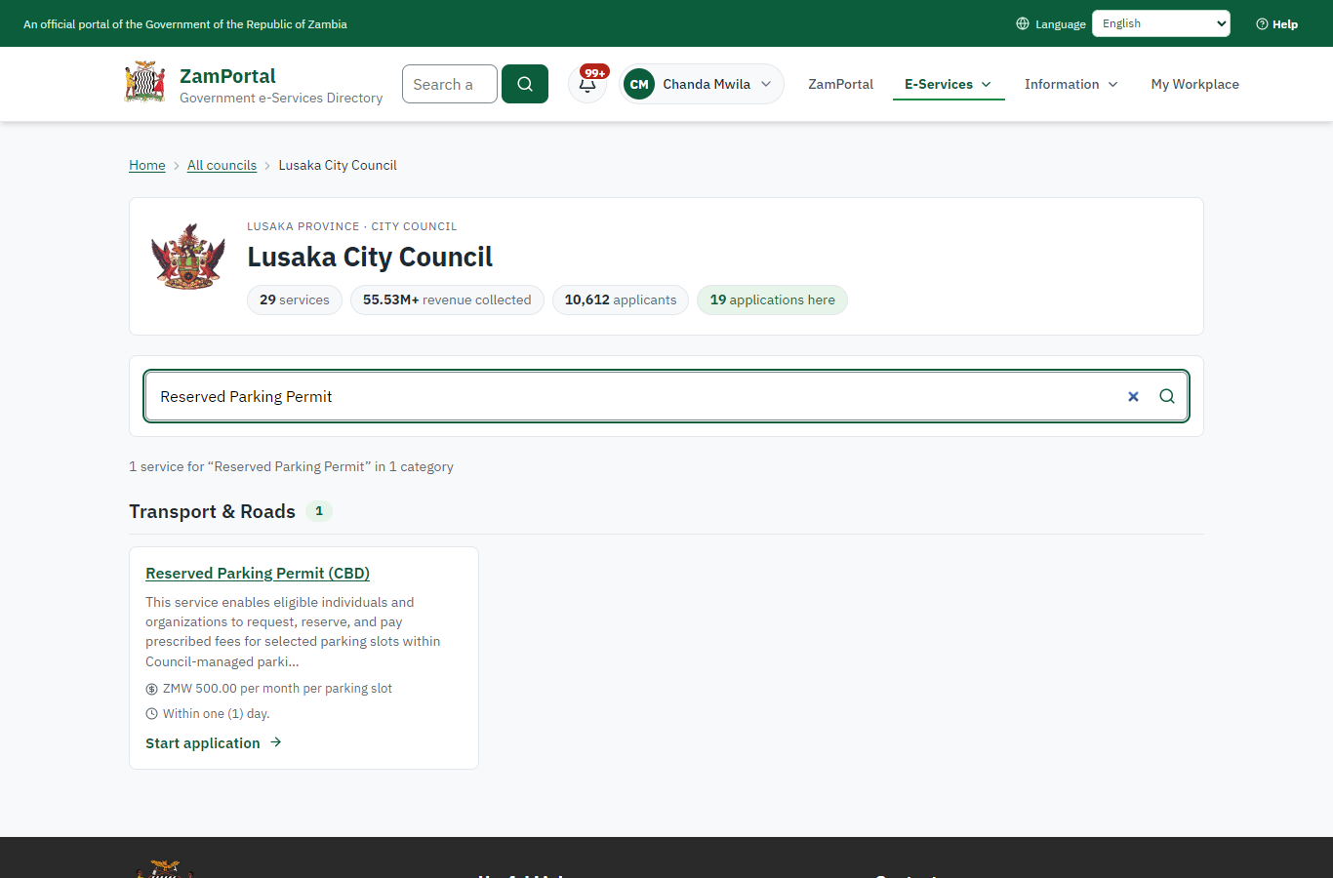 | 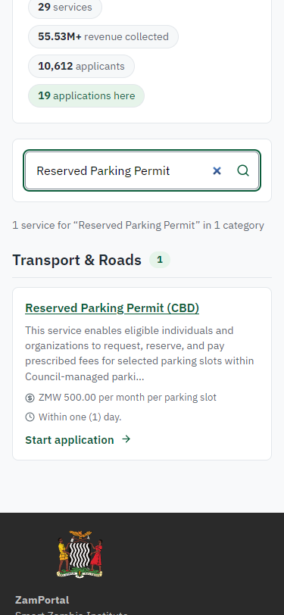
Step 1: Find the service at the council - desktop (left) and a 375 px phone (right).

Step 2. Read the service page
Citizen · National e-Services portal
The service page sets out what the service is for, the fee, how long it takes and the documents to have ready, and names the council the application goes to. "Start application" begins an application at Lusaka City Council (the citizen is signed in with ZamPass).
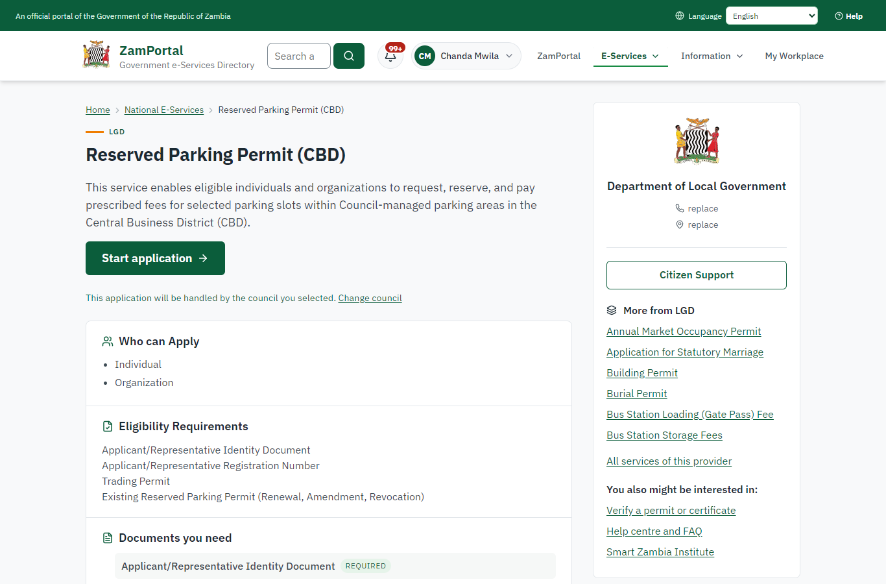 | 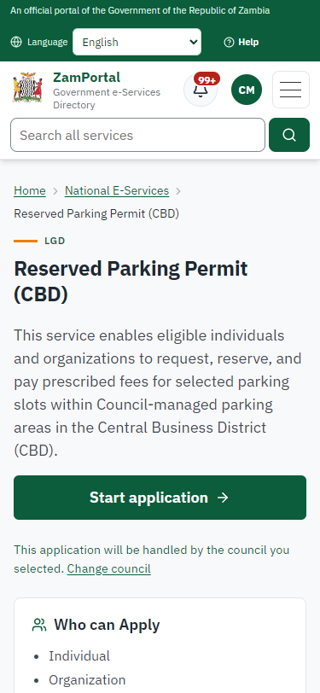
Step 2: Read the service page - desktop (left) and a 375 px phone (right).

Step 3. Confirm the applicant details
Citizen · National e-Services portal
The applicant details are filled in from the citizen's ZamPass account. The citizen says whom they are applying for (themself) and continues with "Proceed to Application".
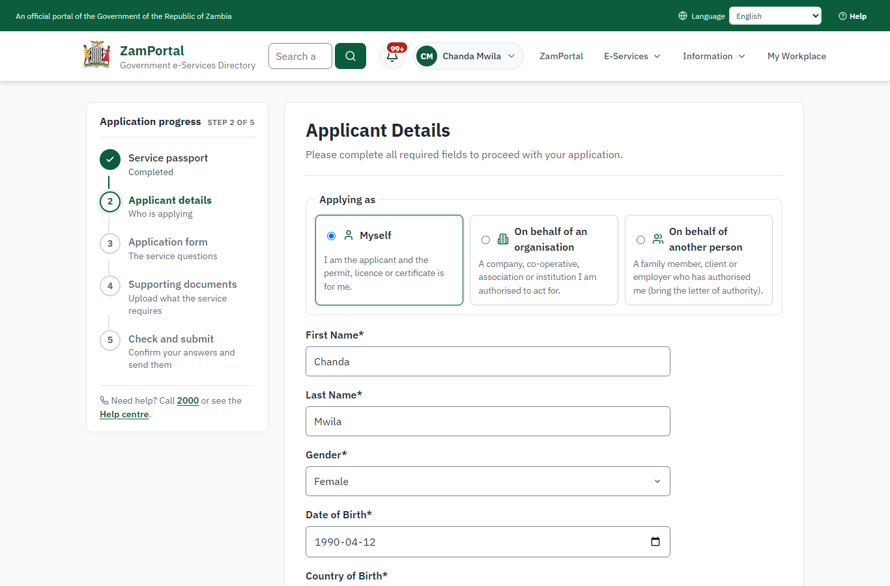 | 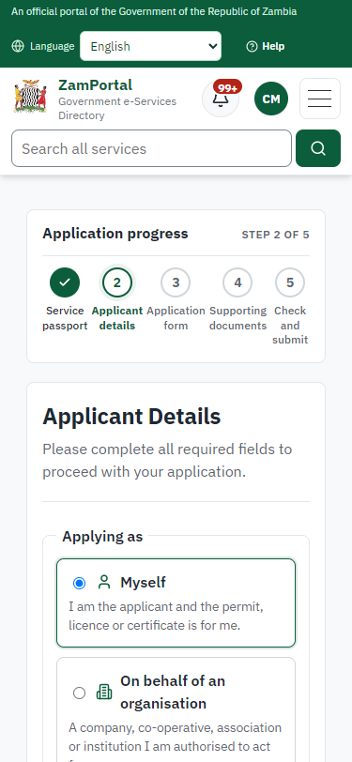
Step 3: Confirm the applicant details - desktop (left) and a 375 px phone (right).

Step 4. Fill in the application form
Citizen · National e-Services portal
The citizen answers the service's own application form, converted from the legacy system (4 answers in this run, all synthetic), for the type of application "New". Questions marked * must be answered; some appear only after an earlier answer. Answers are saved as the citizen types, so an unfinished application can be reopened from My Workplace.
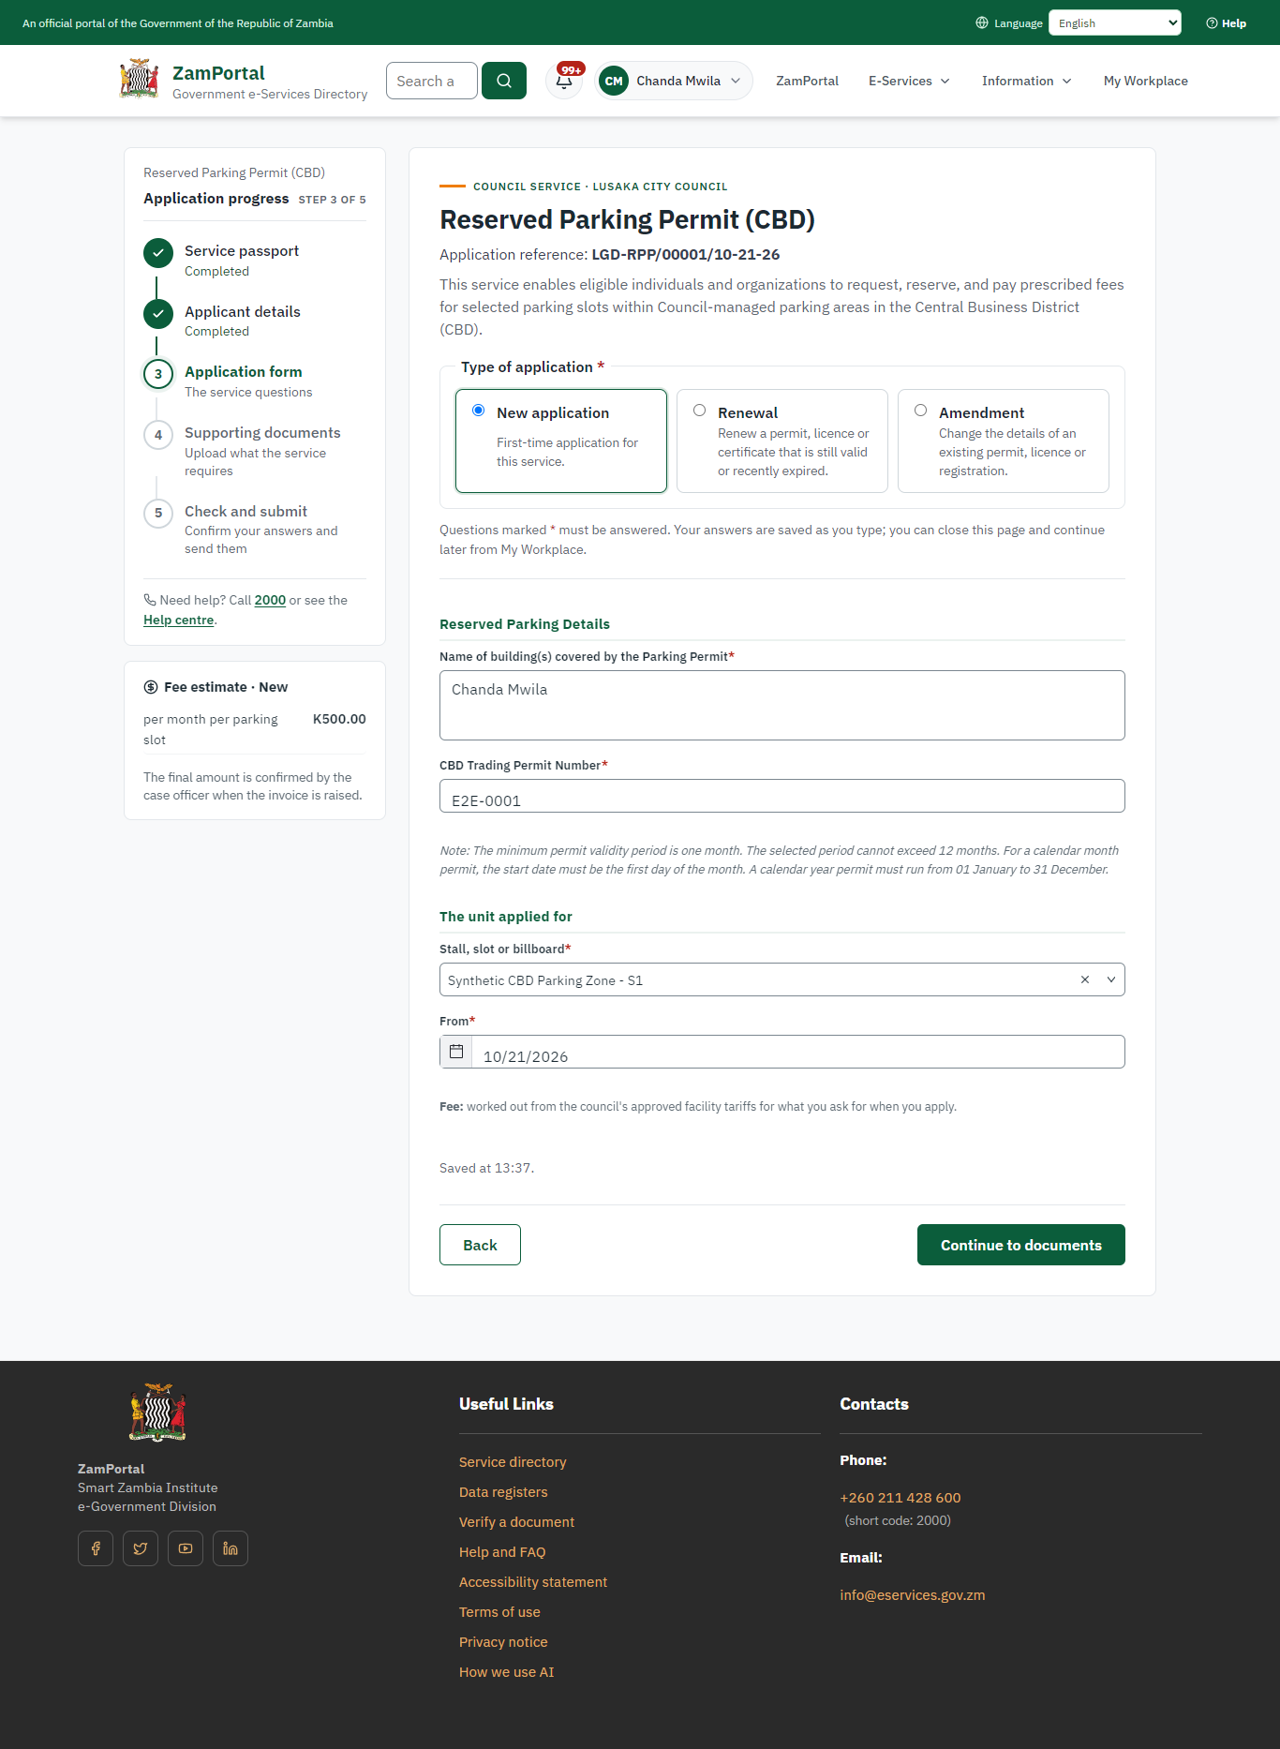 | 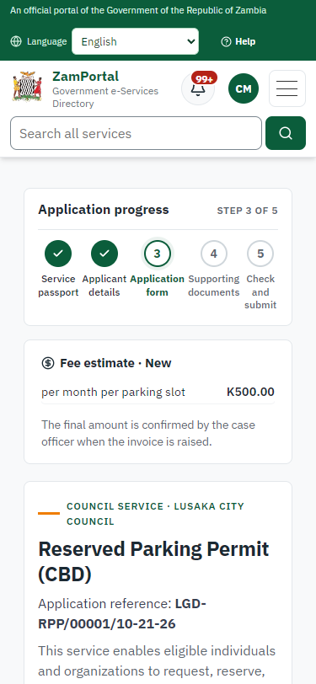
Step 4: Fill in the application form - desktop (left) and a 375 px phone (right).

Step 5. Upload the supporting documents
Citizen · National e-Services portal
Each document the service asks for has its own upload (4 in this run: Applicant/Representative Identity Document, Applicant/Representative Registration Number, Trading Permit, Existing Reserved Parking Permit (Renewal, Amendment, Revocation)). The files are checked and stored with the application; the page confirms each upload.
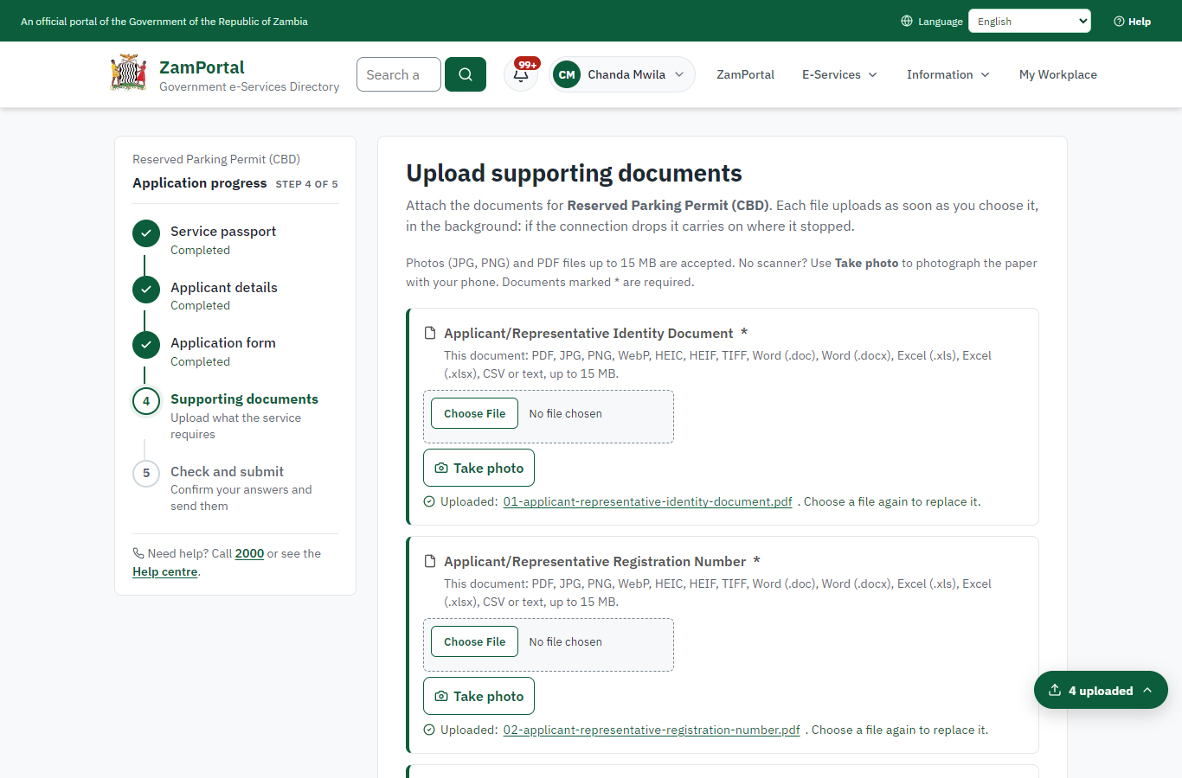 | 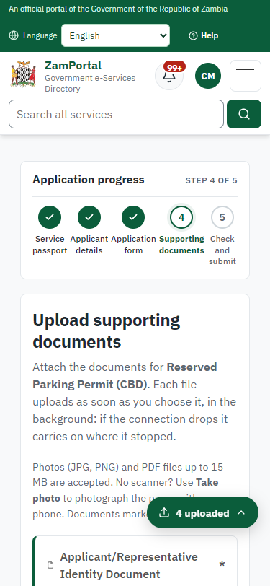
Step 5: Upload the supporting documents - desktop (left) and a 375 px phone (right).

Step 6. Check the answers and confirm the declaration
Citizen · National e-Services portal
Before sending, the citizen sees every answer and document on one page and can go back to change them. The declaration that the information is true and complete must be ticked.
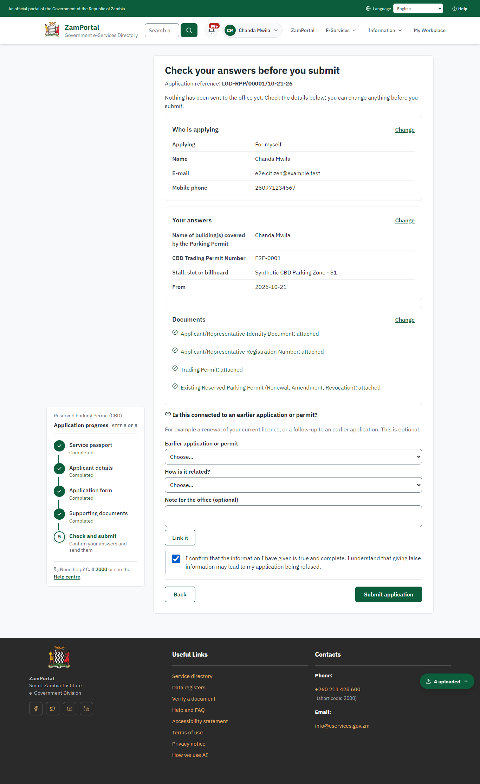 | 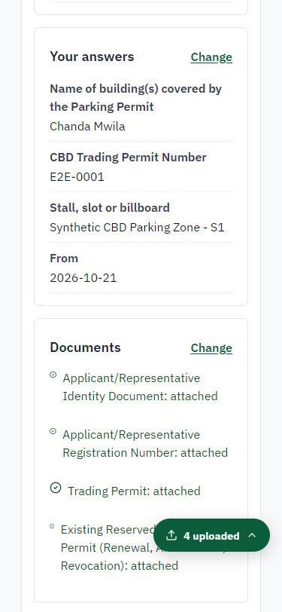
Step 6: Check the answers and confirm the declaration - desktop (left) and a 375 px phone (right).

Step 7. Application sent
Citizen · National e-Services portal
The portal confirms the application with the ministry's reference number (LGD-RPP/00001/10-21-26 in this run). The application goes to the ministry's officers; the citizen follows it in My Workplace.
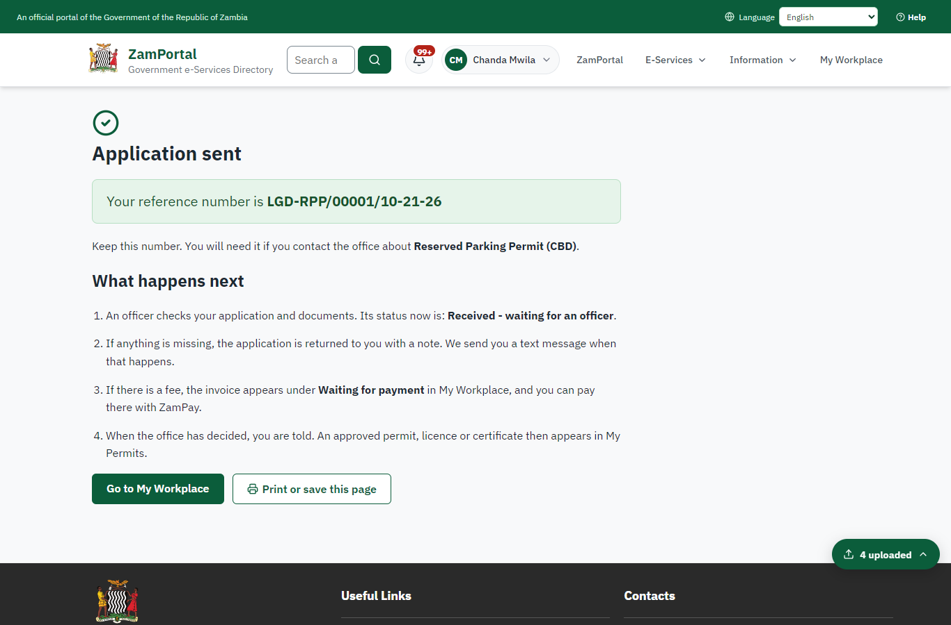 | 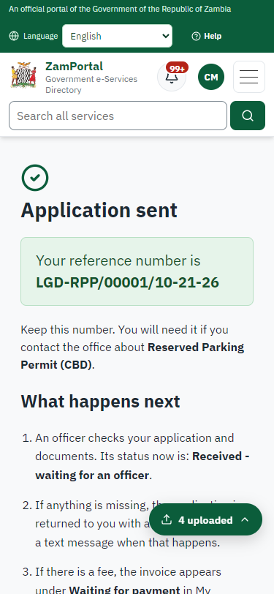
Step 7: Application sent - desktop (left) and a 375 px phone (right).

Step 8. Take the new application on
Case Officer · Back office
The application arrives in the case queue of the ministry that owns the service (Department of Local Government); only its staff see it. The officer opens it by its reference number - answers, documents and process are on the case - assigns it to themself and takes it on.
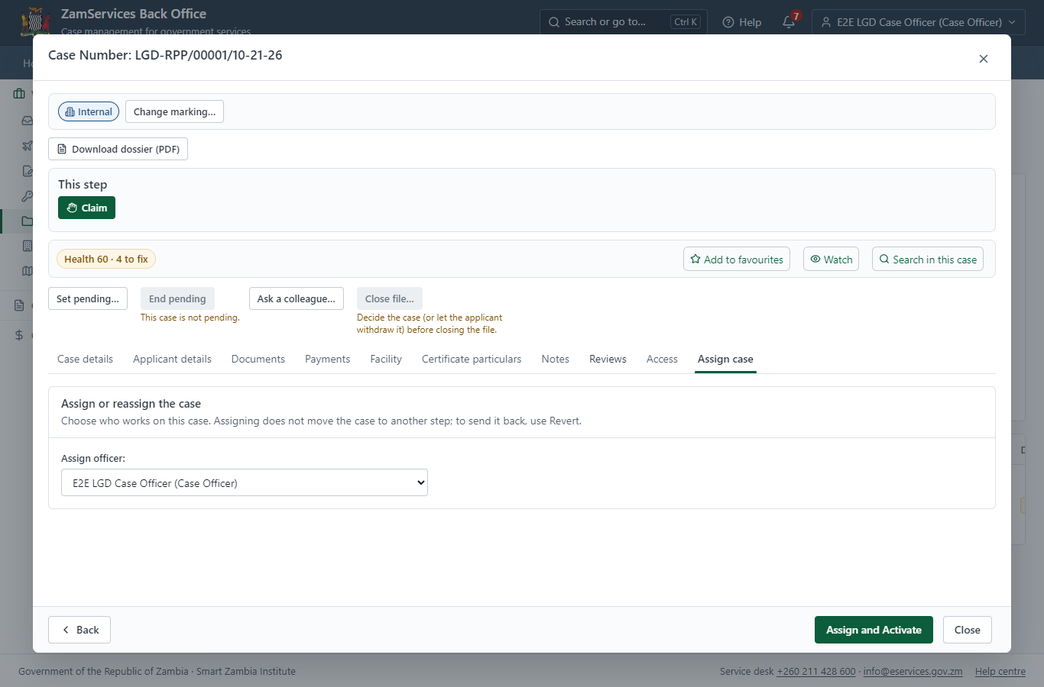
Step 8: Take the new application on.

Step 9. Fill in the certificate particulars
Case Officer · Back office
The issued document prints 5 fields that come from the office rather than from the application (Authority, Service category, Issued document name, Reserved parking slot quantity, Zigs forms inspections). The officer fills them in on the case's "Certificate particulars" tab before the document is issued (synthetic values in this run) and saves; once the document is issued they can no longer change.
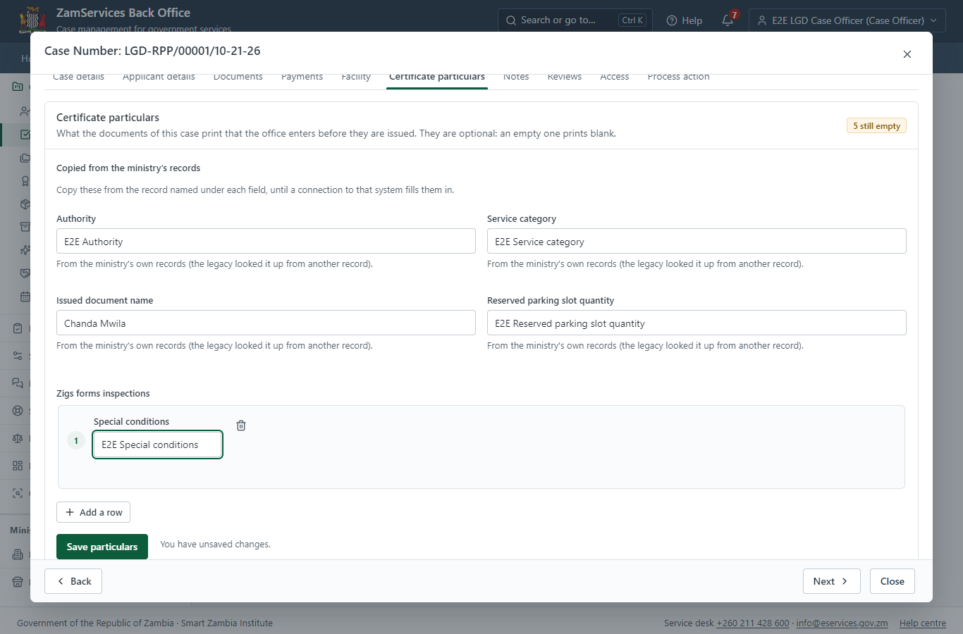
Step 9: Fill in the certificate particulars.

Step 10. Check the application and the unit
Case Officer · Back office
The Case Officer works on "Check the application and the unit" (review in the imported process), checks the application and its documents, and completes the step.
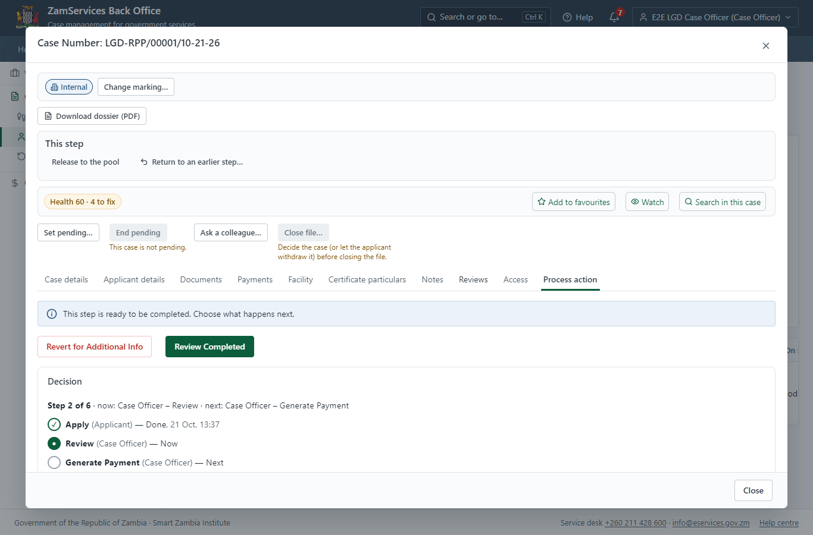
Step 10: Check the application and the unit.

Step 11. Set the fee (approved tariff)
Case Officer · Back office
The Case Officer works out the fee from the service's imported fee schedule ("ZMW 500.00 per month per parking slot"). "Submit Fees and Advance" records it, raises a ZamPay invoice for the applicant and moves the case to payment.
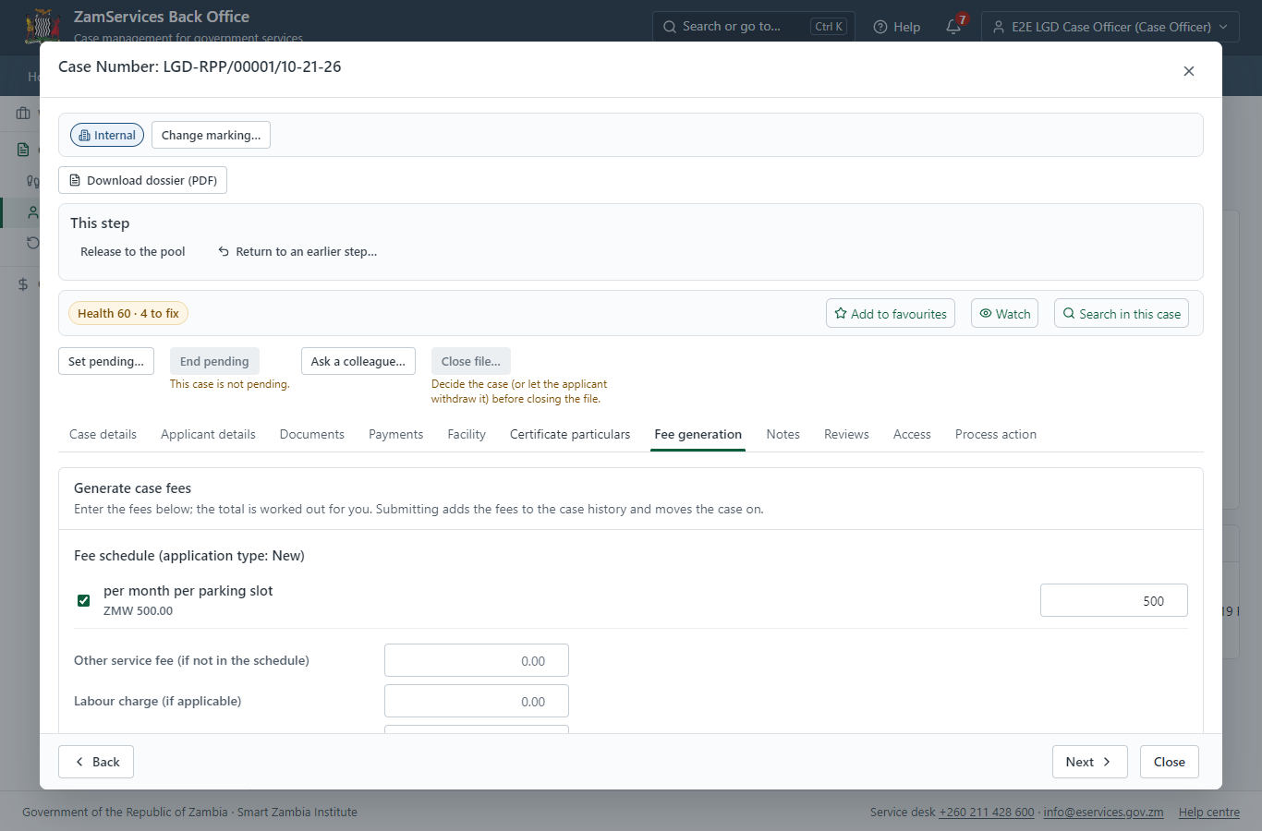
Step 11: Set the fee (approved tariff).

Step 12. See that the fee is due
Citizen · National e-Services portal
The application shows "Waiting for your payment" in My Workplace with a Pay button (K250.00). The office priced the case; the invoice was raised on ZamPay.
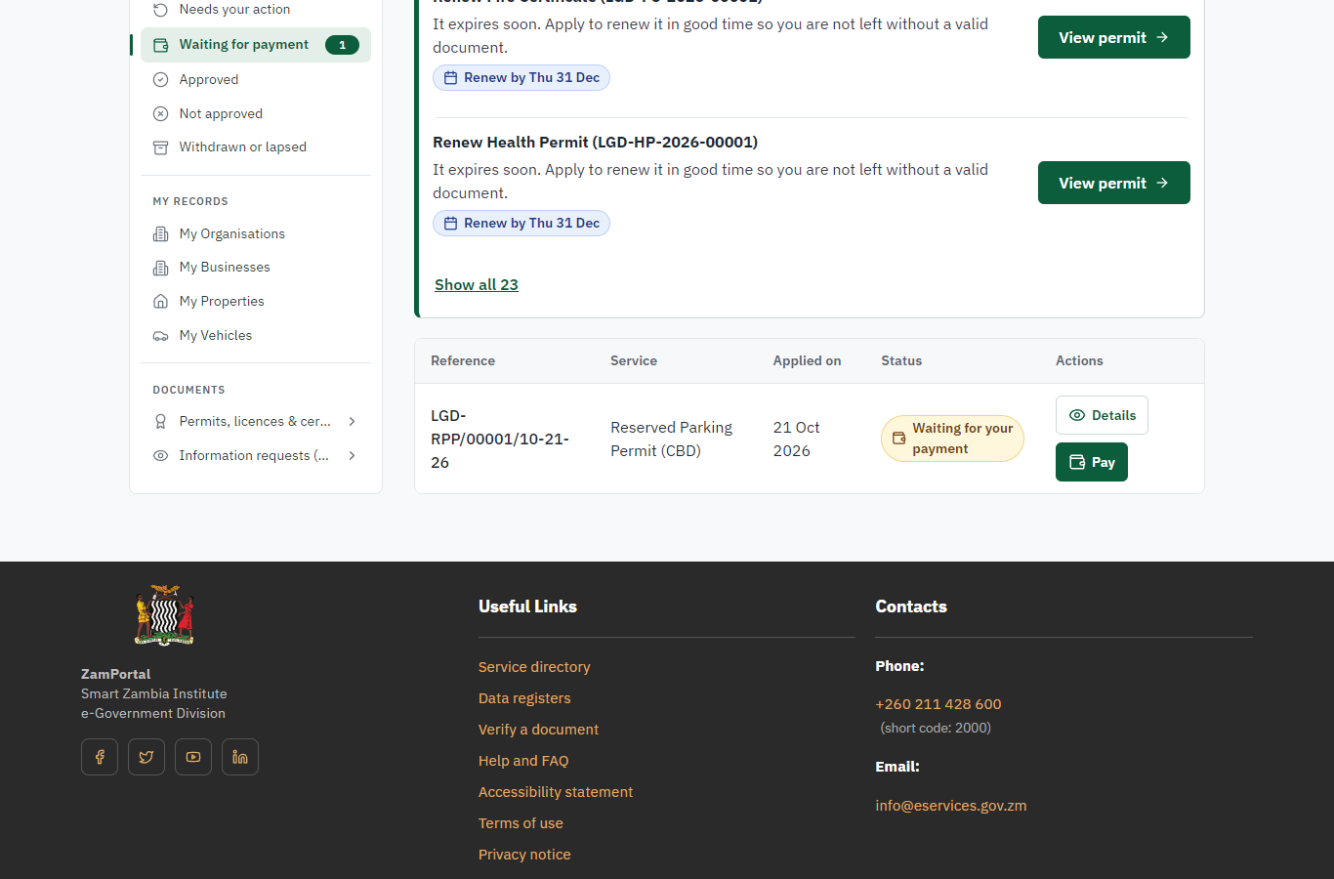 | 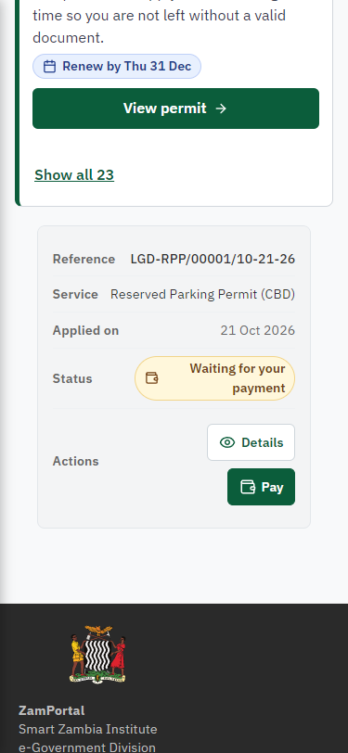
Step 12: See that the fee is due - desktop (left) and a 375 px phone (right).

Step 13. Pay with ZamPay
Citizen · National e-Services portal
Pay opens the invoice (K250.00, the amount set by the platform, never by the page) with its PDF preview; the citizen pays at ZamPay by mobile money or bank card.
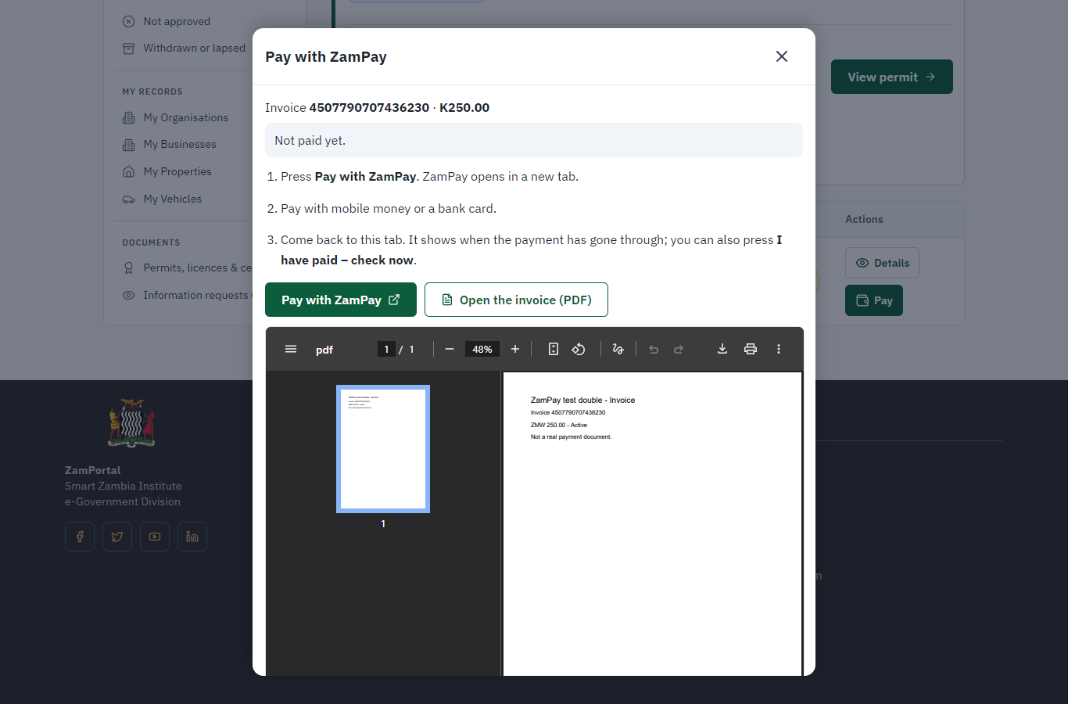 | 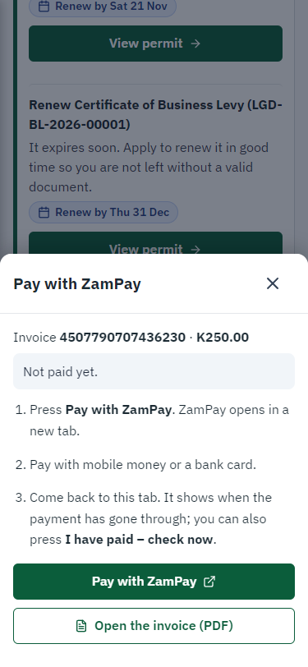
Step 13: Pay with ZamPay - desktop (left) and a 375 px phone (right).

Step 14. Payment received
Citizen · National e-Services portal
ZamPay reports the payment; the dialog says "Paid. Thank you" and the application moves on to the ministry's officers.
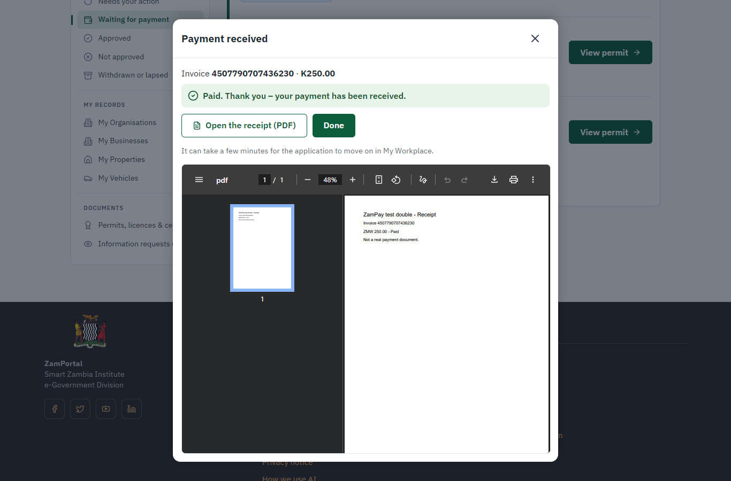 | 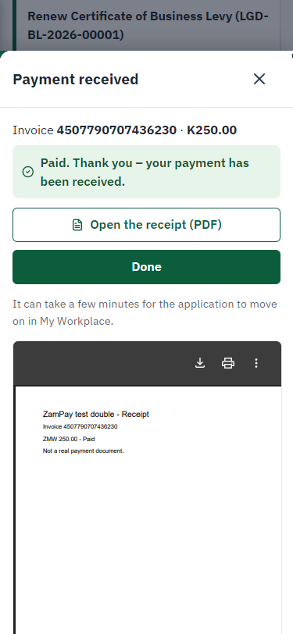
Step 14: Payment received - desktop (left) and a 375 px phone (right).

Step 15. Verify Payment
Case Officer · Back office
The Case Officer works on "Verify Payment" (verify-payment in the imported process), checks the application and its documents, and completes the step.
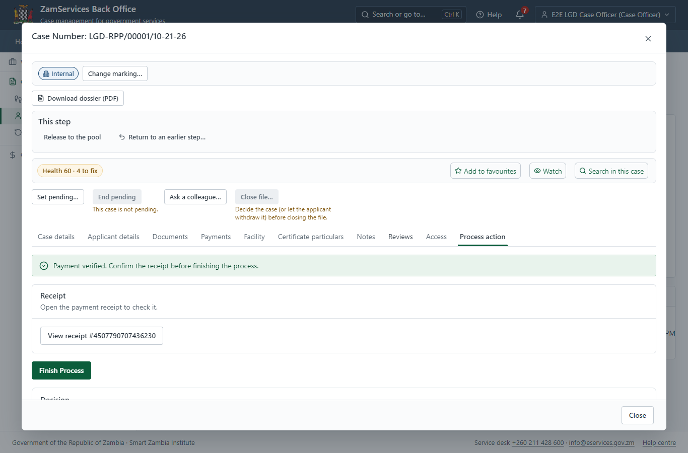
Step 15: Verify Payment.

Step 16. Decide: Approve the permit
Supervisor · Back office
At "Approve the permit" the Supervisor records the decision: approve, with a comment kept in the case history. Approving moves the case on; the last decision completes it and issues the document.
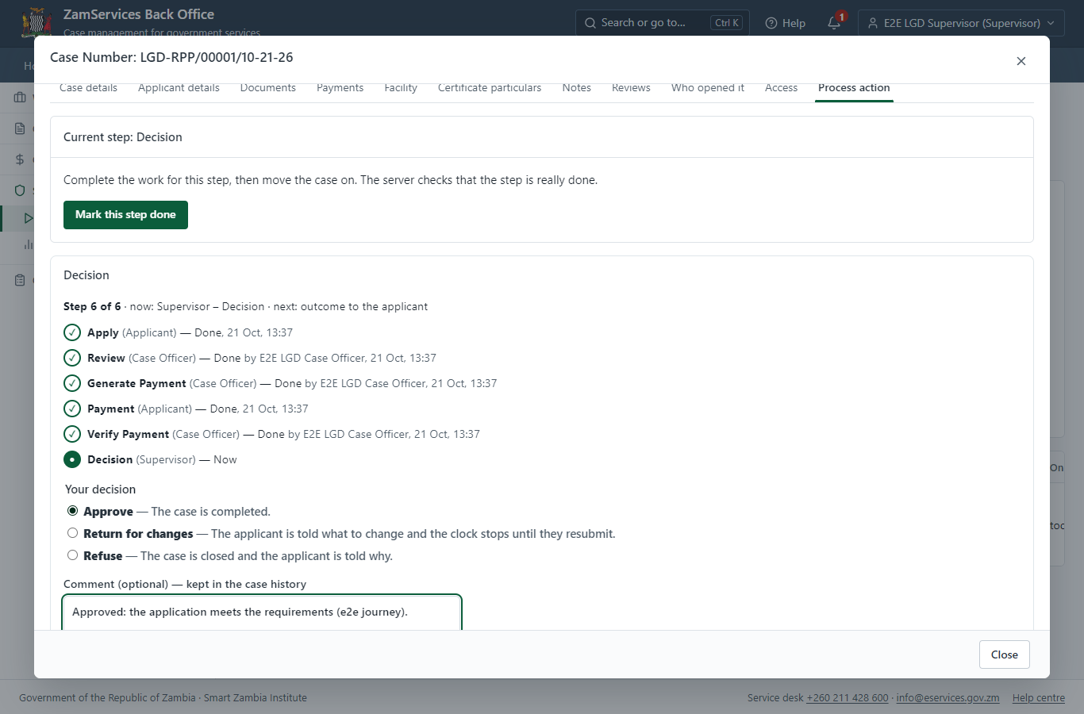
Step 16: Decide: Approve the permit.

Step 17. The document in My permits
Citizen · National e-Services portal
The issued document (LGD-RPPC-2026-00001 in this run: "GS-3 Authorization Document") is listed in "My permits and licences" with its validity and a download of the sealed PDF.
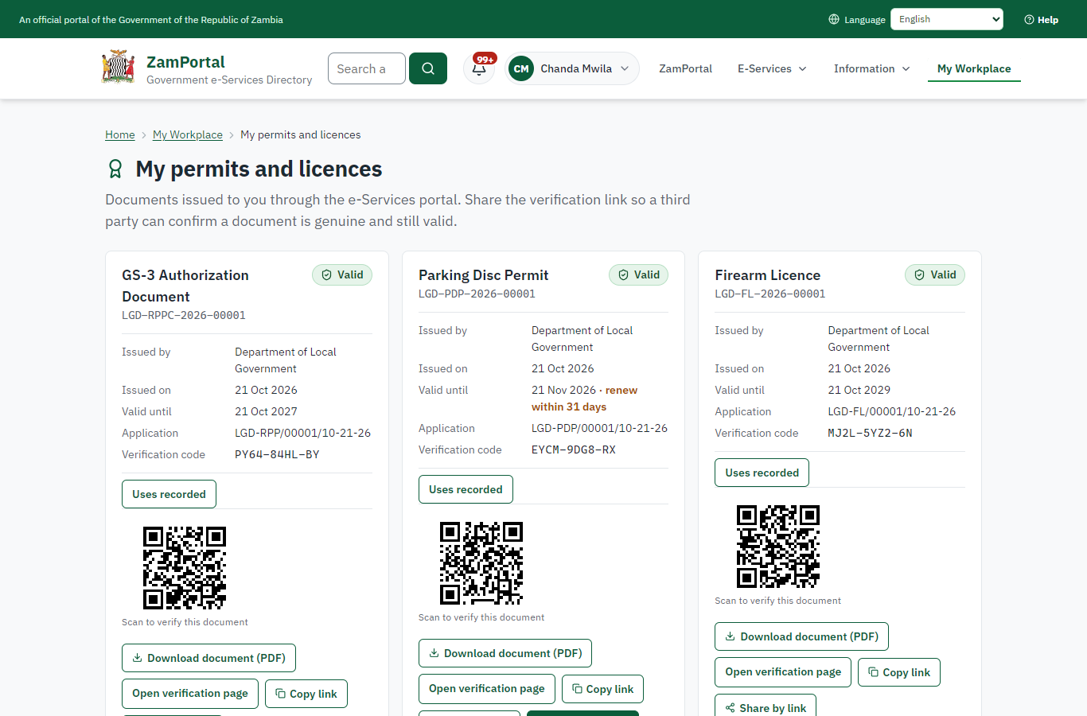 | 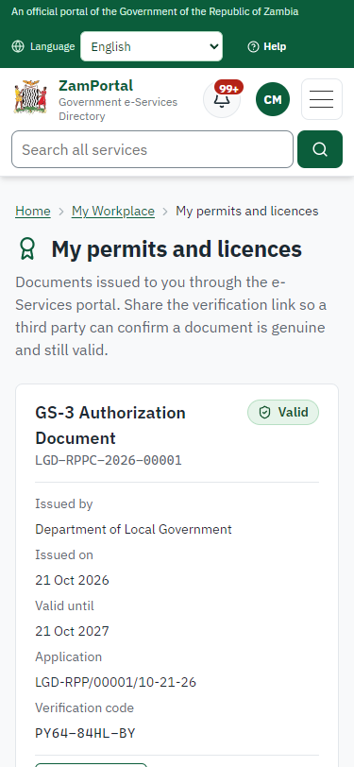
Step 17: The document in My permits - desktop (left) and a 375 px phone (right).

Step 18. Verify the document
Anyone (public) · Public verification page
The QR code on the document opens the public verification page: genuine and current, to whom it was issued, and whether the electronic seal is valid. No sign-in is needed.
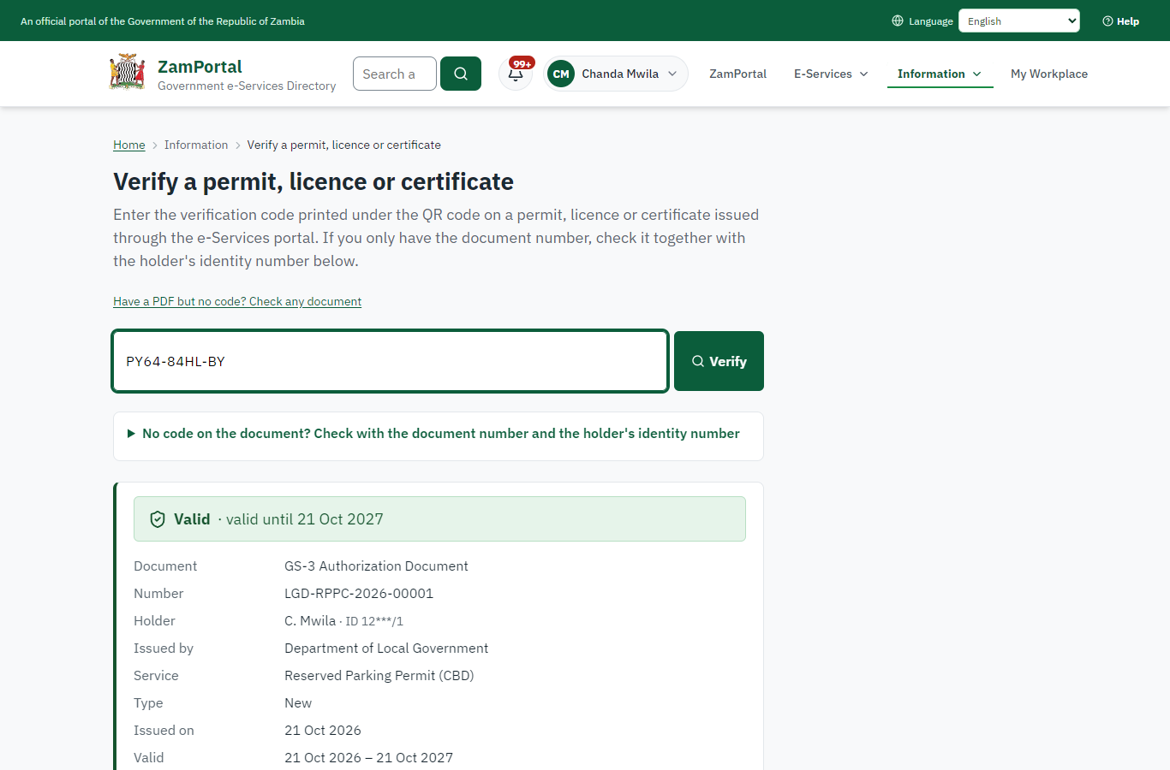 | 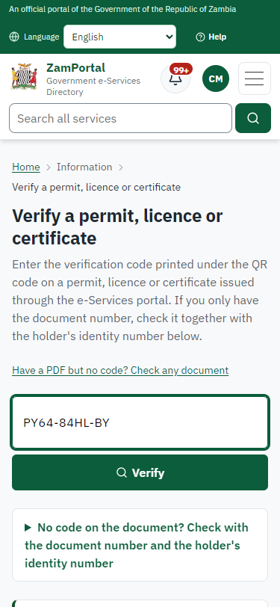
Step 18: Verify the document - desktop (left) and a 375 px phone (right).

3. Payment
Item | In the test run
Fee (as published) | ZMW 500.00 per month per parking slot
Invoice 1 | 4507790707436230
Amount 1 | ZMW 250.00
Paid at 1 | after "Set the fee (approved tariff)"
On screen: step 11 (Set the fee (approved tariff)), step 12 (See that the fee is due), step 13 (Pay with ZamPay), step 14 (Payment received) in section 2.

4. Output documents

GS-3 Authorization Document (sealed PDF)
Issued when the case was approved, from the service's output configuration (service template ReservedParkingPermitCBD.GS3.docx), filled from the application and the decision, sealed with the platform's electronic seal and stored as the issued version. The holder downloads it from My permits; the verification page checks it.
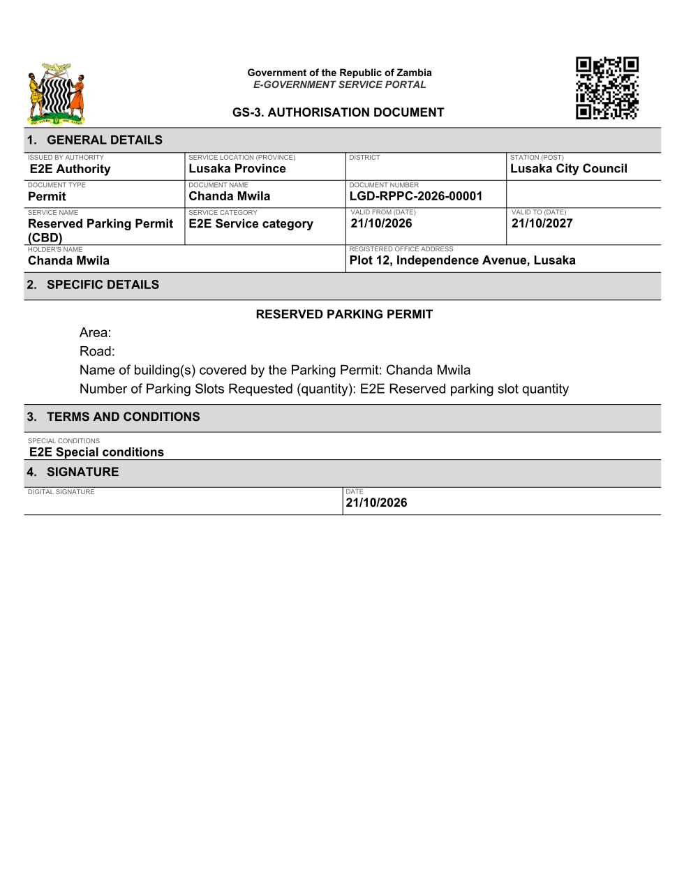
GS-3 Authorization Document (sealed PDF) - first of 1 page, as issued in the test run.

Fields
Field | Value in the test run
Document title | GS-3 Authorization Document
Permit / licence number | LGD-RPPC-2026-00001
Holder | Chanda Mwila
Valid from | 2026-10-21
Valid until | 2027-10-20
Status | active
Verification code (printed with a QR code) | PY64-84HL-BY

Seal
Seal status | sealed
Signature level | PAdES-B-T
Sealed by | the platform seal (development key in the test run)
Signed at | 2026-10-21T11:37:58.377Z
Trusted time-stamp | 2026-10-21T11:37:58.346Z (time-stamping authority)
Document fingerprint (SHA-256) | d79323c5ed51acfb...

Verification
Where | The public verification page of the national portal, <portal>/verify/<verification code>, opened by scanning the QR code on the document.
What it shows | Whether the document is genuine and current, its holder and validity, and whether the electronic seal is valid and who sealed it.
Checking a copy | Anyone can upload a PDF they were given; the page says whether it is exactly the document that was issued. A changed copy is reported as not matching.
On screen: step 17 (The document in My permits), step 18 (Verify the document) in section 2.

5. Notifications
When | Channel | To | Message | Delivery
Application received | in-app (portal bell) | the applicant | Application LGD-RPP/00001/10-21-26 received - Your application LGD-RPP/00001/10-21-26 for Reserved Parking Permit (CBD) has been received by Department of Local Government. | shown
Status changed | in-app (portal bell) | the applicant | Update on application LGD-RPP/00001/10-21-26 - LGD-RPP/00001/10-21-26 (Reserved Parking Permit (CBD)) is now: With the office - being reviewed. | shown
Payment due (invoice raised) | in-app (portal bell) | the applicant | Payment due for application LGD-RPP/00001/10-21-26 - The fee of ZMW 250.00 for Reserved Parking Permit (CBD) (LGD-RPP/00001/10-21-26) is now due. Invoice 4507790707436230. | shown
Payment received | in-app (portal bell) | the applicant | Payment received for LGD-RPP/00001/10-21-26 - Your payment of ZMW 250.00 for LGD-RPP/00001/10-21-26 (Reserved Parking Permit (CBD)) has been received. Receipt: <ZamPay>/pdf?documentType=receipt&invoiceNumber=4507790707436230 | shown
Licence / permit issued | in-app (portal bell) | the applicant | Your Reserved Parking Permit (CBD) document has been issued - LGD-RPPC-2026-00001 has been issued for Reserved Parking Permit (CBD) and is valid until 21/10/2027. | shown
Invitation to rate the service | in-app (portal bell) | the applicant | How was Reserved Parking Permit (CBD)? - How was Reserved Parking Permit (CBD)? Tell us in about a minute. | shown
Decision: approved | in-app (portal bell) | the applicant | Application LGD-RPP/00001/10-21-26 completed - LGD-RPP/00001/10-21-26 (Reserved Parking Permit (CBD)) is complete. Your documents are ready. | shown
Application received | email | e2e.c***@example.test | Application LGD-RPP/00001/10-21-26 received | skipped
Application received | sms | +260 97* *** 567 | Application LGD-RPP/00001/10-21-26 for Reserved Parking Permit (CBD) has been received. Track it: <portal>/my-workplace | delivered
Status changed | sms | +260 97* *** 567 |  | delivered
Payment due (invoice raised) | sms | +260 97* *** 567 | Fee of ZMW 250.00 due for LGD-RPP/00001/10-21-26. Invoice 4507790707436230. Pay: <ZamPay>/pay-for-service/get-invoice/4507790707436230 | delivered
Payment due (invoice raised) | email | e2e.c***@example.test | Payment due for application LGD-RPP/00001/10-21-26 | skipped
Payment received | sms | +260 97* *** 567 |  | delivered
Invitation to rate the service | sms | +260 97* *** 567 |  | skipped
Invitation to rate the service | email | e2e.c***@example.test | How was Reserved Parking Permit (CBD)? | skipped
Licence / permit issued | email | e2e.c***@example.test | Your Reserved Parking Permit (CBD) document has been issued | skipped
Decision: approved | email | e2e.c***@example.test | Application LGD-RPP/00001/10-21-26 completed | skipped
Licence / permit issued | sms | +260 97* *** 567 |  | delivered
Decision: approved | sms | +260 97* *** 567 |  | delivered
Delivery: shown = in the portal's notification bell; delivered = the SMS gateway (a test double in this run) reported the text delivered; skipped = not sent on that channel (e-mail is not configured on the test installation, and some notices go out on one channel only); sent by the national portal = a ministry node handed the notice to the national portal, which texts and e-mails the citizen under its own name and the citizen's preferences. Addresses written <portal>, <ZamPay> stand for the national portal and ZamPay.

6. Legacy mapping
Replaces | Reserved Parking Permit (CBD) in the legacy ZIGS e-Services directory (ZIGS_Services)
Legacy service id | 656
Legacy provider | Department of Local Government (LGD) under Ministry of Local Government and Rural Development
Legacy process | not recorded
Fee in the legacy system | none
Fee taken before submission | yes (as in ZIGS)
Time to issue (legacy) | not recorded
Legacy output templates | GS-3 Authorization Document: ZIGS_Forms_ECouncil / ReservedParkingPermitCBD.GS3  GS-1 Application for a Government Service: ZIGS_Forms_ZDA / GS1  GS-2 Notice of Government Action: ZIGS_Forms_Notices / GS-2.NoticeOfAction
Legacy address | https://ecouncils.gsb.gov.zm
How it was brought over | Imported by the platform's legacy catalogue importer (zcm-backend scripts/zigs/importLegacy.js) from the ZIGS snapshot: form, case types, fees, documents, process and output templates, then served by the new platform.

7. Version and date
Document version | service v1, platform 39fb88e4
Generated | 2026-10-21T11:38:05Z (by the end-to-end run, not edited by hand)
Service version | not versioned (configured directly)
Platform snapshot | backend 39fb88e4  portal 72805f0  back office 58e5946
Test suite | e2e 2f82c10; one installation (combined); seed profile mihud
Journeys | 30-catalogue-service.spec.js: citizen finds the service, answers its form, uploads its documents and sends the application - passed  30-catalogue-service.spec.js: the case goes through every step of its process: payments by the citizen, each officer step by its role - passed  30-catalogue-service.spec.js: the grant document is issued, sealed, filled in and verifiable; the citizen has it in My permits - passed
Result | 3 of 3 journey tests passed
Data | Synthetic test data on a local test installation; provider test doubles for ZamPass, ZamPay, SMS and signing.

