Republic of Zambia
GSB e-Services

Psychometric and Aptitude Testing
Service documentation
Owner: National Productivity Development Department
Service key: npdd/psychometric-and-aptitude-testing
Version: service v1, platform 9b8a591f
Date: 2026-10-17
Generated automatically by the service's end-to-end test run. Every screenshot shows synthetic test data on a local test installation, never real personal data.

Contents
- 1. Service summary
- 2. Application process, step by step
- 3. Payment
- 4. Output documents
- 5. Notifications
- 6. Legacy mapping
- 7. Version and date
This document describes the Psychometric and Aptitude Testing service of National Productivity Development Department as the platform runs it today. It is generated by the service's end-to-end test: every step was performed by the test and every screenshot was taken during that run, with synthetic data. Regenerate it with "npm run docs:services" in the e2e suite; do not edit it by hand.

1. Service summary
Service | Psychometric and Aptitude Testing
Owner (MDA) | National Productivity Development Department (npdd)
Purpose | This service involves administering tests to candidates to determine their suitability for training or employment in terms of aptitude (abilities or capacity). The tests depend on the nature of training or employment being offered and are designed to pick out applicants with the potential to succeed in training or the actual job. The tests give an insight into the applicant? potential and interest. The various Tests include the following: (Language tests, Instruction tests, Reasoning tests, Mathematical attainment tests, Logical Reasoning tests, General Ability tests, Abstraction tests, Administrative Reasoning tests, Personality tests, and other specialized tests, e.g., mechanical and electrical tests).
Who can apply | 1. National Registration Card (NRC). 2. Certificate of Incorporation.
How to apply | Online on the national e-Services portal, signed in with ZamPass; pay with ZamPay.
Fees | a. Consultancy and Advisory Job (Per Assignment): ZMW 250.00  i. Public Sector Organization: ZMW 45.00  ii. Private Sector Organization: ZMW 75.00  iii. Parastatal Organization: ZMW 60.00  iv. Career Guidance: ZMW 80.00
Turnaround | Within 23 working Days.
Validity of the output | N/A
Required documents | National Registration Card (NRC). (required)  Certificate of Incorporation. (required)
Output documents | Standard Test Scores summary  GS-1 Application for a Government Service  GS-2 Notice of Government Action

2. Application process, step by step

The process as configured
Step | Role | Task | Type
1 | Applicant | Apply | form
2 | System | Generate Document | generate-document
3 | Supervisor | Review | review
4 | Case Officer | Review | review
5 | Case Officer | Inspect Site | inspection
6 | Case Officer | Review | review
7 | Case Officer | Verify Payment | verify-payment
8 | Supervisor | Approve | approve
9 | Supervisor | Approve | approve
10 | System | Generate Document | generate-document
11 | Case Officer | Hand Over Document | collection
12 | System | Notify Client | notify

Step by step
Who takes part in this journey: Citizen, Case Officer, Supervisor, Anyone (public). Citizen steps are shown on a desktop and on a 375 px phone; back-office steps on a desktop.

Step 1. Find the service
Citizen · National e-Services portal
On the national e-Services portal the citizen opens All Services and searches for the service by name ("Psychometric and Aptitude Testing"). Each result names the service and the ministry that provides it.
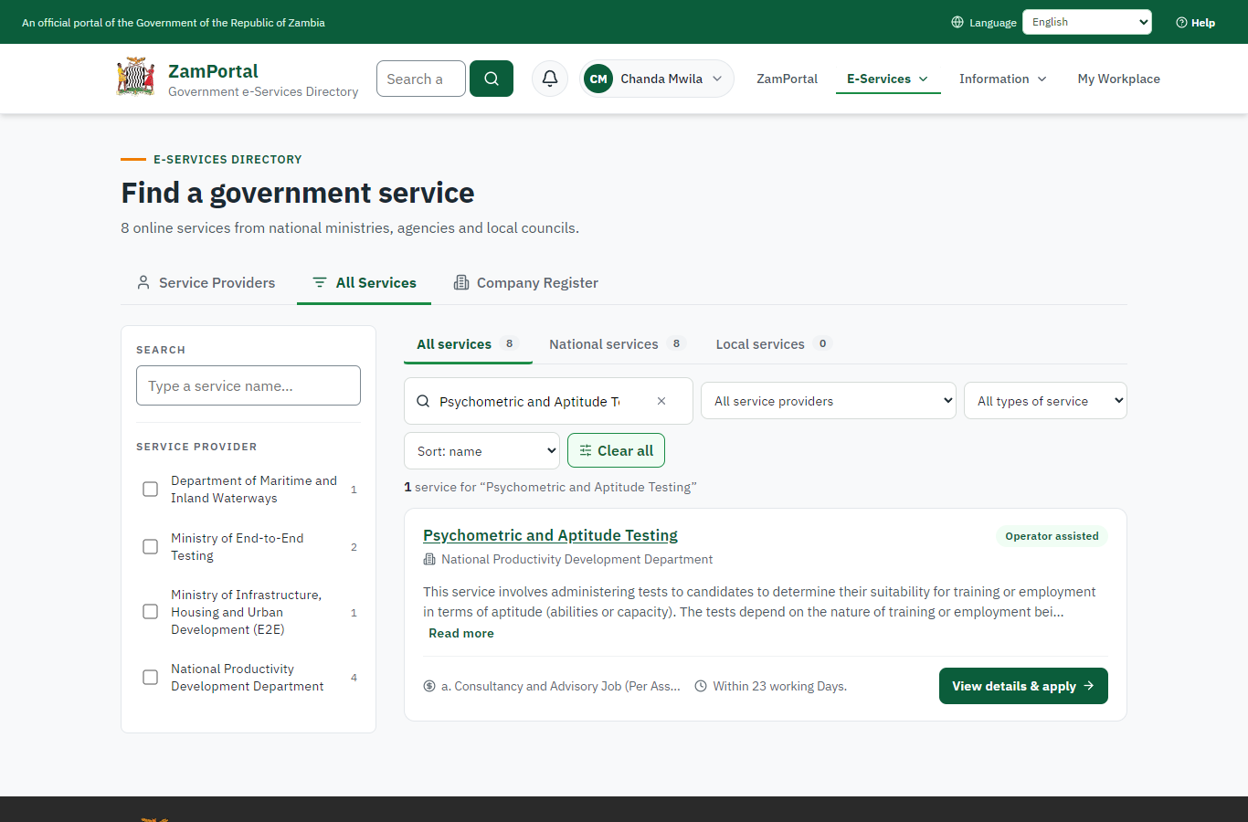 | 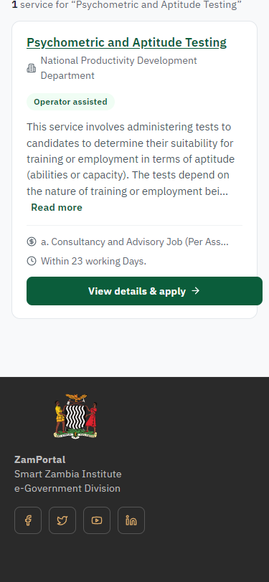
Step 1: Find the service - desktop (left) and a 375 px phone (right).

Step 2. Read the service page
Citizen · National e-Services portal
The service page sets out what the service is for, who provides it, the fee, how long it takes and the documents to have ready. "Start application" begins an application (the citizen is signed in with ZamPass).
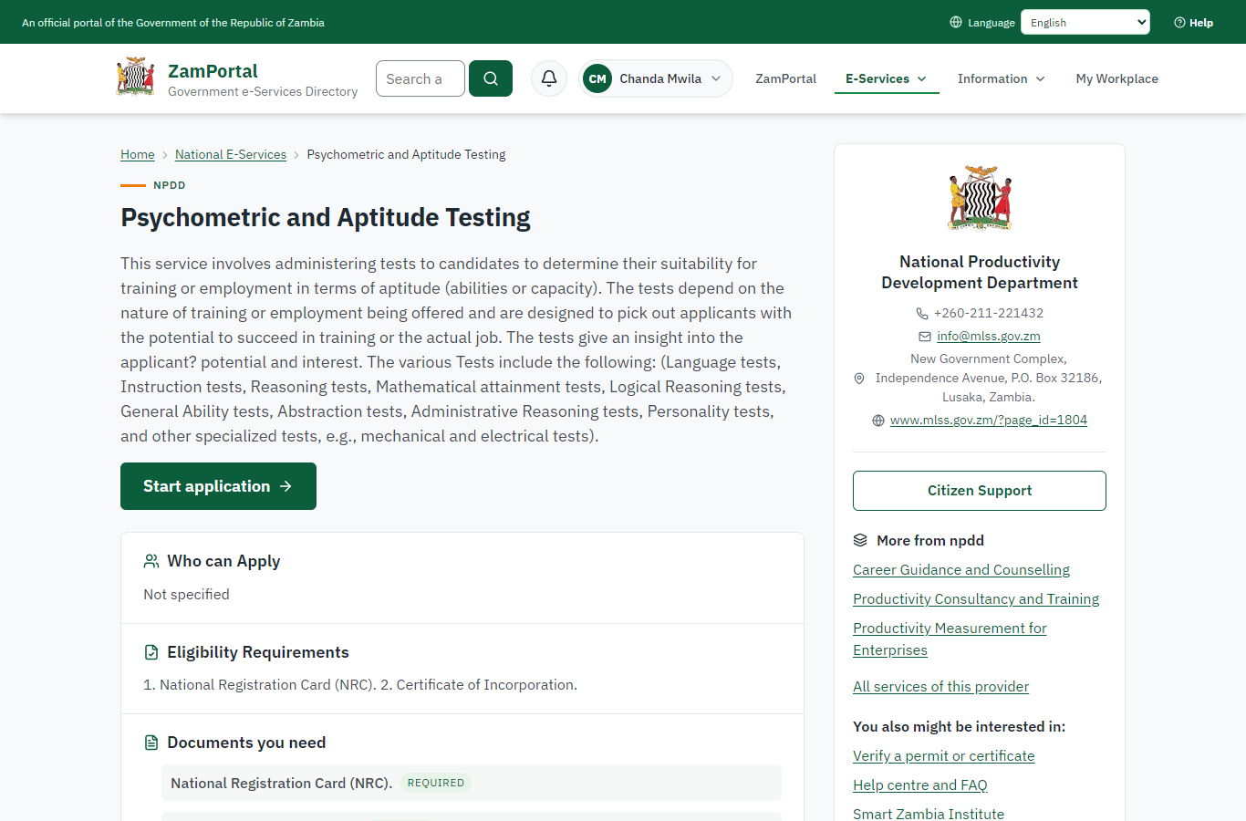 | 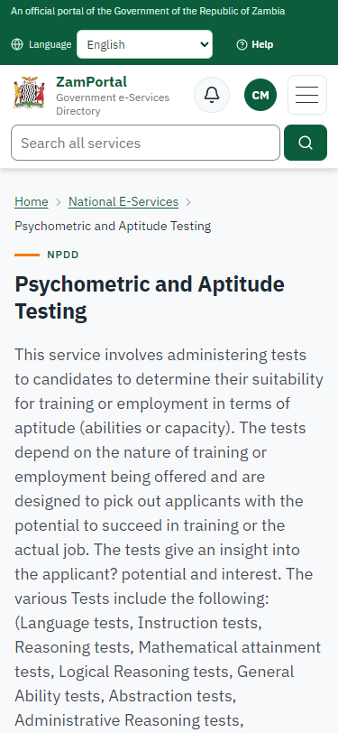
Step 2: Read the service page - desktop (left) and a 375 px phone (right).

Step 3. Confirm the applicant details
Citizen · National e-Services portal
The applicant details are filled in from the citizen's ZamPass account. The citizen says whom they are applying for (themself) and continues with "Proceed to Application".
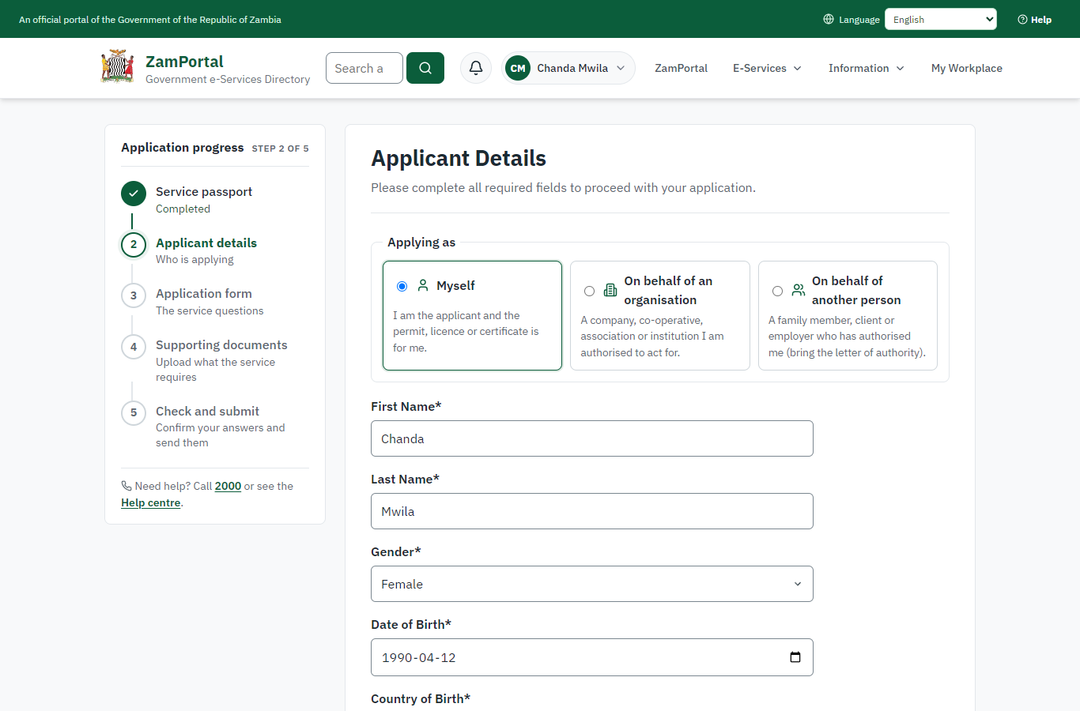 | 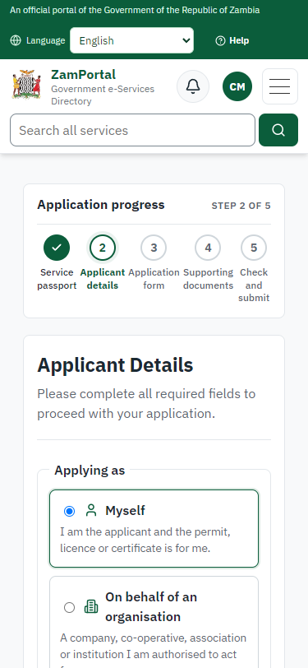
Step 3: Confirm the applicant details - desktop (left) and a 375 px phone (right).

Step 4. Fill in the application form
Citizen · National e-Services portal
The citizen answers the service's own application form, converted from the legacy system (18 answers in this run, all synthetic), for the type of application "New". Questions marked * must be answered; some appear only after an earlier answer. Answers are saved as the citizen types, so an unfinished application can be reopened from My Workplace.
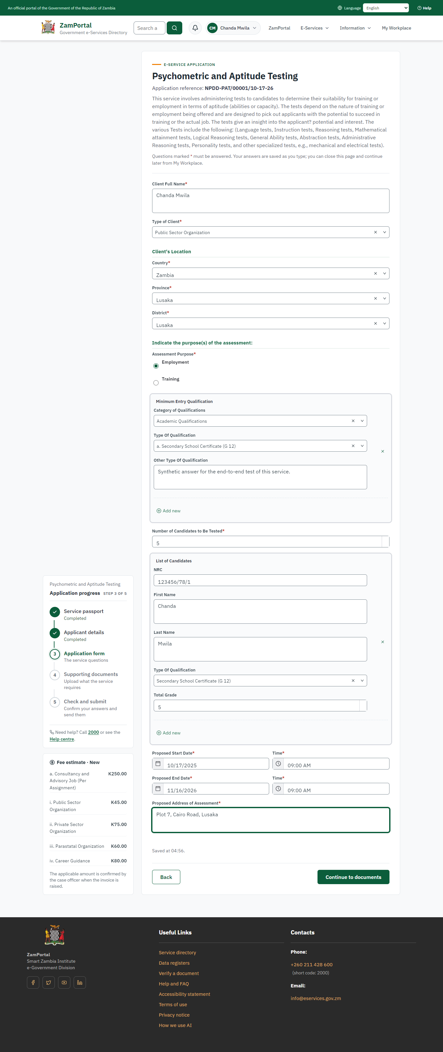 | 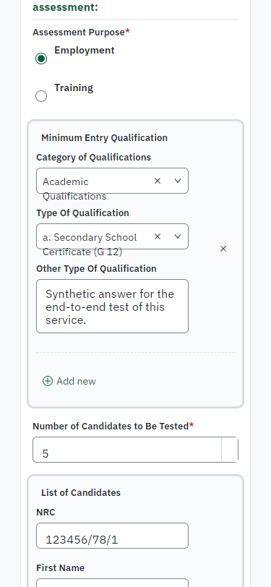
Step 4: Fill in the application form - desktop (left) and a 375 px phone (right).

Step 5. Upload the supporting documents
Citizen · National e-Services portal
Each document the service asks for has its own upload (2 in this run: National Registration Card (NRC)., Certificate of Incorporation.). The files are checked and stored with the application; the page confirms each upload.
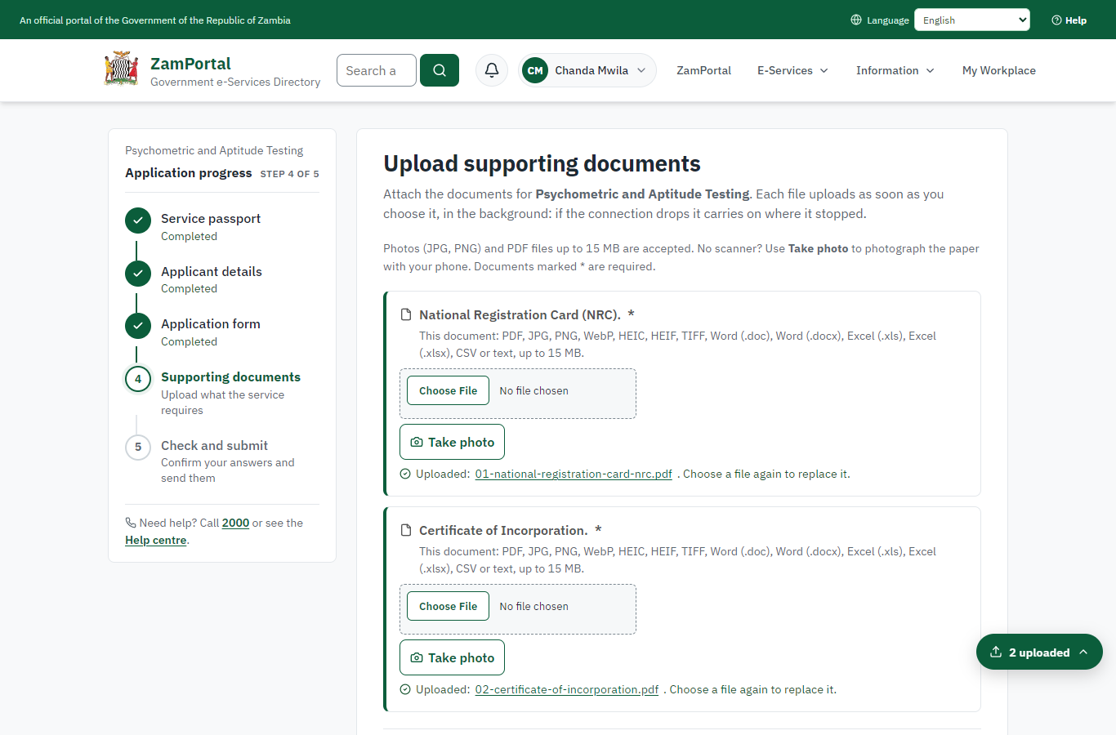 | 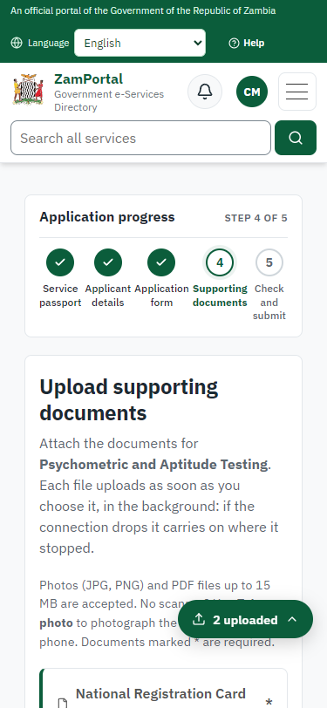
Step 5: Upload the supporting documents - desktop (left) and a 375 px phone (right).

Step 6. Check the answers and confirm the declaration
Citizen · National e-Services portal
Before sending, the citizen sees every answer and document on one page and can go back to change them. The declaration that the information is true and complete must be ticked.
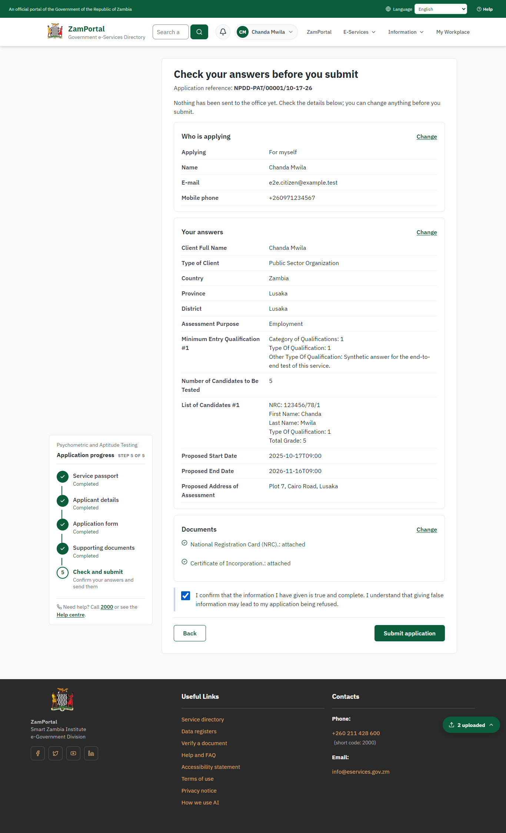 | 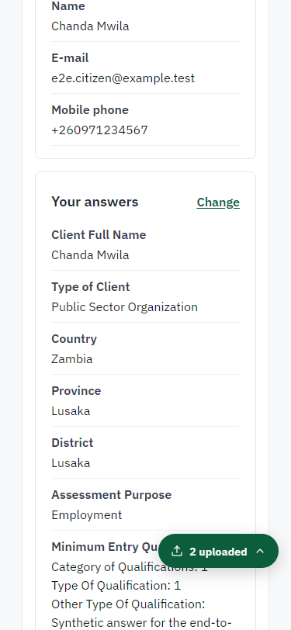
Step 6: Check the answers and confirm the declaration - desktop (left) and a 375 px phone (right).

Step 7. Application sent
Citizen · National e-Services portal
The portal confirms the application with the ministry's reference number (NPDD-PAT/00001/10-17-26 in this run). The application goes to the ministry's officers; the citizen follows it in My Workplace.
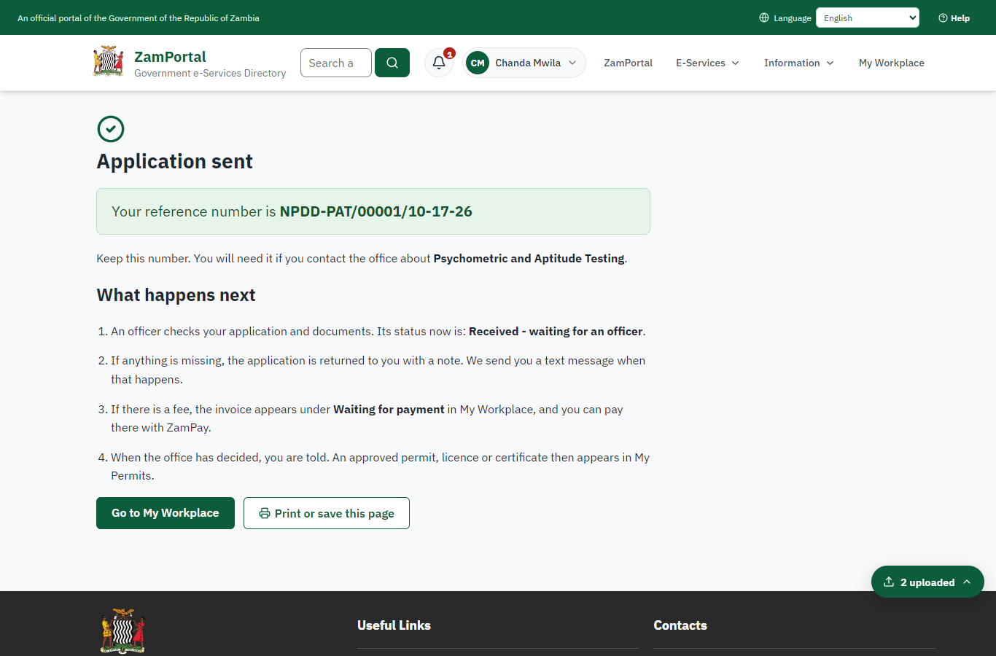 | 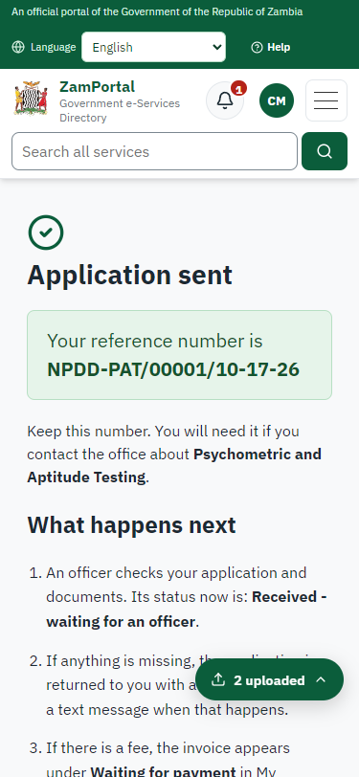
Step 7: Application sent - desktop (left) and a 375 px phone (right).

Step 8. Take the new application on
Case Officer · Back office
The application arrives in the case queue of the ministry that owns the service (National Productivity Development Department); only its staff see it. The officer opens it by its reference number - answers, documents and process are on the case - assigns it to themself and takes it on.
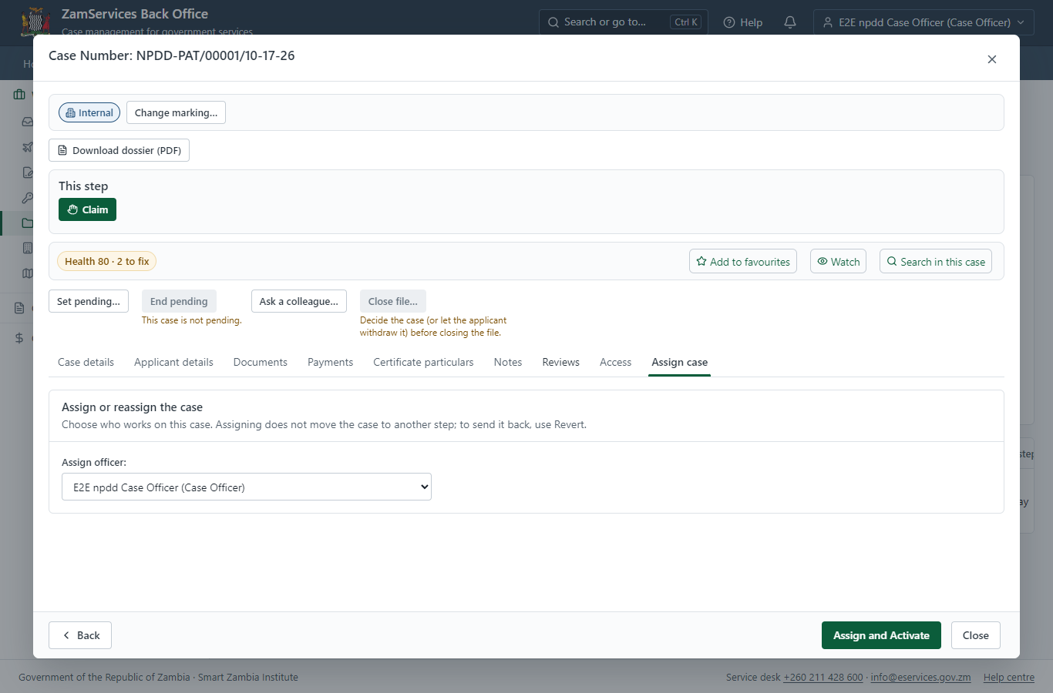
Step 8: Take the new application on.

Step 9. Fill in the certificate particulars
Case Officer · Back office
The issued document prints 19 fields that come from the office rather than from the application (Id, Age, Grade1, Grade2, Grade3, Grade4, Grade5, Grade6, Grade7, Grade8, Grade9, Approval, Raw score, Name of test, Type of test, Candidate email, Candidate phone, Candidate address, Type of qualification). The officer fills them in on the case's "Certificate particulars" tab before the document is issued (synthetic values in this run) and saves; once the document is issued they can no longer change.
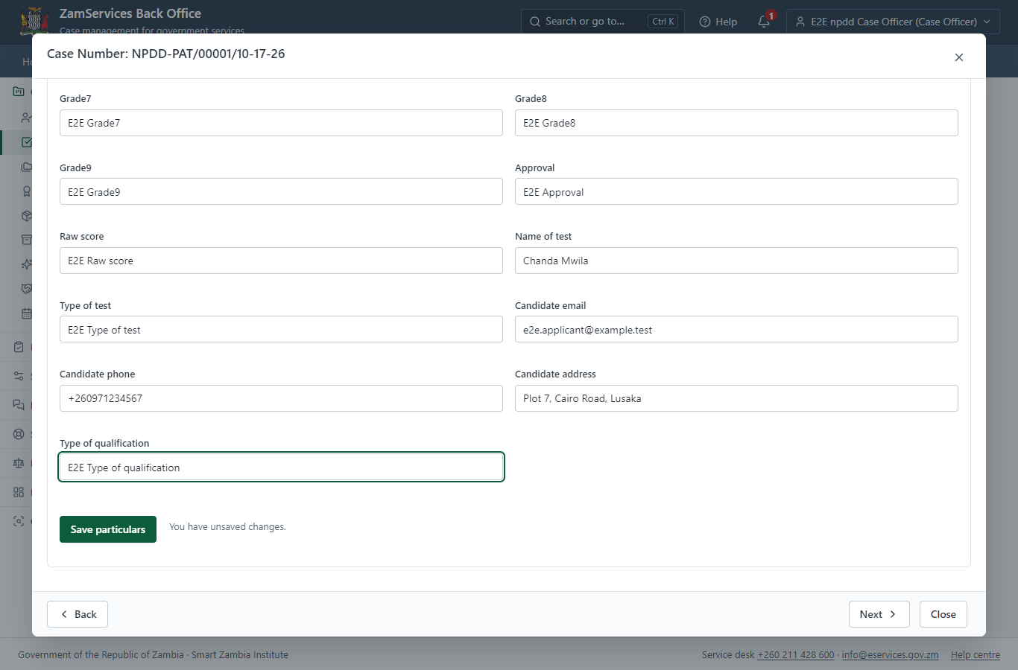
Step 9: Fill in the certificate particulars.

Step 10. Review, Inspect, Assign to Specialist
Supervisor · Back office
The Supervisor works on "Review, Inspect, Assign to Specialist" (review in the imported process), checks the application and its documents, and completes the step.
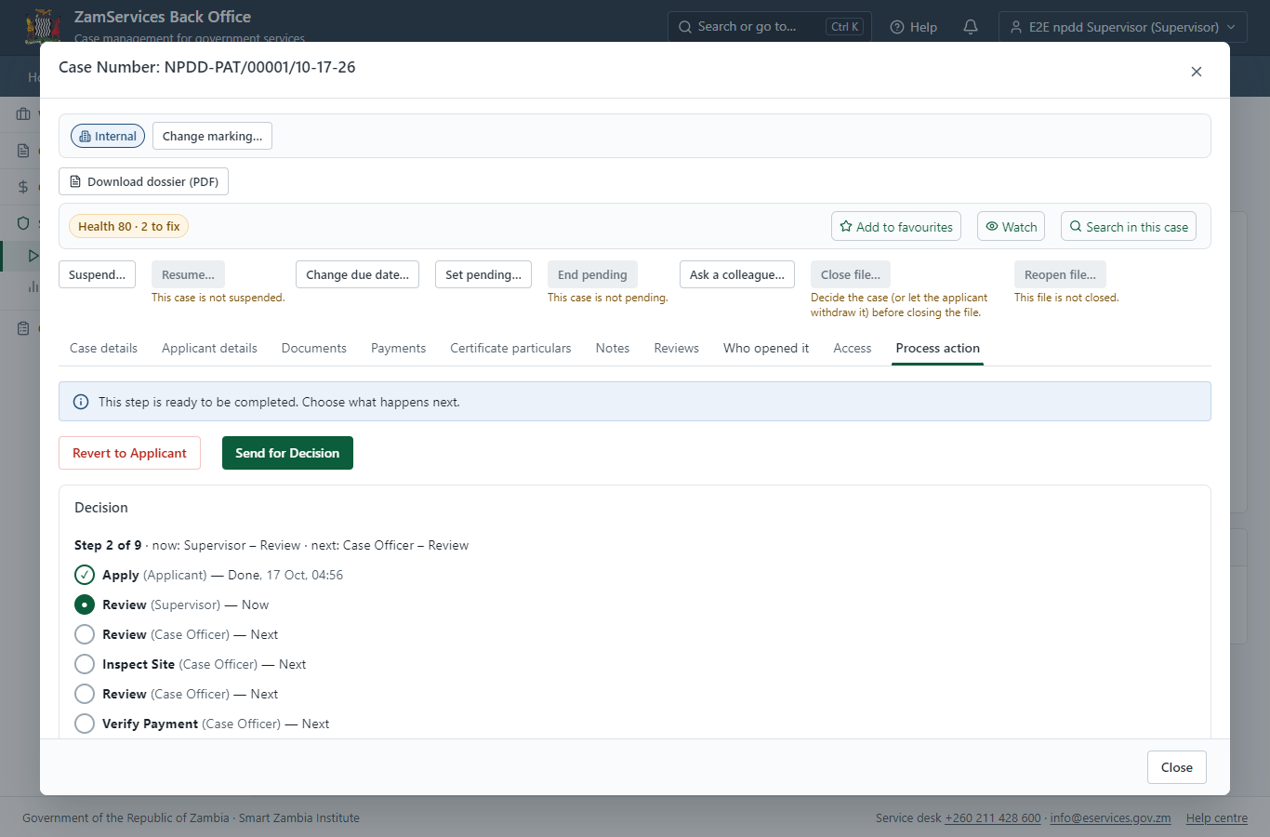
Step 10: Review, Inspect, Assign to Specialist.

Step 11. Receive, Inspect, Report Findings
Case Officer · Back office
The Case Officer works on "Receive, Inspect, Report Findings" (review in the imported process), checks the application and its documents, and completes the step.
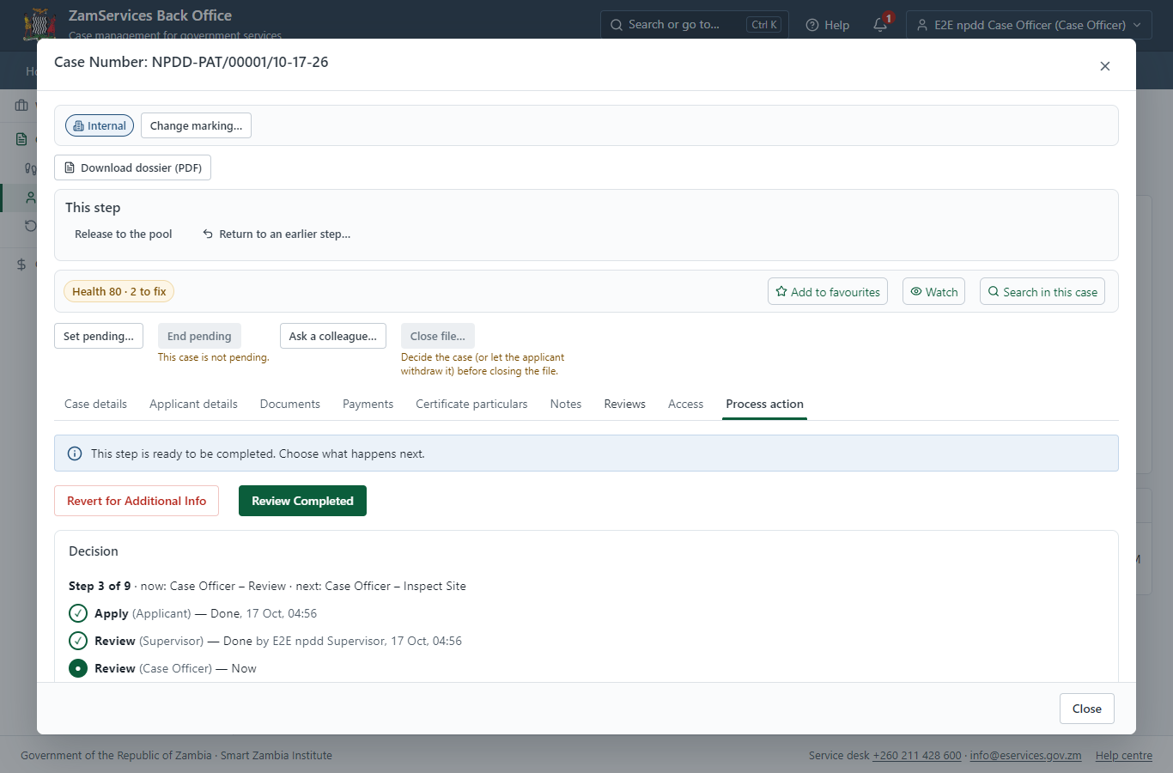
Step 11: Receive, Inspect, Report Findings.

Step 12. Conduct Inspection, Generate Report Findings
Case Officer · Back office
The Case Officer works on "Conduct Inspection, Generate Report Findings" (inspection in the imported process), checks the application and its documents, and completes the step.
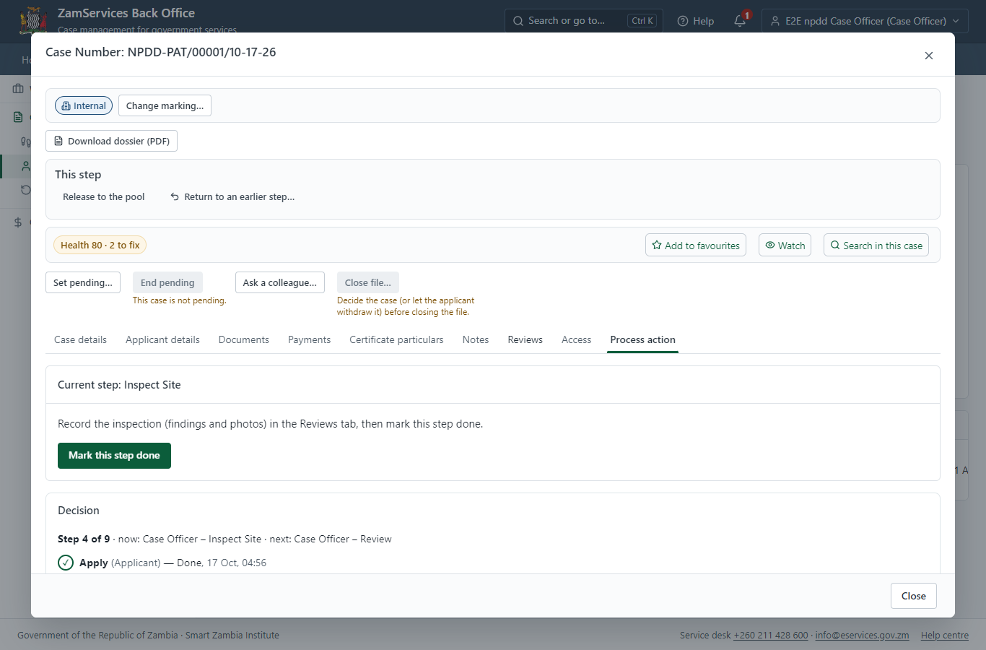
Step 12: Conduct Inspection, Generate Report Findings.

Step 13. Inspection: Conduct Inspection, Generate Report Findings
Case Officer · Back office
"Conduct Inspection, Generate Report Findings" is a site inspection: the case cannot move on until the findings are recorded. The officer assigns the inspection (to themself here) on the case's Reviews tab, visits the place and records each checklist item, the visit and the outcome ("passed" in this run); then completes the step.
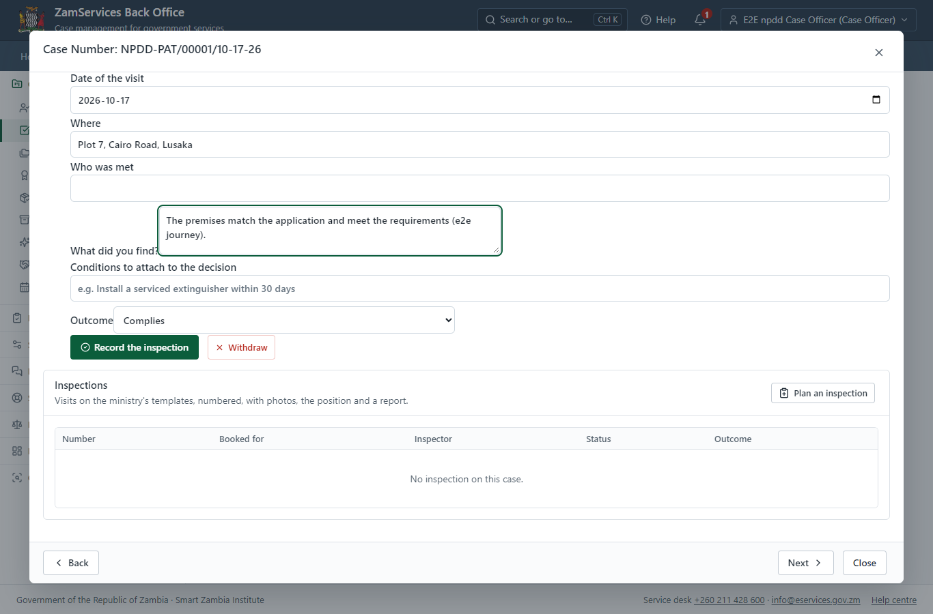
Step 13: Inspection: Conduct Inspection, Generate Report Findings.

Step 14. Review Case & Generate Invoice
Case Officer · Back office
The Case Officer works on "Review Case & Generate Invoice" (review in the imported process), checks the application and its documents, and completes the step.
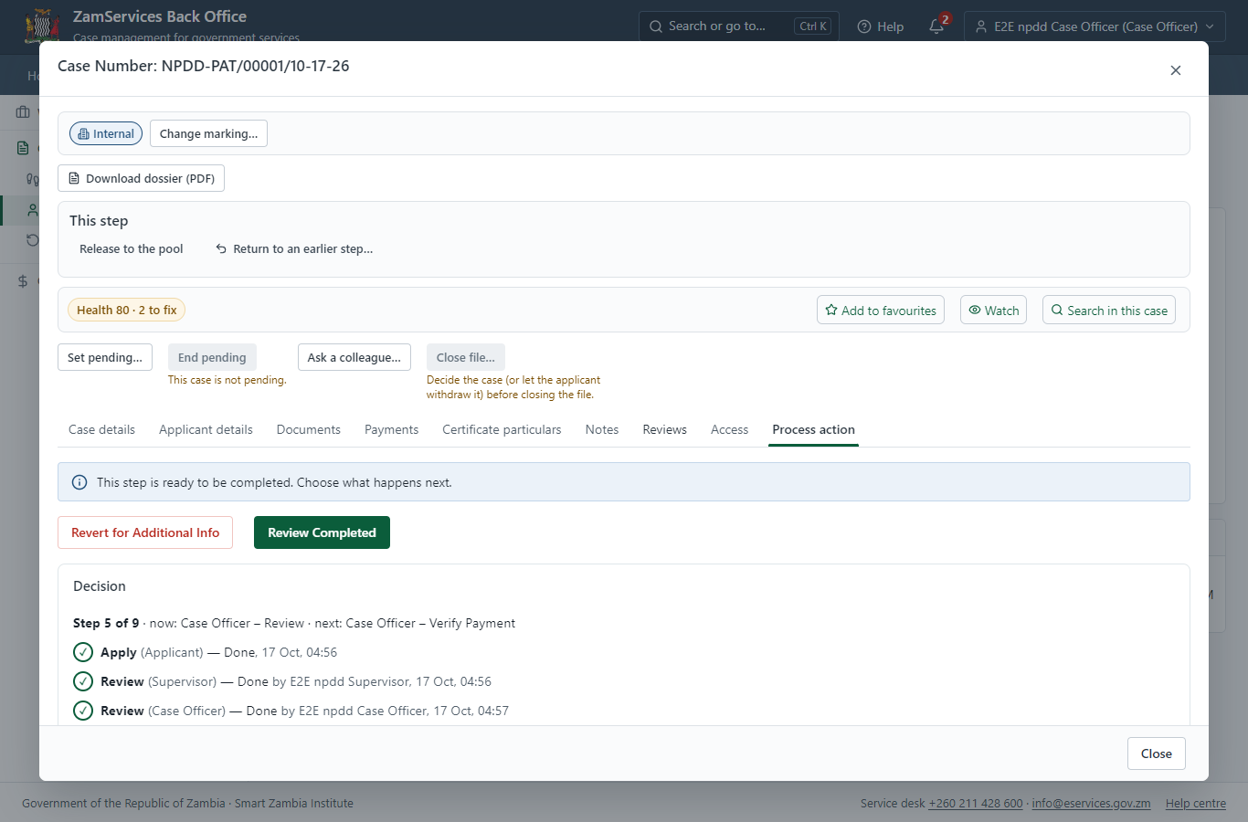
Step 14: Review Case & Generate Invoice.

Step 15. Verify Payment & Make Decision
Case Officer · Back office
The Case Officer works on "Verify Payment & Make Decision" (verify-payment in the imported process), checks the application and its documents, and completes the step.
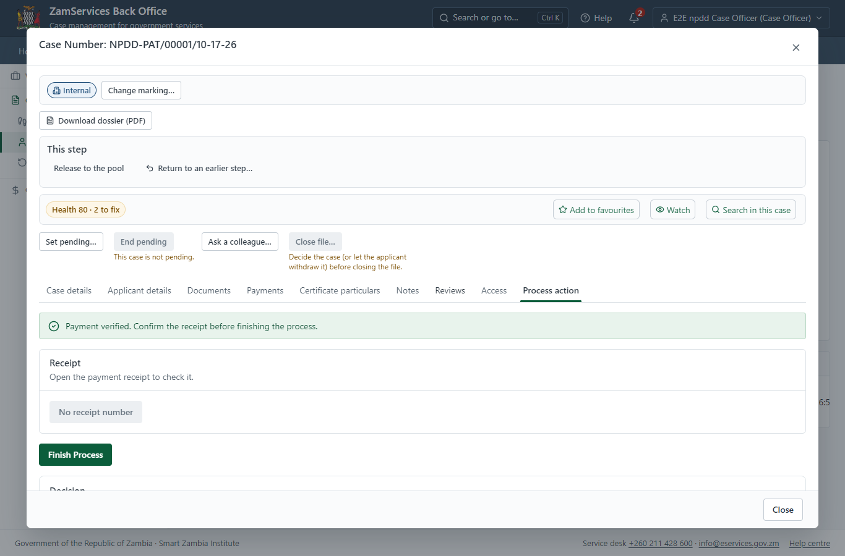
Step 15: Verify Payment & Make Decision.

Step 16. Decide: Supervisor Review, Add Comments, Send for Decision.
Supervisor · Back office
At "Supervisor Review, Add Comments, Send for Decision." the Supervisor records the decision: approve, with a comment kept in the case history. Approving moves the case on; the last decision completes it and issues the document.
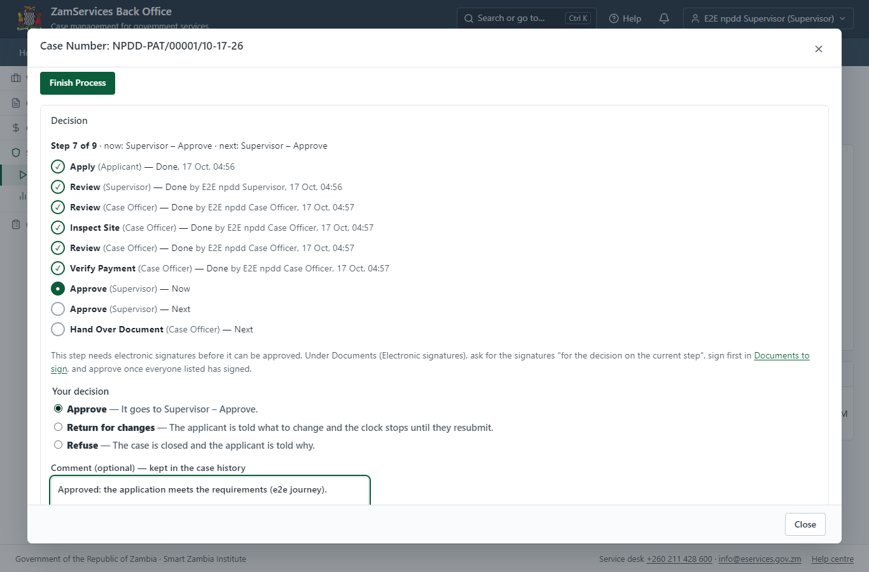
Step 16: Decide: Supervisor Review, Add Comments, Send for Decision..

Step 17. Decide: Supervisor Review Report Findings, Make Final Decision
Supervisor · Back office
At "Supervisor Review Report Findings, Make Final Decision" the Supervisor records the decision: approve, with a comment kept in the case history. Approving moves the case on; the last decision completes it and issues the document.
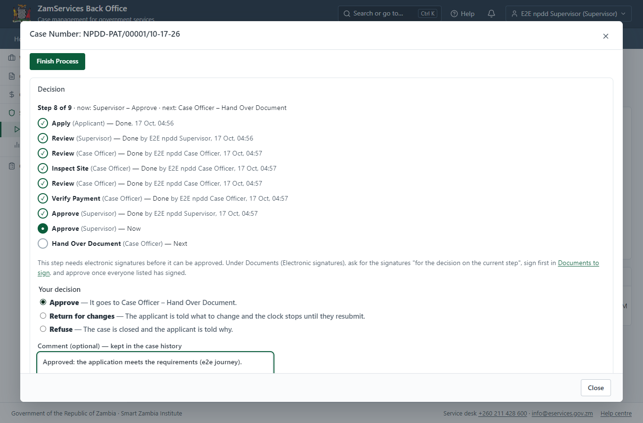
Step 17: Decide: Supervisor Review Report Findings, Make Final Decision.

Step 18. Select Printing and Delivering Option
Case Officer · Back office
The Case Officer works on "Select Printing and Delivering Option" (collection in the imported process), checks the application and its documents, and completes the step.
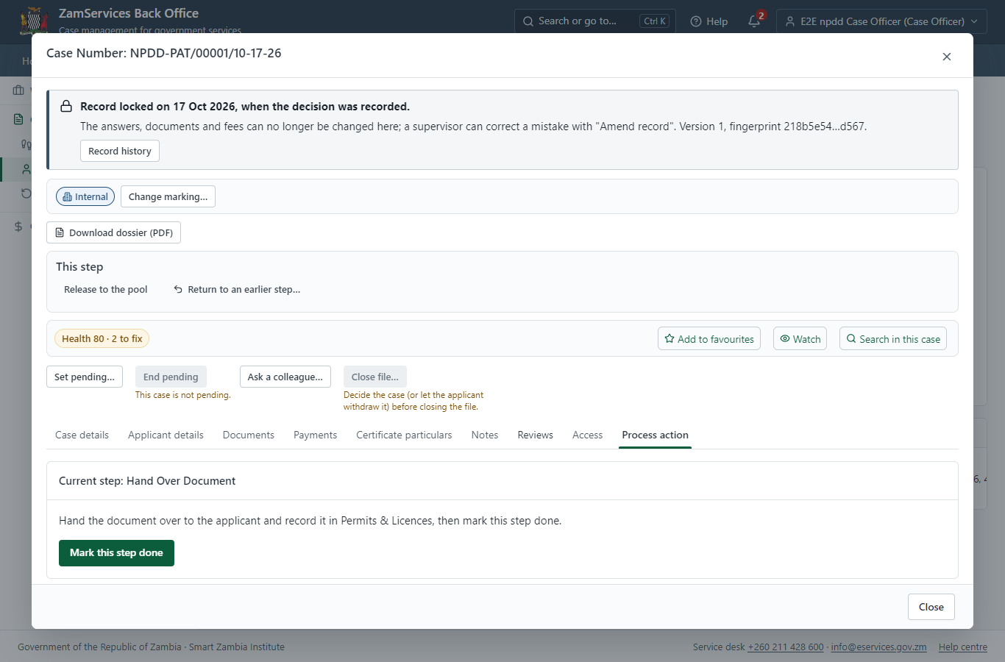
Step 18: Select Printing and Delivering Option.

Step 19. The document in My permits
Citizen · National e-Services portal
The issued document (NPDD-PAT-2026-00001 in this run: "Standard Test Scores summary") is listed in "My permits and licences" with its validity and a download of the sealed PDF.
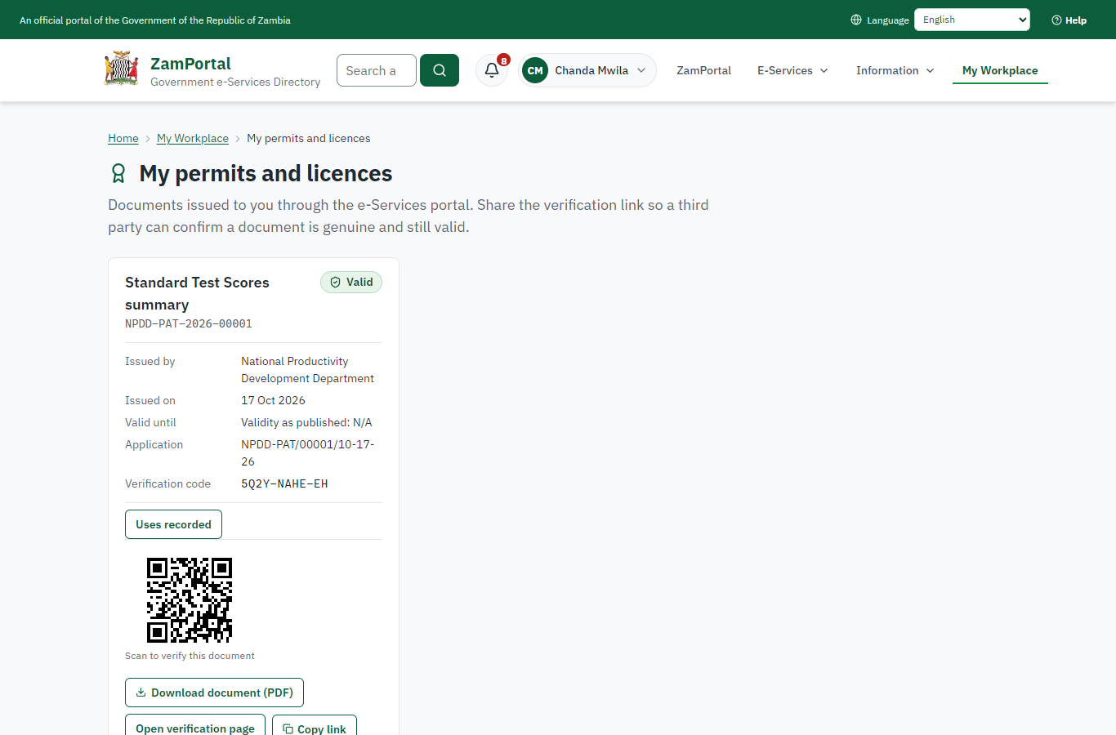 | 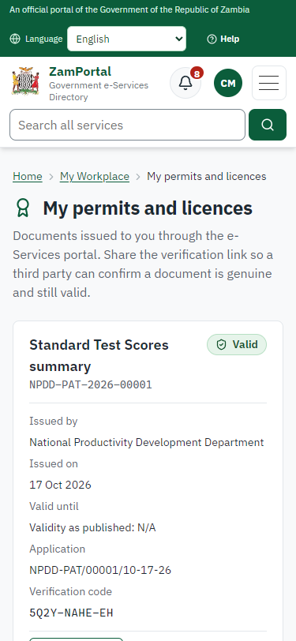
Step 19: The document in My permits - desktop (left) and a 375 px phone (right).

Step 20. Verify the document
Anyone (public) · Public verification page
The QR code on the document opens the public verification page: genuine and current, to whom it was issued, and whether the electronic seal is valid. No sign-in is needed.
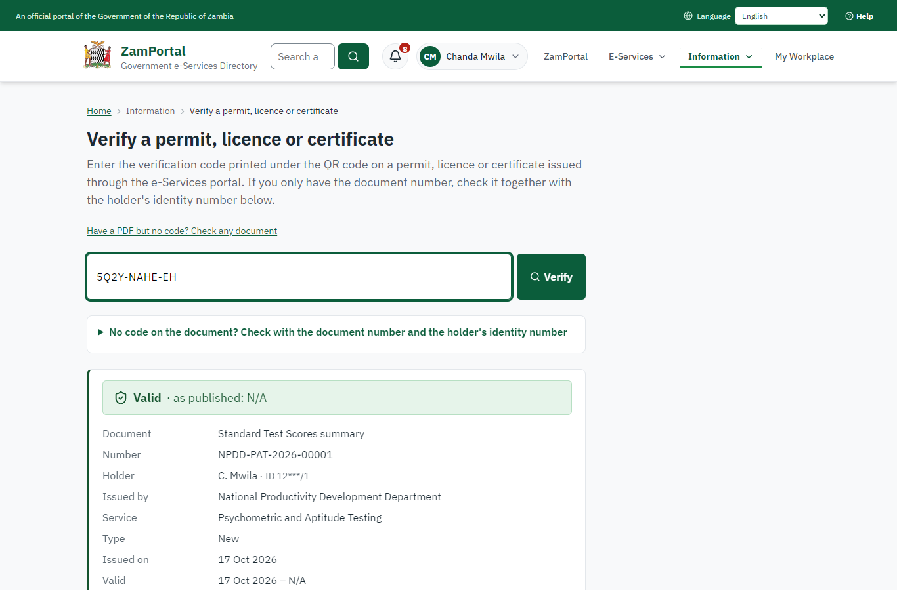 | 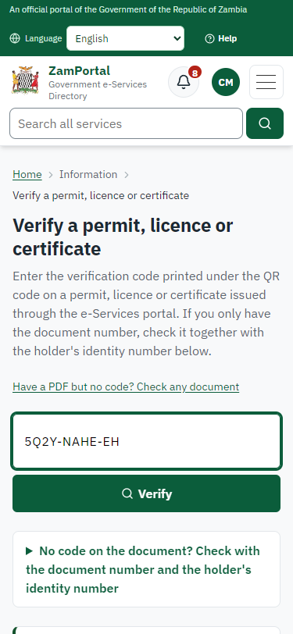
Step 20: Verify the document - desktop (left) and a 375 px phone (right).

3. Payment
Item | In the test run
Fee (as published) | a. Consultancy and Advisory Job (Per Assignment): 250.00 ZMW b. Fee Per Candidate: i. Public Sector Organization - 45.00 ZMW ii. Private Sector Organization - 75.00 ZMW iii. Parastatal Organization - 60.00 ZMW iv. Career Guidance - 80.00 ZMW

4. Output documents

Standard Test Scores summary (sealed PDF)
Issued when the case was approved, from the service's output configuration (service template NPDD_TestScore.Document.docx), filled from the application and the decision, sealed with the platform's electronic seal and stored as the issued version. The holder downloads it from My permits; the verification page checks it.
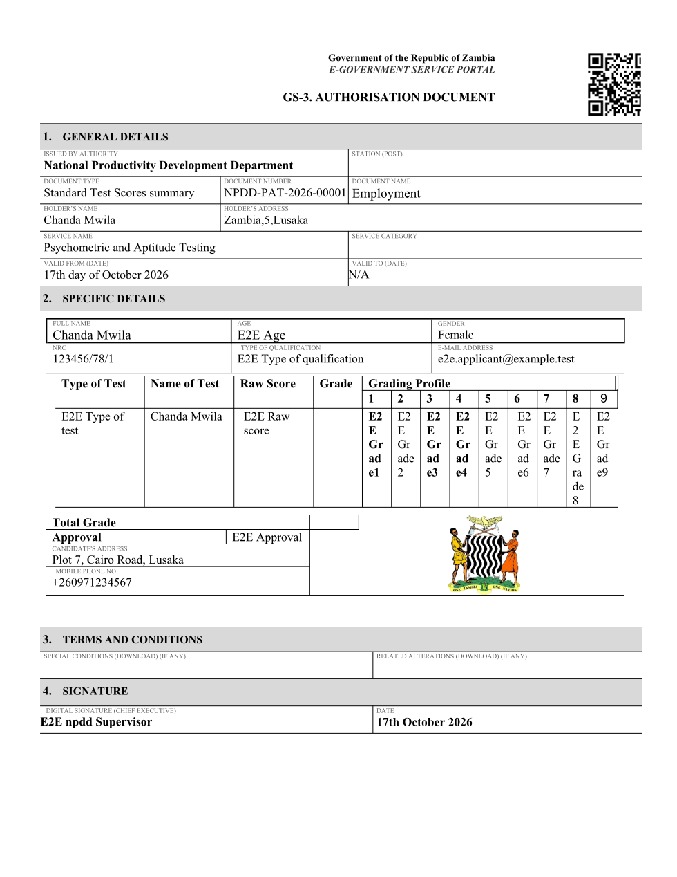
Standard Test Scores summary (sealed PDF) - first of 1 page, as issued in the test run.

Fields
Field | Value in the test run
Document title | Standard Test Scores summary
Permit / licence number | NPDD-PAT-2026-00001
Holder | Chanda Mwila
Valid from | 2026-10-17
Valid until
Status | active
Verification code (printed with a QR code) | 5Q2Y-NAHE-EH

Seal
Seal status | sealed
Signature level | PAdES-B-T
Sealed by | the platform seal (development key in the test run)
Signed at | 2026-10-17T02:57:26.234Z
Trusted time-stamp | 2026-10-17T02:57:26.217Z (time-stamping authority)
Document fingerprint (SHA-256) | 105bc276425a2bf5...

Verification
Where | The public verification page of the national portal, <portal>/verify/<verification code>, opened by scanning the QR code on the document.
What it shows | Whether the document is genuine and current, its holder and validity, and whether the electronic seal is valid and who sealed it.
Checking a copy | Anyone can upload a PDF they were given; the page says whether it is exactly the document that was issued. A changed copy is reported as not matching.
On screen: step 19 (The document in My permits), step 20 (Verify the document) in section 2.

5. Notifications
When | Channel | To | Message | Delivery
Application received | in-app (portal bell) | the applicant | Application NPDD-PAT/00001/10-17-26 received - Your application NPDD-PAT/00001/10-17-26 for Psychometric and Aptitude Testing has been received by National Productivity Development Department. | shown
Status changed | in-app (portal bell) | the applicant | Update on application NPDD-PAT/00001/10-17-26 - NPDD-PAT/00001/10-17-26 (Psychometric and Aptitude Testing) is now: With the office - being reviewed. | shown
case.inspection_scheduled | in-app (portal bell) | the applicant | Inspection for application NPDD-PAT/00001/10-17-26 on Saturday 17 October 2026 - Inspection for NPDD-PAT/00001/10-17-26 (Psychometric and Aptitude Testing) on Saturday 17 October 2026. | shown
review.submitted | in-app (portal bell) | the applicant | Opinion received on case NPDD-PAT/00001/10-17-26 - E2E npdd Case Officer recorded an opinion on case NPDD-PAT/00001/10-17-26: passed. | shown
case.approved | in-app (portal bell) | the applicant | Application NPDD-PAT/00001/10-17-26 approved - NPDD-PAT/00001/10-17-26 (Psychometric and Aptitude Testing) has been approved. | shown
Licence / permit issued | in-app (portal bell) | the applicant | Your Psychometric and Aptitude Testing document has been issued - NPDD-PAT-2026-00001 has been issued for Psychometric and Aptitude Testing. | shown
Decision: approved | in-app (portal bell) | the applicant | Application NPDD-PAT/00001/10-17-26 completed - NPDD-PAT/00001/10-17-26 (Psychometric and Aptitude Testing) is complete. Your documents are ready. | shown
Invitation to rate the service | in-app (portal bell) | the applicant | How was Psychometric and Aptitude Testing? - How was Psychometric and Aptitude Testing? Tell us in about a minute. | shown
Application received | sms | +260 97* *** 567 | Application NPDD-PAT/00001/10-17-26 for Psychometric and Aptitude Testing has been received. Track it: <portal>/my-workplace | delivered
Application received | email | e2e.c***@example.test | Application NPDD-PAT/00001/10-17-26 received | skipped
Status changed | sms | +260 97* *** 567 |  | delivered
review.requested | email | e2e.c***@example.test | Your opinion is requested on application NPDD-PAT/00001/10-17-26 | skipped
case.inspection_scheduled | email | e2e.c***@example.test | Inspection for application NPDD-PAT/00001/10-17-26 on Saturday 17 October 2026 | skipped
case.inspection_scheduled | sms | +260 97* *** 567 |  | delivered
review.submitted | email | e2e.c***@example.test | Opinion received on case NPDD-PAT/00001/10-17-26 | skipped
case.approved | email | e2e.c***@example.test | Application NPDD-PAT/00001/10-17-26 approved | skipped
case.approved | sms | +260 97* *** 567 |  | delivered
Licence / permit issued | email | e2e.c***@example.test | Your Psychometric and Aptitude Testing document has been issued | skipped
Licence / permit issued | sms | +260 97* *** 567 |  | delivered
Invitation to rate the service | sms | +260 97* *** 567 |  | skipped
Invitation to rate the service | email | e2e.c***@example.test | How was Psychometric and Aptitude Testing? | skipped
Decision: approved | sms | +260 97* *** 567 |  | delivered
Decision: approved | email | e2e.c***@example.test | Application NPDD-PAT/00001/10-17-26 completed | skipped
Delivery: shown = in the portal's notification bell; delivered = the SMS gateway (a test double in this run) reported the text delivered; skipped = not sent on that channel (e-mail is not configured on the test installation, and some notices go out on one channel only); sent by the national portal = a ministry node handed the notice to the national portal, which texts and e-mails the citizen under its own name and the citizen's preferences. Addresses written <portal>, <ZamPay> stand for the national portal and ZamPay.

6. Legacy mapping
Replaces | Psychometric and Aptitude Testing in the legacy ZIGS e-Services directory (ZIGS_Services)
Legacy service id | 506
Legacy provider | National Productivity Development Department (npdd) under Ministry of Labour and Social Security (MLSS)
Legacy process | not recorded
Fee in the legacy system | none
Fee taken before submission | yes (as in ZIGS)
Time to issue (legacy) | not recorded
Legacy output templates | Standard Test Scores summary: ZIGS_Forms_NPDD / NPDD_TestScore.Document  GS-1 Application for a Government Service: ZIGS_Forms_ZDA / GS1  GS-2 Notice of Government Action: ZIGS_Forms_Notices / GS-2.NoticeOfAction
Legacy address | https://npddui.gsb.gov.zm
How it was brought over | Imported by the platform's legacy catalogue importer (zcm-backend scripts/zigs/importLegacy.js) from the ZIGS snapshot: form, case types, fees, documents, process and output templates, then served by the new platform.

7. Version and date
Document version | service v1, platform 9b8a591f
Generated | 2026-10-17T02:57:34Z (by the end-to-end run, not edited by hand)
Service version | not versioned (configured directly)
Platform snapshot | backend 9b8a591f  portal dfd4933  back office a975a2c
Test suite | e2e 2b037bb; one installation (combined); seed profile mihud
Journeys | 30-catalogue-service.spec.js: citizen finds the service, answers its form, uploads its documents and sends the application - passed  30-catalogue-service.spec.js: the case goes through every step of its process: payments by the citizen, each officer step by its role - passed  30-catalogue-service.spec.js: the grant document is issued, sealed, filled in and verifiable; the citizen has it in My permits - passed
Result | 3 of 3 journey tests passed
Data | Synthetic test data on a local test installation; provider test doubles for ZamPass, ZamPay, SMS and signing.

