Republic of Zambia
GSB e-Services

Provisional Firearm Certificate
Service documentation
Owner: Zambia Police Service
Service key: ZPS/provisional-firearm-certificate
Version: service v1, platform a0a302b8
Date: 2026-10-21
Generated automatically by the service's end-to-end test run. Every screenshot shows synthetic test data on a local test installation, never real personal data.

Contents
- 1. Service summary
- 2. Application process, step by step
- 3. Payment
- 4. Output documents
- 5. Notifications
- 6. Legacy mapping
- 7. Version and date
This document describes the Provisional Firearm Certificate service of Zambia Police Service as the platform runs it today. It is generated by the service's end-to-end test: every step was performed by the test and every screenshot was taken during that run, with synthetic data. Regenerate it with "npm run docs:services" in the e2e suite; do not edit it by hand.

1. Service summary
Service | Provisional Firearm Certificate
Owner (MDA) | Zambia Police Service (ZPS)
Purpose | Certificate that authorizes the purchase of a firearm and/or ammunition to which the Provisional Firearm Certificate relates.
Who can apply | Individual; Organization
How to apply | Online on the national e-Services portal, signed in with ZamPass; pay with ZamPay.
Fees | Free of charge: ZMW 0.00
Turnaround | Depends on when someone applies and when the firearm committee sits to approve applications.
Validity of the output | 90 days
Required documents | Fingerprints (Obtained from Zambia Police Station) (optional)  Certificate of competence (Obtained from Zambia Police Station) (optional)
Output documents | Provisional Firearm Certificate  Denial of Service  Notice of Approval  Notice of Action  Application form
Legal basis | Firearms Act Chapter 110 (https://zambialaws.com/principal-legislation/chapter-110firearms-act)

2. Application process, step by step

The process as configured
Step | Role | Task | Type
1 | Applicant | Apply | form
2 | System | Generate Document | generate-document
3 | Case Officer | Review | review
4 | Case Officer | Review | review
5 | Supervisor | Approve | approve
6 | Executive | Decision | decision
7 | System | Generate Document | generate-document
8 | System | Generate Document | generate-document
9 | System | Notify Client | notify

Step by step
Who takes part in this journey: Citizen, Case Officer, Supervisor, Executive, Anyone (public). Citizen steps are shown on a desktop and on a 375 px phone; back-office steps on a desktop.

Step 1. Find the service
Citizen · National e-Services portal
On the national e-Services portal the citizen opens All Services and searches for the service by name ("Provisional Firearm Certificate"). Each result names the service and the ministry that provides it.
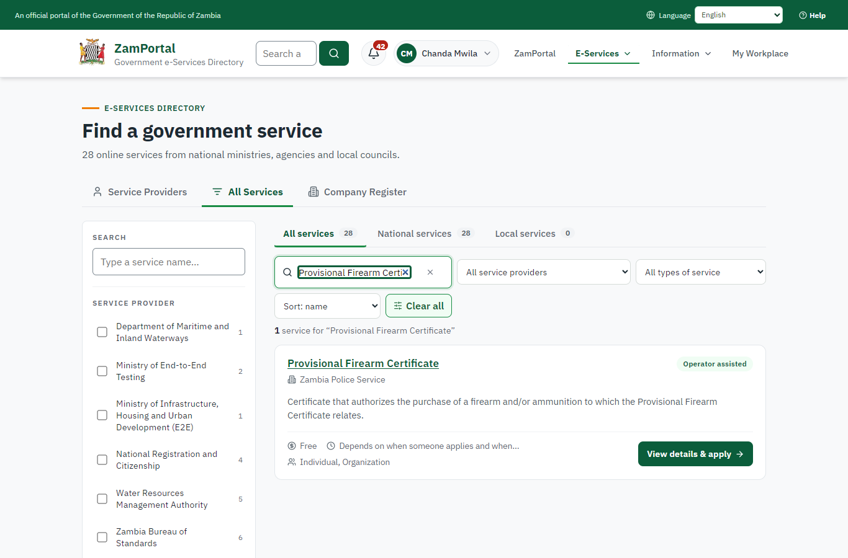 | 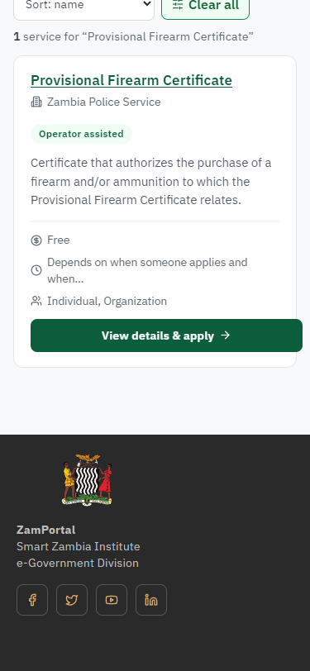
Step 1: Find the service - desktop (left) and a 375 px phone (right).

Step 2. Read the service page
Citizen · National e-Services portal
The service page sets out what the service is for, who provides it, the fee, how long it takes and the documents to have ready. "Start application" begins an application (the citizen is signed in with ZamPass).
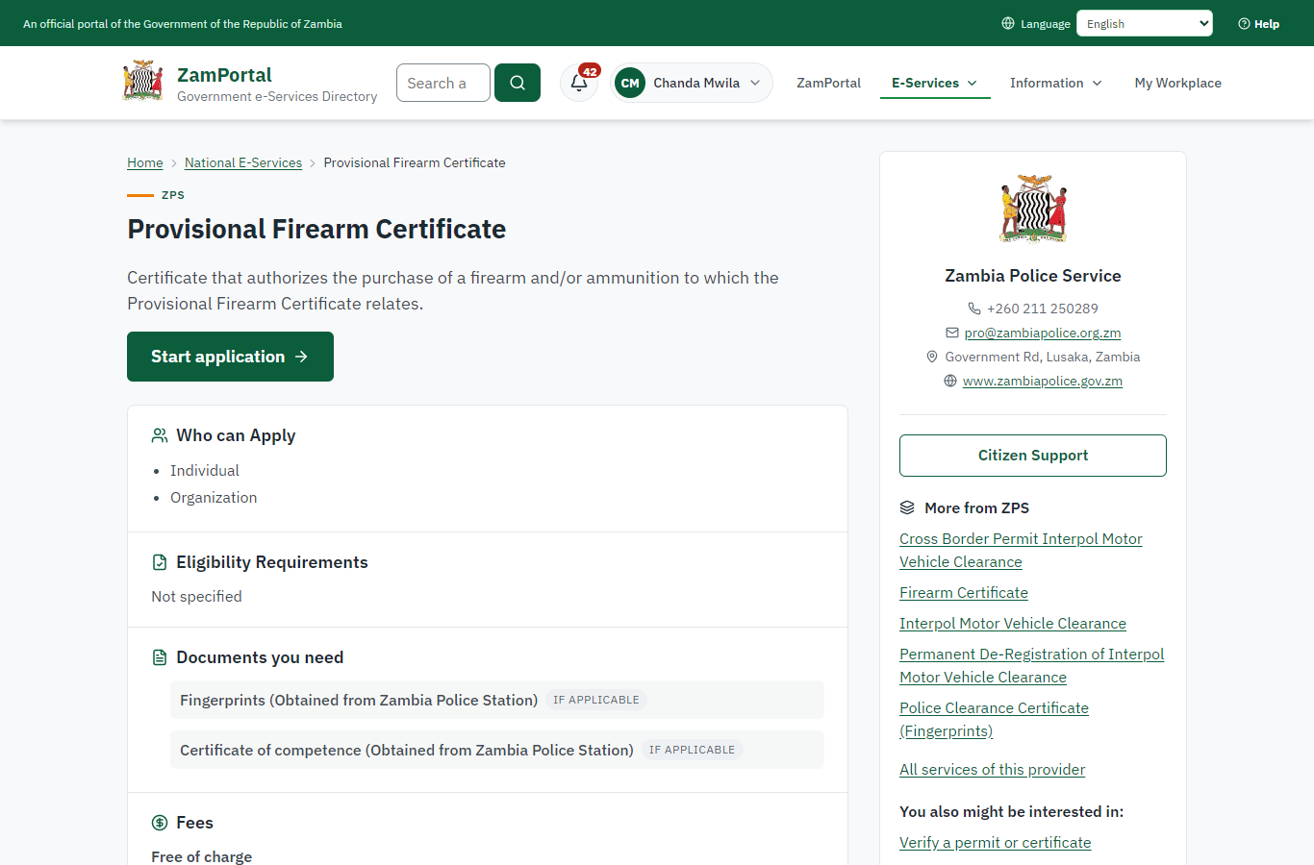 | 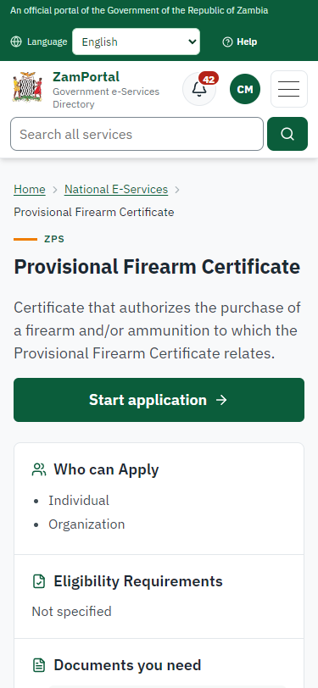
Step 2: Read the service page - desktop (left) and a 375 px phone (right).

Step 3. Confirm the applicant details
Citizen · National e-Services portal
The applicant details are filled in from the citizen's ZamPass account. The citizen says whom they are applying for (themself) and continues with "Proceed to Application".
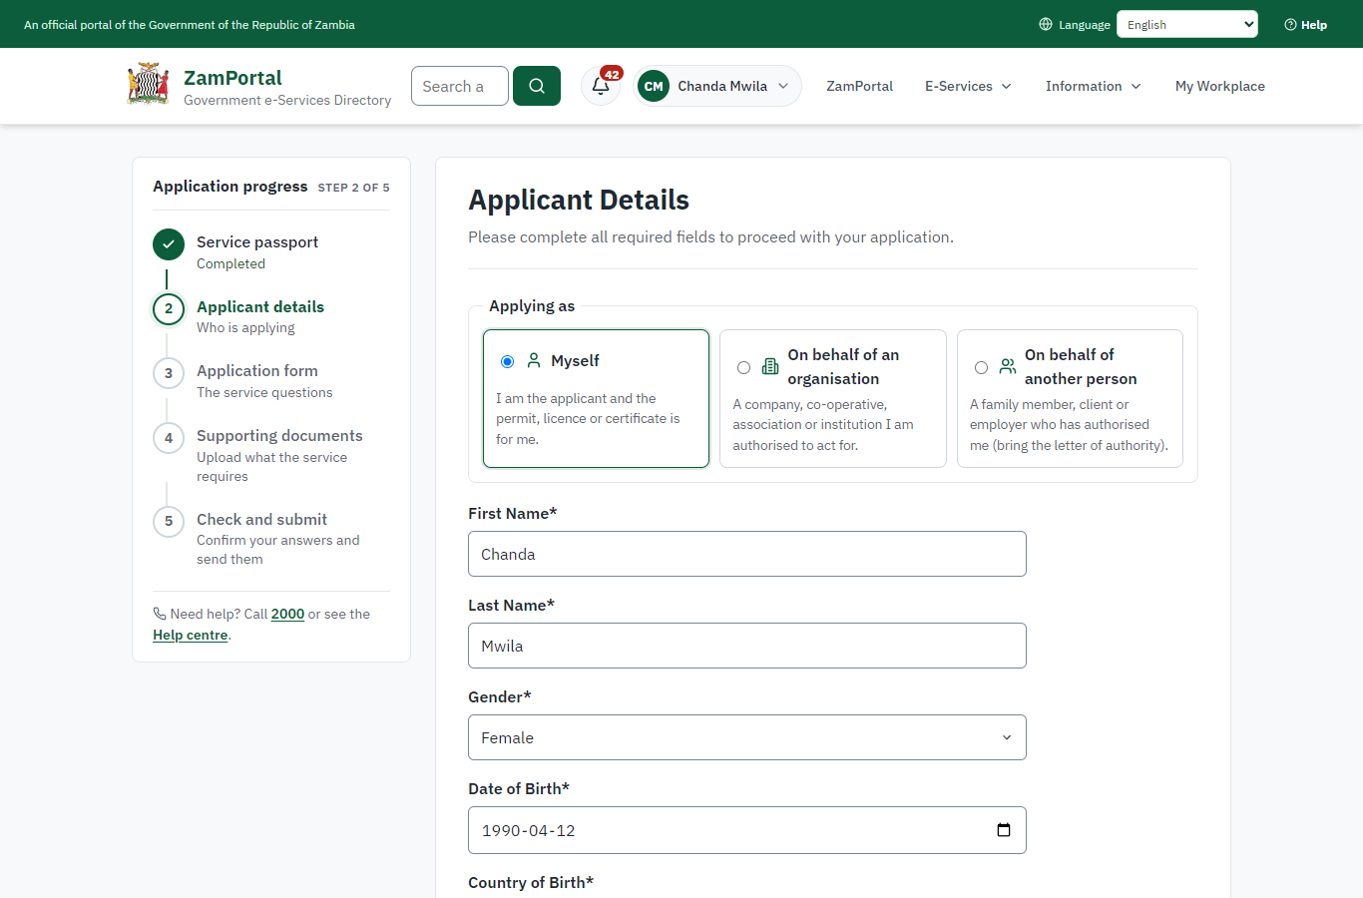 | 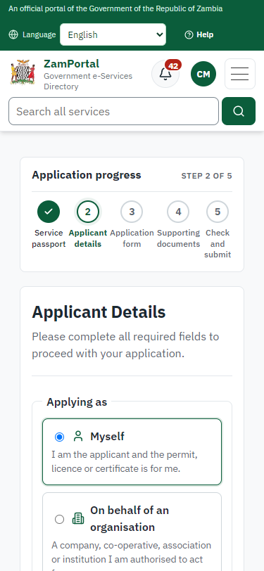
Step 3: Confirm the applicant details - desktop (left) and a 375 px phone (right).

Step 4. Fill in the application form
Citizen · National e-Services portal
The citizen answers the service's own application form, converted from the legacy system (14 answers in this run, all synthetic), for the type of application "New". Questions marked * must be answered; some appear only after an earlier answer. Answers are saved as the citizen types, so an unfinished application can be reopened from My Workplace.
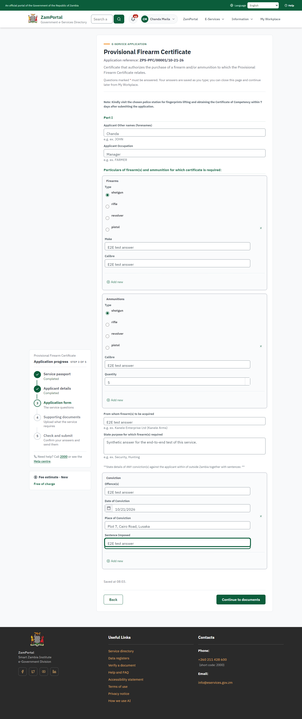 | 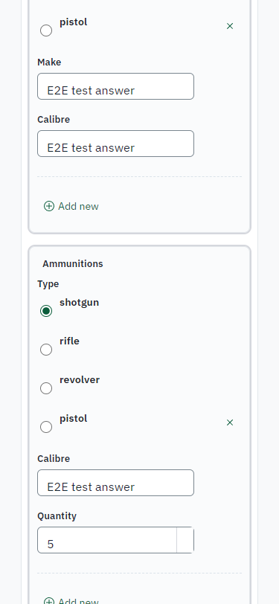
Step 4: Fill in the application form - desktop (left) and a 375 px phone (right).

Step 5. Upload the supporting documents
Citizen · National e-Services portal
Each document the service asks for has its own upload (2 in this run: Fingerprints (Obtained from Zambia Police Station), Certificate of competence (Obtained from Zambia Police Station)). The files are checked and stored with the application; the page confirms each upload.
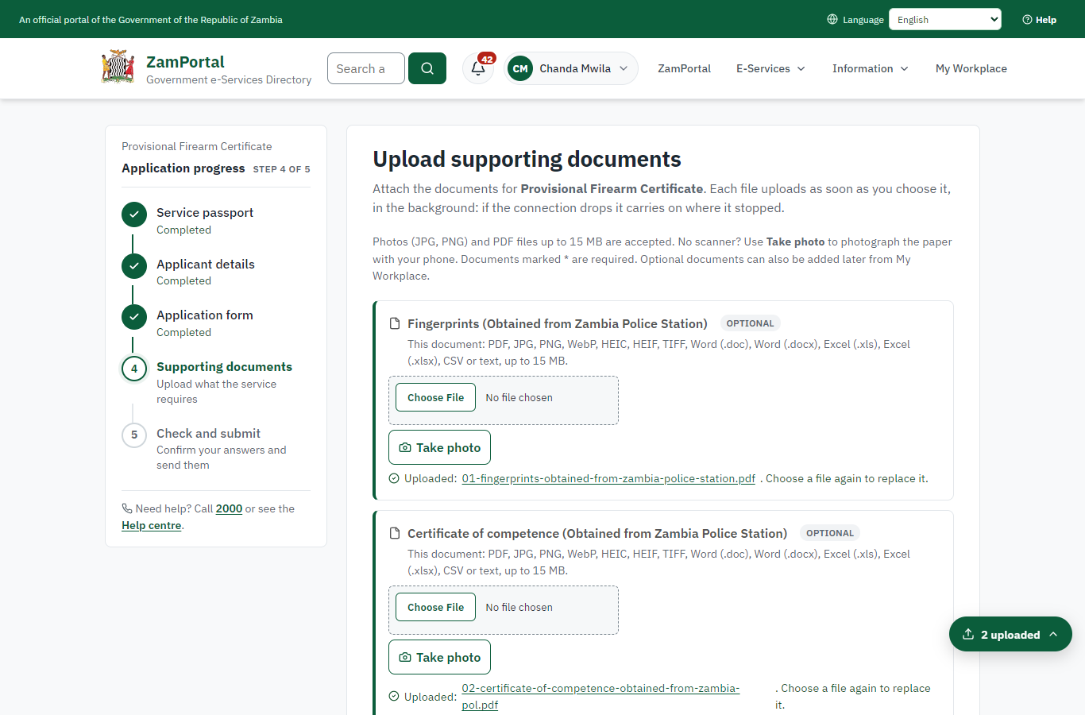 | 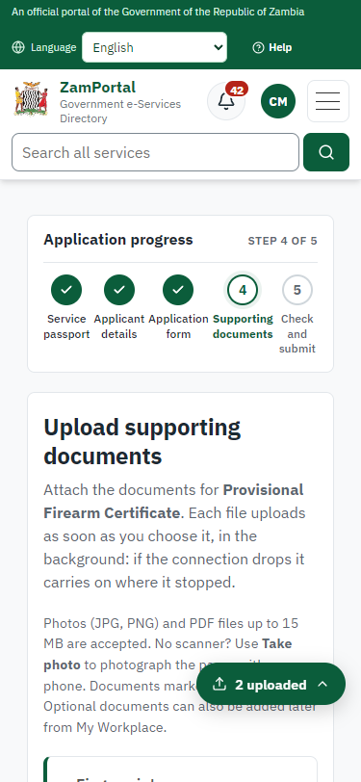
Step 5: Upload the supporting documents - desktop (left) and a 375 px phone (right).

Step 6. Check the answers and confirm the declaration
Citizen · National e-Services portal
Before sending, the citizen sees every answer and document on one page and can go back to change them. The declaration that the information is true and complete must be ticked.
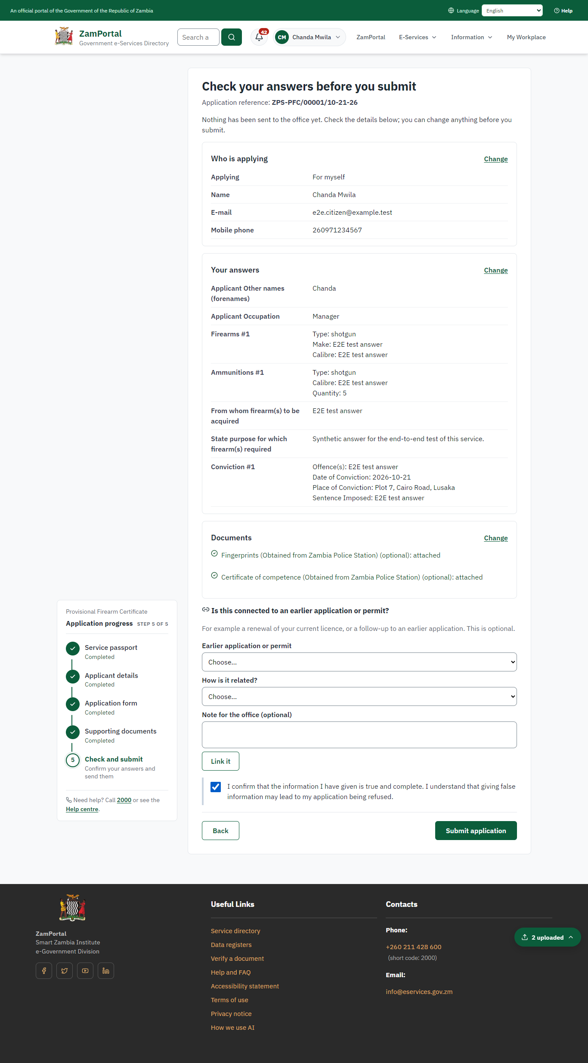 | 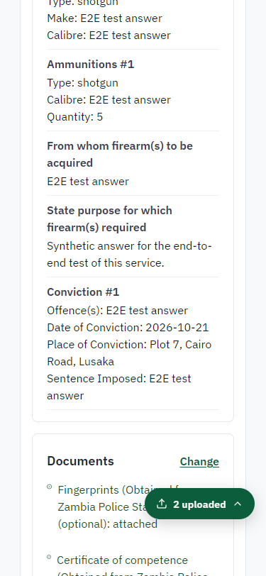
Step 6: Check the answers and confirm the declaration - desktop (left) and a 375 px phone (right).

Step 7. Application sent
Citizen · National e-Services portal
The portal confirms the application with the ministry's reference number (ZPS-PFC/00001/10-21-26 in this run). The application goes to the ministry's officers; the citizen follows it in My Workplace.
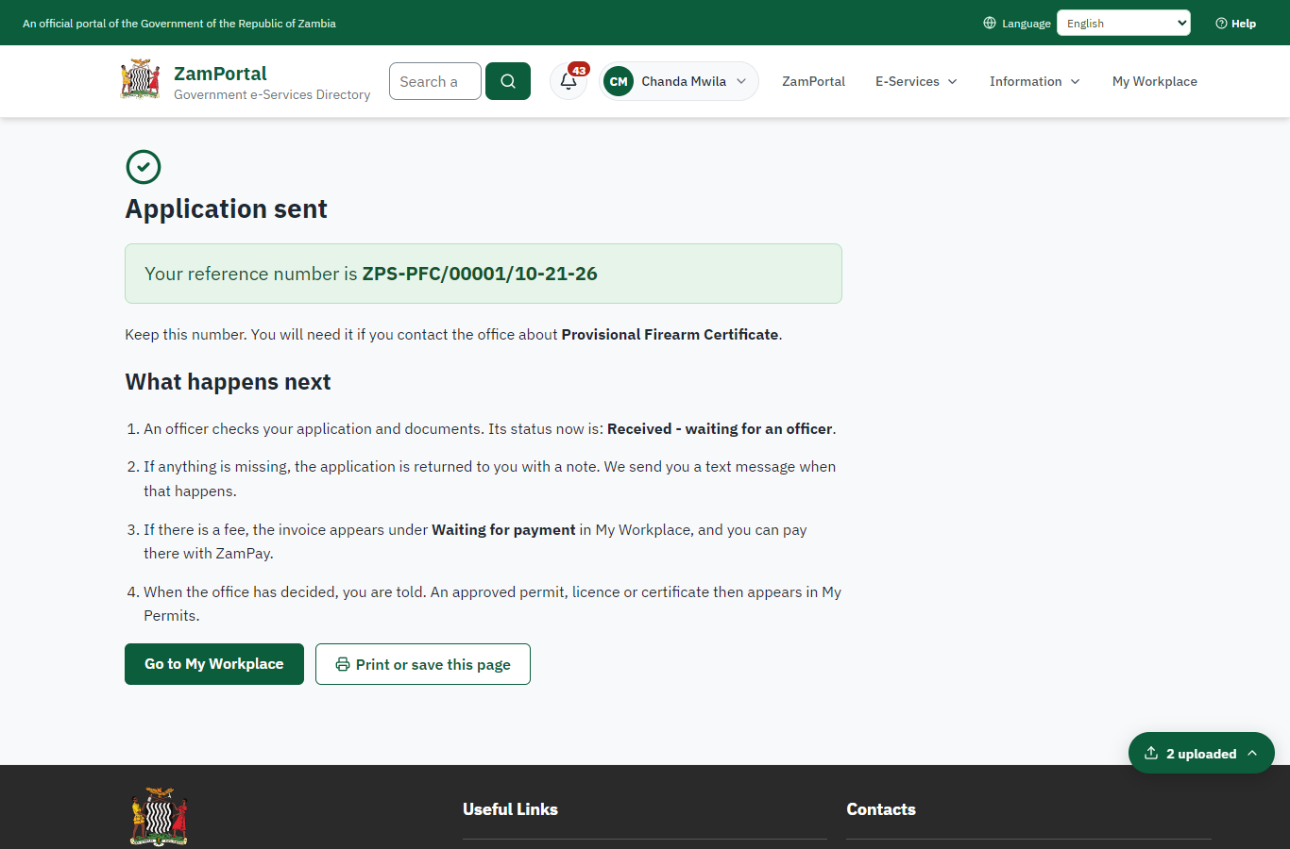 | 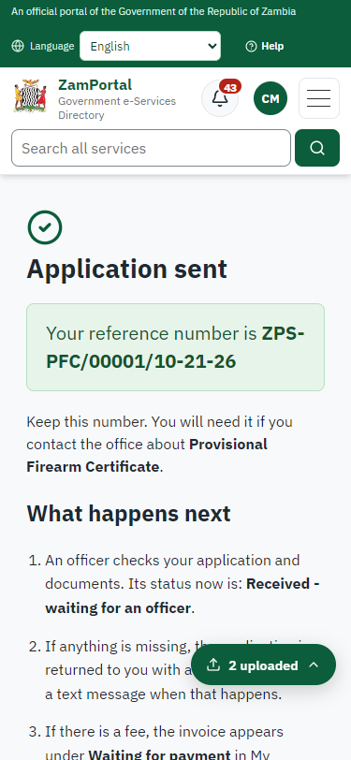
Step 7: Application sent - desktop (left) and a 375 px phone (right).

Step 8. Take the new application on
Case Officer · Back office
The application arrives in the case queue of the ministry that owns the service (Zambia Police Service); only its staff see it. The officer opens it by its reference number - answers, documents and process are on the case - assigns it to themself and takes it on.
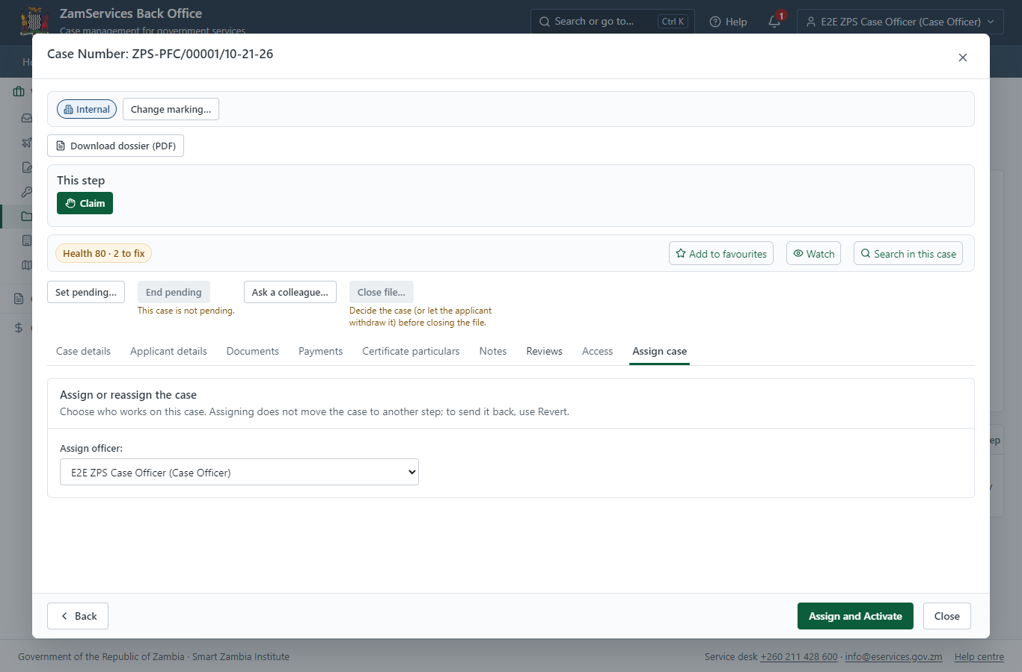
Step 8: Take the new application on.

Step 9. Fill in the certificate particulars
Case Officer · Back office
The issued document prints 4 fields that come from the office rather than from the application (Quantities authorised to be held at any given one time (type, calibre), Special Conditions, Quantities authorised to be purchased in any one year (type, calibre), General description and calibre). The officer fills them in on the case's "Certificate particulars" tab before the document is issued (synthetic values in this run) and saves; once the document is issued they can no longer change.
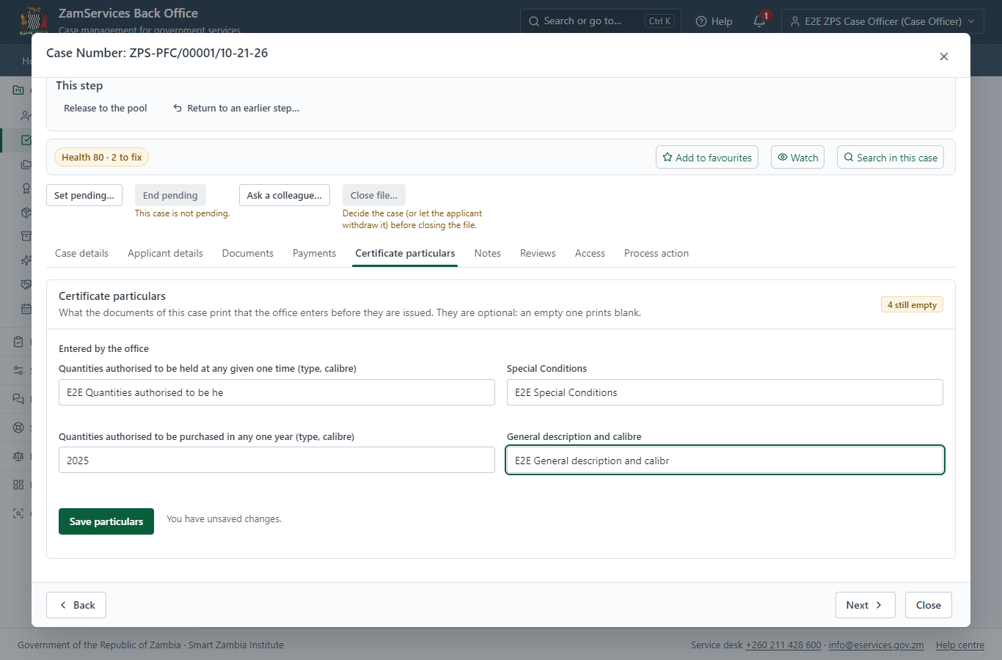
Step 9: Fill in the certificate particulars.

Step 10. Receive, Inspect, Report Findings
Case Officer · Back office
The Case Officer works on "Receive, Inspect, Report Findings" (review in the imported process), checks the application and its documents, and completes the step.
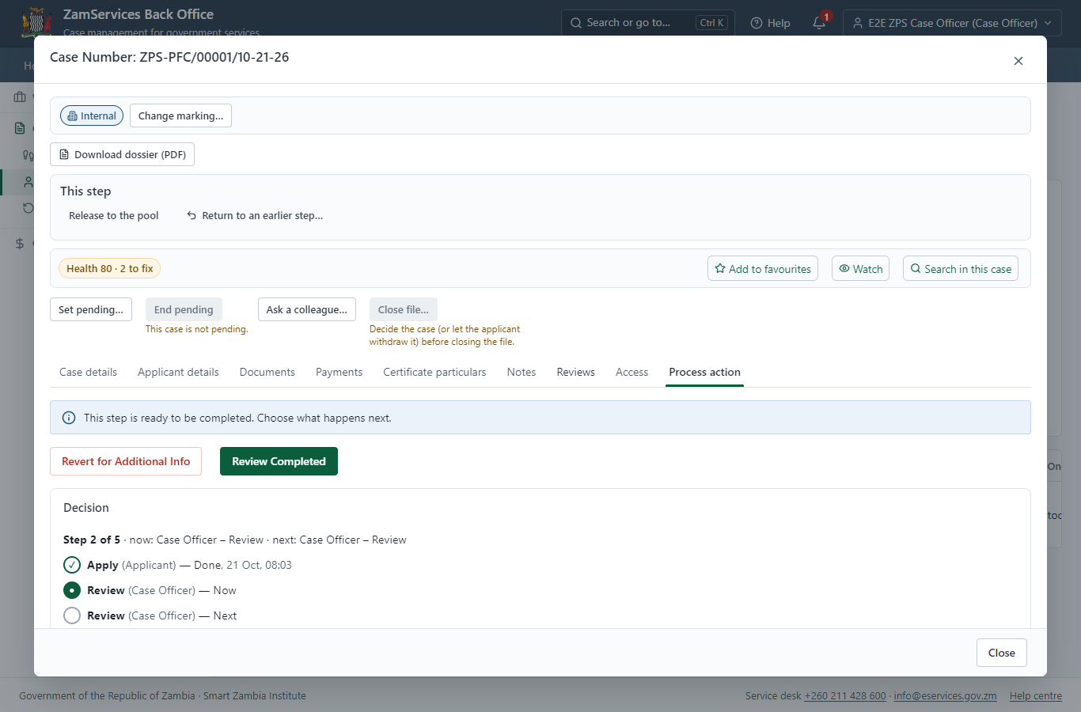
Step 10: Receive, Inspect, Report Findings.

Step 11. Review Expert Reports, Draft Decision
Case Officer · Back office
The Case Officer works on "Review Expert Reports, Draft Decision" (review in the imported process), checks the application and its documents, and completes the step.
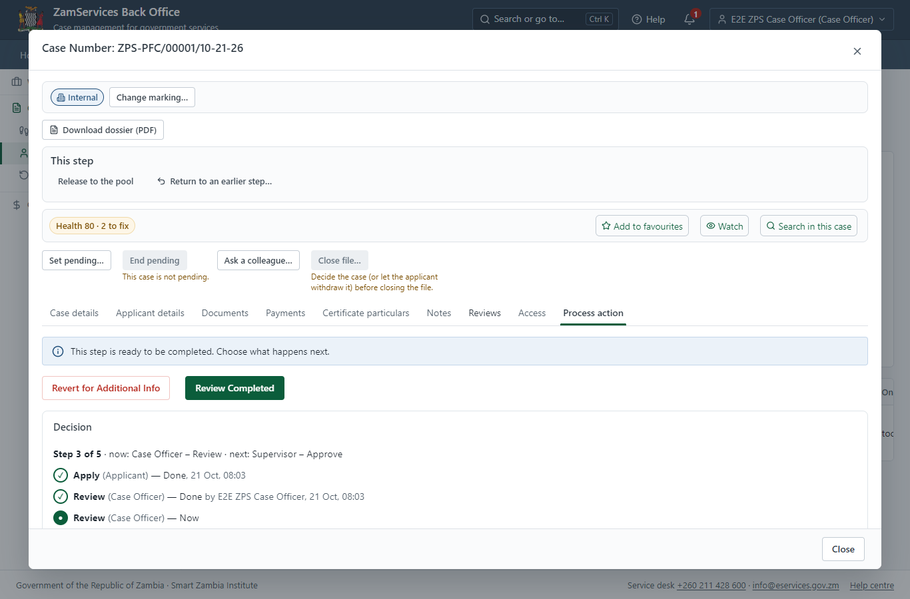
Step 11: Review Expert Reports, Draft Decision.

Step 12. Decide: Review, Inspect, e-Sign Supervisor
Supervisor · Back office
At "Review, Inspect, e-Sign Supervisor" the Supervisor records the decision: approve, with a comment kept in the case history. Approving moves the case on; the last decision completes it and issues the document.
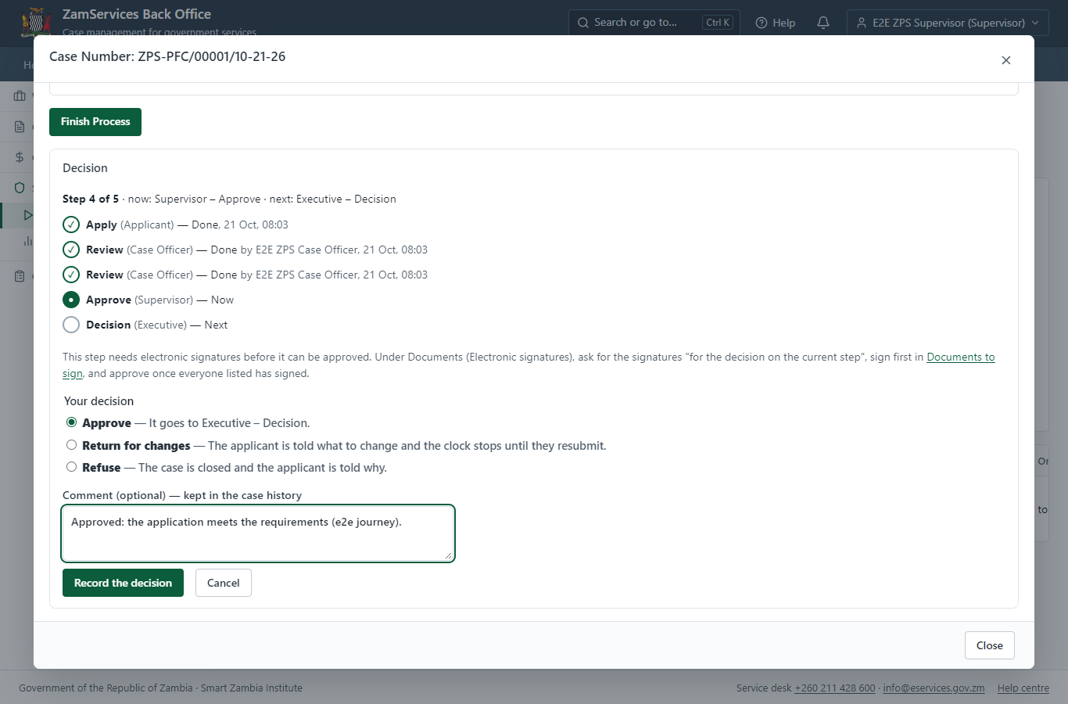
Step 12: Decide: Review, Inspect, e-Sign Supervisor.

Step 13. Decide: Review, Inspect, Decision, e-Sign Executive
Executive · Back office
At "Review, Inspect, Decision, e-Sign Executive" the Executive records the decision: approve, with a comment kept in the case history. Approving moves the case on; the last decision completes it and issues the document.
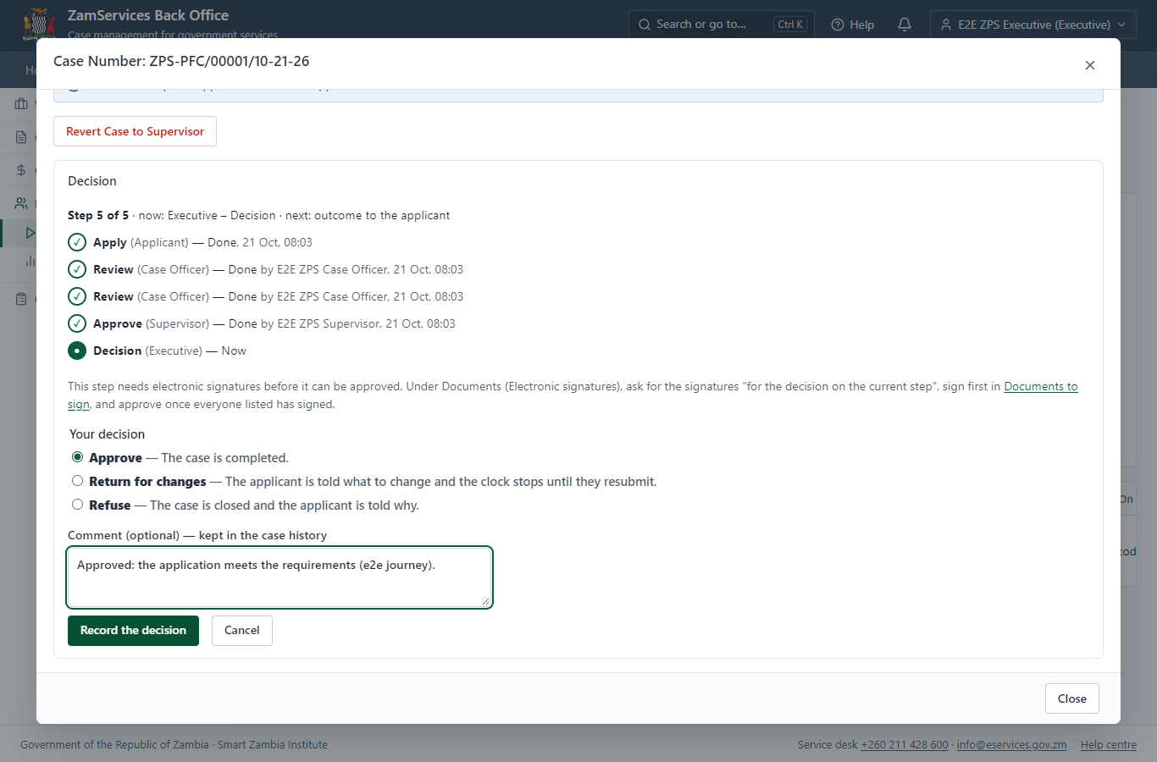
Step 13: Decide: Review, Inspect, Decision, e-Sign Executive.

Step 14. The document in My permits
Citizen · National e-Services portal
The issued document (ZPS-PFC-2026-00001 in this run: "Provisional Firearm Certificate") is listed in "My permits and licences" with its validity and a download of the sealed PDF.
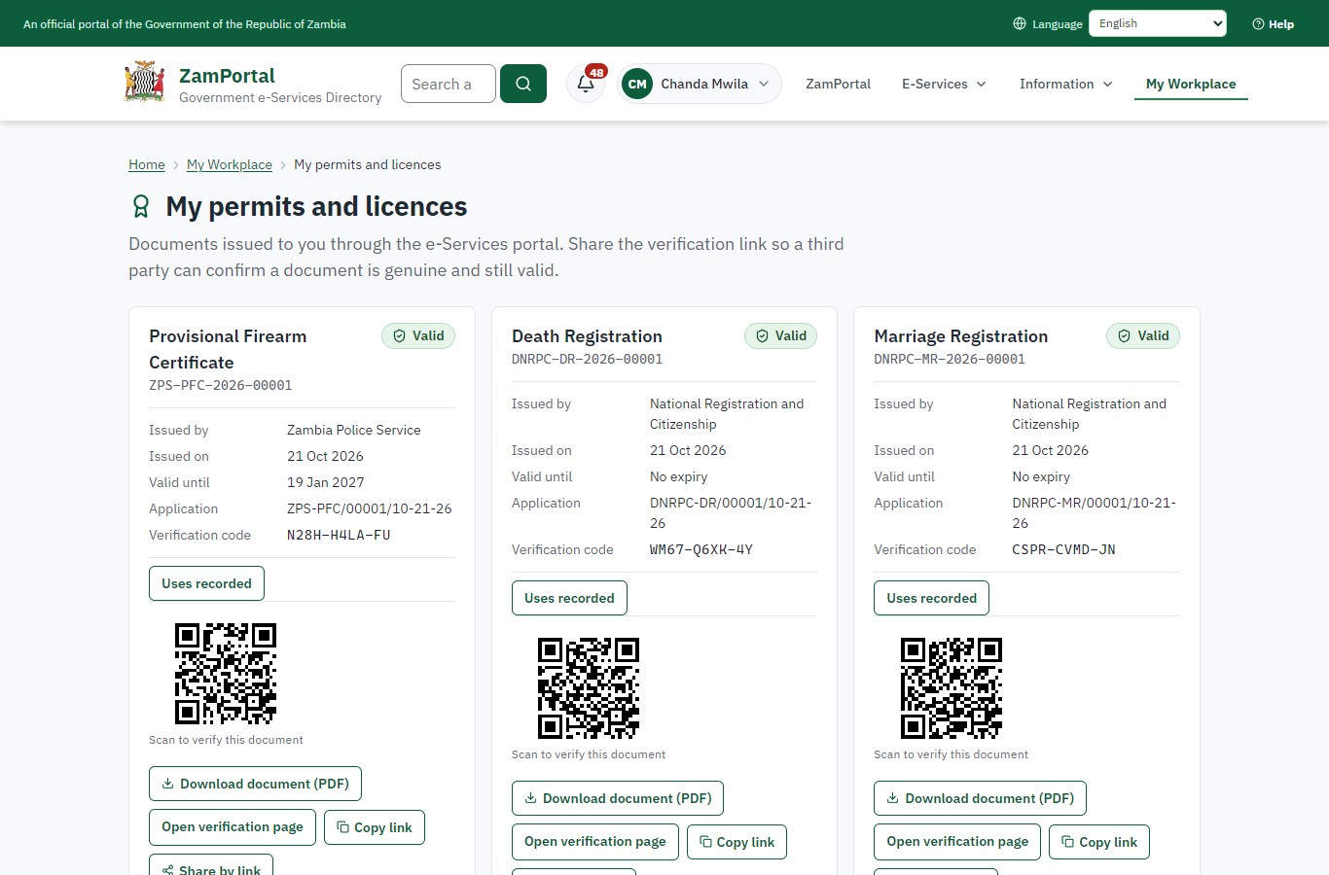 | 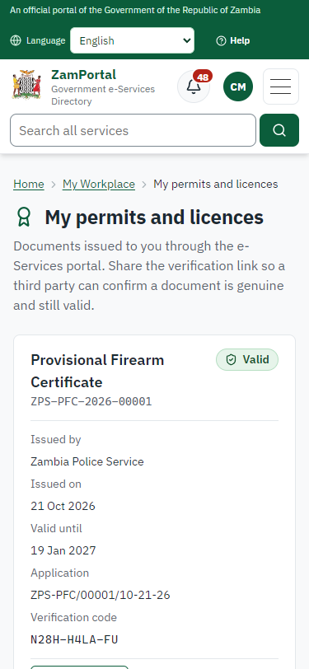
Step 14: The document in My permits - desktop (left) and a 375 px phone (right).

Step 15. Verify the document
Anyone (public) · Public verification page
The QR code on the document opens the public verification page: genuine and current, to whom it was issued, and whether the electronic seal is valid. No sign-in is needed.
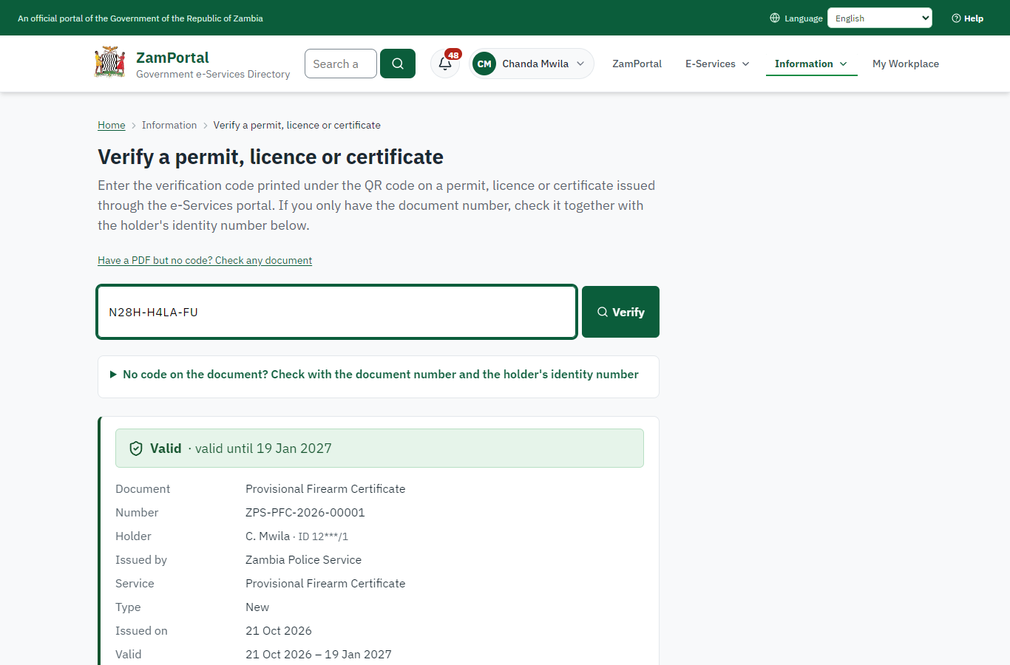 | 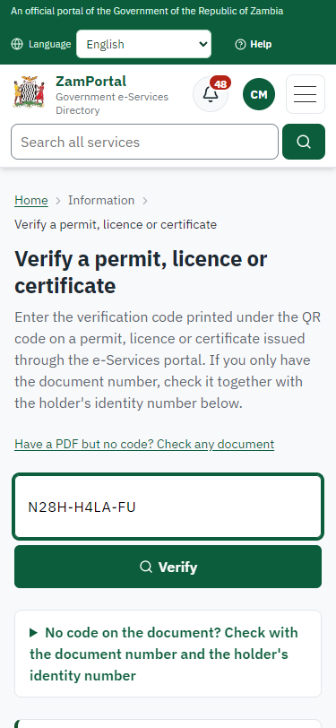
Step 15: Verify the document - desktop (left) and a 375 px phone (right).

3. Payment
Item | In the test run
Fee (as published) | Free

4. Output documents

Provisional Firearm Certificate (sealed PDF)
Issued when the case was approved, from the service's output configuration (service template ZPS_ProvisionalFirearmCertificate.Certifica), filled from the application and the decision, sealed with the platform's electronic seal and stored as the issued version. The holder downloads it from My permits; the verification page checks it.
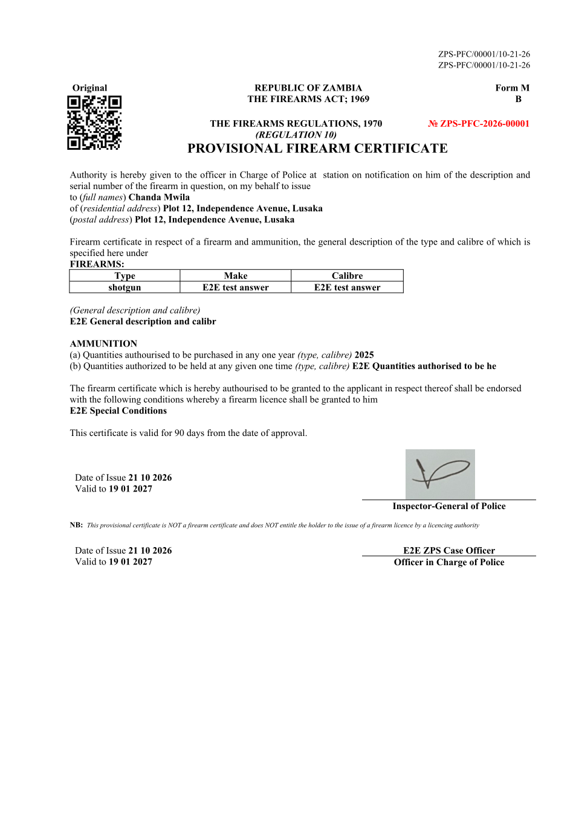
Provisional Firearm Certificate (sealed PDF) - first of 1 page, as issued in the test run.

Fields
Field | Value in the test run
Document title | Provisional Firearm Certificate
Permit / licence number | ZPS-PFC-2026-00001
Holder | Chanda Mwila
Valid from | 2026-10-21
Valid until | 2027-01-19
Status | active
Verification code (printed with a QR code) | N28H-H4LA-FU

Seal
Seal status | sealed
Signature level | PAdES-B-T
Sealed by | the platform seal (development key in the test run)
Signed at | 2026-10-21T06:03:51.617Z
Trusted time-stamp | 2026-10-21T06:03:51.607Z (time-stamping authority)
Document fingerprint (SHA-256) | 2dcb44d5951cb153...

Verification
Where | The public verification page of the national portal, <portal>/verify/<verification code>, opened by scanning the QR code on the document.
What it shows | Whether the document is genuine and current, its holder and validity, and whether the electronic seal is valid and who sealed it.
Checking a copy | Anyone can upload a PDF they were given; the page says whether it is exactly the document that was issued. A changed copy is reported as not matching.
On screen: step 14 (The document in My permits), step 15 (Verify the document) in section 2.

5. Notifications
When | Channel | To | Message | Delivery
Application received | in-app (portal bell) | the applicant | Application ZPS-PFC/00001/10-21-26 received - Your application ZPS-PFC/00001/10-21-26 for Provisional Firearm Certificate has been received by Zambia Police Service. | shown
Status changed | in-app (portal bell) | the applicant | Update on application ZPS-PFC/00001/10-21-26 - ZPS-PFC/00001/10-21-26 (Provisional Firearm Certificate) is now: With the office - being reviewed. | shown
case.approved | in-app (portal bell) | the applicant | Application ZPS-PFC/00001/10-21-26 approved - ZPS-PFC/00001/10-21-26 (Provisional Firearm Certificate) has been approved. | shown
Licence / permit issued | in-app (portal bell) | the applicant | Your Provisional Firearm Certificate document has been issued - ZPS-PFC-2026-00001 has been issued for Provisional Firearm Certificate and is valid until 19/01/2027. | shown
Invitation to rate the service | in-app (portal bell) | the applicant | How was Provisional Firearm Certificate? - How was Provisional Firearm Certificate? Tell us in about a minute. | shown
Decision: approved | in-app (portal bell) | the applicant | Application ZPS-PFC/00001/10-21-26 completed - ZPS-PFC/00001/10-21-26 (Provisional Firearm Certificate) is complete. Your documents are ready. | shown
Application received | sms | +260 97* *** 567 | Application ZPS-PFC/00001/10-21-26 for Provisional Firearm Certificate has been received. Track it: <portal>/my-workplace | delivered
Application received | email | e2e.c***@example.test | Application ZPS-PFC/00001/10-21-26 received | skipped
Status changed | sms | +260 97* *** 567 |  | delivered
case.approved | email | e2e.c***@example.test | Application ZPS-PFC/00001/10-21-26 approved | skipped
case.approved | sms | +260 97* *** 567 |  | delivered
Invitation to rate the service | sms | +260 97* *** 567 |  | skipped
Licence / permit issued | email | e2e.c***@example.test | Your Provisional Firearm Certificate document has been issued | skipped
Invitation to rate the service | email | e2e.c***@example.test | How was Provisional Firearm Certificate? | skipped
Decision: approved | email | e2e.c***@example.test | Application ZPS-PFC/00001/10-21-26 completed | skipped
Licence / permit issued | sms | +260 97* *** 567 |  | delivered
Decision: approved | sms | +260 97* *** 567 |  | delivered
Delivery: shown = in the portal's notification bell; delivered = the SMS gateway (a test double in this run) reported the text delivered; skipped = not sent on that channel (e-mail is not configured on the test installation, and some notices go out on one channel only); sent by the national portal = a ministry node handed the notice to the national portal, which texts and e-mails the citizen under its own name and the citizen's preferences. Addresses written <portal>, <ZamPay> stand for the national portal and ZamPay.

6. Legacy mapping
Replaces | Provisional Firearm Certificate in the legacy ZIGS e-Services directory (ZIGS_Services)
Legacy service id | 88
Legacy provider | Zambia Police Service (ZPS) under Ministry of Home Affairs and Internal Security
Legacy process | LicenseReview (process 9)
Fee in the legacy system | none
Fee taken before submission | yes (as in ZIGS)
Time to issue (legacy) | not recorded
Legacy output templates | Provisional Firearm Certificate: ZIGS_Forms_ZPS / ZPS_ProvisionalFirearmCertificate.Certificate  Denial of Service: ZIGS_Forms_ZPS / ZPS_ProvisionalFirearmCertificate.DenialService  Notice of Approval: ZIGS_Forms_ZPS / ZPS_ProvisionalFirearmCertificate.NoticeApproval  Notice of Action: ZIGS_Forms_Notices / GS-2.NoticeOfAction  Application form: ZIGS_Forms_ZPS / ZPS_ProvisionalFirearmCertificate.Application
Legacy address | none recorded
How it was brought over | Imported by the platform's legacy catalogue importer (zcm-backend scripts/zigs/importLegacy.js) from the ZIGS snapshot: form, case types, fees, documents, process and output templates, then served by the new platform.

7. Version and date
Document version | service v1, platform a0a302b8
Generated | 2026-10-21T06:03:58Z (by the end-to-end run, not edited by hand)
Service version | not versioned (configured directly)
Platform snapshot | backend a0a302b8  portal 72805f0  back office 58e5946
Test suite | e2e 5999d9b; one installation (combined); seed profile mihud
Journeys | 30-catalogue-service.spec.js: citizen finds the service, answers its form, uploads its documents and sends the application - passed  30-catalogue-service.spec.js: the case goes through every step of its process: payments by the citizen, each officer step by its role - passed  30-catalogue-service.spec.js: the grant document is issued, sealed, filled in and verifiable; the citizen has it in My permits - passed
Result | 3 of 3 journey tests passed
Data | Synthetic test data on a local test installation; provider test doubles for ZamPass, ZamPay, SMS and signing.

