Republic of Zambia
GSB e-Services

Property Rates
Service documentation
Owner: Department of Local Government
Service key: LGD/property-rates
Version: service v1, platform 7eecca5c
Date: 2026-10-21
Generated automatically by the service's end-to-end test run. Every screenshot shows synthetic test data on a local test installation, never real personal data.

Contents
- 1. Service summary
- 2. Application process, step by step
- 3. Payment
- 4. Output documents
- 5. Notifications
- 6. Legacy mapping
- 7. Version and date
This document describes the Property Rates service of Department of Local Government as the platform runs it today. It is generated by the service's end-to-end test: every step was performed by the test and every screenshot was taken during that run, with synthetic data. Regenerate it with "npm run docs:services" in the e2e suite; do not edit it by hand.

1. Service summary
Service | Property Rates
Owner (MDA) | Department of Local Government (LGD)
Purpose | Property rates are annual levies imposed by the local council on all rateable properties within its jurisdiction in accordance with the Rating Act No. 21 of 2018. The Council bills property once a year and each bill must be paid within that year. If a property has arrears, those must be settled first, or the full outstanding balance may be paid in a single payment.
Who can apply | Organization; Individual
How to apply | Online on the national e-Services portal, signed in with ZamPass; pay with ZamPay.
Fees | Fee set by the office: (variable)
Turnaround | Automated
Validity of the output | 31 December of the current year
Required documents | None
Output documents | GS-1 Application for a Government Service  GS-2 Notice of Government Action

2. Application process, step by step

The process as configured
Step | Role | Task | Type
1 | Applicant | Apply | form
2 | Case Officer | Generate Payment | generate-payment
3 | Applicant | Payment | payment
4 | System | Generate Document | generate-document
5 | System | Notify Client | notify

Step by step
Who takes part in this journey: Finance officer, Citizen, Anyone (public), Case Officer. Citizen steps are shown on a desktop and on a 375 px phone; back-office steps on a desktop.

Step 1. Preview the billing run
Finance officer · Back office
In Finance -> Billing a finance officer (the Accountant role) chooses the scheme ("Property rates - Lusaka City Council") and the period (2026) and previews the run: every account, what it would be billed (worked out on the server from the council's approved tariffs and records) and why any is skipped. Nothing is billed yet.
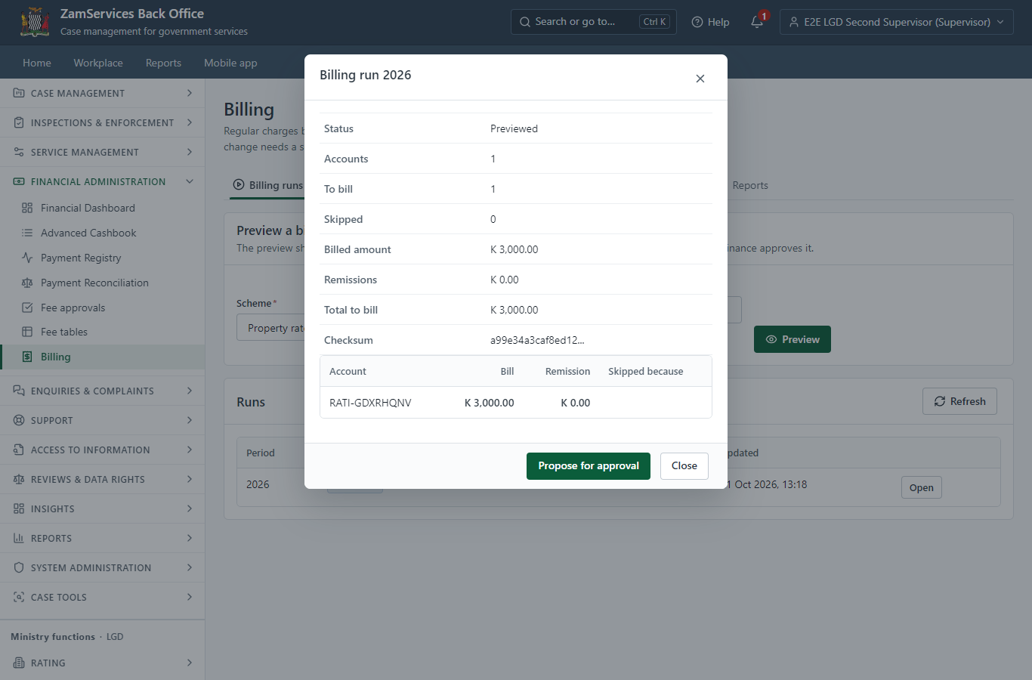
Step 1: Preview the billing run.

Step 2. Approve the billing run
Finance officer · Back office
A second finance officer opens the proposed run and approves it ("Approve and bill"); the officer who proposed it cannot. The approval posts one bill per account for the period - posting again never bills twice - and the bills appear on the holders' accounts.
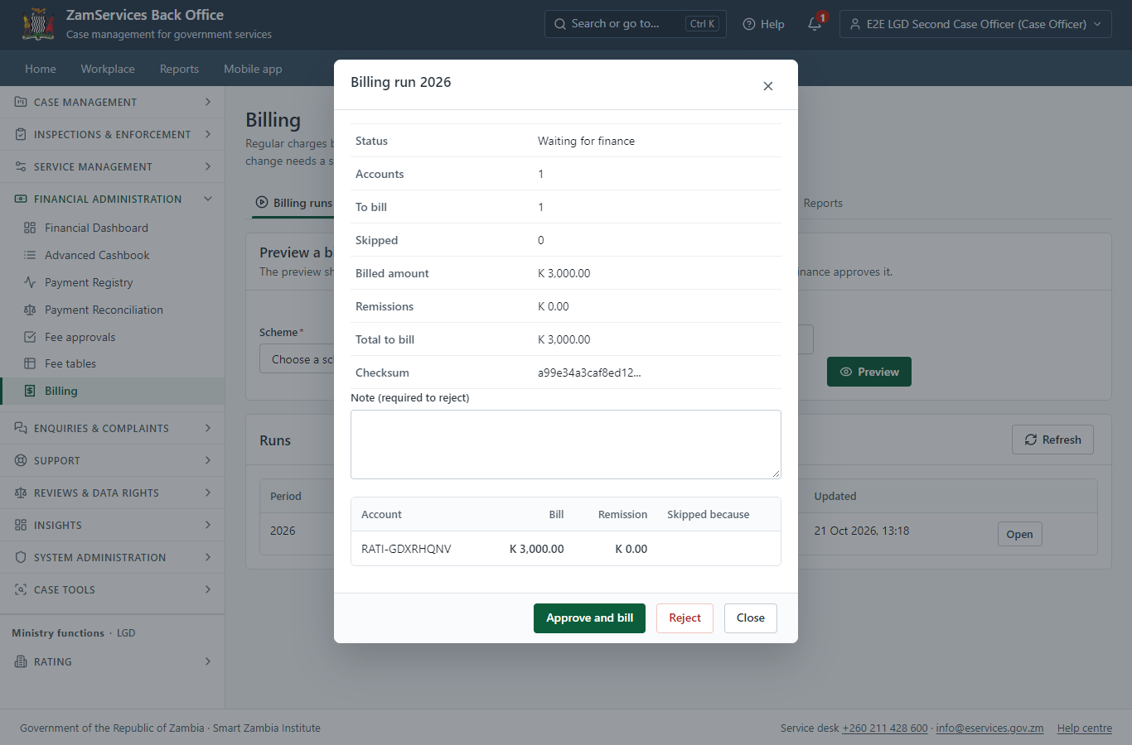
Step 2: Approve the billing run.

Step 3. Find the service at the council
Citizen · National e-Services portal
The service is delivered by the local authorities: on the national e-Services portal the citizen opens Councils, chooses their council (Lusaka City Council in this run) and searches its services ("Property Rates"). The application is then registered with that council and priced with its own fees.
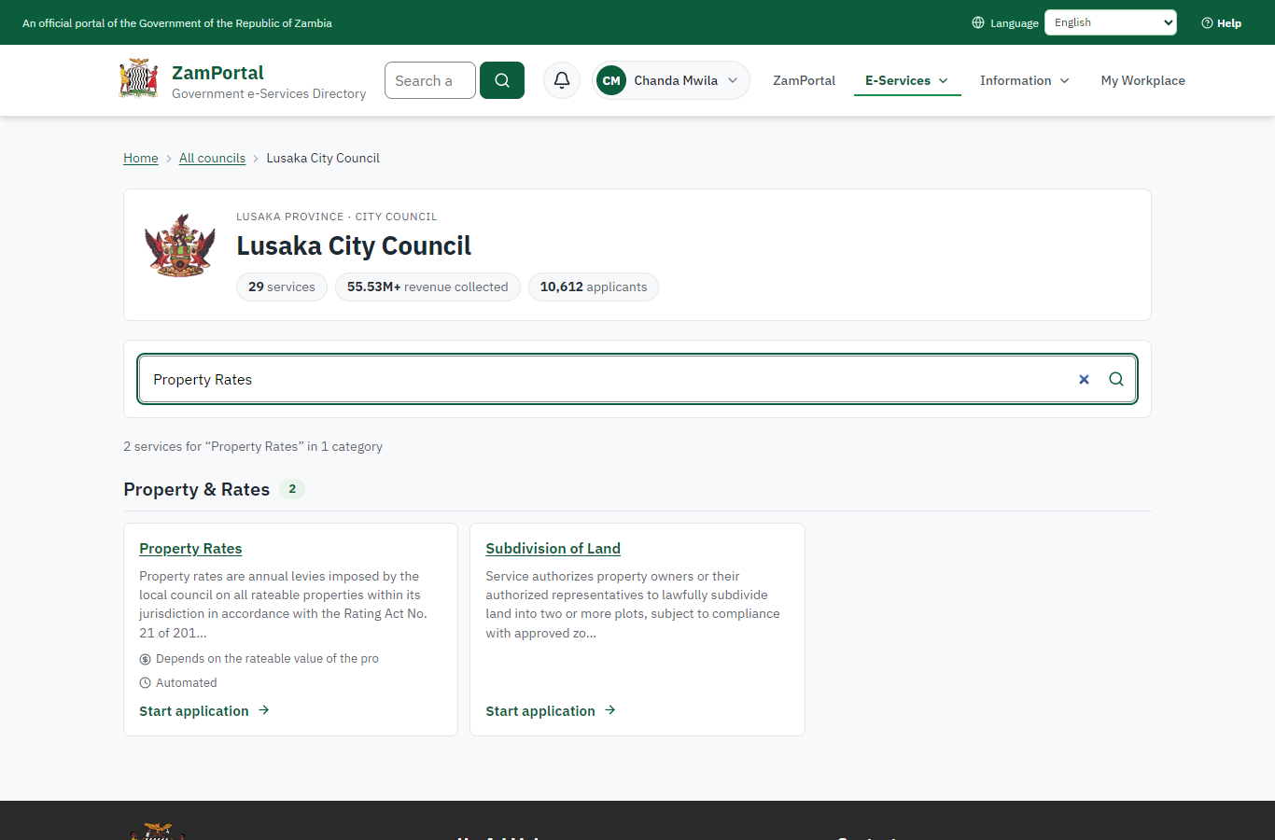 | 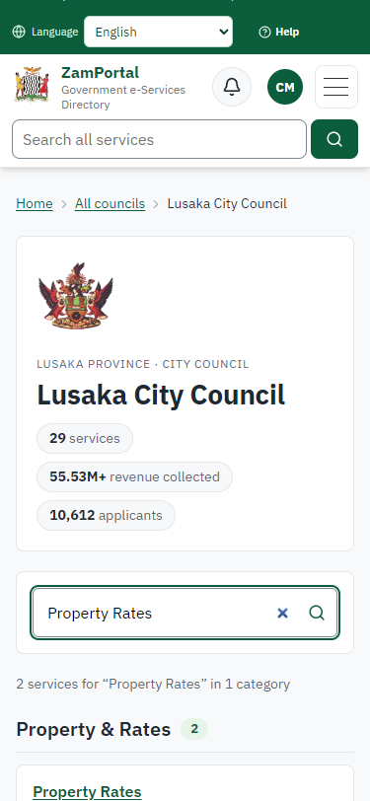
Step 3: Find the service at the council - desktop (left) and a 375 px phone (right).

Step 4. Read the service page
Citizen · National e-Services portal
The service page sets out what the service is for, the fee, how long it takes and the documents to have ready, and names the council the application goes to. "Start application" begins an application at Lusaka City Council (the citizen is signed in with ZamPass).
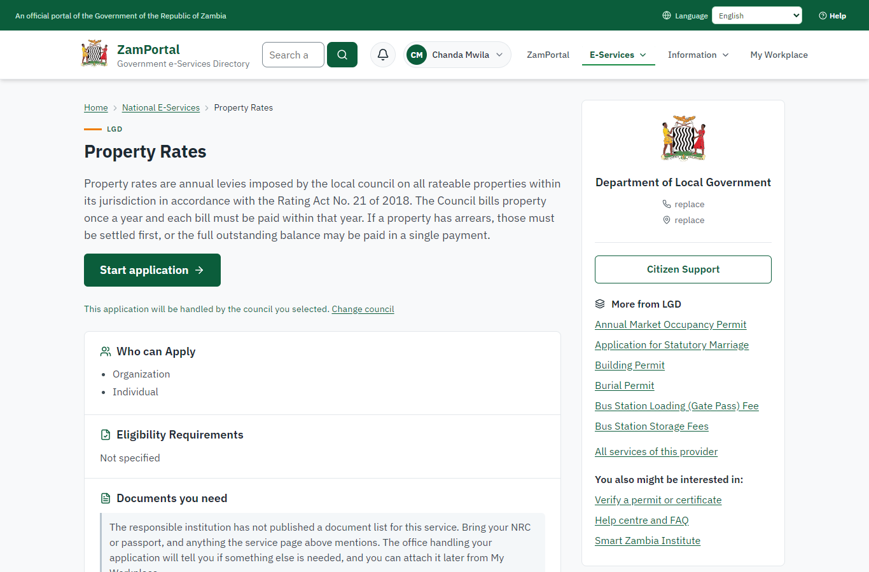 | 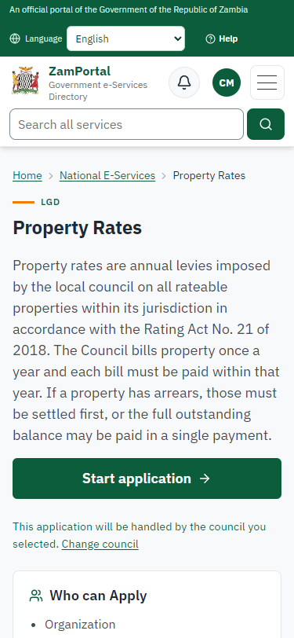
Step 4: Read the service page - desktop (left) and a 375 px phone (right).

Step 5. See the account and what is owed
Citizen · National e-Services portal
"Start application" opens the service's account page instead of a form: the citizen's Property rates (E2E/R/1, 7 Synthetic Road, Rhodes Park, reference RATI-GDXRHQNV) with what is owed now and the recent bills (K3,000.00 for 2026). The account is the citizen's because the office linked them to it; nothing is typed.
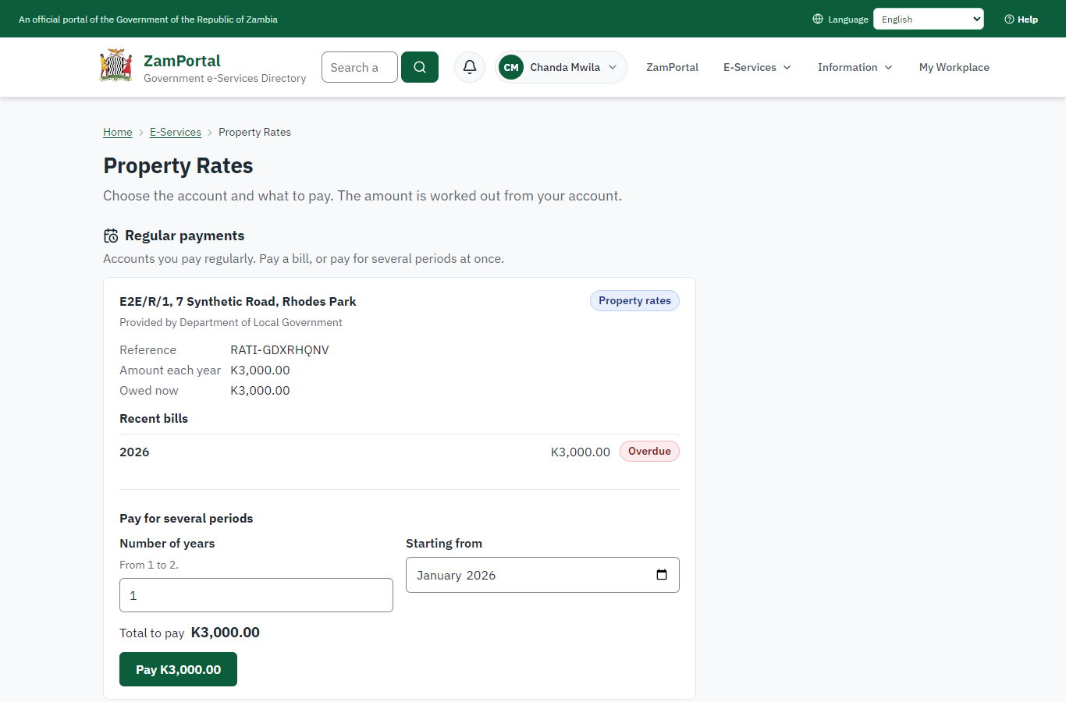 | 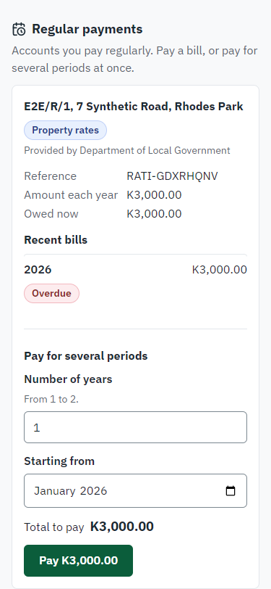
Step 5: See the account and what is owed - desktop (left) and a 375 px phone (right).

Step 6. Pay with ZamPay
Citizen · National e-Services portal
Pay raises a ZamPay invoice for the amount the server works out from the account (K3,000.00; a total the page shows that differs is refused and the server's is shown). The citizen pays at ZamPay by mobile money or bank card.
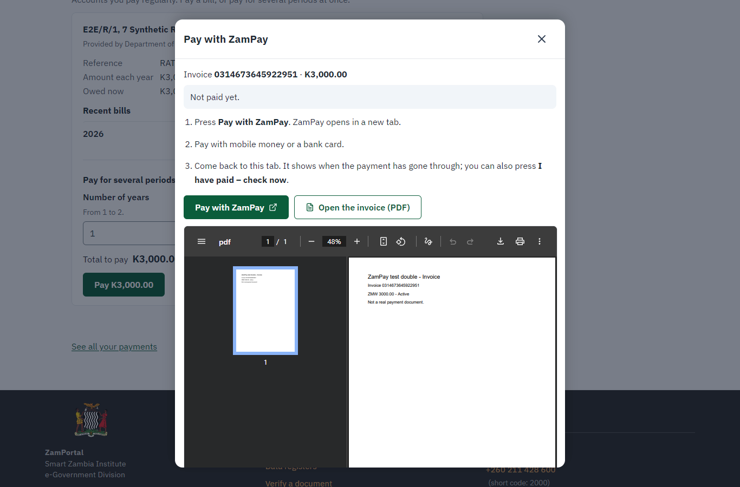 | 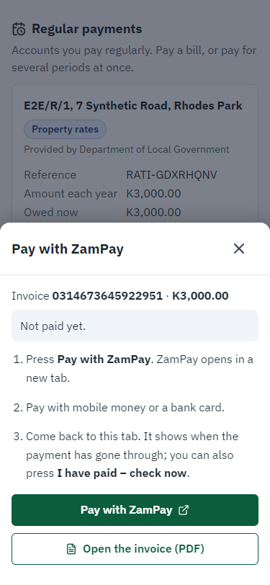
Step 6: Pay with ZamPay - desktop (left) and a 375 px phone (right).

Step 7. Payment received
Citizen · National e-Services portal
ZamPay reports the payment; it is allocated to the account on the server (penalties first, then the oldest bill), and the bill shows as paid.
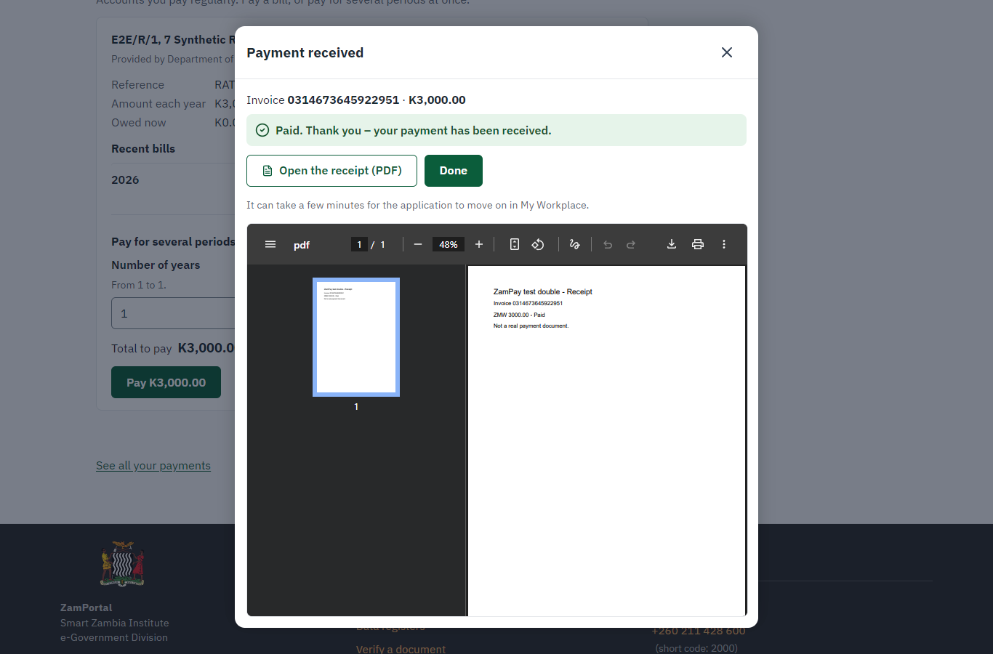 | 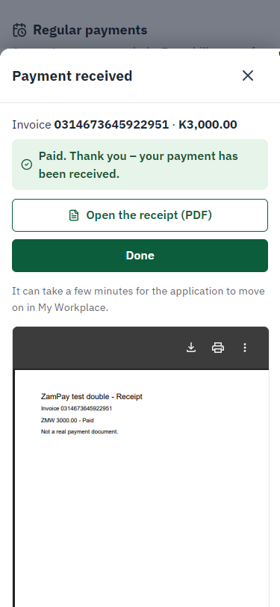
Step 7: Payment received - desktop (left) and a 375 px phone (right).

Step 8. Verify the receipt
Anyone (public) · Public verification page
The receipt's QR code opens the public receipt page: genuine, its number and the payment it records. No sign-in is needed.
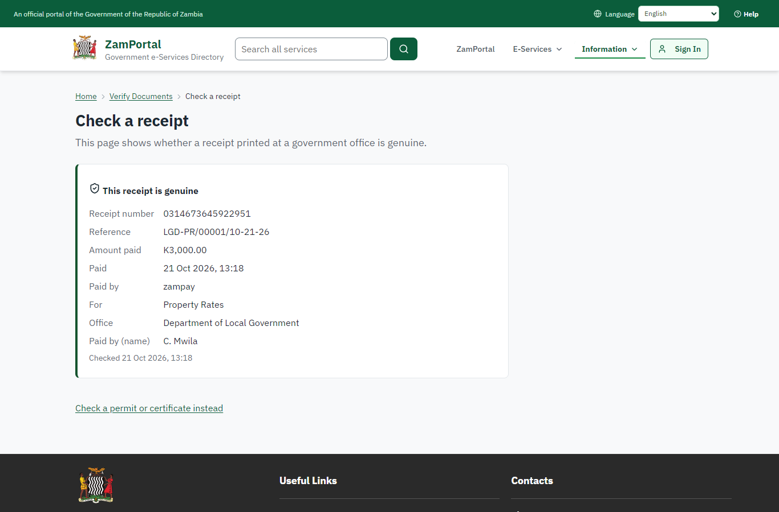 | 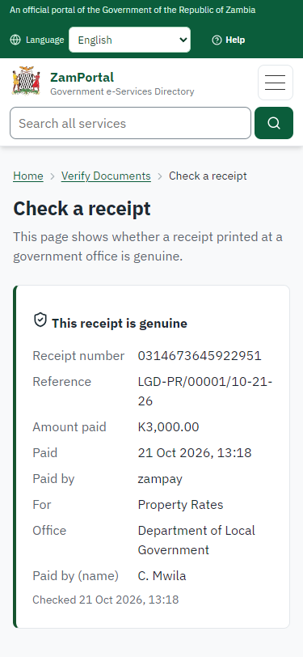
Step 8: Verify the receipt - desktop (left) and a 375 px phone (right).

Step 9. The account and its statement
Case Officer · Back office
The office sees the account in Finance -> Billing: its bills, the payment allocated to them and the balance (nil). "Statement (PDF)" issues the statement of account: a numbered document, sealed by the platform, with a QR code to the public verification page.
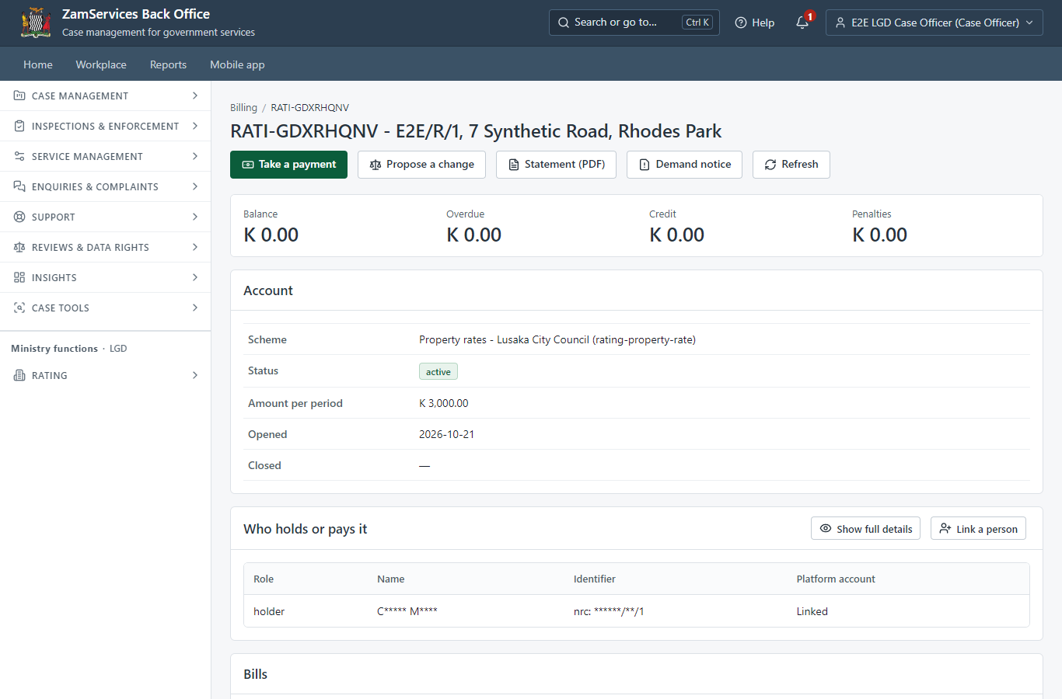
Step 9: The account and its statement.

Step 10. Verify the statement
Anyone (public) · Public verification page
The QR code on the statement opens the public verification page: the statement's number, the account and the balance it shows at its date, and that it is genuine. No name is shown.
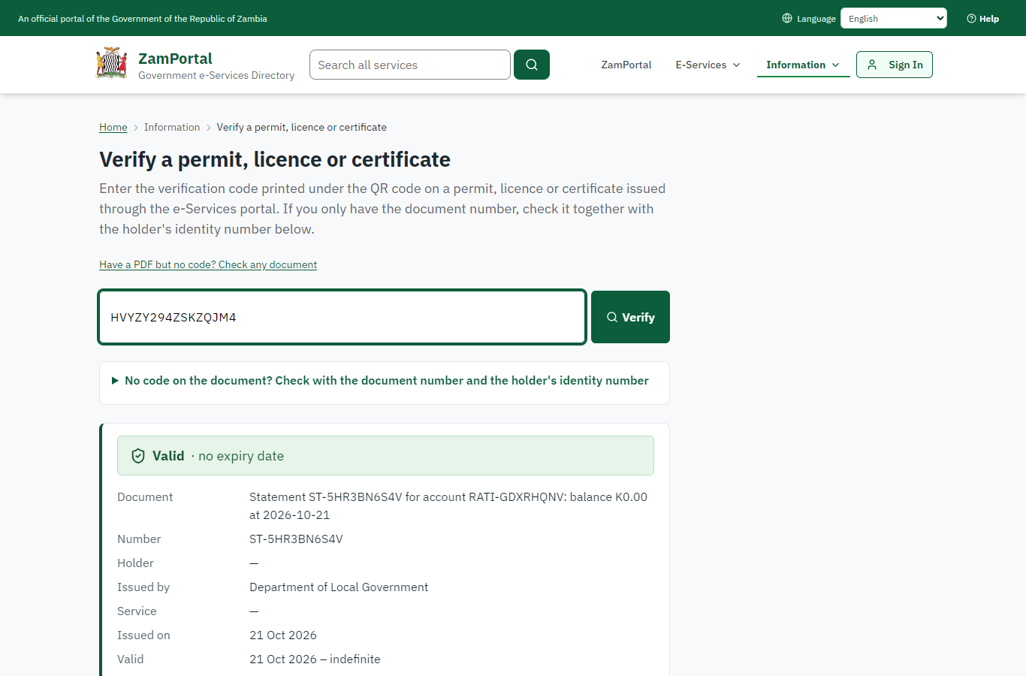 | 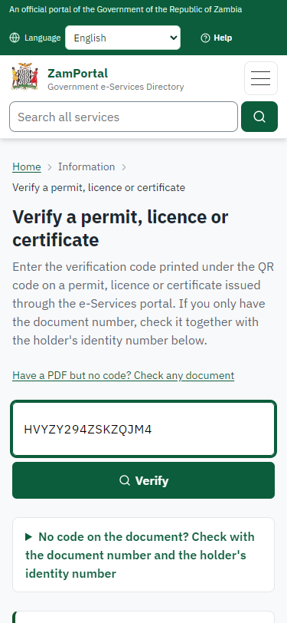
Step 10: Verify the statement - desktop (left) and a 375 px phone (right).

3. Payment
Item | In the test run
Fee (as published) | Depends on the rateable value of the property.
Bill | BL-FYKAXTZKGB (2026)
Invoice | 0314673645922951
Amount | ZMW 3000.00
Receipt | 0314673645922951
On screen: step 1 (Preview the billing run), step 2 (Approve the billing run), step 5 (See the account and what is owed), step 6 (Pay with ZamPay), step 7 (Payment received) in section 2.

4. Output documents

Statement of account (sealed PDF)
Issued on demand from the account's ledger: every bill and payment with the running balance. Numbered, sealed with the platform's electronic seal and verifiable by its QR code.
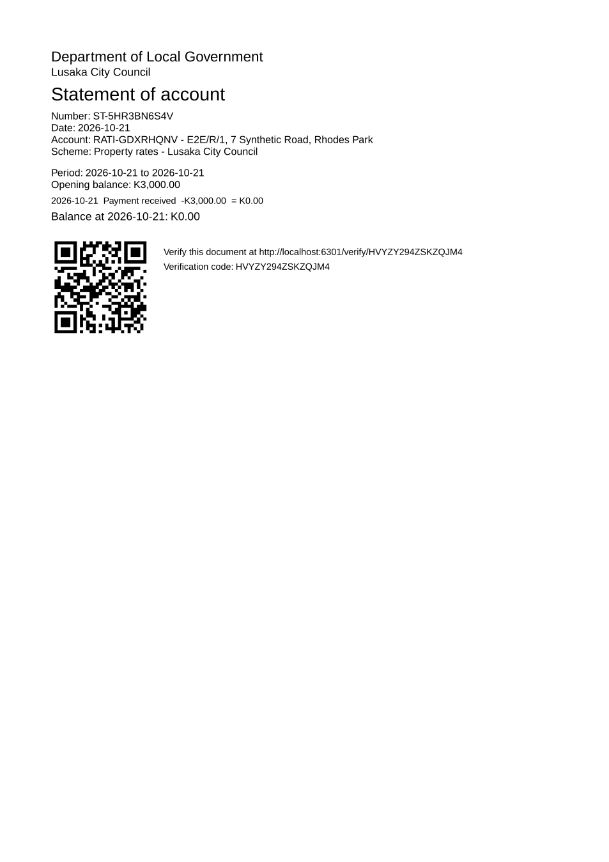
Statement of account (sealed PDF) - first of 1 page, as issued in the test run.

Fields
Field | Value in the test run
Statement number | ST-5HR3BN6S4V
Account | RATI-GDXRHQNV
Account | E2E/R/1, 7 Synthetic Road, Rhodes Park
Bill | BL-FYKAXTZKGB: K3,000.00 for 2026
Balance | nil after the payment

Seal
Seal | the platform's electronic seal

Verification
Where | The public verification page (/verify/<code>), the address under the QR code
What it shows | The statement number, the account and the balance at the statement date; never a name.
On screen: step 8 (Verify the receipt), step 9 (The account and its statement), step 10 (Verify the statement) in section 2.

5. Notifications
When | Channel | To | Message | Delivery
Payment received | in-app (portal bell) | the applicant | Payment received for LGD-PR/00001/10-21-26 - Your payment of ZMW 3000.00 for LGD-PR/00001/10-21-26 (Property Rates) has been received. Receipt: <ZamPay>/pdf?documentType=receipt&invoiceNumber=0314673645922951 | shown
Payment due (invoice raised) | email | +260 97* *** 567 | Payment due for application LGD-PR/00001/10-21-26 | skipped
Payment due (invoice raised) | sms | +260 97* *** 567 |  | delivered
Payment received | sms | +260 97* *** 567 |  | delivered
Delivery: shown = in the portal's notification bell; delivered = the SMS gateway (a test double in this run) reported the text delivered; skipped = not sent on that channel (e-mail is not configured on the test installation, and some notices go out on one channel only); sent by the national portal = a ministry node handed the notice to the national portal, which texts and e-mails the citizen under its own name and the citizen's preferences. Addresses written <portal>, <ZamPay> stand for the national portal and ZamPay.

6. Legacy mapping
Replaces | Property Rates in the legacy ZIGS e-Services directory (ZIGS_Services)
Legacy service id | 601
Legacy provider | Department of Local Government (LGD) under Ministry of Local Government and Rural Development
Legacy process | not recorded
Fee in the legacy system | none
Fee taken before submission | yes (as in ZIGS)
Time to issue (legacy) | not recorded
Legacy output templates | GS-1 Application for a Government Service: ZIGS_Forms_ZDA / GS1  GS-2 Notice of Government Action: ZIGS_Forms_Notices / GS-2.NoticeOfAction
Legacy address | https://ecouncils.gsb.gov.zm
How it was brought over | Imported by the platform's legacy catalogue importer (zcm-backend scripts/zigs/importLegacy.js) from the ZIGS snapshot: form, case types, fees, documents, process and output templates, then served by the new platform.

7. Version and date
Document version | service v1, platform 7eecca5c
Generated | 2026-10-21T11:19:03Z (by the end-to-end run, not edited by hand)
Service version | not versioned (configured directly)
Platform snapshot | backend 7eecca5c  portal 72805f0  back office 58e5946
Test suite | e2e 2f82c10; one installation (combined); seed profile mihud
Journeys | 30-catalogue-service.spec.js: the office keeps the account and bills the period: finance previews and proposes, another finance officer approves - passed  30-catalogue-service.spec.js: the citizen finds the service at the council and pays the bill from the service's page - passed  30-catalogue-service.spec.js: the receipt verifies; the statement of account is sealed and its QR code verifies - passed
Result | 3 of 3 journey tests passed
Data | Synthetic test data on a local test installation; provider test doubles for ZamPass, ZamPay, SMS and signing.

