Republic of Zambia
GSB e-Services

Forestry Produce Conveyance Permit
Service documentation
Owner: Forestry Department
Service key: MGEE/produce-conveyance-permit
Version: service v1, platform 86947eee
Date: 2026-10-21
Generated automatically by the service's end-to-end test run. Every screenshot shows synthetic test data on a local test installation, never real personal data.

Contents
- 1. Service summary
- 2. Application process, step by step
- 3. Payment
- 4. Output documents
- 5. Notifications
- 6. Legacy mapping
- 7. Version and date
This document describes the Forestry Produce Conveyance Permit service of Forestry Department as the platform runs it today. It is generated by the service's end-to-end test: every step was performed by the test and every screenshot was taken during that run, with synthetic data. Regenerate it with "npm run docs:services" in the e2e suite; do not edit it by hand.

1. Service summary
Service | Forestry Produce Conveyance Permit
Owner (MDA) | Forestry Department (MGEE)
Purpose | The Forestry Produce Conveyance Permit is issued to authorize a citizen to convey forest produce.
Who can apply | Individual; Organization
How to apply | Online on the national e-Services portal, signed in with ZamPass; pay with ZamPay.
Fees | Fee set by the office: (variable)
Turnaround | 2 days
Validity of the output | 14 days
Required documents | Forestry Concession Licence (required)  National Registration Card (NRC) (required)  Forestry Production Permit (required)  Certificate of Incorporation / ZDA (if company, church, society) (required)
Output documents | Forestry Produce Conveyance Permit  Approval letter  Application form  GS-2 Notice of Government Action
Legal basis | The Forest Act No. 4 of 2015 (http://www.parliament.gov.zm/node/4535)  Lands Act Cap 184 of 1995 (http://www.parliament.gov.zm/sites/default/files/documents/acts/Lands%20Act.pdf)  SI No. 52 of 2013 (http://extwprlegs1.fao.org/docs/pdf/zam133574.pdf)  SI no. 50 of 2016 Specifies the fee schedules (https://www.enotices.co.zm/download/statutory-instrument-no-050-of-2016-the-forest-concession-licence-regulations-pdf/)

2. Application process, step by step

The process as configured
Step | Role | Task | Type
1 | Applicant | Apply | form
2 | System | Generate Document | generate-document
3 | Case Officer | Review | review
4 | Supervisor | Review | review
5 | Executive | Approve | approve
6 | Case Officer | Verify Payment | verify-payment
7 | Executive | Decision | decision
8 | System | Generate Document | generate-document
9 | System | Notify Client | notify

Step by step
Who takes part in this journey: Citizen. Citizen steps are shown on a desktop and on a 375 px phone; back-office steps on a desktop.

Step 1. Start the conveyance application
Citizen · National e-Services portal
The citizen gives the permit the produce comes from (felling, production or concession licence) and the produce lines. The source permit must be on record, in force and the applicant's own.
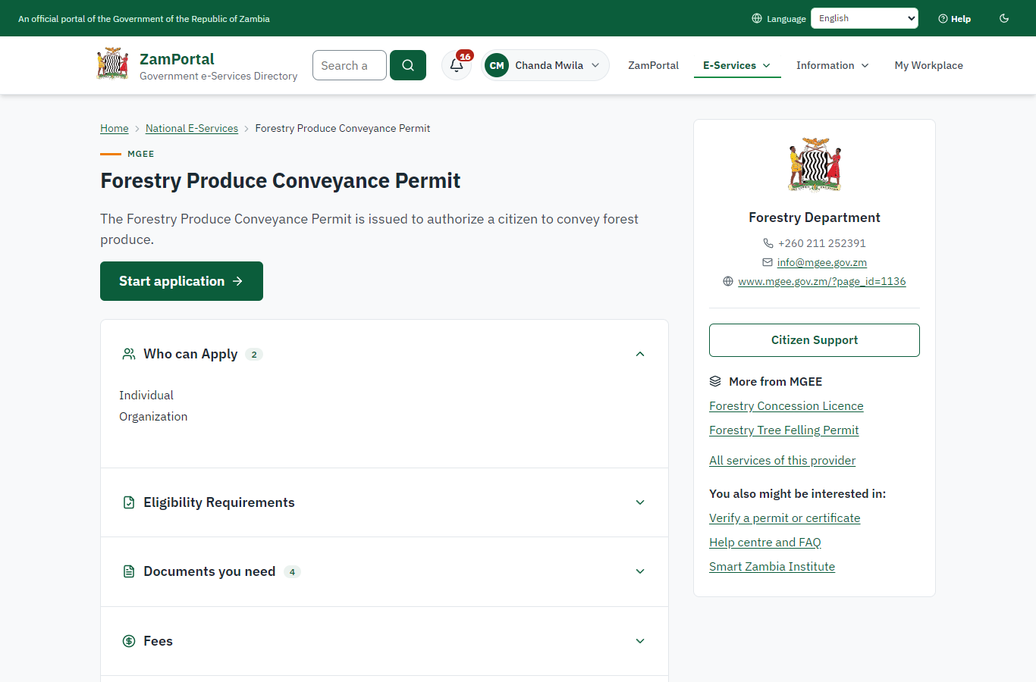 | 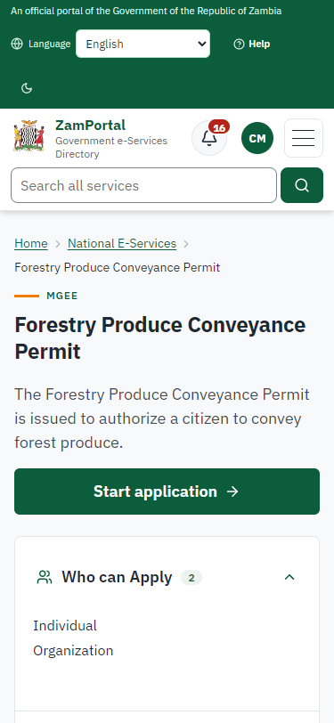
Step 1: Start the conveyance application - desktop (left) and a 375 px phone (right).

Step 2. Send a conveyance of 4 m³ from the felling permit
Citizen · National e-Services portal (sent through the API the portal uses in the test run: no screenshot)
Sent through the API the portal uses. The 4 m³ are held against what the felling permit still allows (one allowance per species); a source permit that is not on record is refused (case MGEE-FPCP/00001/10-22-26 in this run).

Step 3. Ask for more than is left
Citizen · National e-Services portal (sent through the API the portal uses in the test run: no screenshot)
Asking for 9 m³ when 6 are left is accepted with a warning to the Forestry Department's supervisors, and only what is left is held (the rule can be set to refuse instead). The officers then process the case (not yet driven by this journey).

3. Payment
Not recorded for this service.

4. Output documents
Not recorded for this service.

5. Notifications
No notifications were recorded in the test run.

6. Legacy mapping
Replaces | Forestry Produce Conveyance Permit in the legacy ZIGS e-Services directory (ZIGS_Services)
Legacy service id | 158
Legacy provider | Forestry Department (MGEE) under Ministry of Green Economy and Environment
Legacy process | LicenseReview (process 9)
Fee in the legacy system | none
Fee taken before submission | yes (as in ZIGS)
Time to issue (legacy) | New: 2 calendar days
Legacy output templates | Forestry Produce Conveyance Permit: ZIGS_Forms_MGEE / MGEE_ForestryProduceConveyance.Certificate  Approval letter: ZIGS_Forms_MGEE / MGEE_ForestryProduceConveyance.ApprovalLetter  Application form: ZIGS_Forms_MGEE / MGEE_ForestryProduceConveyance.Application  GS-2 Notice of Government Action: ZIGS_Forms_Notices / GS-2.NoticeOfAction
Legacy address | none recorded
How it was brought over | Imported by the platform's legacy catalogue importer (zcm-backend scripts/zigs/importLegacy.js) from the ZIGS snapshot: form, case types, fees, documents, process and output templates, then served by the new platform.

7. Version and date
Document version | service v1, platform 86947eee
Generated | 2026-10-21T23:44:18Z (by the end-to-end run, not edited by hand)
Service version | not versioned (configured directly)
Platform snapshot | backend 86947eee  portal 8d4a375  back office 8b37374
Test suite | e2e f4407ea; one installation (combined); seed profile mihud
Journeys | 16-forestry-felling-conveyance.spec.js: citizen: conveys timber from the felling permit; the ledger holds it, an excess is flagged - passed
Result | 1 of 1 journey tests passed
Data | Synthetic test data on a local test installation; provider test doubles for ZamPass, ZamPay, SMS and signing.

