Republic of Zambia
GSB e-Services

Printing Services (Maps and Others)
Service documentation
Owner: Survey Department
Service key: MLNR/printing-services-maps-and-others
Version: service v1, platform a0a302b8
Date: 2026-10-21
Generated automatically by the service's end-to-end test run. Every screenshot shows synthetic test data on a local test installation, never real personal data.

Contents
- 1. Service summary
- 2. Application process, step by step
- 3. Payment
- 4. Output documents
- 5. Notifications
- 6. Legacy mapping
- 7. Version and date
This document describes the Printing Services (Maps and Others) service of Survey Department as the platform runs it today. It is generated by the service's end-to-end test: every step was performed by the test and every screenshot was taken during that run, with synthetic data. Regenerate it with "npm run docs:services" in the e2e suite; do not edit it by hand.

1. Service summary
Service | Printing Services (Maps and Others)
Owner (MDA) | Survey Department (MLNR)
Purpose | Printing services for Maps and Other Products
Who can apply | Individual; Organization
How to apply | Online on the national e-Services portal, signed in with ZamPass; pay with ZamPay.
Fees | Fee set by the office: (variable)
Turnaround | 5 working days
Validity of the output | N/A
Required documents | National Registration Card (NRC) (required)  Certificate of Incorporation / ZDA (if company, church, society) (required)  Copy of the product to print (optional)
Output documents | Notice of Action  Application form
Legal basis | The Land Survey Act No Chapter 188 of the Laws of Zambia (http://www.parliament.gov.zm/sites/default/files/documents/acts/Land%20Survey%20Act.pdf)

2. Application process, step by step

The process as configured
Step | Role | Task | Type
1 | Applicant | Apply | form
2 | System | Generate Document | generate-document
3 | Case Officer | Review | review
4 | Supervisor | Review | review
5 | Case Officer | Inspect Site | inspection
6 | Supervisor | Review | review
7 | Executive | Decision | decision
8 | System | Generate Document | generate-document
9 | System | Notify Client | notify

Step by step
Who takes part in this journey: Citizen, Case Officer, Supervisor, Executive, Anyone (public). Citizen steps are shown on a desktop and on a 375 px phone; back-office steps on a desktop.

Step 1. Find the service
Citizen · National e-Services portal
On the national e-Services portal the citizen opens All Services and searches for the service by name ("Printing Services Maps and Others"). Each result names the service and the ministry that provides it.
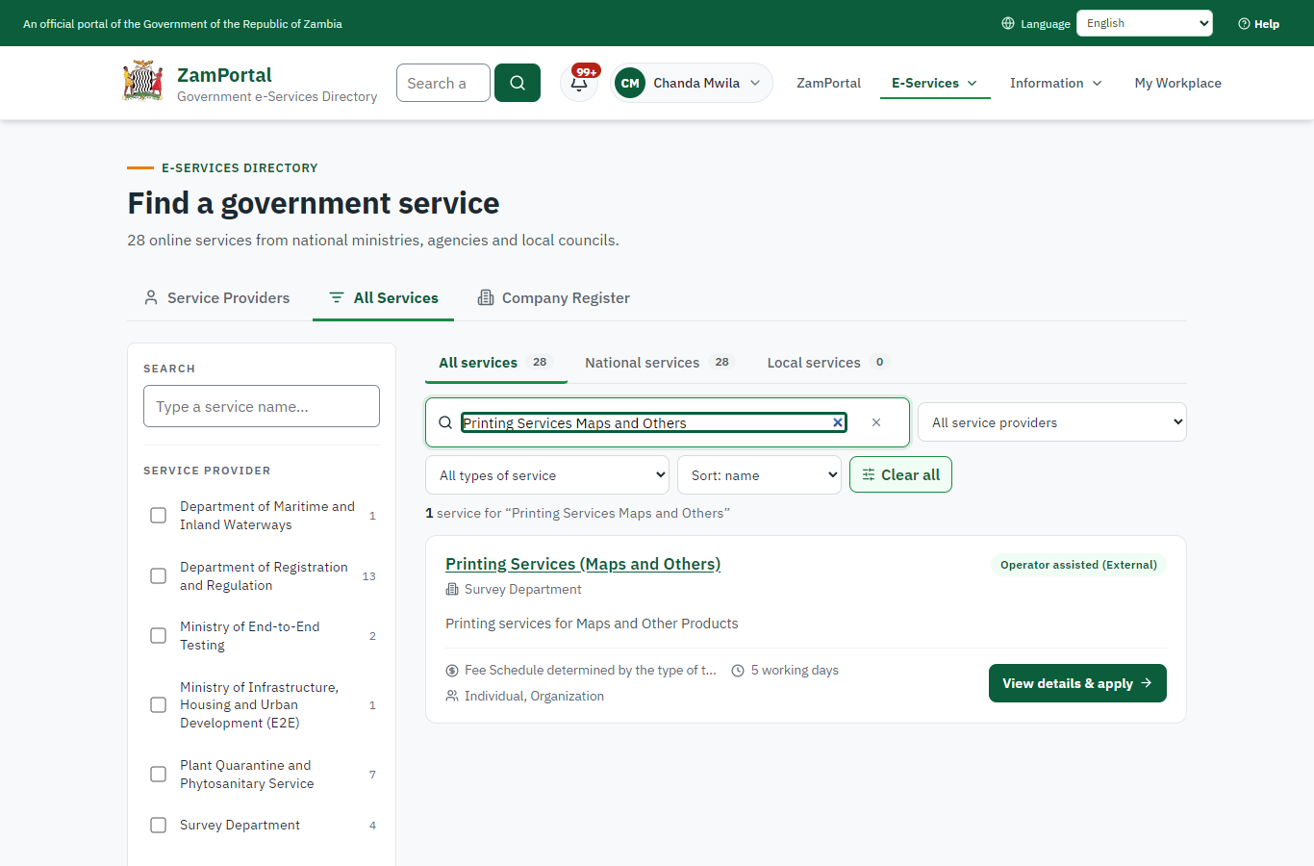 | 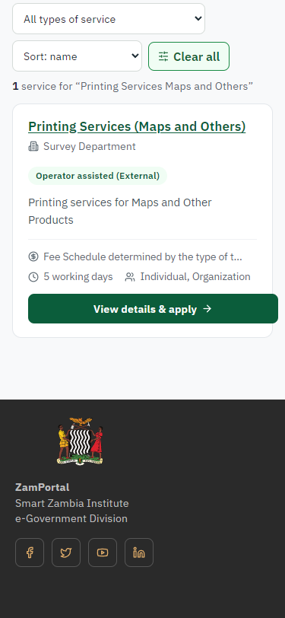
Step 1: Find the service - desktop (left) and a 375 px phone (right).

Step 2. Read the service page
Citizen · National e-Services portal
The service page sets out what the service is for, who provides it, the fee, how long it takes and the documents to have ready. "Start application" begins an application (the citizen is signed in with ZamPass).
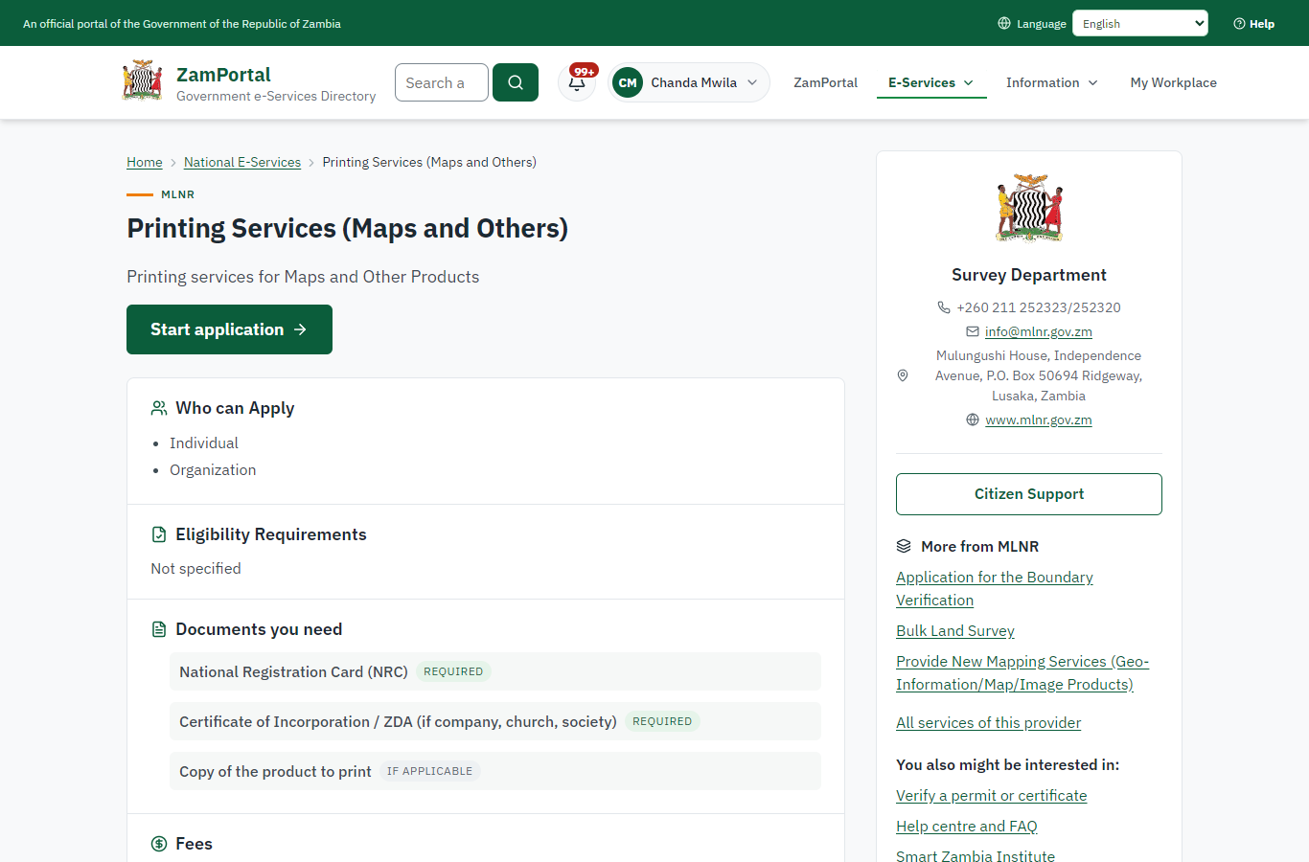 | 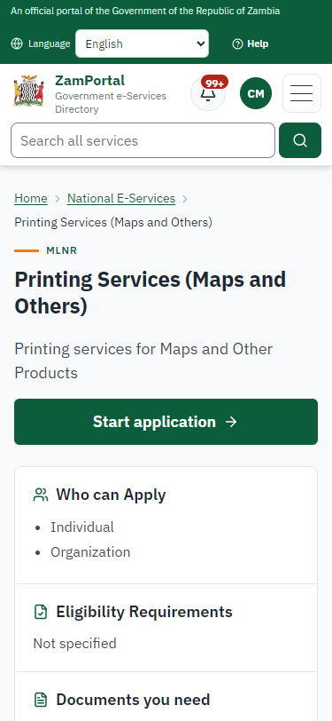
Step 2: Read the service page - desktop (left) and a 375 px phone (right).

Step 3. Confirm the applicant details
Citizen · National e-Services portal
The applicant details are filled in from the citizen's ZamPass account. The citizen says whom they are applying for (themself) and continues with "Proceed to Application".
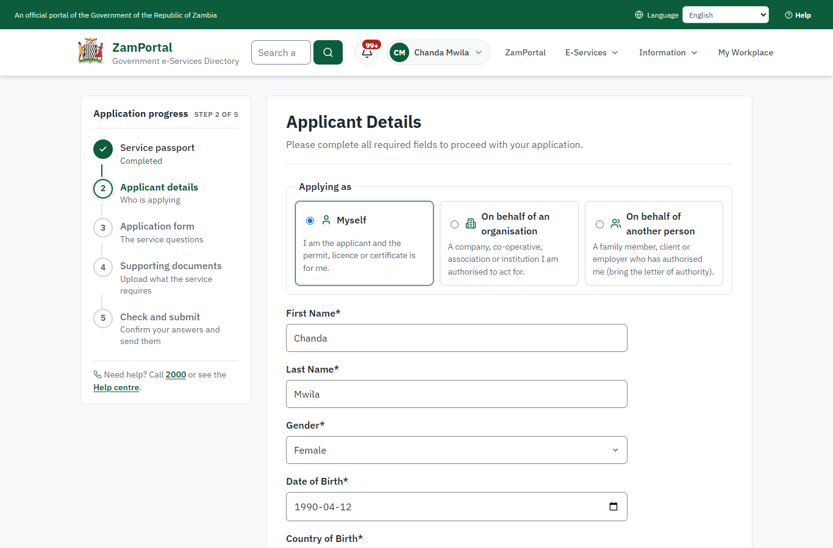 | 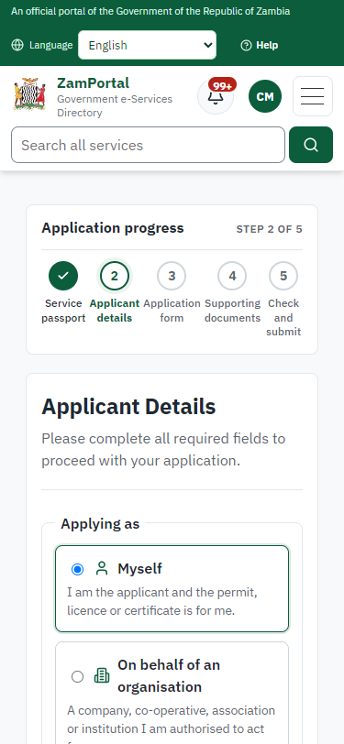
Step 3: Confirm the applicant details - desktop (left) and a 375 px phone (right).

Step 4. Fill in the application form
Citizen · National e-Services portal
The citizen answers the service's own application form, converted from the legacy system (7 answers in this run, all synthetic), for the type of application "New". Questions marked * must be answered; some appear only after an earlier answer. Answers are saved as the citizen types, so an unfinished application can be reopened from My Workplace.
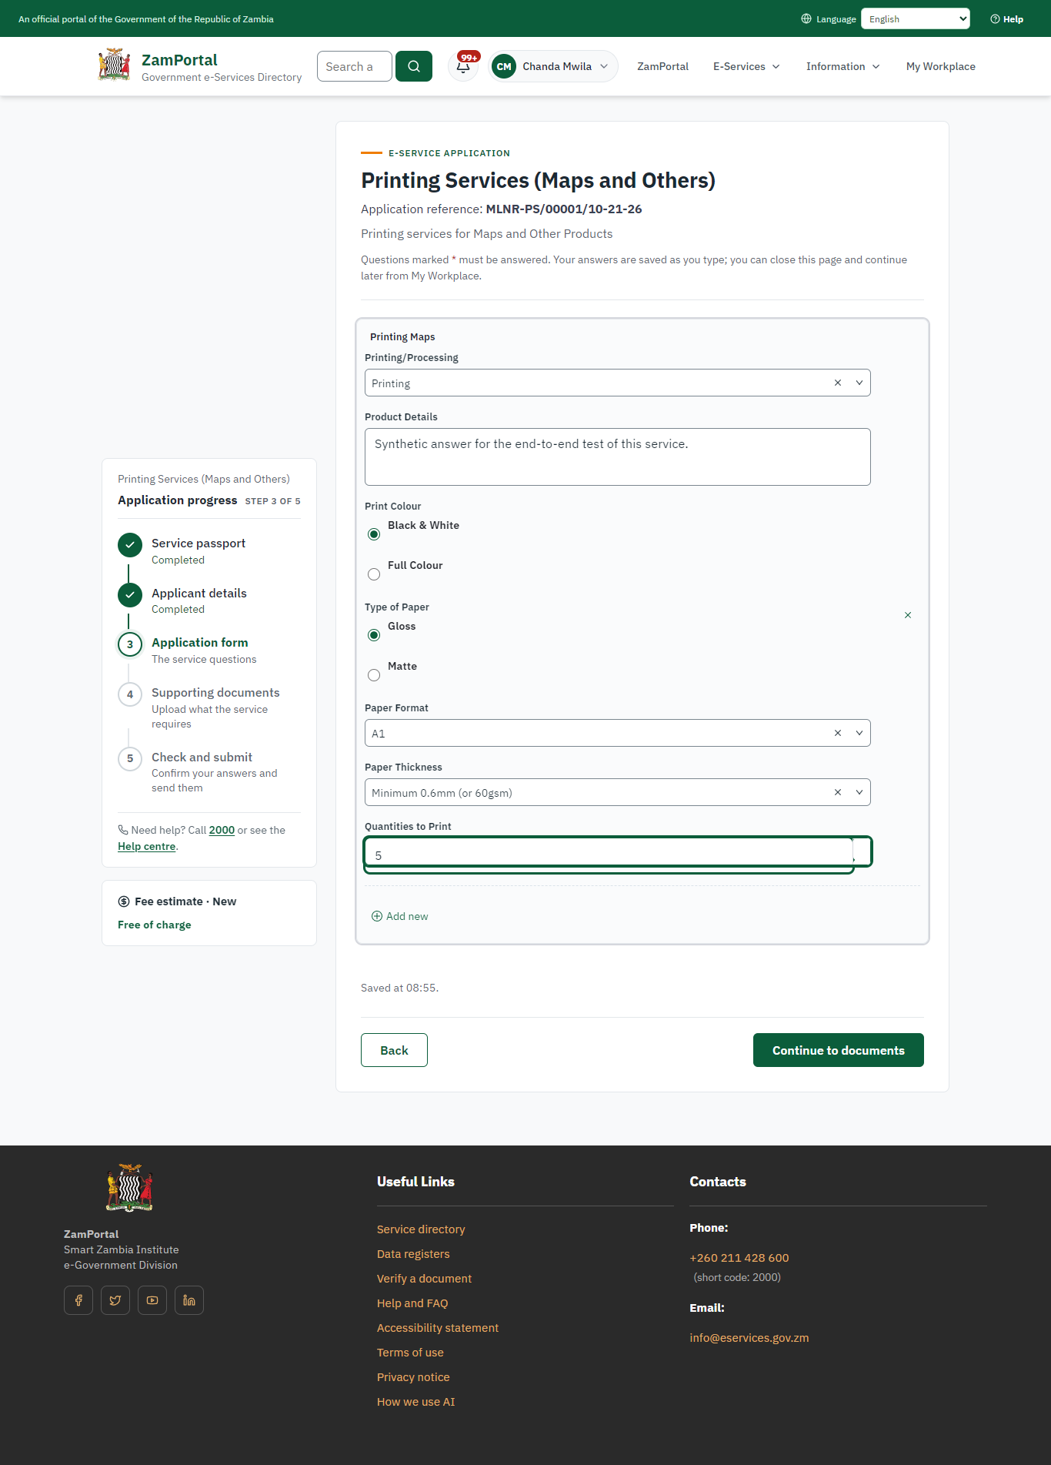 | 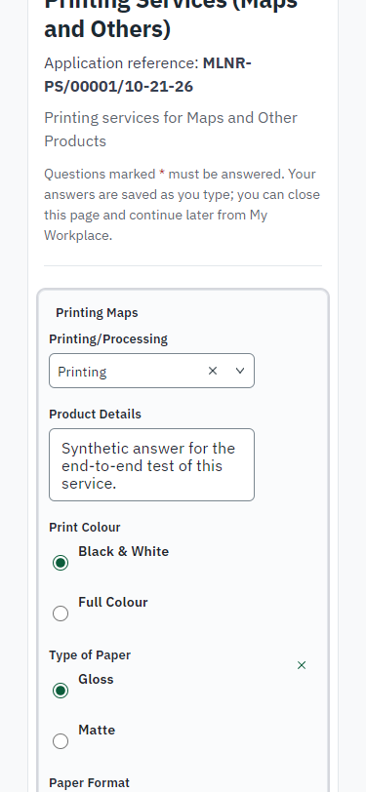
Step 4: Fill in the application form - desktop (left) and a 375 px phone (right).

Step 5. Upload the supporting documents
Citizen · National e-Services portal
Each document the service asks for has its own upload (3 in this run: National Registration Card (NRC), Certificate of Incorporation / ZDA (if company, church, society), Copy of the product to print). The files are checked and stored with the application; the page confirms each upload.
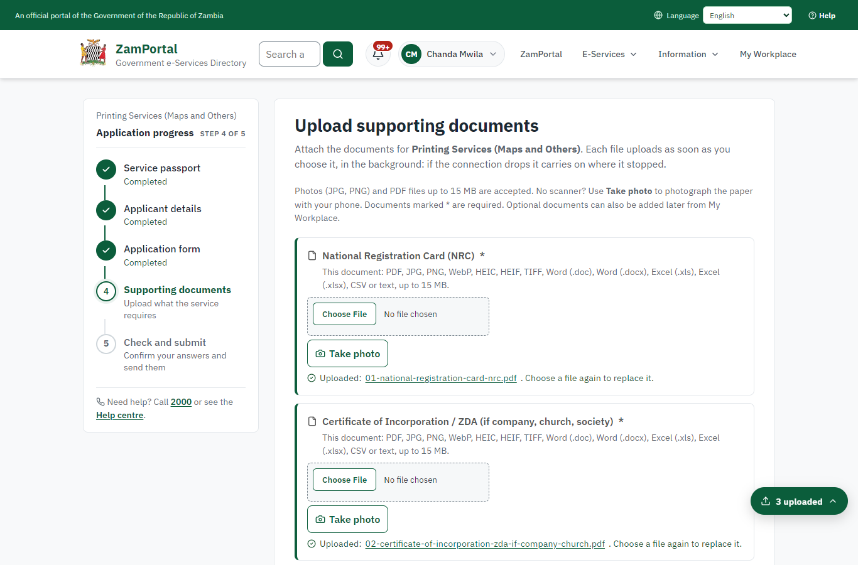 | 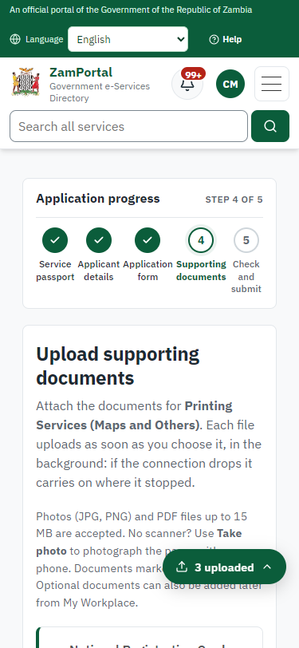
Step 5: Upload the supporting documents - desktop (left) and a 375 px phone (right).

Step 6. Check the answers and confirm the declaration
Citizen · National e-Services portal
Before sending, the citizen sees every answer and document on one page and can go back to change them. The declaration that the information is true and complete must be ticked.
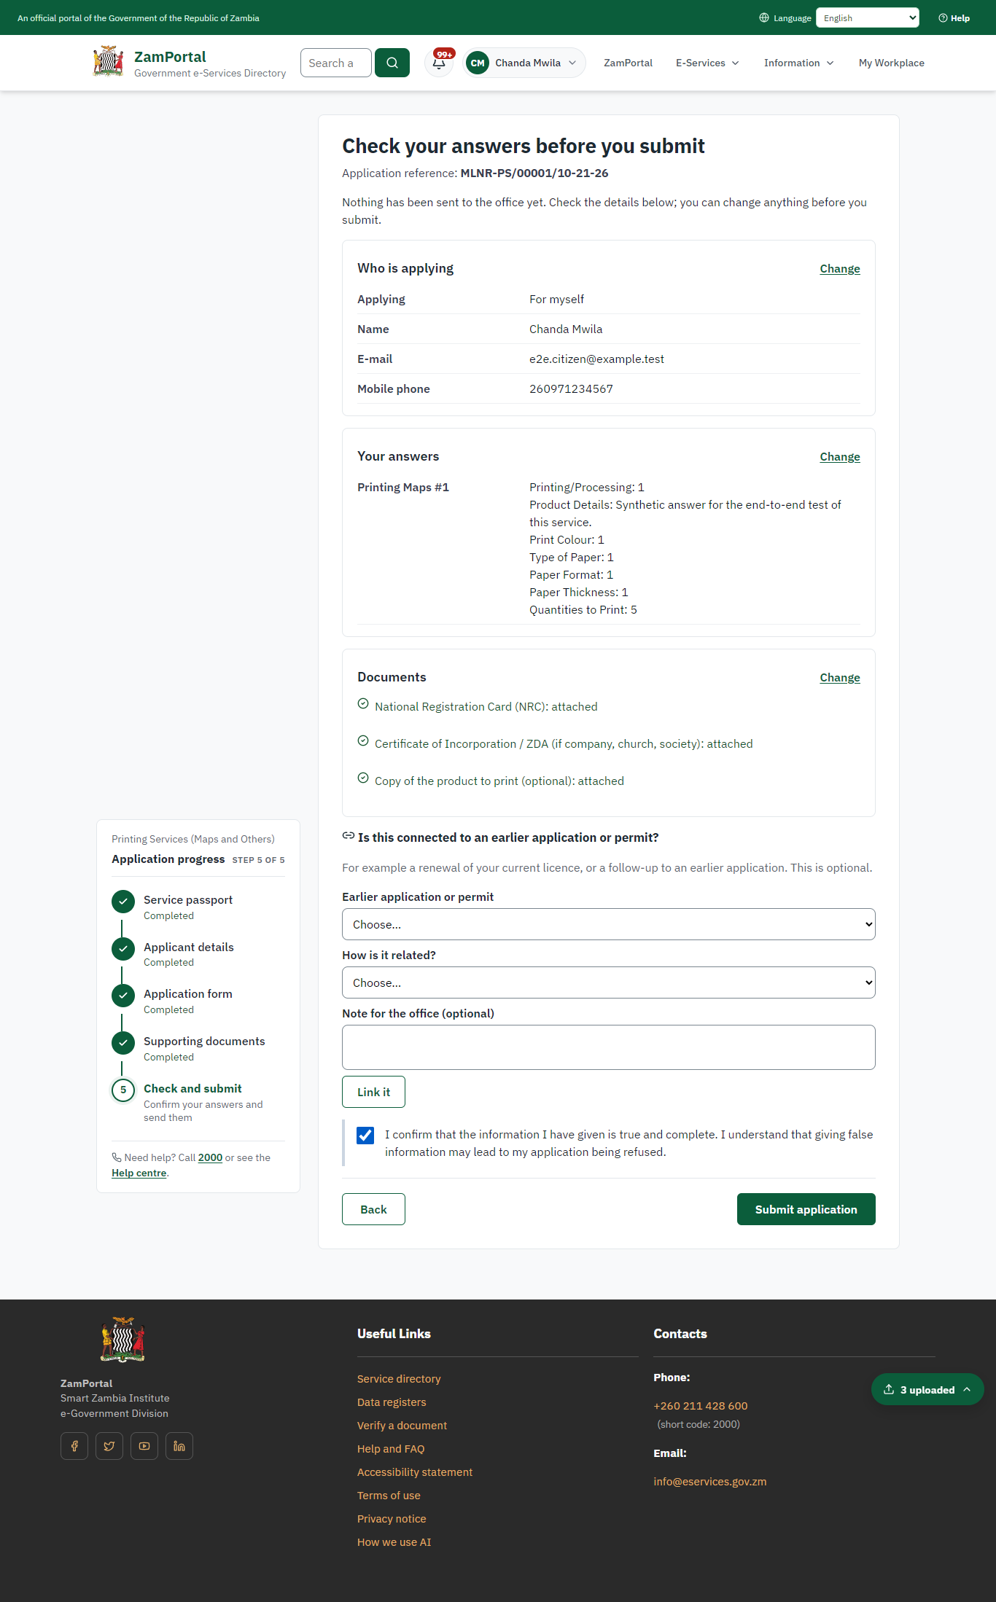 | 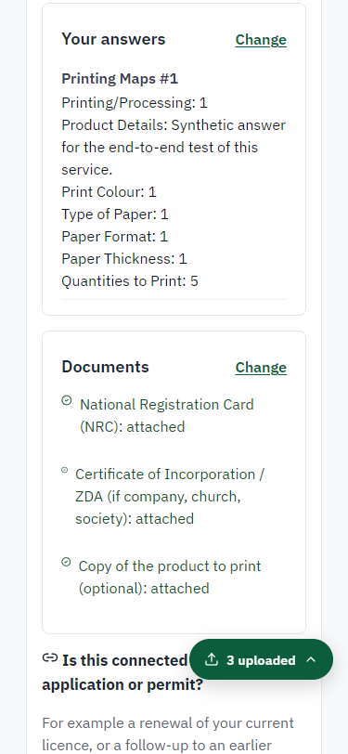
Step 6: Check the answers and confirm the declaration - desktop (left) and a 375 px phone (right).

Step 7. Application sent
Citizen · National e-Services portal
The portal confirms the application with the ministry's reference number (MLNR-PS/00001/10-21-26 in this run). The application goes to the ministry's officers; the citizen follows it in My Workplace.
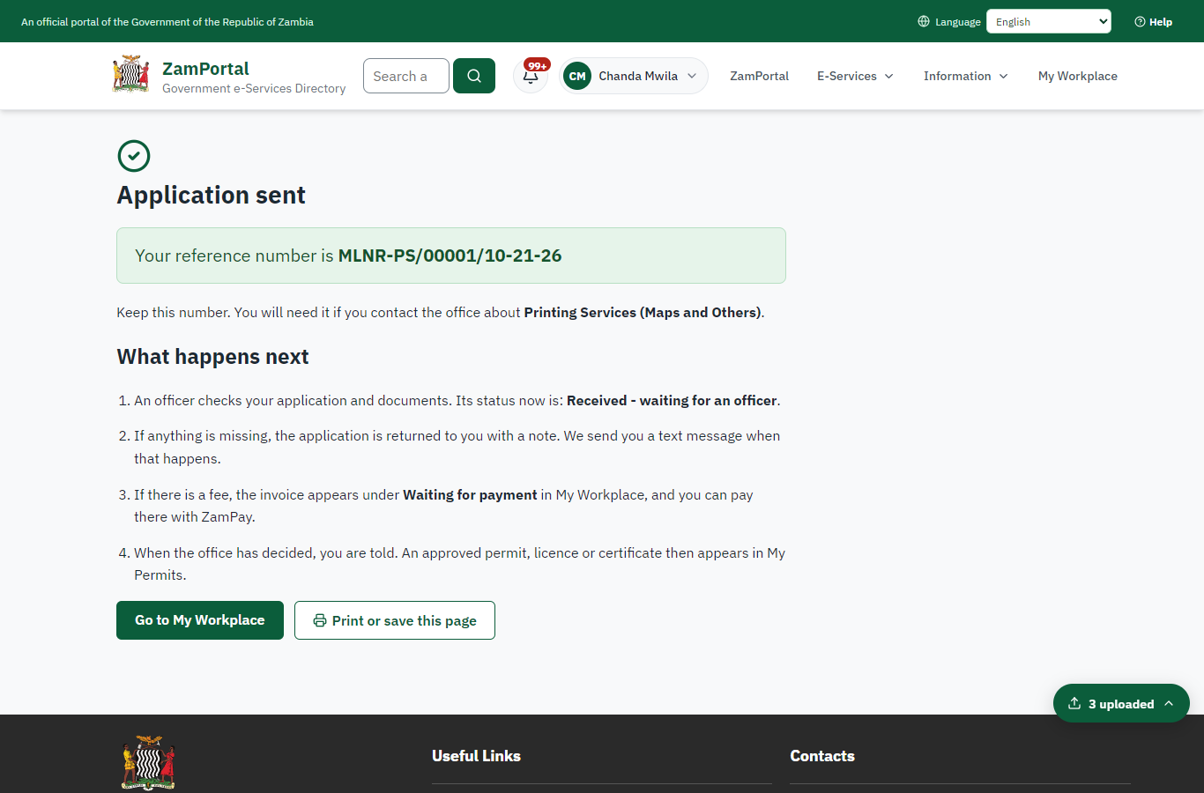 | 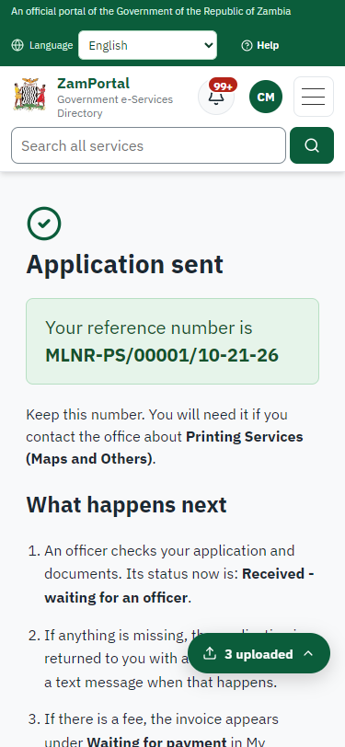
Step 7: Application sent - desktop (left) and a 375 px phone (right).

Step 8. Take the new application on
Case Officer · Back office
The application arrives in the case queue of the ministry that owns the service (Survey Department); only its staff see it. The officer opens it by its reference number - answers, documents and process are on the case - assigns it to themself and takes it on.
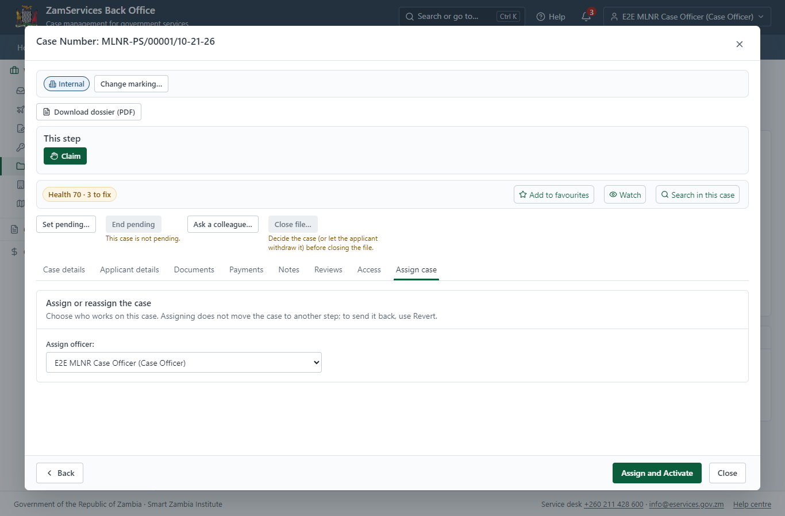
Step 8: Take the new application on.

Step 9. Receive, Inspect, Generate Quotation
Case Officer · Back office
The Case Officer works on "Receive, Inspect, Generate Quotation" (review in the imported process), checks the application and its documents, and completes the step.
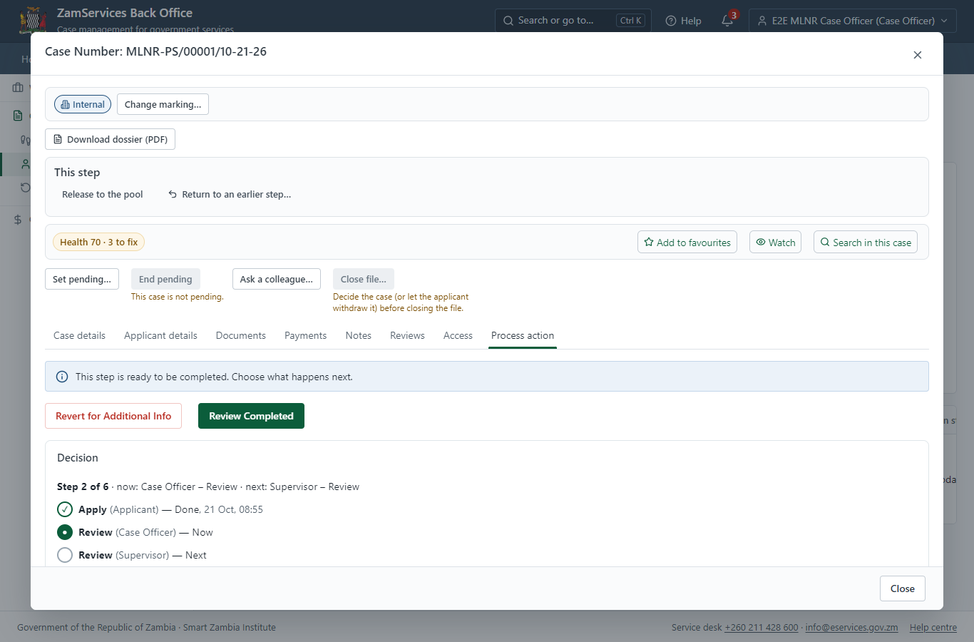
Step 9: Receive, Inspect, Generate Quotation.

Step 10. Review Case, Send Quotation
Supervisor · Back office
The Supervisor works on "Review Case, Send Quotation" (review in the imported process), checks the application and its documents, and completes the step.
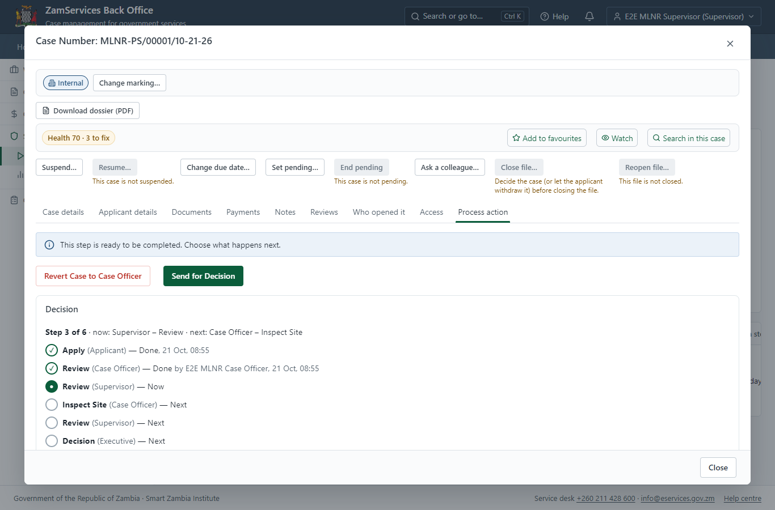
Step 10: Review Case, Send Quotation.

Step 11. Schedule visit / Upload Verification Report
Case Officer · Back office
The Case Officer works on "Schedule visit / Upload Verification Report" (inspection in the imported process), checks the application and its documents, and completes the step.
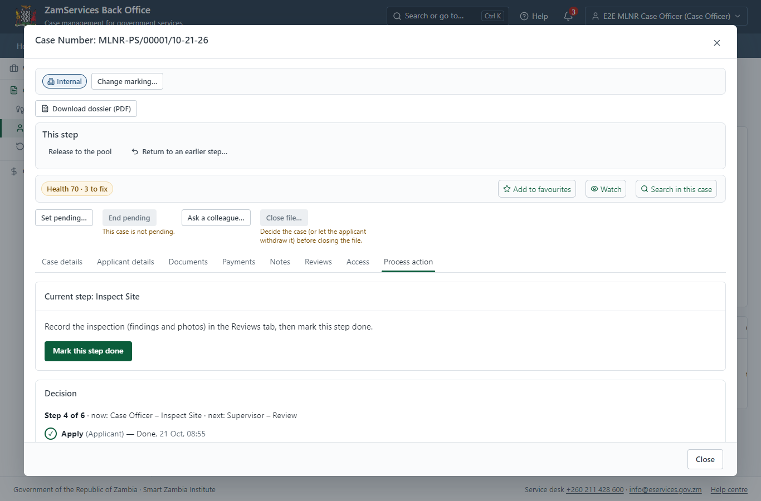
Step 11: Schedule visit / Upload Verification Report.

Step 12. Inspection: Schedule visit / Upload Verification Report
Case Officer · Back office
"Schedule visit / Upload Verification Report" is a site inspection: the case cannot move on until the findings are recorded. The officer assigns the inspection (to themself here) on the case's Reviews tab, visits the place and records each checklist item, the visit and the outcome ("passed" in this run); then completes the step.
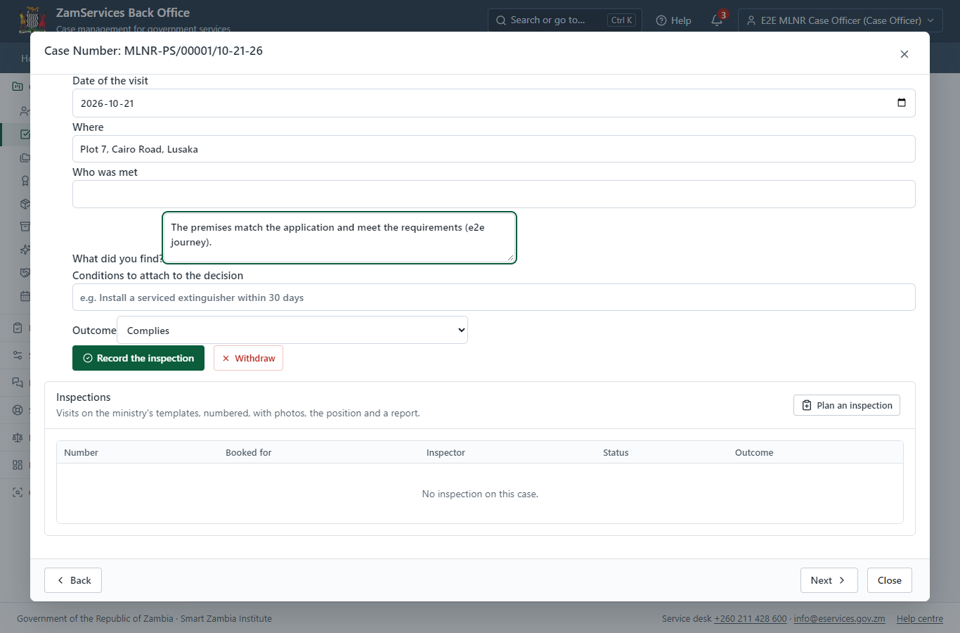
Step 12: Inspection: Schedule visit / Upload Verification Report.

Step 13. Review, Add Comments, Send for Signature
Supervisor · Back office
The Supervisor works on "Review, Add Comments, Send for Signature" (review in the imported process), checks the application and its documents, and completes the step.
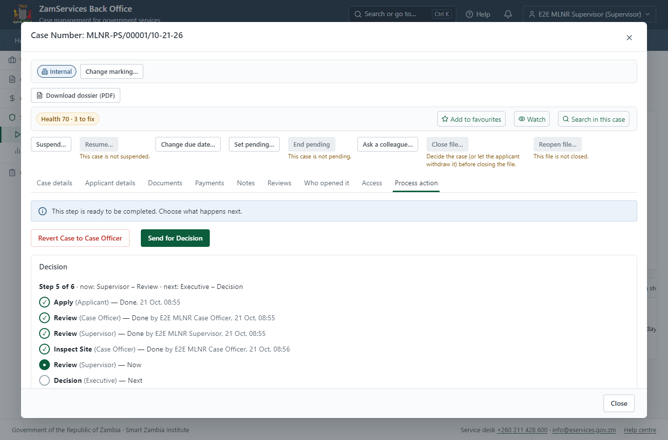
Step 13: Review, Add Comments, Send for Signature.

Step 14. Decide: Review Verification Report, Upload Letter of Response
Executive · Back office
At "Review Verification Report, Upload Letter of Response" the Executive records the decision: approve, with a comment kept in the case history. Approving moves the case on; the last decision completes it and issues the document.
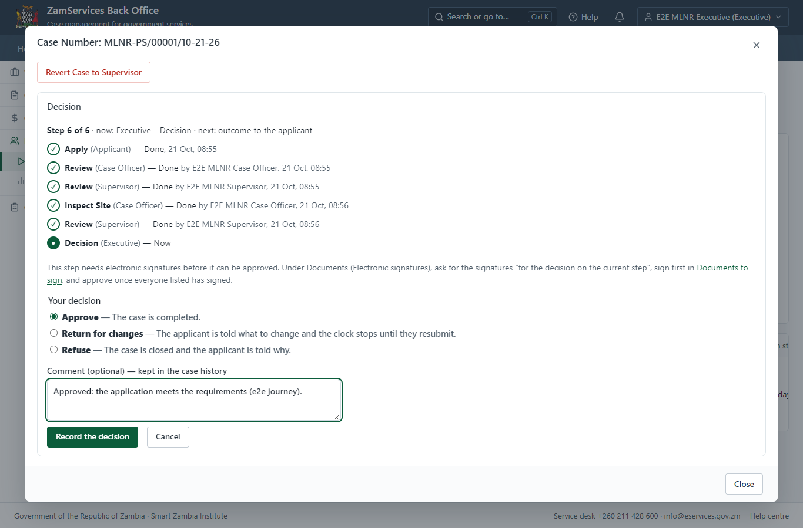
Step 14: Decide: Review Verification Report, Upload Letter of Response.

Step 15. Issue the document
Case Officer · Back office
The service's validity ("N/A") is not a fixed period, so completing the case does not issue the document by itself: the officer issues it from the completed case ("Issue / check permit"). It is generated from the service's output configuration and sealed.
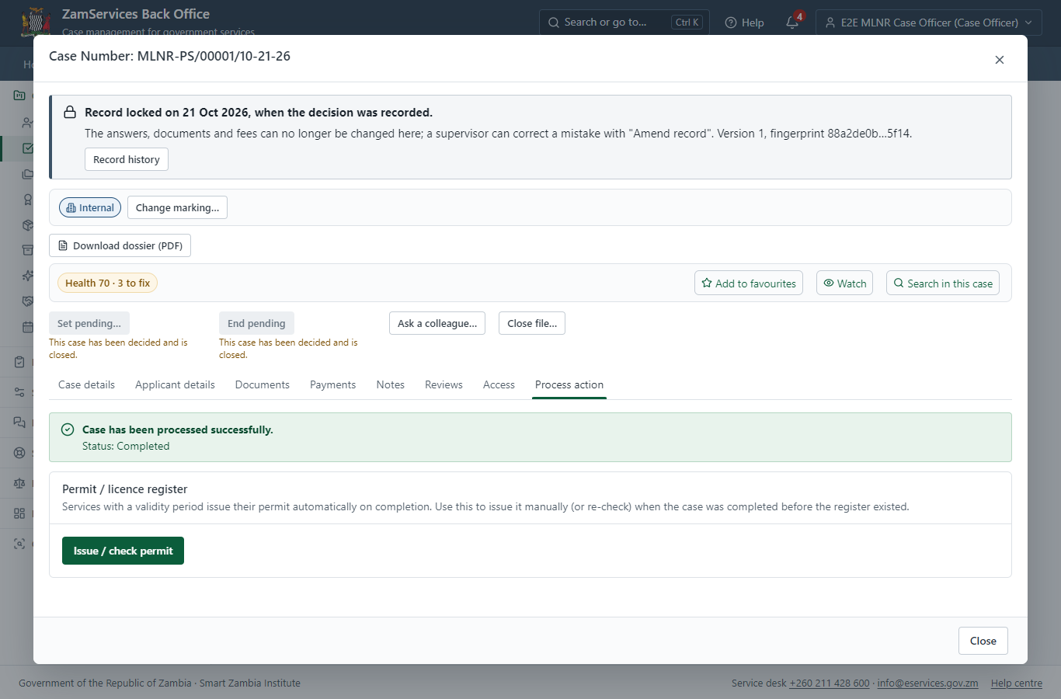
Step 15: Issue the document.

Step 16. The document in My permits
Citizen · National e-Services portal
The issued document (MLNR-PSMO-2026-00001 in this run: "Printing Services (Maps and Others)") is listed in "My permits and licences" with its validity and a download of the sealed PDF.
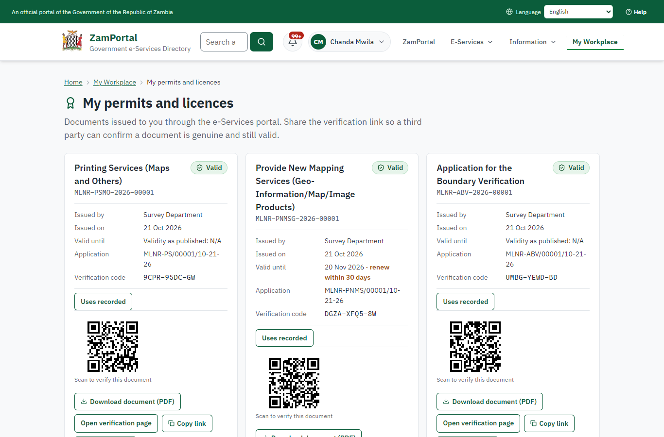 | 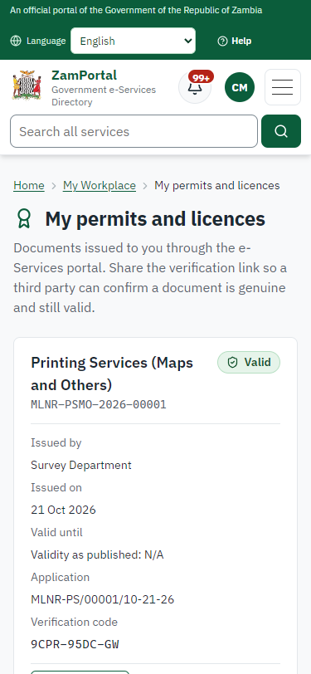
Step 16: The document in My permits - desktop (left) and a 375 px phone (right).

Step 17. Verify the document
Anyone (public) · Public verification page
The QR code on the document opens the public verification page: genuine and current, to whom it was issued, and whether the electronic seal is valid. No sign-in is needed.
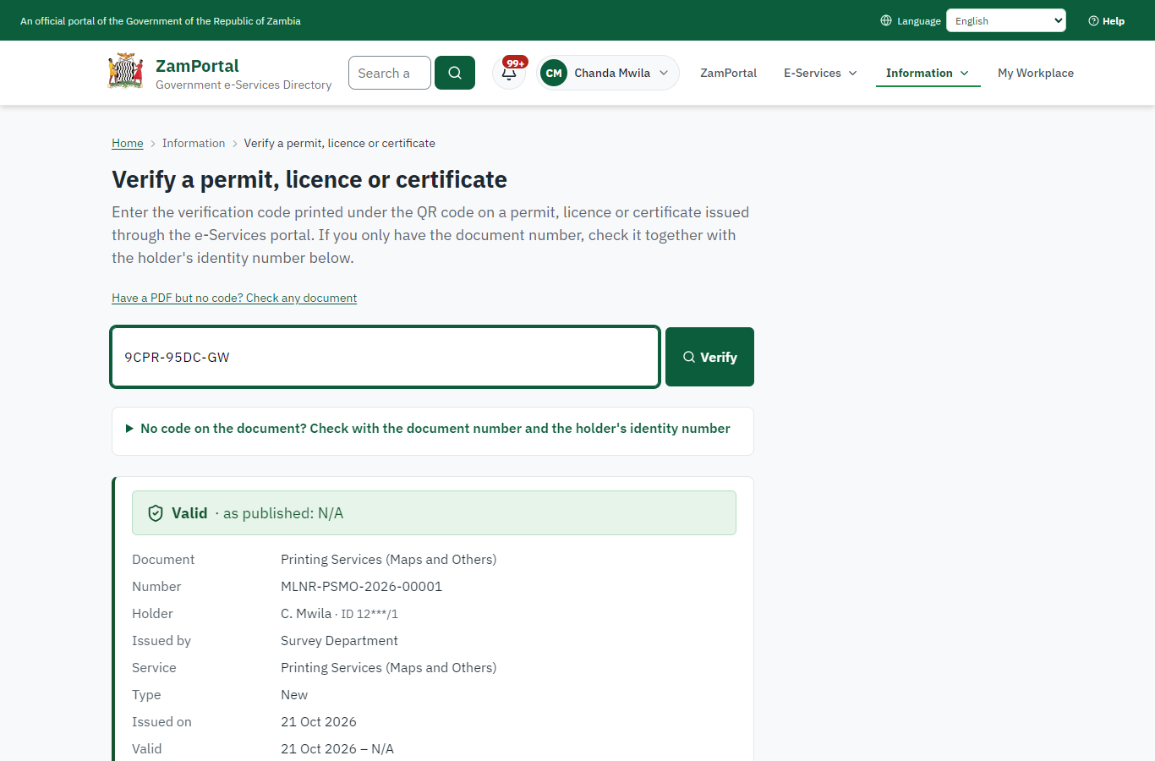 | 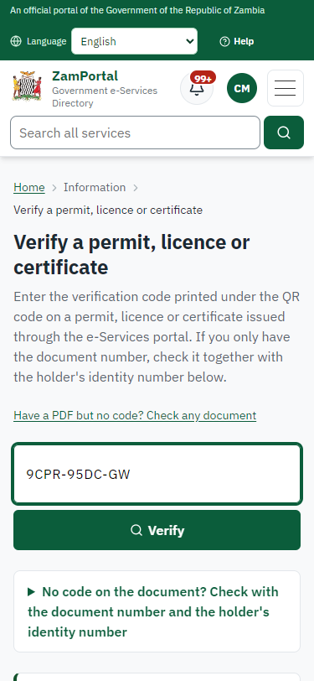
Step 17: Verify the document - desktop (left) and a 375 px phone (right).

3. Payment
Item | In the test run
Fee (as published) | Fee Schedule determined by the type of the product. To be calculated and provided by the Case Officer.

4. Output documents

Printing Services (Maps and Others) (sealed PDF)
Issued when the case was approved, from the service's output configuration (permitDocument/issued@1), filled from the application and the decision, sealed with the platform's electronic seal and stored as the issued version. The holder downloads it from My permits; the verification page checks it.
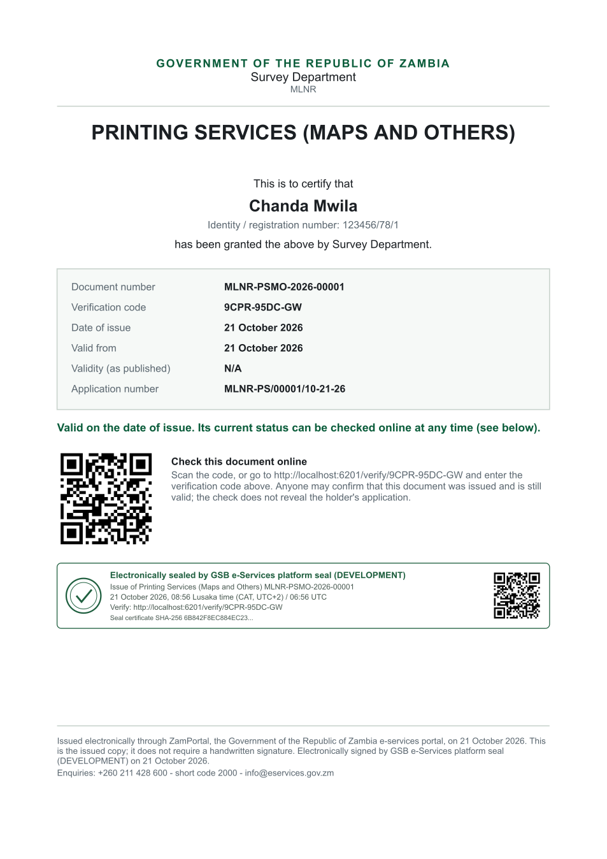
Printing Services (Maps and Others) (sealed PDF) - first of 1 page, as issued in the test run.

Fields
Field | Value in the test run
Document title | Printing Services (Maps and Others)
Permit / licence number | MLNR-PSMO-2026-00001
Holder | Chanda Mwila
Valid from | 2026-10-21
Valid until
Status | active
Verification code (printed with a QR code) | 9CPR-95DC-GW

Seal
Seal status | sealed
Signature level | PAdES-B-T
Sealed by | the platform seal (development key in the test run)
Signed at | 2026-10-21T06:56:19.566Z
Trusted time-stamp | 2026-10-21T06:56:20.288Z (time-stamping authority)
Document fingerprint (SHA-256) | 6eb71de115f77eb7...

Verification
Where | The public verification page of the national portal, <portal>/verify/<verification code>, opened by scanning the QR code on the document.
What it shows | Whether the document is genuine and current, its holder and validity, and whether the electronic seal is valid and who sealed it.
Checking a copy | Anyone can upload a PDF they were given; the page says whether it is exactly the document that was issued. A changed copy is reported as not matching.
On screen: step 15 (Issue the document), step 16 (The document in My permits), step 17 (Verify the document) in section 2.

5. Notifications
When | Channel | To | Message | Delivery
Application received | in-app (portal bell) | the applicant | Application MLNR-PS/00001/10-21-26 received - Your application MLNR-PS/00001/10-21-26 for Printing Services (Maps and Others) has been received by Survey Department. | shown
Status changed | in-app (portal bell) | the applicant | Update on application MLNR-PS/00001/10-21-26 - MLNR-PS/00001/10-21-26 (Printing Services (Maps and Others)) is now: With the office - being reviewed. | shown
case.inspection_scheduled | in-app (portal bell) | the applicant | Inspection for application MLNR-PS/00001/10-21-26 on Wednesday 21 October 2026 - Inspection for MLNR-PS/00001/10-21-26 (Printing Services (Maps and Others)) on Wednesday 21 October 2026. | shown
review.submitted | in-app (portal bell) | the applicant | Opinion received on case MLNR-PS/00001/10-21-26 - E2E MLNR Case Officer recorded an opinion on case MLNR-PS/00001/10-21-26: passed. | shown
Invitation to rate the service | in-app (portal bell) | the applicant | How was Printing Services (Maps and Others)? - How was Printing Services (Maps and Others)? Tell us in about a minute. | shown
Decision: approved | in-app (portal bell) | the applicant | Application MLNR-PS/00001/10-21-26 completed - MLNR-PS/00001/10-21-26 (Printing Services (Maps and Others)) is complete. Your documents are ready. | shown
Licence / permit issued | in-app (portal bell) | the applicant | Your Printing Services (Maps and Others) document has been issued - MLNR-PSMO-2026-00001 has been issued for Printing Services (Maps and Others). | shown
Application received | sms | +260 97* *** 567 | Application MLNR-PS/00001/10-21-26 for Printing Services (Maps and Others) has been received. Track it: <portal>/my-workplace | delivered
Application received | email | e2e.c***@example.test | Application MLNR-PS/00001/10-21-26 received | skipped
Status changed | sms | +260 97* *** 567 |  | delivered
review.requested | email | e2e.c***@example.test | Your opinion is requested on application MLNR-PS/00001/10-21-26 | skipped
case.inspection_scheduled | email | e2e.c***@example.test | Inspection for application MLNR-PS/00001/10-21-26 on Wednesday 21 October 2026 | skipped
case.inspection_scheduled | sms | +260 97* *** 567 |  | delivered
review.submitted | email | e2e.c***@example.test | Opinion received on case MLNR-PS/00001/10-21-26 | skipped
Invitation to rate the service | sms | +260 97* *** 567 |  | skipped
Invitation to rate the service | email | e2e.c***@example.test | How was Printing Services (Maps and Others)? | skipped
Decision: approved | email | e2e.c***@example.test | Application MLNR-PS/00001/10-21-26 completed | skipped
Decision: approved | sms | +260 97* *** 567 |  | delivered
Licence / permit issued | email | e2e.c***@example.test | Your Printing Services (Maps and Others) document has been issued | skipped
Licence / permit issued | sms | +260 97* *** 567 |  | delivered
Delivery: shown = in the portal's notification bell; delivered = the SMS gateway (a test double in this run) reported the text delivered; skipped = not sent on that channel (e-mail is not configured on the test installation, and some notices go out on one channel only); sent by the national portal = a ministry node handed the notice to the national portal, which texts and e-mails the citizen under its own name and the citizen's preferences. Addresses written <portal>, <ZamPay> stand for the national portal and ZamPay.

6. Legacy mapping
Replaces | Printing Services (Maps and Others) in the legacy ZIGS e-Services directory (ZIGS_Services)
Legacy service id | 399
Legacy provider | Survey Department (MLNR) under Ministry of Lands and Natural Resources
Legacy process | Standard.Review_3Step (process 103)
Fee in the legacy system | none
Fee taken before submission | yes (as in ZIGS)
Time to issue (legacy) | New: 5 working days
Legacy output templates | Notice of Action: ZIGS_Forms_Notices / GS-2.NoticeOfAction  Application form: ZIGS_Forms_MLNR / MLNR_PrintingService.Application
Legacy address | none recorded
How it was brought over | Imported by the platform's legacy catalogue importer (zcm-backend scripts/zigs/importLegacy.js) from the ZIGS snapshot: form, case types, fees, documents, process and output templates, then served by the new platform.

7. Version and date
Document version | service v1, platform a0a302b8
Generated | 2026-10-21T06:56:28Z (by the end-to-end run, not edited by hand)
Service version | not versioned (configured directly)
Platform snapshot | backend a0a302b8  portal 72805f0  back office 58e5946
Test suite | e2e 5999d9b; one installation (combined); seed profile mihud
Journeys | 30-catalogue-service.spec.js: citizen finds the service, answers its form, uploads its documents and sends the application - passed  30-catalogue-service.spec.js: the case goes through every step of its process: payments by the citizen, each officer step by its role - passed  30-catalogue-service.spec.js: the grant document is issued, sealed, filled in and verifiable; the citizen has it in My permits - passed
Result | 3 of 3 journey tests passed
Data | Synthetic test data on a local test installation; provider test doubles for ZamPass, ZamPay, SMS and signing.

