Republic of Zambia
GSB e-Services

Mineral Processing Licence
Service documentation
Owner: Cadastre Department
Service key: MMMD/mineral-processing-licence
Version: service v1, platform a0a302b8
Date: 2026-10-21
Generated automatically by the service's end-to-end test run. Every screenshot shows synthetic test data on a local test installation, never real personal data.

Contents
- 1. Service summary
- 2. Application process, step by step
- 3. Payment
- 4. Output documents
- 5. Notifications
- 6. Legacy mapping
- 7. Version and date
This document describes the Mineral Processing Licence service of Cadastre Department as the platform runs it today. It is generated by the service's end-to-end test: every step was performed by the test and every screenshot was taken during that run, with synthetic data. Regenerate it with "npm run docs:services" in the e2e suite; do not edit it by hand.

1. Service summary
Service | Mineral Processing Licence
Owner (MDA) | Cadastre Department (MMMD)
Purpose | This License is issued to individuals or organization who intends to process minerals in Zambia.
Who can apply | Individual; Organization
How to apply | Online on the national e-Services portal, signed in with ZamPass; pay with ZamPay.
Fees | Mineral Processing Licence - Application Fee: ZMW 48000.00
Turnaround | 60 days
Validity of the output | Twenty-five (25) years
Required documents | Documentation on title to land or written consent of legal occupier of land, written consent from the surface right holder or mining right holder (required)  Proof that the applicant has not contravened any provision of this Mines and Minerals Development Act of 2015 and any other relevant written law (required)  Description and plan of surrounding developments and details of expected infrastructure requirements (required)  Feasibility study for processing operations (should include a forecast of capital investment, proposed plant capacity… (required) - Feasibility study for processing operations (should include a forecast of capital investment, proposed plant capacity, the estimated recovery rate of mineral products and the proposed treatment methods and disposal of ore and minerals recovered)  Environmental Management Plan (should include proposals for prevention of pollution, treatment of waste… (required) - Environmental Management Plan (should include proposals for prevention of pollution, treatment of waste, protection and reclamation of land and water resources and for eliminating or minimizing adverse effects on the environment)  Proposals for employment and training of citizens of Zambia (required)  Tax Clearance Certificate (issued under Income Tax Act, Cap. 323) (required)  Coordinates of Area Applied For (required)
Output documents | Denial of Service  Mineral Processing Licence  Notice of Approval  Approval Letter  Application form  GS-2 Notice of Government Action  GF-1 Treasury Invoice  GF-2 Treasury Receipt
Legal basis | The Mines and Minerals Development Act of 2015 (http://www.parliament.gov.zm/sites/default/files/documents/acts/The%20Mines%20and%20Minerals%20Act%2C%202015.pdf)  The Mines and Minerals Act no 14 of 2016 (http://www.parliament.gov.zm/sites/default/files/documents/amendment_act/The%20Mines%20and%20Minerals%20Act%20No%2014%2C%202016.pdf)  SI N0 7 of 2016 (https://zambialii.org/zm/legislation/statutory-instrument/2016/no-7-2016)

2. Application process, step by step

The process as configured
Step | Role | Task | Type
1 | Applicant | Apply | form
2 | Applicant | Payment | payment
3 | System | Generate Document | generate-document
4 | Case Officer | Review | review
5 | Case Officer | Review | review
6 | Supervisor | Review | review
7 | Executive | Decision | decision
8 | System | Generate Document | generate-document
9 | System | Generate Document | generate-document
10 | System | Generate Document | generate-document
11 | System | Notify Client | notify

Step by step
Who takes part in this journey: Citizen, Case Officer, Supervisor, Executive, Anyone (public). Citizen steps are shown on a desktop and on a 375 px phone; back-office steps on a desktop.

Step 1. Find the service
Citizen · National e-Services portal
On the national e-Services portal the citizen opens All Services and searches for the service by name ("Mineral Processing Licence"). Each result names the service and the ministry that provides it.
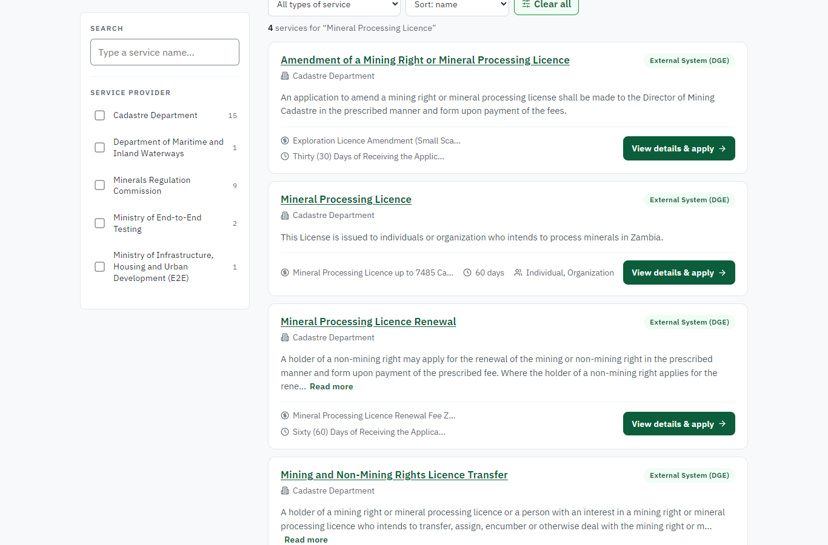 | 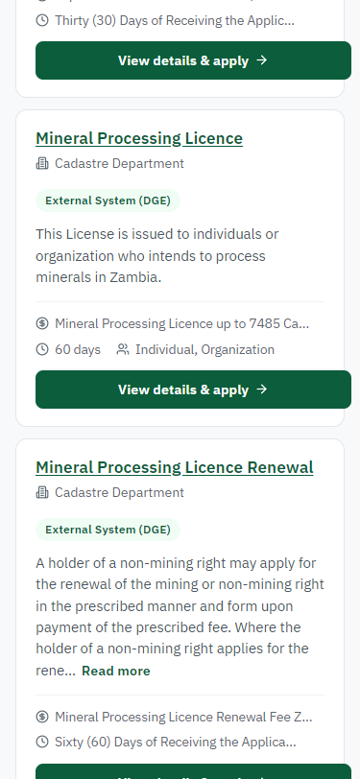
Step 1: Find the service - desktop (left) and a 375 px phone (right).

Step 2. Read the service page
Citizen · National e-Services portal
The service page sets out what the service is for, who provides it, the fee, how long it takes and the documents to have ready. "Start application" begins an application (the citizen is signed in with ZamPass).
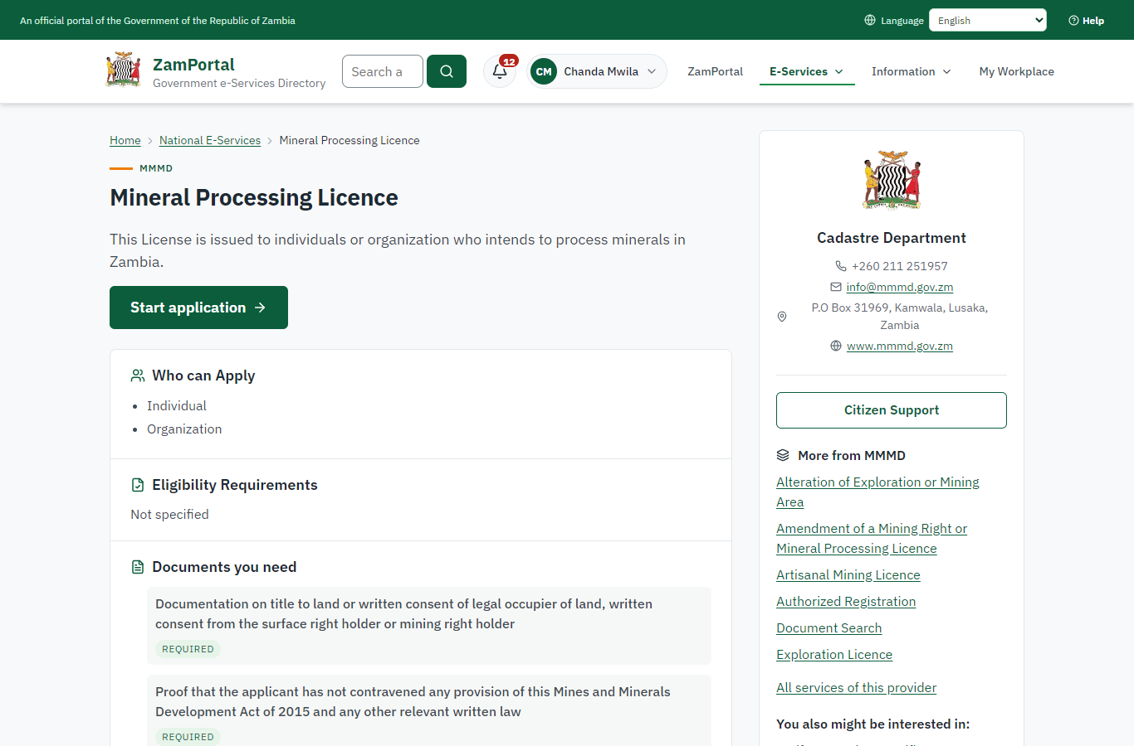 | 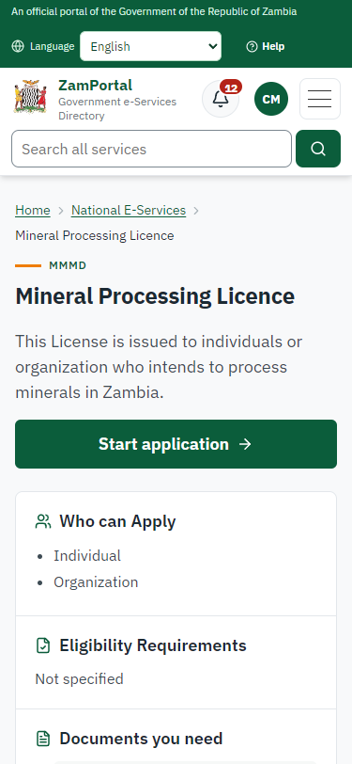
Step 2: Read the service page - desktop (left) and a 375 px phone (right).

Step 3. Confirm the applicant details
Citizen · National e-Services portal
The applicant details are filled in from the citizen's ZamPass account. The citizen says whom they are applying for (themself) and continues with "Proceed to Application".
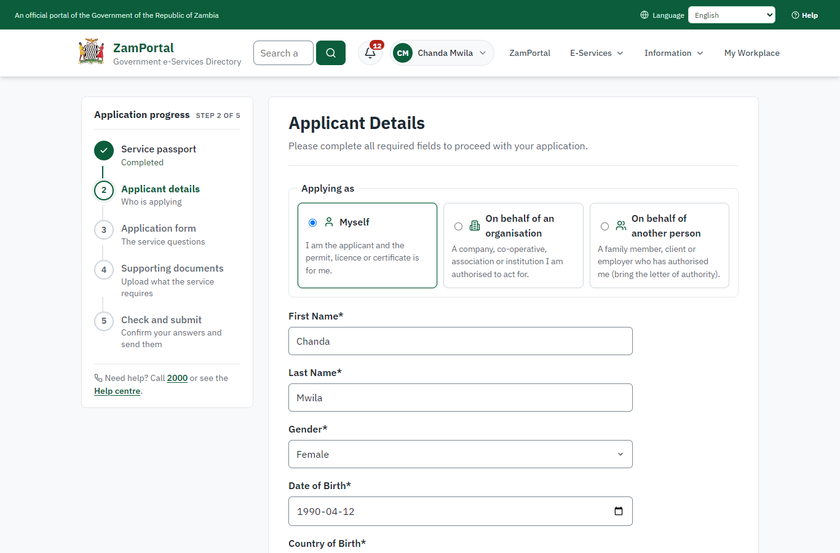 | 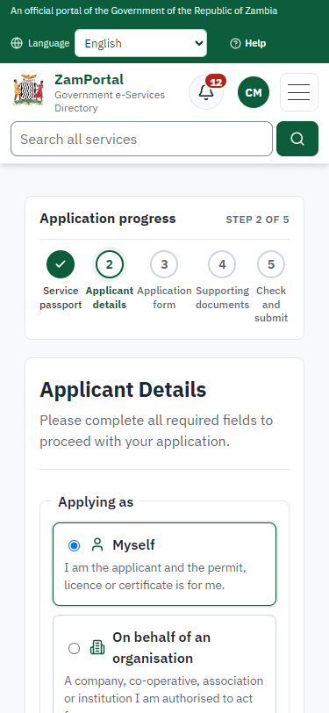
Step 3: Confirm the applicant details - desktop (left) and a 375 px phone (right).

Step 4. Fill in the application form
Citizen · National e-Services portal
The citizen answers the service's own application form, converted from the legacy system (34 answers in this run, all synthetic), for the type of application "New". Questions marked * must be answered; some appear only after an earlier answer. Answers are saved as the citizen types, so an unfinished application can be reopened from My Workplace.
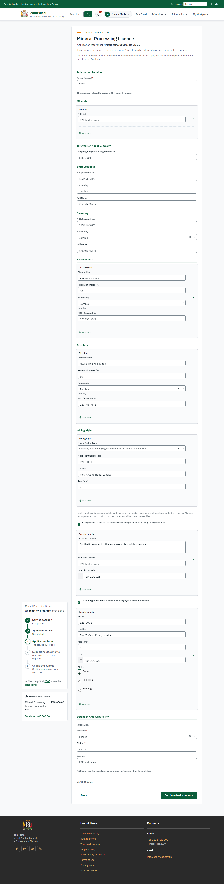 | 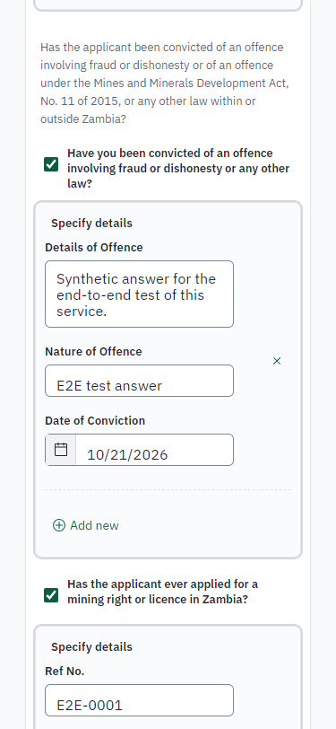
Step 4: Fill in the application form - desktop (left) and a 375 px phone (right).

Step 5. Upload the supporting documents
Citizen · National e-Services portal
Each document the service asks for has its own upload (8 in this run: Documentation on title to land or written consent of legal occupier of land, written consent from the surface right holder or mining right holder, Proof that the applicant has not contravened any provision of this Mines and Minerals Development Act of 2015 and any other relevant written law, Description and plan of surrounding developments and details of expected infrastructure requirements, Feasibility study for processing operations (should include a forecast of capital investment, proposed plant capacity…, Environmental Management Plan (should include proposals for prevention of pollution, treatment of waste…, Proposals for employment and training of citizens of Zambia, Tax Clearance Certificate (issued under Income Tax Act, Cap. 323), Coordinates of Area Applied For). The files are checked and stored with the application; the page confirms each upload.
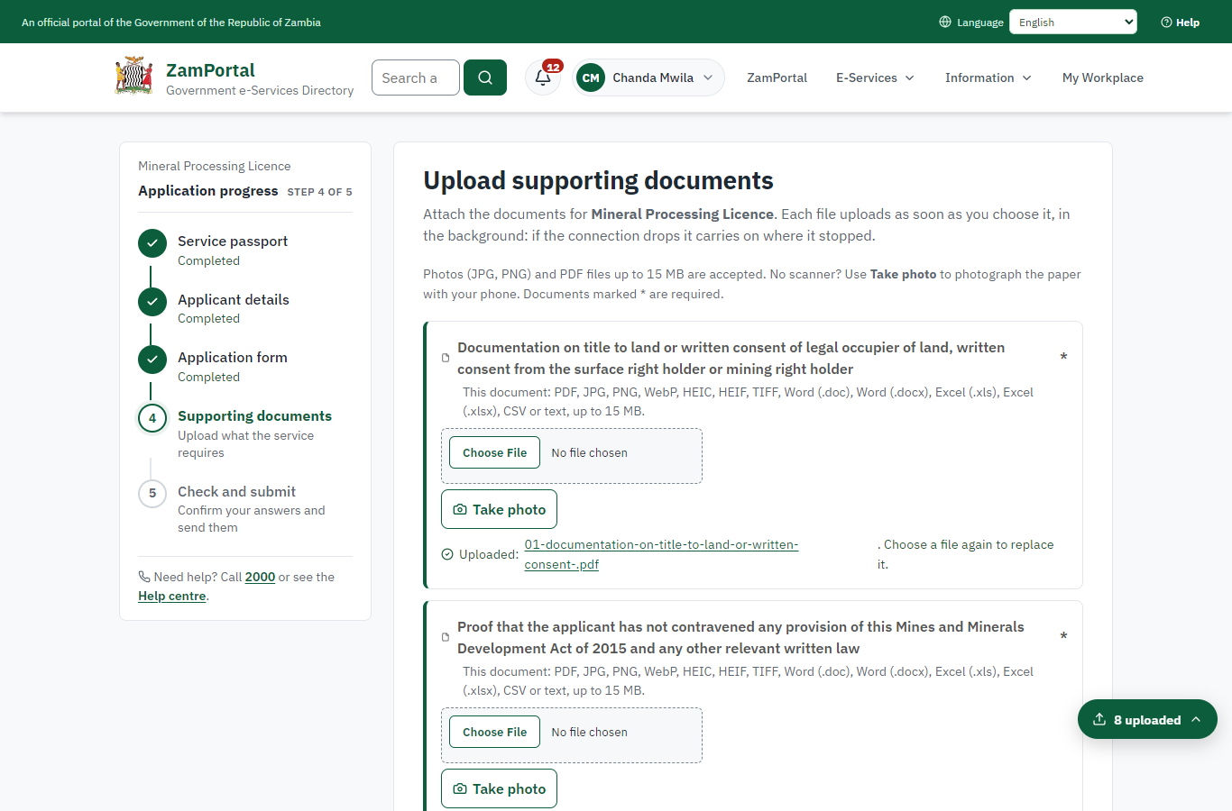 | 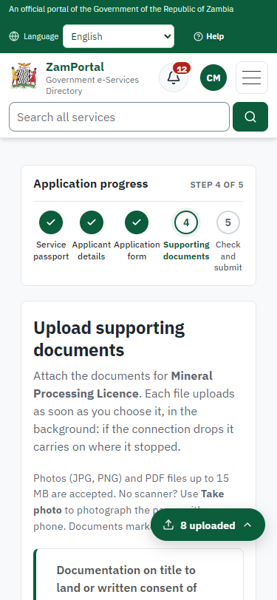
Step 5: Upload the supporting documents - desktop (left) and a 375 px phone (right).

Step 6. Check the answers and confirm the declaration
Citizen · National e-Services portal
Before sending, the citizen sees every answer and document on one page and can go back to change them. The declaration that the information is true and complete must be ticked.
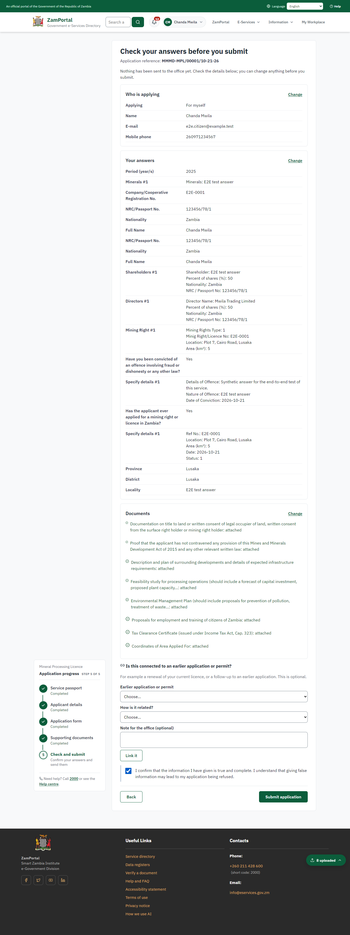 | 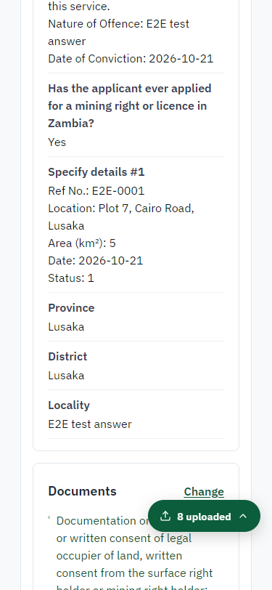
Step 6: Check the answers and confirm the declaration - desktop (left) and a 375 px phone (right).

Step 7. Application sent
Citizen · National e-Services portal
The portal confirms the application with the ministry's reference number (MMMD-MPL/00001/10-21-26 in this run). The fee is due now: it is taken with the application, so the invoice was raised when the application was sent.
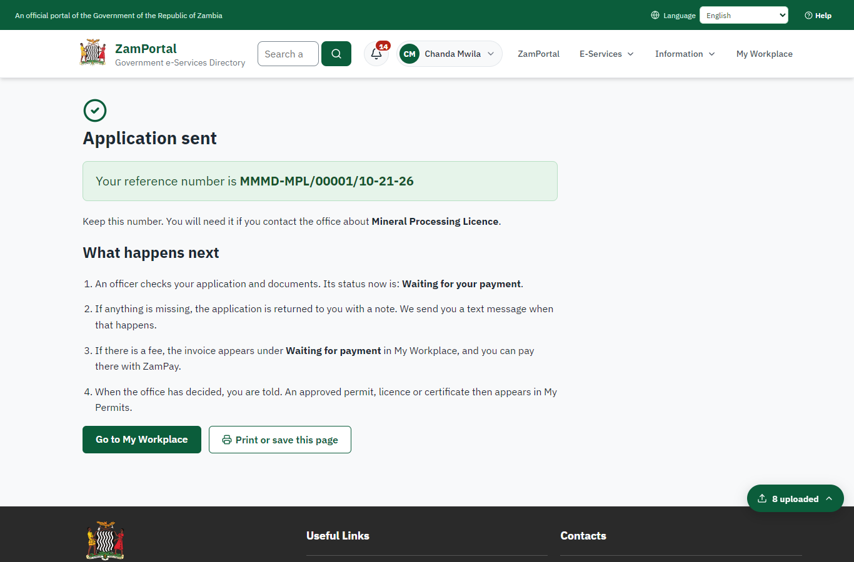 | 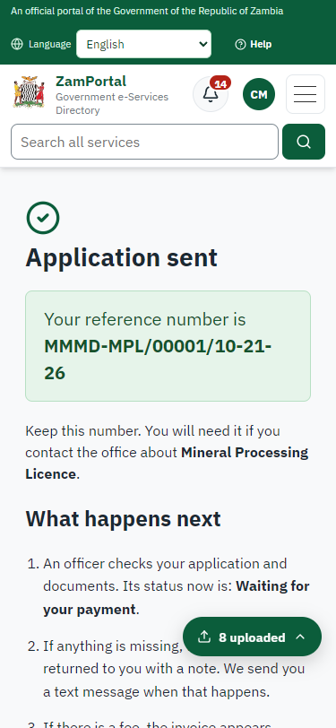
Step 7: Application sent - desktop (left) and a 375 px phone (right).

Step 8. See that the fee is due
Citizen · National e-Services portal
The application shows "Waiting for your payment" in My Workplace with a Pay button (K48,000.00). The fee is taken with the application; the invoice was raised on ZamPay.
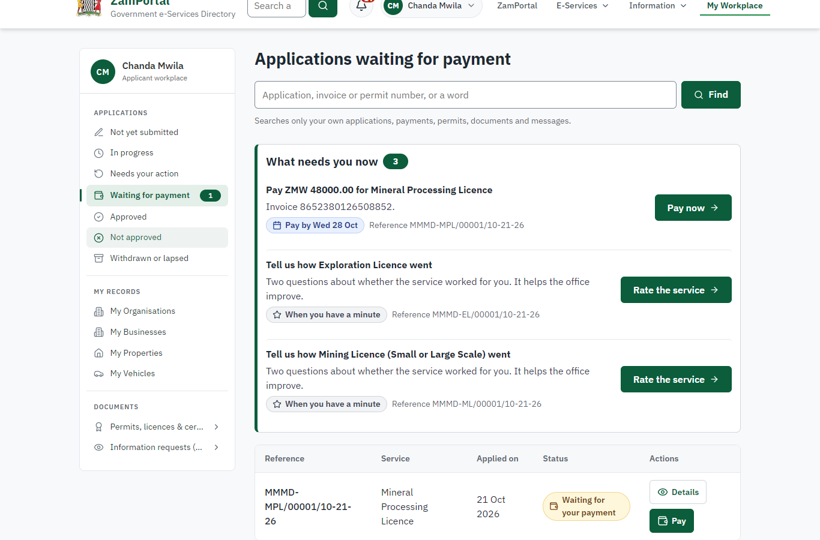 | 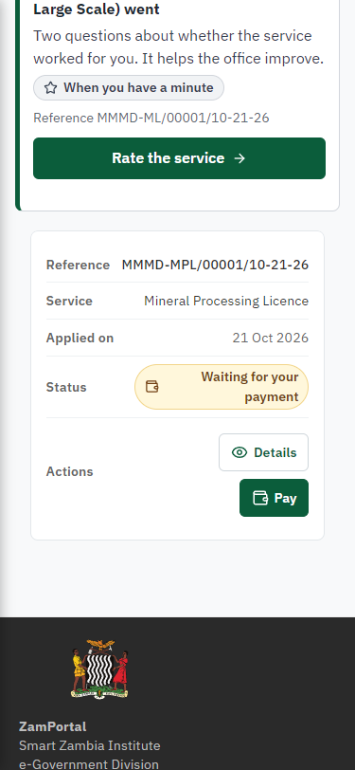
Step 8: See that the fee is due - desktop (left) and a 375 px phone (right).

Step 9. Pay with ZamPay
Citizen · National e-Services portal
Pay opens the invoice (K48,000.00, the amount set by the platform, never by the page) with its PDF preview; the citizen pays at ZamPay by mobile money or bank card.
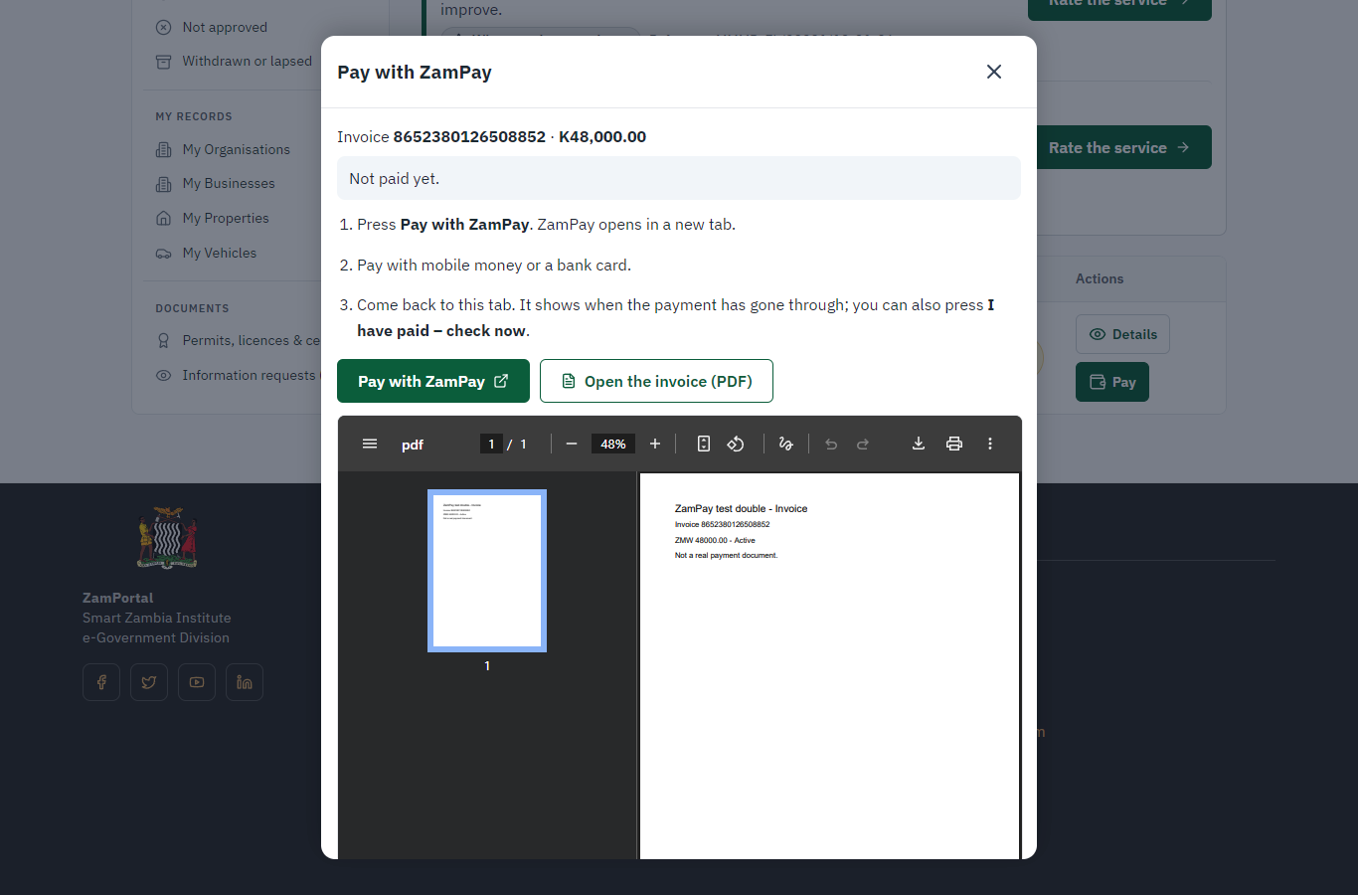 | 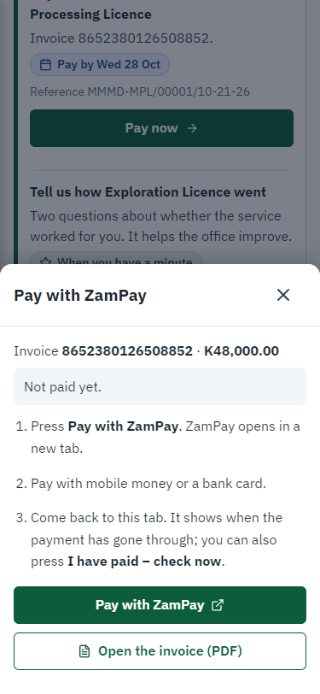
Step 9: Pay with ZamPay - desktop (left) and a 375 px phone (right).

Step 10. Payment received
Citizen · National e-Services portal
ZamPay reports the payment; the dialog says "Paid. Thank you" and the application moves on to the ministry's officers.
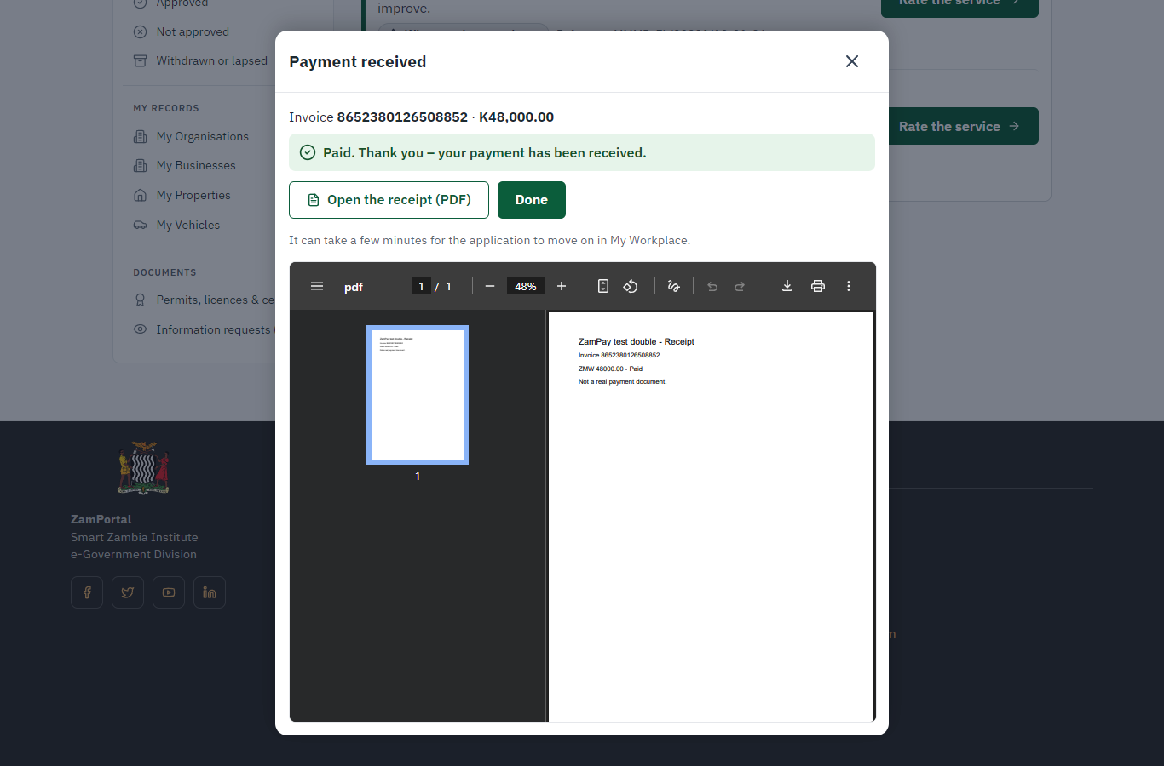 | 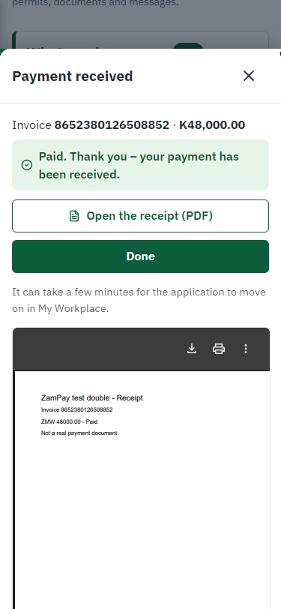
Step 10: Payment received - desktop (left) and a 375 px phone (right).

Step 11. Take the new application on
Case Officer · Back office
The application arrives in the case queue of the ministry that owns the service (Cadastre Department); only its staff see it. The officer opens it by its reference number - answers, documents and process are on the case - assigns it to themself and takes it on.
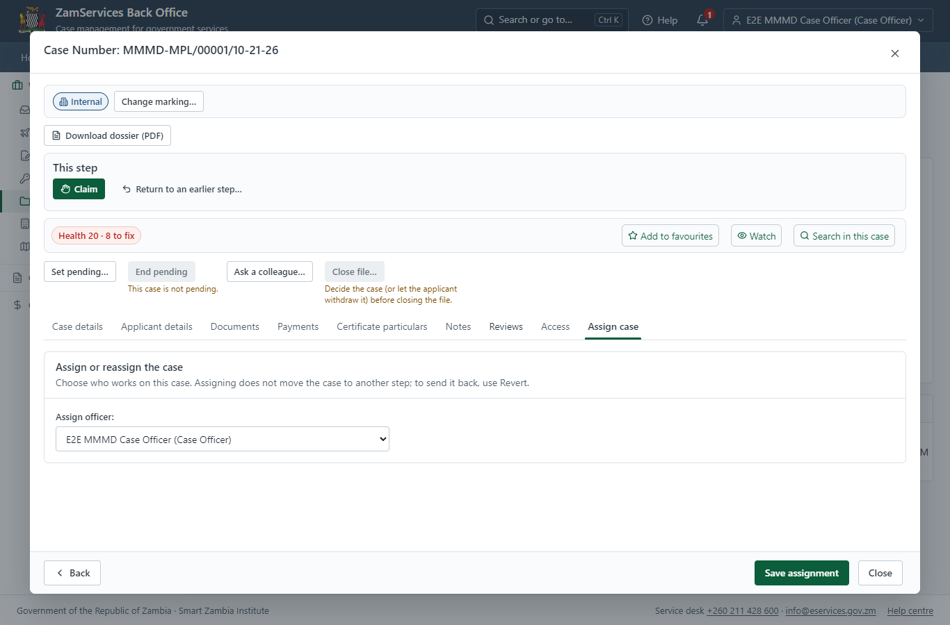
Step 11: Take the new application on.

Step 12. Fill in the certificate particulars
Case Officer · Back office
The issued document prints 1 field that come from the office rather than from the application (Bordered on the Plan). The officer fills them in on the case's "Certificate particulars" tab before the document is issued (synthetic values in this run) and saves; once the document is issued they can no longer change.
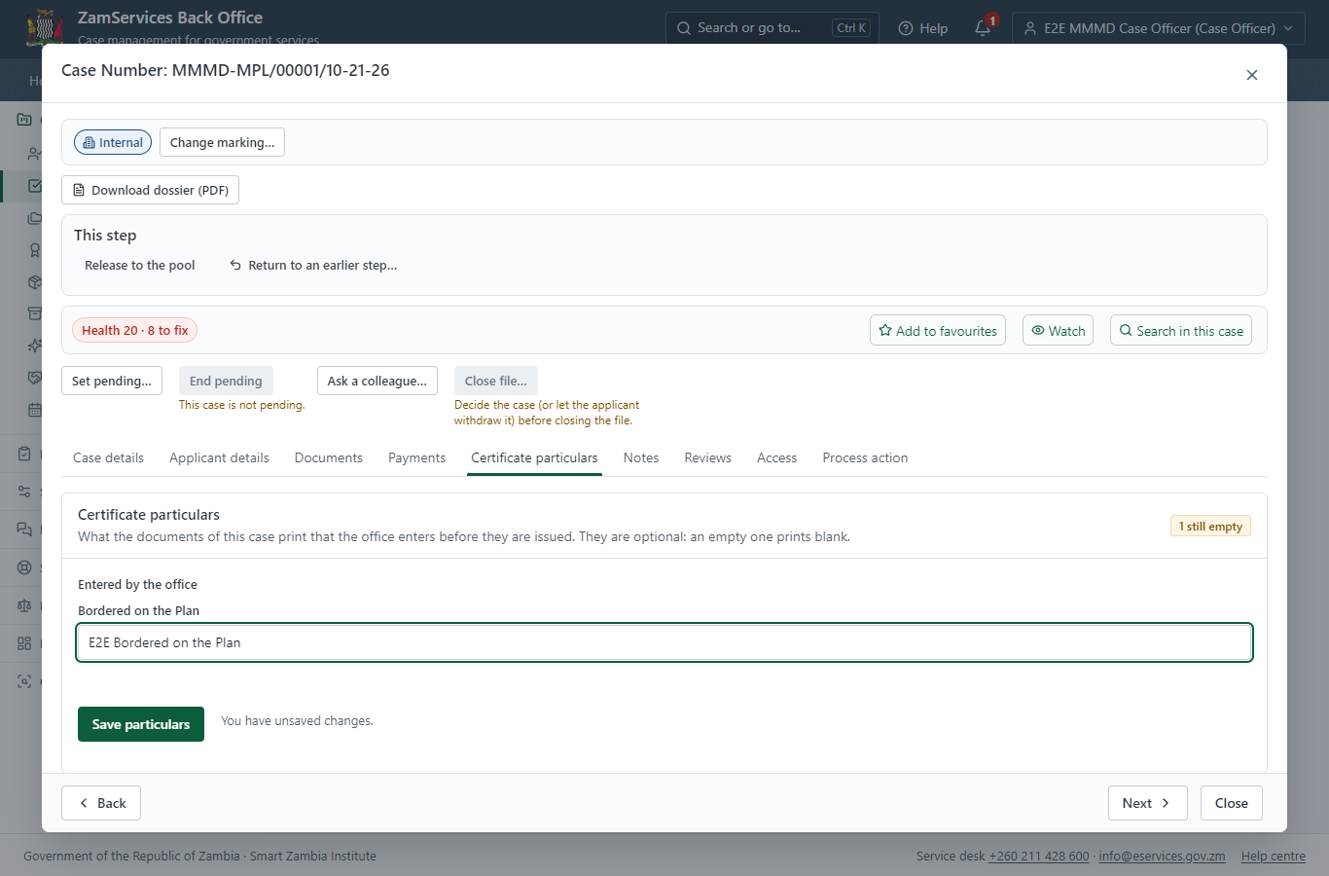
Step 12: Fill in the certificate particulars.

Step 13. Review Application
Case Officer · Back office
The Case Officer works on "Review Application" (review in the imported process), checks the application and its documents, and completes the step.
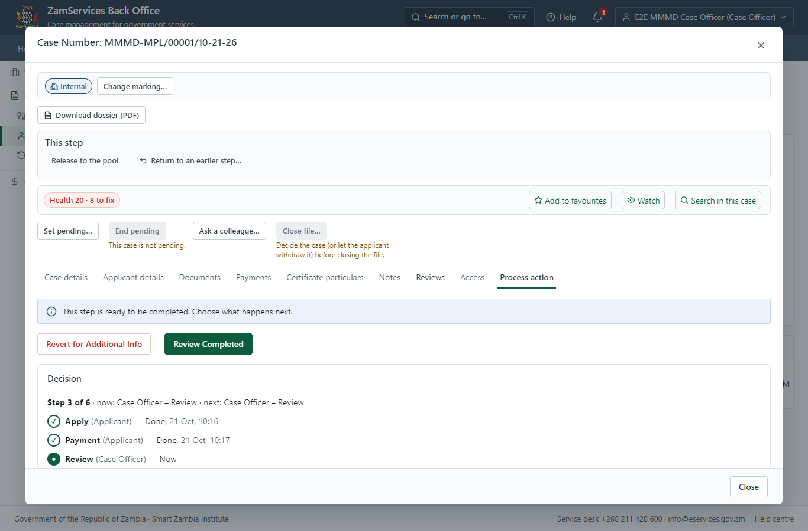
Step 13: Review Application.

Step 14. Review Expert Reports, Draft Decision
Case Officer · Back office
The Case Officer works on "Review Expert Reports, Draft Decision" (review in the imported process), checks the application and its documents, and completes the step.
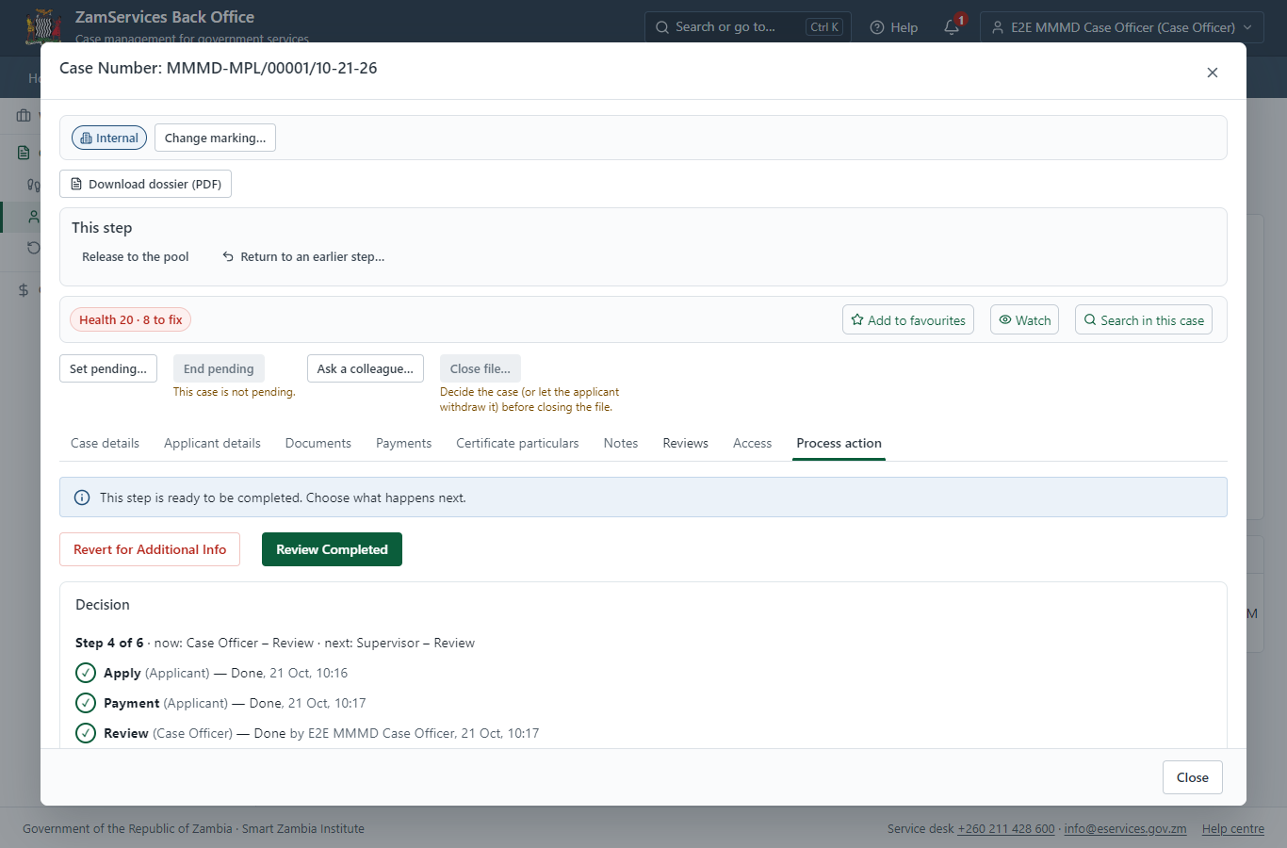
Step 14: Review Expert Reports, Draft Decision.

Step 15. Review, Add Comments, Send for Signature
Supervisor · Back office
The Supervisor works on "Review, Add Comments, Send for Signature" (review in the imported process), checks the application and its documents, and completes the step.
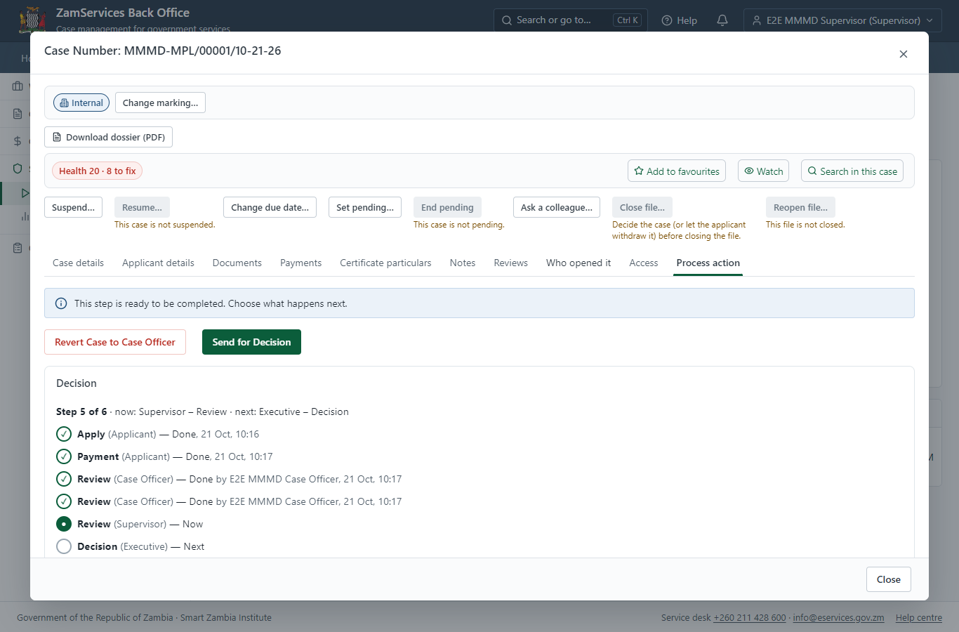
Step 15: Review, Add Comments, Send for Signature.

Step 16. Decide: Review, Inspect, e-Sign
Executive · Back office
At "Review, Inspect, e-Sign" the Executive records the decision: approve, with a comment kept in the case history. Approving moves the case on; the last decision completes it and issues the document.
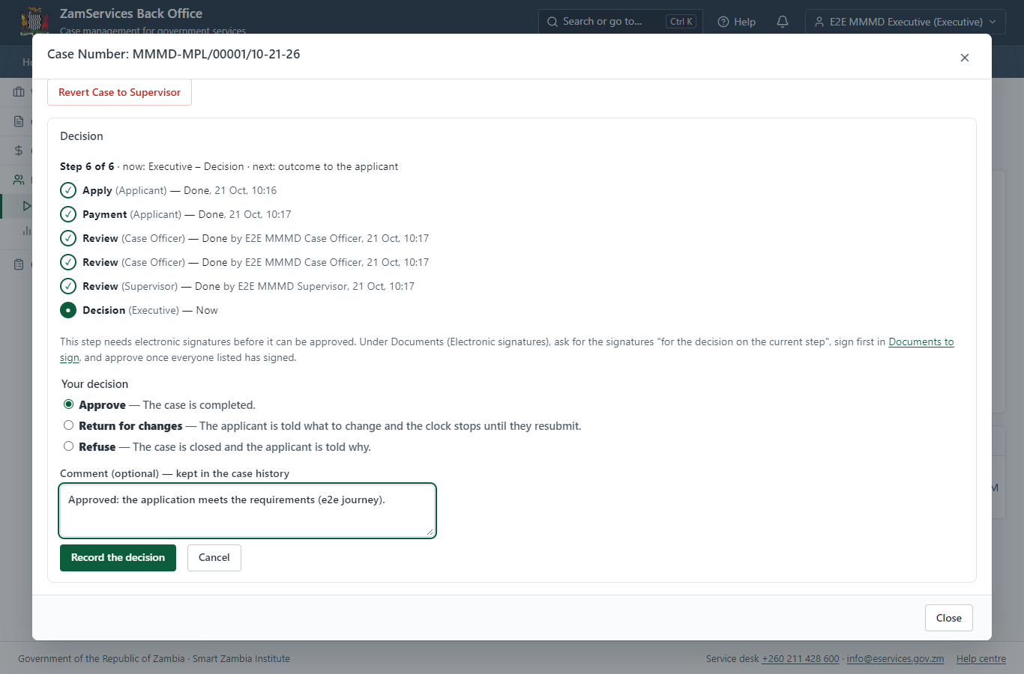
Step 16: Decide: Review, Inspect, e-Sign.

Step 17. The document in My permits
Citizen · National e-Services portal
The issued document (MMMD-MPL-2026-00001 in this run: "Mineral Processing Licence") is listed in "My permits and licences" with its validity and a download of the sealed PDF.
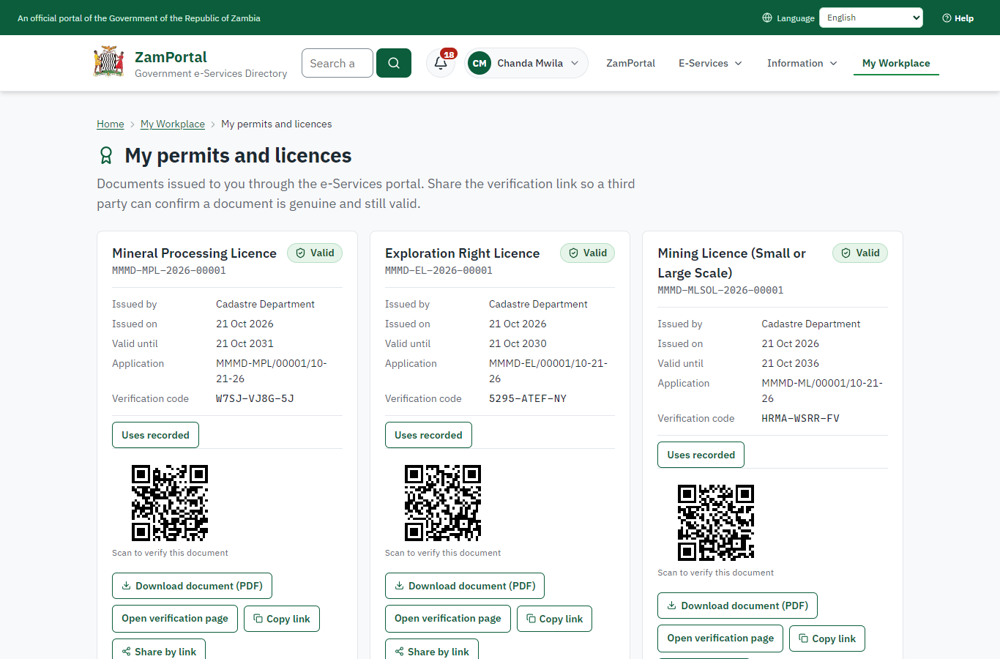 | 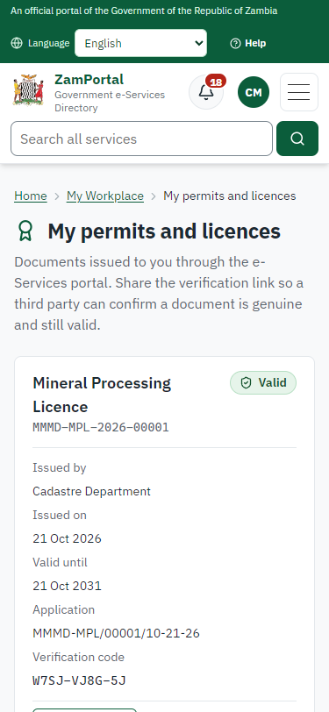
Step 17: The document in My permits - desktop (left) and a 375 px phone (right).

Step 18. Verify the document
Anyone (public) · Public verification page
The QR code on the document opens the public verification page: genuine and current, to whom it was issued, and whether the electronic seal is valid. No sign-in is needed.
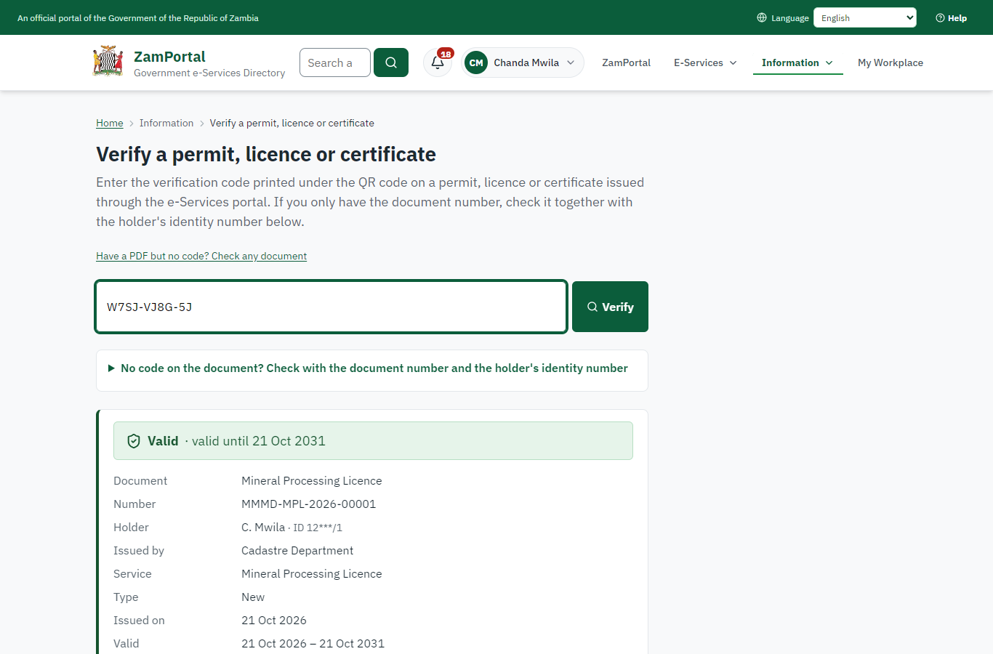 | 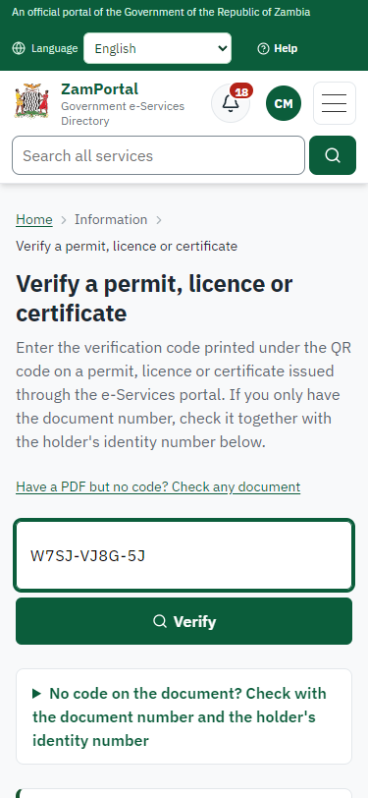
Step 18: Verify the document - desktop (left) and a 375 px phone (right).

3. Payment
Item | In the test run
Fee (as published) | Mineral Processing Licence up to 7485 Cadestre Units Mineral Processing Licence Application Fee ZMW 64,000.00 Area Charge per hectare/year ZMW 22.40
Invoice 1 | 8652380126508852
Amount 1 | ZMW 48000.00
Paid at 1 | with the application
On screen: step 8 (See that the fee is due), step 9 (Pay with ZamPay), step 10 (Payment received) in section 2.

4. Output documents

Mineral Processing Licence (sealed PDF)
Issued when the case was approved, from the service's output configuration (service template MMMD_MineralProcessingLicence.Certificate.d), filled from the application and the decision, sealed with the platform's electronic seal and stored as the issued version. The holder downloads it from My permits; the verification page checks it.
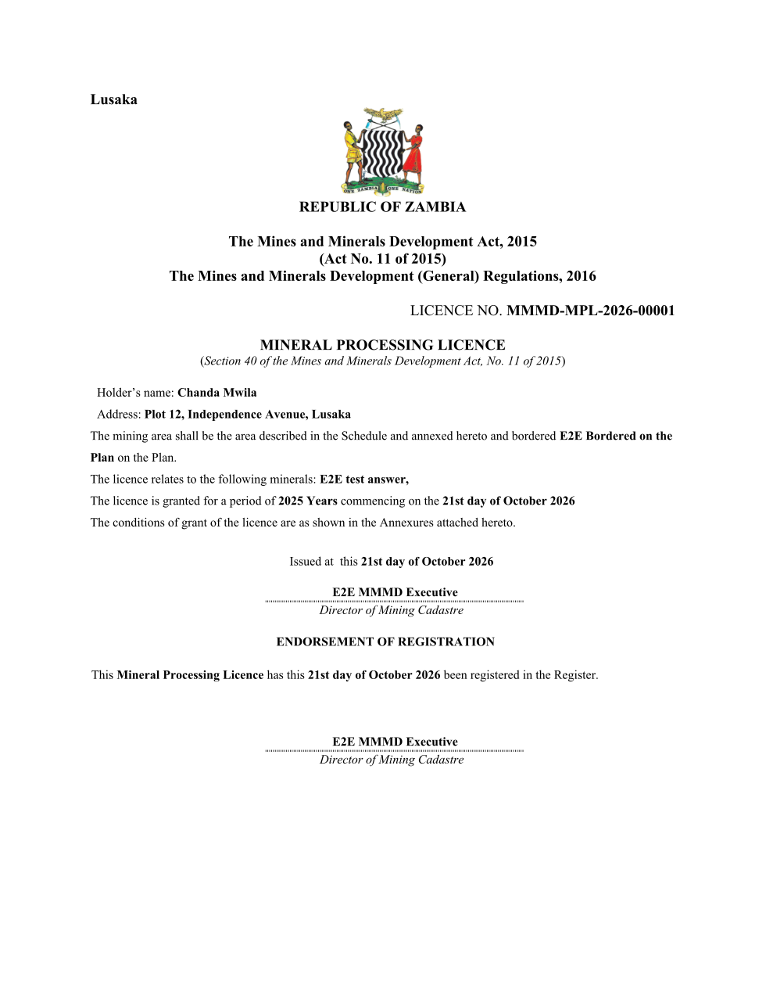
Mineral Processing Licence (sealed PDF) - first of 2 pages, as issued in the test run.

Fields
Field | Value in the test run
Document title | Mineral Processing Licence
Permit / licence number | MMMD-MPL-2026-00001
Holder | Chanda Mwila
Valid from | 2026-10-21
Valid until | 2031-10-21
Status | active
Verification code (printed with a QR code) | W7SJ-VJ8G-5J

Seal
Seal status | sealed
Signature level | PAdES-B-T
Sealed by | the platform seal (development key in the test run)
Signed at | 2026-10-21T08:17:43.198Z
Trusted time-stamp | 2026-10-21T08:17:43.179Z (time-stamping authority)
Document fingerprint (SHA-256) | f5c6a29873a1d290...

Verification
Where | The public verification page of the national portal, <portal>/verify/<verification code>, opened by scanning the QR code on the document.
What it shows | Whether the document is genuine and current, its holder and validity, and whether the electronic seal is valid and who sealed it.
Checking a copy | Anyone can upload a PDF they were given; the page says whether it is exactly the document that was issued. A changed copy is reported as not matching.
On screen: step 17 (The document in My permits), step 18 (Verify the document) in section 2.

5. Notifications
When | Channel | To | Message | Delivery
Payment due (invoice raised) | in-app (portal bell) | the applicant | Payment due for application MMMD-MPL/00001/10-21-26 - The fee of ZMW 48000.00 for Mineral Processing Licence (MMMD-MPL/00001/10-21-26) is now due. Invoice 8652380126508852. | shown
Application received | in-app (portal bell) | the applicant | Application MMMD-MPL/00001/10-21-26 received - Your application MMMD-MPL/00001/10-21-26 for Mineral Processing Licence has been received by Cadastre Department. | shown
Payment received | in-app (portal bell) | the applicant | Payment received for MMMD-MPL/00001/10-21-26 - Your payment of ZMW 48000.00 for MMMD-MPL/00001/10-21-26 (Mineral Processing Licence) has been received. Receipt: <ZamPay>/pdf?documentType=receipt&invoiceNumber=8652380126508852 | shown
Licence / permit issued | in-app (portal bell) | the applicant | Your Mineral Processing Licence document has been issued - MMMD-MPL-2026-00001 has been issued for Mineral Processing Licence and is valid until 21/10/2031. | shown
Decision: approved | in-app (portal bell) | the applicant | Application MMMD-MPL/00001/10-21-26 completed - MMMD-MPL/00001/10-21-26 (Mineral Processing Licence) is complete. Your documents are ready. | shown
Invitation to rate the service | in-app (portal bell) | the applicant | How was Mineral Processing Licence? - How was Mineral Processing Licence? Tell us in about a minute. | shown
Payment due (invoice raised) | sms | +260 97* *** 567 | Fee of ZMW 48000.00 due for MMMD-MPL/00001/10-21-26. Invoice 8652380126508852. Pay: <ZamPay>/pay-for-service/get-invoice/8652380126508852 | delivered
Payment due (invoice raised) | email | e2e.c***@example.test | Payment due for application MMMD-MPL/00001/10-21-26 | skipped
Application received | sms | +260 97* *** 567 | Application MMMD-MPL/00001/10-21-26 for Mineral Processing Licence has been received. Track it: <portal>/my-workplace | delivered
Application received | email | e2e.c***@example.test | Application MMMD-MPL/00001/10-21-26 received | skipped
Payment received | sms | +260 97* *** 567 |  | delivered
Invitation to rate the service | sms | +260 97* *** 567 |  | skipped
Invitation to rate the service | email | e2e.c***@example.test | How was Mineral Processing Licence? | skipped
Licence / permit issued | sms | +260 97* *** 567 |  | delivered
Decision: approved | sms | +260 97* *** 567 |  | delivered
Licence / permit issued | email | e2e.c***@example.test | Your Mineral Processing Licence document has been issued | skipped
Decision: approved | email | e2e.c***@example.test | Application MMMD-MPL/00001/10-21-26 completed | skipped
Delivery: shown = in the portal's notification bell; delivered = the SMS gateway (a test double in this run) reported the text delivered; skipped = not sent on that channel (e-mail is not configured on the test installation, and some notices go out on one channel only); sent by the national portal = a ministry node handed the notice to the national portal, which texts and e-mails the citizen under its own name and the citizen's preferences. Addresses written <portal>, <ZamPay> stand for the national portal and ZamPay.

6. Legacy mapping
Replaces | Mineral Processing Licence in the legacy ZIGS e-Services directory (ZIGS_Services)
Legacy service id | 106
Legacy provider | Cadastre Department (MMMD) under Ministry of Mines and Minerals Development
Legacy process | LicenseReview (process 9)
Fee in the legacy system | Mineral Processing Licence - Application Fee: ZMW 48000 (New)
Fee taken before submission | yes (as in ZIGS)
Time to issue (legacy) | New: 60 calendar days
Legacy output templates | Denial of Service: ZIGS_Forms_MMMD / MMMD_MineralProcessingLicence.DenialService  Mineral Processing Licence: ZIGS_Forms_MMMD / MMMD_MineralProcessingLicence.Certificate  Notice of Approval: ZIGS_Forms_MMMD / MMMD_MineralProcessingLicence.NoticeApproval  Approval Letter: ZIGS_Forms_MMMD / MMMD_MineralProcessingLicence.ApprovalLetter  Application form: ZIGS_Forms_MMMD / MMMD_MineralProcessingLicence.Application  GS-2 Notice of Government Action: ZIGS_Forms_Notices / GS-2.NoticeOfAction  GF-1 Treasury Invoice: ZIGS_CustomForms / GF-1 Invoice  GF-2 Treasury Receipt: ZIGS_CustomForms / GF-2 Receipt
Legacy address | https://mmmdui.gsb.gov.zm
How it was brought over | Imported by the platform's legacy catalogue importer (zcm-backend scripts/zigs/importLegacy.js) from the ZIGS snapshot: form, case types, fees, documents, process and output templates, then served by the new platform.

7. Version and date
Document version | service v1, platform a0a302b8
Generated | 2026-10-21T08:17:51Z (by the end-to-end run, not edited by hand)
Service version | not versioned (configured directly)
Platform snapshot | backend a0a302b8  portal 72805f0  back office 58e5946
Test suite | e2e 5999d9b; one installation (combined); seed profile mihud
Journeys | 30-catalogue-service.spec.js: citizen finds the service, answers its form, uploads its documents and sends the application - passed  30-catalogue-service.spec.js: the case goes through every step of its process: payments by the citizen, each officer step by its role - passed  30-catalogue-service.spec.js: the grant document is issued, sealed, filled in and verifiable; the citizen has it in My permits - passed
Result | 3 of 3 journey tests passed
Data | Synthetic test data on a local test installation; provider test doubles for ZamPass, ZamPay, SMS and signing.

