Republic of Zambia
GSB e-Services

Market Ablution Fees
Service documentation
Owner: Department of Local Government
Service key: LGD/market-ablution-fees
Version: service v1, platform 8787cde1
Date: 2026-10-21
Generated automatically by the service's end-to-end test run. Every screenshot shows synthetic test data on a local test installation, never real personal data.

Contents
- 1. Service summary
- 2. Application process, step by step
- 3. Payment
- 4. Output documents
- 5. Notifications
- 6. Legacy mapping
- 7. Version and date
This document describes the Market Ablution Fees service of Department of Local Government as the platform runs it today. It is generated by the service's end-to-end test: every step was performed by the test and every screenshot was taken during that run, with synthetic data. Regenerate it with "npm run docs:services" in the e2e suite; do not edit it by hand.

1. Service summary
Service | Market Ablution Fees
Owner (MDA) | Department of Local Government (LGD)
Purpose | To pay the Market Ablution Fee, please scan the QR code displayed at the facility
Who can apply | Anyone using the facility.
How to apply | At the place itself: scan the QR code of the payment point with a phone; the national e-Services portal shows the charge and the payer pays with ZamPay (mobile money or card). No sign-in, no application, no name.
Fees | Not set in the service configuration.
Turnaround | QR code based service
Validity of the output | Not applicable
Required documents | None
Output documents | GS-1 Application for a Government Service  GS-2 Notice of Government Action

2. Application process, step by step

The process as configured
Step | Role | Task | Type
1 | Applicant | Apply | form
2 | Applicant | Payment | payment
3 | System | Generate Document | generate-document
4 | System | Notify Client | notify

Step by step
Who takes part in this journey: Executive, Supervisor, Citizen, Anyone (public). Citizen steps are shown on a desktop and on a 375 px phone; back-office steps on a desktop.

Step 1. The council offers the service
Executive · Back office
System administration -> Councils -> Lusaka City Council -> Services: the council's executive switches "Market Ablution Fees" on for the council ("Offer"). A payment point sells only what its site's council offers; switching the service off again stops every point of the council at once. The change is audited.
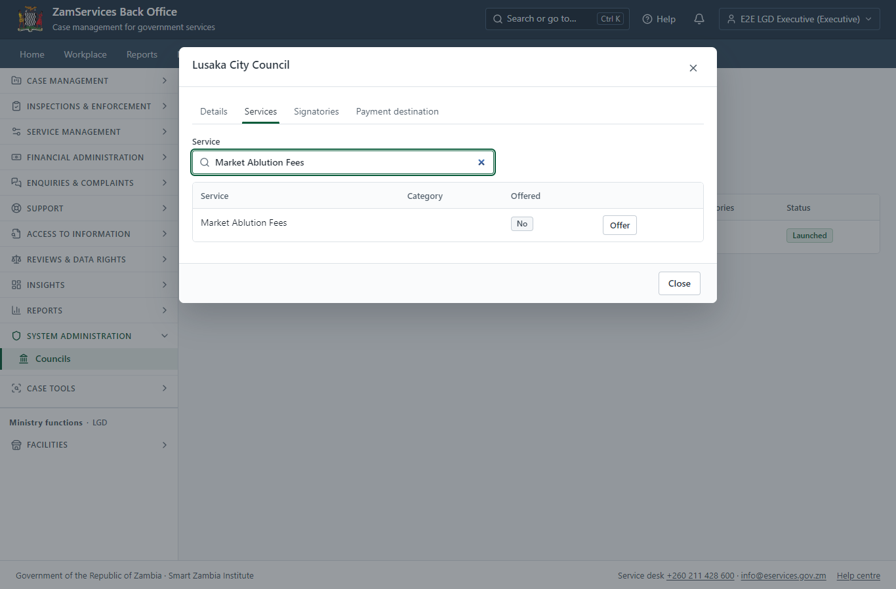
Step 1: The council offers the service.

Step 2. Add a pay-at-point code
Supervisor · Back office
In Ministry functions -> Facilities -> Pay-at-point codes the supervisor adds a payment point for the site (Synthetic Central Market) and the service's approved tariff (Ablution, per use, K2.00). The QR code printed for it carries a random token, never an amount: the price is read from the approved tariff every time someone pays.
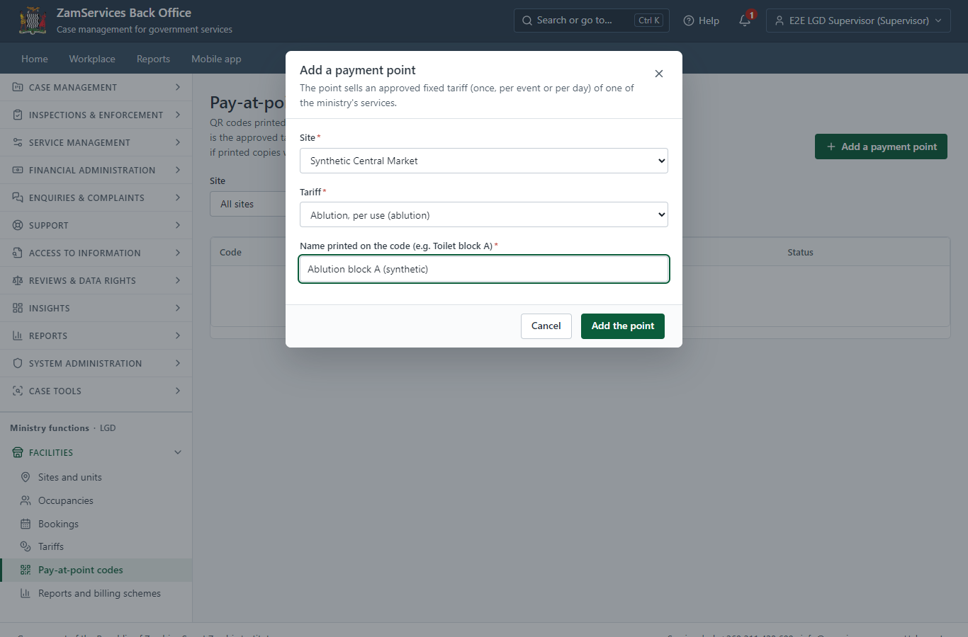
Step 2: Add a pay-at-point code.

Step 3. Print the QR codes
Supervisor · Back office (done through its case API in the test run: no screenshot)
"Print sheet" on the same screen gives an A4 PDF with one QR code per active payment point of the site, each with its name, the site and the price, and the words "Scan to pay with your phone". The office prints it and fixes each code at its point. A code can be switched off, or renewed (every printed copy of the old one stops working) - both with a reason, kept in the audit trail.

Step 4. Scan the code: what is paid
Citizen · National e-Services portal
The QR code opens the portal's pay-at-point page (<portal>/pay/<token>; the token only names the point). It shows what is paid and the price the server works out from the approved tariff: Ablution, per use at Synthetic Central Market, K2.00, and who is paid. Nobody signs in and nobody is asked for a name or a number.
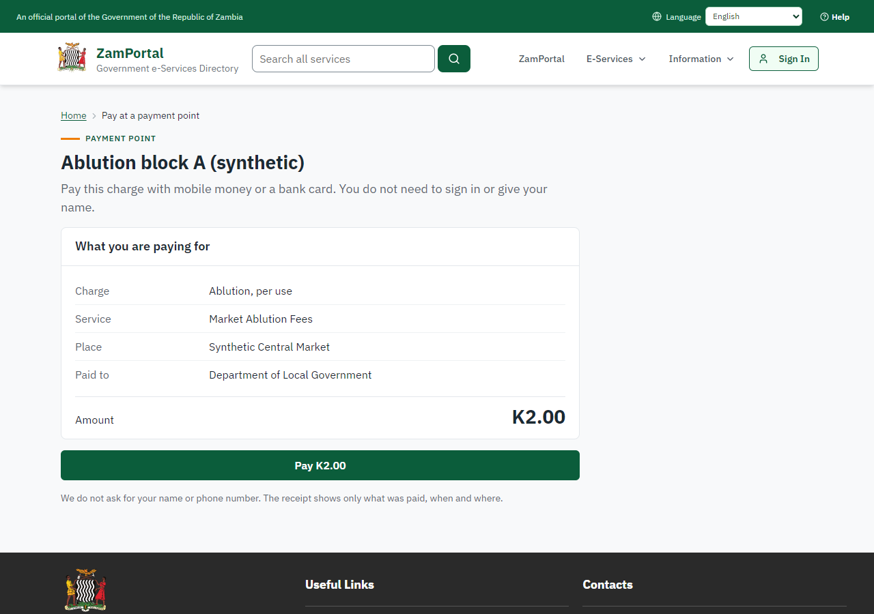 | 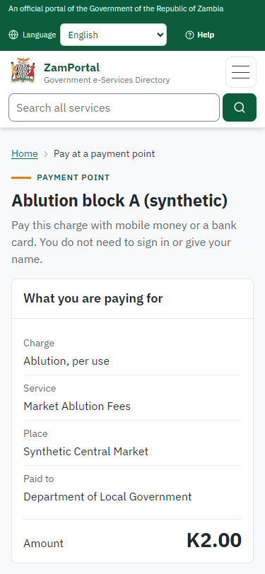
Step 4: Scan the code: what is paid - desktop (left) and a 375 px phone (right).

Step 5. Pay: the ticket invoice
Citizen · National e-Services portal
Pay raises a ZamPay invoice for this browser at the server's price (K2.00; the page sends no amount). Pressing Pay again, or reloading, hands out the same invoice while it is open, so nobody is charged twice. "Pay with ZamPay" opens ZamPay in a new tab.
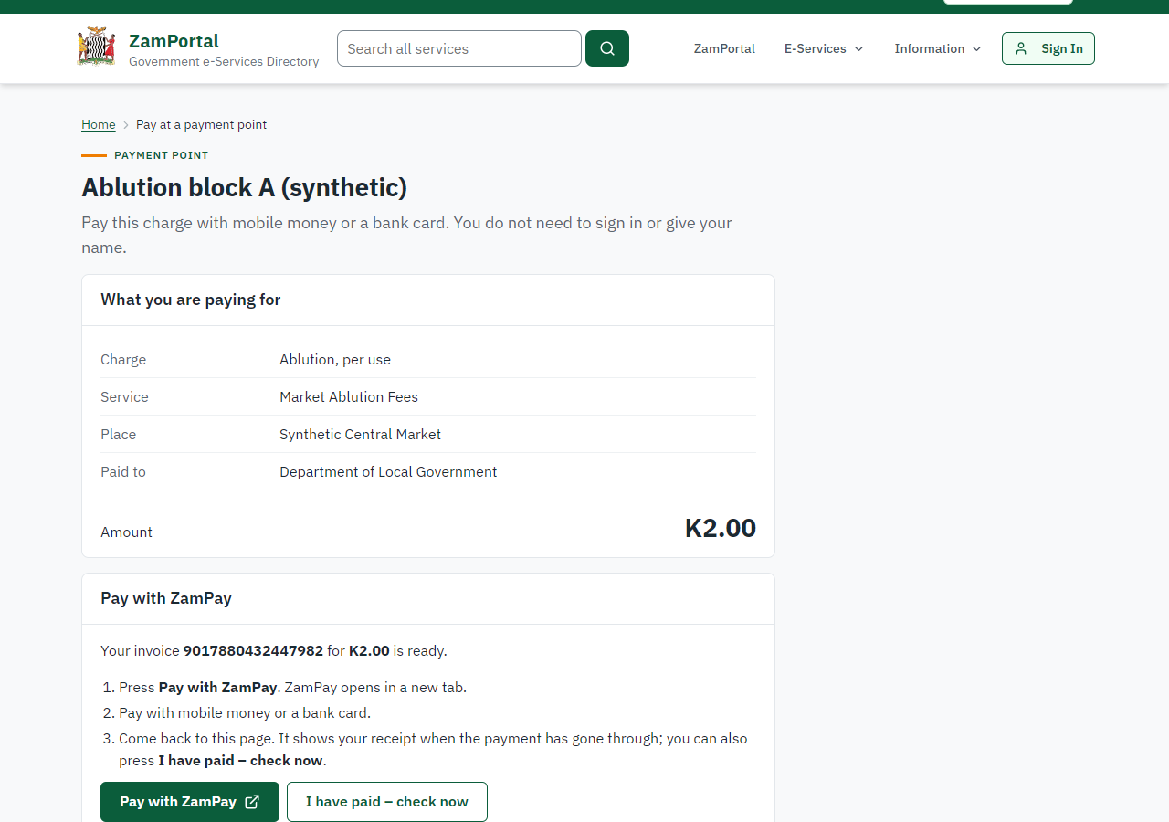 | 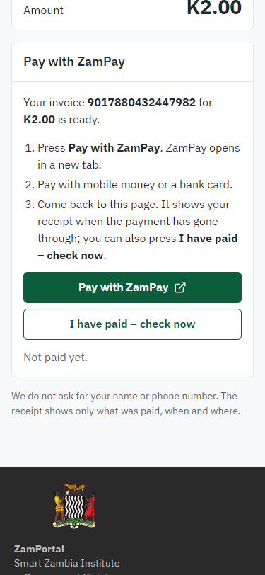
Step 5: Pay: the ticket invoice - desktop (left) and a 375 px phone (right).

Step 6. Pay at ZamPay
Citizen · National e-Services portal
ZamPay shows the invoice and the amount; the payer chooses mobile money or a card and pays (here the provider test double, never the real gateway).
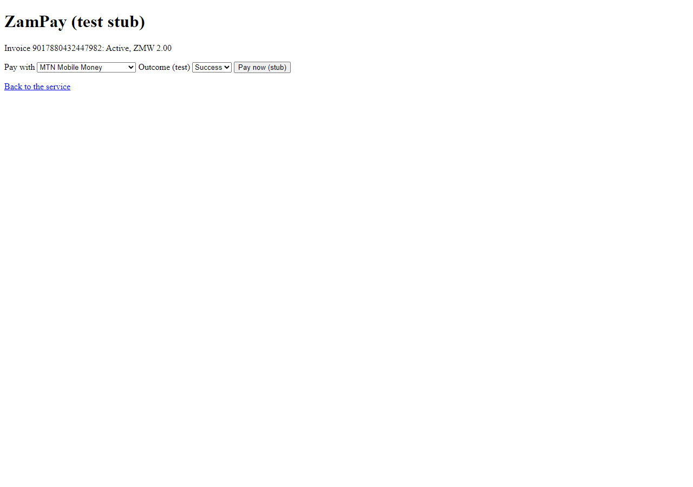 | 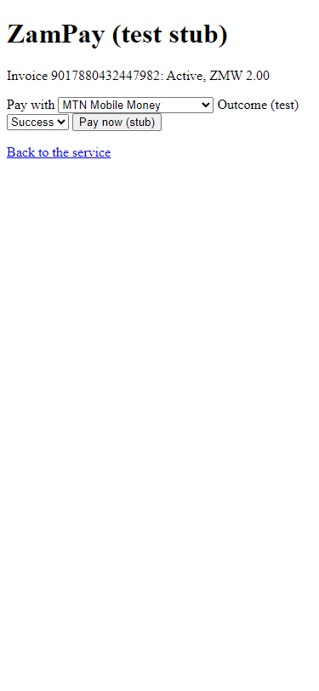
Step 6: Pay at ZamPay - desktop (left) and a 375 px phone (right).

Step 7. The receipt
Citizen · National e-Services portal
Once ZamPay's answer is recorded (through the platform's one payment path, never on the page's word) the page shows the receipt: its number (9017880432447982), the amount, when, what for, where and who was paid, with a QR code anyone can scan to check it. Coming back to the page from the same phone shows it again; "Pay again" starts a new payment.
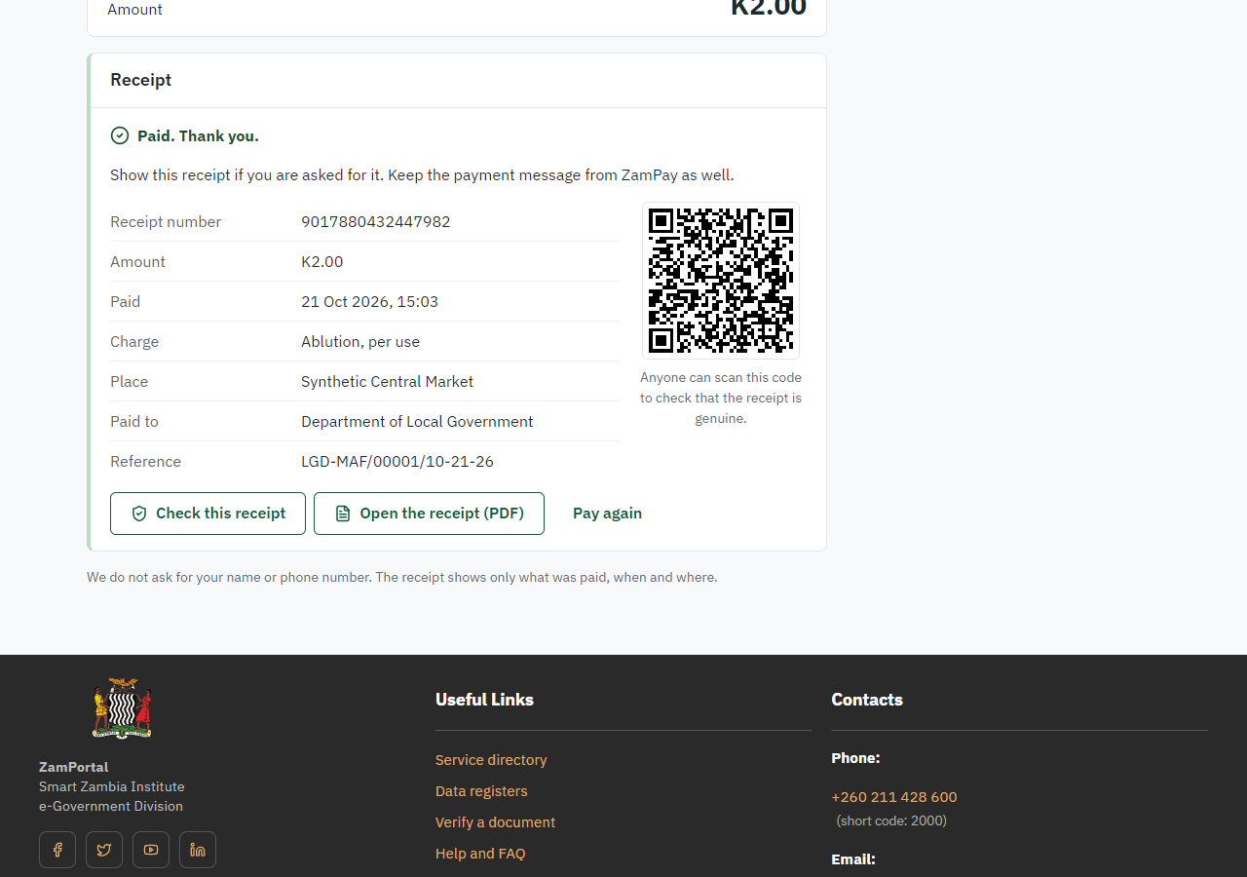 | 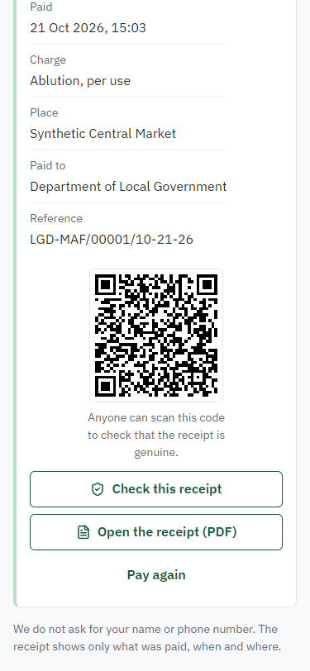
Step 7: The receipt - desktop (left) and a 375 px phone (right).

Step 8. Verify the receipt
Anyone (public) · Public verification page
The receipt's QR code opens the public receipt page: genuine, its number, the amount, when, the service and the office. No sign-in is needed and no name is shown (the payer gave none). A wrong or made-up code gets the same "not found" answer.
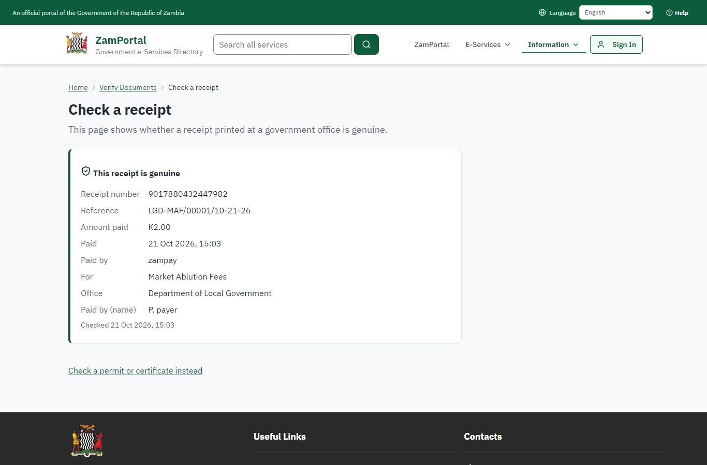 | 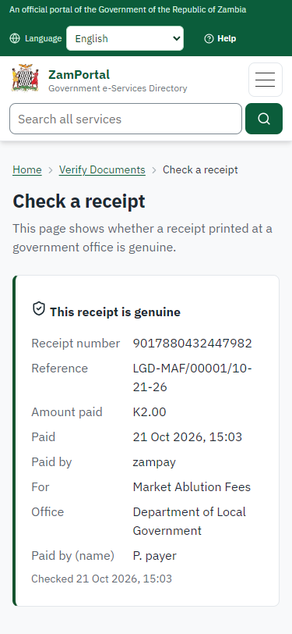
Step 8: Verify the receipt - desktop (left) and a 375 px phone (right).

3. Payment
Item | In the test run
Fee (as published) | the point's tariff
Tariff | Ablution, per use (ablution)
Invoice | 9017880432447982
Amount | ZMW 2.00
Receipt | 9017880432447982
Paid by | anyone at the point: no account, no name
On screen: step 5 (Pay: the ticket invoice), step 6 (Pay at ZamPay), step 7 (The receipt) in section 2.

4. Output documents

Receipt on the payer's phone
The receipt the pay-at-point page shows once the payment is recorded. The payer keeps it on the phone (or ZamPay's own receipt PDF, offered on the same page); a market attendant scans its QR code to check it.
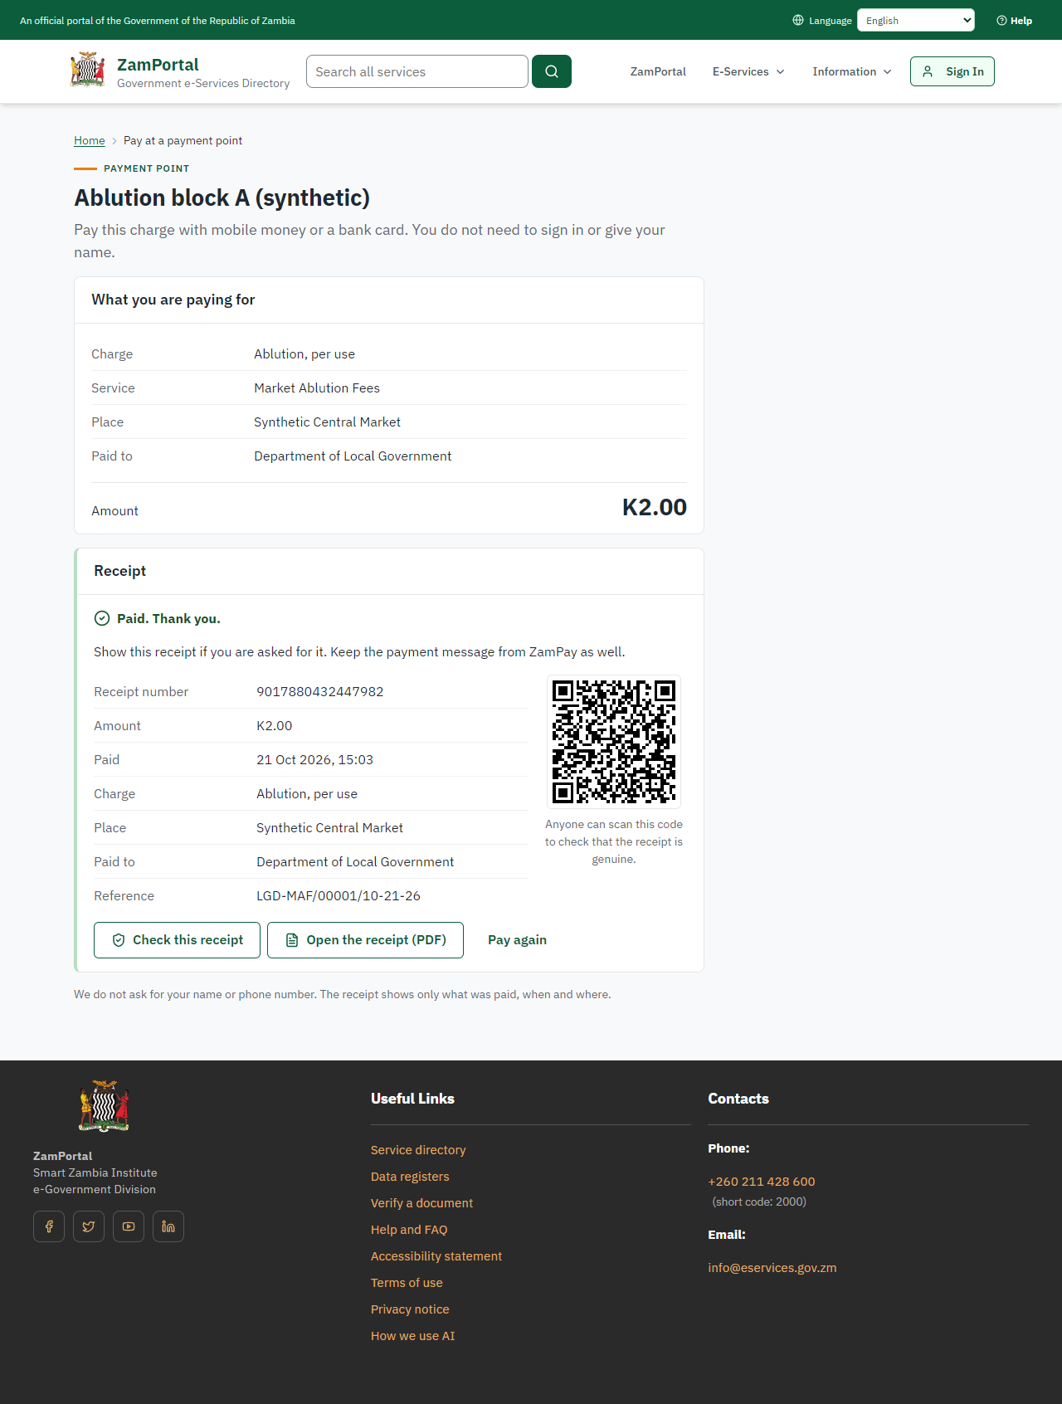
Receipt on the payer's phone, as issued in the test run.

Fields
Field | Value in the test run
Receipt number | 9017880432447982
Amount | K2.00
Charge | Ablution, per use
Place | Synthetic Central Market
Invoice | 9017880432447982
Reference | LGD-MAF/00001/10-21-26

Verification
QR code | Opens the public receipt page (<portal>/verify/receipt/<reference>?sig=<signature>); the signature is made by the server, so a receipt cannot be forged or guessed
What it shows | Genuine, the receipt number, the amount, when, the service and the office; never a name

Payment point sheet (QR codes to print)
The A4 sheet the office prints from Pay-at-point codes: one QR code per active payment point of the site, with its name, the site and the price. The code carries only a random token; the price is always the approved tariff on the server.
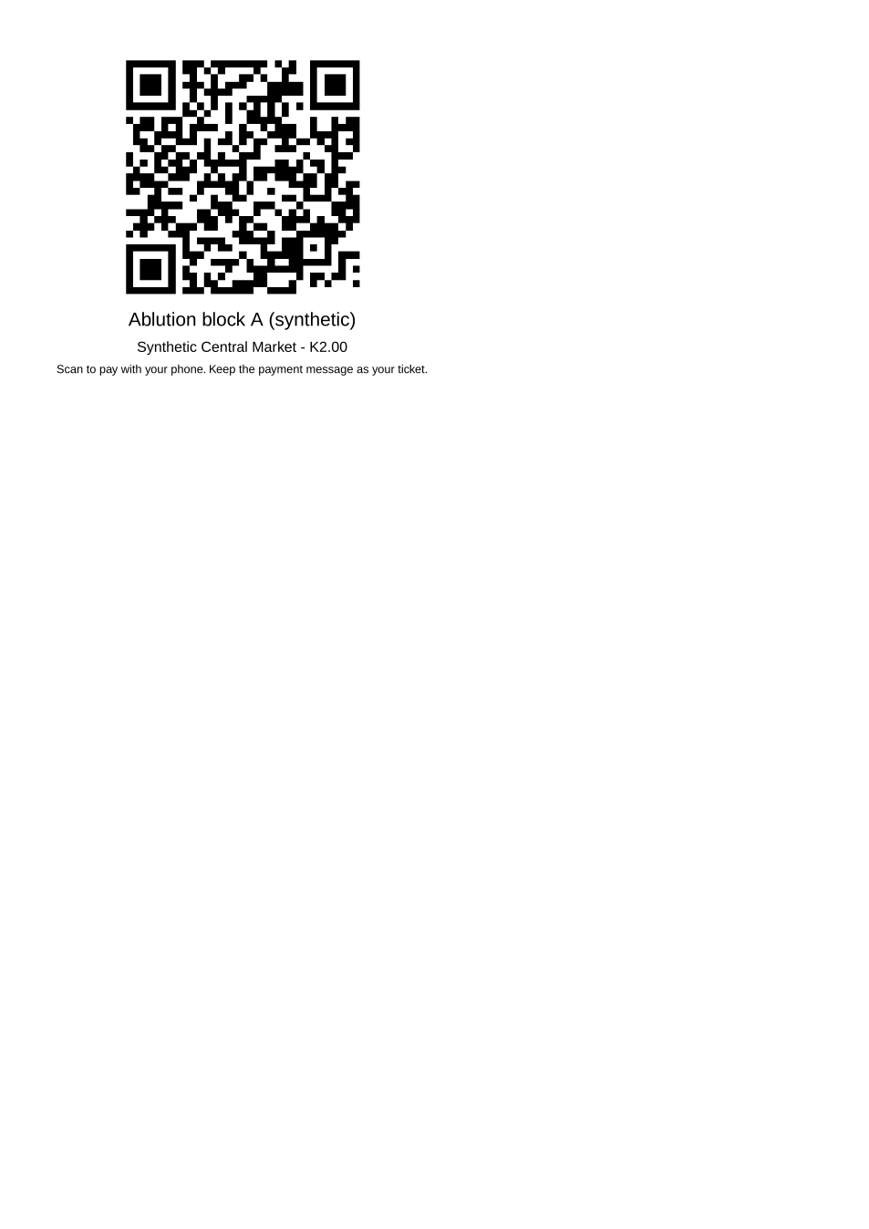
Payment point sheet (QR codes to print) - first of 1 page, as issued in the test run.

Fields
Field | Value in the test run
Point | Ablution block A (synthetic)
Site | Synthetic Central Market
Price | K2.00
Address in the QR code | <portal>/pay/<token>

Verification
Renewing a code | A supervisor can renew a point's code (with a reason): every printed copy of the old code stops working at once
Switching off | A switched-off point, an unknown and a made-up code all answer "This payment point is not available"
On screen: step 8 (Verify the receipt) in section 2.

5. Notifications
When | Channel | To | Message | Delivery
Payment due (invoice raised) | in-app (portal bell) | the ticket (no person: nobody sees it) | Payment due for application LGD-MAF/00001/10-21-26 - The fee of ZMW 2.00 for Market Ablution Fees (LGD-MAF/00001/10-21-26) is now due. Invoice 9017880432447982. | shown
Payment received | in-app (portal bell) | the ticket (no person: nobody sees it) | Payment received for LGD-MAF/00001/10-21-26 - Your payment of ZMW 2.00 for LGD-MAF/00001/10-21-26 (Market Ablution Fees) has been received. Receipt: <ZamPay>/pdf?documentType=receipt&invoiceNumber=9017880432447982 | shown
Payment due (invoice raised) | sms | nobody (no contact details) |  | skipped
Payment due (invoice raised) | email | nobody (no contact details) | Payment due for application LGD-MAF/00001/10-21-26 | skipped
Payment received | sms | nobody (no contact details) |  | skipped
Payment received | ZamPay | the payer | ZamPay confirms the payment to the phone or card used; the pay-at-point page shows the receipt. | sent by ZamPay
Delivery: shown = in the portal's notification bell; delivered = the SMS gateway (a test double in this run) reported the text delivered; skipped = not sent on that channel (e-mail is not configured on the test installation, and some notices go out on one channel only); sent by the national portal = a ministry node handed the notice to the national portal, which texts and e-mails the citizen under its own name and the citizen's preferences. Addresses written <portal>, <ZamPay> stand for the national portal and ZamPay.

6. Legacy mapping
Replaces | Market Ablution Fees in the legacy ZIGS e-Services directory (ZIGS_Services)
Legacy service id | 607
Legacy provider | Department of Local Government (LGD) under Ministry of Local Government and Rural Development
Legacy process | not recorded
Fee in the legacy system | none
Fee taken before submission | yes (as in ZIGS)
Time to issue (legacy) | not recorded
Legacy output templates | GS-1 Application for a Government Service: ZIGS_Forms_ZDA / GS1  GS-2 Notice of Government Action: ZIGS_Forms_Notices / GS-2.NoticeOfAction
Legacy address | https://ecouncils.gsb.gov.zm
How it was brought over | Imported by the platform's legacy catalogue importer (zcm-backend scripts/zigs/importLegacy.js) from the ZIGS snapshot: form, case types, fees, documents, process and output templates, then served by the new platform.

7. Version and date
Document version | service v1, platform 8787cde1
Generated | 2026-10-21T13:03:45Z (by the end-to-end run, not edited by hand)
Service version | not versioned (configured directly)
Platform snapshot | backend 8787cde1  portal 6762d63  back office 58e5946
Test suite | e2e 50a3441; one installation (combined); seed profile mihud
Journeys | 30-catalogue-service.spec.js: the office adds a pay-at-point code for the service's approved tariff and prints its QR code - passed  30-catalogue-service.spec.js: the payer scans the code, sees what is paid, pays with ZamPay and gets the receipt - passed  30-catalogue-service.spec.js: the receipt verifies on the public receipt page - passed
Result | 3 of 3 journey tests passed
Data | Synthetic test data on a local test installation; provider test doubles for ZamPass, ZamPay, SMS and signing.

