Republic of Zambia
GSB e-Services

Inspection of By-Laws of a Co-operative Society
Service documentation
Owner: Department of Registration and Regulation
Service key: DOC/inspection-of-by-laws-of-a-co-operative-society
Version: service v1, platform a0a302b8
Date: 2026-10-21
Generated automatically by the service's end-to-end test run. Every screenshot shows synthetic test data on a local test installation, never real personal data.

Contents
- 1. Service summary
- 2. Application process, step by step
- 3. Payment
- 4. Output documents
- 5. Notifications
- 6. Legacy mapping
- 7. Version and date
This document describes the Inspection of By-Laws of a Co-operative Society service of Department of Registration and Regulation as the platform runs it today. It is generated by the service's end-to-end test: every step was performed by the test and every screenshot was taken during that run, with synthetic data. Regenerate it with "npm run docs:services" in the e2e suite; do not edit it by hand.

1. Service summary
Service | Inspection of By-Laws of a Co-operative Society
Owner (MDA) | Department of Registration and Regulation (DOC)
Purpose | Any person can request the inspection of the By-Laws of a Co-operative Society, registered under the Co-operative Societies Act, and the provision of registration details and the list of members.
Who can apply | Individual
How to apply | Online on the national e-Services portal, signed in with ZamPass; pay with ZamPay.
Fees | Inspection of By-Laws of a Co-operative Society: ZMW 200.00
Turnaround | 30 days
Validity of the output | Indefinite
Required documents | None
Output documents | Notice Of Action  Application form  Notice Registration Details  GF-1 Treasury Invoice  GF-2 Treasury Receipt
Legal basis | Co-operative Societies Act, No. 20 of 1998 (https://www.ilo.org/dyn/natlex/docs/ELECTRONIC/53147/111628/F824149747/ZMB53147.pdf)  Co-operative Societies Regulations, SI No. 26 of 1999 (http://extwprlegs1.fao.org/docs/pdf/zam16012.pdf)

2. Application process, step by step

The process as configured
Step | Role | Task | Type
1 | Applicant | Apply | form
2 | Applicant | Payment | payment
3 | System | Generate Document | generate-document
4 | Case Officer | Review | review
5 | Supervisor | Review | review
6 | Executive | Decision | decision
7 | System | Generate Document | generate-document
8 | System | Notify Client | notify

Step by step
Who takes part in this journey: Citizen, Case Officer, Supervisor, Executive, Anyone (public). Citizen steps are shown on a desktop and on a 375 px phone; back-office steps on a desktop.

Step 1. Find the service
Citizen · National e-Services portal
On the national e-Services portal the citizen opens All Services and searches for the service by name ("Inspection of By-Laws of a Co-operative"). Each result names the service and the ministry that provides it.
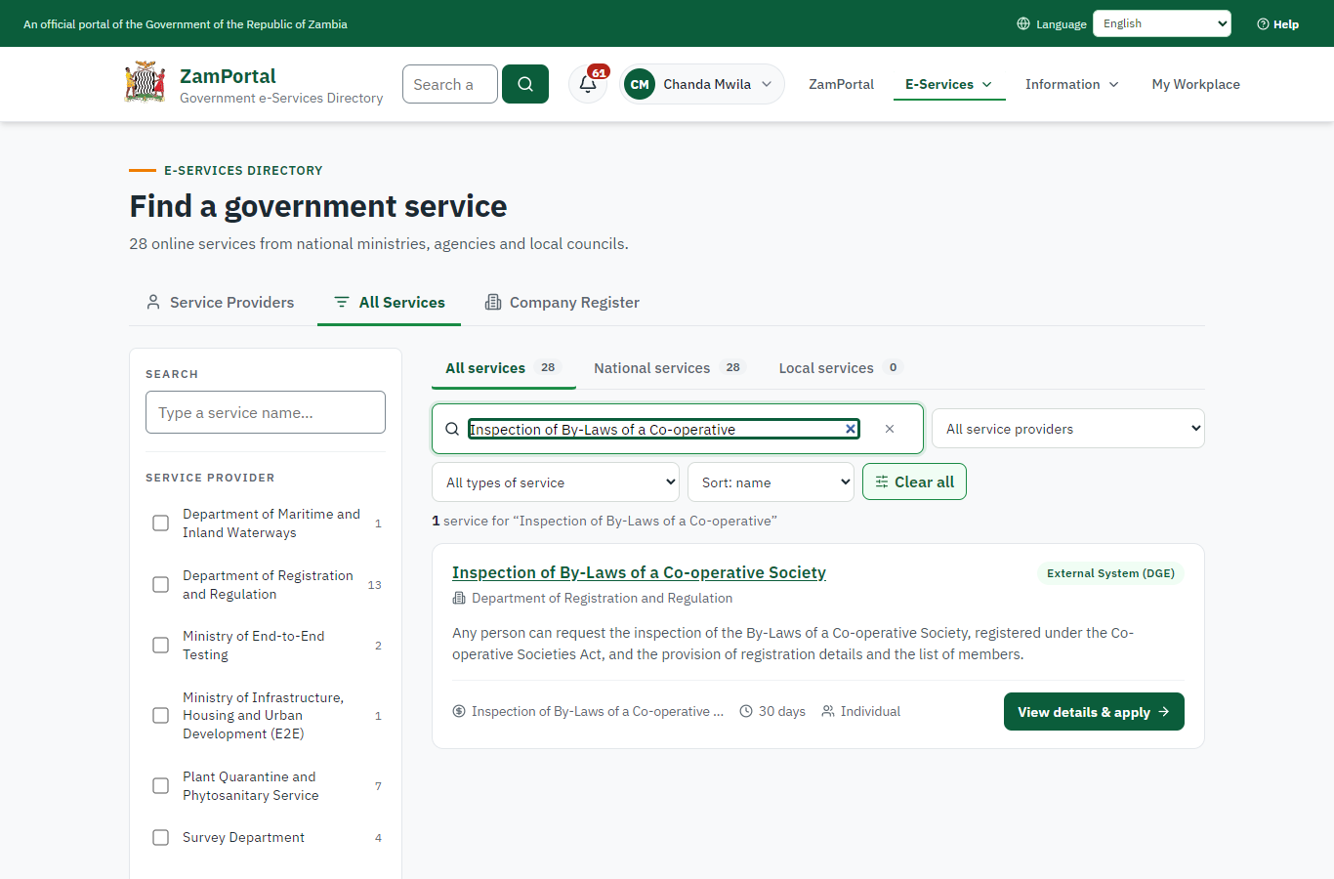 | 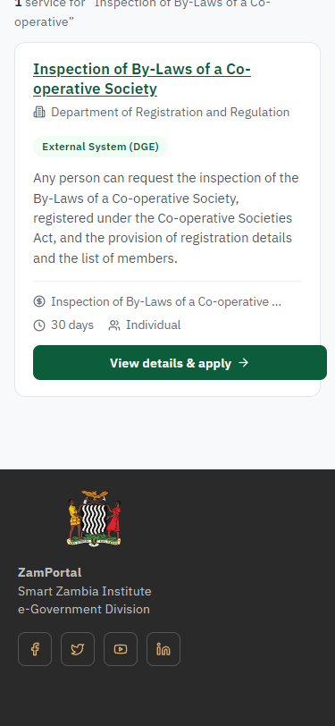
Step 1: Find the service - desktop (left) and a 375 px phone (right).

Step 2. Read the service page
Citizen · National e-Services portal
The service page sets out what the service is for, who provides it, the fee, how long it takes and the documents to have ready. "Start application" begins an application (the citizen is signed in with ZamPass).
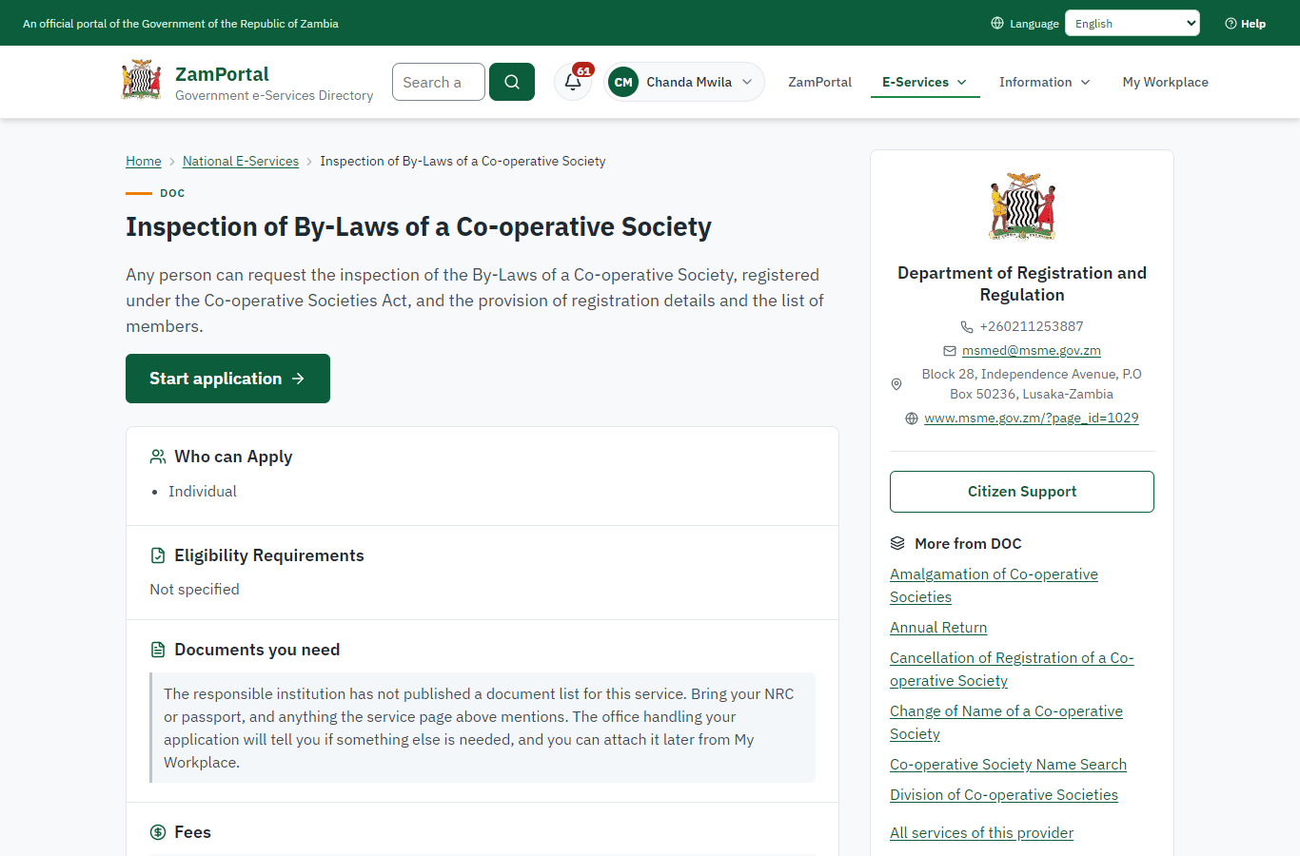 | 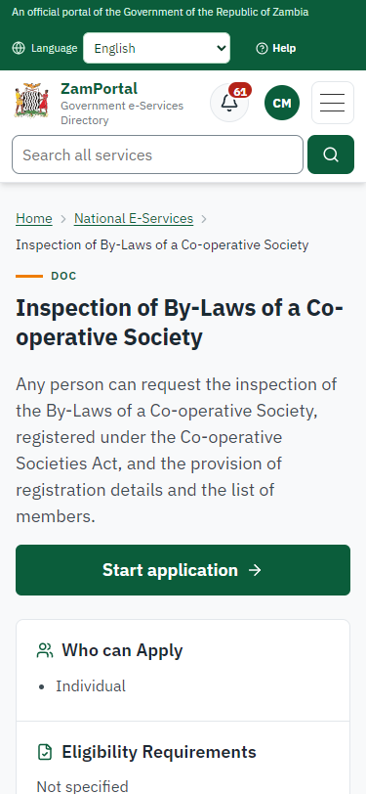
Step 2: Read the service page - desktop (left) and a 375 px phone (right).

Step 3. Confirm the applicant details
Citizen · National e-Services portal
The applicant details are filled in from the citizen's ZamPass account. The citizen says whom they are applying for (themself) and continues with "Proceed to Application".
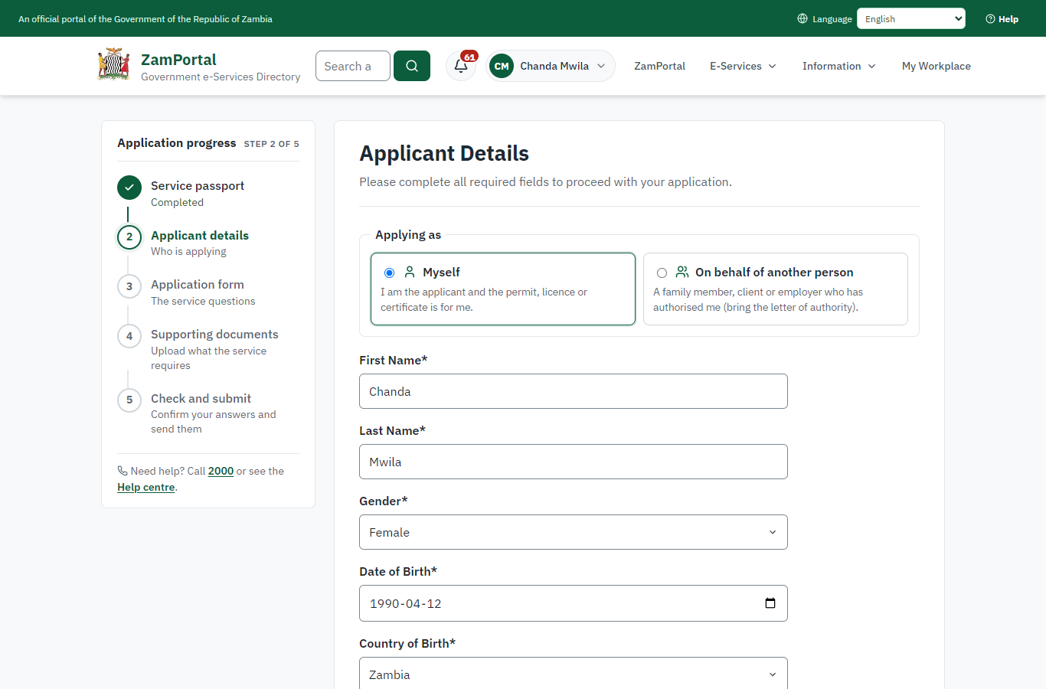 | 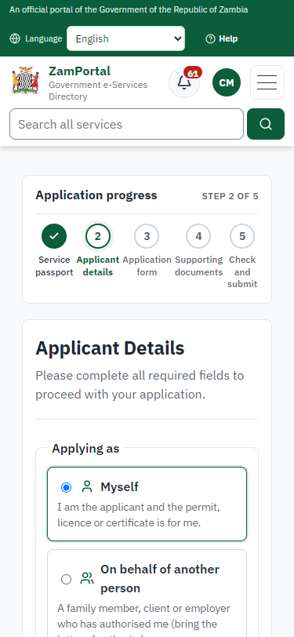
Step 3: Confirm the applicant details - desktop (left) and a 375 px phone (right).

Step 4. Fill in the application form
Citizen · National e-Services portal
The citizen answers the service's own application form, converted from the legacy system (4 answers in this run, all synthetic), for the type of application "New". Questions marked * must be answered; some appear only after an earlier answer. Answers are saved as the citizen types, so an unfinished application can be reopened from My Workplace.
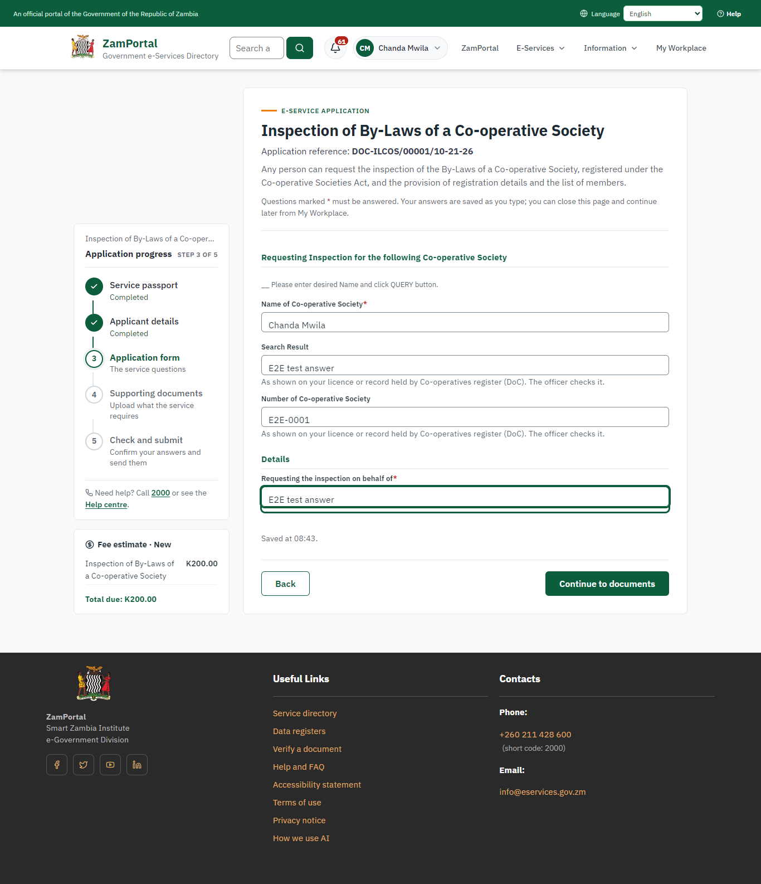 | 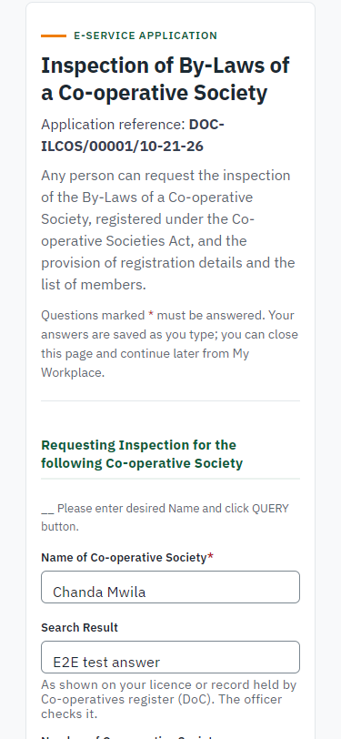
Step 4: Fill in the application form - desktop (left) and a 375 px phone (right).

Step 5. Upload the supporting documents
Citizen · National e-Services portal
The service asks for no supporting documents, so the citizen continues straight to the check of the answers.
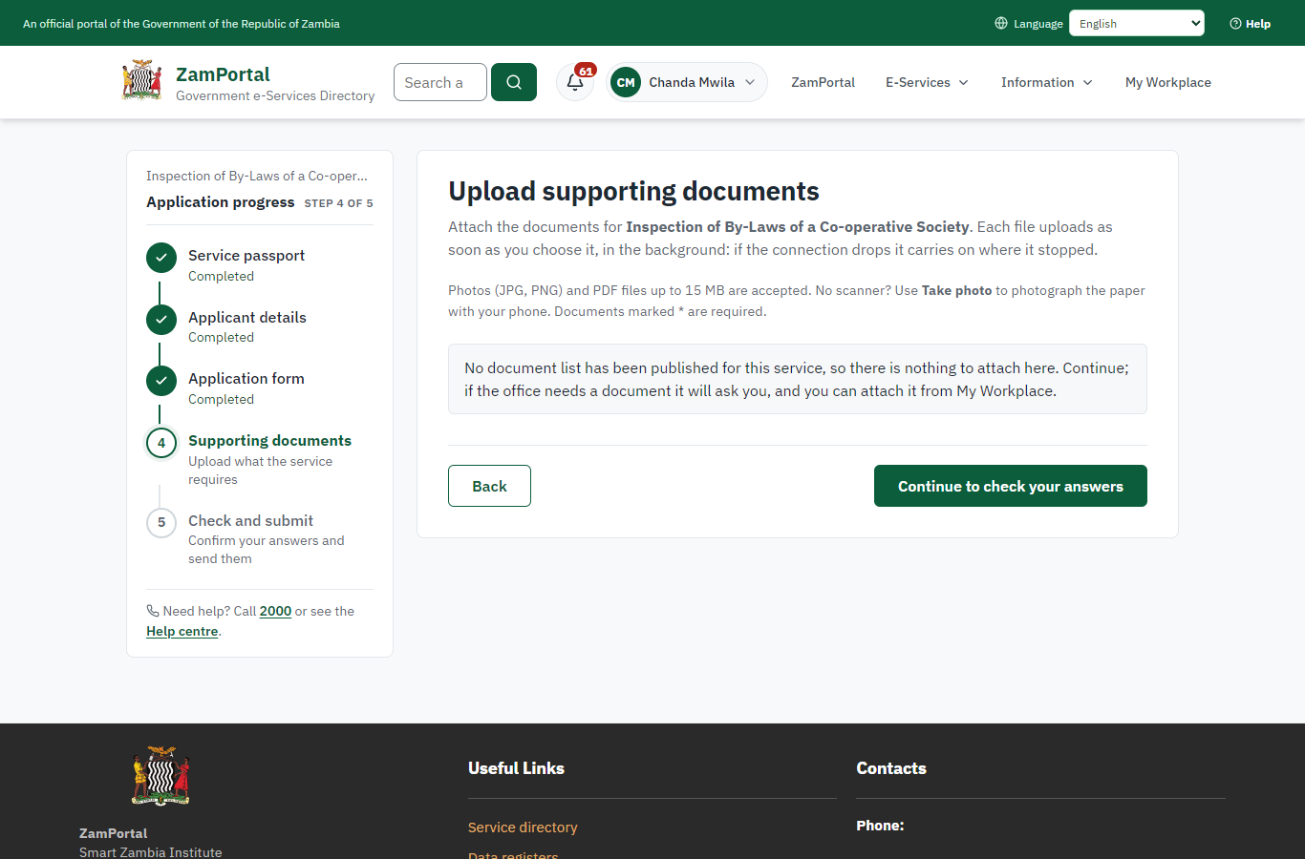 | 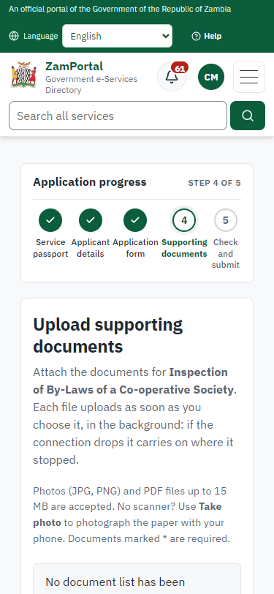
Step 5: Upload the supporting documents - desktop (left) and a 375 px phone (right).

Step 6. Check the answers and confirm the declaration
Citizen · National e-Services portal
Before sending, the citizen sees every answer and document on one page and can go back to change them. The declaration that the information is true and complete must be ticked.
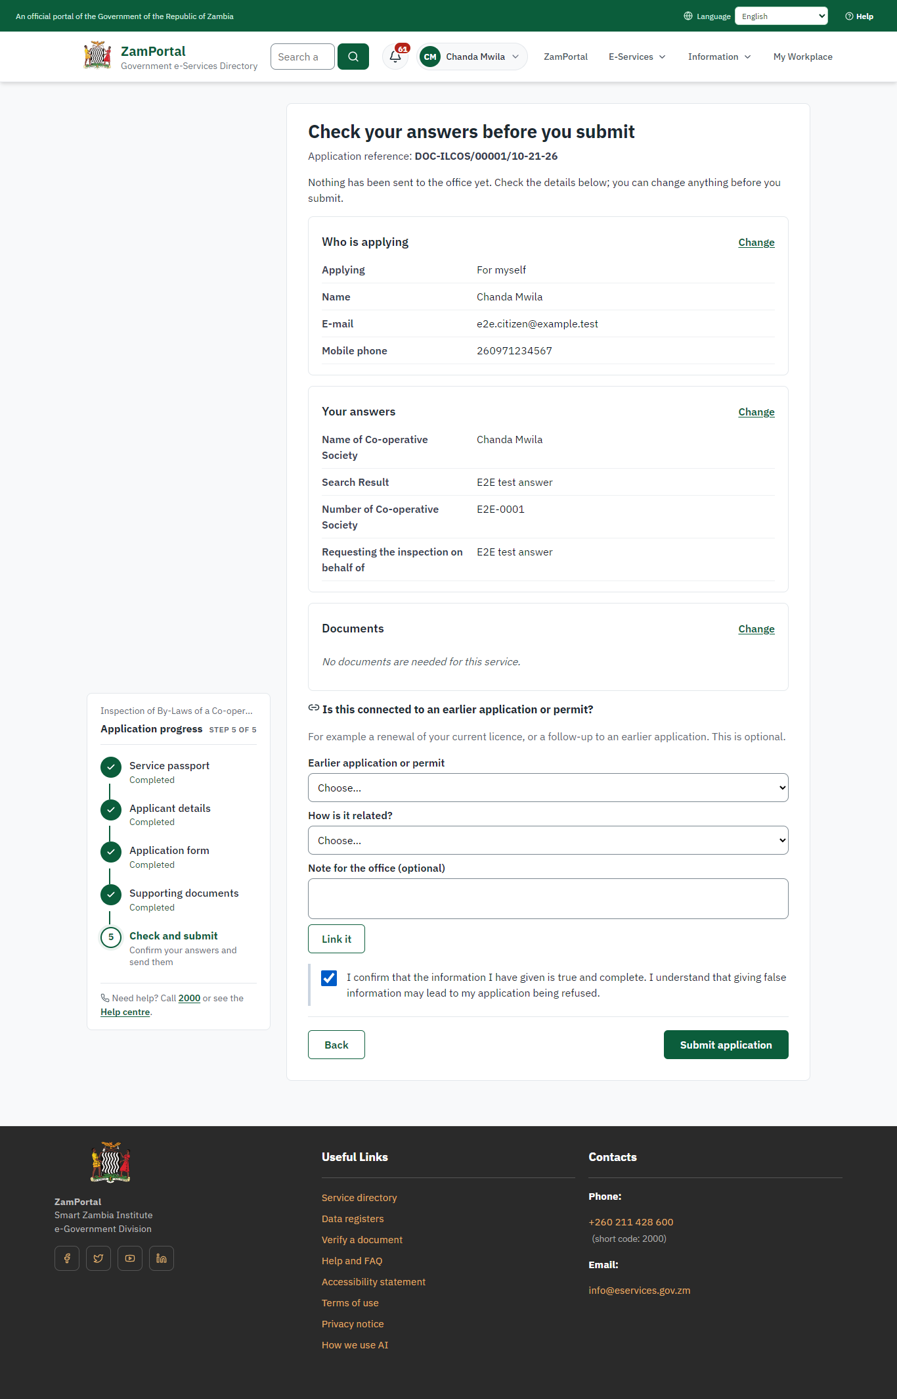 | 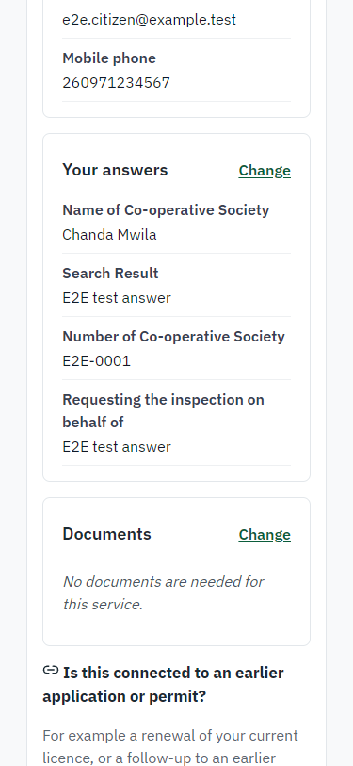
Step 6: Check the answers and confirm the declaration - desktop (left) and a 375 px phone (right).

Step 7. Application sent
Citizen · National e-Services portal
The portal confirms the application with the ministry's reference number (DOC-ILCOS/00001/10-21-26 in this run). The fee is due now: it is taken with the application, so the invoice was raised when the application was sent.
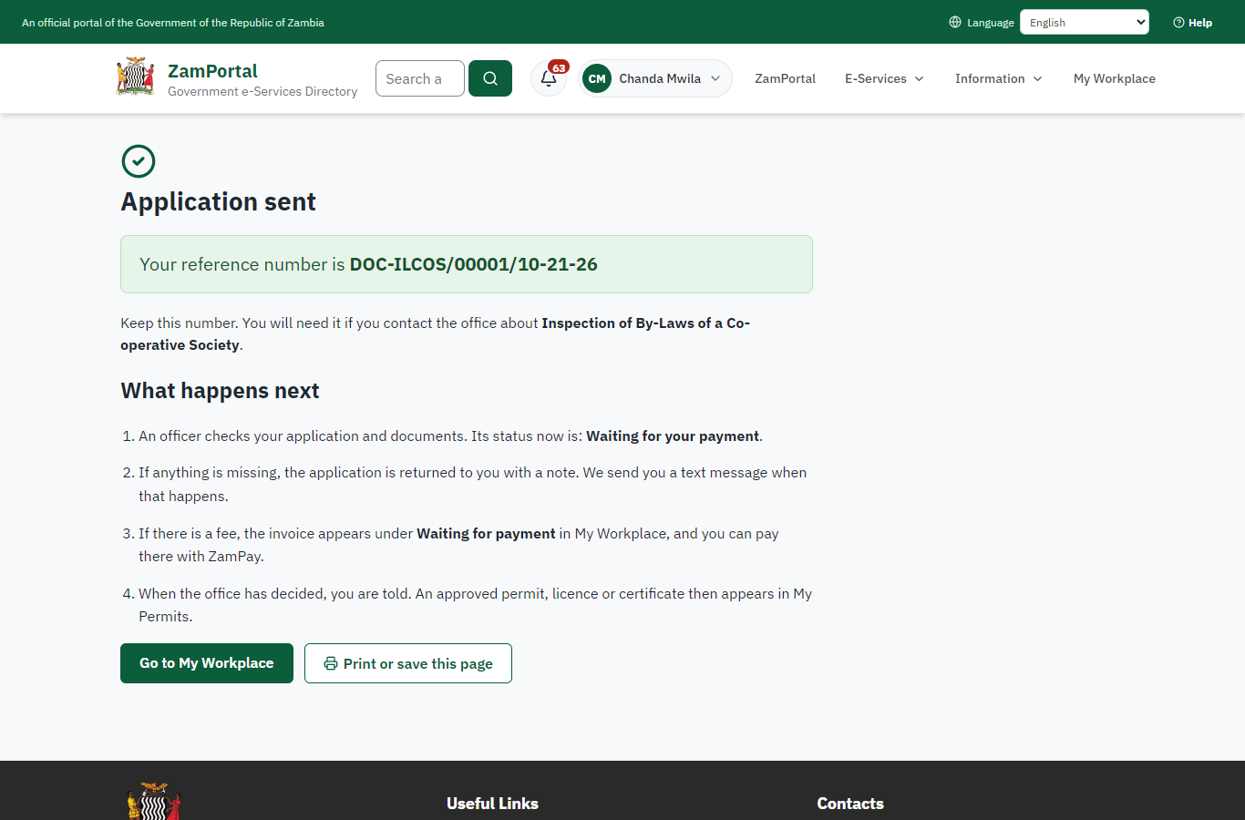 | 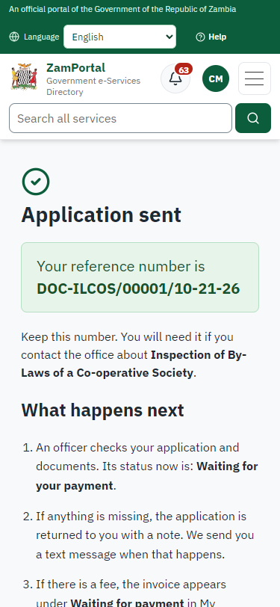
Step 7: Application sent - desktop (left) and a 375 px phone (right).

Step 8. See that the fee is due
Citizen · National e-Services portal
The application shows "Waiting for your payment" in My Workplace with a Pay button (K200.00). The fee is taken with the application; the invoice was raised on ZamPay.
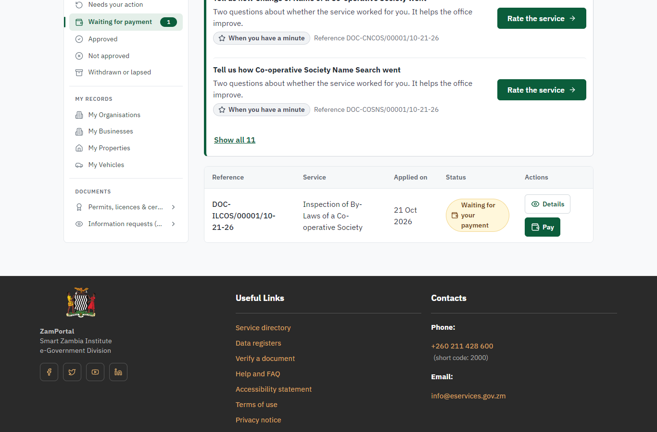 | 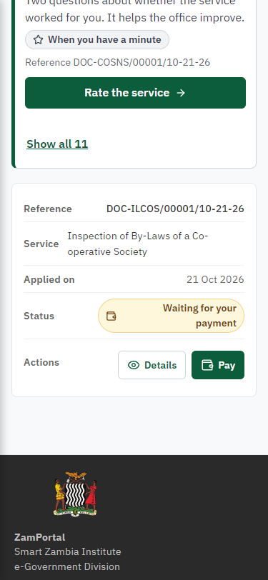
Step 8: See that the fee is due - desktop (left) and a 375 px phone (right).

Step 9. Pay with ZamPay
Citizen · National e-Services portal
Pay opens the invoice (K200.00, the amount set by the platform, never by the page) with its PDF preview; the citizen pays at ZamPay by mobile money or bank card.
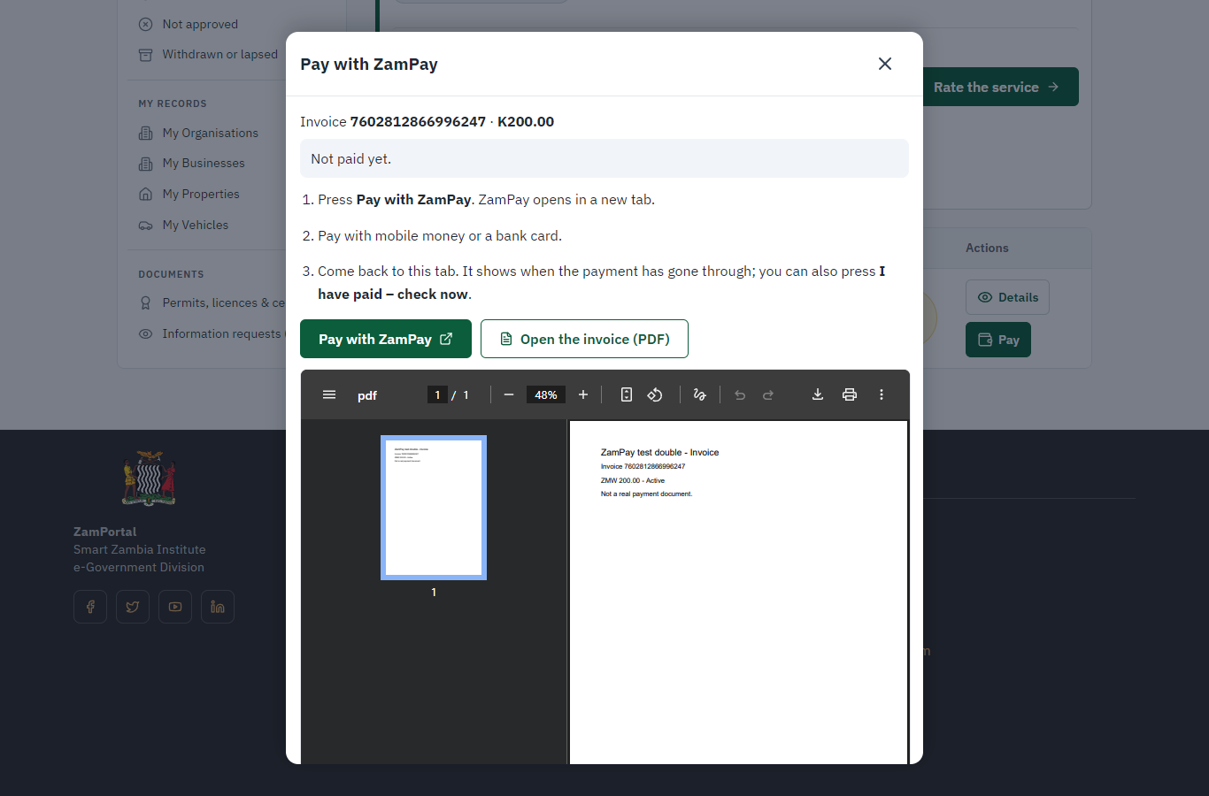 | 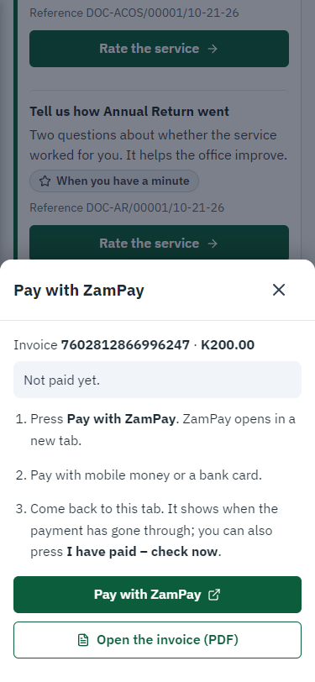
Step 9: Pay with ZamPay - desktop (left) and a 375 px phone (right).

Step 10. Payment received
Citizen · National e-Services portal
ZamPay reports the payment; the dialog says "Paid. Thank you" and the application moves on to the ministry's officers.
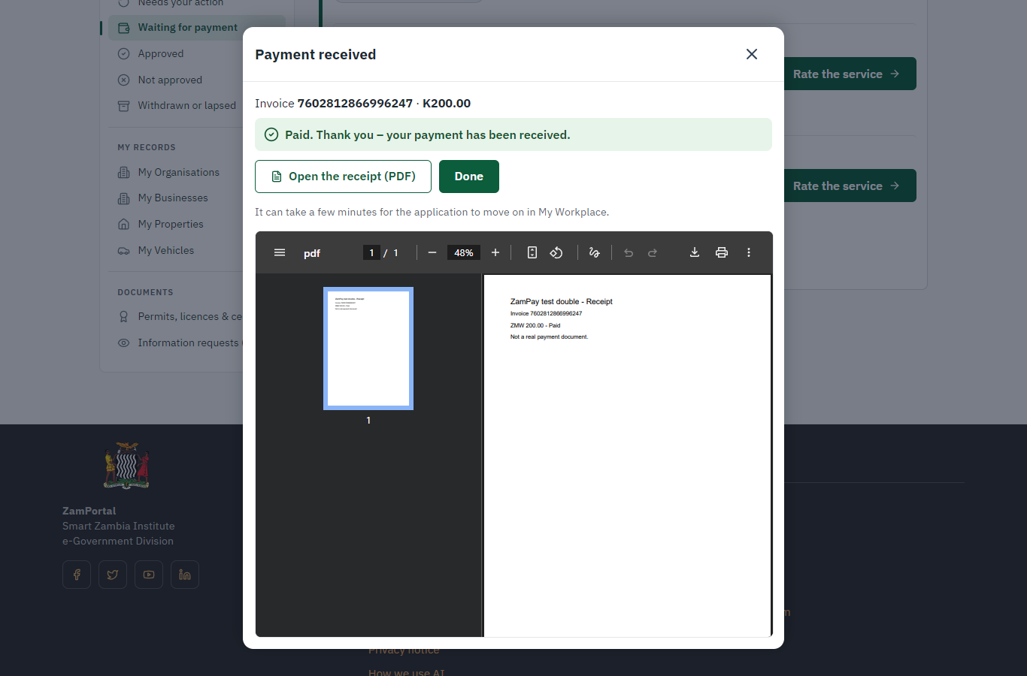 | 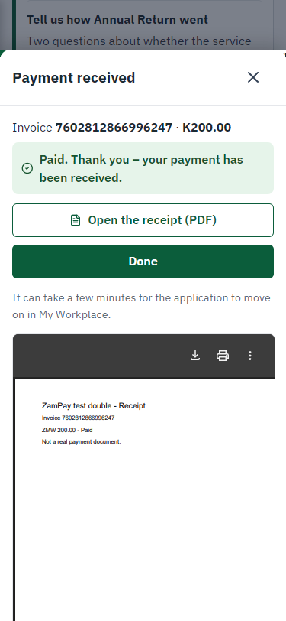
Step 10: Payment received - desktop (left) and a 375 px phone (right).

Step 11. Take the new application on
Case Officer · Back office
The application arrives in the case queue of the ministry that owns the service (Department of Registration and Regulation); only its staff see it. The officer opens it by its reference number - answers, documents and process are on the case - assigns it to themself and takes it on.
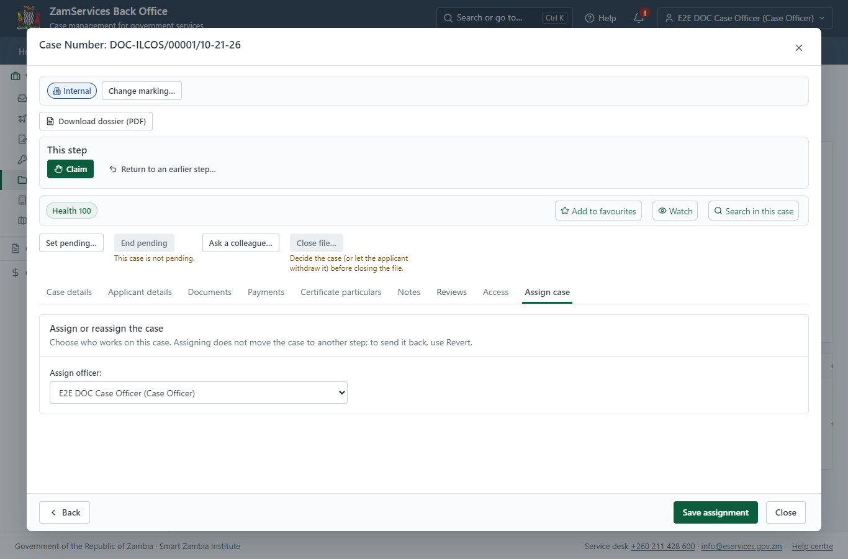
Step 11: Take the new application on.

Step 12. Fill in the certificate particulars
Case Officer · Back office
The issued document prints 8 fields that come from the office rather than from the application (Position, Society no, Society name, Society id status, Society id postal address, Society id registered office, Society id date of registration, Reg entity founders). The officer fills them in on the case's "Certificate particulars" tab before the document is issued (synthetic values in this run) and saves; once the document is issued they can no longer change.
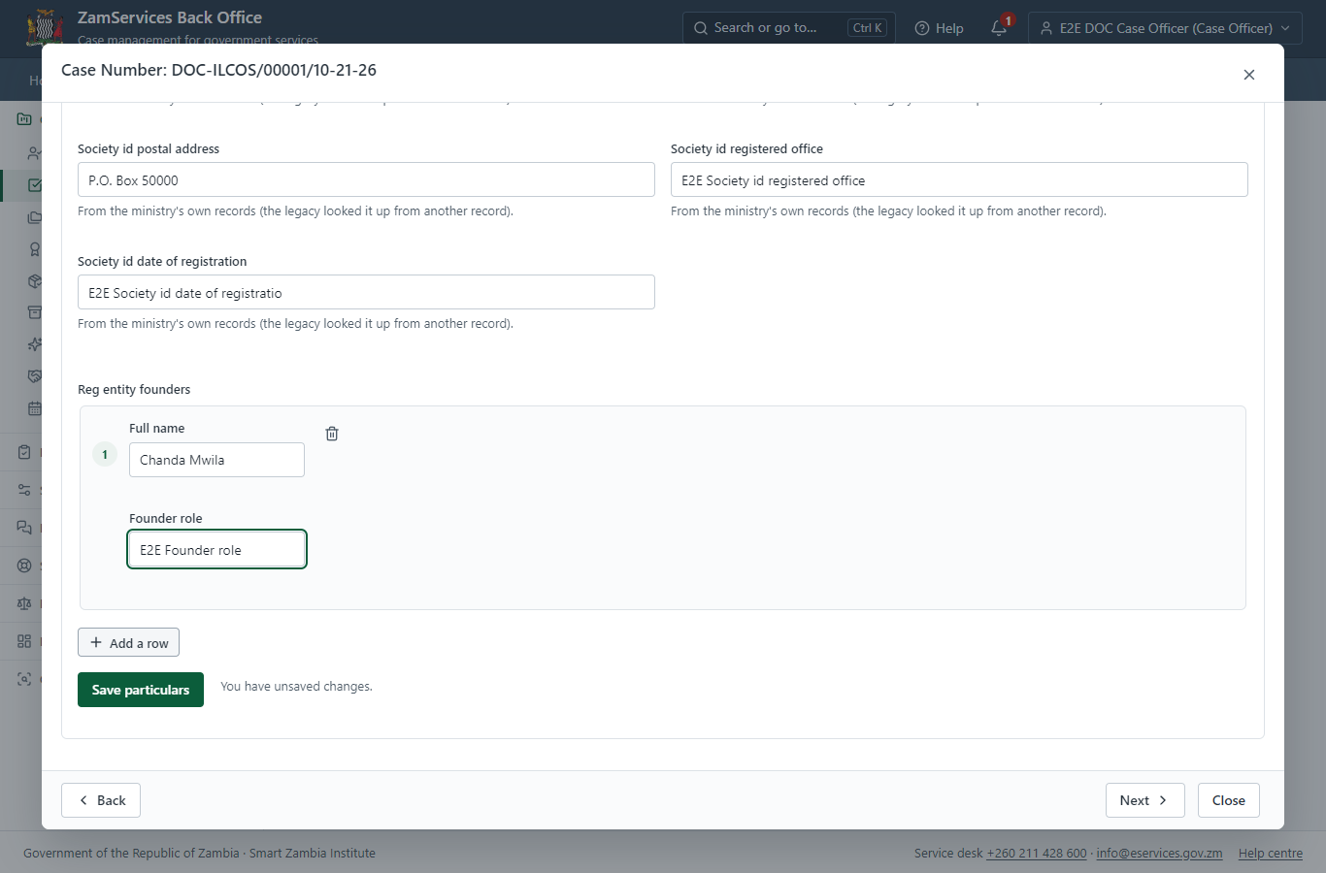
Step 12: Fill in the certificate particulars.

Step 13. Inspect the case by Case Officer
Case Officer · Back office
The Case Officer works on "Inspect the case by Case Officer" (review in the imported process), checks the application and its documents, and completes the step.
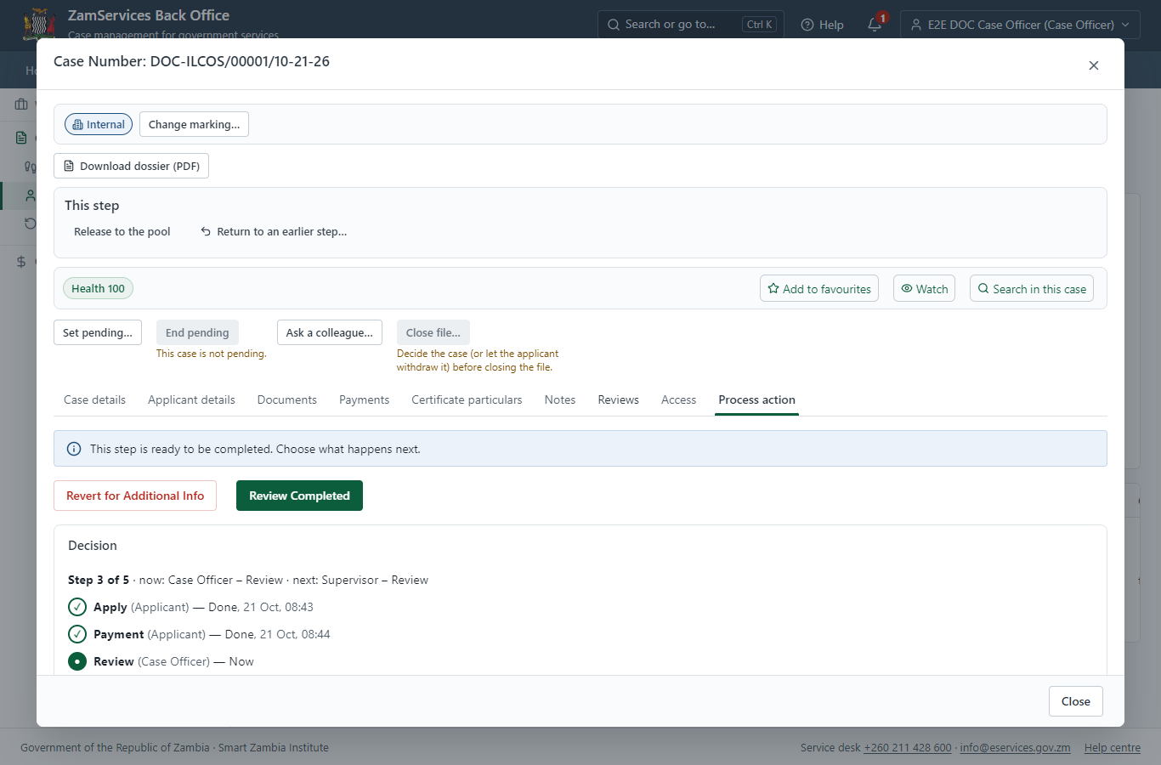
Step 13: Inspect the case by Case Officer.

Step 14. Inspect the case by Supervisor
Supervisor · Back office
The Supervisor works on "Inspect the case by Supervisor" (review in the imported process), checks the application and its documents, and completes the step.
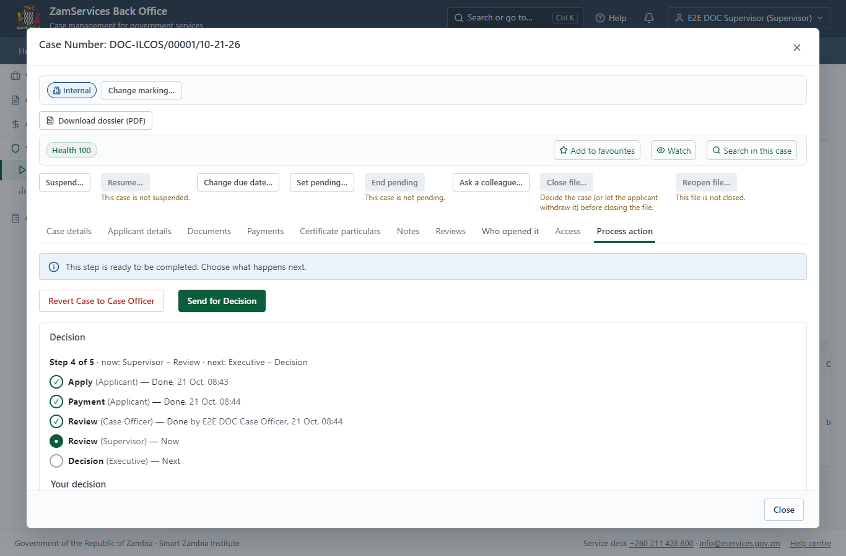
Step 14: Inspect the case by Supervisor.

Step 15. Decide: Review, Inspect, e-Sign Executive
Executive · Back office
At "Review, Inspect, e-Sign Executive" the Executive records the decision: approve, with a comment kept in the case history. Approving moves the case on; the last decision completes it and issues the document.
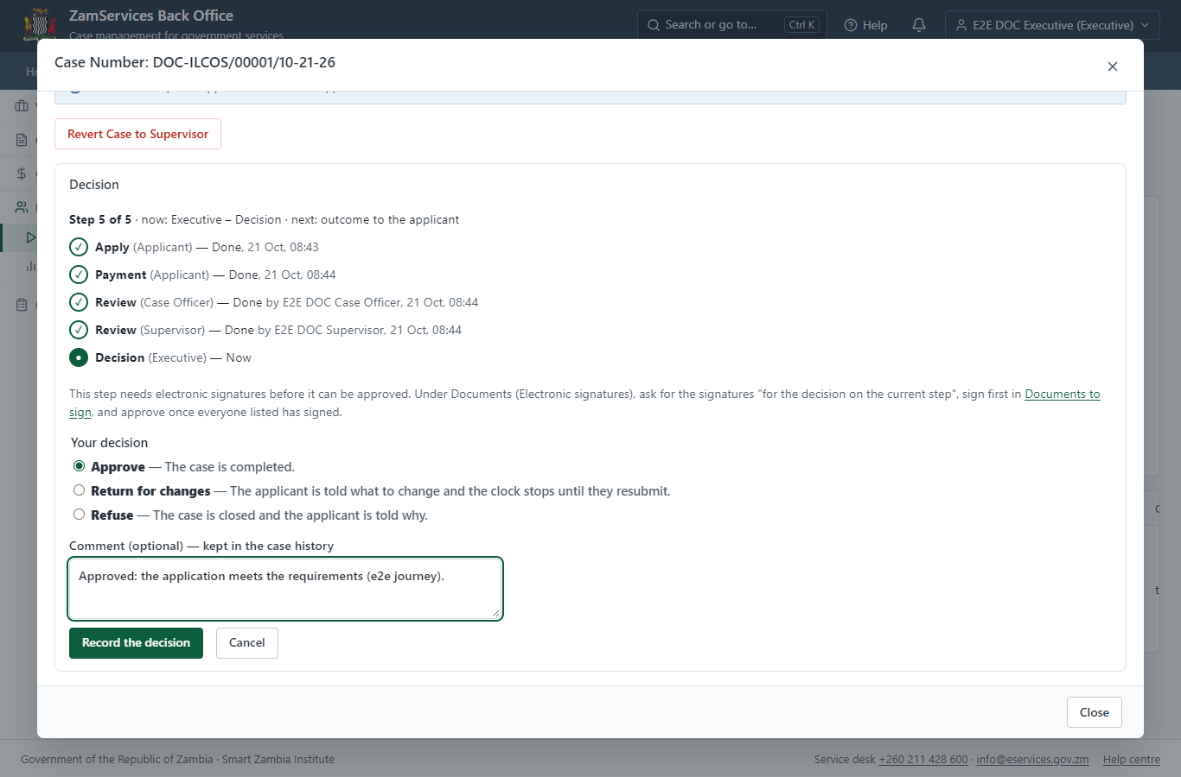
Step 15: Decide: Review, Inspect, e-Sign Executive.

Step 16. The document in My permits
Citizen · National e-Services portal
The issued document (DOC-IBLCO-2026-00001 in this run: "Notice Registration Details") is listed in "My permits and licences" with its validity and a download of the sealed PDF.
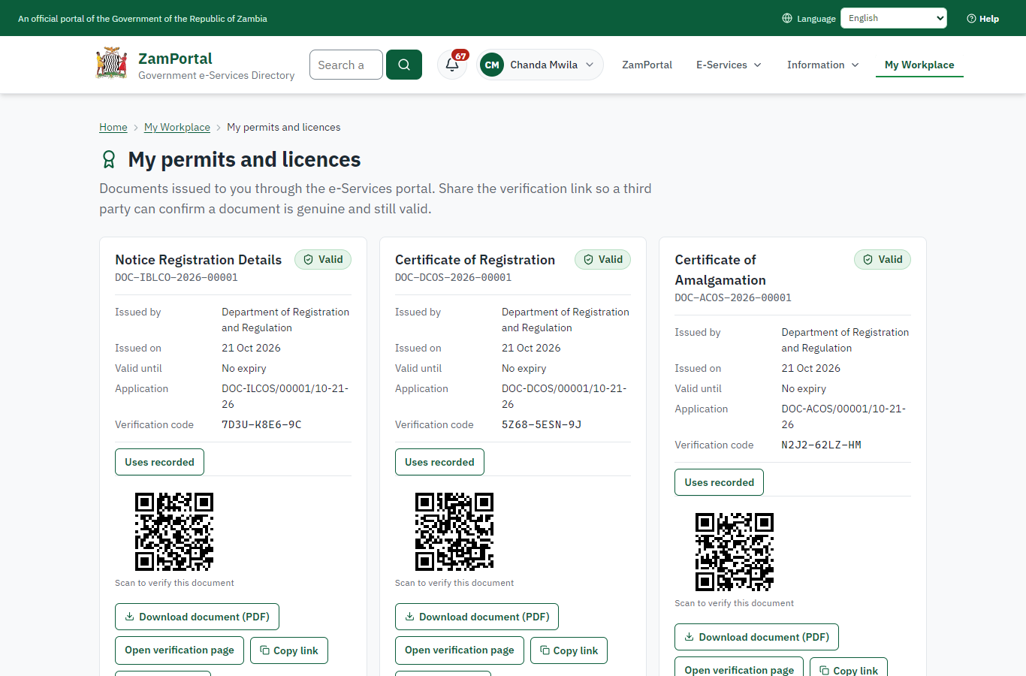 | 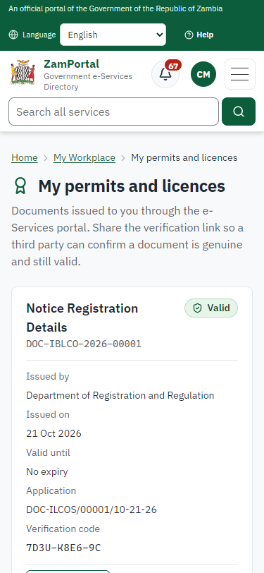
Step 16: The document in My permits - desktop (left) and a 375 px phone (right).

Step 17. Verify the document
Anyone (public) · Public verification page
The QR code on the document opens the public verification page: genuine and current, to whom it was issued, and whether the electronic seal is valid. No sign-in is needed.
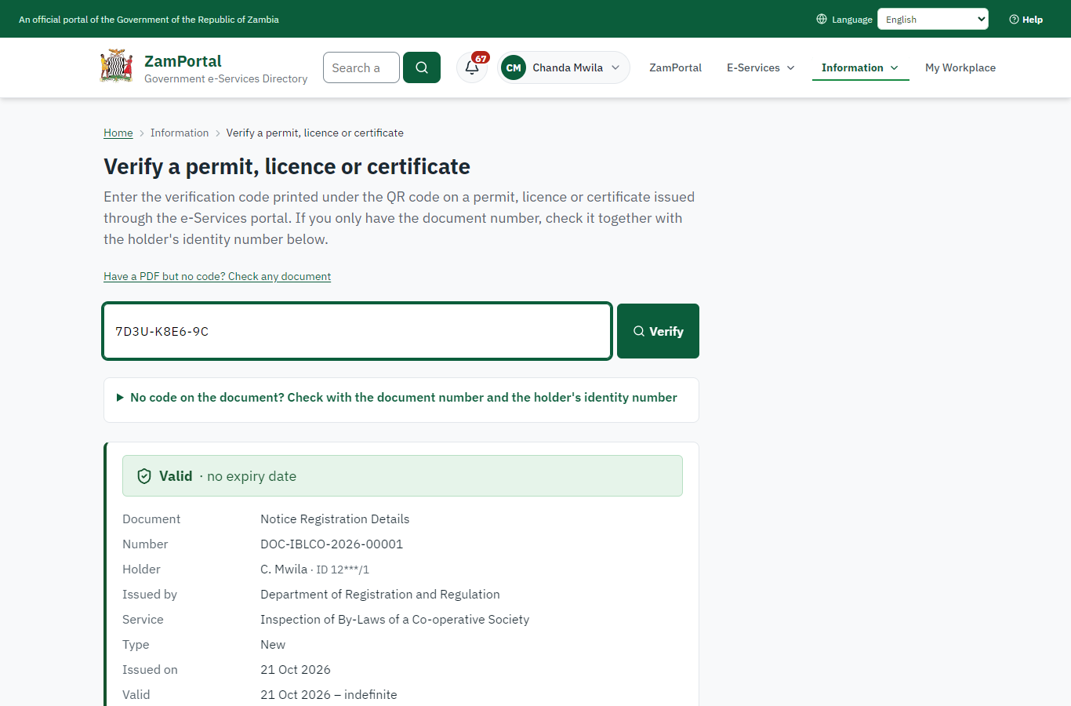 | 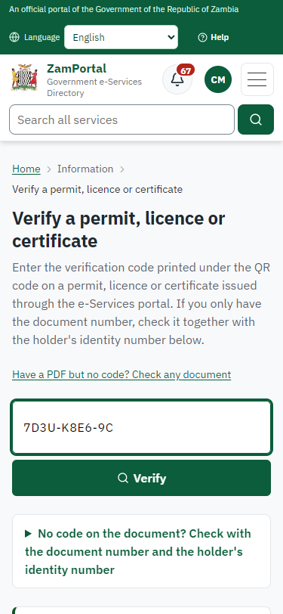
Step 17: Verify the document - desktop (left) and a 375 px phone (right).

3. Payment
Item | In the test run
Fee (as published) | Inspection of By-Laws of a Co-operative Society – 200 ZMW
Invoice 1 | 7602812866996247
Amount 1 | ZMW 200.00
Paid at 1 | with the application
On screen: step 8 (See that the fee is due), step 9 (Pay with ZamPay), step 10 (Payment received) in section 2.

4. Output documents

Notice Registration Details (sealed PDF)
Issued when the case was approved, from the service's output configuration (service template DOC_NoticeRegistrationDetails.Certificate.d), filled from the application and the decision, sealed with the platform's electronic seal and stored as the issued version. The holder downloads it from My permits; the verification page checks it.
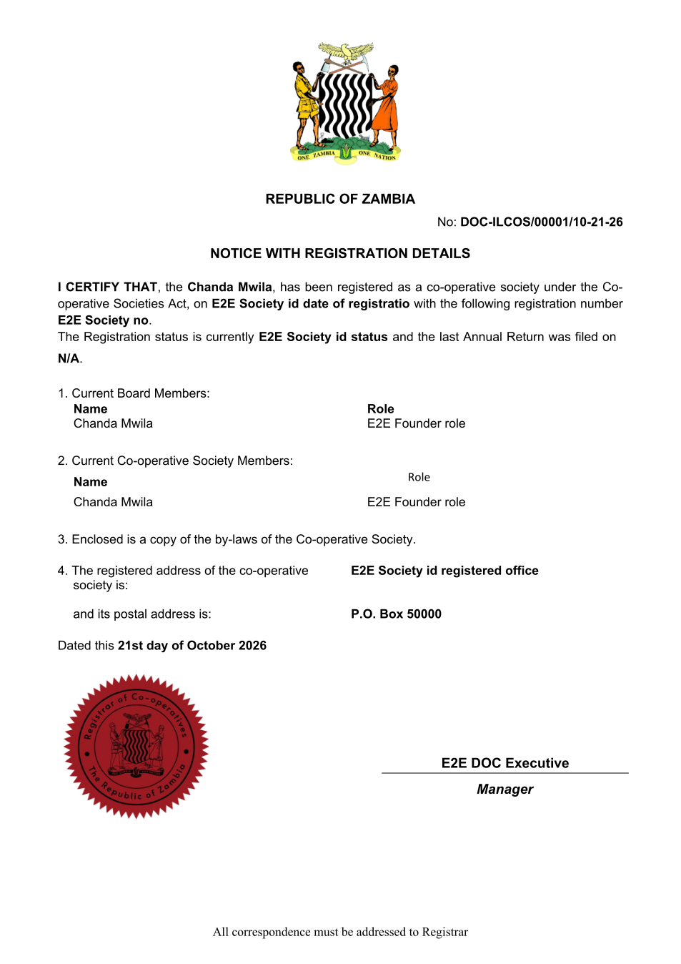
Notice Registration Details (sealed PDF) - first of 1 page, as issued in the test run.

Fields
Field | Value in the test run
Document title | Notice Registration Details
Permit / licence number | DOC-IBLCO-2026-00001
Holder | Chanda Mwila
Valid from | 2026-10-21
Valid until
Status | active
Verification code (printed with a QR code) | 7D3U-K8E6-9C

Seal
Seal status | sealed
Signature level | PAdES-B-T
Sealed by | the platform seal (development key in the test run)
Signed at | 2026-10-21T06:44:40.971Z
Trusted time-stamp | 2026-10-21T06:44:40.864Z (time-stamping authority)
Document fingerprint (SHA-256) | b90ddd83bd0c8452...

Verification
Where | The public verification page of the national portal, <portal>/verify/<verification code>, opened by scanning the QR code on the document.
What it shows | Whether the document is genuine and current, its holder and validity, and whether the electronic seal is valid and who sealed it.
Checking a copy | Anyone can upload a PDF they were given; the page says whether it is exactly the document that was issued. A changed copy is reported as not matching.
On screen: step 16 (The document in My permits), step 17 (Verify the document) in section 2.

5. Notifications
When | Channel | To | Message | Delivery
Payment due (invoice raised) | in-app (portal bell) | the applicant | Payment due for application DOC-ILCOS/00001/10-21-26 - The fee of ZMW 200.00 for Inspection of By-Laws of a Co-operative Society (DOC-ILCOS/00001/10-21-26) is now due. Invoice 7602812866996247. | shown
Application received | in-app (portal bell) | the applicant | Application DOC-ILCOS/00001/10-21-26 received - Your application DOC-ILCOS/00001/10-21-26 for Inspection of By-Laws of a Co-operative Society has been received by Department of Registration and Regulation. | shown
Payment received | in-app (portal bell) | the applicant | Payment received for DOC-ILCOS/00001/10-21-26 - Your payment of ZMW 200.00 for DOC-ILCOS/00001/10-21-26 (Inspection of By-Laws of a Co-operative Society) has been received. Receipt: <ZamPay>/pdf?documentType=receipt&invoiceNumber=7602812866996247 | shown
Decision: approved | in-app (portal bell) | the applicant | Application DOC-ILCOS/00001/10-21-26 completed - DOC-ILCOS/00001/10-21-26 (Inspection of By-Laws of a Co-operative Society) is complete. Your documents are ready. | shown
Licence / permit issued | in-app (portal bell) | the applicant | Your Inspection of By-Laws of a Co-operative Society document has been issued - DOC-IBLCO-2026-00001 has been issued for Inspection of By-Laws of a Co-operative Society. | shown
Invitation to rate the service | in-app (portal bell) | the applicant | How was Inspection of By-Laws of a Co-operative Society? - How was Inspection of By-Laws of a Co-operative Society? Tell us in about a minute. | shown
Payment due (invoice raised) | sms | +260 97* *** 567 | Fee of ZMW 200.00 due for DOC-ILCOS/00001/10-21-26. Invoice 7602812866996247. Pay: <ZamPay>/pay-for-service/get-invoice/7602812866996247 | delivered
Payment due (invoice raised) | email | e2e.c***@example.test | Payment due for application DOC-ILCOS/00001/10-21-26 | skipped
Application received | sms | +260 97* *** 567 | Application DOC-ILCOS/00001/10-21-26 for Inspection of By-Laws of a Co-operative Society has been received. Track it: <portal>/my-workplace | delivered
Application received | email | e2e.c***@example.test | Application DOC-ILCOS/00001/10-21-26 received | skipped
Payment received | sms | +260 97* *** 567 |  | delivered
Invitation to rate the service | sms | +260 97* *** 567 |  | skipped
Invitation to rate the service | email | e2e.c***@example.test | How was Inspection of By-Laws of a Co-operative Society? | skipped
Licence / permit issued | sms | +260 97* *** 567 |  | delivered
Decision: approved | sms | +260 97* *** 567 |  | delivered
Licence / permit issued | email | e2e.c***@example.test | Your Inspection of By-Laws of a Co-operative Society document has been issued | skipped
Decision: approved | email | e2e.c***@example.test | Application DOC-ILCOS/00001/10-21-26 completed | skipped
Delivery: shown = in the portal's notification bell; delivered = the SMS gateway (a test double in this run) reported the text delivered; skipped = not sent on that channel (e-mail is not configured on the test installation, and some notices go out on one channel only); sent by the national portal = a ministry node handed the notice to the national portal, which texts and e-mails the citizen under its own name and the citizen's preferences. Addresses written <portal>, <ZamPay> stand for the national portal and ZamPay.

6. Legacy mapping
Replaces | Inspection of By-Laws of a Co-operative Society in the legacy ZIGS e-Services directory (ZIGS_Services)
Legacy service id | 329
Legacy provider | Department of Registration and Regulation (DOC) under Ministry of Small and Medium Enterprise Development
Legacy process | Standard.Review_3Step (process 103)
Fee in the legacy system | Inspection of By-Laws of a Co-operative Society: ZMW 200 (New)
Fee taken before submission | yes (as in ZIGS)
Time to issue (legacy) | New: 30 working days
Legacy output templates | Notice Of Action: ZIGS_Forms_Notices / GS-2.NoticeOfAction  Application form: ZIGS_Forms_DOC / DOC_InspectionOfByLaws.Application  Notice Registration Details: ZIGS_Forms_DOC / DOC_NoticeRegistrationDetails.Certificate  GF-1 Treasury Invoice: ZIGS_CustomForms / GF-1 Invoice  GF-2 Treasury Receipt: ZIGS_CustomForms / GF-2 Receipt
Legacy address | https://cooperatives.gsb.gov.zm
How it was brought over | Imported by the platform's legacy catalogue importer (zcm-backend scripts/zigs/importLegacy.js) from the ZIGS snapshot: form, case types, fees, documents, process and output templates, then served by the new platform.

7. Version and date
Document version | service v1, platform a0a302b8
Generated | 2026-10-21T06:44:54Z (by the end-to-end run, not edited by hand)
Service version | not versioned (configured directly)
Platform snapshot | backend a0a302b8  portal 72805f0  back office 58e5946
Test suite | e2e 5999d9b; one installation (combined); seed profile mihud
Journeys | 30-catalogue-service.spec.js: citizen finds the service, answers its form, uploads its documents and sends the application - passed  30-catalogue-service.spec.js: the case goes through every step of its process: payments by the citizen, each officer step by its role - passed  30-catalogue-service.spec.js: the grant document is issued, sealed, filled in and verifiable; the citizen has it in My permits - passed
Result | 3 of 3 journey tests passed
Data | Synthetic test data on a local test installation; provider test doubles for ZamPass, ZamPay, SMS and signing.

