Republic of Zambia
GSB e-Services

Immigration Temporary Employment Permit
Service documentation
Owner: Department of Immigration
Service key: ZIMS/immigration-temporary-employment-permit
Version: service v1, platform eb3a209f
Date: 2026-10-16
Generated automatically by the service's end-to-end test run. Every screenshot shows synthetic test data on a local test installation, never real personal data.

Contents
- 1. Service summary
- 2. Application process, step by step
- 3. Payment
- 4. Output documents
- 5. Notifications
- 6. Legacy mapping
- 7. Version and date
This document describes the Immigration Temporary Employment Permit service of Department of Immigration as the platform runs it today. It is generated by the service's end-to-end test: every step was performed by the test and every screenshot was taken during that run, with synthetic data. Regenerate it with "npm run docs:services" in the e2e suite; do not edit it by hand.

1. Service summary
Service | Immigration Temporary Employment Permit
Owner (MDA) | Department of Immigration (ZIMS)
Purpose | This Permit is issued to any business visitor intending to remain in Zambia for a period exceeding thirty (30) days.
Who can apply | Foreigner; Organization
How to apply | Online on the national e-Services portal, signed in with ZamPass; pay with ZamPay.
Fees | FOR PRIVATE SECTOR – Issuance: ZMW 4500.00  FOR PRIVATE SECTOR – Renewal: ZMW 5250.00  FOR PRIVATE SECTOR – Duplicate: ZMW 5250.00  FOR PRIVATE SECTOR – Variation: ZMW 5250.00  FOR PRIVATE SECTOR – Issuance: ZMW 2250.00  FOR PRIVATE SECTOR – Renewal: ZMW 3000.00  FOR PRIVATE SECTOR – Duplicate: ZMW 2250.00  FOR PRIVATE SECTOR – Variation: ZMW 3000.00
Turnaround | Application – instantly  Examination – depends on local conditions
Validity of the output | The period granted shall not exceed six (6) months in any period of twelve (12) month
Required documents | FOR ISSUANCE: (required)  Application Form (Form 25) (required)  Recent passport size photograph (required)  Certified Photocopies of current passport (required)  Covering letter to the Director – General of Immigration from the employer indicating the nature of work the applicant intends to undertake in Zambia (required)  Prescribed fee (required)  FOR RENEWAL /EXTENSION: (required)  Application Form 11 (required)  Covering letter from the concerned employer indicating the reasons for extension (required)  FOR DUPLICATE/REPLACEMENT: (required)  Covering letter to the Director General from the applicant (required)  Application Form used to apply for the old permit (Form 25) (required)  Copy of old permit (if possible) (required)  Police Report (required)  Certified passport copy (required)
Output documents | Form 26 (New)  Application form (Amendment)  GS-2 Notice of Government Action
Legal basis | Immigration and Deportation Act, 2010 (http://www.parliament.gov.zm/sites/default/files/documents/acts/Immigration%20and%20Deportation%20Act.pdf)

2. Application process, step by step

The process as configured
Step | Role | Task | Type
1 | Applicant | Apply | form
2 | Applicant | Payment | payment
3 | System | Generate Document | generate-document
4 | Case Officer | Approve | approve
5 | System | Generate Document | generate-document
6 | System | Notify Client | notify

Step by step
Who takes part in this journey: Citizen, Case Officer, Anyone (public). Citizen steps are shown on a desktop and on a 375 px phone; back-office steps on a desktop.

Step 1. Find the service
Citizen · National e-Services portal
On the national e-Services portal the citizen opens All Services and searches for the service by name ("Immigration Temporary Employment Permit"). Each result names the service and the ministry that provides it.
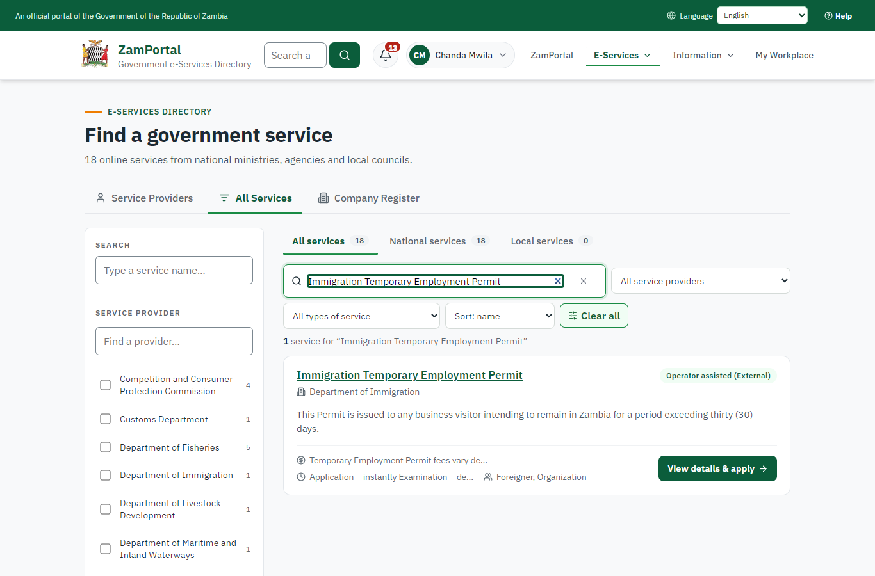 | 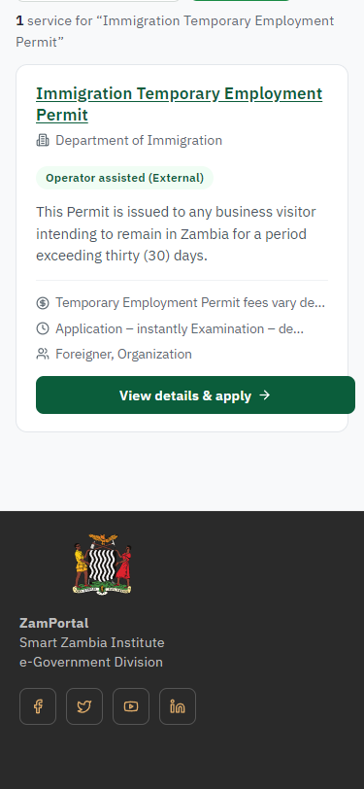
Step 1: Find the service - desktop (left) and a 375 px phone (right).

Step 2. Read the service page
Citizen · National e-Services portal
The service page sets out what the service is for, who provides it, the fee, how long it takes and the documents to have ready. "Start application" begins an application (the citizen is signed in with ZamPass).
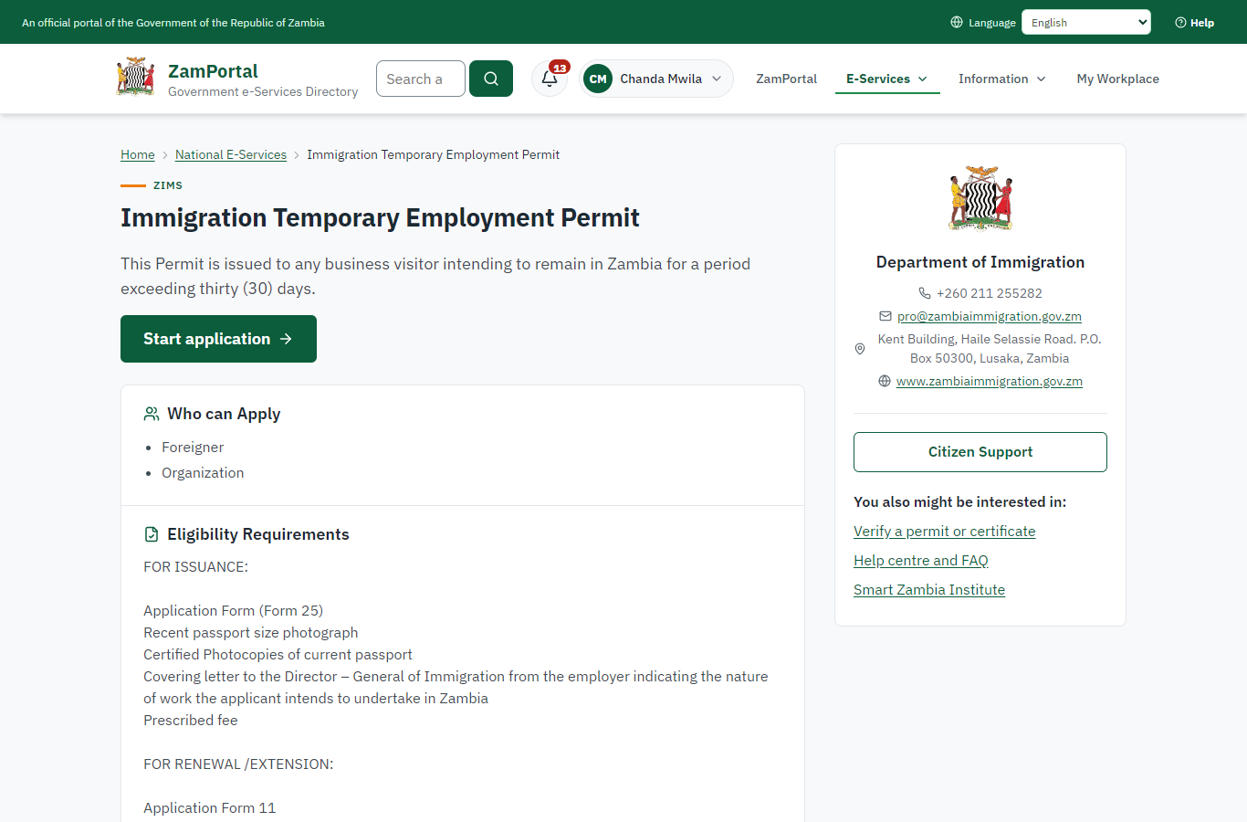 | 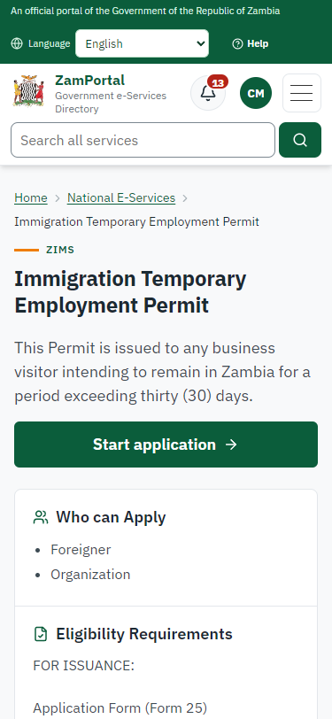
Step 2: Read the service page - desktop (left) and a 375 px phone (right).

Step 3. Confirm the applicant details
Citizen · National e-Services portal
The applicant details are filled in from the citizen's ZamPass account. The citizen says whom they are applying for (themself) and continues with "Proceed to Application".
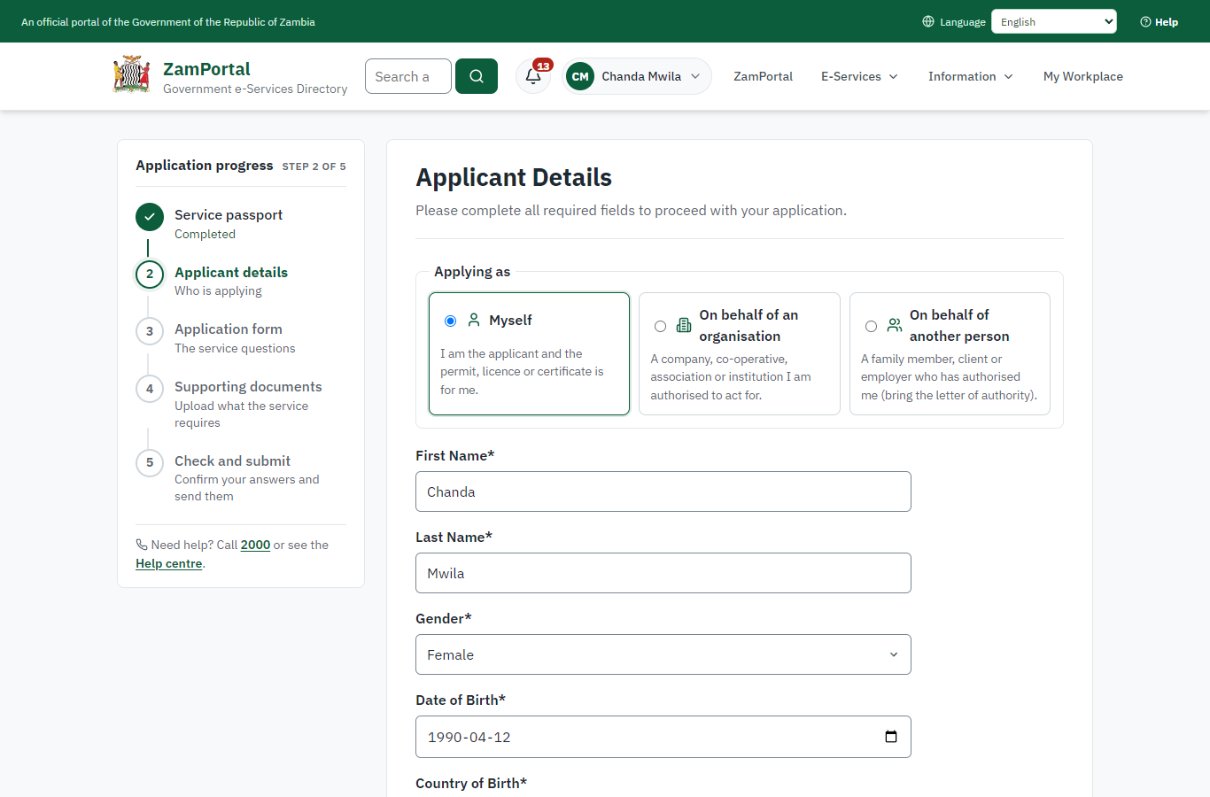 | 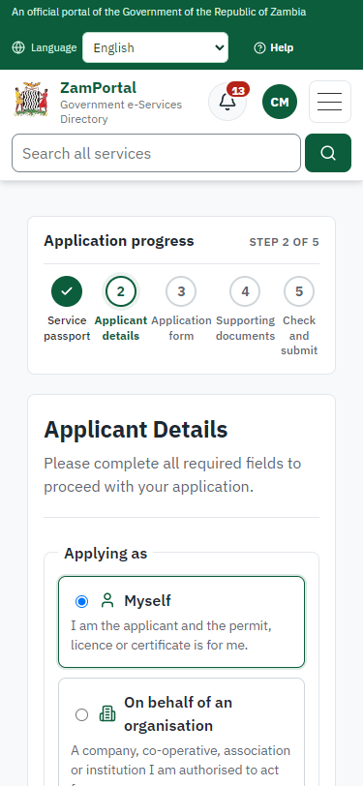
Step 3: Confirm the applicant details - desktop (left) and a 375 px phone (right).

Step 4. Fill in the application form
Citizen · National e-Services portal
The citizen answers the service's own application form, converted from the legacy system (21 answers in this run, all synthetic), for the type of application "New". Questions marked * must be answered; some appear only after an earlier answer. Answers are saved as the citizen types, so an unfinished application can be reopened from My Workplace.
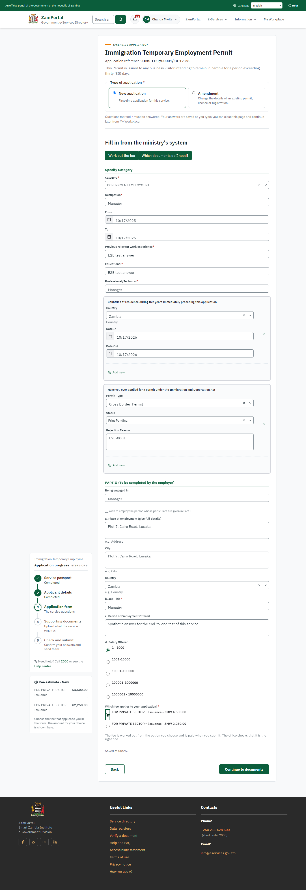 | 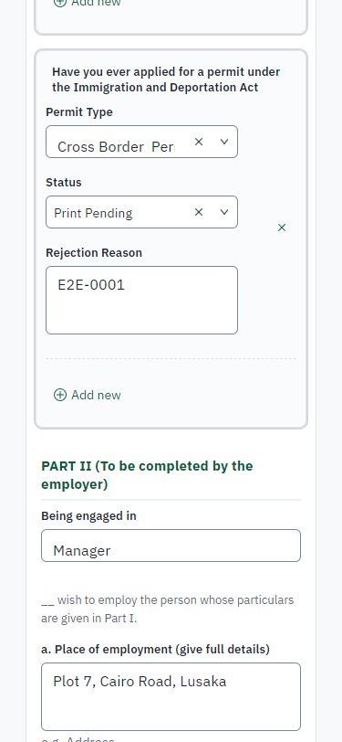
Step 4: Fill in the application form - desktop (left) and a 375 px phone (right).

Step 5. Upload the supporting documents
Citizen · National e-Services portal
Each document the service asks for has its own upload (15 in this run: FOR ISSUANCE:, Application Form (Form 25), Recent passport size photograph, Certified Photocopies of current passport, Covering letter to the Director – General of Immigration from the employer indicating the nature of work the applicant intends to undertake in Zambia, Prescribed fee, FOR RENEWAL /EXTENSION:, Application Form 11, Covering letter from the concerned employer indicating the reasons for extension, FOR DUPLICATE/REPLACEMENT:, Covering letter to the Director General from the applicant, Application Form used to apply for the old permit (Form 25), Copy of old permit (if possible), Police Report, Certified passport copy). The files are checked and stored with the application; the page confirms each upload.
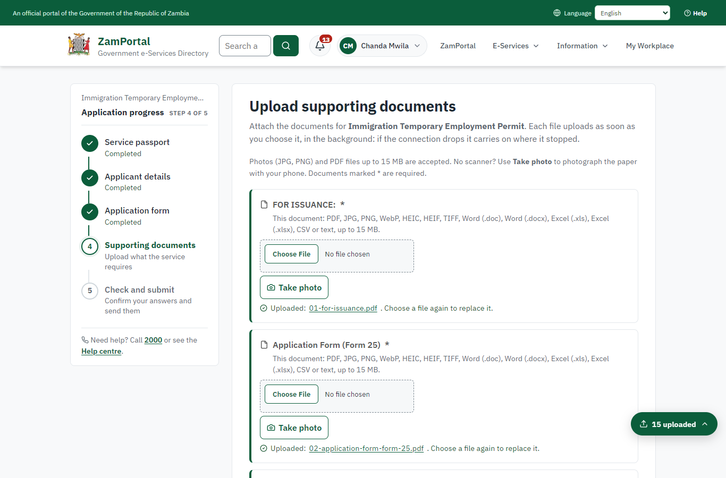 | 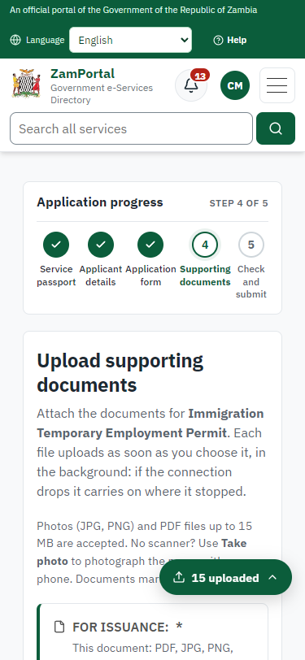
Step 5: Upload the supporting documents - desktop (left) and a 375 px phone (right).

Step 6. Check the answers and confirm the declaration
Citizen · National e-Services portal
Before sending, the citizen sees every answer and document on one page and can go back to change them. The declaration that the information is true and complete must be ticked.
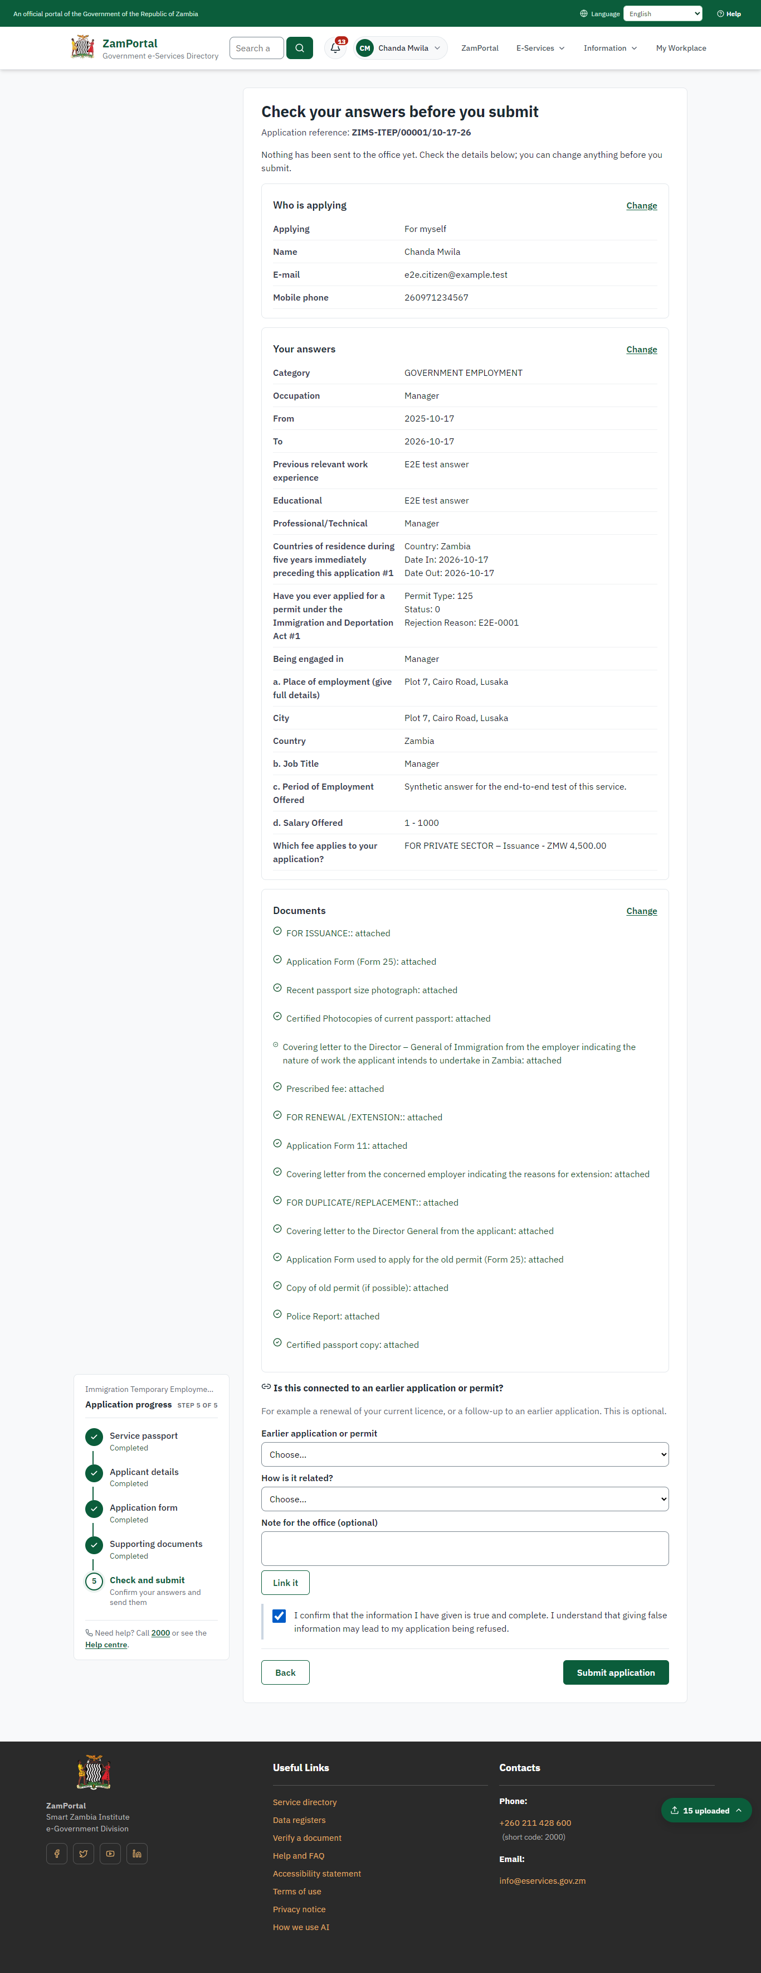 | 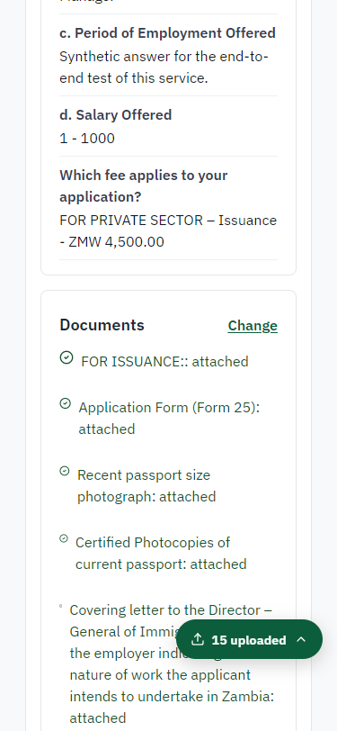
Step 6: Check the answers and confirm the declaration - desktop (left) and a 375 px phone (right).

Step 7. Application sent
Citizen · National e-Services portal
The portal confirms the application with the ministry's reference number (ZIMS-ITEP/00001/10-17-26 in this run). The fee is due now: it is taken with the application, so the invoice was raised when the application was sent.
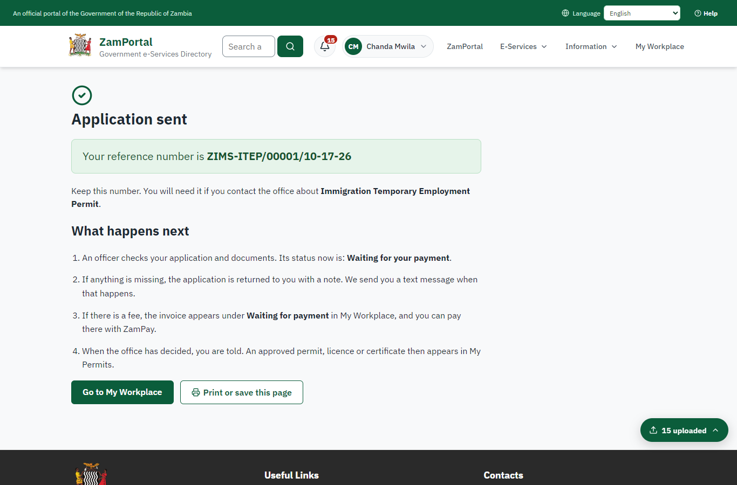 | 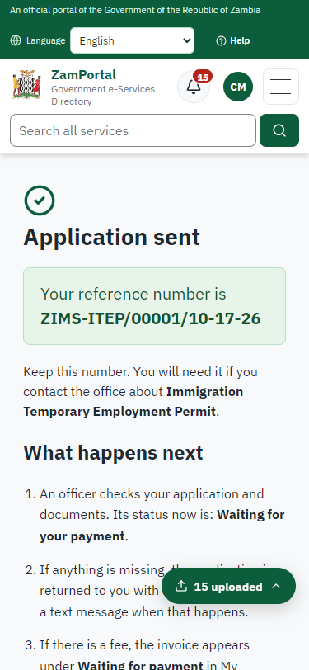
Step 7: Application sent - desktop (left) and a 375 px phone (right).

Step 8. See that the fee is due
Citizen · National e-Services portal
The application shows "Waiting for your payment" in My Workplace with a Pay button (K6,000.00). The fee is taken with the application; the invoice was raised on ZamPay.
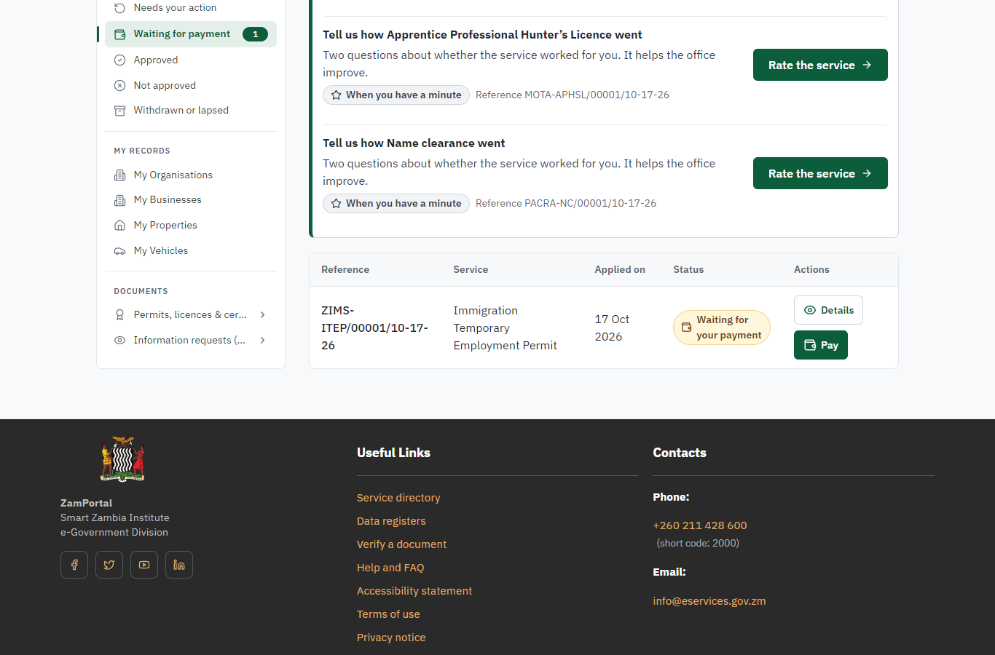 | 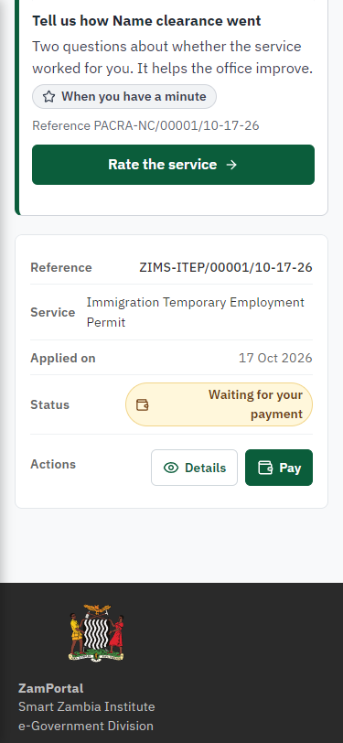
Step 8: See that the fee is due - desktop (left) and a 375 px phone (right).

Step 9. Pay with ZamPay
Citizen · National e-Services portal
Pay opens the invoice (K6,000.00, the amount set by the platform, never by the page) with its PDF preview; the citizen pays at ZamPay by mobile money or bank card.
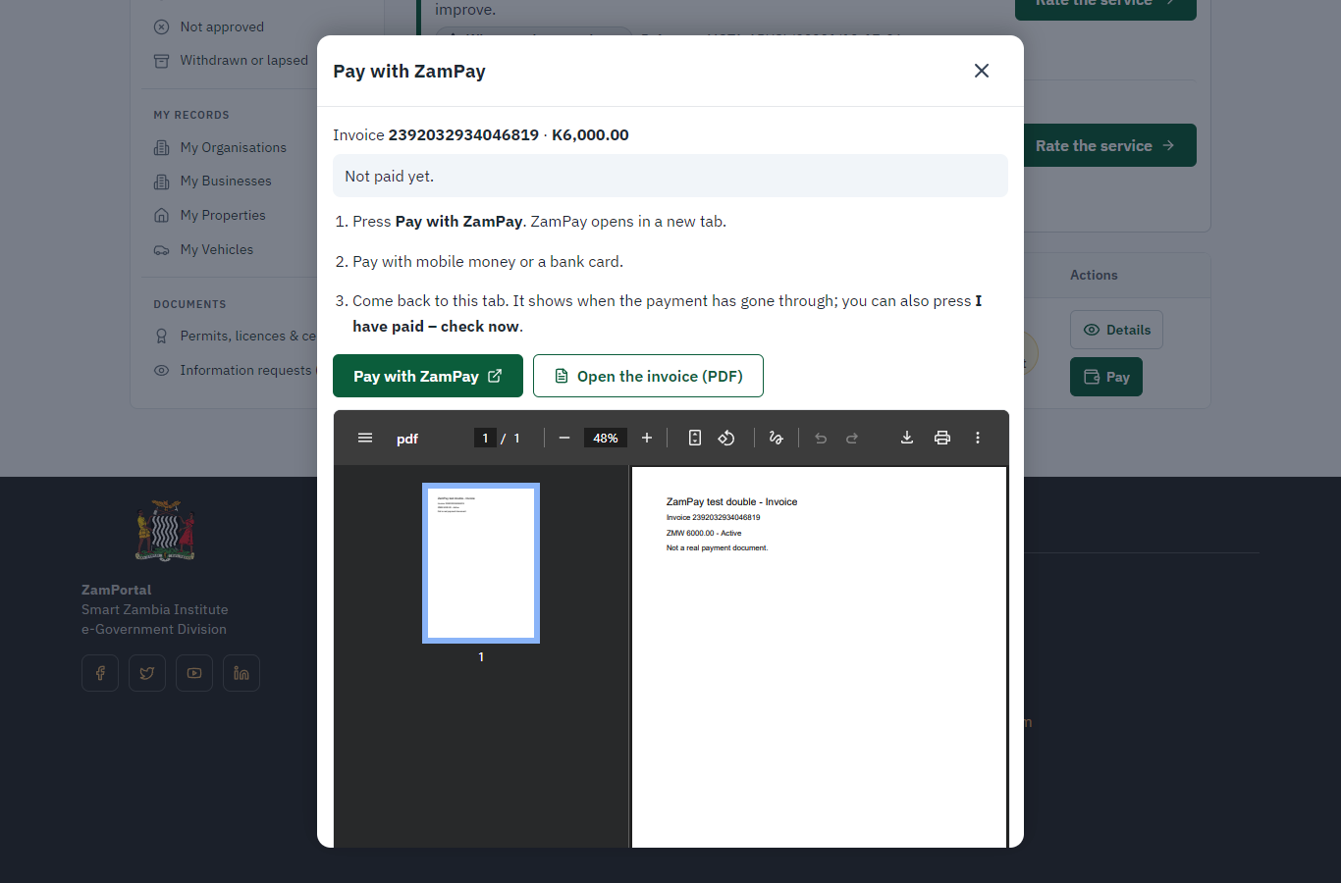 | 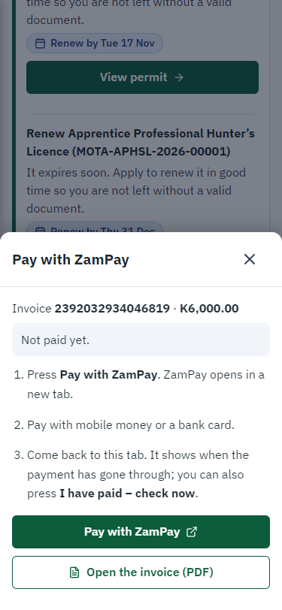
Step 9: Pay with ZamPay - desktop (left) and a 375 px phone (right).

Step 10. Payment received
Citizen · National e-Services portal
ZamPay reports the payment; the dialog says "Paid. Thank you" and the application moves on to the ministry's officers.
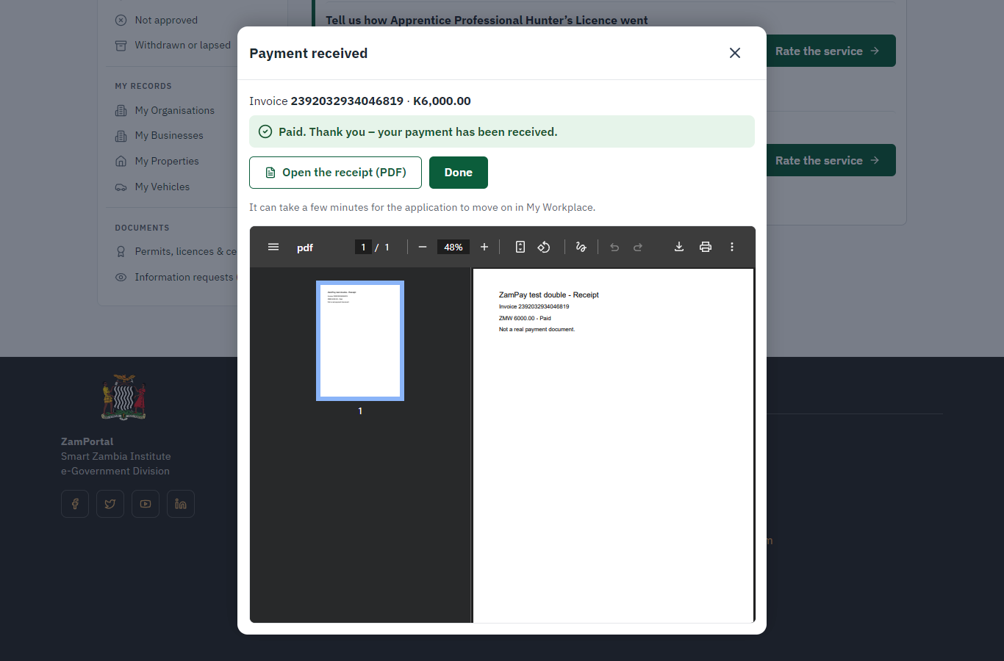 | 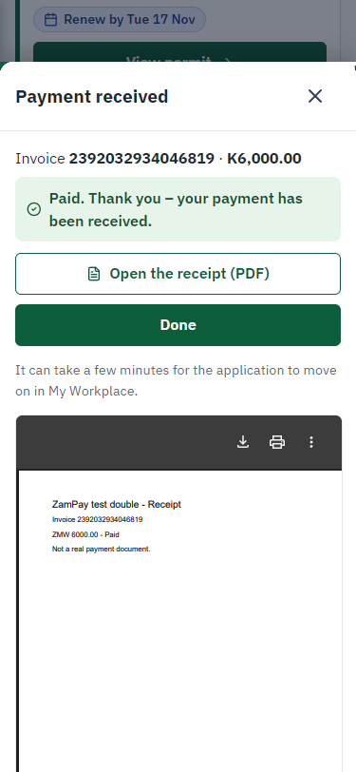
Step 10: Payment received - desktop (left) and a 375 px phone (right).

Step 11. Take the new application on
Case Officer · Back office
The application arrives in the case queue of the ministry that owns the service (Department of Immigration); only its staff see it. The officer opens it by its reference number - answers, documents and process are on the case - assigns it to themself and takes it on.
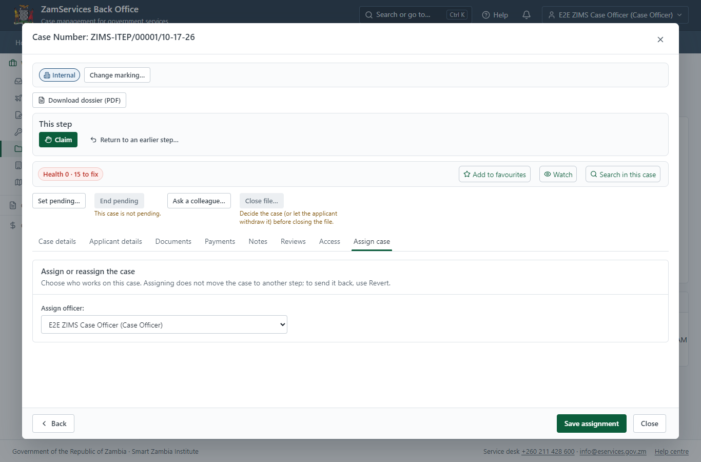
Step 11: Take the new application on.

Step 12. Decide: Record the decision of ZIMS (processed in its own system)
Case Officer · Back office
At "Record the decision of ZIMS (processed in its own system)" the Case Officer records the decision: approve, with a comment kept in the case history. Approving moves the case on; the last decision completes it and issues the document.
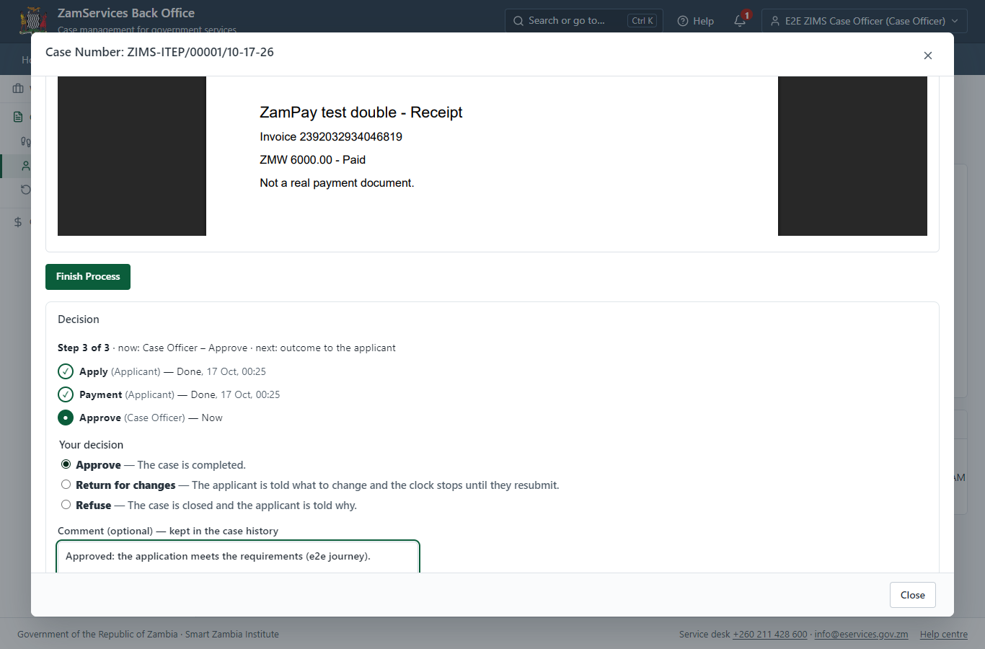
Step 12: Decide: Record the decision of ZIMS (processed in its own system).

Step 13. Issue the document
Case Officer · Back office
The service's validity ("The period granted shall not exceed six (6) months in any period of twelve (12) month") is not a fixed period, so completing the case does not issue the document by itself: the officer issues it from the completed case ("Issue / check permit"). It is generated from the service's output configuration and sealed.
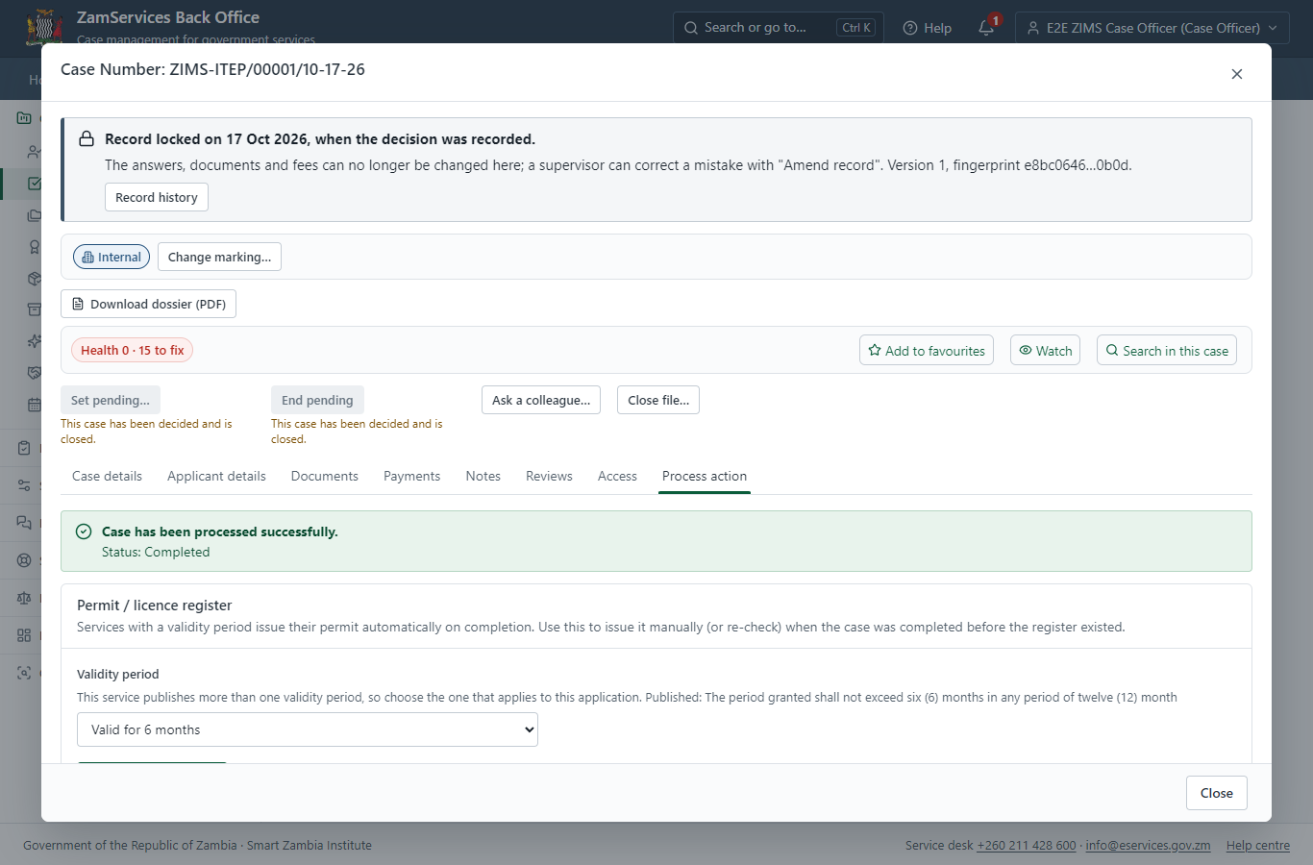
Step 13: Issue the document.

Step 14. The document in My permits
Citizen · National e-Services portal
The issued document (ZIMS-ITEP-2026-00001 in this run: "Immigration Temporary Employment Permit") is listed in "My permits and licences" with its validity and a download of the sealed PDF.
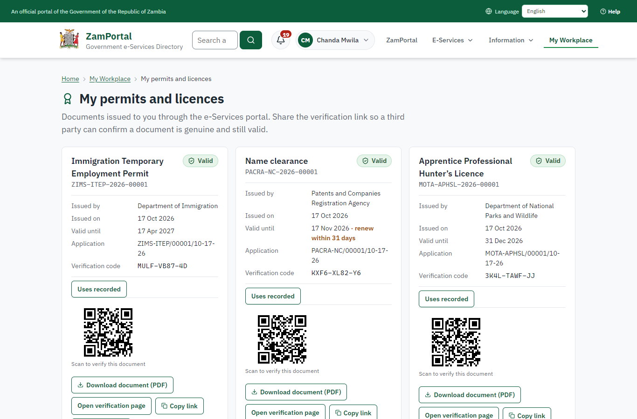 | 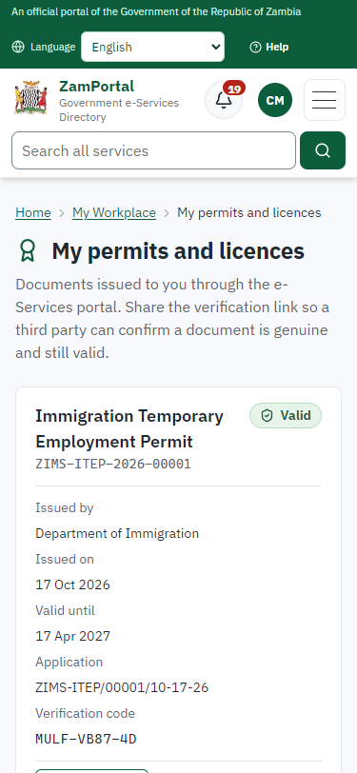
Step 14: The document in My permits - desktop (left) and a 375 px phone (right).

Step 15. Verify the document
Anyone (public) · Public verification page
The QR code on the document opens the public verification page: genuine and current, to whom it was issued, and whether the electronic seal is valid. No sign-in is needed.
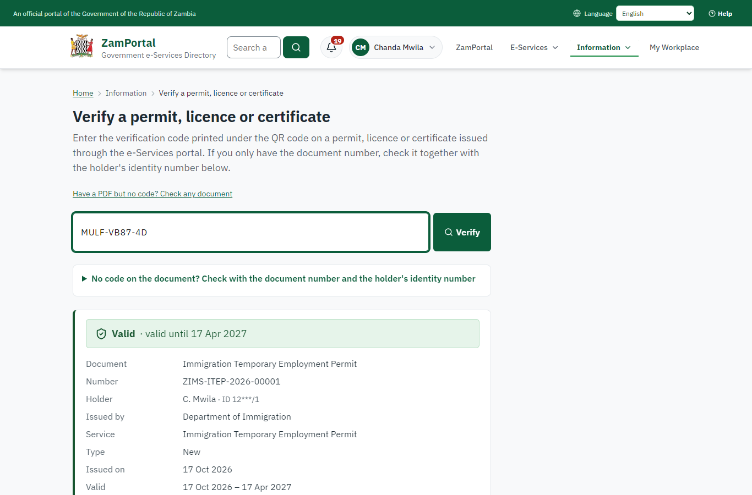 | 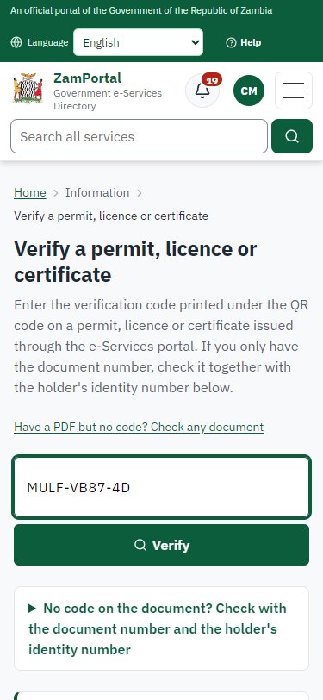
Step 15: Verify the document - desktop (left) and a 375 px phone (right).

3. Payment
Item | In the test run
Fee (as published) | Temporary Employment Permit fees vary depending upon the organization that you are applying under FOR PRIVATE SECTOR: Issuance - 4,500 ZMW Renewal - 5,250 ZMW Duplicate - 5,250 ZMW Variation - 5,250 ZMW FOR GOVERNMENT, QUASI-GOVERNMENT, NGOs & OTHER NON-PROFIT MAKING ORGANIZATIONS: Issuance - 2,250 ZMW Renewal - 3,000 ZMW Duplicate - 2,250 ZMW Variation - 3,000 ZMW
Invoice 1 | 2392032934046819
Amount 1 | ZMW 6000.00
Paid at 1 | with the application
On screen: step 8 (See that the fee is due), step 9 (Pay with ZamPay), step 10 (Payment received) in section 2.

4. Output documents

Immigration Temporary Employment Permit (sealed PDF)
Issued when the case was approved, from the service's output configuration (permitDocument/issued@1), filled from the application and the decision, sealed with the platform's electronic seal and stored as the issued version. The holder downloads it from My permits; the verification page checks it.
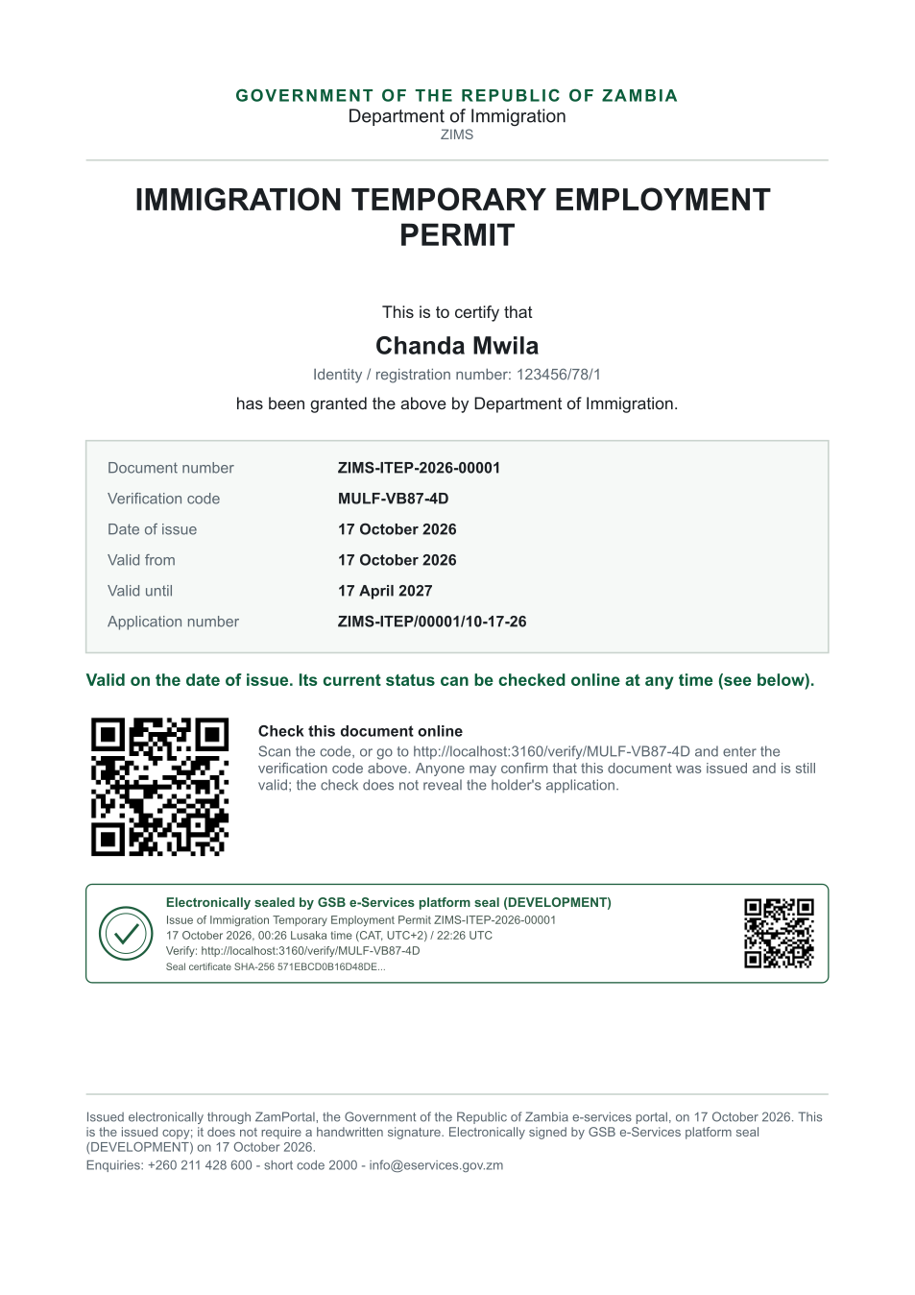
Immigration Temporary Employment Permit (sealed PDF) - first of 1 page, as issued in the test run.

Fields
Field | Value in the test run
Document title | Immigration Temporary Employment Permit
Permit / licence number | ZIMS-ITEP-2026-00001
Holder | Chanda Mwila
Valid from | 2026-10-16
Valid until | 2027-04-16
Status | active
Verification code (printed with a QR code) | MULF-VB87-4D

Seal
Seal status | sealed
Signature level | PAdES-B-T
Sealed by | the platform seal (development key in the test run)
Signed at | 2026-10-16T22:26:03.098Z
Trusted time-stamp | 2026-10-16T22:26:03.488Z (time-stamping authority)
Document fingerprint (SHA-256) | f4ea5945370f4165...

Verification
Where | The public verification page of the national portal, <portal>/verify/<verification code>, opened by scanning the QR code on the document.
What it shows | Whether the document is genuine and current, its holder and validity, and whether the electronic seal is valid and who sealed it.
Checking a copy | Anyone can upload a PDF they were given; the page says whether it is exactly the document that was issued. A changed copy is reported as not matching.
On screen: step 13 (Issue the document), step 14 (The document in My permits), step 15 (Verify the document) in section 2.

5. Notifications
When | Channel | To | Message | Delivery
Payment due (invoice raised) | in-app (portal bell) | the applicant | Payment due for application ZIMS-ITEP/00001/10-17-26 - The fee of ZMW 6000.00 for Immigration Temporary Employment Permit (ZIMS-ITEP/00001/10-17-26) is now due. Invoice 2392032934046819. | shown
Application received | in-app (portal bell) | the applicant | Application ZIMS-ITEP/00001/10-17-26 received - Your application ZIMS-ITEP/00001/10-17-26 for Immigration Temporary Employment Permit has been received by Department of Immigration. | shown
Payment received | in-app (portal bell) | the applicant | Payment received for ZIMS-ITEP/00001/10-17-26 - Your payment of ZMW 6000.00 for ZIMS-ITEP/00001/10-17-26 (Immigration Temporary Employment Permit) has been received. Receipt: <ZamPay>/pdf?documentType=receipt&invoiceNumber=2392032934046819 | shown
Invitation to rate the service | in-app (portal bell) | the applicant | How was Immigration Temporary Employment Permit? - How was Immigration Temporary Employment Permit? Tell us in about a minute. | shown
Decision: approved | in-app (portal bell) | the applicant | Application ZIMS-ITEP/00001/10-17-26 completed - ZIMS-ITEP/00001/10-17-26 (Immigration Temporary Employment Permit) is complete. Your documents are ready. | shown
Licence / permit issued | in-app (portal bell) | the applicant | Your Immigration Temporary Employment Permit document has been issued - ZIMS-ITEP-2026-00001 has been issued for Immigration Temporary Employment Permit and is valid until 17/04/2027. | shown
Payment due (invoice raised) | email | e2e.c***@example.test | Payment due for application ZIMS-ITEP/00001/10-17-26 | skipped
Payment due (invoice raised) | sms | +260 97* *** 567 | Fee of ZMW 6000.00 due for ZIMS-ITEP/00001/10-17-26. Invoice 2392032934046819. Pay: <ZamPay>/pay-for-service/get-invoice/2392032934046819 | delivered
Application received | sms | +260 97* *** 567 | Application ZIMS-ITEP/00001/10-17-26 for Immigration Temporary Employment Permit has been received. Track it: <portal>/my-workplace | delivered
Application received | email | e2e.c***@example.test | Application ZIMS-ITEP/00001/10-17-26 received | skipped
Payment received | sms | +260 97* *** 567 |  | delivered
Invitation to rate the service | sms | +260 97* *** 567 |  | skipped
Invitation to rate the service | email | e2e.c***@example.test | How was Immigration Temporary Employment Permit? | skipped
Decision: approved | sms | +260 97* *** 567 |  | delivered
Decision: approved | email | e2e.c***@example.test | Application ZIMS-ITEP/00001/10-17-26 completed | skipped
Licence / permit issued | email | e2e.c***@example.test | Your Immigration Temporary Employment Permit document has been issued | skipped
Licence / permit issued | sms | +260 97* *** 567 |  | delivered
Delivery: shown = in the portal's notification bell; delivered = the SMS gateway (a test double in this run) reported the text delivered; skipped = not sent on that channel (e-mail is not configured on the test installation, and some notices go out on one channel only); sent by the national portal = a ministry node handed the notice to the national portal, which texts and e-mails the citizen under its own name and the citizen's preferences. Addresses written <portal>, <ZamPay> stand for the national portal and ZamPay.

6. Legacy mapping
Replaces | Immigration Temporary Employment Permit in the legacy ZIGS e-Services directory (ZIGS_Services)
Legacy service id | 20
Legacy provider | Department of Immigration (ZIMS) under Ministry of Home Affairs and Internal Security
Legacy process | not recorded
Fee in the legacy system | none
Fee taken before submission | yes (as in ZIGS)
Time to issue (legacy) | not recorded
Legacy output templates | Form 26 (New): ZIMS_Application / ZIMS_TemporaryEmploymentPermit.Form26  Application form (Amendment): ZIMS_Application / ZIMS_Variations_ExtentionReplacement  GS-2 Notice of Government Action: ZIGS_Forms_Notices / GS-2.NoticeOfAction
Legacy address | none recorded
How it was brought over | Imported by the platform's legacy catalogue importer (zcm-backend scripts/zigs/importLegacy.js) from the ZIGS snapshot: form, case types, fees, documents, process and output templates, then served by the new platform.

7. Version and date
Document version | service v1, platform eb3a209f
Generated | 2026-10-16T22:26:07Z (by the end-to-end run, not edited by hand)
Service version | not versioned (configured directly)
Platform snapshot | backend eb3a209f  portal 6b49da8  back office a975a2c
Test suite | e2e 591ae63; one installation (combined); seed profile mihud
Journeys | 30-catalogue-service.spec.js: citizen finds the service, answers its form, uploads its documents and sends the application - passed  30-catalogue-service.spec.js: the case goes through every step of its process: payments by the citizen, each officer step by its role - passed  30-catalogue-service.spec.js: the grant document is issued, sealed, filled in and verifiable; the citizen has it in My permits - passed
Result | 3 of 3 journey tests passed
Data | Synthetic test data on a local test installation; provider test doubles for ZamPass, ZamPay, SMS and signing.

