Republic of Zambia
GSB e-Services

Hunting Licence - Resident
Service documentation
Owner: Department of National Parks and Wildlife
Service key: DNPW/hunting-licence-resident
Version: service v1, platform 55109bbd
Date: 2026-10-21
Generated automatically by the service's end-to-end test run. Every screenshot shows synthetic test data on a local test installation, never real personal data.

Contents
- 1. Service summary
- 2. Application process, step by step
- 3. Payment
- 4. Output documents
- 5. Notifications
- 6. Legacy mapping
- 7. Version and date
This document describes the Hunting Licence - Resident service of Department of National Parks and Wildlife as the platform runs it today. It is generated by the service's end-to-end test: every step was performed by the test and every screenshot was taken during that run, with synthetic data. Regenerate it with "npm run docs:services" in the e2e suite; do not edit it by hand.

1. Service summary
Service | Hunting Licence - Resident
Owner (MDA) | Department of National Parks and Wildlife (MOTA)
Purpose | A hunting licence issued to a Zambian citizen or established resident to hunt the animals it lists in a game management area. Each animal is drawn from the hunting quota of that area, species and class of applicant for the year.
Who can apply | Zambian citizens and established residents (bona fide residents of the GMA apply under their own class and quota); at least 18 years old; outside the closed season.
How to apply | Online on the national e-Services portal, signed in with ZamPass; pay with ZamPay.
Fees | Application Fee for a Hunting Licence - Resident: ZMW 22.40  Basic Fee: ZMW 222.40  Basic Fee: ZMW 444.80
Turnaround | Within 28 days.
Validity of the output | Up to 31st December.
Required documents | Proof of residence in the GMA applied for (optional)  Copy of valid Firearm Licence in Applicant’s name (i.e., the cover page, the page showing the firearm’s calibre, the licence validity page) (required)
Output documents | Hunting Licence - Resident  Approval Letter  Denial of Service  Notice of Action  Application form  GF-1 Treasury Invoice  GF-2 Treasury Receipt
Legal basis | The Zambia Wildlife Act, No. 14 of 2015 (http://www.parliament.gov.zm/sites/default/files/documents/acts/The%20%20Zambia%20Wildlife%20Act%2C%202015.pdf)  SI No. 60 of 2007 - The Zambia Wildlife (Licences and Fees) Regulations (https://zambialaws.com/subsidiary-legislation/chapter-201-zambia-wildlife-act#Zambia%20Wildlife%20(Licence%20and%20Fees)%20Regulations,%202007!)

2. Application process, step by step

The process as configured
Step | Role | Task | Type
1 | Applicant | Apply | form
2 | Case Officer | Generate Payment | generate-payment
3 | Applicant | Payment | payment
4 | System | Generate Document | generate-document
5 | Case Officer | Review | review
6 | Supervisor | Review | review
7 | Supervisor | Approve | parallel-approval
8 | Case Officer | Verify Payment | verify-payment
9 | Executive | Decision | decision
10 | System | Generate Document | generate-document
11 | System | Generate Document | generate-document
12 | System | Notify Client | notify

Step by step
Who takes part in this journey: Supervisor, Citizen, Case Officer, Executive, Anyone (public). Citizen steps are shown on a desktop and on a 375 px phone; back-office steps on a desktop.

Step 1. The hunting quota of the year
Supervisor · Back office
Ministry functions, Wildlife, Hunting quotas: the quota of each hunting area, species and class of applicant for the year. The supervisor set the figures as drafts and asked for approval with a reason; the executive approved them (the person who asks can never approve). Approved quotas change only by an adjustment, approved the same way.
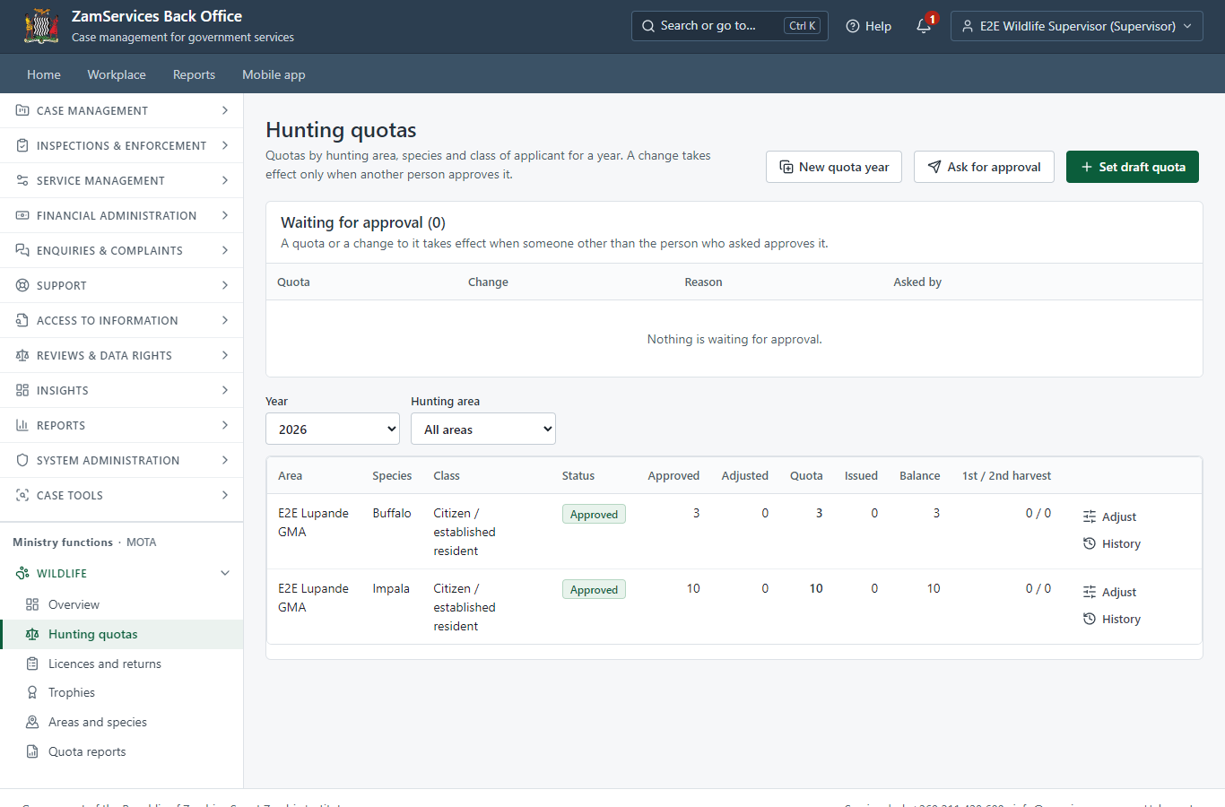
Step 1: The hunting quota of the year.

Step 2. Find the service and read its page
Citizen · National e-Services portal
The citizen finds "Hunting Licence - Resident" in the national directory and reads its page: who provides it, what it costs (the fee is the total of the animals applied for), what to have ready.
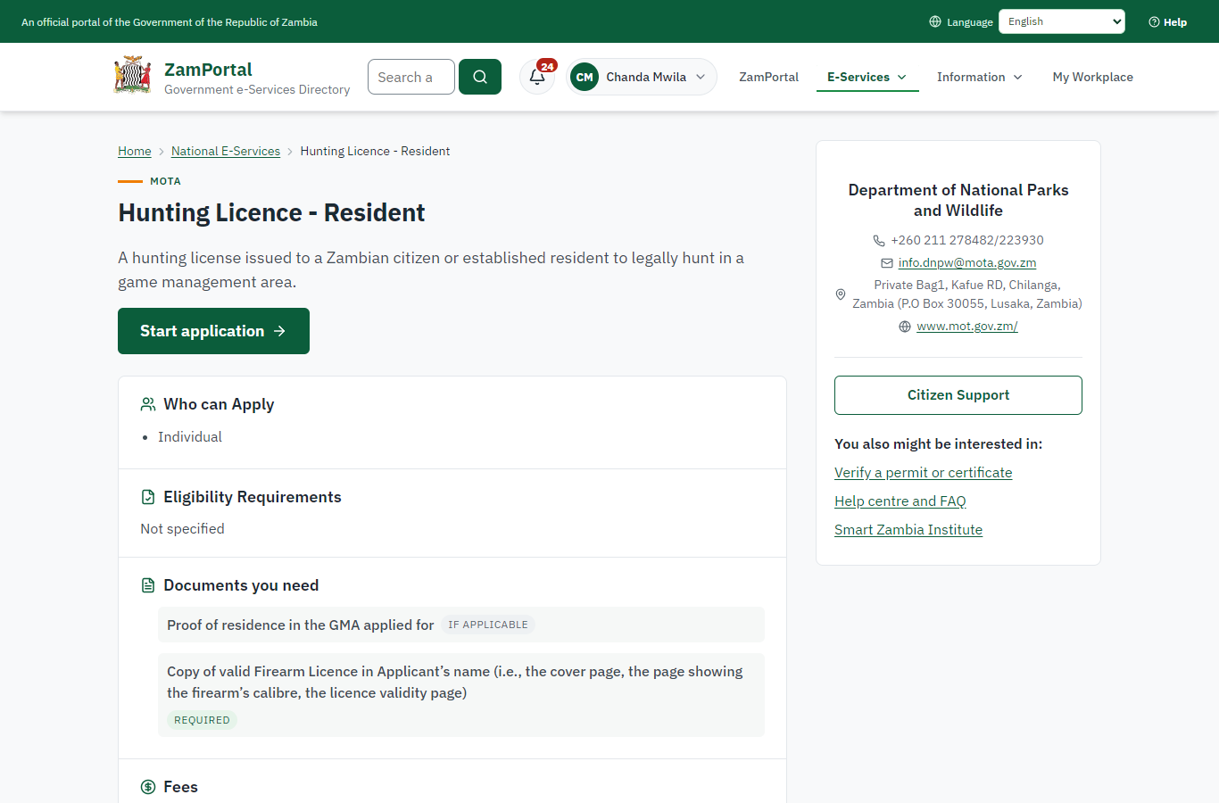 | 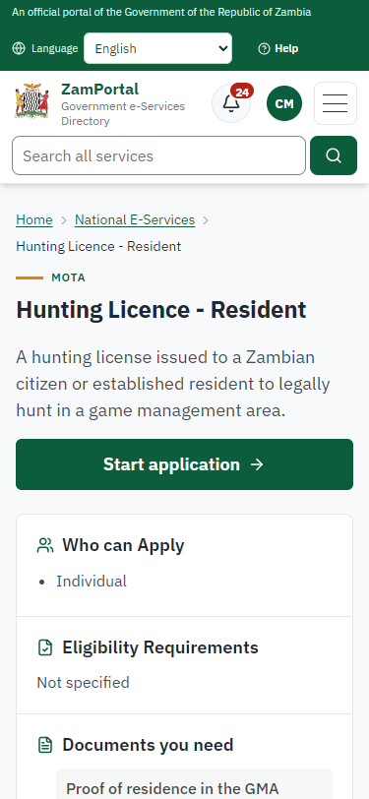
Step 2: Find the service and read its page - desktop (left) and a 375 px phone (right).

Step 3. The application form: class, GMA and the animals
Citizen · National e-Services portal
The form carried over from the legacy service (citizen or established resident, the GMA, the reason for the hunt, firearm details) with the list of animals applied for: hunting area, species and number.
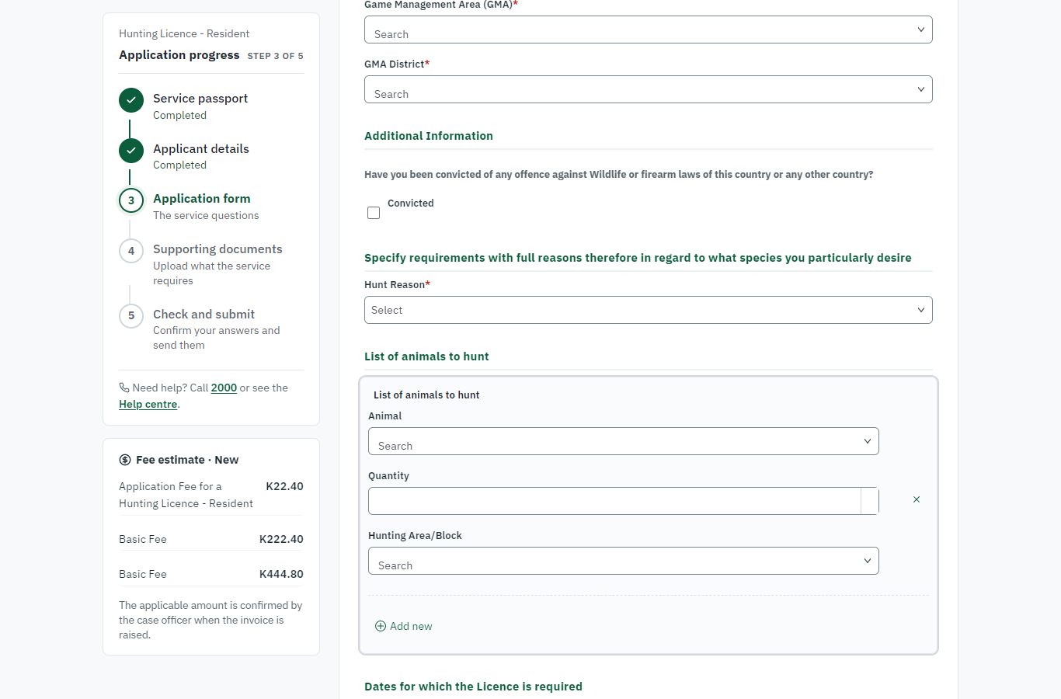 | 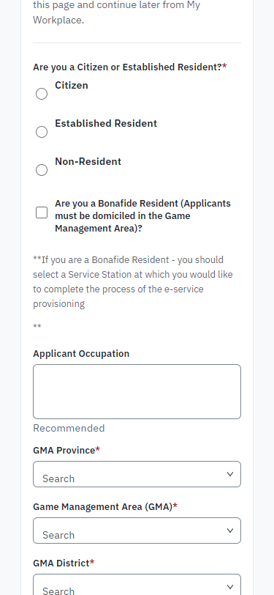
Step 3: The application form: class, GMA and the animals - desktop (left) and a 375 px phone (right).

Step 4. Send the application with the documents
Citizen · National e-Services portal (sent through the API the portal uses in the test run: no screenshot)
The application is sent as a citizen for one buffalo in the E2E Lupande GMA, with every required document (sent through the API the portal uses: the animal list is filled the same way). The platform checks the class, the applicant's age, the closed season and that an approved quota with an animal left exists, and records the animal line. The fee, K1,500.00 (the buffalo fee for citizens and established residents), is worked out on the server and invoiced at once (case MOTA-HLR/00001/10-21-26 in this run). Nothing is taken from the quota yet: it is drawn when the licence is issued, as before.

Step 5. Pay the licence fee
Citizen · National e-Services portal
The citizen pays the fee with ZamPay from My Workplace. (The invoice preview is hidden: the ZamPay test double serves an empty PDF.)
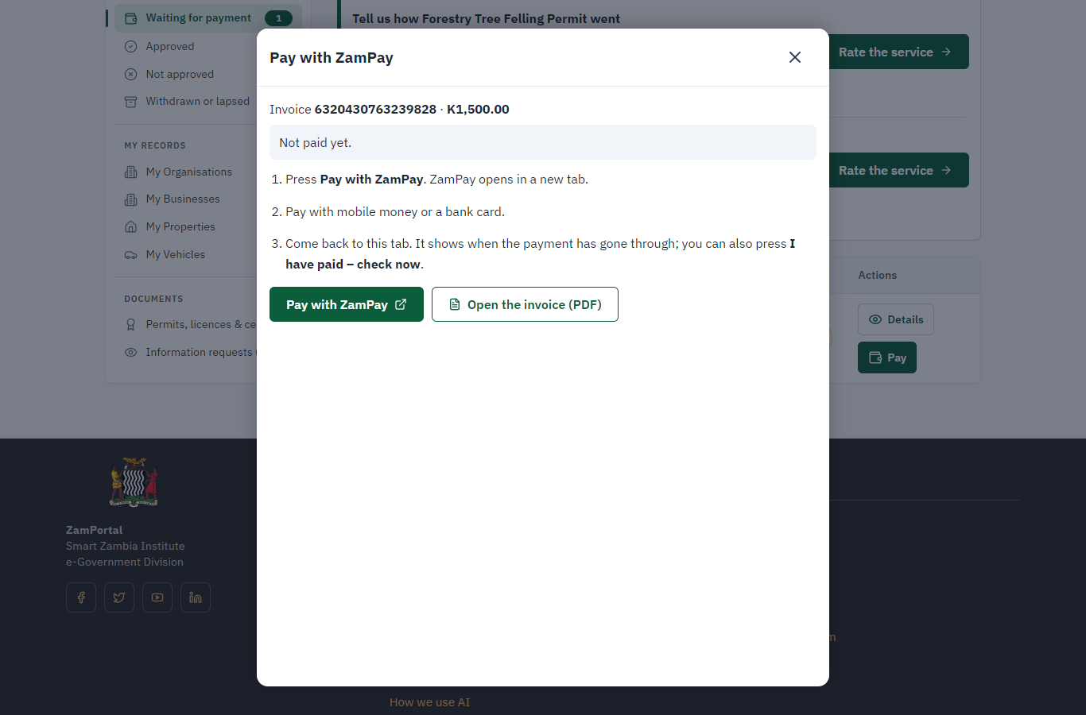 | 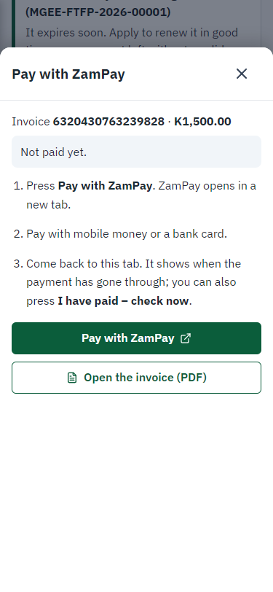
Step 5: Pay the licence fee - desktop (left) and a 375 px phone (right).

Step 6. Receive, Inspect, Report Findings, Draft Decision
Case Officer · Back office (done through its case API in the test run: no screenshot)
The officer completes "Receive, Inspect, Report Findings, Draft Decision". The case moves from "CO Review" to "SV Review".

Step 7. Review, Add Comments, Send for Signature
Supervisor · Back office (done through its case API in the test run: no screenshot)
The officer completes "Review, Add Comments, Send for Signature". The case moves from "SV Review" to "SV Approve".

Step 8. Organize Voting, Report Decision
Supervisor · Back office (done through its case API in the test run: no screenshot)
The officer the committee approves (two members, quorum 2 of 3). The case moves from "SV Approve" to "CO Verify Payment".

Step 9. Verify additional payment
Case Officer · Back office (done through its case API in the test run: no screenshot)
The officer completes "Verify additional payment". The case moves from "CO Verify Payment" to "EX Decision".

Step 10. Review, Inspect, e-Sign Executive
Executive · Back office (done through its case API in the test run: no screenshot)
The officer decides: approve ("Review, Inspect, e-Sign Executive"). The case moves from "EX Decision" to "Completed".

Step 11. The quota after the licence was issued
Supervisor · Back office
The buffalo quota shows one animal issued and the balance one lower, with the primary harvest counted (legacy prc_MOTA_DeductQuota). Had the last animal gone to another licence first, the decision would have been refused and the application left undecided.
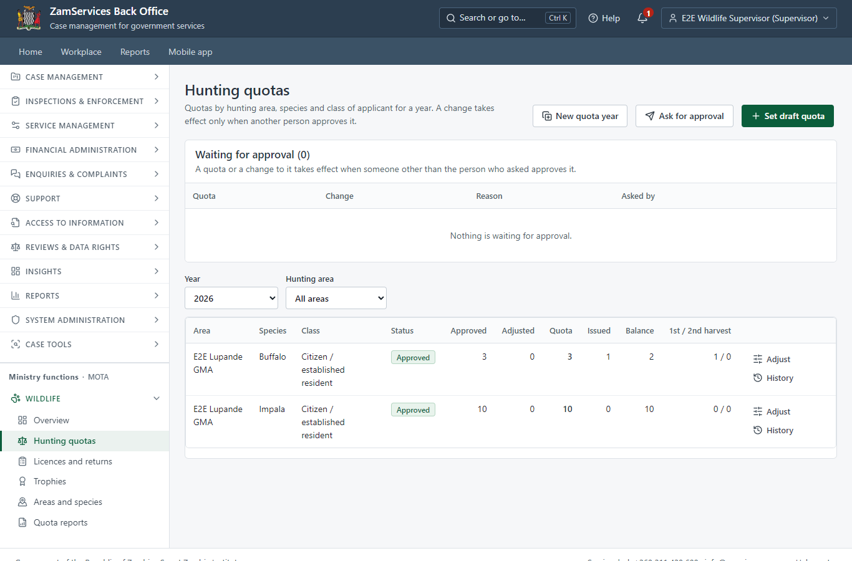
Step 11: The quota after the licence was issued.

Step 12. The harvest return
Case Officer · Back office
Ministry functions, Wildlife, Licences and returns: the hunter reported one buffalo harvested; the officer records the return once, with the trophy taken (identification mark, type, weight). The trophy is on the trophy register, held by the licence holder, ready for an export permit application. An animal younger than the species' minimum trophy age would be listed under Data checks.
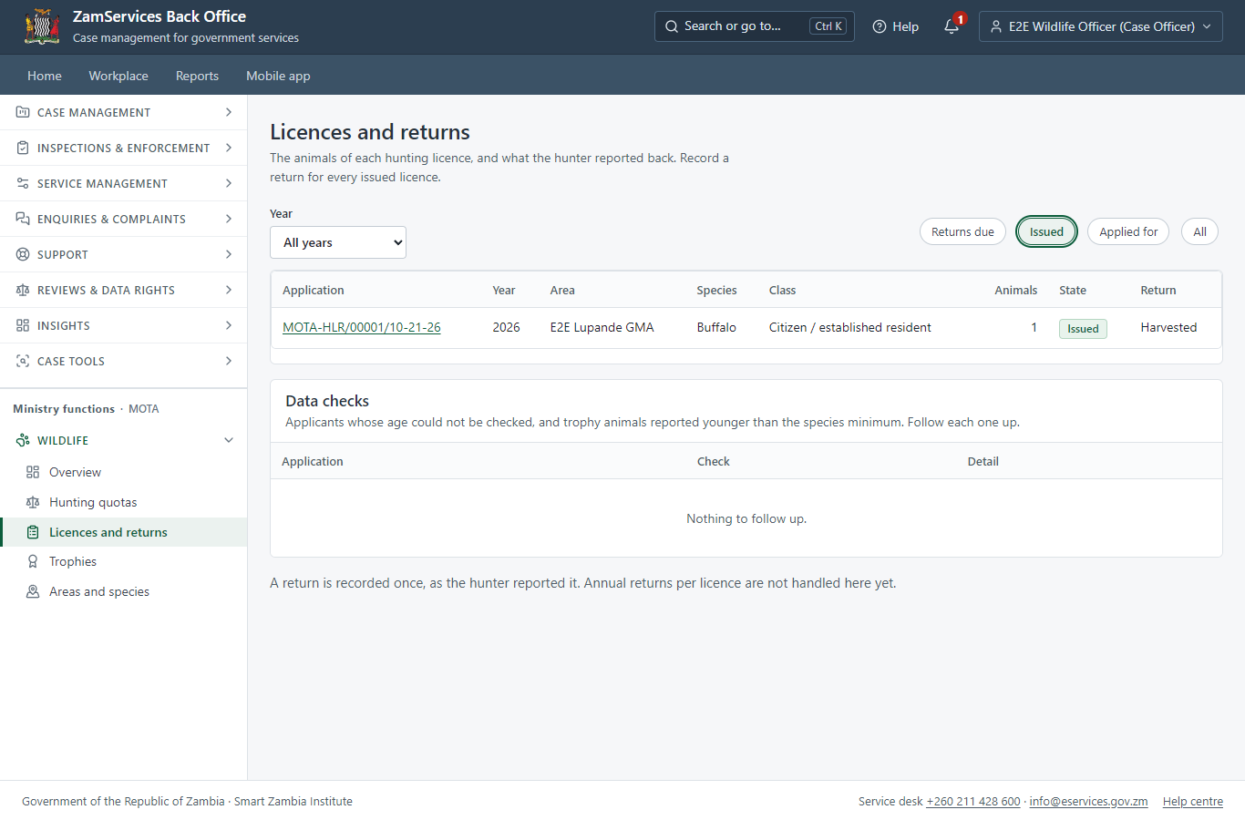
Step 12: The harvest return.

Step 13. The licence in My permits, with its animals
Citizen · National e-Services portal
The licence is on the citizen's generic "My permits and licences" with the animals it allows, as plain particulars from the issuing office (no wildlife page on the portal).
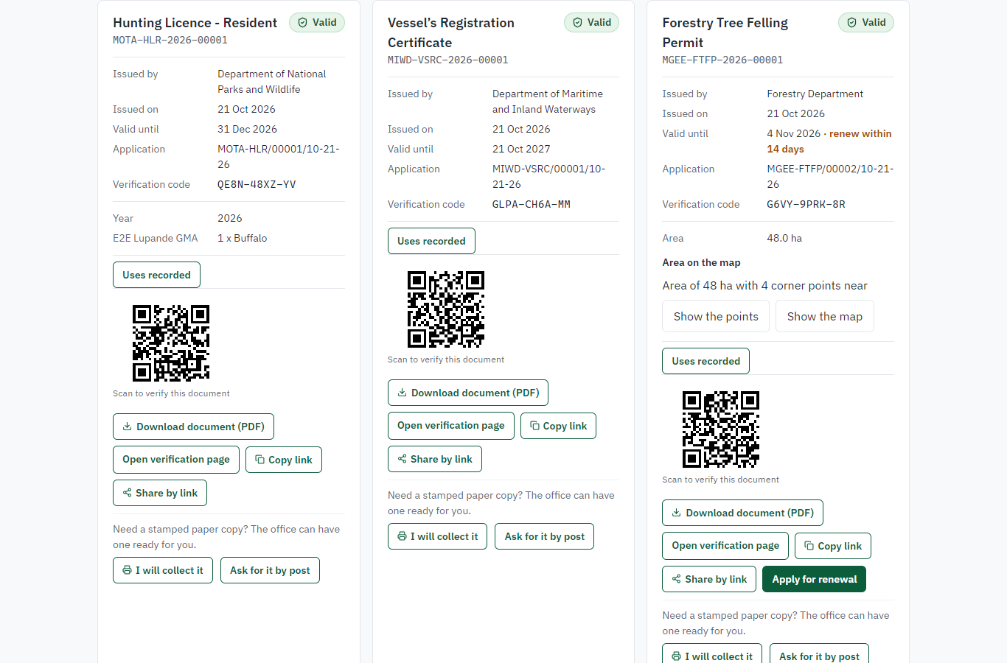 | 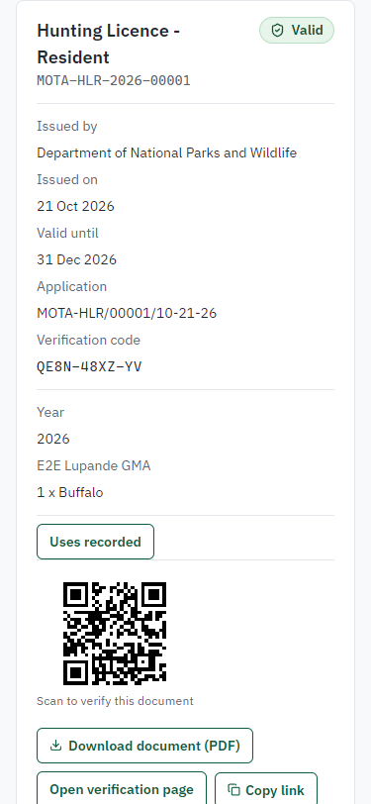
Step 13: The licence in My permits, with its animals - desktop (left) and a 375 px phone (right).

Step 14. Verify the licence
Anyone (public) · Public verification page
The QR code on the licence opens the national verification page: genuine and current, to whom it was issued, and the electronic seal.
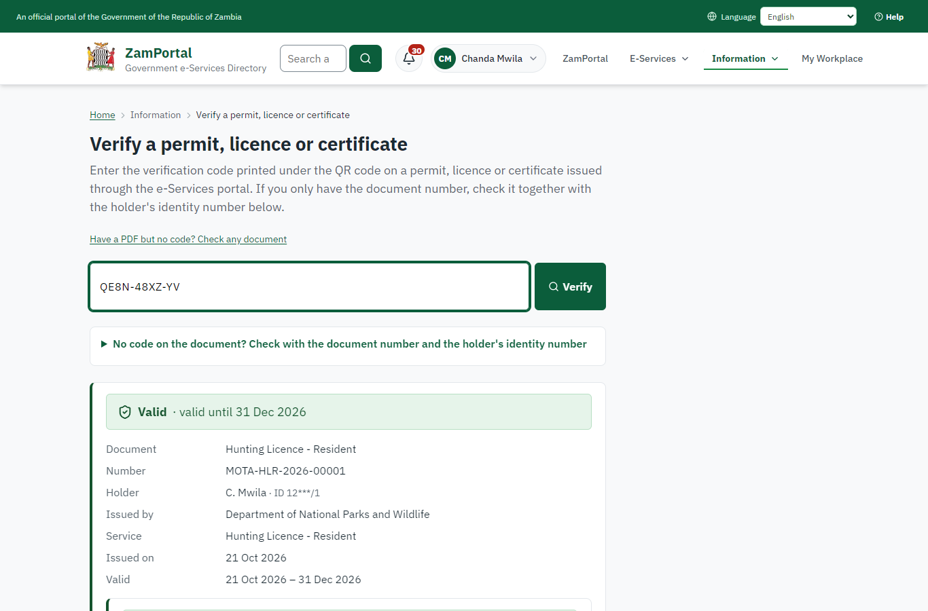 | 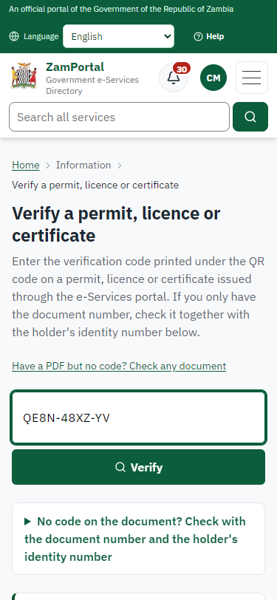
Step 14: Verify the licence - desktop (left) and a 375 px phone (right).

3. Payment
Item | In the test run
Fee | K1,500.00: the species fee for the class of applicant (Buffalo, citizen / established resident); a second animal of a species costs 1.5 times the fee (legacy rule)
When it is paid | With the application
Invoice number | 6320430763239828
Paid through | ZamPay (the ZamPay test double in this run)
On screen: step 5 (Pay the licence fee) in section 2.

4. Output documents

Hunting Licence - Resident (sealed PDF)
The legacy DNPW resident hunting licence certificate, filled in by the platform: the station of issue (the office of the officer who issued it), the licensee, the firearms, the animals drawn from the quota (animal, hunting area, period, fee) and the fees paid; QR to the verification page; electronic seal.
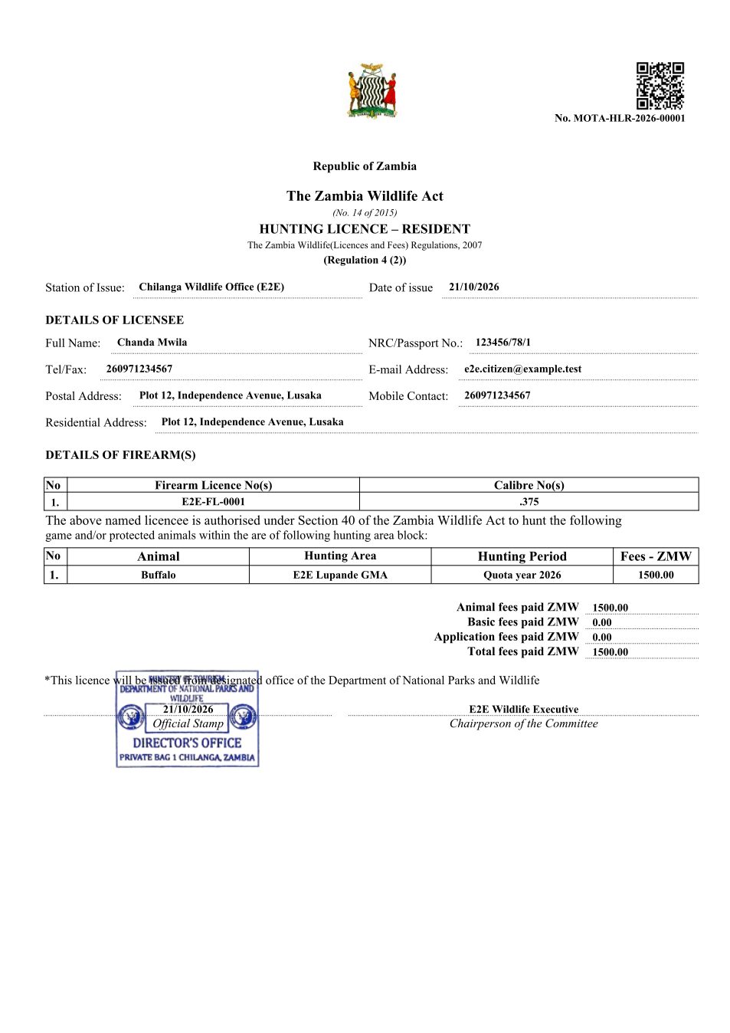
Hunting Licence - Resident (sealed PDF) - first of 2 pages, as issued in the test run.

Fields
Field | Value in the test run
Document title | Hunting Licence - Resident
Permit / licence number | MOTA-HLR-2026-00001
Holder | Chanda Mwila
Valid from | 2026-10-21
Valid until | 2026-12-31
Status | active
Verification code (printed with a QR code) | QE8N-48XZ-YV

Seal
Seal status | sealed
Signature level | PAdES-B-T
Sealed by | the platform seal (development key in the test run)
Signed at | 2026-10-21T21:56:09.963Z
Trusted time-stamp | 2026-10-21T21:56:09.929Z (time-stamping authority)
Document fingerprint (SHA-256) | 6af4ebe3274acdfd...

Verification
Where | The public verification page of the national portal, <portal>/verify/<verification code>, opened by scanning the QR code on the document.
What it shows | Whether the document is genuine and current, its holder and validity, and whether the electronic seal is valid and who sealed it.
Checking a copy | Anyone can upload a PDF they were given; the page says whether it is exactly the document that was issued. A changed copy is reported as not matching.
On screen: step 13 (The licence in My permits, with its animals), step 14 (Verify the licence) in section 2.

5. Notifications
When | Channel | To | Message | Delivery
Payment due (invoice raised) | in-app (portal bell) | the applicant | Payment due for application MOTA-HLR/00001/10-21-26 - The fee of ZMW 1500.00 for Hunting Licence - Resident (MOTA-HLR/00001/10-21-26) is now due. Invoice 6320430763239828. | shown
Application received | in-app (portal bell) | the applicant | Application MOTA-HLR/00001/10-21-26 received - Your application MOTA-HLR/00001/10-21-26 for Hunting Licence - Resident has been received by Department of National Parks and Wildlife. | shown
Payment received | in-app (portal bell) | the applicant | Payment received for MOTA-HLR/00001/10-21-26 - Your payment of ZMW 1500.00 for MOTA-HLR/00001/10-21-26 (Hunting Licence - Resident) has been received. Receipt: <ZamPay>/pdf?documentType=receipt&invoiceNumber=6320430763239828 | shown
Invitation to rate the service | in-app (portal bell) | the applicant | How was Hunting Licence - Resident? - How was Hunting Licence - Resident? Tell us in about a minute. | shown
Licence / permit issued | in-app (portal bell) | the applicant | Your Hunting Licence - Resident document has been issued - MOTA-HLR-2026-00001 has been issued for Hunting Licence - Resident and is valid until 31/12/2026. | shown
Decision: approved | in-app (portal bell) | the applicant | Application MOTA-HLR/00001/10-21-26 completed - MOTA-HLR/00001/10-21-26 (Hunting Licence - Resident) is complete. Your documents are ready. | shown
Payment due (invoice raised) | sms | +260 97* *** 567 | Fee of ZMW 1500.00 due for MOTA-HLR/00001/10-21-26. Invoice 6320430763239828. Pay: <ZamPay>/pay-for-service/get-invoice/6320430763239828 | delivered
Application received | sms | +260 97* *** 567 | Application MOTA-HLR/00001/10-21-26 for Hunting Licence - Resident has been received. Track it: <portal>/my-workplace | delivered
Application received | email | e2e.c***@example.test | Application MOTA-HLR/00001/10-21-26 received | skipped
Payment due (invoice raised) | email | e2e.c***@example.test | Payment due for application MOTA-HLR/00001/10-21-26 | skipped
Payment received | sms | +260 97* *** 567 |  | delivered
Invitation to rate the service | sms | +260 97* *** 567 |  | skipped
Invitation to rate the service | email | e2e.c***@example.test | How was Hunting Licence - Resident? | skipped
Licence / permit issued | sms | +260 97* *** 567 |  | delivered
Decision: approved | sms | +260 97* *** 567 |  | delivered
Licence / permit issued | email | e2e.c***@example.test | Your Hunting Licence - Resident document has been issued | skipped
Decision: approved | email | e2e.c***@example.test | Application MOTA-HLR/00001/10-21-26 completed | skipped
Delivery: shown = in the portal's notification bell; delivered = the SMS gateway (a test double in this run) reported the text delivered; skipped = not sent on that channel (e-mail is not configured on the test installation, and some notices go out on one channel only); sent by the national portal = a ministry node handed the notice to the national portal, which texts and e-mails the citizen under its own name and the citizen's preferences. Addresses written <portal>, <ZamPay> stand for the national portal and ZamPay.

6. Legacy mapping
Legacy system | ZIGS / ZambiaDNPW (MOTA database)
Legacy service | 105 Hunting Licence - Resident
Quota | ZIGS_MOTA_AnimalQuota (now allocation pools of the wildlife module)
Deduction | prc_MOTA_DeductQuota at issuance (kept: input F91)

7. Version and date
Document version | service v1, platform 55109bbd
Generated | 2026-10-21T21:56:38Z (by the end-to-end run, not edited by hand)
Service version | not versioned (configured directly)
Platform snapshot | backend 55109bbd  portal 9dadc82  back office 9dd768e
Test suite | e2e b5e6f8e; one installation (combined); seed profile mihud
Journeys | 19-wildlife-hunting-licence.spec.js: quota: set by the supervisor, approved by the executive; the year's table - passed  19-wildlife-hunting-licence.spec.js: citizen: finds the service and starts the application - passed  19-wildlife-hunting-licence.spec.js: citizen: sends the application; the fee is worked out on the server and invoiced at once - passed  19-wildlife-hunting-licence.spec.js: citizen: pays K1,500.00 in the portal - passed  19-wildlife-hunting-licence.spec.js: officers: reviews, the committee, payment check, decision; the quota is drawn at issuance - passed  19-wildlife-hunting-licence.spec.js: case officer: records the harvest return with the trophy taken - passed  19-wildlife-hunting-licence.spec.js: citizen: My permits shows the licence with its animals; sealed licence; verification - passed
Result | 7 of 7 journey tests passed
Data | Synthetic test data on a local test installation; provider test doubles for ZamPass, ZamPay, SMS and signing.

