Republic of Zambia
GSB e-Services

Hotel Manager Registration
Service documentation
Owner: Department of Tourism
Service key: MOTA/hotel-manager-registration
Version: service v1, platform a0a302b8
Date: 2026-10-21
Generated automatically by the service's end-to-end test run. Every screenshot shows synthetic test data on a local test installation, never real personal data.

Contents
- 1. Service summary
- 2. Application process, step by step
- 3. Payment
- 4. Output documents
- 5. Notifications
- 6. Legacy mapping
- 7. Version and date
This document describes the Hotel Manager Registration service of Department of Tourism as the platform runs it today. It is generated by the service's end-to-end test: every step was performed by the test and every screenshot was taken during that run, with synthetic data. Regenerate it with "npm run docs:services" in the e2e suite; do not edit it by hand.

1. Service summary
Service | Hotel Manager Registration
Owner (MDA) | Department of Tourism (MOTA)
Purpose | A person who intends to manage an accommodation establishment or to be employed as a manager, and meets the qualifications and experience specified in Section 58 of the Act and the statutory instrument, shall apply to the Council for a once-off registration.
Who can apply | Individual
How to apply | Online on the national e-Services portal, signed in with ZamPass; pay with ZamPay.
Fees | Hotel Manager Registration Fee: ZMW 3000.00
Turnaround | 30 days
Validity of the output | Does not expire, unless one gets de-registered
Required documents | Curriculum Vitae (required)  Certified Copies of All Academic Certificates (required)  Certified Copies of Professional Certificates (required)  Proof of Employment (Letter from Employer) (required)  Copy of Medical Certificate (Food Handlers) (optional)  Copy of Professional Membership (If a Member) (optional)
Output documents | Notice of Action  Denial of Service  Hotel Manager Registration  Notice of Approval  Application form  GF-1 Treasury Invoice  GF-2 Treasury Receipt
Legal basis | Tourism and Hospitality Act No 13 of 2015 (http://www.parliament.gov.zm/sites/default/files/documents/acts/The%20Tourism%20and%20Hospitality%20Act%2C%202015.pdf)  Guidelines for the registration of Hotel Managers (https://www.mota.gov.zm/?wpfb_dl=80)  Statutory Instrument No. 93 of 2016 (https://www.enotices.co.zm/download/statutory-instrument-no-093-of-2016-the-tourism-and-hospitality-casino-regulations-pdf/)

2. Application process, step by step

The process as configured
Step | Role | Task | Type
1 | Applicant | Apply | form
2 | Applicant | Payment | payment
3 | System | Generate Document | generate-document
4 | Case Officer | Review | review
5 | Case Officer | Review | review
6 | Supervisor | Review | review
7 | Supervisor | Approve | parallel-approval
8 | Executive | Decision | decision
9 | System | Generate Document | generate-document
10 | System | Generate Document | generate-document
11 | System | Notify Client | notify

Step by step
Who takes part in this journey: Citizen, Case Officer, Supervisor, Executive, Anyone (public). Citizen steps are shown on a desktop and on a 375 px phone; back-office steps on a desktop.

Step 1. Find the service
Citizen · National e-Services portal
On the national e-Services portal the citizen opens All Services and searches for the service by name ("Hotel Manager Registration"). Each result names the service and the ministry that provides it.
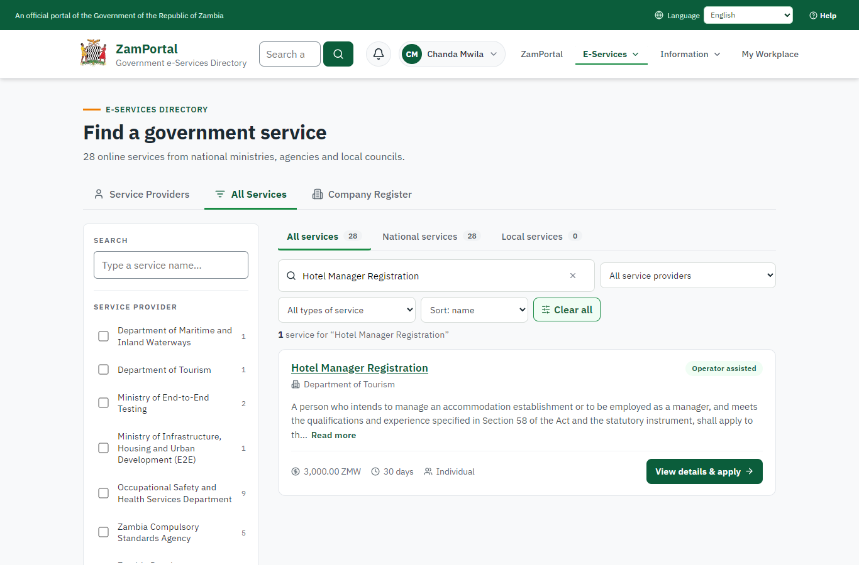 | 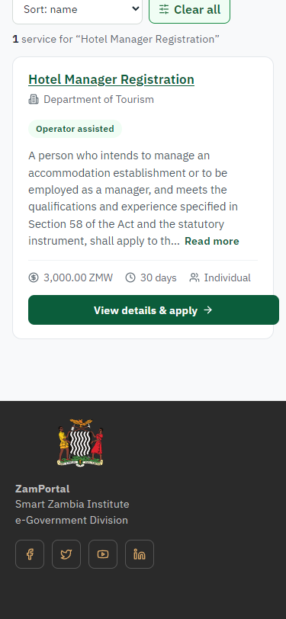
Step 1: Find the service - desktop (left) and a 375 px phone (right).

Step 2. Read the service page
Citizen · National e-Services portal
The service page sets out what the service is for, who provides it, the fee, how long it takes and the documents to have ready. "Start application" begins an application (the citizen is signed in with ZamPass).
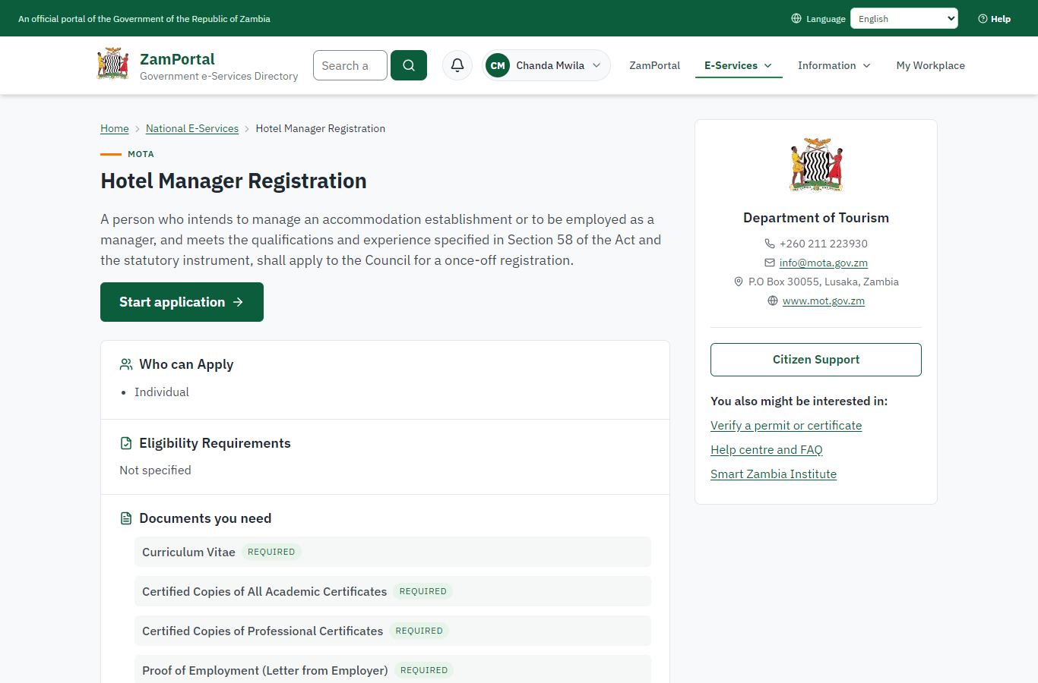 | 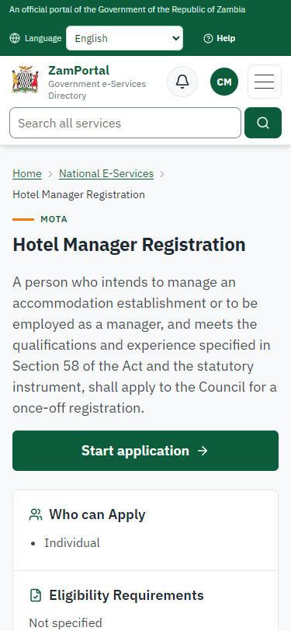
Step 2: Read the service page - desktop (left) and a 375 px phone (right).

Step 3. Confirm the applicant details
Citizen · National e-Services portal
The applicant details are filled in from the citizen's ZamPass account. The citizen says whom they are applying for (themself) and continues with "Proceed to Application".
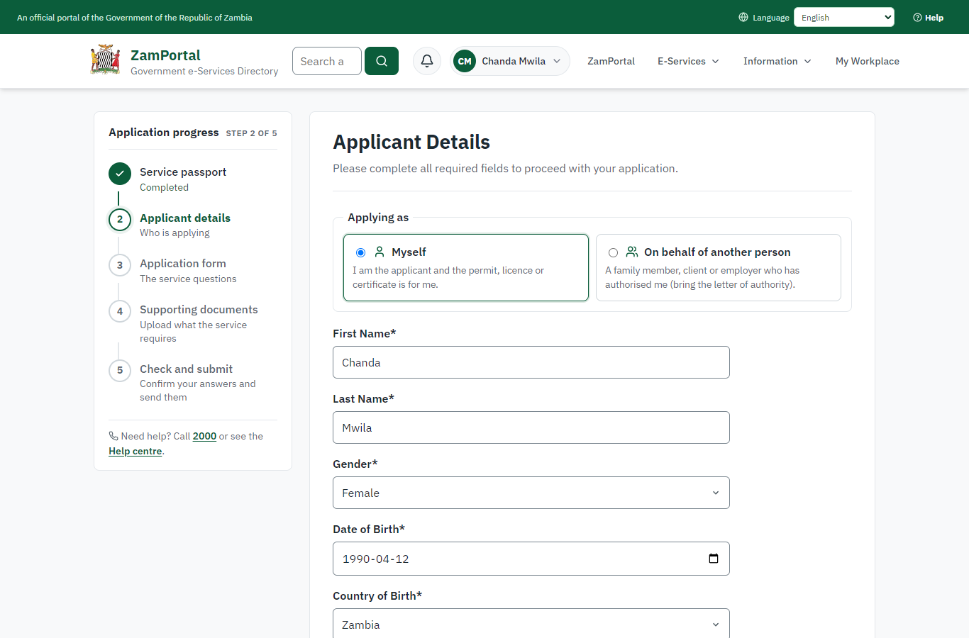 | 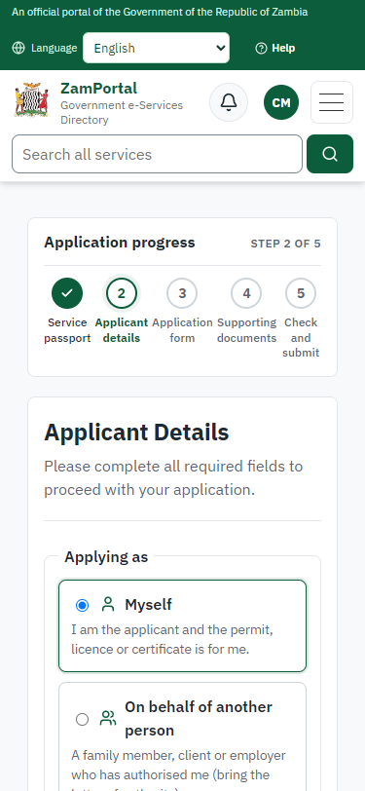
Step 3: Confirm the applicant details - desktop (left) and a 375 px phone (right).

Step 4. Fill in the application form
Citizen · National e-Services portal
The citizen answers the service's own application form, converted from the legacy system (21 answers in this run, all synthetic), for the type of application "New". Questions marked * must be answered; some appear only after an earlier answer. Answers are saved as the citizen types, so an unfinished application can be reopened from My Workplace.
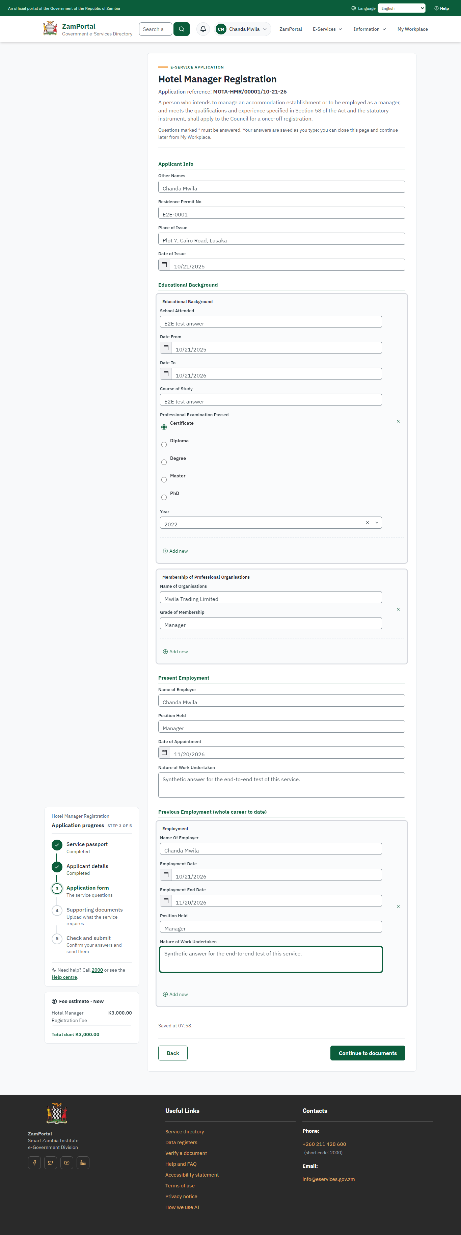 | 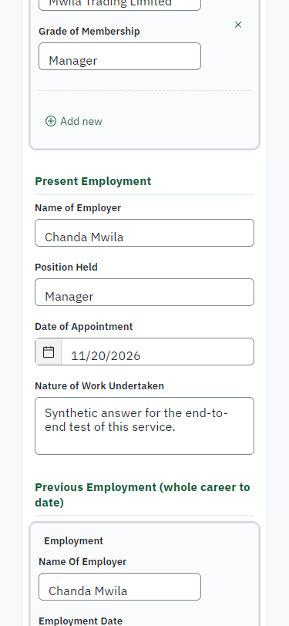
Step 4: Fill in the application form - desktop (left) and a 375 px phone (right).

Step 5. Upload the supporting documents
Citizen · National e-Services portal
Each document the service asks for has its own upload (6 in this run: Curriculum Vitae, Certified Copies of All Academic Certificates, Certified Copies of Professional Certificates, Proof of Employment (Letter from Employer), Copy of Medical Certificate (Food Handlers), Copy of Professional Membership (If a Member)). The files are checked and stored with the application; the page confirms each upload.
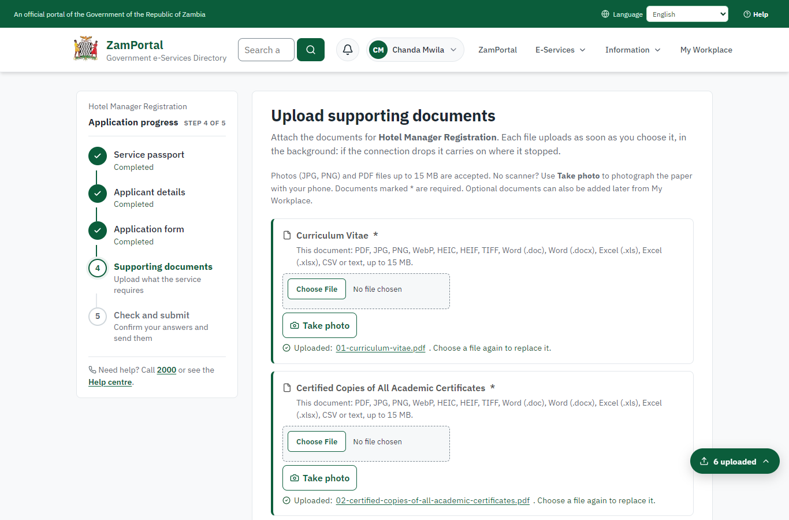 | 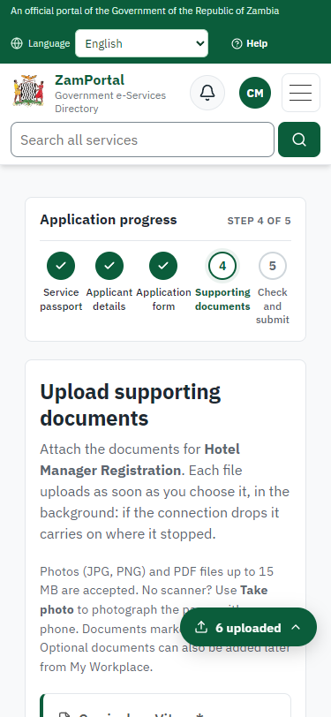
Step 5: Upload the supporting documents - desktop (left) and a 375 px phone (right).

Step 6. Check the answers and confirm the declaration
Citizen · National e-Services portal
Before sending, the citizen sees every answer and document on one page and can go back to change them. The declaration that the information is true and complete must be ticked.
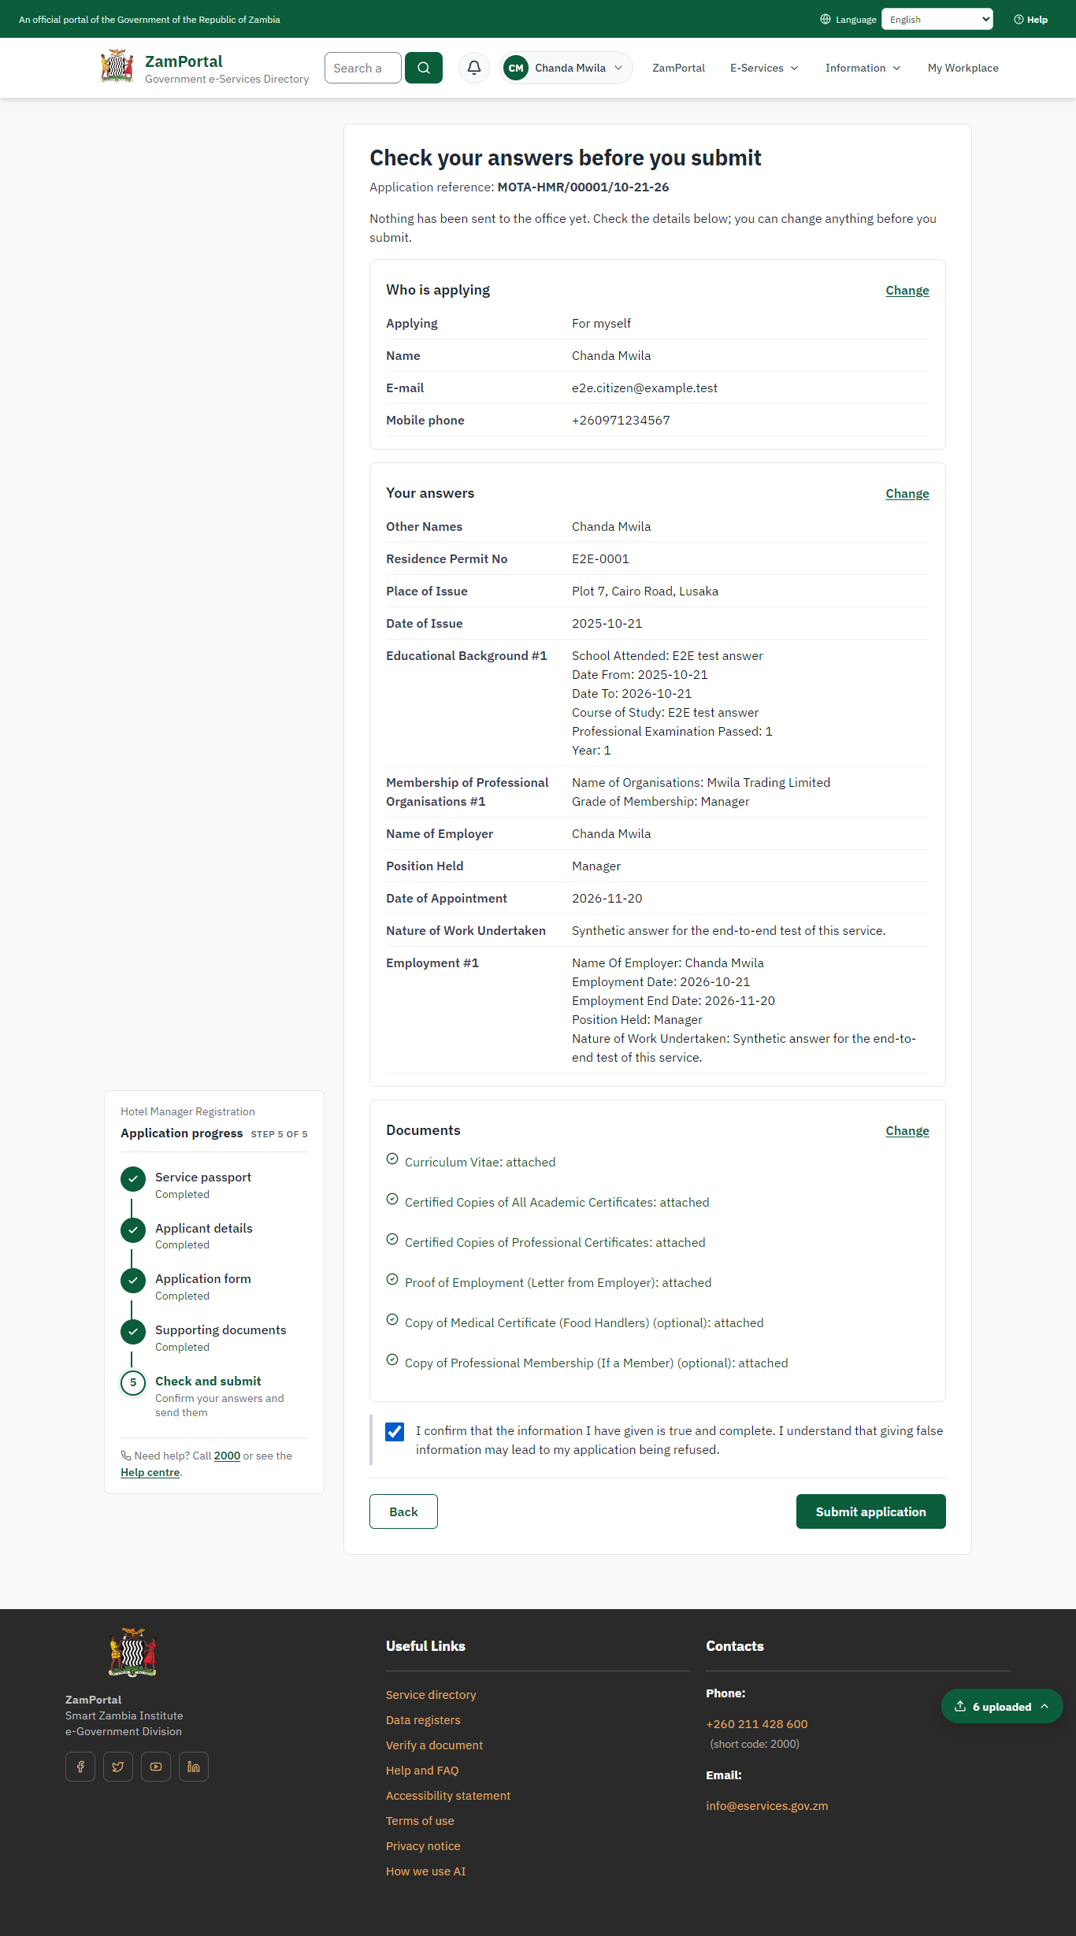 | 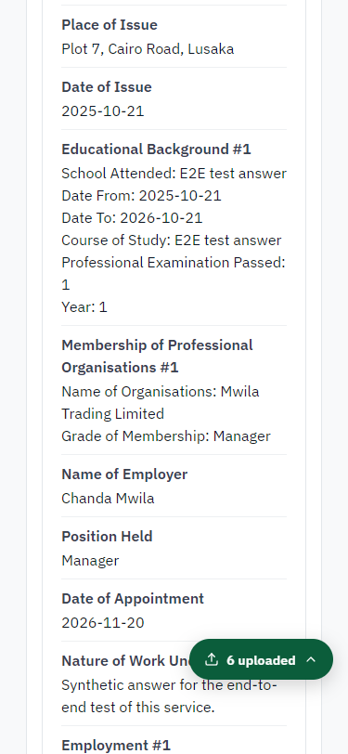
Step 6: Check the answers and confirm the declaration - desktop (left) and a 375 px phone (right).

Step 7. Application sent
Citizen · National e-Services portal
The portal confirms the application with the ministry's reference number (MOTA-HMR/00001/10-21-26 in this run). The fee is due now: it is taken with the application, so the invoice was raised when the application was sent.
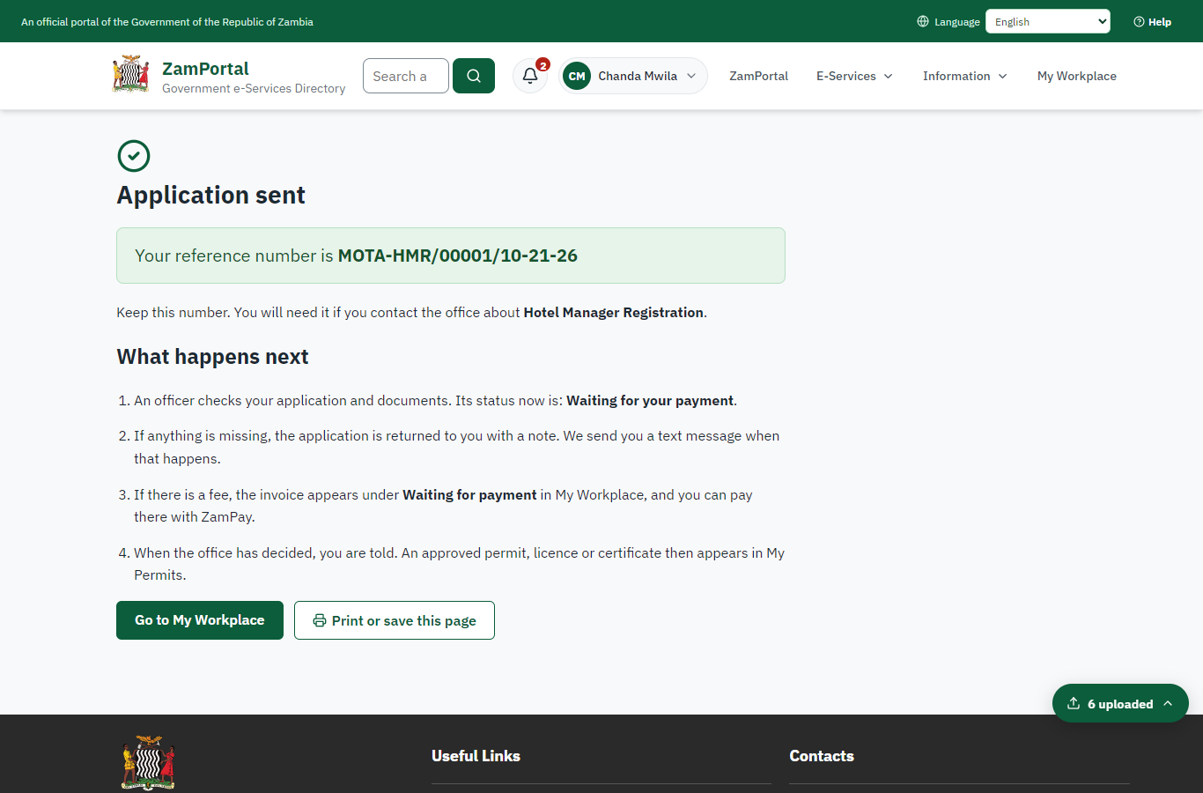 | 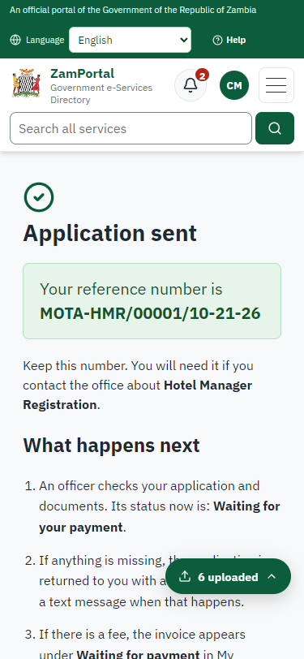
Step 7: Application sent - desktop (left) and a 375 px phone (right).

Step 8. See that the fee is due
Citizen · National e-Services portal
The application shows "Waiting for your payment" in My Workplace with a Pay button (K3,000.00). The fee is taken with the application; the invoice was raised on ZamPay.
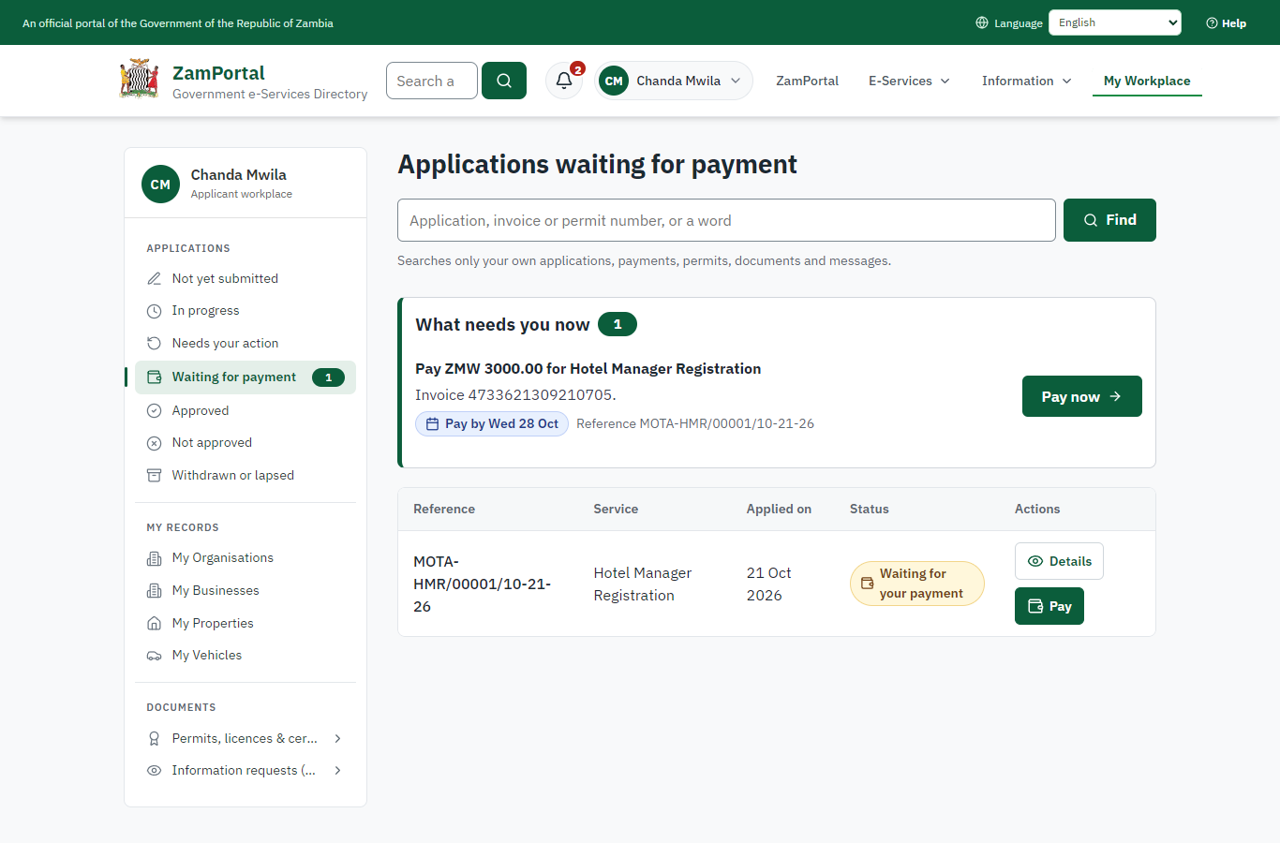 | 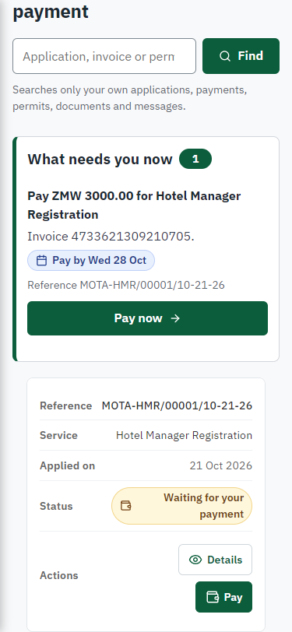
Step 8: See that the fee is due - desktop (left) and a 375 px phone (right).

Step 9. Pay with ZamPay
Citizen · National e-Services portal
Pay opens the invoice (K3,000.00, the amount set by the platform, never by the page) with its PDF preview; the citizen pays at ZamPay by mobile money or bank card.
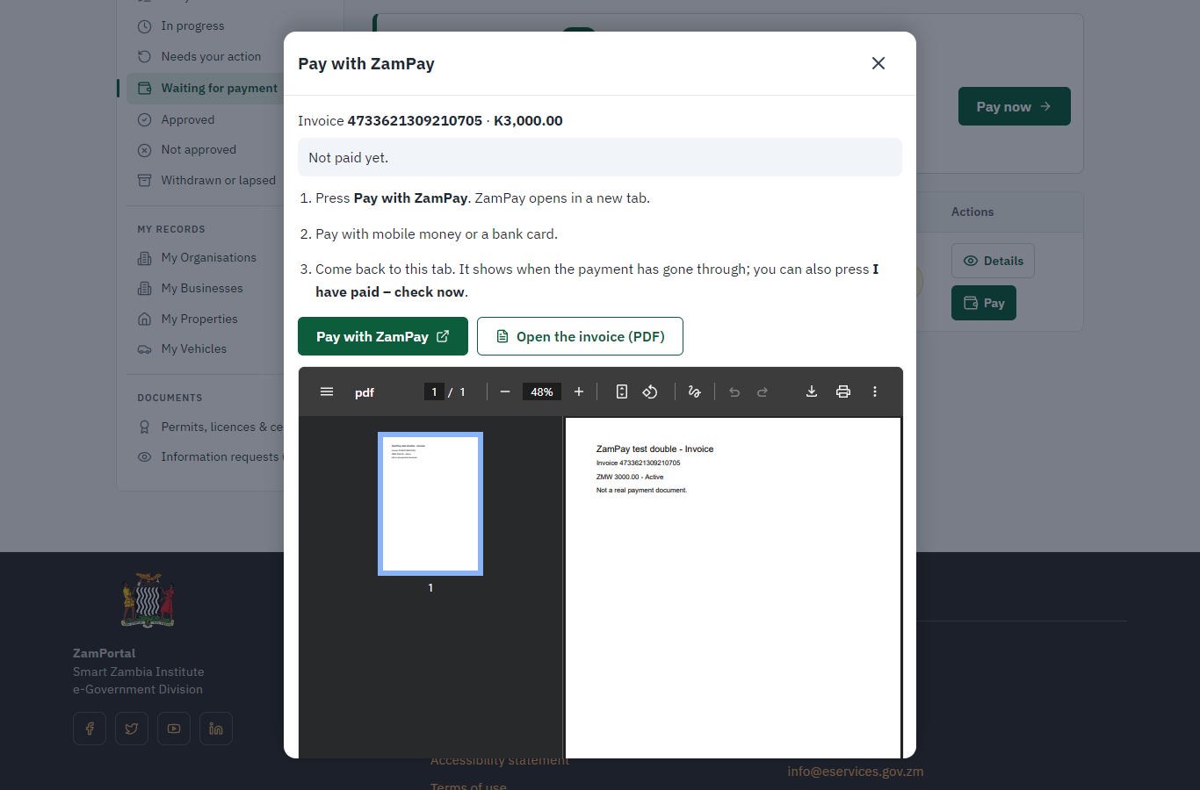 | 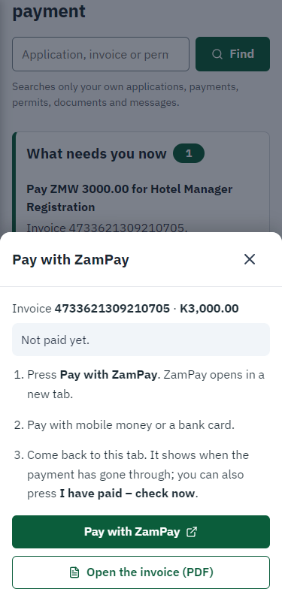
Step 9: Pay with ZamPay - desktop (left) and a 375 px phone (right).

Step 10. Payment received
Citizen · National e-Services portal
ZamPay reports the payment; the dialog says "Paid. Thank you" and the application moves on to the ministry's officers.
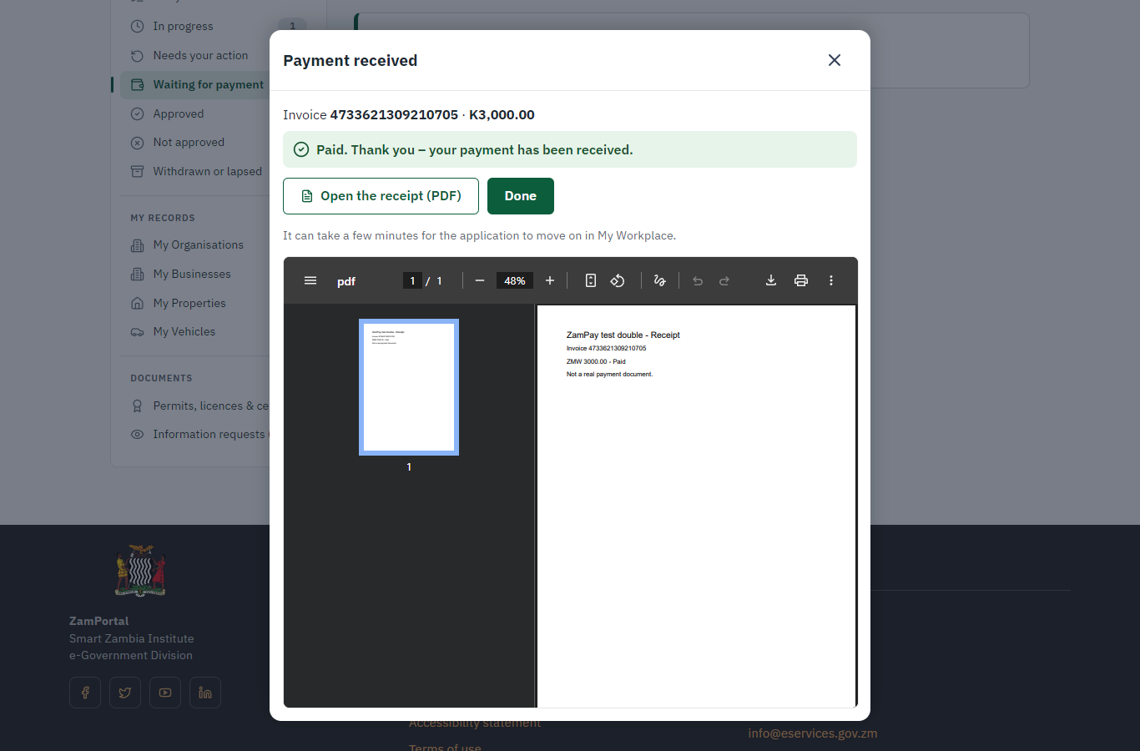 | 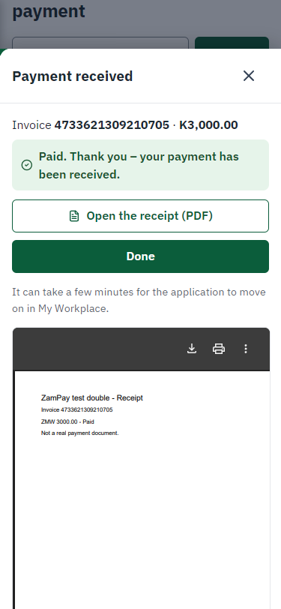
Step 10: Payment received - desktop (left) and a 375 px phone (right).

Step 11. Take the new application on
Case Officer · Back office
The application arrives in the case queue of the ministry that owns the service (Department of Tourism); only its staff see it. The officer opens it by its reference number - answers, documents and process are on the case - assigns it to themself and takes it on.
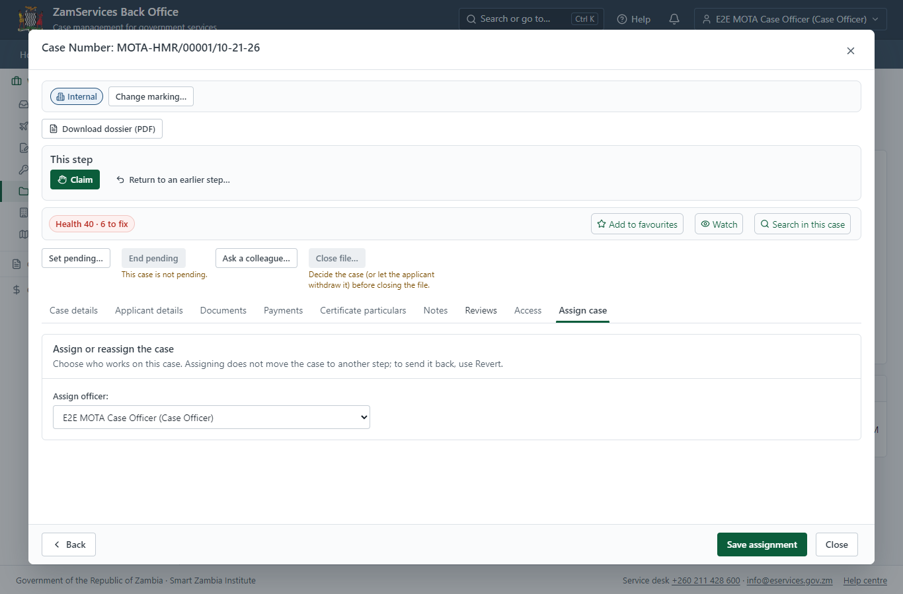
Step 11: Take the new application on.

Step 12. Fill in the certificate particulars
Case Officer · Back office
The issued document prints 3 fields that come from the office rather than from the application (Physical address, Last Name, First Name). The officer fills them in on the case's "Certificate particulars" tab before the document is issued (synthetic values in this run) and saves; once the document is issued they can no longer change.
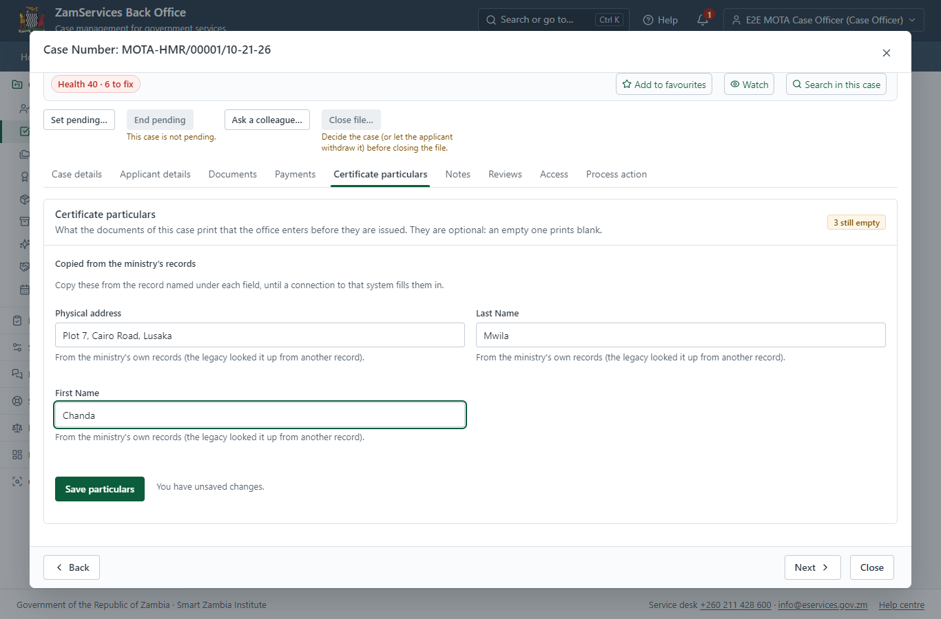
Step 12: Fill in the certificate particulars.

Step 13. Receive, Inspect, Report Findings
Case Officer · Back office
The Case Officer works on "Receive, Inspect, Report Findings" (review in the imported process), checks the application and its documents, and completes the step.
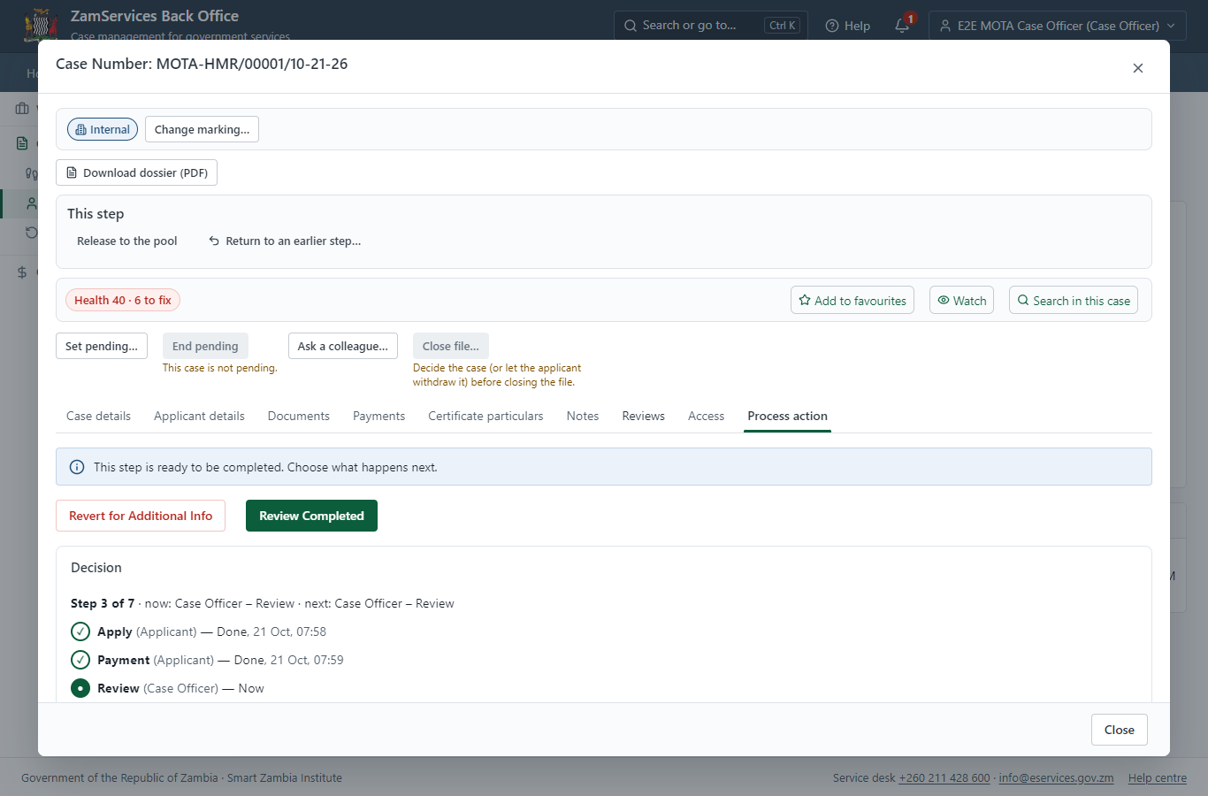
Step 13: Receive, Inspect, Report Findings.

Step 14. Review Expert Reports, Draft Decision
Case Officer · Back office
The Case Officer works on "Review Expert Reports, Draft Decision" (review in the imported process), checks the application and its documents, and completes the step.
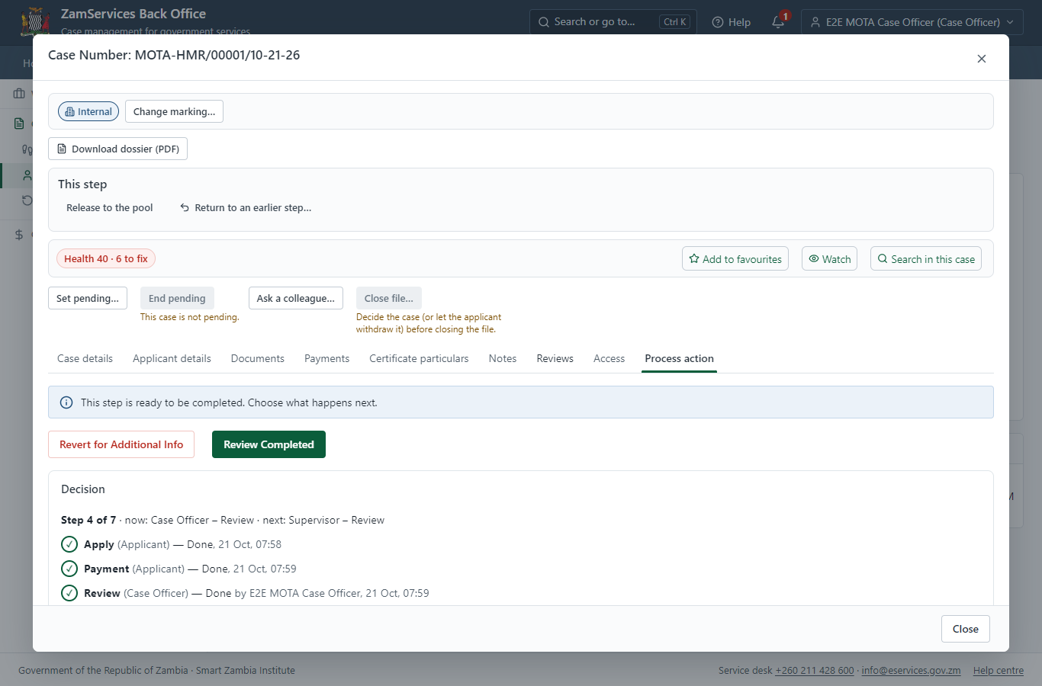
Step 14: Review Expert Reports, Draft Decision.

Step 15. Review, Add Comments, Send for Signature
Supervisor · Back office
The Supervisor works on "Review, Add Comments, Send for Signature" (review in the imported process), checks the application and its documents, and completes the step.
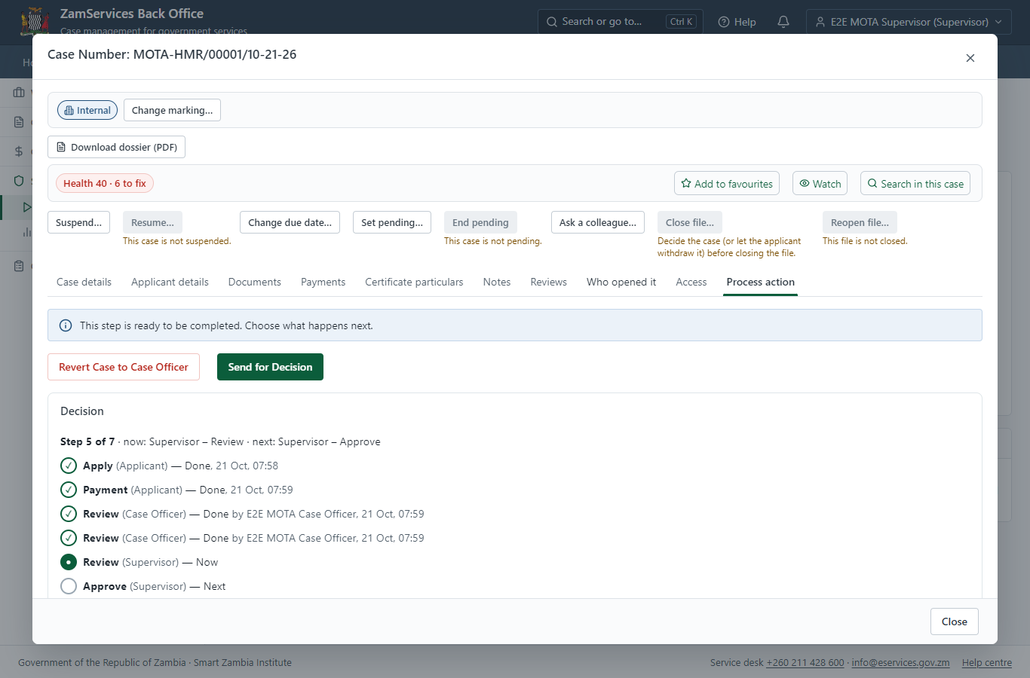
Step 15: Review, Add Comments, Send for Signature.

Step 16. Committee: Organize Voting, Report Decision
Supervisor · Back office
"Organize Voting, Report Decision" is a committee step: the members named by the process (Committee member 1, Committee member 2, Committee member 3) each record a vote on their own task under "This step"; the step completes when its rule (quorum, quorum 2) is met. Each member is a different officer.
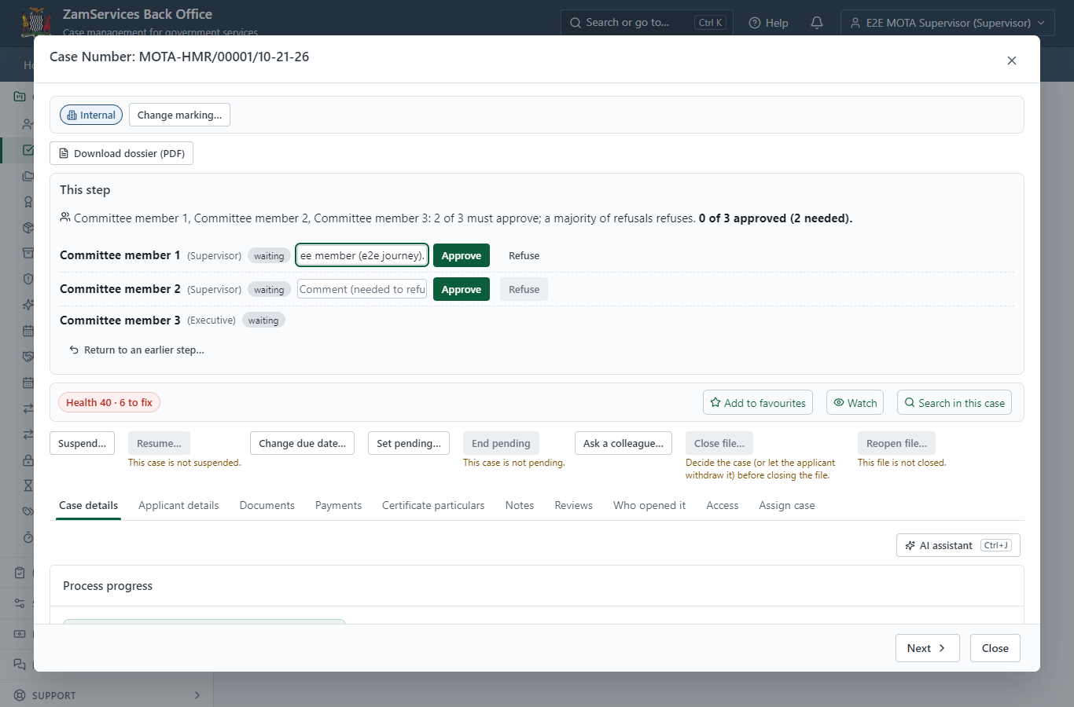
Step 16: Committee: Organize Voting, Report Decision.

Step 17. Decide: Review, Inspect, e-Sign
Executive · Back office
At "Review, Inspect, e-Sign" the Executive records the decision: approve, with a comment kept in the case history. Approving moves the case on; the last decision completes it and issues the document.
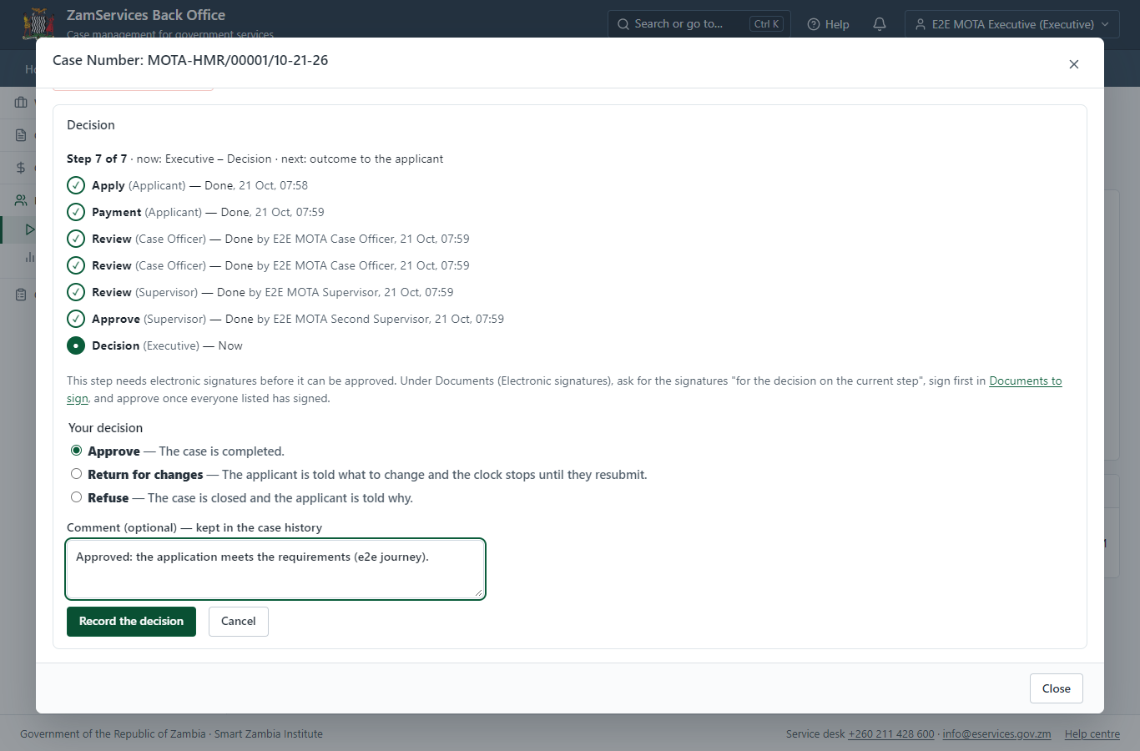
Step 17: Decide: Review, Inspect, e-Sign.

Step 18. The document in My permits
Citizen · National e-Services portal
The issued document (MOTA-HMR-2026-00001 in this run: "Hotel Manager Registration") is listed in "My permits and licences" with its validity and a download of the sealed PDF.
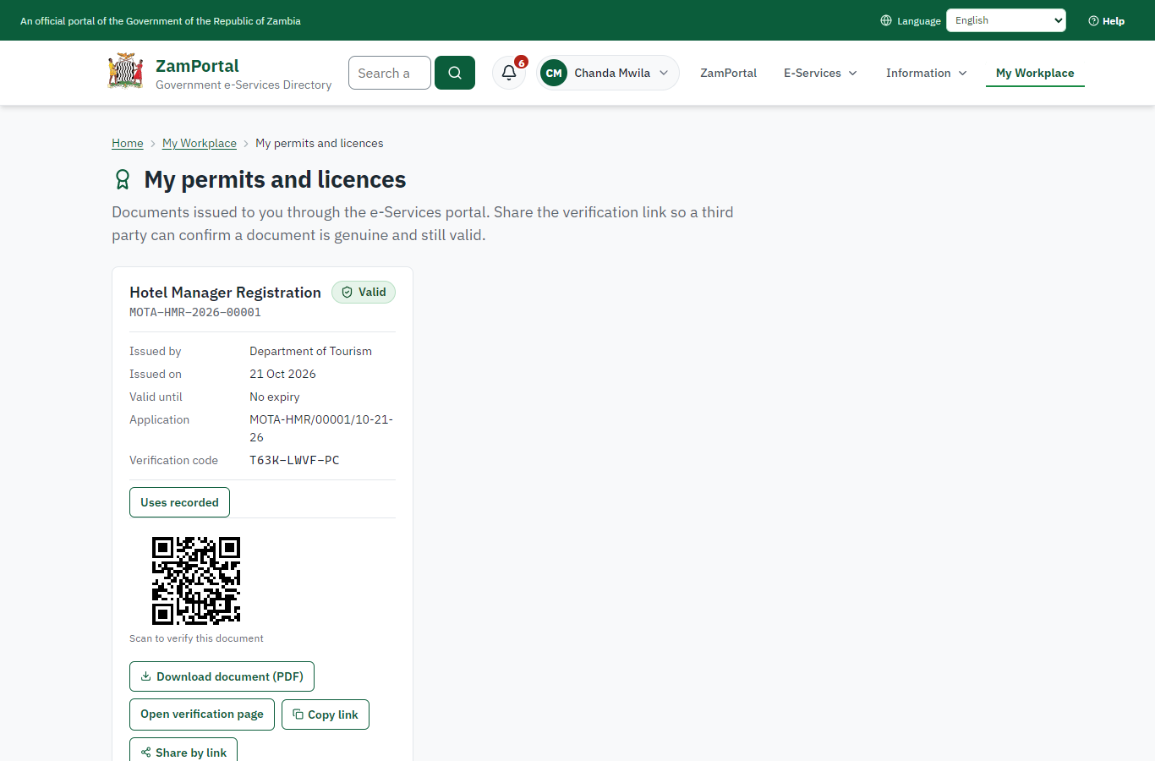 | 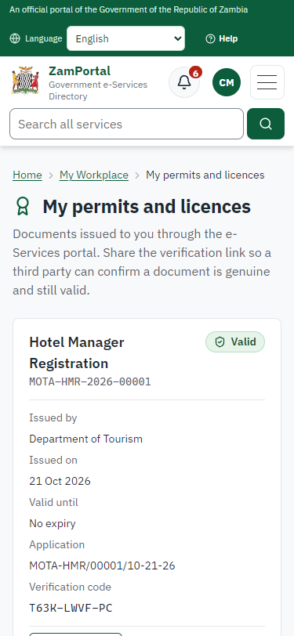
Step 18: The document in My permits - desktop (left) and a 375 px phone (right).

Step 19. Verify the document
Anyone (public) · Public verification page
The QR code on the document opens the public verification page: genuine and current, to whom it was issued, and whether the electronic seal is valid. No sign-in is needed.
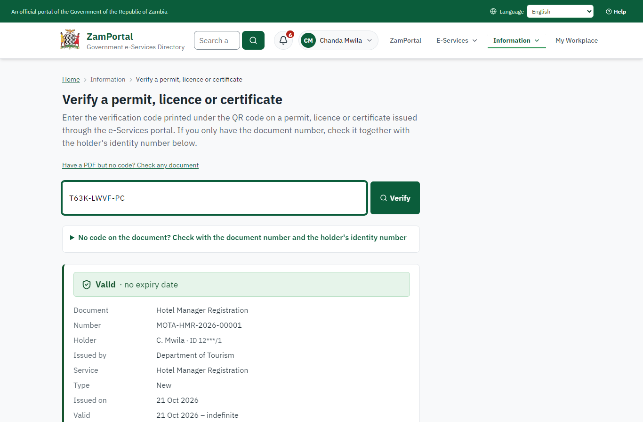 | 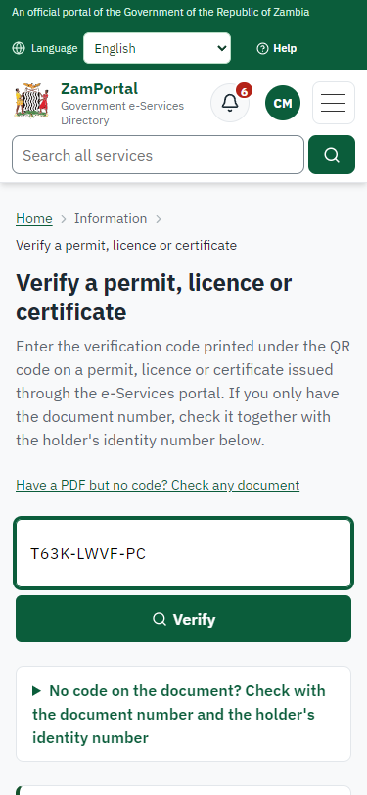
Step 19: Verify the document - desktop (left) and a 375 px phone (right).

3. Payment
Item | In the test run
Fee (as published) | 3,000.00 ZMW
Invoice 1 | 4733621309210705
Amount 1 | ZMW 3000.00
Paid at 1 | with the application
On screen: step 8 (See that the fee is due), step 9 (Pay with ZamPay), step 10 (Payment received) in section 2.

4. Output documents

Hotel Manager Registration (sealed PDF)
Issued when the case was approved, from the service's output configuration (service template MOTA_HotelManagersRegistration.Certificate.), filled from the application and the decision, sealed with the platform's electronic seal and stored as the issued version. The holder downloads it from My permits; the verification page checks it.
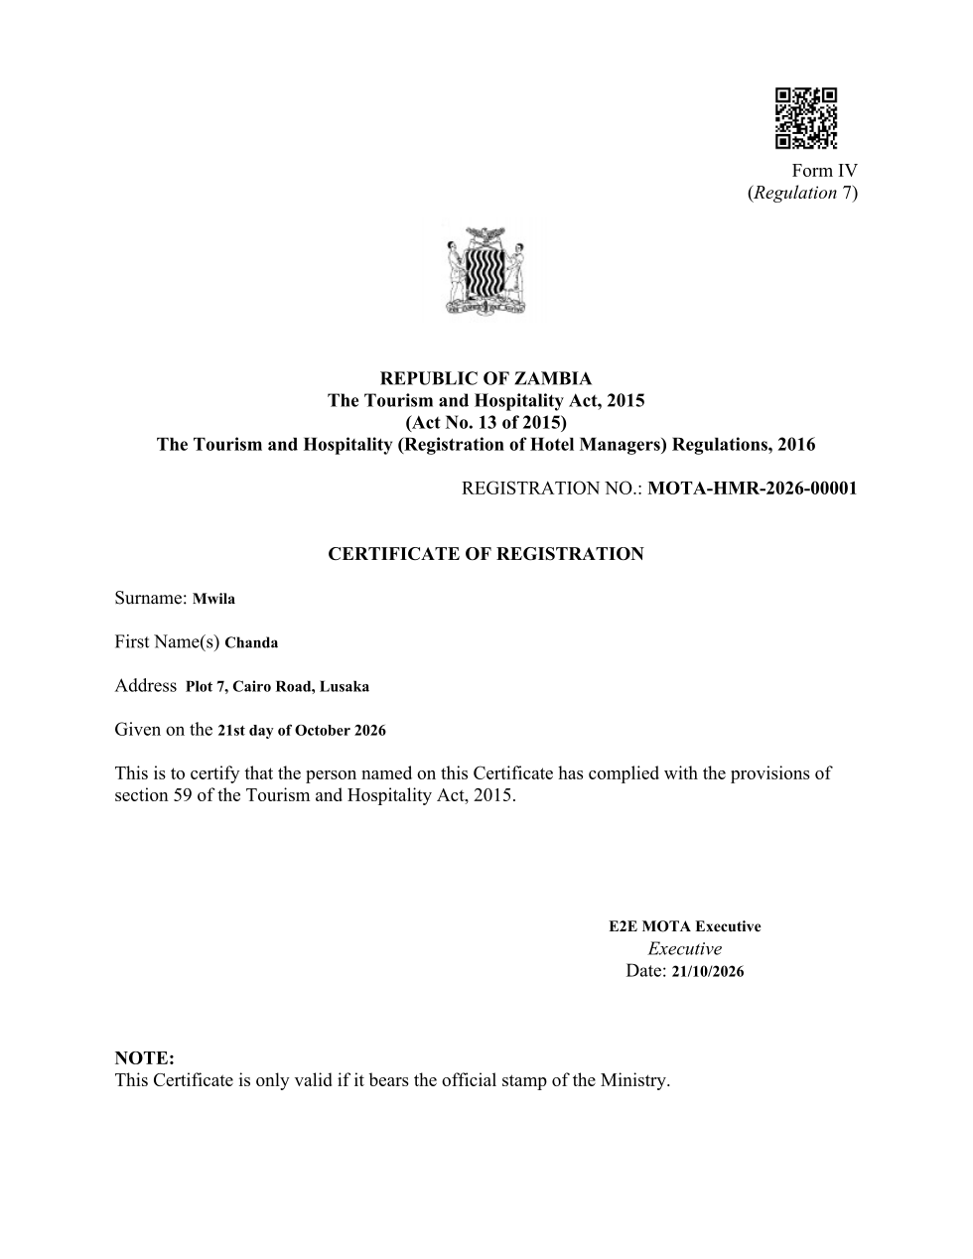
Hotel Manager Registration (sealed PDF) - first of 1 page, as issued in the test run.

Fields
Field | Value in the test run
Document title | Hotel Manager Registration
Permit / licence number | MOTA-HMR-2026-00001
Holder | Chanda Mwila
Valid from | 2026-10-21
Valid until
Status | active
Verification code (printed with a QR code) | T63K-LWVF-PC

Seal
Seal status | sealed
Signature level | PAdES-B-T
Sealed by | the platform seal (development key in the test run)
Signed at | 2026-10-21T05:59:43.352Z
Trusted time-stamp | 2026-10-21T05:59:43.336Z (time-stamping authority)
Document fingerprint (SHA-256) | 091b45b1ad41d644...

Verification
Where | The public verification page of the national portal, <portal>/verify/<verification code>, opened by scanning the QR code on the document.
What it shows | Whether the document is genuine and current, its holder and validity, and whether the electronic seal is valid and who sealed it.
Checking a copy | Anyone can upload a PDF they were given; the page says whether it is exactly the document that was issued. A changed copy is reported as not matching.
On screen: step 18 (The document in My permits), step 19 (Verify the document) in section 2.

5. Notifications
When | Channel | To | Message | Delivery
Payment due (invoice raised) | in-app (portal bell) | the applicant | Payment due for application MOTA-HMR/00001/10-21-26 - The fee of ZMW 3000.00 for Hotel Manager Registration (MOTA-HMR/00001/10-21-26) is now due. Invoice 4733621309210705. | shown
Application received | in-app (portal bell) | the applicant | Application MOTA-HMR/00001/10-21-26 received - Your application MOTA-HMR/00001/10-21-26 for Hotel Manager Registration has been received by Department of Tourism. | shown
Payment received | in-app (portal bell) | the applicant | Payment received for MOTA-HMR/00001/10-21-26 - Your payment of ZMW 3000.00 for MOTA-HMR/00001/10-21-26 (Hotel Manager Registration) has been received. Receipt: <ZamPay>/pdf?documentType=receipt&invoiceNumber=4733621309210705 | shown
Licence / permit issued | in-app (portal bell) | the applicant | Your Hotel Manager Registration document has been issued - MOTA-HMR-2026-00001 has been issued for Hotel Manager Registration. | shown
Invitation to rate the service | in-app (portal bell) | the applicant | How was Hotel Manager Registration? - How was Hotel Manager Registration? Tell us in about a minute. | shown
Decision: approved | in-app (portal bell) | the applicant | Application MOTA-HMR/00001/10-21-26 completed - MOTA-HMR/00001/10-21-26 (Hotel Manager Registration) is complete. Your documents are ready. | shown
Application received | email | e2e.c***@example.test | Application MOTA-HMR/00001/10-21-26 received | skipped
Payment due (invoice raised) | sms | +260 97* *** 567 | Fee of ZMW 3000.00 due for MOTA-HMR/00001/10-21-26. Invoice 4733621309210705. Pay: <ZamPay>/pay-for-service/get-invoice/4733621309210705 | delivered
Payment due (invoice raised) | email | e2e.c***@example.test | Payment due for application MOTA-HMR/00001/10-21-26 | skipped
Application received | sms | +260 97* *** 567 | Application MOTA-HMR/00001/10-21-26 for Hotel Manager Registration has been received. Track it: <portal>/my-workplace | delivered
Payment received | sms | +260 97* *** 567 |  | delivered
Invitation to rate the service | sms | +260 97* *** 567 |  | skipped
Invitation to rate the service | email | e2e.c***@example.test | How was Hotel Manager Registration? | skipped
Licence / permit issued | email | e2e.c***@example.test | Your Hotel Manager Registration document has been issued | skipped
Decision: approved | email | e2e.c***@example.test | Application MOTA-HMR/00001/10-21-26 completed | skipped
Licence / permit issued | sms | +260 97* *** 567 |  | delivered
Decision: approved | sms | +260 97* *** 567 |  | delivered
Delivery: shown = in the portal's notification bell; delivered = the SMS gateway (a test double in this run) reported the text delivered; skipped = not sent on that channel (e-mail is not configured on the test installation, and some notices go out on one channel only); sent by the national portal = a ministry node handed the notice to the national portal, which texts and e-mails the citizen under its own name and the citizen's preferences. Addresses written <portal>, <ZamPay> stand for the national portal and ZamPay.

6. Legacy mapping
Replaces | Hotel Manager Registration in the legacy ZIGS e-Services directory (ZIGS_Services)
Legacy service id | 95
Legacy provider | Department of Tourism (MOTA) under Ministry of Tourism
Legacy process | FullReview (process 3)
Fee in the legacy system | Hotel Manager Registration Fee: ZMW 3000 (New)
Fee taken before submission | yes (as in ZIGS)
Time to issue (legacy) | New: 30 calendar days
Legacy output templates | Notice of Action: ZIGS_Forms_Notices / GS-2.NoticeOfAction  Denial of Service: ZIGS_Forms_MOTA / MOTA_HotelManagersRegistration.DenialService  Hotel Manager Registration: ZIGS_Forms_MOTA / MOTA_HotelManagersRegistration.Certificate  Notice of Approval: ZIGS_Forms_MOTA / MOTA_HotelManagersRegistration.NoticeApproval  Application form: ZIGS_Forms_MOTA / MOTA_HotelManagersRegistration.Application  GF-1 Treasury Invoice: ZIGS_CustomForms / GF-1 Invoice  GF-2 Treasury Receipt: ZIGS_CustomForms / GF-2 Receipt
Legacy address | none recorded
How it was brought over | Imported by the platform's legacy catalogue importer (zcm-backend scripts/zigs/importLegacy.js) from the ZIGS snapshot: form, case types, fees, documents, process and output templates, then served by the new platform.

7. Version and date
Document version | service v1, platform a0a302b8
Generated | 2026-10-21T05:59:53Z (by the end-to-end run, not edited by hand)
Service version | not versioned (configured directly)
Platform snapshot | backend a0a302b8  portal 72805f0  back office 58e5946
Test suite | e2e 5999d9b; one installation (combined); seed profile mihud
Journeys | 30-catalogue-service.spec.js: citizen finds the service, answers its form, uploads its documents and sends the application - passed  30-catalogue-service.spec.js: the case goes through every step of its process: payments by the citizen, each officer step by its role - passed  30-catalogue-service.spec.js: the grant document is issued, sealed, filled in and verifiable; the citizen has it in My permits - passed
Result | 3 of 3 journey tests passed
Data | Synthetic test data on a local test installation; provider test doubles for ZamPass, ZamPay, SMS and signing.

