Republic of Zambia
GSB e-Services

Exploration Licence
Service documentation
Owner: Cadastre Department
Service key: MMMD/exploration-licence
Version: service v1, platform 7e6d0b65
Date: 2026-10-22
Generated automatically by the service's end-to-end test run. Every screenshot shows synthetic test data on a local test installation, never real personal data.

Contents
- 1. Service summary
- 2. Application process, step by step
- 3. Payment
- 4. Output documents
- 5. Notifications
- 6. Legacy mapping
- 7. Version and date
This document describes the Exploration Licence service of Cadastre Department as the platform runs it today. It is generated by the service's end-to-end test: every step was performed by the test and every screenshot was taken during that run, with synthetic data. Regenerate it with "npm run docs:services" in the e2e suite; do not edit it by hand.

1. Service summary
Service | Exploration Licence
Owner (MDA) | Cadastre Department (MMMD)
Purpose | An exploration licence confers on the holder exclusive rights to carry on exploration in the exploration area for the minerals specified in the licence and to do all such other acts and things as are necessary for, or incidental to, the carrying on of those operations.
Who can apply | Not set in the service configuration.
How to apply | Online on the national e-Services portal, signed in with ZamPass; pay with ZamPay.
Fees | Small Scale Exploration Licence Application Fee: ZMW 1200.00  Large Scale Exploration Licence Application Fee: ZMW 4000.00  Area charge per [@year] (Small Scale Exploration Licence Year 1-4): ZMW 0.80  Area charge per year (Small Scale Year 5-7): ZMW 1.50  Area charge per year (Large Scale Year 1-4): ZMW 1.60  Area charge per year (Large Scale Year 5-7): ZMW 4.80  Area charge per year (Large Scale Year 8-10): ZMW 6.40
Turnaround | Sixty (60) Days of Receiving the Application
Validity of the output | 4 years
Required documents | None
Output documents | Exploration Right Licence  GS-1 Application for a Government Service  GS-2 Notice of Government Action

2. Application process, step by step

The process as configured
Step | Role | Task | Type
1 | Applicant | Apply | form
2 | Case Officer | Review | review
3 | Case Officer | Generate Payment | generate-payment
4 | Applicant | Payment | payment
5 | Case Officer | Verify Payment | verify-payment
6 | Case Officer | Technical review | mining-technical-review
7 | Supervisor | Consent | mining-consent
8 | Supervisor | Review | review
9 | Executive | Decision | decision
10 | System | Generate Document | generate-document
11 | System | Notify Client | notify

Step by step
Who takes part in this journey: Citizen, Case Officer, Executive, Supervisor, Licensing committee (chair: Executive), Anyone (public). Citizen steps are shown on a desktop and on a 375 px phone; back-office steps on a desktop.

Step 1. Find the service and read its page
Citizen · National e-Services portal
The citizen finds "Exploration Licence" in the national directory and opens its page: who provides it, the fees (the application fee and the yearly area charges per hectare), how long it takes and what to have ready.
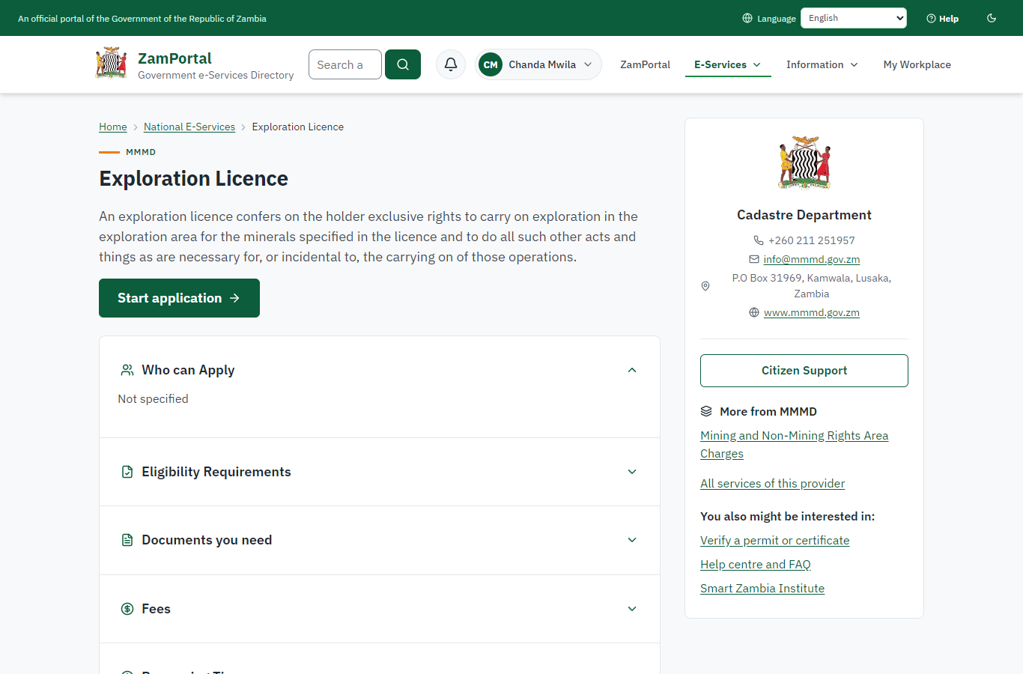 | 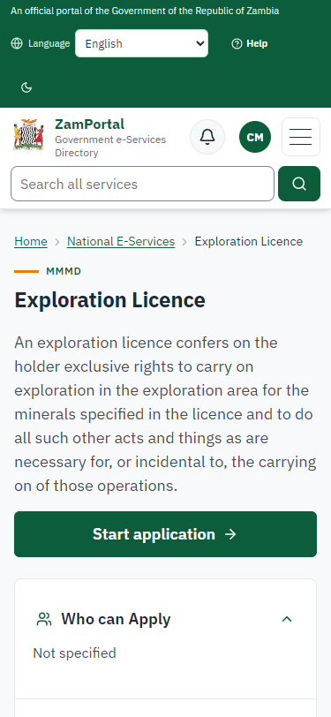
Step 1: Find the service and read its page - desktop (left) and a 375 px phone (right).

Step 2. Start the application
Citizen · National e-Services portal
The application starts with who is applying (the citizen, or on behalf of a company or co-operative). The service form that follows asks for the scale, the minerals, where the area is and who will hold the licence, then the licence area: drawn on the map, uploaded (KML, GeoJSON, a zipped shapefile) or typed as the corners in latitude / longitude or UTM. The applicant's eligibility questions of the legacy form follow.
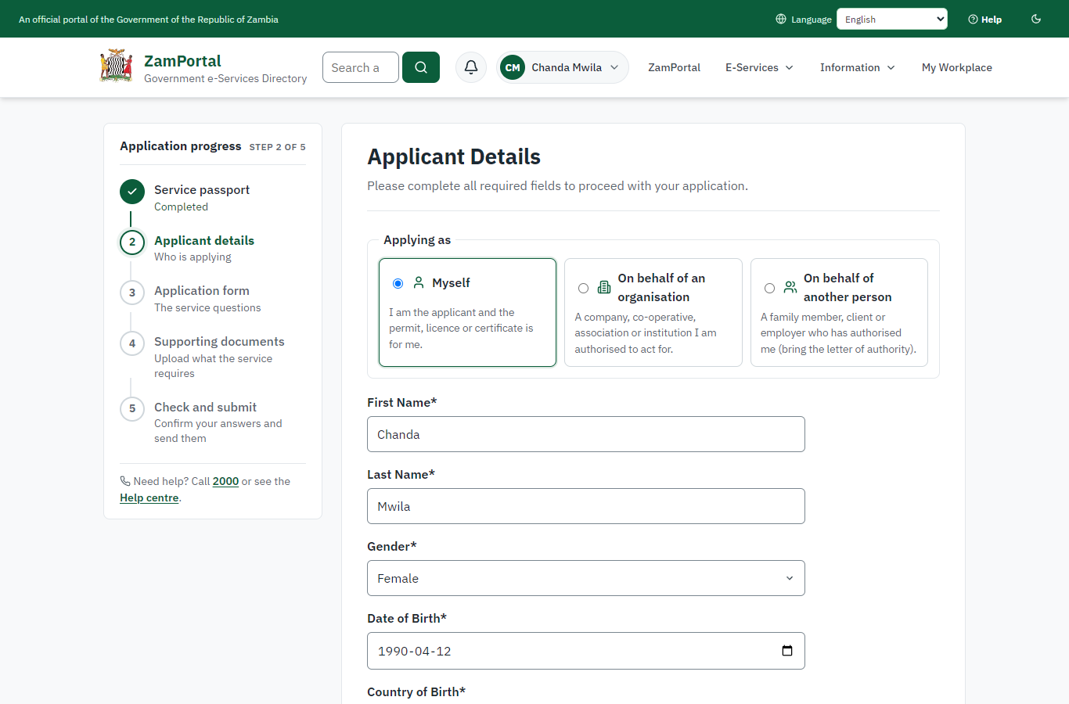 | 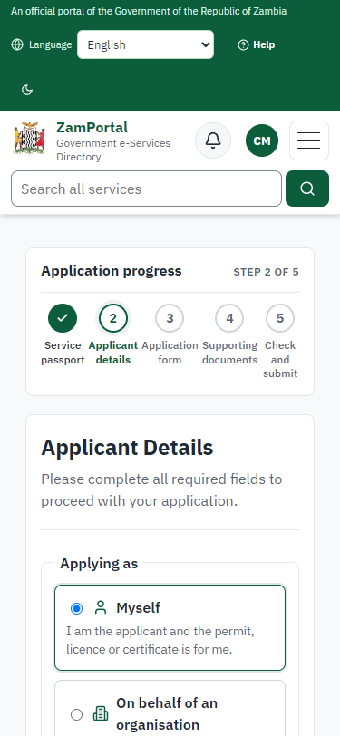
Step 2: Start the application - desktop (left) and a 375 px phone (right).

Step 3. An area over another right is refused
Citizen · National e-Services portal (sent through the API the portal uses in the test run: no screenshot)
The first area the citizen gave overlaps exploration licence EL-2025-E2E01, already in force: the application is refused at once with "The area overlaps a right already granted or applied for: EL-2025-E2E01. Reduce the area so it does not overlap." (first come, first served). Nothing is recorded.

Step 4. Send the application
Citizen · National e-Services portal (sent through the API the portal uses in the test run: no screenshot)
The area beside it is accepted: the cadastre keeps the corners exactly as given (UTM zone 35S, EPSG:32735), works out the WGS 84 outline for maps, measures 400 ha (120.46 cadastre units) in metres and holds the area for this application. The application gets reference MC-2026-00001.

Step 5. Take the application on
Case Officer · Back office (done through its case API in the test run: no screenshot)
The Case Officer takes the new application on (assigned to them). The case moves from "Submitted" to "CO Review".

Step 6. Check the application, its documents and the applicant's eligibility
Case Officer · Back office (done through its case API in the test run: no screenshot)
The Case Officer completes "Check the application, its documents and the applicant's eligibility". The case moves from "CO Review" to "CO Generate Payment".

Step 7. Set the application fee from the service fee schedule
Case Officer · Back office (done through its case API in the test run: no screenshot)
The officer sets the application fee from the service's fee schedule, the line for the licence's scale: Large Scale Exploration Licence Application Fee, ZMW 4,000.00. The applicant is invoiced.

Step 8. Pay the application fee
Citizen · National e-Services portal
The application waits for the application fee in My Workplace, with a Pay button (ZamPay: mobile money or bank card).
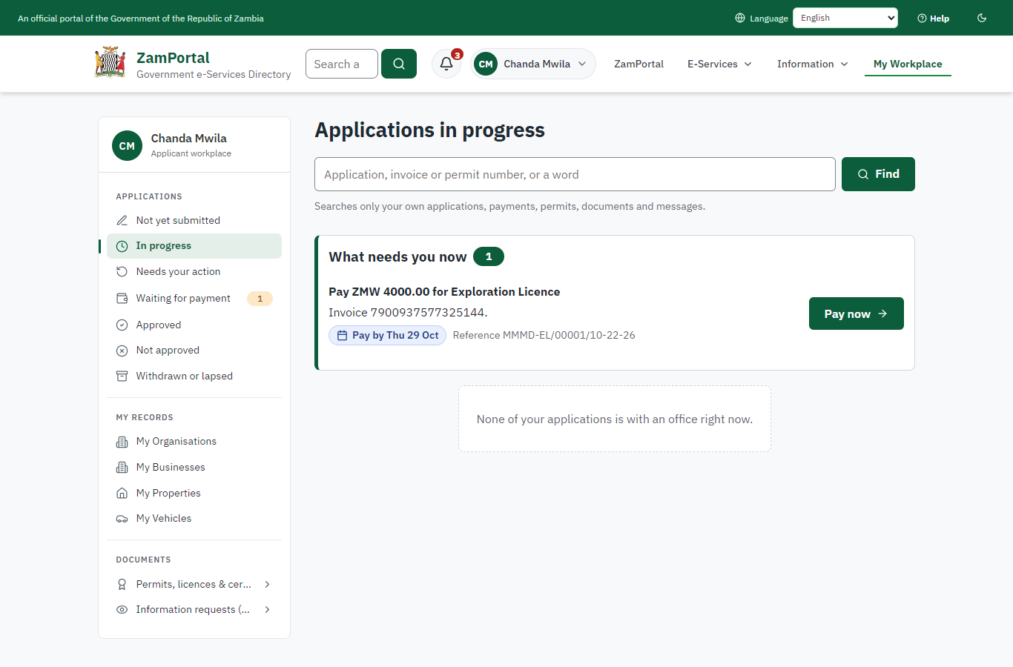 | 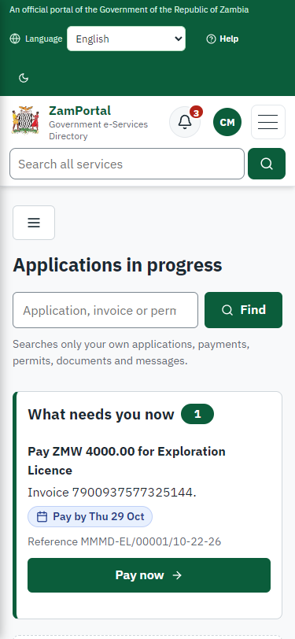
Step 8: Pay the application fee - desktop (left) and a 375 px phone (right).

Step 9. Verify Payment
Case Officer · Back office (done through its case API in the test run: no screenshot)
The Case Officer completes "Verify Payment". The case moves from "CO Verify Payment" to "CO Review".

Step 10. The cadastre check
Case Officer · Back office
On the case's "Mineral rights" tab the officer runs the cadastre check on today's register: the area overlaps no other mineral right, is within the area limit of an exploration licence, and half of it (200 ha) lies in a forest reserve - a restricted area published on the reference map layers - so the consent of the authority responsible is needed. The tab also shows the first year's area charge the system works out (400 ha x the approved rate).
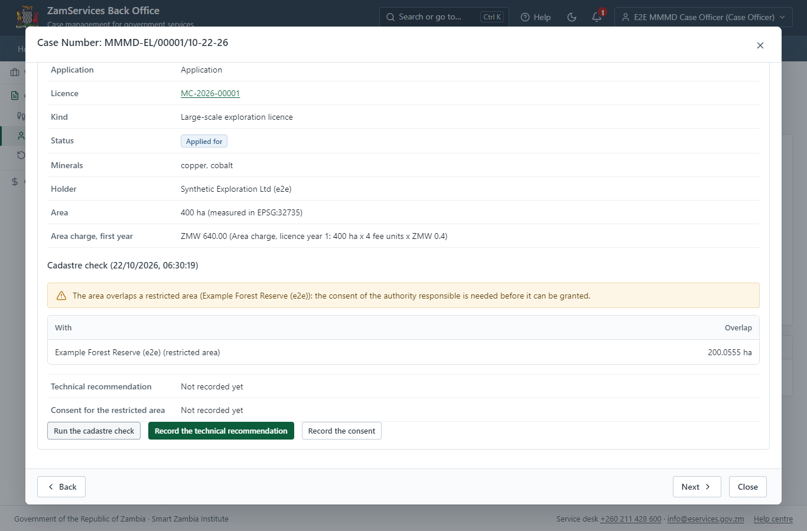
Step 10: The cadastre check.

Step 11. Record the technical recommendation
Case Officer · Back office
The officer records the recommendation (grant) with its reasons. A grant cannot be recommended while the check finds an overlap; the officer who recommends may not approve the application.
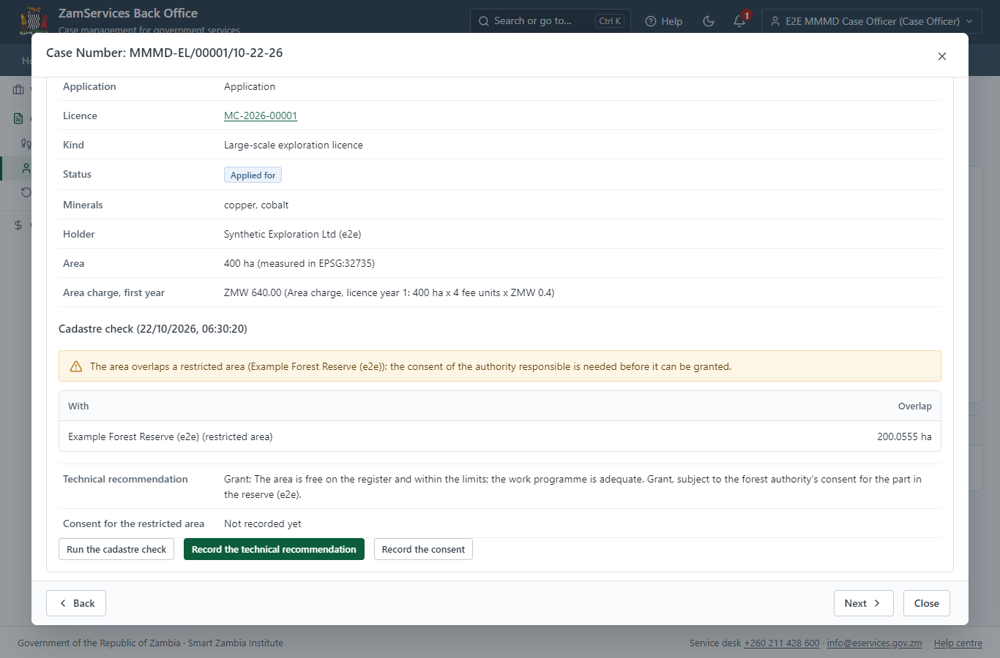
Step 11: Record the technical recommendation.

Step 12. Cadastre check of the area and technical recommendation
Case Officer · Back office (done through its case API in the test run: no screenshot)
The Case Officer completes "Cadastre check of the area and technical recommendation". The case moves from "CO Review" to "SV Review".

Step 13. Record the consent for the restricted area
Executive · Back office (done through its case API in the test run: no screenshot)
The Executive records the decision of the authority responsible for the forest reserve, as received (granted, with its letter's reference and conditions). The consent step cannot be left - and the licence cannot be granted - until it is recorded.

Step 14. Consent where the area touches a restricted area
Supervisor · Back office (done through its case API in the test run: no screenshot)
The Supervisor completes "Consent where the area touches a restricted area". The case moves from "SV Review" to "SV Review".

Step 15. Review and send for signature
Supervisor · Back office (done through its case API in the test run: no screenshot)
The Supervisor completes "Review and send for signature". The case moves from "SV Review" to "EX Decision".

Step 16. The licensing committee decides
Licensing committee (chair: Executive) · Back office (done through its case API in the test run: no screenshot)
The chair puts the application on the agenda of a meeting of the licensing committee (MRLCE/2026/1 in this run), records who attended (the quorum is checked) and the resolution "approve" with its reasons, and closes the meeting. Closing it decides the application; deciding it by hand is refused. On approval the area is checked once more against the register, under one lock, so two overlapping applications can never both be granted.

Step 17. The mineral rights register
Supervisor · Back office
Ministry functions -> Mining cadastre -> Mineral rights register: every licence of the ministry with its kind, holder, district, area, status and term; filters by number, name or holder, kind, status, district and "being processed".
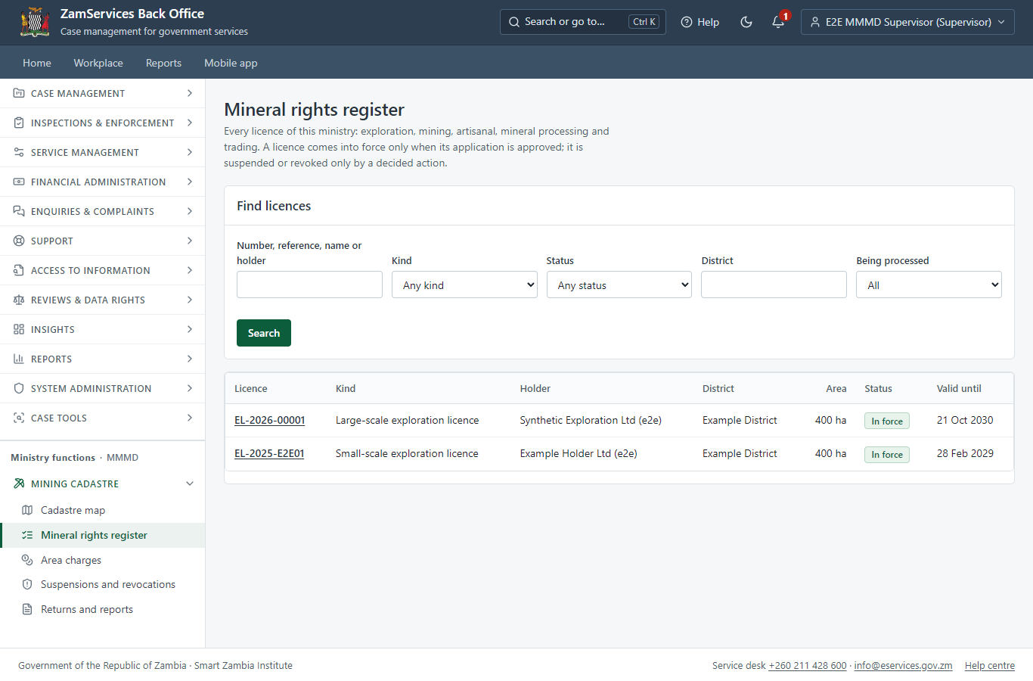
Step 17: The mineral rights register.

Step 18. The licence page
Supervisor · Back office
The licence: number, kind, minerals, holder and term; its area on the map and its corners exactly as delivered (UTM zone 35S), measured in metres; the area charge account (ZMW 640.00 a year in years 1-4); suspension, revocation or reinstatement proposals (decided by another officer); returns; history.
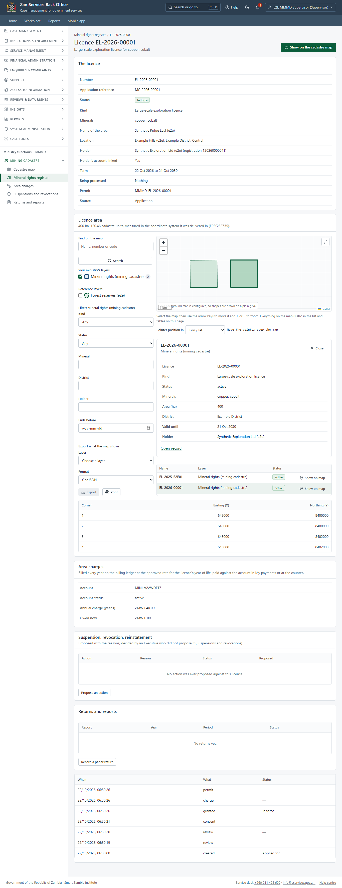
Step 18: The licence page.

Step 19. The cadastre map
Supervisor · Back office
Ministry functions -> Mining cadastre -> Cadastre map: every right granted, suspended or applied for as its area, coloured by status, over the core map; other ministries' published layers (forest concessions, protected areas, land parcels) can be shown with it. Other ministries see these areas on their own maps without the holder.
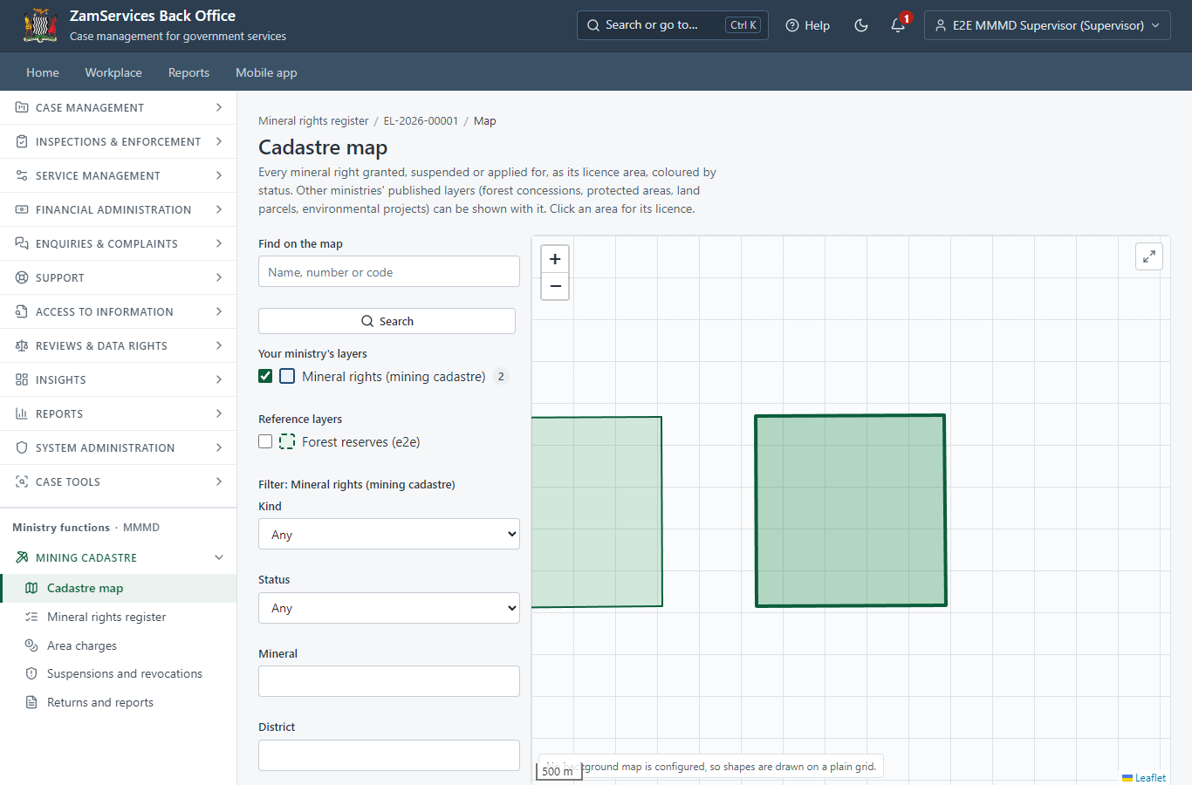
Step 19: The cadastre map.

Step 20. The licence in My permits
Citizen · National e-Services portal
The licence is listed in "My permits and licences" with its particulars (number, minerals, area, status, validity) and its area (a generic block: any permit with a geometry can show it), and a download of the sealed PDF.
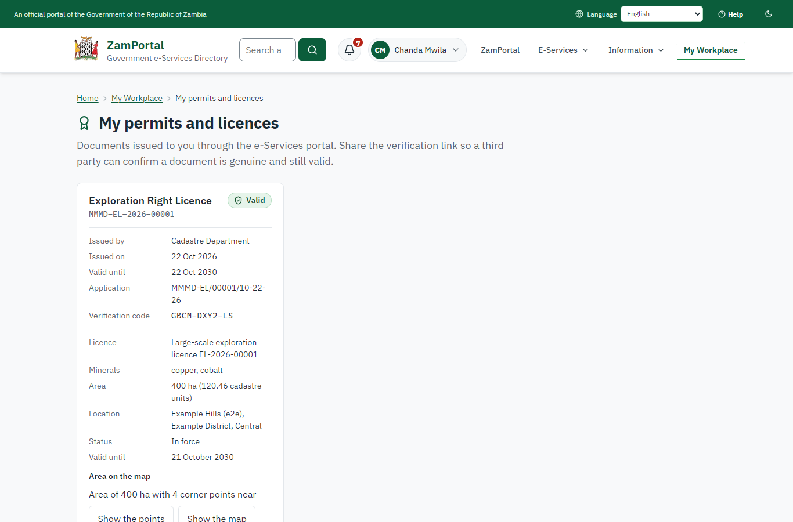 | 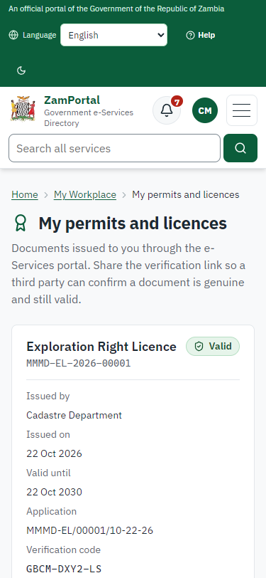
Step 20: The licence in My permits - desktop (left) and a 375 px phone (right).

Step 21. Verify the licence
Anyone (public) · Public verification page
The QR code on the licence opens the public verification page: genuine and current, and whether the electronic seal is valid. No holder details are shown.
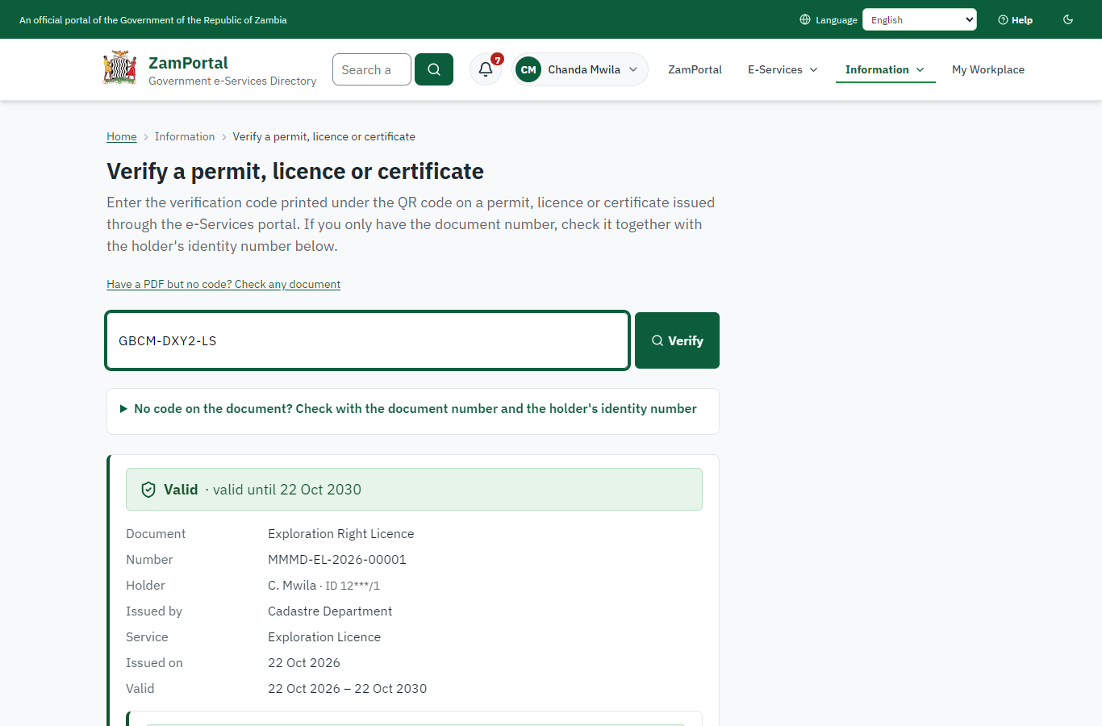 | 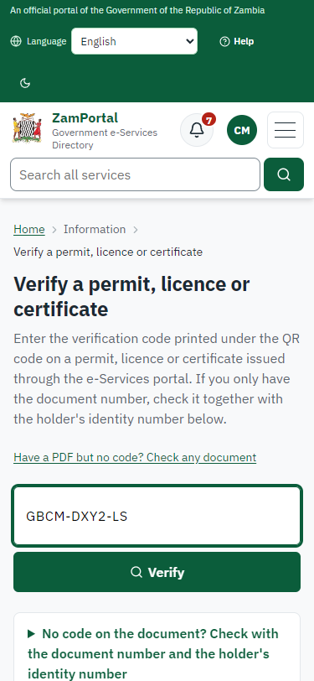
Step 21: Verify the licence - desktop (left) and a 375 px phone (right).

3. Payment
Item | In the test run
Application fee | ZMW 4,000.00 (the service's fee schedule: large-scale exploration licence application)
When it is paid | After the officer has checked the application, before the technical review
Invoice number | 7900937577325144
Paid through | ZamPay (the ZamPay test double in this run)
Yearly area charges | Billed separately every year once the licence is granted (Mining and Non-Mining Rights Area Charges)
On screen: step 8 (Pay the application fee) in section 2.

4. Output documents

Exploration licence (sealed PDF)
The licence issued when the licensing committee grants the application: the right (number, kind, minerals), its area and the coordinate system its corners are kept in, its term, and the yearly area charges as its conditions; sealed with the platform's electronic seal.
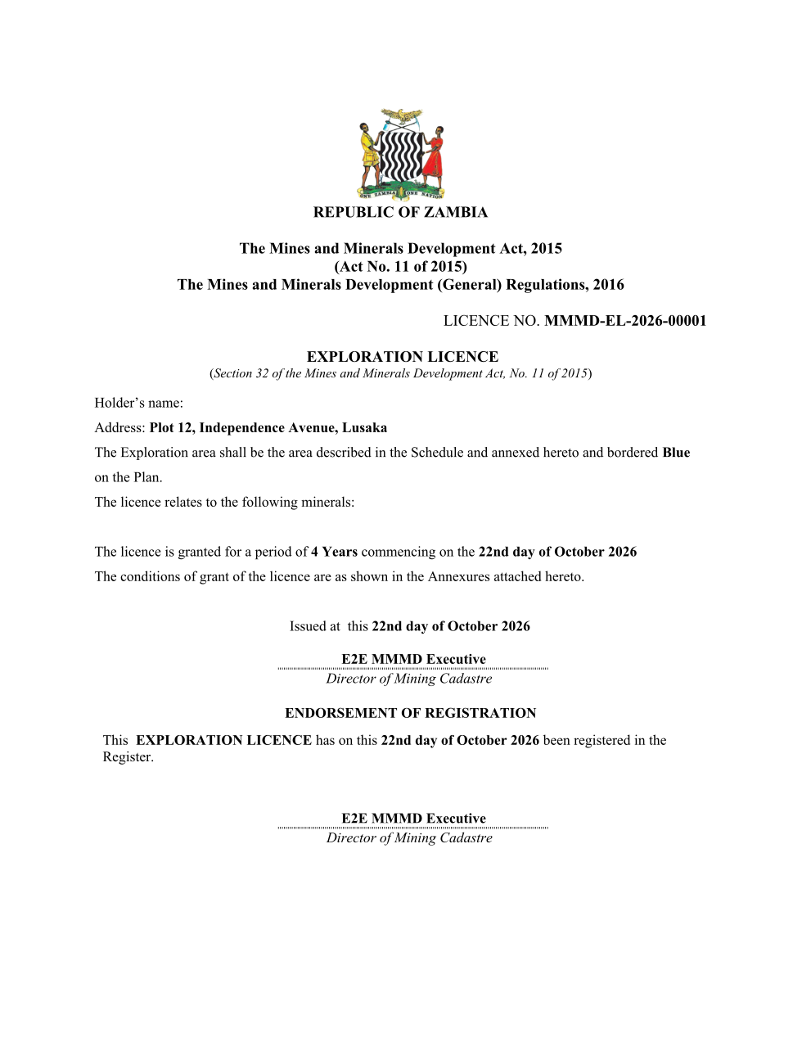
Exploration licence (sealed PDF) - first of 2 pages, as issued in the test run.

Fields
Field | Value in the test run
Document title | Exploration Right Licence
Permit / licence number | MMMD-EL-2026-00001
Holder | Chanda Mwila
Valid from | 2026-10-22
Valid until | 2030-10-21
Status | active
Verification code (printed with a QR code) | GBCM-DXY2-LS

Seal
Seal status | sealed
Signature level | PAdES-B-T
Sealed by | the platform seal (development key in the test run)
Signed at | 2026-10-22T04:30:47.726Z
Trusted time-stamp | 2026-10-22T04:30:47.675Z (time-stamping authority)
Document fingerprint (SHA-256) | 6b6866eabee3fdce...

Verification
Where | The public verification page of the national portal, <portal>/verify/<verification code>, opened by scanning the QR code on the document.
What it shows | Whether the document is genuine and current, its holder and validity, and whether the electronic seal is valid and who sealed it.
Checking a copy | Anyone can upload a PDF they were given; the page says whether it is exactly the document that was issued. A changed copy is reported as not matching.
On screen: step 17 (The mineral rights register), step 18 (The licence page), step 19 (The cadastre map), step 20 (The licence in My permits), step 21 (Verify the licence) in section 2.

5. Notifications
When | Channel | To | Message | Delivery
Application received | in-app (portal bell) | the applicant | Application MMMD-EL/00001/10-22-26 received - Your application MMMD-EL/00001/10-22-26 for Exploration Licence has been received by Cadastre Department. | shown
Status changed | in-app (portal bell) | the applicant | Update on application MMMD-EL/00001/10-22-26 - MMMD-EL/00001/10-22-26 (Exploration Licence) is now: With the office - being reviewed. | shown
Payment due (invoice raised) | in-app (portal bell) | the applicant | Payment due for application MMMD-EL/00001/10-22-26 - The fee of ZMW 4000.00 for Exploration Licence (MMMD-EL/00001/10-22-26) is now due. Invoice 7900937577325144. | shown
Payment received | in-app (portal bell) | the applicant | Payment received for MMMD-EL/00001/10-22-26 - Your payment of ZMW 4000.00 for MMMD-EL/00001/10-22-26 (Exploration Licence) has been received. Receipt: <ZamPay>/pdf?documentType=receipt&invoiceNumber=7900937577325144 | shown
Licence / permit issued | in-app (portal bell) | the applicant | Your Exploration Licence document has been issued - MMMD-EL-2026-00001 has been issued for Exploration Licence and is valid until 22/10/2030. | shown
Invitation to rate the service | in-app (portal bell) | the applicant | How was Exploration Licence? - How was Exploration Licence? Tell us in about a minute. | shown
Decision: approved | in-app (portal bell) | the applicant | Application MMMD-EL/00001/10-22-26 completed - MMMD-EL/00001/10-22-26 (Exploration Licence) is complete. Your documents are ready. | shown
Application received | sms | +260 97* *** 567 | Application MMMD-EL/00001/10-22-26 for Exploration Licence has been received. Track it: <portal>/my-workplace | delivered
Application received | email | e2e.c***@example.test | Application MMMD-EL/00001/10-22-26 received | skipped
Status changed | sms | +260 97* *** 567 |  | delivered
Payment due (invoice raised) | email | e2e.c***@example.test | Payment due for application MMMD-EL/00001/10-22-26 | skipped
Payment due (invoice raised) | sms | +260 97* *** 567 | Fee of ZMW 4000.00 due for MMMD-EL/00001/10-22-26. Invoice 7900937577325144. Pay: <ZamPay>/pay-for-service/get-invoice/7900937577325144 | delivered
Payment received | sms | +260 97* *** 567 |  | delivered
Invitation to rate the service | sms | +260 97* *** 567 |  | skipped
Invitation to rate the service | email | e2e.c***@example.test | How was Exploration Licence? | skipped
Licence / permit issued | sms | +260 97* *** 567 |  | delivered
Decision: approved | email | e2e.c***@example.test | Application MMMD-EL/00001/10-22-26 completed | skipped
Licence / permit issued | email | e2e.c***@example.test | Your Exploration Licence document has been issued | skipped
Decision: approved | sms | +260 97* *** 567 |  | delivered
Delivery: shown = in the portal's notification bell; delivered = the SMS gateway (a test double in this run) reported the text delivered; skipped = not sent on that channel (e-mail is not configured on the test installation, and some notices go out on one channel only); sent by the national portal = a ministry node handed the notice to the national portal, which texts and e-mails the citizen under its own name and the citizen's preferences. Addresses written <portal>, <ZamPay> stand for the national portal and ZamPay.

6. Legacy mapping
Replaces | Exploration Licence in the legacy ZIGS e-Services directory (ZIGS_Services)
Legacy service id | 100
Legacy provider | Cadastre Department (MMMD) under Ministry of Mines and Minerals Development
Legacy process | LicenseReview (process 9)
Fee in the legacy system | none
Fee taken before submission | yes (as in ZIGS)
Time to issue (legacy) | not recorded
Legacy output templates | Exploration Right Licence: ZIGS_Forms_MMMD / MMMD_ExplorationRightLicence.Certificate  GS-1 Application for a Government Service: ZIGS_Forms_ZDA / GS1  GS-2 Notice of Government Action: ZIGS_Forms_Notices / GS-2.NoticeOfAction
Legacy address | https://mmmdui.gsb.gov.zm
How it was brought over | Imported by the platform's legacy catalogue importer (zcm-backend scripts/zigs/importLegacy.js) from the ZIGS snapshot: form, case types, fees, documents, process and output templates, then served by the new platform.

7. Version and date
Document version | service v1, platform 7e6d0b65
Generated | 2026-10-22T04:31:16Z (by the end-to-end run, not edited by hand)
Service version | not versioned (configured directly)
Platform snapshot | backend 7e6d0b65  portal f14fd24  back office 80a771f
Test suite | e2e 6c7099e; one installation (combined); seed profile mihud
Journeys | 41-mining-licence-area-charges.spec.js: citizen: finds the service, gives the licence area; an overlapping area is refused, the free one accepted - passed  41-mining-licence-area-charges.spec.js: officer checks the application and sets the fee; the citizen pays it - passed  41-mining-licence-area-charges.spec.js: officer: the cadastre check and the technical recommendation on the case's "Mineral rights" tab; consent; supervisor - passed  41-mining-licence-area-charges.spec.js: the licensing committee grants it: the licence in force, the permit sealed, the area charge account opened - passed  41-mining-licence-area-charges.spec.js: officers: the register, the licence page with its corners as delivered, the cadastre map - passed  41-mining-licence-area-charges.spec.js: citizen: the licence in My permits with its area; sealed; verifies - passed  41-mining-licence-area-charges.spec.js: area charges: finance bills the year (another finance officer approves the run); the holder pays from the service's page - passed
Result | 7 of 7 journey tests passed
Data | Synthetic test data on a local test installation; provider test doubles for ZamPass, ZamPay, SMS and signing.

