Republic of Zambia
GSB e-Services

Examination of Motor Vehicle ("Road Fitness Test")
Service documentation
Owner: Road Transport and Safety Agency
Service key: RTSA/examination-of-motor-vehicle-road-fitness-test
Version: service v1, platform 9b8a591f
Date: 2026-10-17
Generated automatically by the service's end-to-end test run. Every screenshot shows synthetic test data on a local test installation, never real personal data.

Contents
- 1. Service summary
- 2. Application process, step by step
- 3. Payment
- 4. Output documents
- 5. Notifications
- 6. Legacy mapping
- 7. Version and date
This document describes the Examination of Motor Vehicle ("Road Fitness Test") service of Road Transport and Safety Agency as the platform runs it today. It is generated by the service's end-to-end test: every step was performed by the test and every screenshot was taken during that run, with synthetic data. Regenerate it with "npm run docs:services" in the e2e suite; do not edit it by hand.

1. Service summary
Service | Examination of Motor Vehicle ("Road Fitness Test")
Owner (MDA) | Road Transport and Safety Agency (RTSA)
Purpose | Registration for a technical safety inspection of motor vehicle or trailer.
Who can apply | Individual
How to apply | Online on the national e-Services portal, signed in with ZamPass; pay with ZamPay.
Fees | Application for Roadworthiness (Test Certificate): ZMW 64.00  Application for Roadworthiness (Certificate of Fitness): ZMW 55.00
Turnaround | Instantly
Validity of the output | • Personal motor vehicles or trailers – 12 months  • Public Service Vehicles (PSV), Cargo - 12 months  • Public Service Vehicles (PSV), Passengers (long-term licence) - 4 months  • Public Service Vehicles (PSV), Passengers (short-term licence) - 3 months
Required documents | None
Output documents | Examination of Motor Vehicle ("Road Fitness Test")  GS-1 Application for a Government Service  GS-2 Notice of Government Action  GF-1 Treasury Invoice  GF-2 Treasury Receipt
Legal basis | Road Traffic Act Nr. 11 of 2002 (http://www.parliament.gov.zm/sites/default/files/documents/acts/Roads%20and%20Road%20Traffic%20Act.pdf)  Statutory Instrument No. 41 of 2015 (Fee & Penalty Unit Value) (http://www.seczambia.org.zm/wp-content/uploads/2018/08/SI-No-41-of-2015-Fees-and-Fines-Act.pdf)  Statutory Instrument No. 87 of 2016 (Obligatory Test Certificate) (https://www.enotices.co.zm/categories/statutory-instruments-2016/)  The Road Traffic (Driving Licence) Regulations

2. Application process, step by step

The process as configured
Step | Role | Task | Type
1 | Applicant | Apply | form
2 | Applicant | Payment | payment
3 | Case Officer | Review | review
4 | System | Generate Document | generate-document
5 | System | Generate Document | generate-document
6 | System | Notify Client | notify

Step by step
Who takes part in this journey: Citizen, Case Officer, Anyone (public). Citizen steps are shown on a desktop and on a 375 px phone; back-office steps on a desktop.

Step 1. Find the service
Citizen · National e-Services portal
On the national e-Services portal the citizen opens All Services and searches for the service by name ("Examination of Motor Vehicle Road Fitness"). Each result names the service and the ministry that provides it.
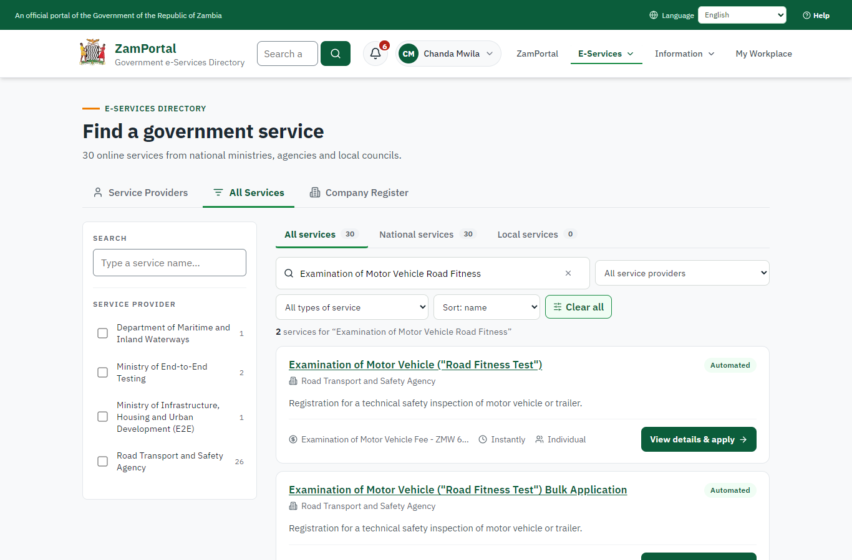 | 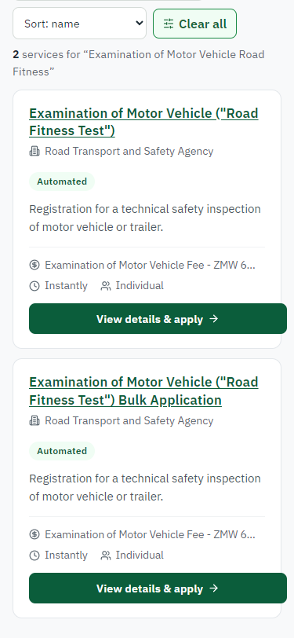
Step 1: Find the service - desktop (left) and a 375 px phone (right).

Step 2. Read the service page
Citizen · National e-Services portal
The service page sets out what the service is for, who provides it, the fee, how long it takes and the documents to have ready. "Start application" begins an application (the citizen is signed in with ZamPass).
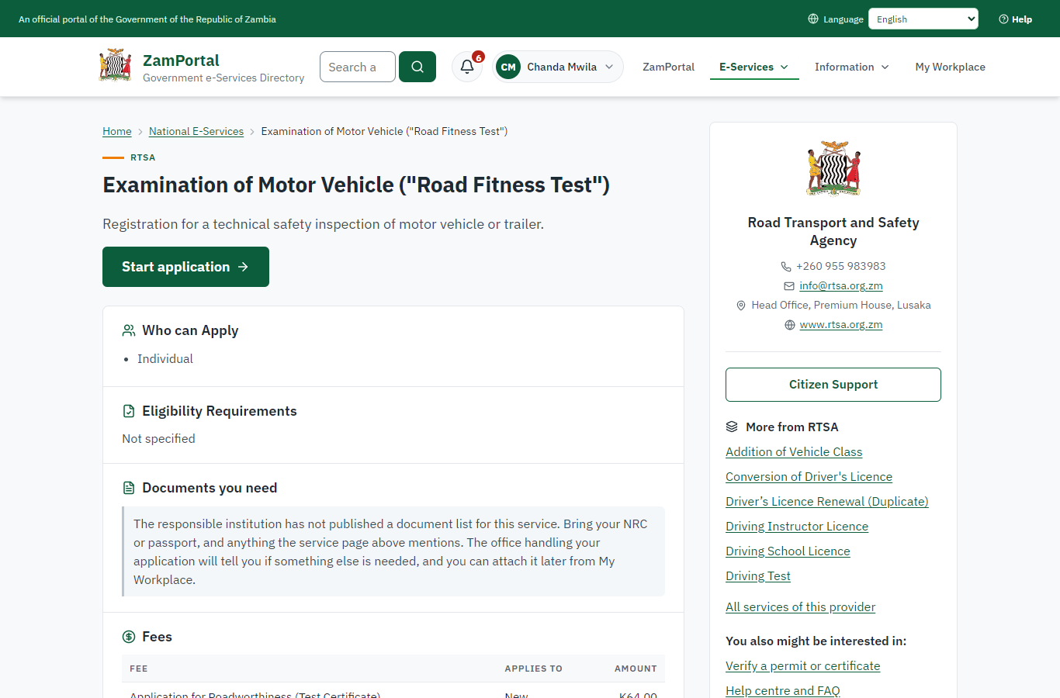 | 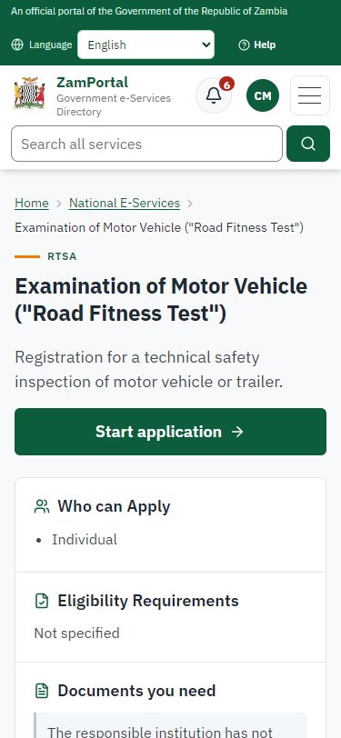
Step 2: Read the service page - desktop (left) and a 375 px phone (right).

Step 3. Confirm the applicant details
Citizen · National e-Services portal
The applicant details are filled in from the citizen's ZamPass account. The citizen says whom they are applying for (themself) and continues with "Proceed to Application".
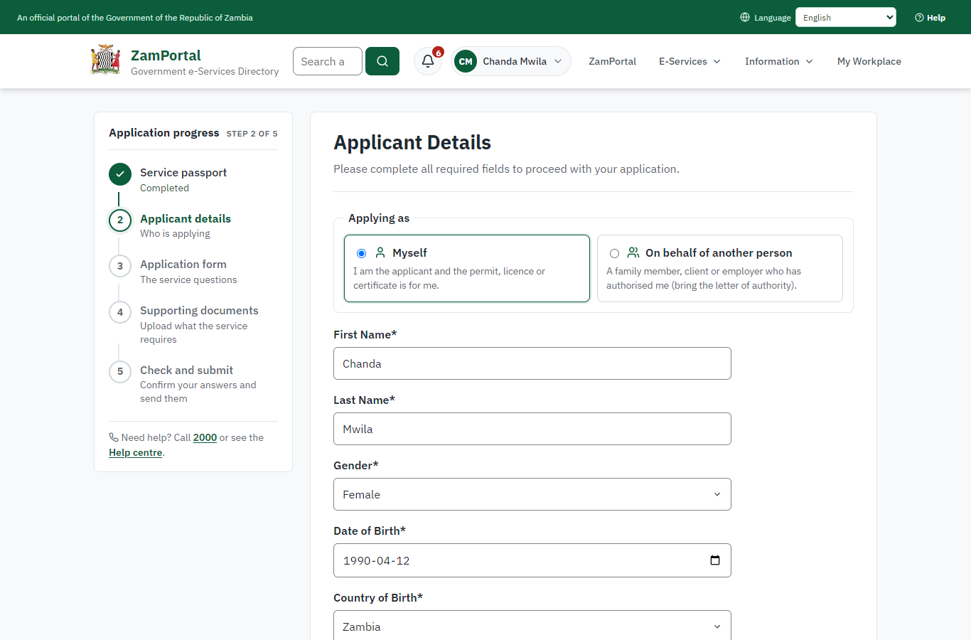 | 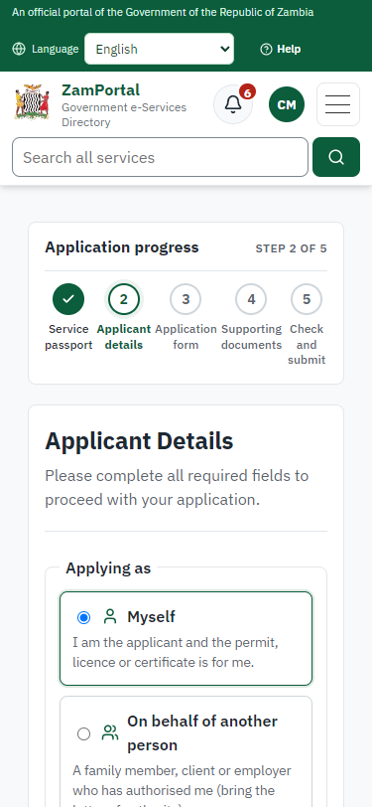
Step 3: Confirm the applicant details - desktop (left) and a 375 px phone (right).

Step 4. Fill in the application form
Citizen · National e-Services portal
The citizen answers the service's own application form, converted from the legacy system (12 answers in this run, all synthetic), for the type of application "New". Questions marked * must be answered; some appear only after an earlier answer. Answers are saved as the citizen types, so an unfinished application can be reopened from My Workplace.
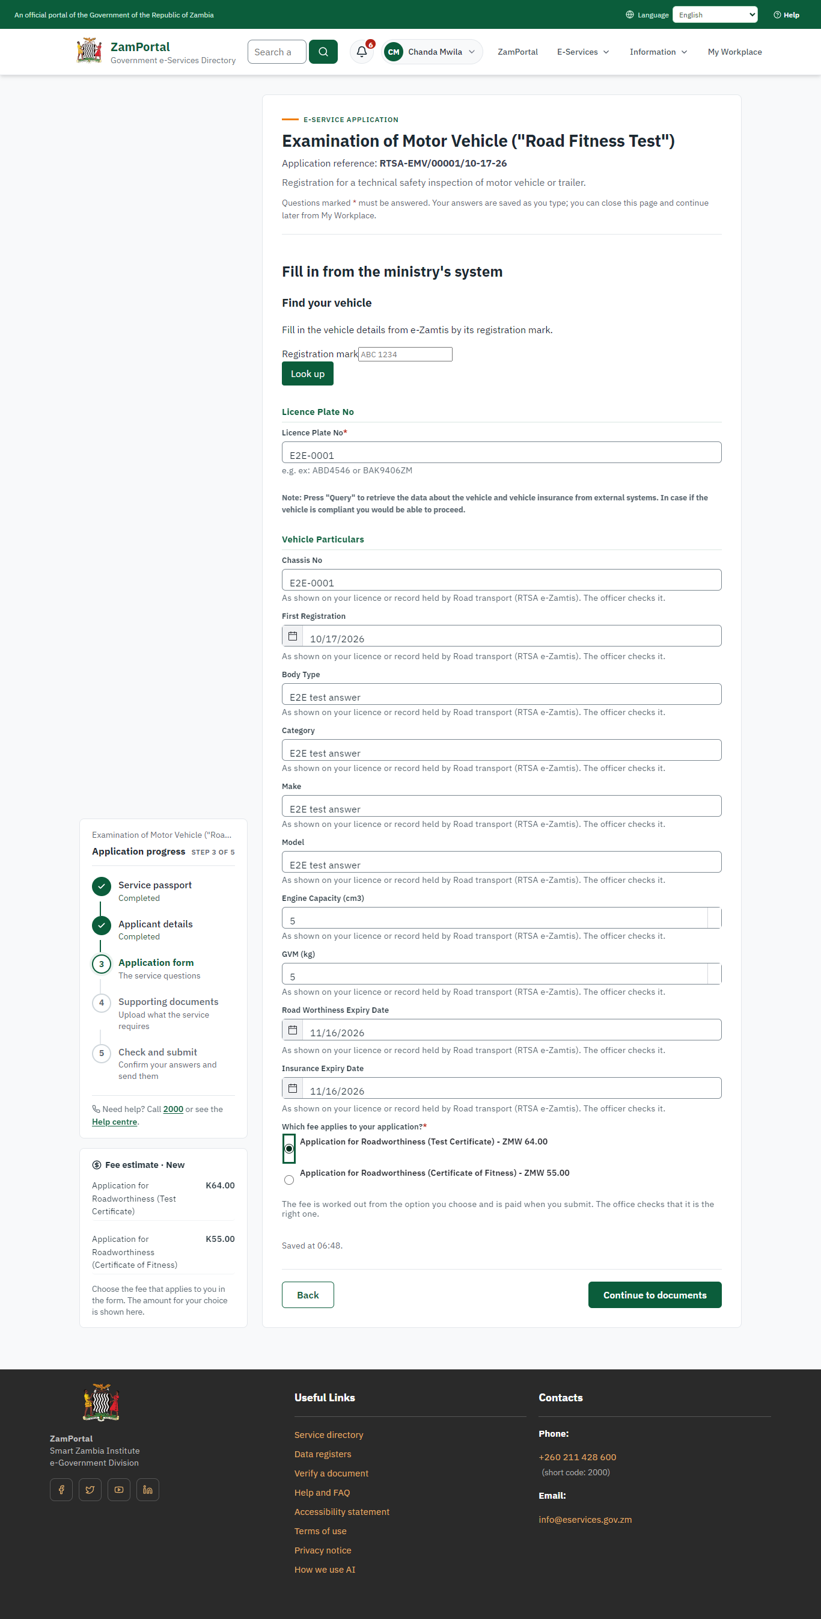 | 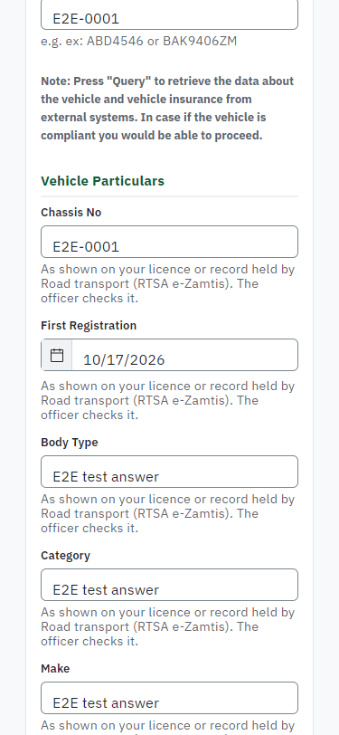
Step 4: Fill in the application form - desktop (left) and a 375 px phone (right).

Step 5. Upload the supporting documents
Citizen · National e-Services portal
The service asks for no supporting documents, so the citizen continues straight to the check of the answers.
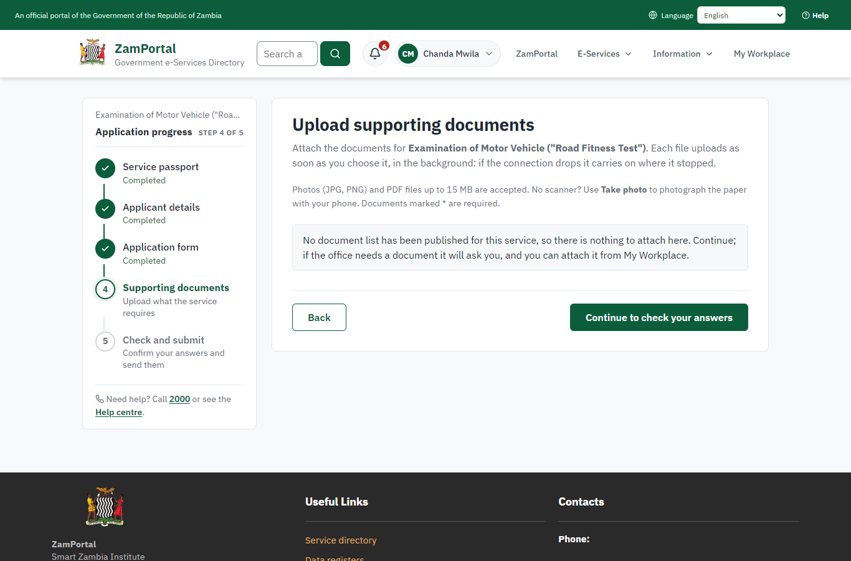 | 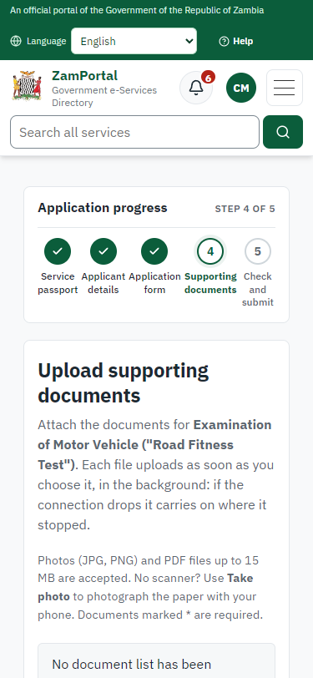
Step 5: Upload the supporting documents - desktop (left) and a 375 px phone (right).

Step 6. Check the answers and confirm the declaration
Citizen · National e-Services portal
Before sending, the citizen sees every answer and document on one page and can go back to change them. The declaration that the information is true and complete must be ticked.
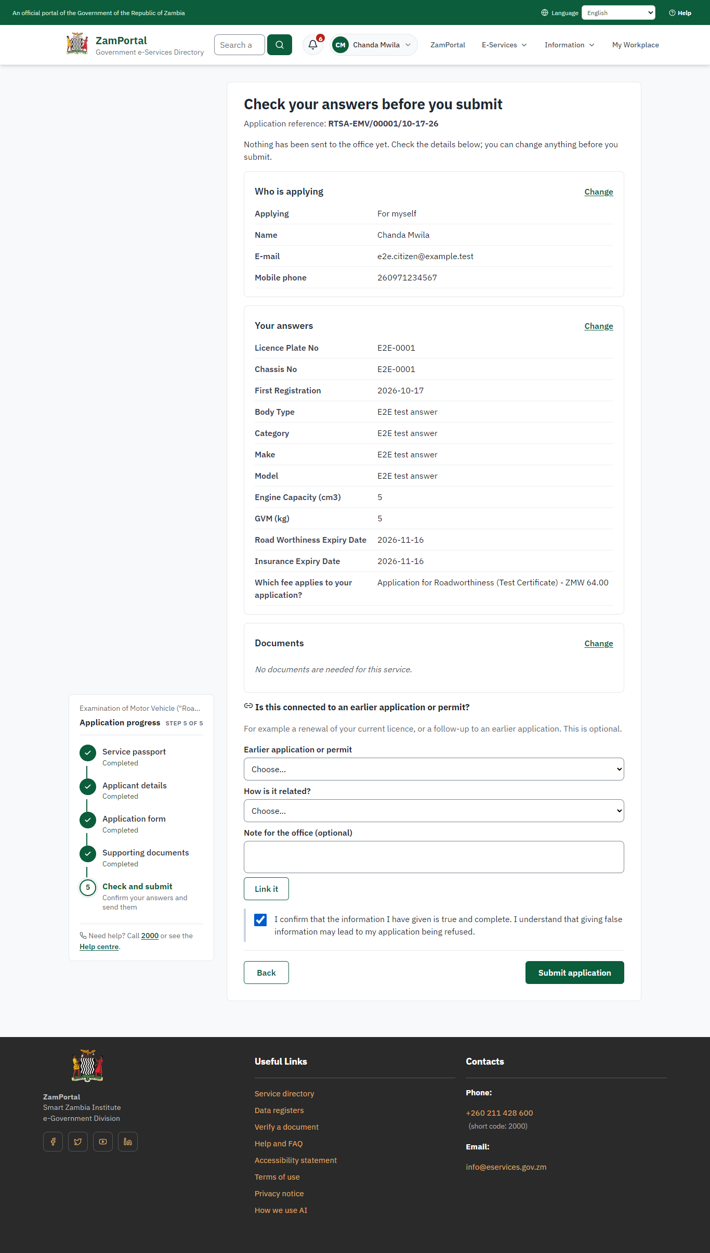 | 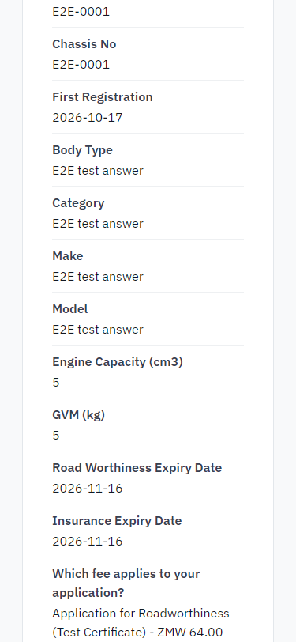
Step 6: Check the answers and confirm the declaration - desktop (left) and a 375 px phone (right).

Step 7. Application sent
Citizen · National e-Services portal
The portal confirms the application with the ministry's reference number (RTSA-EMV/00001/10-17-26 in this run). The fee is due now: it is taken with the application, so the invoice was raised when the application was sent.
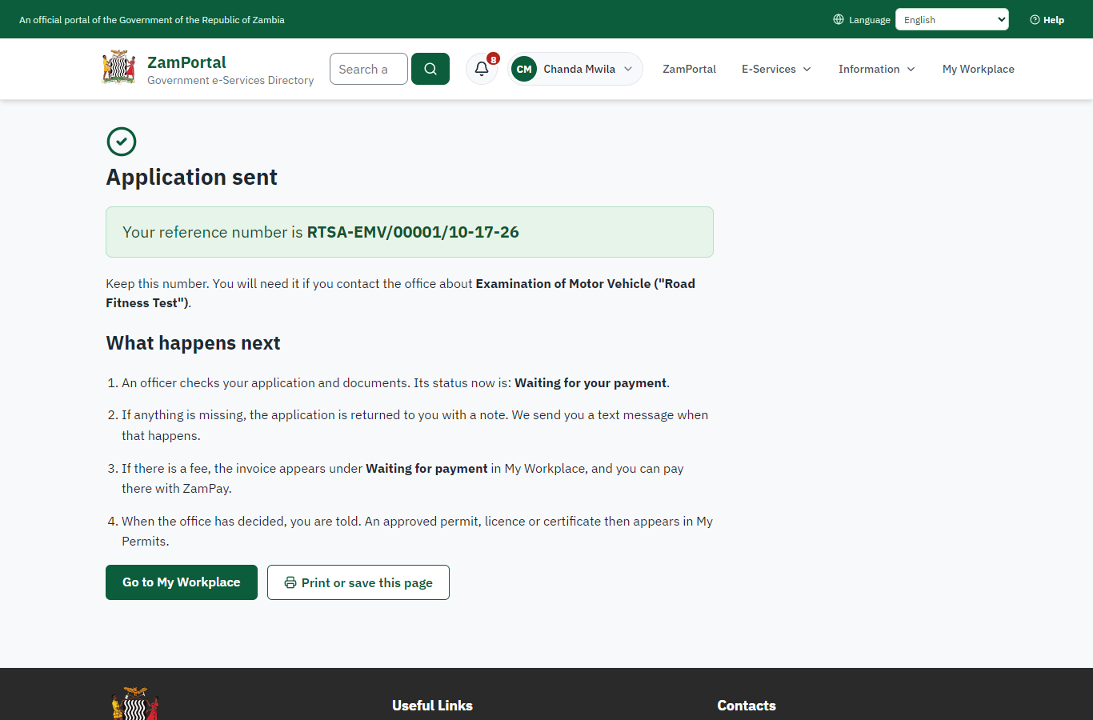 | 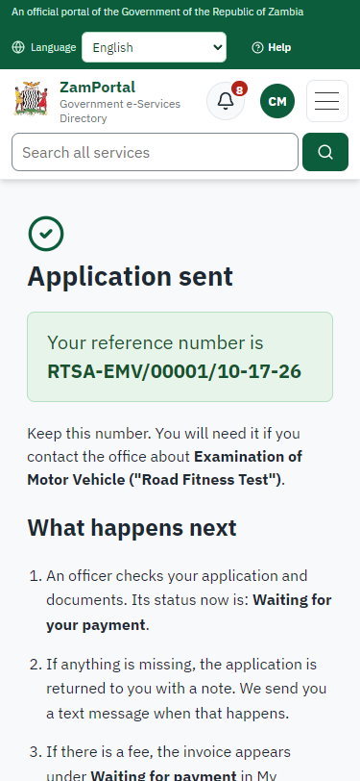
Step 7: Application sent - desktop (left) and a 375 px phone (right).

Step 8. See that the fee is due
Citizen · National e-Services portal
The application shows "Waiting for your payment" in My Workplace with a Pay button (K64.00). The fee is taken with the application; the invoice was raised on ZamPay.
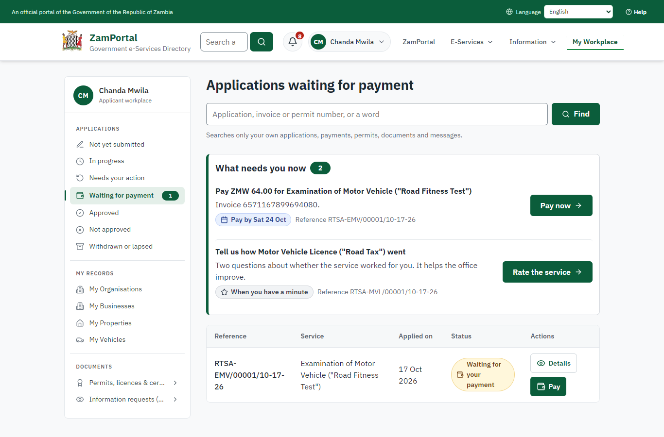 | 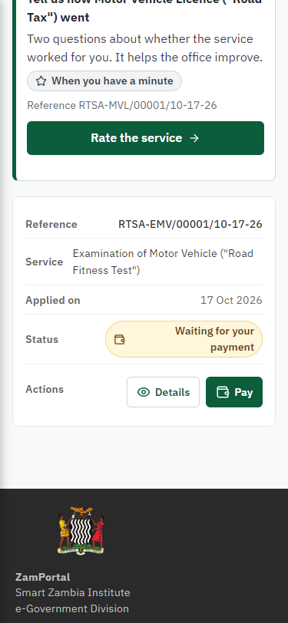
Step 8: See that the fee is due - desktop (left) and a 375 px phone (right).

Step 9. Pay with ZamPay
Citizen · National e-Services portal
Pay opens the invoice (K64.00, the amount set by the platform, never by the page) with its PDF preview; the citizen pays at ZamPay by mobile money or bank card.
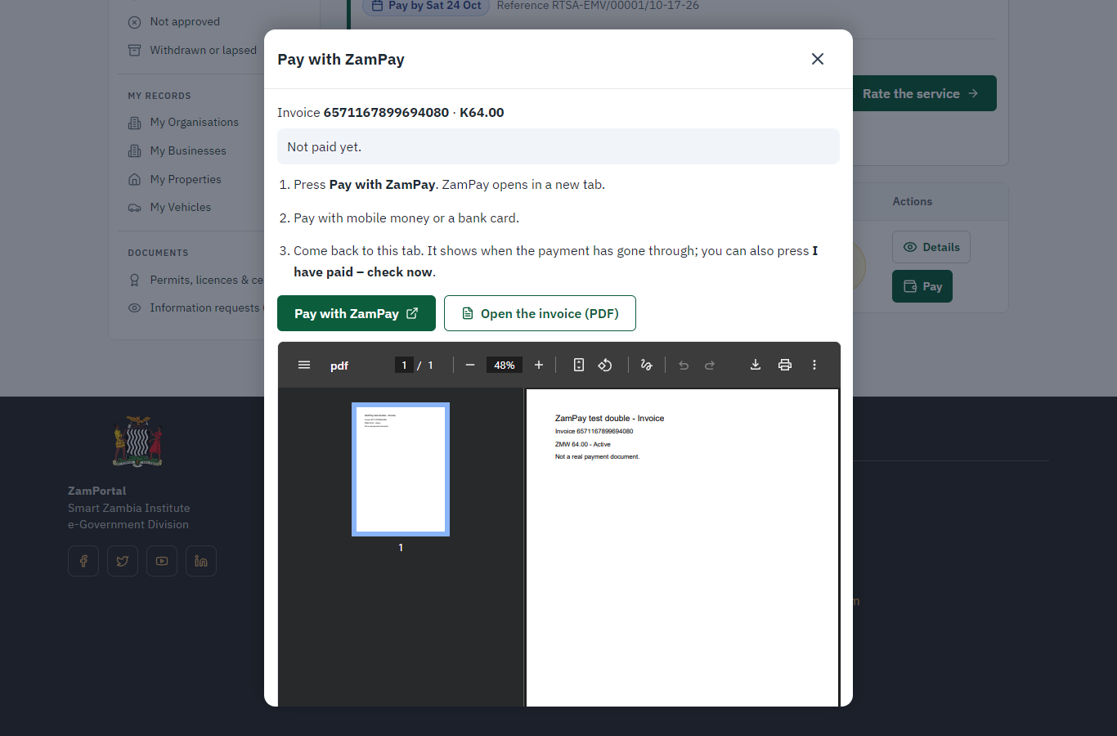 | 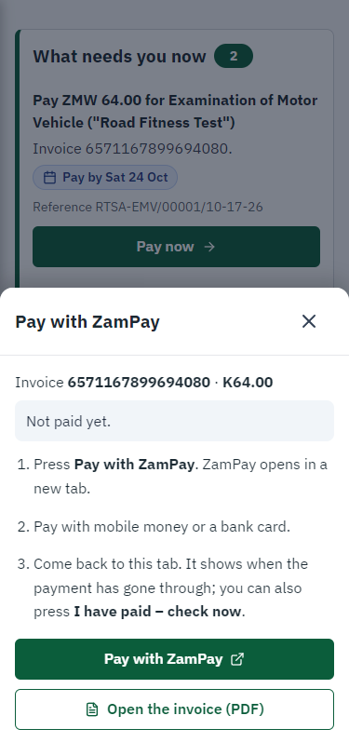
Step 9: Pay with ZamPay - desktop (left) and a 375 px phone (right).

Step 10. Payment received
Citizen · National e-Services portal
ZamPay reports the payment; the dialog says "Paid. Thank you" and the application moves on to the ministry's officers.
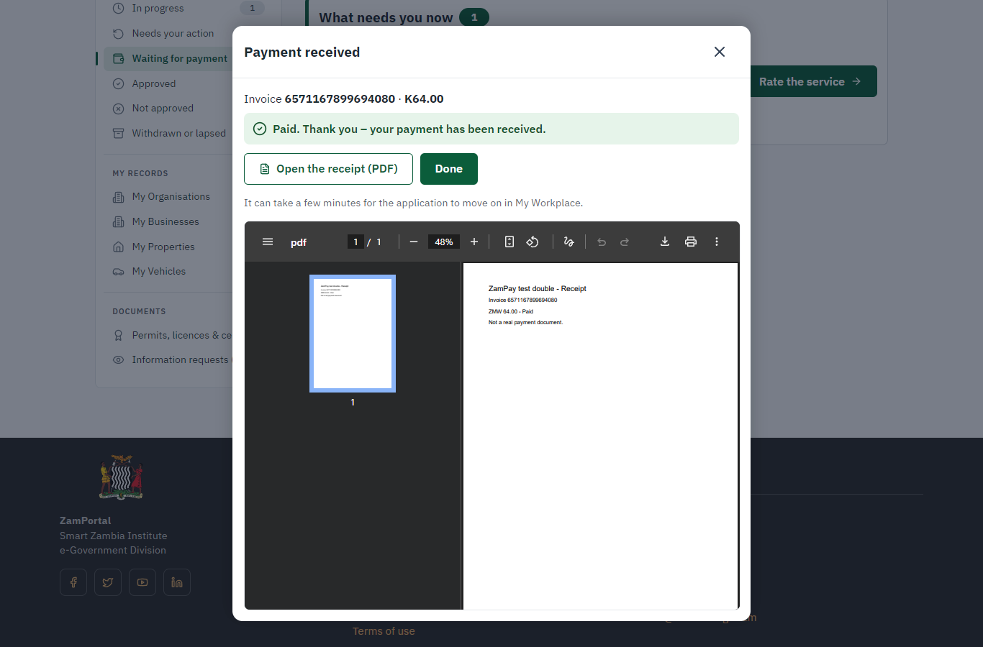 | 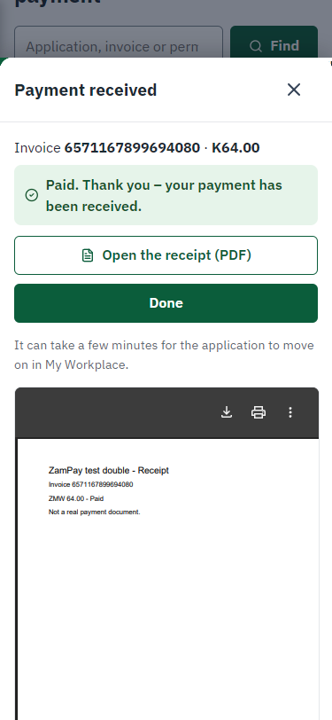
Step 10: Payment received - desktop (left) and a 375 px phone (right).

Step 11. Take the new application on
Case Officer · Back office
The application arrives in the case queue of the ministry that owns the service (Road Transport and Safety Agency); only its staff see it. The officer opens it by its reference number - answers, documents and process are on the case - assigns it to themself and takes it on.
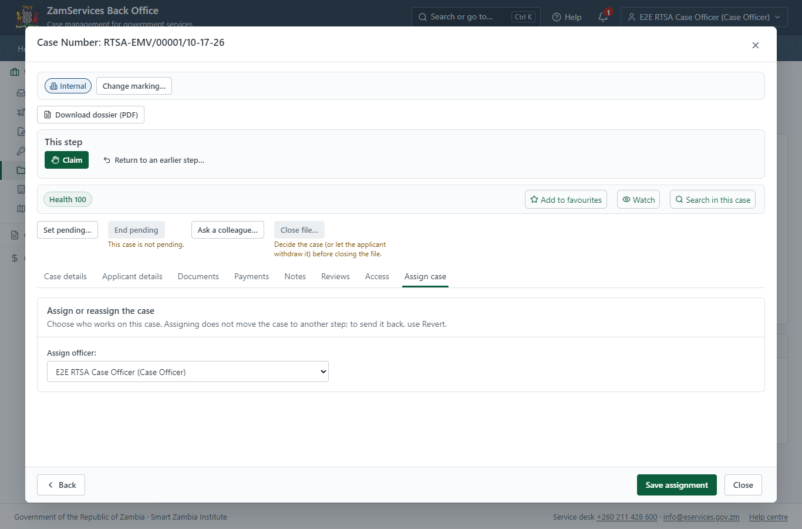
Step 11: Take the new application on.

Step 12. Fill in the certificate particulars
Case Officer · Back office
The issued document prints 5 fields that come from the office rather than from the application (Main color, Model number, Engine number, Examination Id, Reinspection Date). The officer fills them in on the case's "Certificate particulars" tab before the document is issued (synthetic values in this run) and saves; once the document is issued they can no longer change.
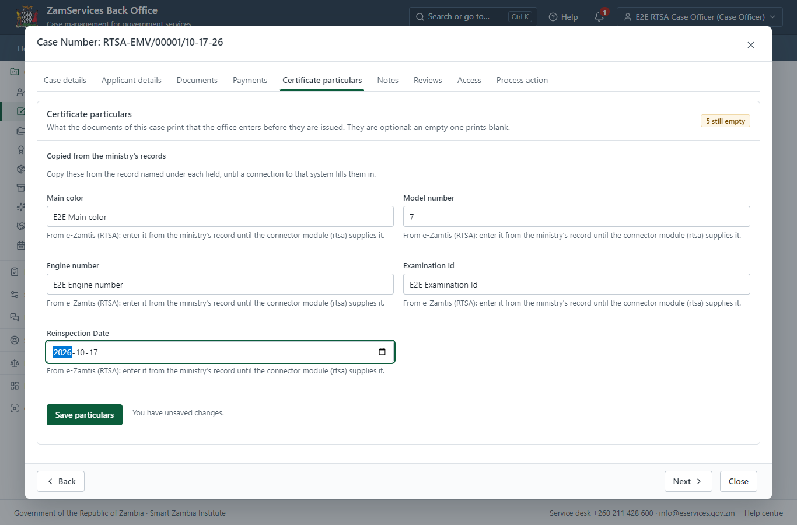
Step 12: Fill in the certificate particulars.

Step 13. Enter the certificate particulars
Case Officer · Back office
The Case Officer works on "Enter the certificate particulars" (review in the imported process), checks the application and its documents, and completes the step.
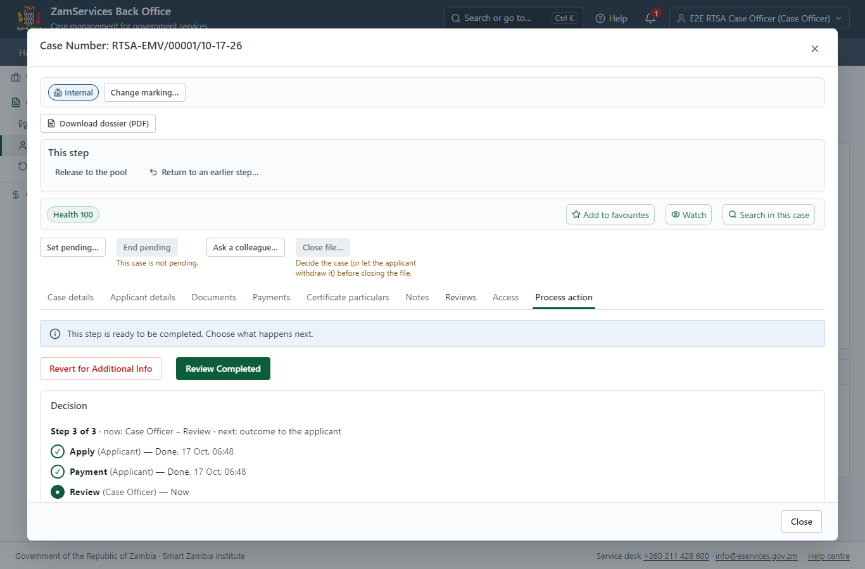
Step 13: Enter the certificate particulars.

Step 14. Issue the document
Case Officer · Back office
The service's validity ("• Personal motor vehicles or trailers – 12 months • Public Service Vehicles (PSV), Cargo - 12 months • Public Service Vehicles (PSV), Passengers (long-term licence) - 4 months • Public Service Vehicles (PSV), Passengers (short-term licence) - 3 months") is not a fixed period, so completing the case does not issue the document by itself: the officer issues it from the completed case ("Issue / check permit"). It is generated from the service's output configuration and sealed.
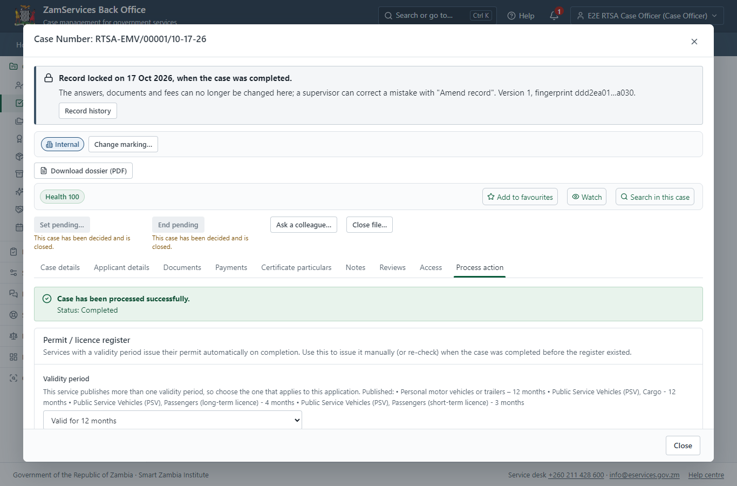
Step 14: Issue the document.

Step 15. The document in My permits
Citizen · National e-Services portal
The issued document (RTSA-EMVRF-2026-00001 in this run: "Examination of Motor Vehicle ("Road Fitness Test")") is listed in "My permits and licences" with its validity and a download of the sealed PDF.
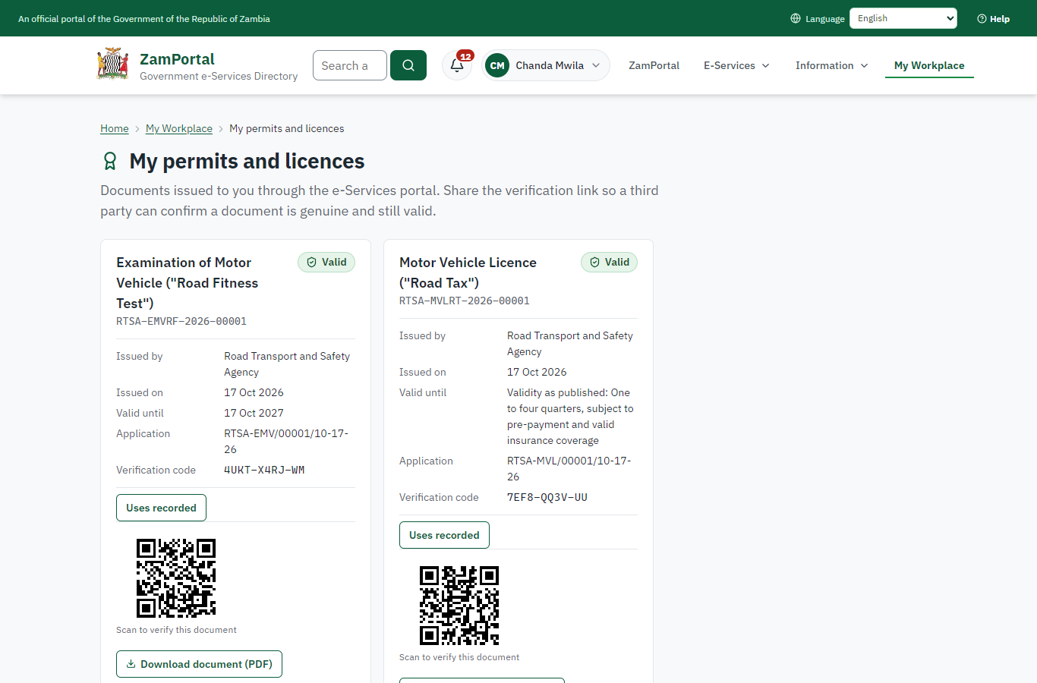 | 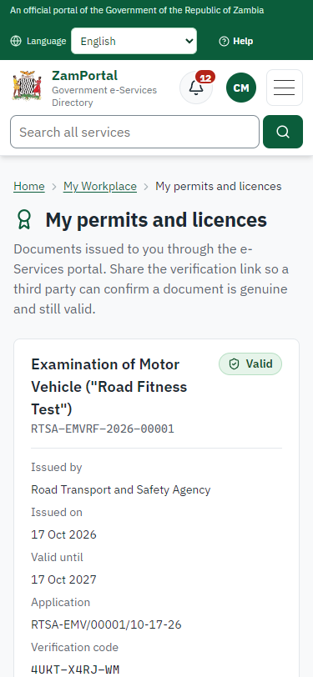
Step 15: The document in My permits - desktop (left) and a 375 px phone (right).

Step 16. Verify the document
Anyone (public) · Public verification page
The QR code on the document opens the public verification page: genuine and current, to whom it was issued, and whether the electronic seal is valid. No sign-in is needed.
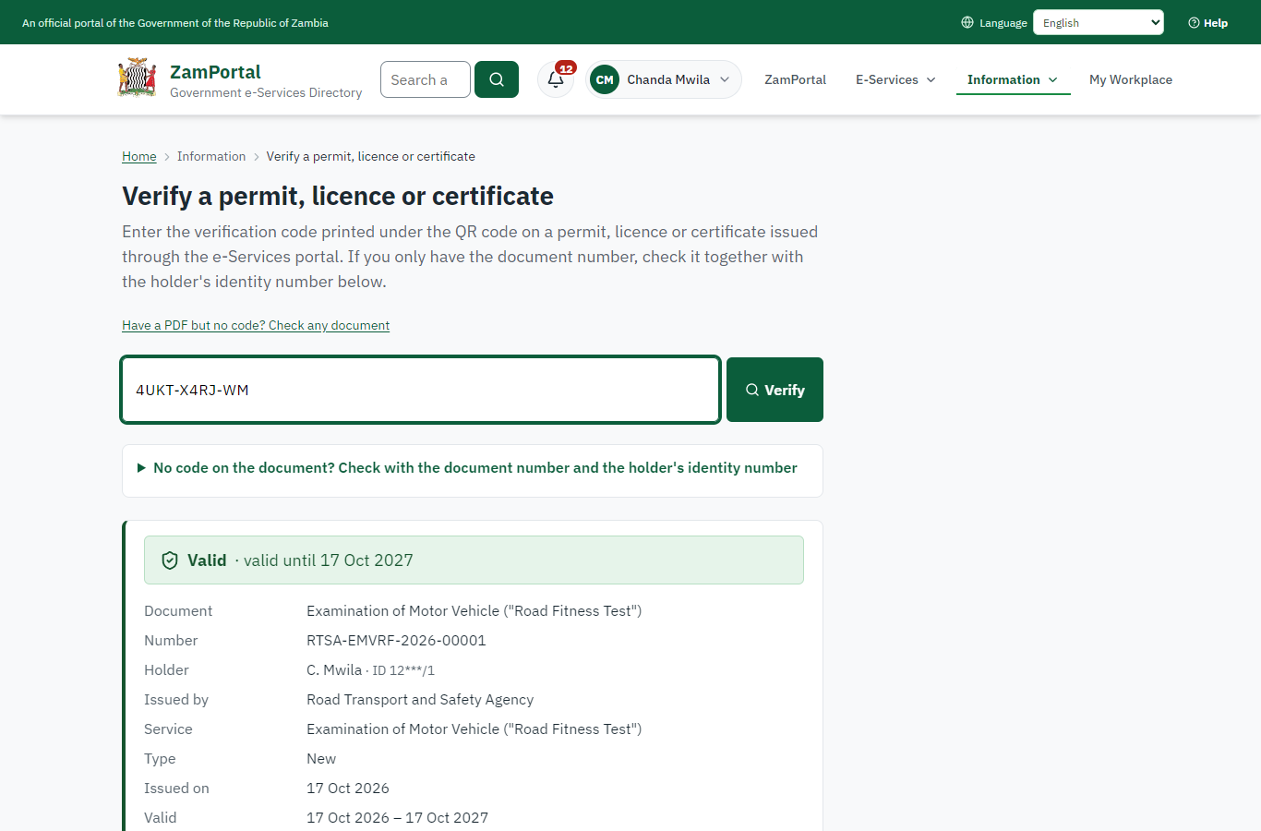 | 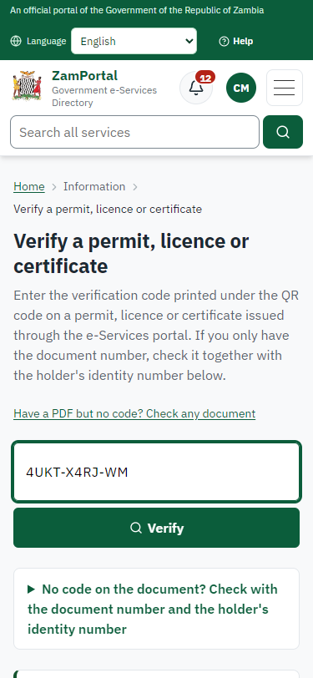
Step 16: Verify the document - desktop (left) and a 375 px phone (right).

3. Payment
Item | In the test run
Fee (as published) | Examination of Motor Vehicle Fee - ZMW 64
Invoice 1 | 6571167899694080
Amount 1 | ZMW 64.00
Paid at 1 | with the application
On screen: step 8 (See that the fee is due), step 9 (Pay with ZamPay), step 10 (Payment received) in section 2.

4. Output documents

Examination of Motor Vehicle ("Road Fitness Test") (sealed PDF)
Issued when the case was approved, from the service's output configuration (service template RTSA_ExaminationOfMotorVehicle.Certificate.), filled from the application and the decision, sealed with the platform's electronic seal and stored as the issued version. The holder downloads it from My permits; the verification page checks it.
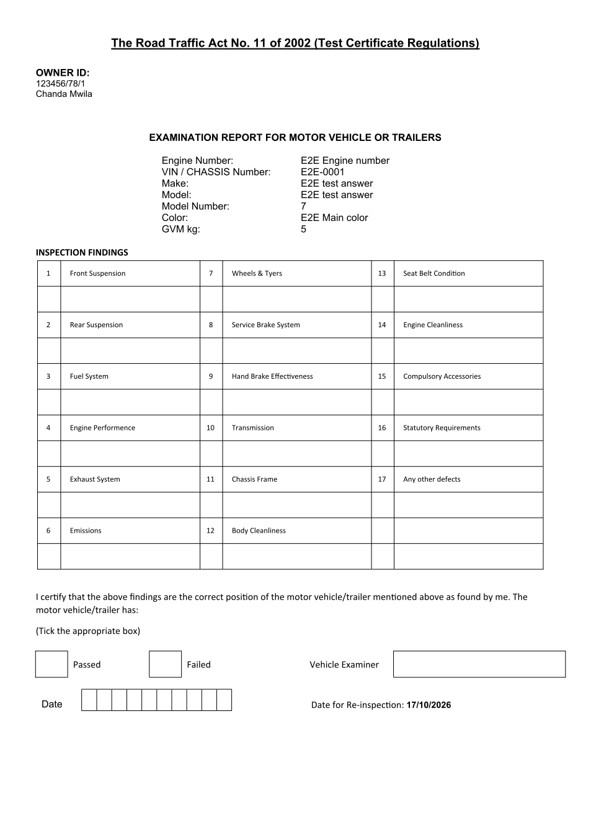
Examination of Motor Vehicle ("Road Fitness Test") (sealed PDF) - first of 2 pages, as issued in the test run.

Fields
Field | Value in the test run
Document title | Examination of Motor Vehicle ("Road Fitness Test")
Permit / licence number | RTSA-EMVRF-2026-00001
Holder | Chanda Mwila
Valid from | 2026-10-17
Valid until | 2027-10-17
Status | active
Verification code (printed with a QR code) | 4UKT-X4RJ-WM

Seal
Seal status | sealed
Signature level | PAdES-B-T
Sealed by | the platform seal (development key in the test run)
Signed at | 2026-10-17T04:49:03.796Z
Trusted time-stamp | 2026-10-17T04:49:03.780Z (time-stamping authority)
Document fingerprint (SHA-256) | 6d707831ebee8db3...

Verification
Where | The public verification page of the national portal, <portal>/verify/<verification code>, opened by scanning the QR code on the document.
What it shows | Whether the document is genuine and current, its holder and validity, and whether the electronic seal is valid and who sealed it.
Checking a copy | Anyone can upload a PDF they were given; the page says whether it is exactly the document that was issued. A changed copy is reported as not matching.
On screen: step 14 (Issue the document), step 15 (The document in My permits), step 16 (Verify the document) in section 2.

5. Notifications
When | Channel | To | Message | Delivery
Payment due (invoice raised) | in-app (portal bell) | the applicant | Payment due for application RTSA-EMV/00001/10-17-26 - The fee of ZMW 64.00 for Examination of Motor Vehicle ("Road Fitness Test") (RTSA-EMV/00001/10-17-26) is now due. Invoice 6571167899694080. | shown
Application received | in-app (portal bell) | the applicant | Application RTSA-EMV/00001/10-17-26 received - Your application RTSA-EMV/00001/10-17-26 for Examination of Motor Vehicle ("Road Fitness Test") has been received by Road Transport and Safety Agency. | shown
Payment received | in-app (portal bell) | the applicant | Payment received for RTSA-EMV/00001/10-17-26 - Your payment of ZMW 64.00 for RTSA-EMV/00001/10-17-26 (Examination of Motor Vehicle ("Road Fitness Test")) has been received. Receipt: <ZamPay>/pdf?documentType=receipt&invoiceNumber=6571167899694080 | shown
Decision: approved | in-app (portal bell) | the applicant | Application RTSA-EMV/00001/10-17-26 completed - RTSA-EMV/00001/10-17-26 (Examination of Motor Vehicle ("Road Fitness Test")) is complete. Your documents are ready. | shown
Invitation to rate the service | in-app (portal bell) | the applicant | How was Examination of Motor Vehicle ("Road Fitness Test")? - How was Examination of Motor Vehicle ("Road Fitness Test")? Tell us in about a minute. | shown
Licence / permit issued | in-app (portal bell) | the applicant | Your Examination of Motor Vehicle ("Road Fitness Test") document has been issued - RTSA-EMVRF-2026-00001 has been issued for Examination of Motor Vehicle ("Road Fitness Test") and is valid until 17/10/2027. | shown
Payment due (invoice raised) | email | e2e.c***@example.test | Payment due for application RTSA-EMV/00001/10-17-26 | skipped
Payment due (invoice raised) | sms | +260 97* *** 567 | Fee of ZMW 64.00 due for RTSA-EMV/00001/10-17-26. Invoice 6571167899694080. Pay: <ZamPay>/pay-for-service/get-invoice/6571167899694080 | delivered
Application received | sms | +260 97* *** 567 | Application RTSA-EMV/00001/10-17-26 for Examination of Motor Vehicle ("Road Fitness Test") has been received. Track it: <portal>/my-workplace | delivered
Application received | email | e2e.c***@example.test | Application RTSA-EMV/00001/10-17-26 received | skipped
Payment received | sms | +260 97* *** 567 |  | delivered
Invitation to rate the service | sms | +260 97* *** 567 |  | skipped
Invitation to rate the service | email | e2e.c***@example.test | How was Examination of Motor Vehicle ("Road Fitness Test")? | skipped
Decision: approved | email | e2e.c***@example.test | Application RTSA-EMV/00001/10-17-26 completed | skipped
Decision: approved | sms | +260 97* *** 567 |  | delivered
Licence / permit issued | email | e2e.c***@example.test | Your Examination of Motor Vehicle ("Road Fitness Test") document has been issued | skipped
Licence / permit issued | sms | +260 97* *** 567 |  | delivered
Delivery: shown = in the portal's notification bell; delivered = the SMS gateway (a test double in this run) reported the text delivered; skipped = not sent on that channel (e-mail is not configured on the test installation, and some notices go out on one channel only); sent by the national portal = a ministry node handed the notice to the national portal, which texts and e-mails the citizen under its own name and the citizen's preferences. Addresses written <portal>, <ZamPay> stand for the national portal and ZamPay.

6. Legacy mapping
Replaces | Examination of Motor Vehicle ("Road Fitness Test") in the legacy ZIGS e-Services directory (ZIGS_Services)
Legacy service id | 9
Legacy provider | Road Transport and Safety Agency (RTSA) under Ministry of Transport and Logistics
Legacy process | not recorded
Fee in the legacy system | Application for Roadworthiness (Test Certificate): ZMW 64 (New)  Application for Roadworthiness (Certificate of Fitness): ZMW 55 (New)
Fee taken before submission | yes (as in ZIGS)
Time to issue (legacy) | New: 1 calendar day
Legacy output templates | Examination of Motor Vehicle ("Road Fitness Test"): ZIGS_Forms_RTSA / RTSA_ExaminationOfMotorVehicle.Certificate  GS-1 Application for a Government Service: ZIGS_Forms_ZDA / GS1  GS-2 Notice of Government Action: ZIGS_Forms_Notices / GS-2.NoticeOfAction  GF-1 Treasury Invoice: ZIGS_CustomForms / GF-1 Invoice  GF-2 Treasury Receipt: ZIGS_CustomForms / GF-2 Receipt
Legacy address | none recorded
How it was brought over | Imported by the platform's legacy catalogue importer (zcm-backend scripts/zigs/importLegacy.js) from the ZIGS snapshot: form, case types, fees, documents, process and output templates, then served by the new platform.

7. Version and date
Document version | service v1, platform 9b8a591f
Generated | 2026-10-17T04:49:08Z (by the end-to-end run, not edited by hand)
Service version | not versioned (configured directly)
Platform snapshot | backend 9b8a591f  portal dfd4933  back office a975a2c
Test suite | e2e 2b037bb; one installation (combined); seed profile mihud
Journeys | 30-catalogue-service.spec.js: citizen finds the service, answers its form, uploads its documents and sends the application - passed  30-catalogue-service.spec.js: the case goes through every step of its process: payments by the citizen, each officer step by its role - passed  30-catalogue-service.spec.js: the grant document is issued, sealed, filled in and verifiable; the citizen has it in My permits - passed
Result | 3 of 3 journey tests passed
Data | Synthetic test data on a local test installation; provider test doubles for ZamPass, ZamPay, SMS and signing.

