Republic of Zambia
GSB e-Services

Driving Test
Service documentation
Owner: Road Transport and Safety Agency
Service key: RTSA/driving-test
Version: service v1, platform 9b8a591f
Date: 2026-10-17
Generated automatically by the service's end-to-end test run. Every screenshot shows synthetic test data on a local test installation, never real personal data.

Contents
- 1. Service summary
- 2. Application process, step by step
- 3. Payment
- 4. Output documents
- 5. Notifications
- 6. Legacy mapping
- 7. Version and date
This document describes the Driving Test service of Road Transport and Safety Agency as the platform runs it today. It is generated by the service's end-to-end test: every step was performed by the test and every screenshot was taken during that run, with synthetic data. Regenerate it with "npm run docs:services" in the e2e suite; do not edit it by hand.

1. Service summary
Service | Driving Test
Owner (MDA) | Road Transport and Safety Agency (RTSA)
Purpose | Service covers the process of obtaining a PSV / Driver’s Licence - official document, permitting a specific individual to operate one or more types of motorized vehicles.
Who can apply | Individual
How to apply | Online on the national e-Services portal, signed in with ZamPass; pay with ZamPay.
Fees | Driving Test Fee: ZMW 87.00
Turnaround | Upon successful completion, the PSV/Driver's Licence card is issued instantly
Validity of the output | PSV Licence - 3 years  Driver's Licence - 5 years
Required documents | Personal ID (required)  Provisional Driver's Licence (required)
Output documents | GS-2 Notice of Government Action  Notice of Approval  Application form (New)  Test Booking Information (New)  GF-1 Treasury Invoice  GF-2 Treasury Receipt
Legal basis | Road Traffic Act 11 of 2002 (https://www.rtsa.org.zm/wp-content/uploads/2019/09/The-Road-Traffic-Act-No-11-of-2002.pdf)  SI-41 of 2015 (http://www.parliament.gov.zm/acts-of-parliament)

2. Application process, step by step

The process as configured
Step | Role | Task | Type
1 | Applicant | Apply | form
2 | Applicant | Payment | payment
3 | System | Generate Document | generate-document
4 | System | Generate Document | generate-document
5 | System | Notify Client | notify

Step by step
Who takes part in this journey: Citizen. Citizen steps are shown on a desktop and on a 375 px phone; back-office steps on a desktop.

Step 1. Find the service
Citizen · National e-Services portal
On the national e-Services portal the citizen opens All Services and searches for the service by name ("Driving Test"). Each result names the service and the ministry that provides it.
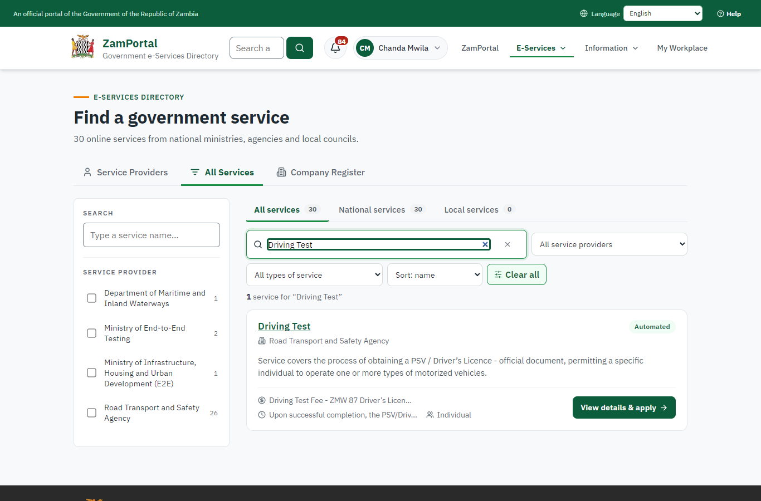 | 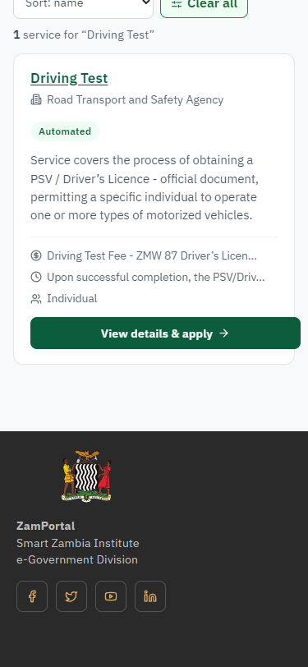
Step 1: Find the service - desktop (left) and a 375 px phone (right).

Step 2. Read the service page
Citizen · National e-Services portal
The service page sets out what the service is for, who provides it, the fee, how long it takes and the documents to have ready. "Start application" begins an application (the citizen is signed in with ZamPass).
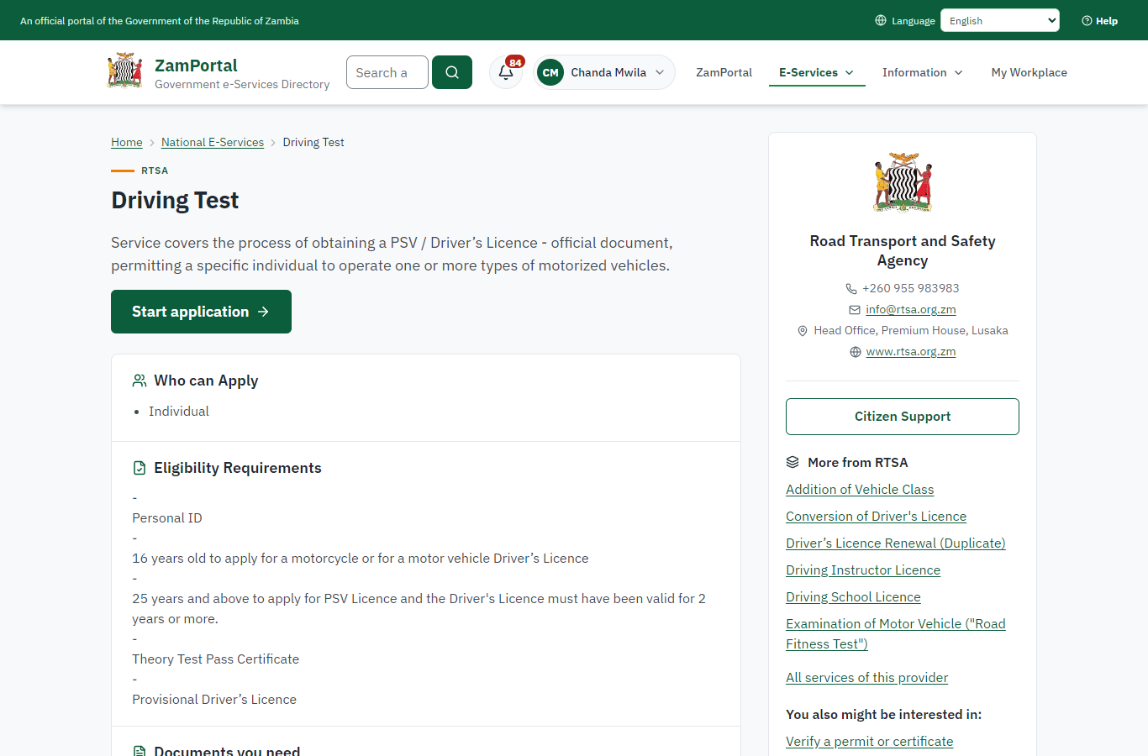 | 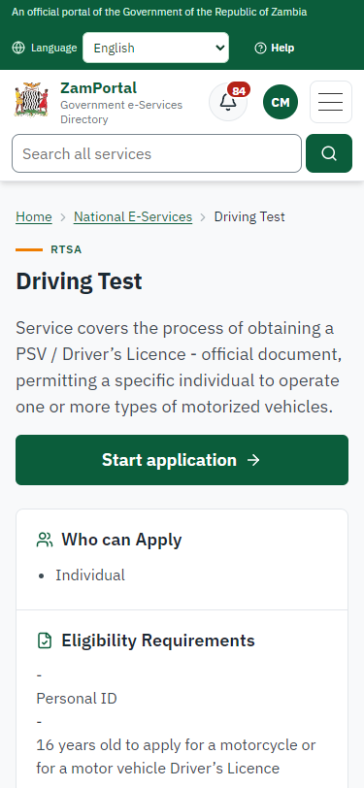
Step 2: Read the service page - desktop (left) and a 375 px phone (right).

Step 3. Confirm the applicant details
Citizen · National e-Services portal
The applicant details are filled in from the citizen's ZamPass account. The citizen says whom they are applying for (themself) and continues with "Proceed to Application".
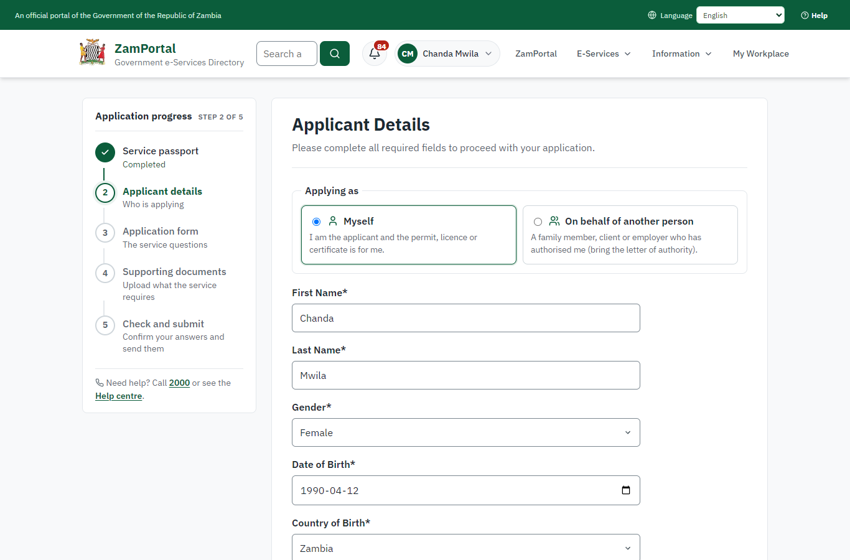 | 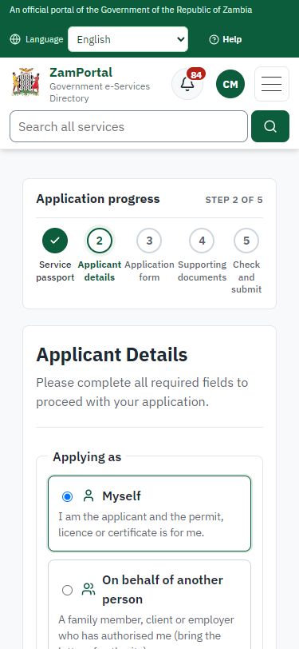
Step 3: Confirm the applicant details - desktop (left) and a 375 px phone (right).

Step 4. Fill in the application form
Citizen · National e-Services portal
The citizen answers the service's own application form, converted from the legacy system (8 answers in this run, all synthetic), for the type of application "New". Questions marked * must be answered; some appear only after an earlier answer. Answers are saved as the citizen types, so an unfinished application can be reopened from My Workplace.
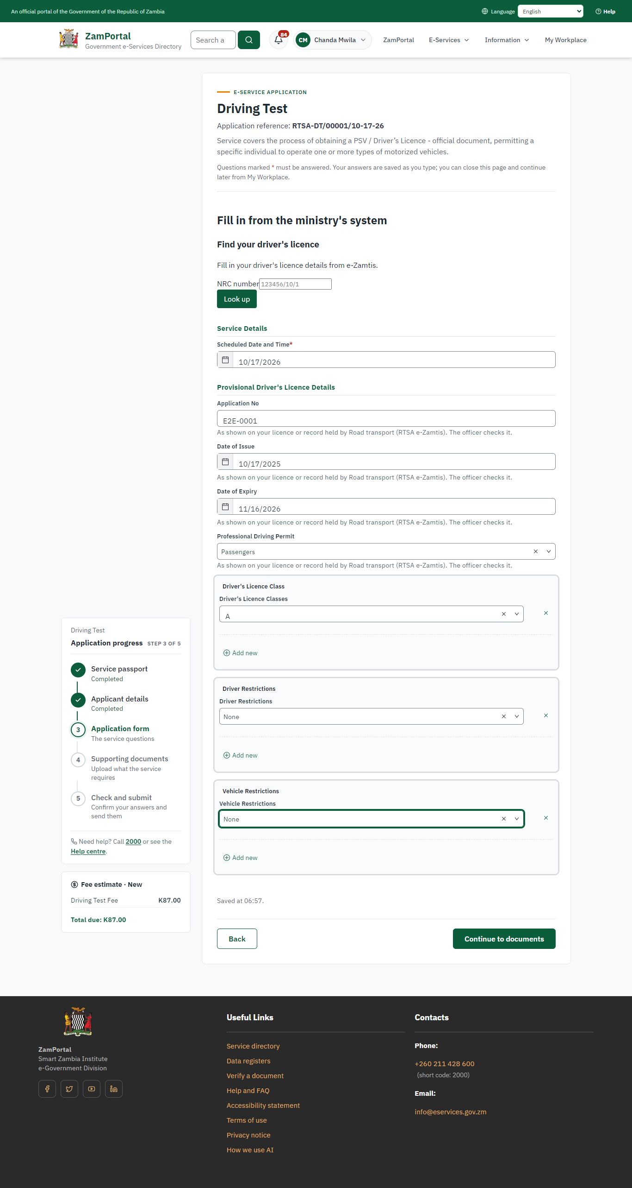 | 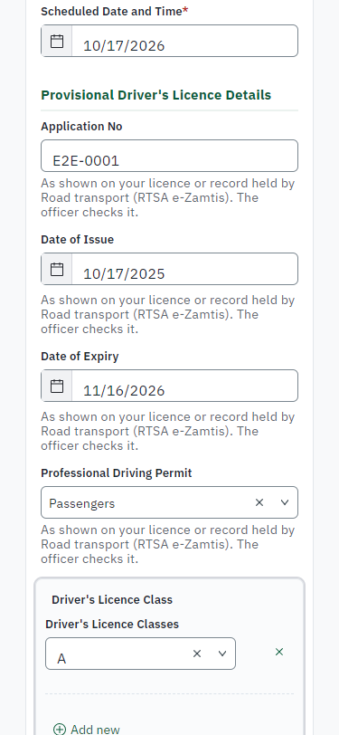
Step 4: Fill in the application form - desktop (left) and a 375 px phone (right).

Step 5. Upload the supporting documents
Citizen · National e-Services portal
Each document the service asks for has its own upload (2 in this run: Personal ID, Provisional Driver's Licence). The files are checked and stored with the application; the page confirms each upload.
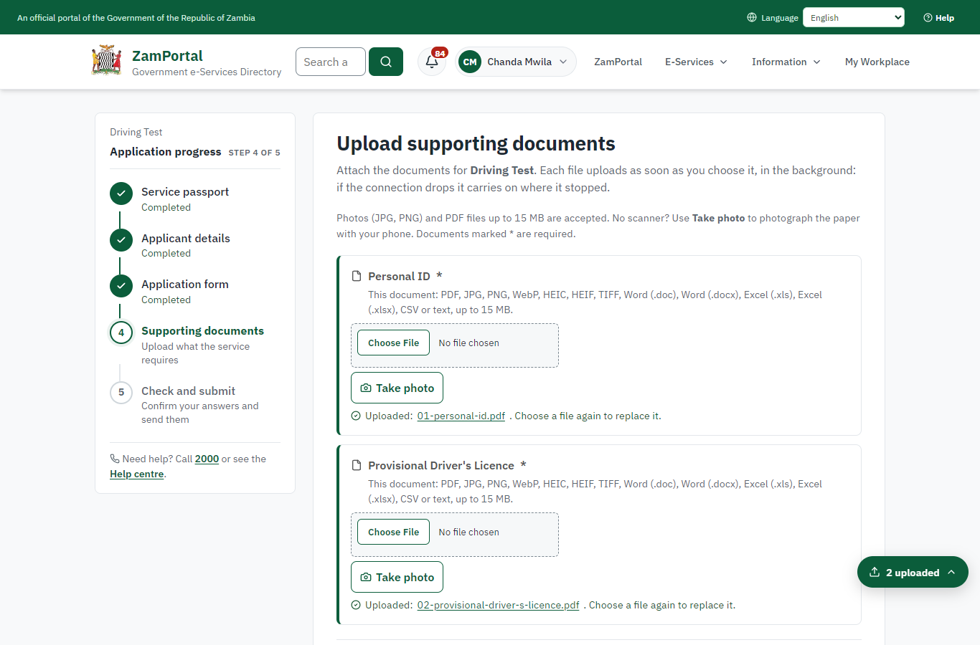 | 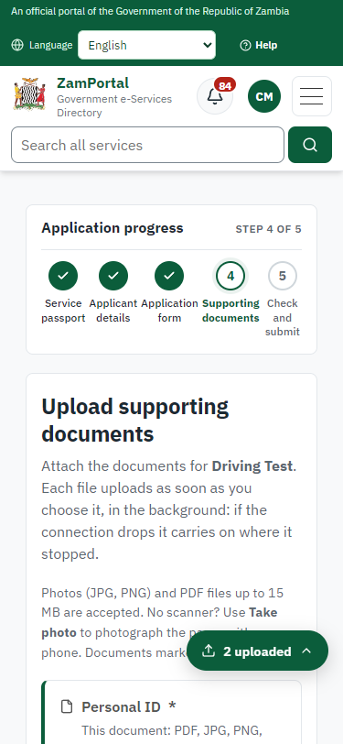
Step 5: Upload the supporting documents - desktop (left) and a 375 px phone (right).

Step 6. Check the answers and confirm the declaration
Citizen · National e-Services portal
Before sending, the citizen sees every answer and document on one page and can go back to change them. The declaration that the information is true and complete must be ticked.
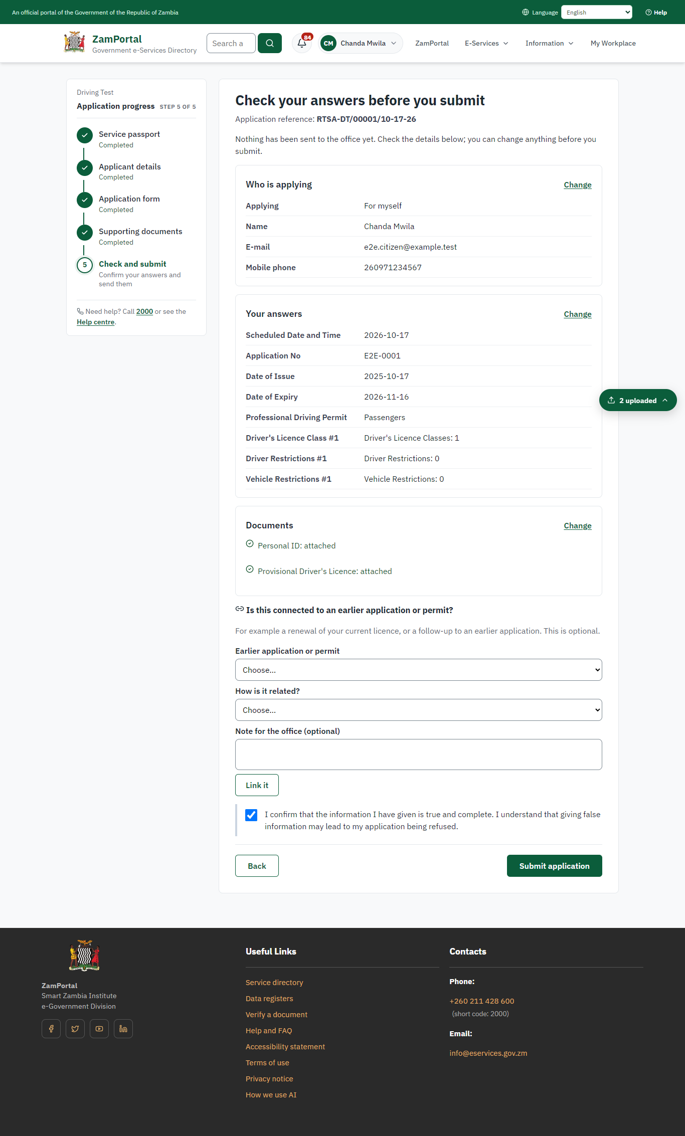 | 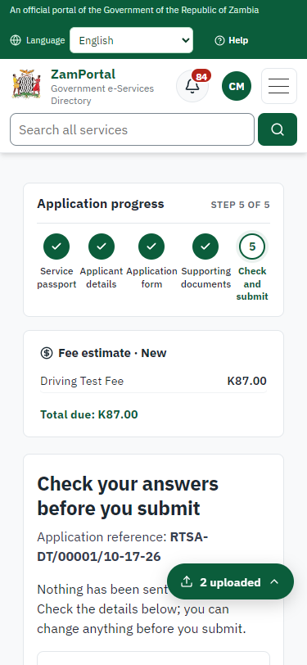
Step 6: Check the answers and confirm the declaration - desktop (left) and a 375 px phone (right).

Step 7. Application sent
Citizen · National e-Services portal
The portal confirms the application with the ministry's reference number (RTSA-DT/00001/10-17-26 in this run). The fee is due now: it is taken with the application, so the invoice was raised when the application was sent.
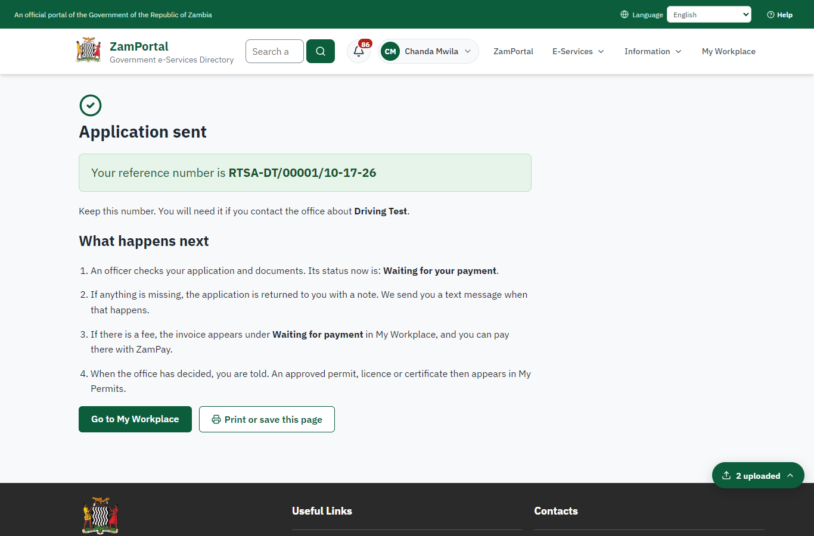 | 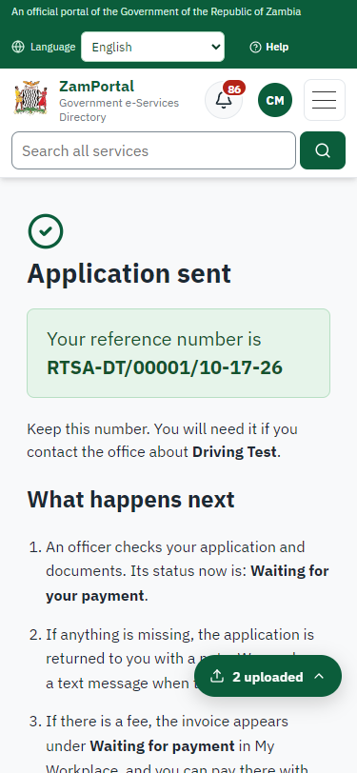
Step 7: Application sent - desktop (left) and a 375 px phone (right).

Step 8. See that the fee is due
Citizen · National e-Services portal
The application shows "Waiting for your payment" in My Workplace with a Pay button (K87.00). The fee is taken with the application; the invoice was raised on ZamPay.
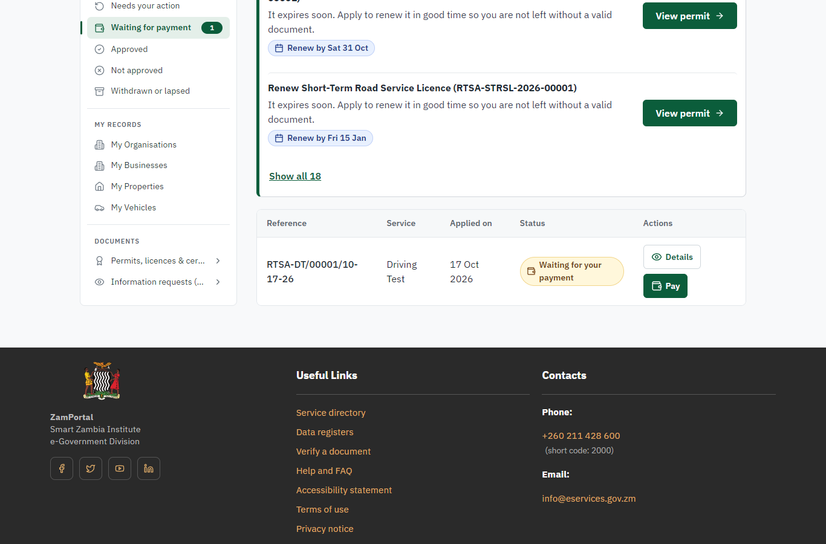 | 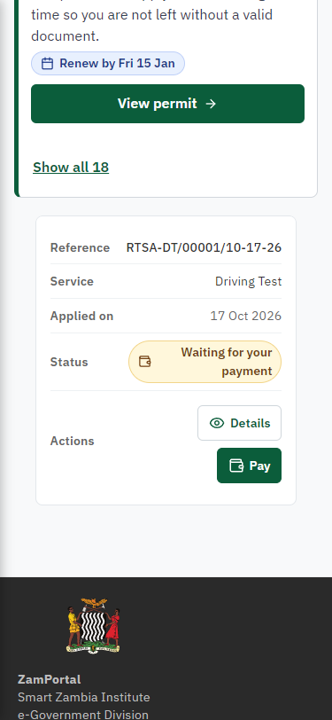
Step 8: See that the fee is due - desktop (left) and a 375 px phone (right).

Step 9. Pay with ZamPay
Citizen · National e-Services portal
Pay opens the invoice (K87.00, the amount set by the platform, never by the page) with its PDF preview; the citizen pays at ZamPay by mobile money or bank card.
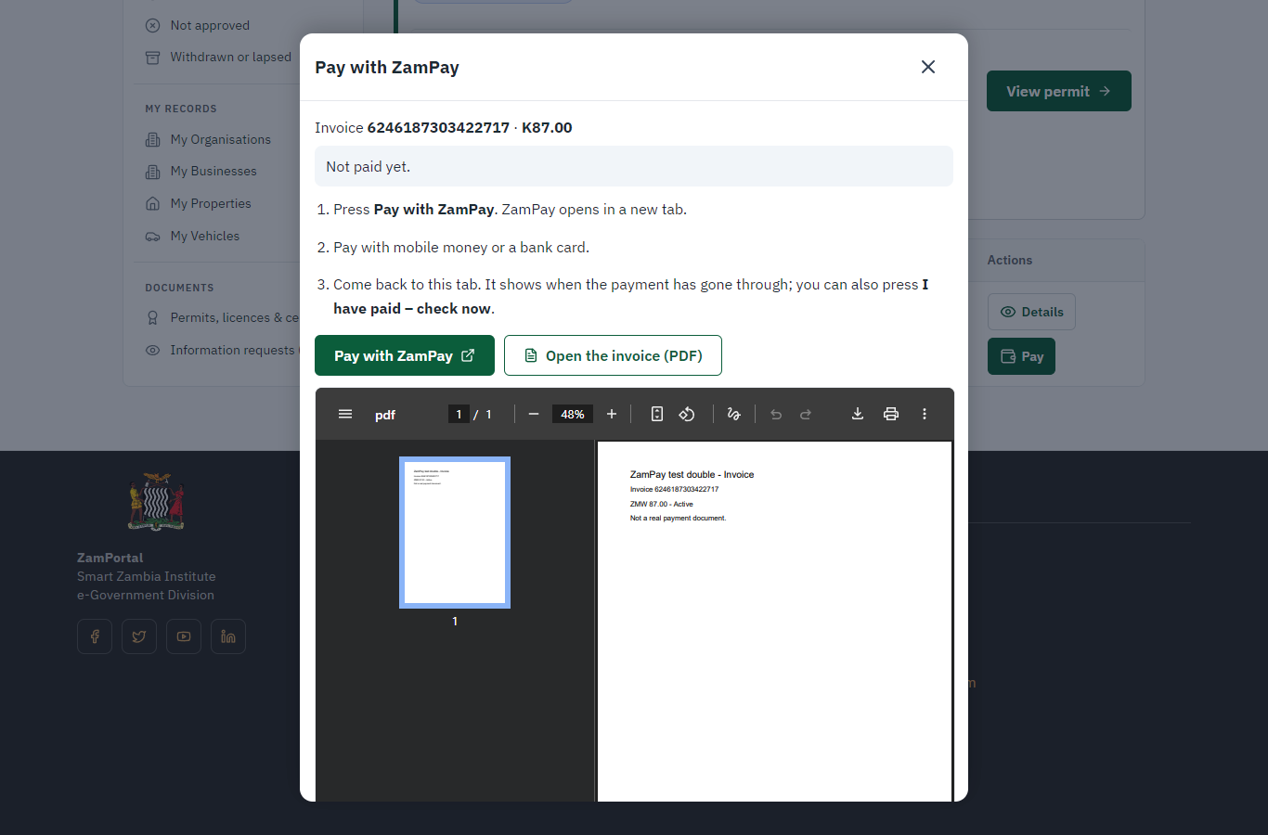 | 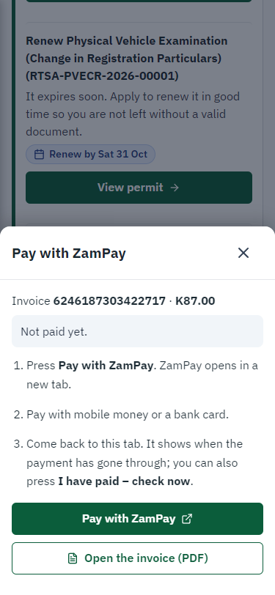
Step 9: Pay with ZamPay - desktop (left) and a 375 px phone (right).

Step 10. Payment received
Citizen · National e-Services portal
ZamPay reports the payment; the dialog says "Paid. Thank you" and the application moves on to the ministry's officers.
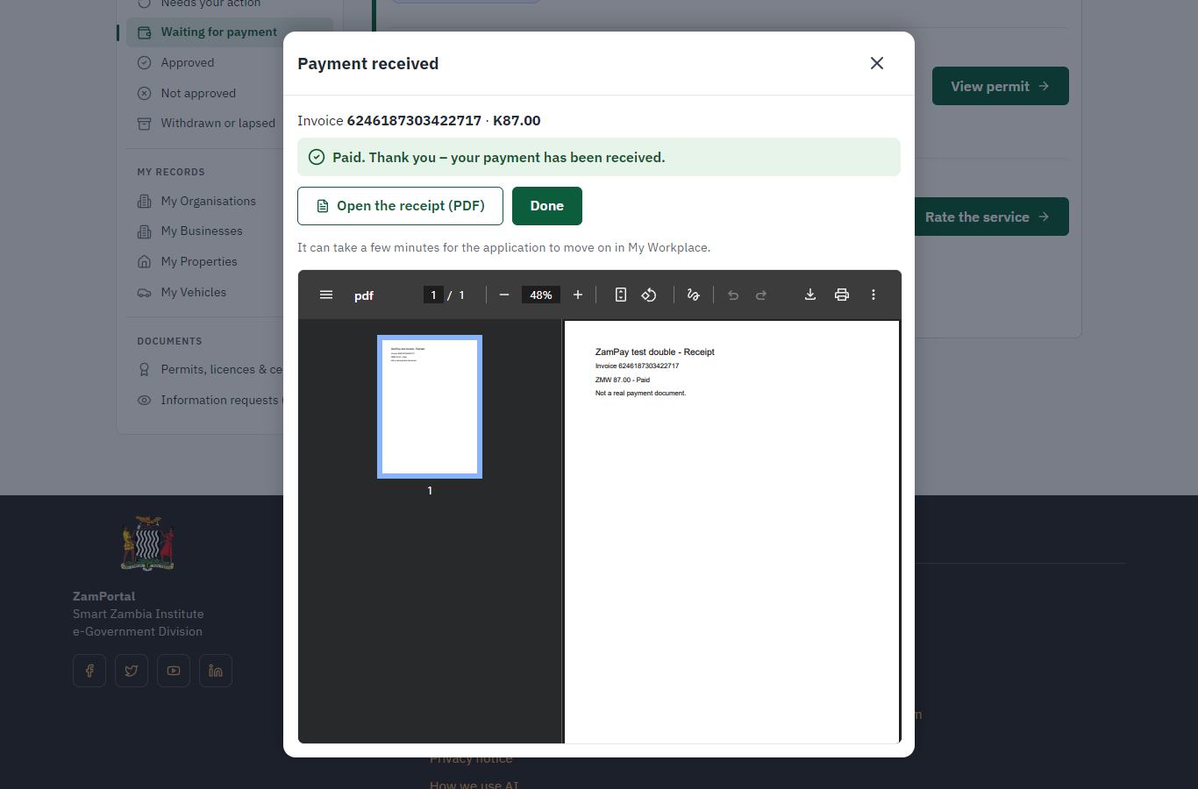 | 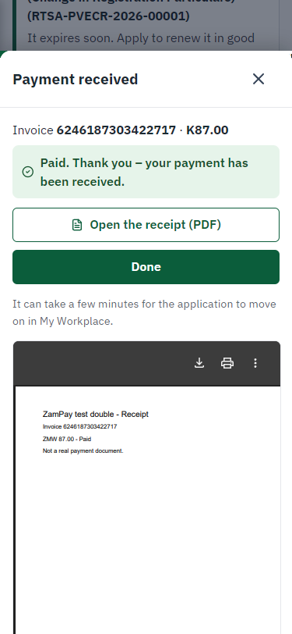
Step 10: Payment received - desktop (left) and a 375 px phone (right).

3. Payment
On screen: step 8 (See that the fee is due), step 9 (Pay with ZamPay), step 10 (Payment received) in section 2.

4. Output documents

GS-2 Notice of Government Action (PDF)
The service grants no certificate, licence or permit: when the case is completed the applicant downloads this notice of the government action from the application in My Workplace.
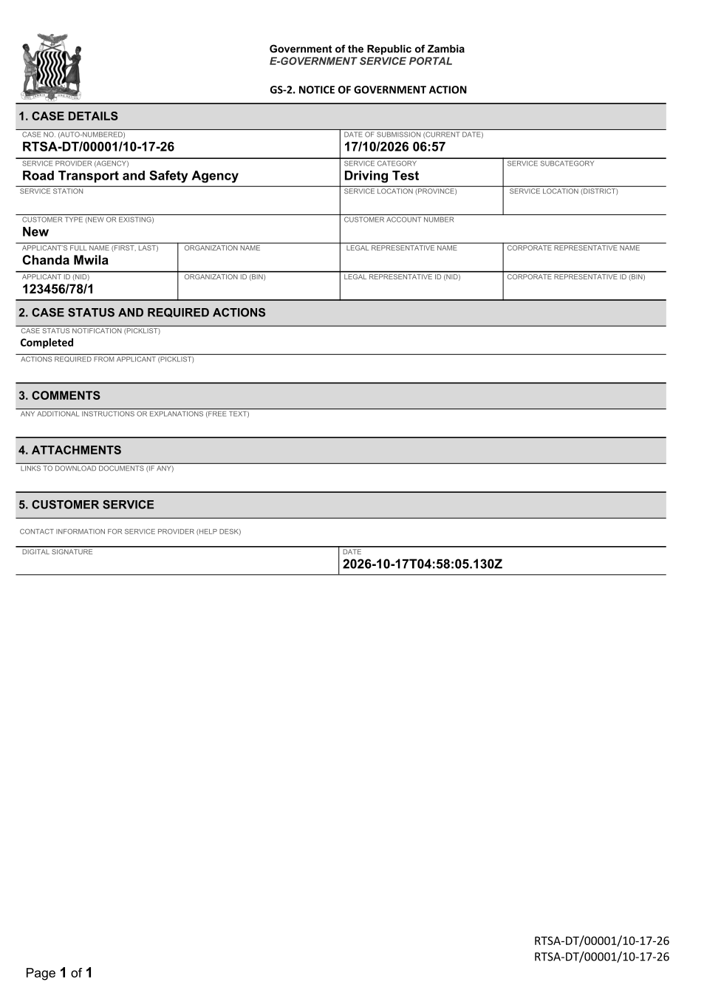
GS-2 Notice of Government Action (PDF) - first of 1 page, as issued in the test run.

Fields
Field | Value in the test run
Line 1 | RTSA-DT/00001/10-17-26
Line 2 | RTSA-DT/00001/10-17-26
Line 3 | Page 1 of 1
Line 4 | Government of the Republic of Zambia
Line 5 | E-GOVERNMENT SERVICE PORTAL
Line 6 | GS-2. NOTICE OF GOVERNMENT ACTION
Line 7 | 1. CASE DETAILS
Line 8 | CASE NO. (AUTO-NUMBERED)
Line 9 | RTSA-DT/00001/10-17-26
Line 10 | DATE OF SUBMISSION (CURRENT DATE)
Line 11 | 17/10/2026 06:57
Line 12 | SERVICE PROVIDER (AGENCY)
Line 13 | Road Transport and Safety Agency
Line 14 | SERVICE CATEGORY

5. Notifications
When | Channel | To | Message | Delivery
Payment due (invoice raised) | in-app (portal bell) | the applicant | Payment due for application RTSA-DT/00001/10-17-26 - The fee of ZMW 87.00 for Driving Test (RTSA-DT/00001/10-17-26) is now due. Invoice 6246187303422717. | shown
Application received | in-app (portal bell) | the applicant | Application RTSA-DT/00001/10-17-26 received - Your application RTSA-DT/00001/10-17-26 for Driving Test has been received by Road Transport and Safety Agency. | shown
Invitation to rate the service | in-app (portal bell) | the applicant | How was Driving Test? - How was Driving Test? Tell us in about a minute. | shown
Payment received | in-app (portal bell) | the applicant | Payment received for RTSA-DT/00001/10-17-26 - Your payment of ZMW 87.00 for RTSA-DT/00001/10-17-26 (Driving Test) has been received. Receipt: <ZamPay>/pdf?documentType=receipt&invoiceNumber=6246187303422717 | shown
Decision: approved | in-app (portal bell) | the applicant | Application RTSA-DT/00001/10-17-26 completed - RTSA-DT/00001/10-17-26 (Driving Test) is complete. Your documents are ready. | shown
Payment due (invoice raised) | email | e2e.c***@example.test | Payment due for application RTSA-DT/00001/10-17-26 | skipped
Payment due (invoice raised) | sms | +260 97* *** 567 | Fee of ZMW 87.00 due for RTSA-DT/00001/10-17-26. Invoice 6246187303422717. Pay: <ZamPay>/pay-for-service/get-invoice/6246187303422717 | delivered
Application received | email | e2e.c***@example.test | Application RTSA-DT/00001/10-17-26 received | skipped
Application received | sms | +260 97* *** 567 | Application RTSA-DT/00001/10-17-26 for Driving Test has been received. Track it: <portal>/my-workplace | delivered
Invitation to rate the service | sms | +260 97* *** 567 |  | skipped
Invitation to rate the service | email | e2e.c***@example.test | How was Driving Test? | skipped
Decision: approved | email | e2e.c***@example.test | Application RTSA-DT/00001/10-17-26 completed | skipped
Payment received | sms | +260 97* *** 567 | Your payment of ZMW 87.00 for application RTSA-DT/00001/10-17-26 (Driving Test) has been received. Receipt: <ZamPay>/pdf?documentType=receipt&invoiceNumber=6246187303422717 Processing continues. | delivered
Decision: approved | sms | +260 97* *** 567 | RTSA-DT/00001/10-17-26 (Driving Test) is complete. Download your documents: <portal>/my-workplace | delivered
Delivery: shown = in the portal's notification bell; delivered = the SMS gateway (a test double in this run) reported the text delivered; skipped = not sent on that channel (e-mail is not configured on the test installation, and some notices go out on one channel only); sent by the national portal = a ministry node handed the notice to the national portal, which texts and e-mails the citizen under its own name and the citizen's preferences. Addresses written <portal>, <ZamPay> stand for the national portal and ZamPay.

6. Legacy mapping
Replaces | Driving Test in the legacy ZIGS e-Services directory (ZIGS_Services)
Legacy service id | 127
Legacy provider | Road Transport and Safety Agency (RTSA) under Ministry of Transport and Logistics
Legacy process | CaseOfficerReviewRTSA (process 2)
Fee in the legacy system | Driving Test Fee: ZMW 87 (New)
Fee taken before submission | yes (as in ZIGS)
Time to issue (legacy) | New: 1 working day
Legacy output templates | GS-2 Notice of Government Action: ZIGS_Forms_Notices / GS-2.NoticeOfActionExam  Notice of Approval: ZIGS_Forms_RTSA / RTSA_DriverLicence.New.NoticeApproval  Application form (New): ZIGS_Forms_RTSA / RTSA_DriverLicence.New.Application  Test Booking Information (New): ZIGS_Forms_RTSA / RTSA_DriverLicence.TestBookingInformation  GF-1 Treasury Invoice: ZIGS_CustomForms / GF-1 Invoice  GF-2 Treasury Receipt: ZIGS_CustomForms / GF-2 Receipt
Legacy address | none recorded
How it was brought over | Imported by the platform's legacy catalogue importer (zcm-backend scripts/zigs/importLegacy.js) from the ZIGS snapshot: form, case types, fees, documents, process and output templates, then served by the new platform.

7. Version and date
Document version | service v1, platform 9b8a591f
Generated | 2026-10-17T04:58:15Z (by the end-to-end run, not edited by hand)
Service version | not versioned (configured directly)
Platform snapshot | backend 9b8a591f  portal dfd4933  back office a975a2c
Test suite | e2e 2b037bb; one installation (combined); seed profile mihud
Journeys | 30-catalogue-service.spec.js: citizen finds the service, answers its form, uploads its documents and sends the application - passed  30-catalogue-service.spec.js: the case goes through every step of its process: payments by the citizen, each officer step by its role - passed  30-catalogue-service.spec.js: the grant document is issued, sealed, filled in and verifiable; the citizen has it in My permits - passed
Result | 3 of 3 journey tests passed
Data | Synthetic test data on a local test installation; provider test doubles for ZamPass, ZamPay, SMS and signing.

