Republic of Zambia
GSB e-Services

Driver’s Licence Renewal (Duplicate)
Service documentation
Owner: Road Transport and Safety Agency
Service key: RTSA/drivers-licence-renewal-duplicate
Version: service v1, platform 9b8a591f
Date: 2026-10-17
Generated automatically by the service's end-to-end test run. Every screenshot shows synthetic test data on a local test installation, never real personal data.

Contents
- 1. Service summary
- 2. Application process, step by step
- 3. Payment
- 4. Output documents
- 5. Notifications
- 6. Legacy mapping
- 7. Version and date
This document describes the Driver’s Licence Renewal (Duplicate) service of Road Transport and Safety Agency as the platform runs it today. It is generated by the service's end-to-end test: every step was performed by the test and every screenshot was taken during that run, with synthetic data. Regenerate it with "npm run docs:services" in the e2e suite; do not edit it by hand.

1. Service summary
Service | Driver’s Licence Renewal (Duplicate)
Owner (MDA) | Road Transport and Safety Agency (RTSA)
Purpose | Renewal of an expired driver’s licence or replacement of a lost, stolen, or damaged licence card.
Who can apply | Individual
How to apply | Online on the national e-Services portal, signed in with ZamPass; pay with ZamPay.
Fees | Driver Licence Renewal: ZMW 312.00  Driver Licence Duplicate: ZMW 144.00  Renewal of Expired Driving License: ZMW 398.00
Turnaround | Instantly
Validity of the output | Renewal - five (5) years  Duplicate - expiration date of the original licence
Required documents | National ID (or passport for foreign nationals) (required), Renewal applications only  Police report (if stolen) (required), Duplicate applications only
Output documents | GS-2 Notice of Government Action  Notice of Approval (Renewal)  Notice of Approval (Duplicate)  Denial of Service (Renewal)  Denial of Service (Duplicate)  Application form (Renewal)  Application form (Duplicate)  GS-1 Application for a Government Service  GF-1 Treasury Invoice  GF-2 Treasury Receipt
Legal basis | Road Traffic Act Nr. 11 of 2002 (http://www.parliament.gov.zm/sites/default/files/documents/acts/Roads%20and%20Road%20Traffic%20Act.pdf)  Statutory Instrument No. 41 of 2015 (Fee & Penalty Unit Value) (http://www.seczambia.org.zm/wp-content/uploads/2018/08/SI-No-41-of-2015-Fees-and-Fines-Act.pdf)  Statutory Instrument No. 38 The Road Traffic (Fees) Regulations of 2008 (https://www.rtsa.org.zm/wp-content/uploads/2020/04/SI-No.-38-of-2008-the-Road-Traffic-Fees-Regulations-.pdf)  The Road Traffic (Driving Licence) Regulations

2. Application process, step by step

The process as configured
Step | Role | Task | Type
1 | Applicant | Apply | form
2 | Case Officer | Generate Payment | generate-payment
3 | Applicant | Payment | payment
4 | System | Generate Document | generate-document
5 | Case Officer | Approve | approve
6 | System | Generate Document | generate-document
7 | System | Notify Client | notify

Step by step
Who takes part in this journey: Citizen, Case Officer, Anyone (public). Citizen steps are shown on a desktop and on a 375 px phone; back-office steps on a desktop.

Step 1. Find the service
Citizen · National e-Services portal
On the national e-Services portal the citizen opens All Services and searches for the service by name ("Licence Renewal Duplicate"). Each result names the service and the ministry that provides it.
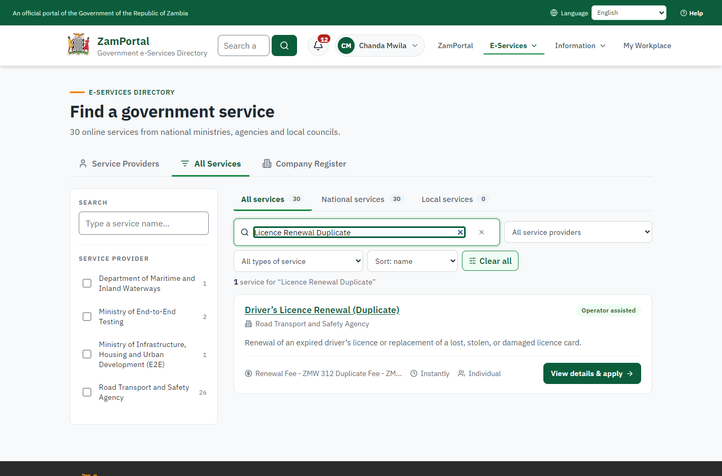 | 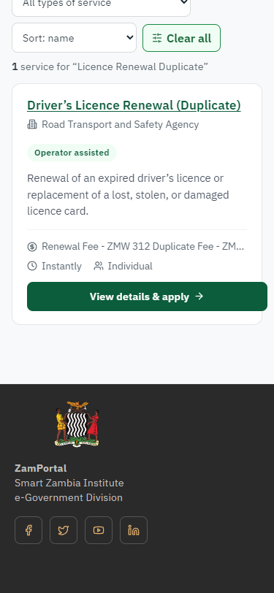
Step 1: Find the service - desktop (left) and a 375 px phone (right).

Step 2. Read the service page
Citizen · National e-Services portal
The service page sets out what the service is for, who provides it, the fee, how long it takes and the documents to have ready. "Start application" begins an application (the citizen is signed in with ZamPass).
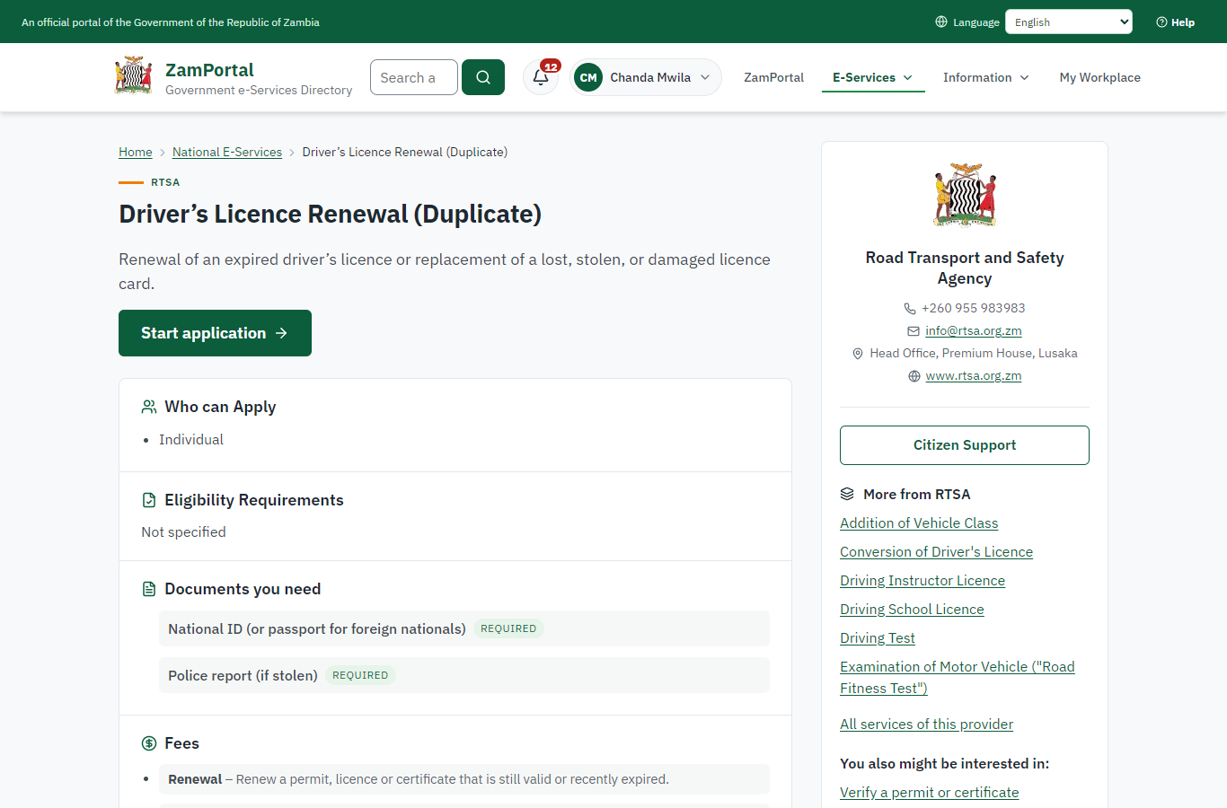 | 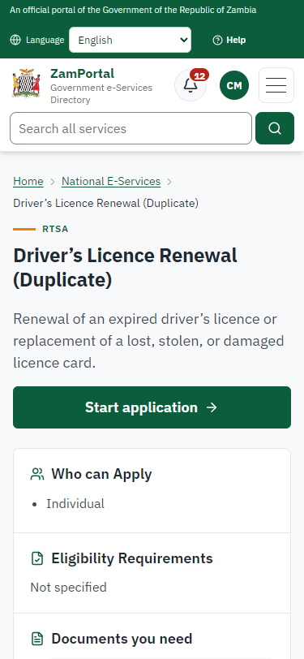
Step 2: Read the service page - desktop (left) and a 375 px phone (right).

Step 3. Confirm the applicant details
Citizen · National e-Services portal
The applicant details are filled in from the citizen's ZamPass account. The citizen says whom they are applying for (themself) and continues with "Proceed to Application".
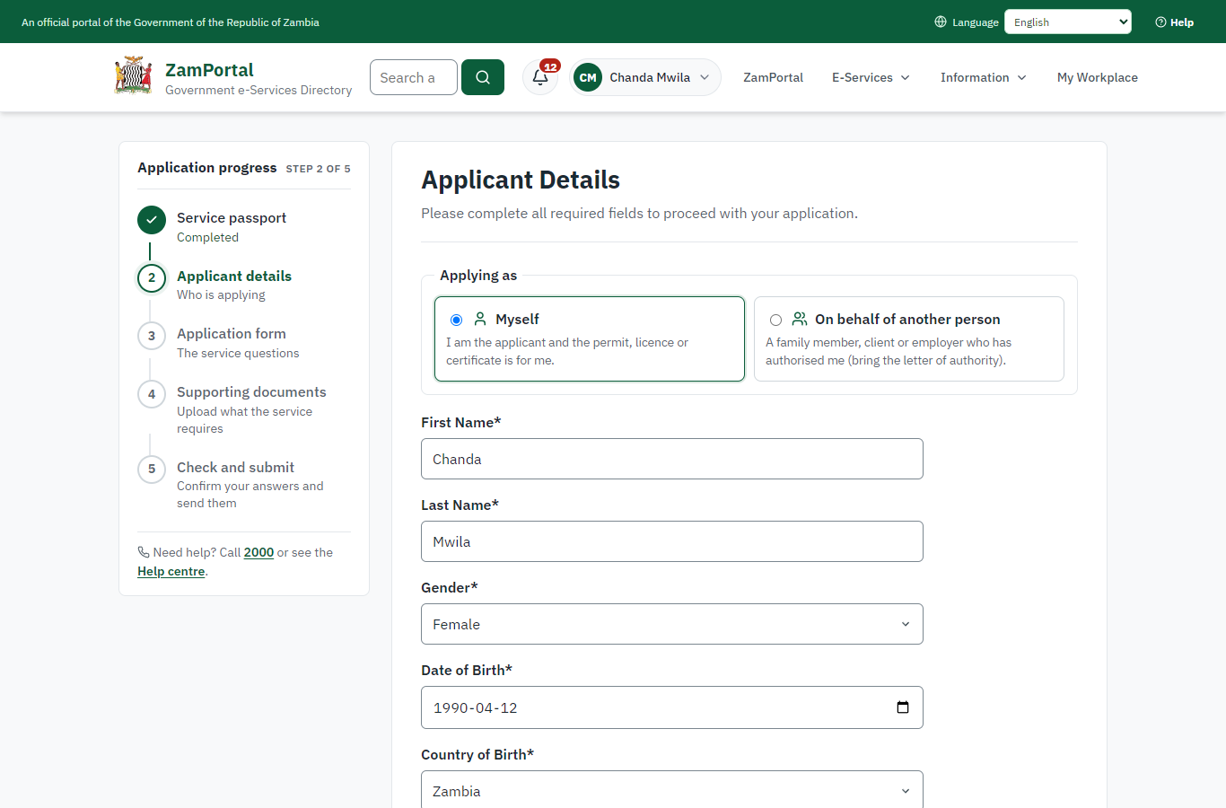 | 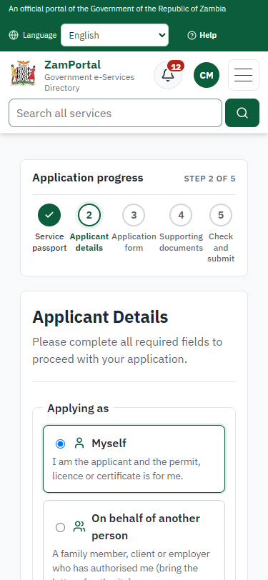
Step 3: Confirm the applicant details - desktop (left) and a 375 px phone (right).

Step 4. Fill in the application form
Citizen · National e-Services portal
The citizen answers the service's own application form, converted from the legacy system (21 answers in this run, all synthetic), for the type of application "Renewal". Questions marked * must be answered; some appear only after an earlier answer. Answers are saved as the citizen types, so an unfinished application can be reopened from My Workplace.
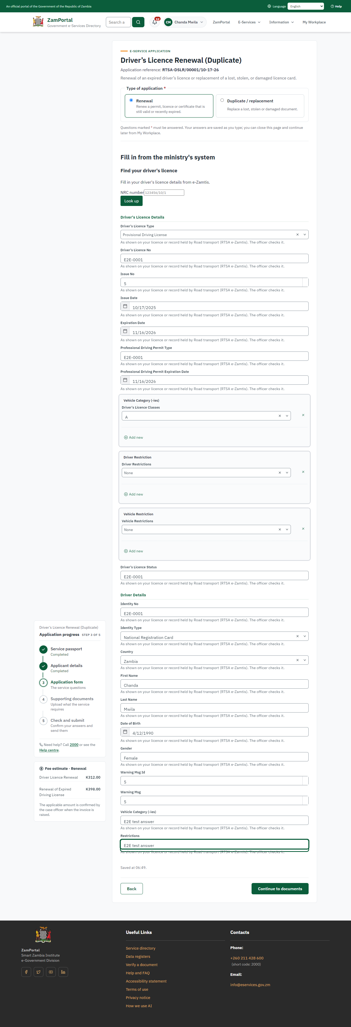 | 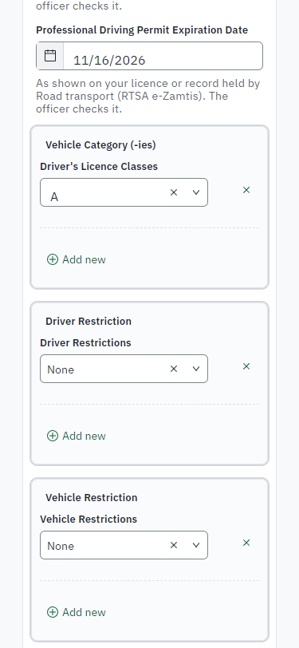
Step 4: Fill in the application form - desktop (left) and a 375 px phone (right).

Step 5. Upload the supporting documents
Citizen · National e-Services portal
Each document the service asks for has its own upload (1 in this run: National ID (or passport for foreign nationals)). The files are checked and stored with the application; the page confirms each upload.
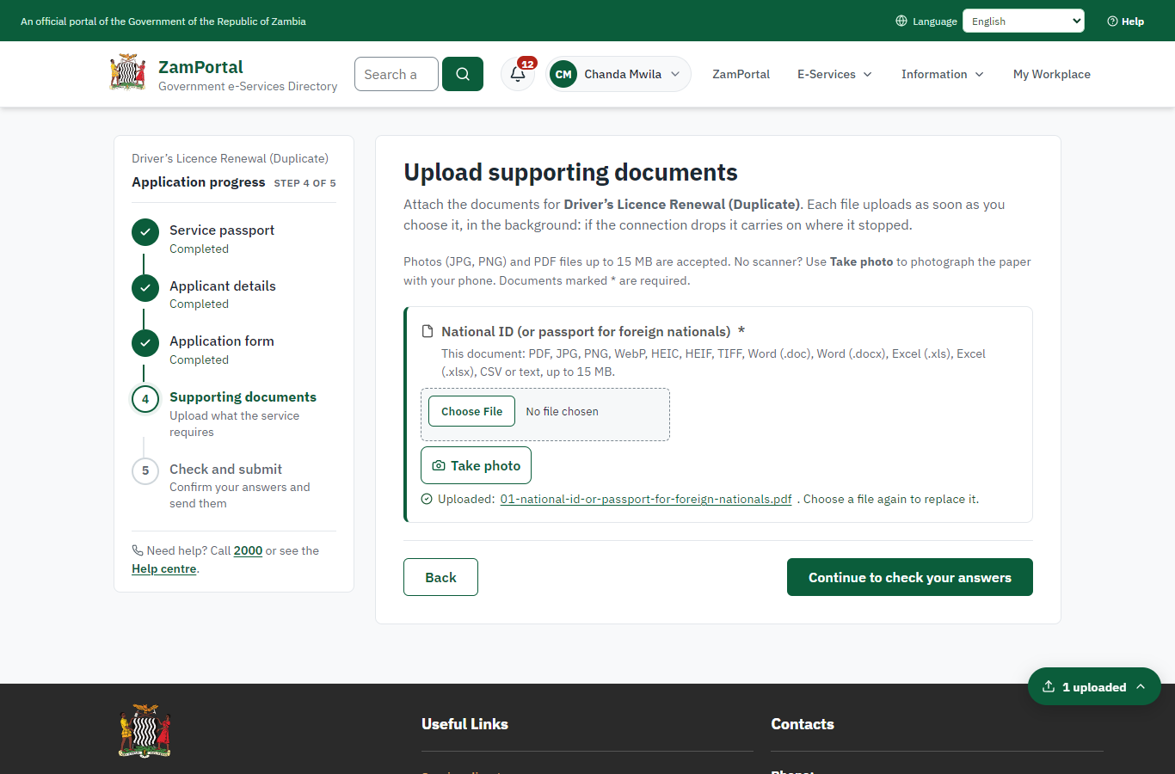 | 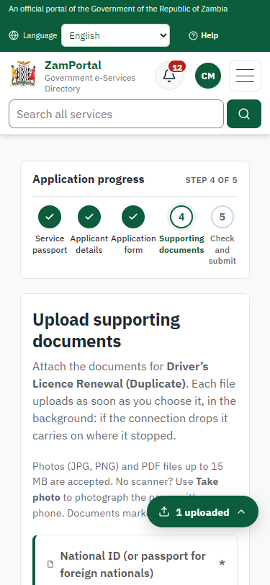
Step 5: Upload the supporting documents - desktop (left) and a 375 px phone (right).

Step 6. Check the answers and confirm the declaration
Citizen · National e-Services portal
Before sending, the citizen sees every answer and document on one page and can go back to change them. The declaration that the information is true and complete must be ticked.
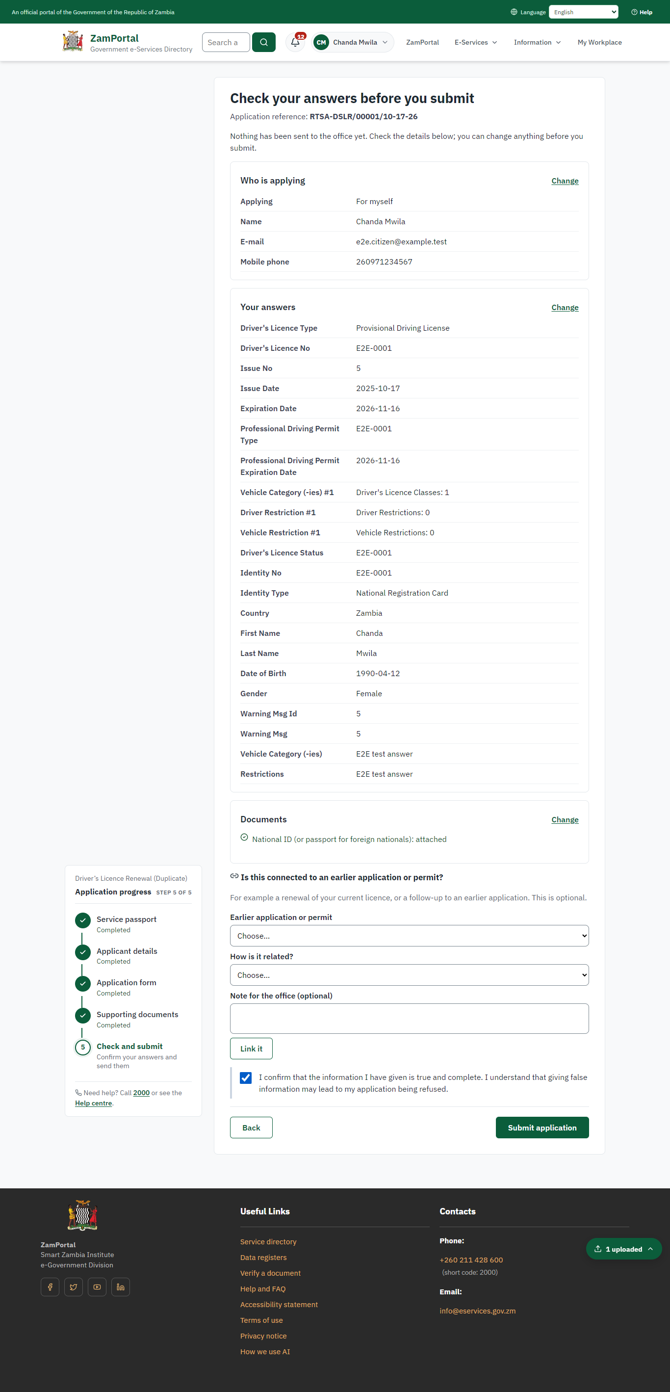 | 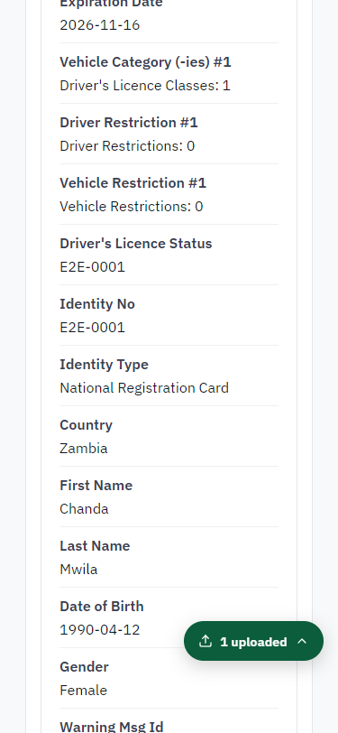
Step 6: Check the answers and confirm the declaration - desktop (left) and a 375 px phone (right).

Step 7. Application sent
Citizen · National e-Services portal
The portal confirms the application with the ministry's reference number (RTSA-DSLR/00001/10-17-26 in this run). The application goes to the ministry's officers; the citizen follows it in My Workplace.
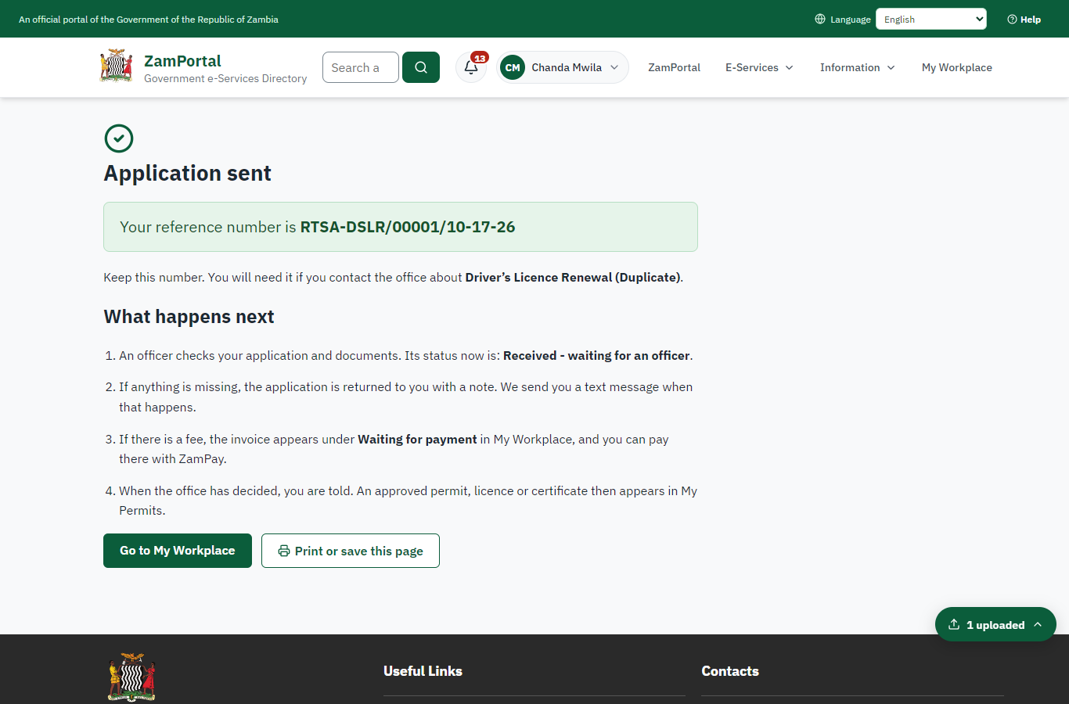 | 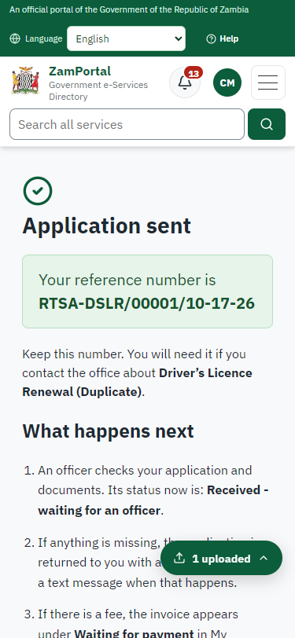
Step 7: Application sent - desktop (left) and a 375 px phone (right).

Step 8. Take the new application on
Case Officer · Back office
The application arrives in the case queue of the ministry that owns the service (Road Transport and Safety Agency); only its staff see it. The officer opens it by its reference number - answers, documents and process are on the case - assigns it to themself and takes it on.
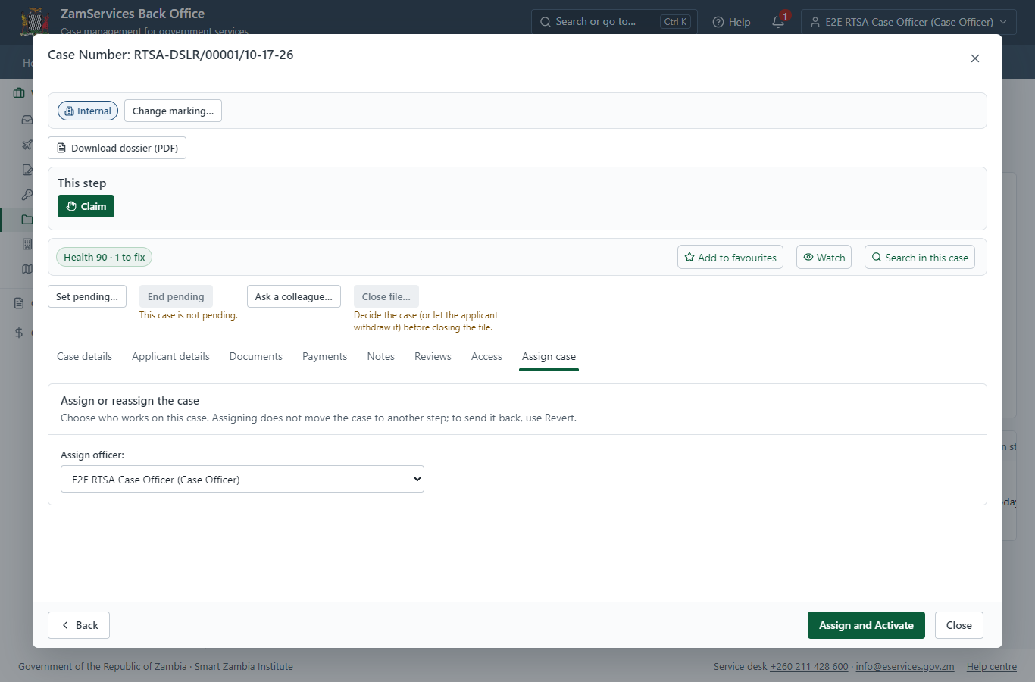
Step 8: Take the new application on.

Step 9. Work out the fee
Case Officer · Back office
The Case Officer works out the fee from the service's imported fee schedule ("Renewal Fee - ZMW 312 Duplicate Fee - ZMW 144 Renewal of Expiring Driving Licence - ZMW 398"). "Submit Fees and Advance" records it, raises a ZamPay invoice for the applicant and moves the case to payment.
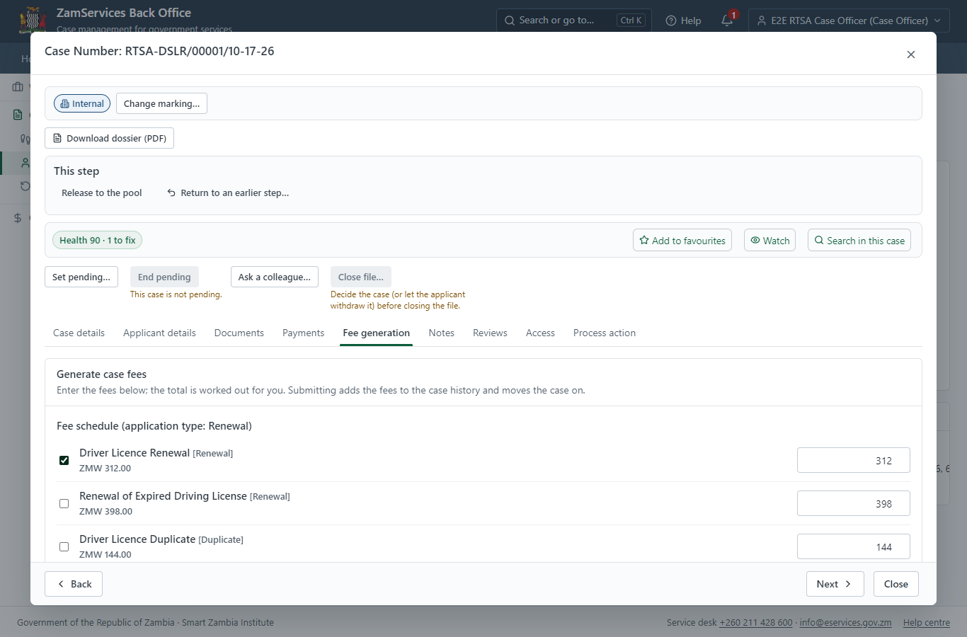
Step 9: Work out the fee.

Step 10. See that the fee is due
Citizen · National e-Services portal
The application shows "Waiting for your payment" in My Workplace with a Pay button (K312.00). The office priced the case; the invoice was raised on ZamPay.
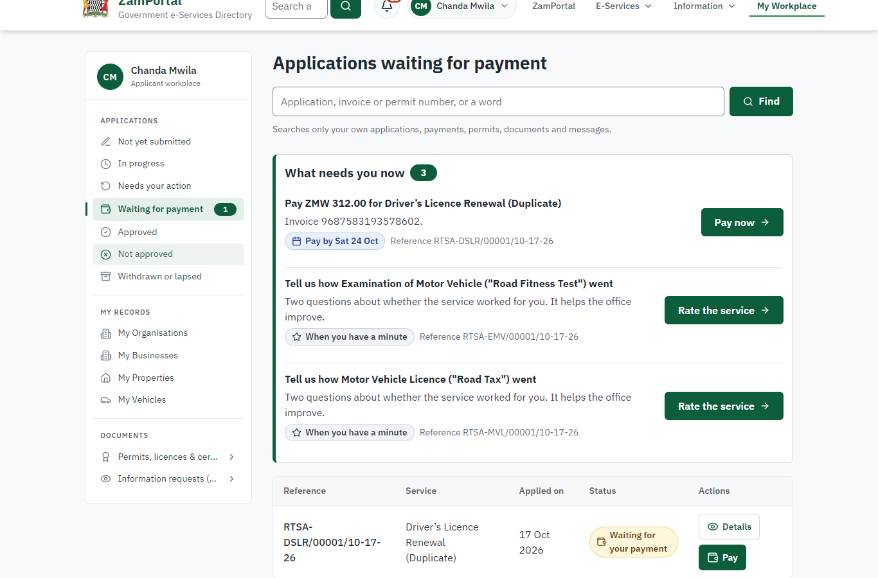 | 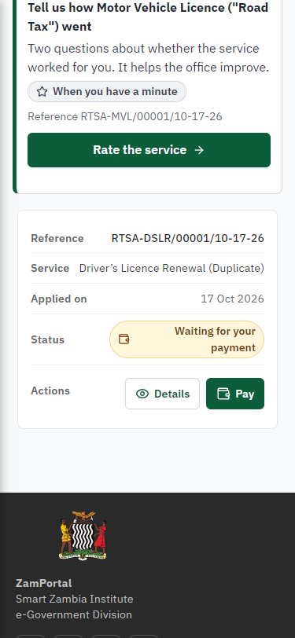
Step 10: See that the fee is due - desktop (left) and a 375 px phone (right).

Step 11. Pay with ZamPay
Citizen · National e-Services portal
Pay opens the invoice (K312.00, the amount set by the platform, never by the page) with its PDF preview; the citizen pays at ZamPay by mobile money or bank card.
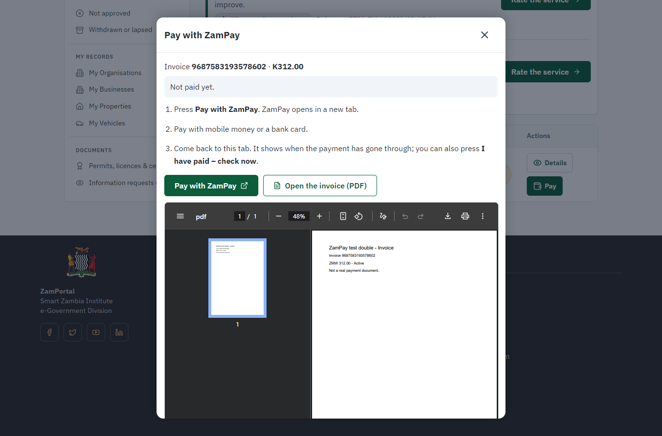 | 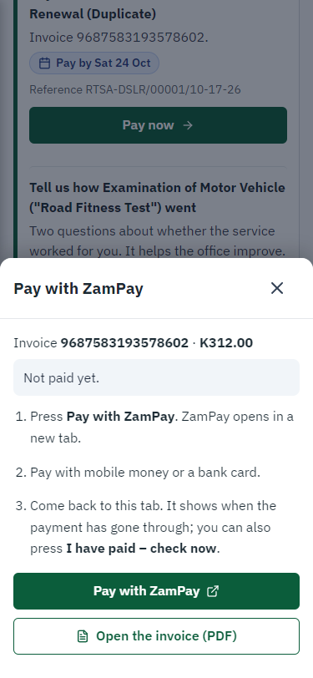
Step 11: Pay with ZamPay - desktop (left) and a 375 px phone (right).

Step 12. Payment received
Citizen · National e-Services portal
ZamPay reports the payment; the dialog says "Paid. Thank you" and the application moves on to the ministry's officers.
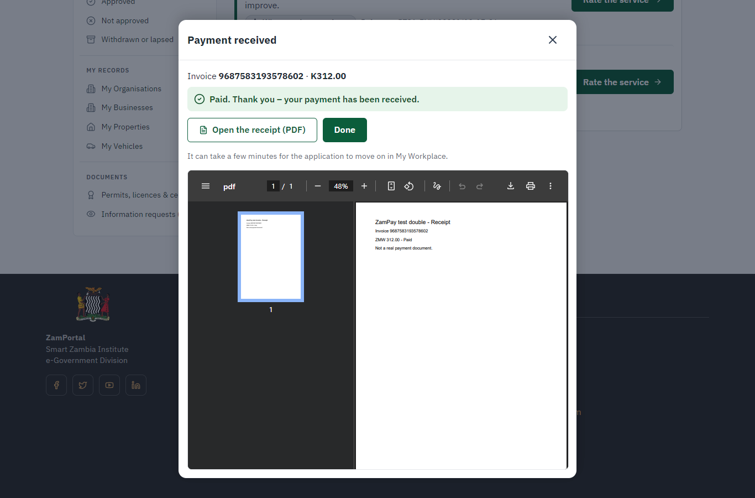 | 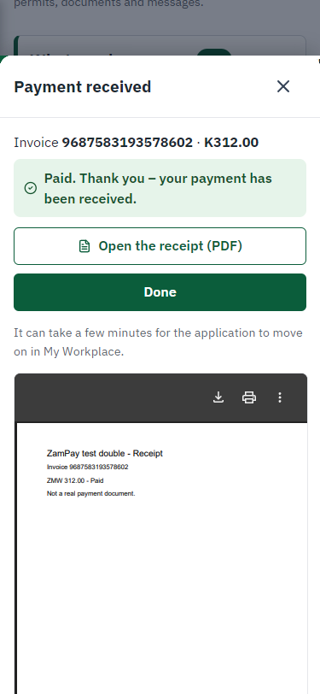
Step 12: Payment received - desktop (left) and a 375 px phone (right).

Step 13. Decide: Review
Case Officer · Back office
At "Review" the Case Officer records the decision: approve, with a comment kept in the case history. Approving moves the case on; the last decision completes it and issues the document.
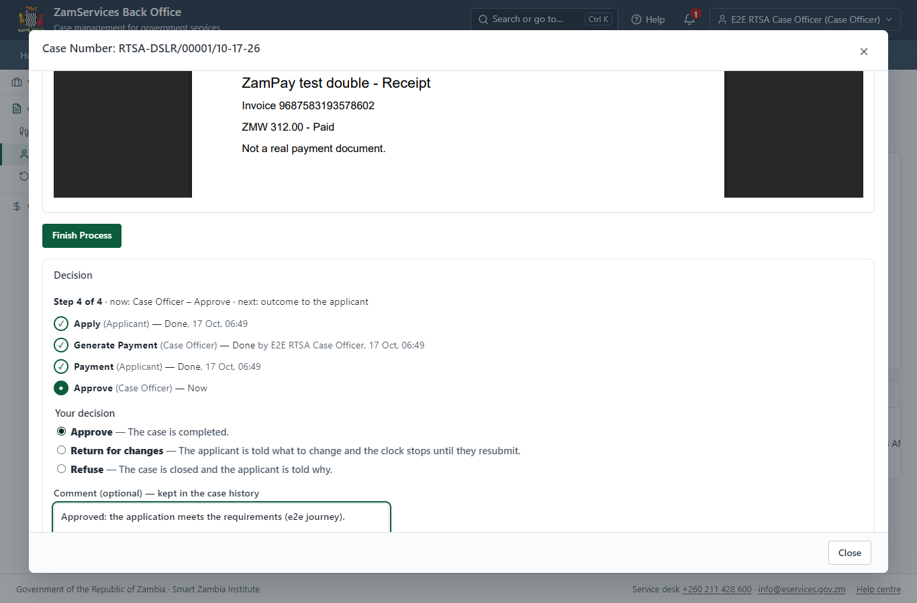
Step 13: Decide: Review.

Step 14. The document in My permits
Citizen · National e-Services portal
The issued document (RTSA-DSLRD-2026-00001 in this run: "Driver’s Licence Renewal (Duplicate)") is listed in "My permits and licences" with its validity and a download of the sealed PDF.
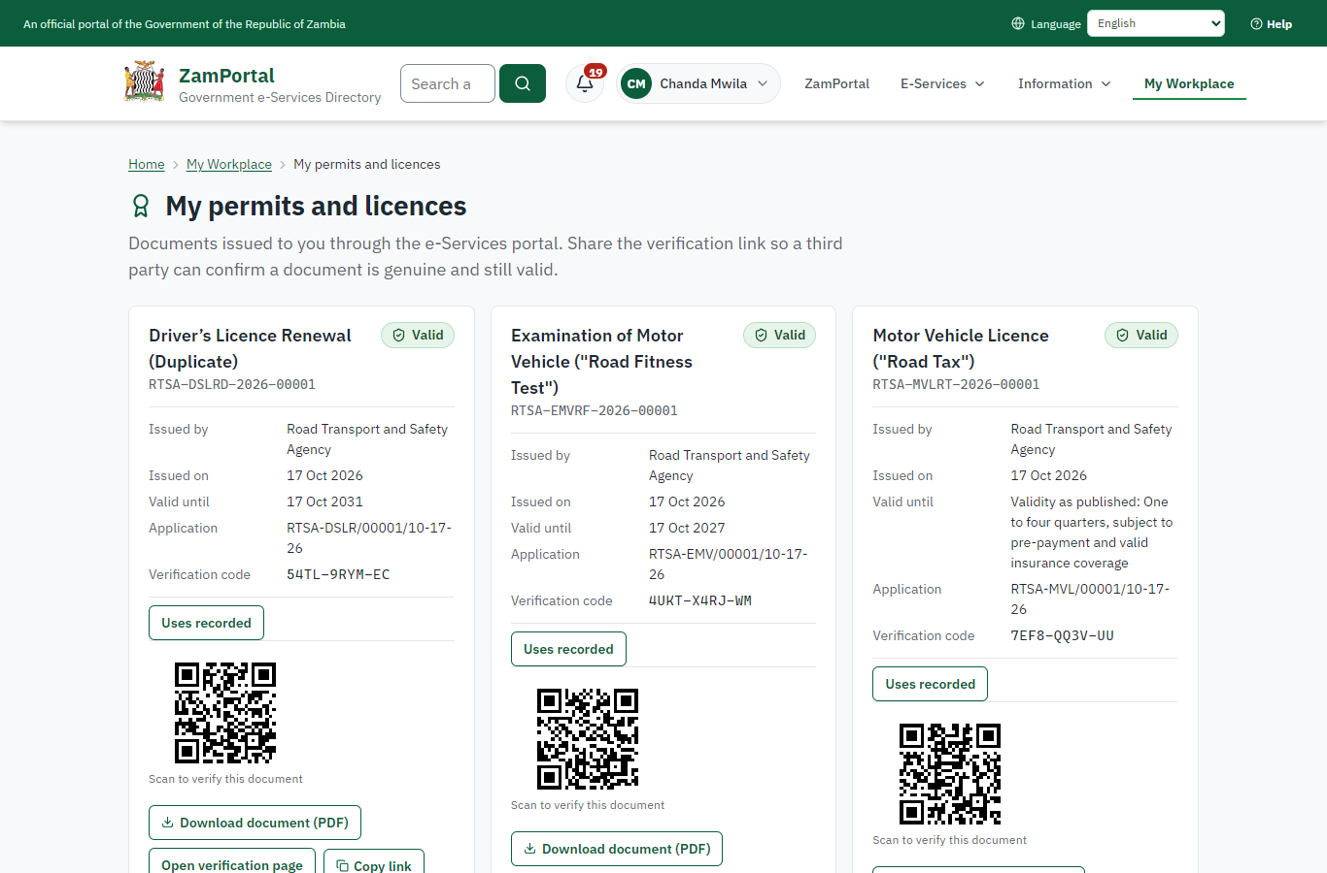 | 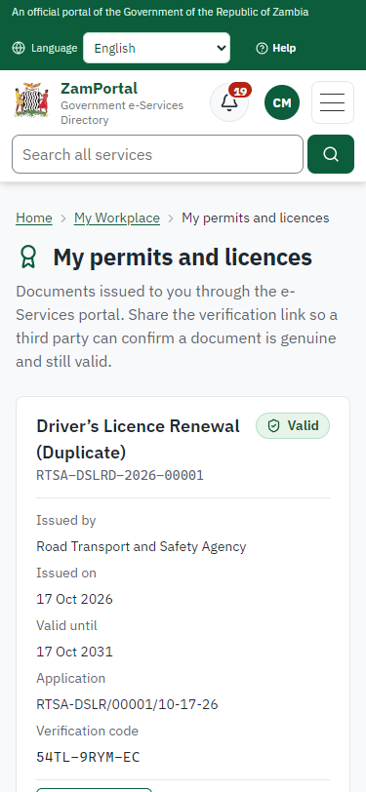
Step 14: The document in My permits - desktop (left) and a 375 px phone (right).

Step 15. Verify the document
Anyone (public) · Public verification page
The QR code on the document opens the public verification page: genuine and current, to whom it was issued, and whether the electronic seal is valid. No sign-in is needed.
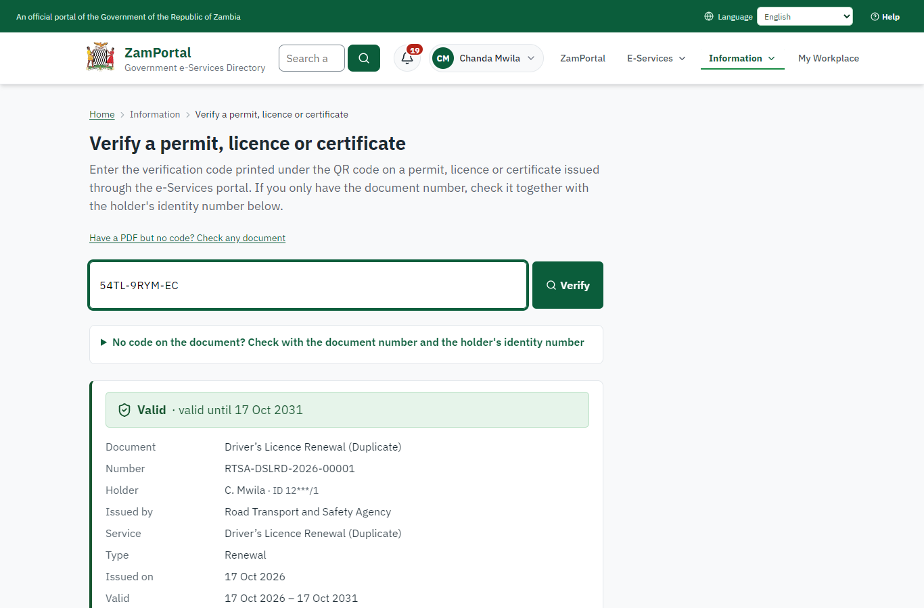 | 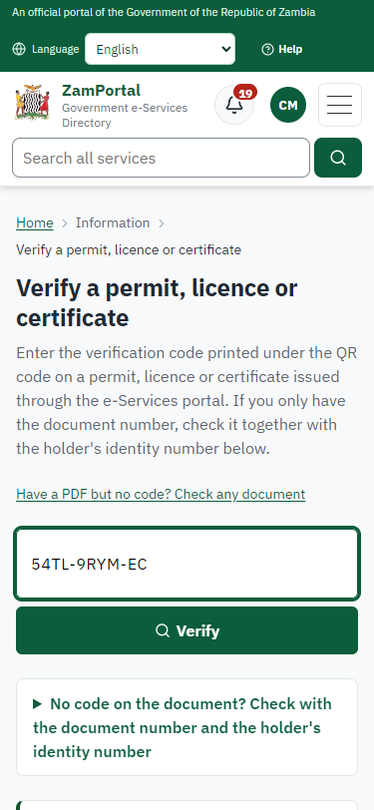
Step 15: Verify the document - desktop (left) and a 375 px phone (right).

3. Payment
Item | In the test run
Fee (as published) | Renewal Fee - ZMW 312 Duplicate Fee - ZMW 144 Renewal of Expiring Driving Licence - ZMW 398
Invoice 1 | 9687583193578602
Amount 1 | ZMW 312.00
Paid at 1 | after "Work out the fee"
On screen: step 9 (Work out the fee), step 10 (See that the fee is due), step 11 (Pay with ZamPay), step 12 (Payment received) in section 2.

4. Output documents

Driver’s Licence Renewal (Duplicate) (sealed PDF)
Issued when the case was approved, from the service's output configuration (permitDocument/issued@1), filled from the application and the decision, sealed with the platform's electronic seal and stored as the issued version. The holder downloads it from My permits; the verification page checks it.
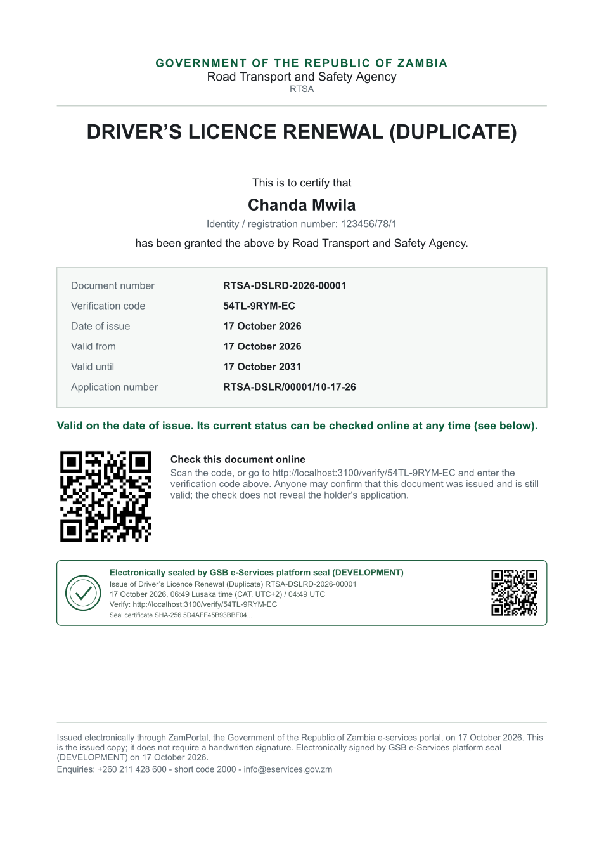
Driver’s Licence Renewal (Duplicate) (sealed PDF) - first of 1 page, as issued in the test run.

Fields
Field | Value in the test run
Document title | Driver’s Licence Renewal (Duplicate)
Permit / licence number | RTSA-DSLRD-2026-00001
Holder | Chanda Mwila
Valid from | 2026-10-17
Valid until | 2031-10-17
Status | active
Verification code (printed with a QR code) | 54TL-9RYM-EC

Seal
Seal status | sealed
Signature level | PAdES-B-T
Sealed by | the platform seal (development key in the test run)
Signed at | 2026-10-17T04:49:38.494Z
Trusted time-stamp | 2026-10-17T04:49:39.065Z (time-stamping authority)
Document fingerprint (SHA-256) | 0b235c2f4cd1d41a...

Verification
Where | The public verification page of the national portal, <portal>/verify/<verification code>, opened by scanning the QR code on the document.
What it shows | Whether the document is genuine and current, its holder and validity, and whether the electronic seal is valid and who sealed it.
Checking a copy | Anyone can upload a PDF they were given; the page says whether it is exactly the document that was issued. A changed copy is reported as not matching.
On screen: step 14 (The document in My permits), step 15 (Verify the document) in section 2.

5. Notifications
When | Channel | To | Message | Delivery
Application received | in-app (portal bell) | the applicant | Application RTSA-DSLR/00001/10-17-26 received - Your application RTSA-DSLR/00001/10-17-26 for Driver’s Licence Renewal (Duplicate) has been received by Road Transport and Safety Agency. | shown
Status changed | in-app (portal bell) | the applicant | Update on application RTSA-DSLR/00001/10-17-26 - RTSA-DSLR/00001/10-17-26 (Driver’s Licence Renewal (Duplicate)) is now: With the office - fees being worked out. | shown
Payment due (invoice raised) | in-app (portal bell) | the applicant | Payment due for application RTSA-DSLR/00001/10-17-26 - The fee of ZMW 312.00 for Driver’s Licence Renewal (Duplicate) (RTSA-DSLR/00001/10-17-26) is now due. Invoice 9687583193578602. | shown
Payment received | in-app (portal bell) | the applicant | Payment received for RTSA-DSLR/00001/10-17-26 - Your payment of ZMW 312.00 for RTSA-DSLR/00001/10-17-26 (Driver’s Licence Renewal (Duplicate)) has been received. Receipt: <ZamPay>/pdf?documentType=receipt&invoiceNumber=9687583193578602 | shown
Licence / permit issued | in-app (portal bell) | the applicant | Your Driver’s Licence Renewal (Duplicate) document has been issued - RTSA-DSLRD-2026-00001 has been issued for Driver’s Licence Renewal (Duplicate) and is valid until 17/10/2031. | shown
Invitation to rate the service | in-app (portal bell) | the applicant | How was Driver’s Licence Renewal (Duplicate)? - How was Driver’s Licence Renewal (Duplicate)? Tell us in about a minute. | shown
Decision: approved | in-app (portal bell) | the applicant | Application RTSA-DSLR/00001/10-17-26 completed - RTSA-DSLR/00001/10-17-26 (Driver’s Licence Renewal (Duplicate)) is complete. Your documents are ready. | shown
Application received | sms | +260 97* *** 567 | Application RTSA-DSLR/00001/10-17-26 for Driver’s Licence Renewal (Duplicate) has been received. Track it: <portal>/my-workplace | delivered
Application received | email | e2e.c***@example.test | Application RTSA-DSLR/00001/10-17-26 received | skipped
Status changed | sms | +260 97* *** 567 |  | delivered
Payment due (invoice raised) | sms | +260 97* *** 567 | Fee of ZMW 312.00 due for RTSA-DSLR/00001/10-17-26. Invoice 9687583193578602. Pay: <ZamPay>/pay-for-service/get-invoice/9687583193578602 | delivered
Payment due (invoice raised) | email | e2e.c***@example.test | Payment due for application RTSA-DSLR/00001/10-17-26 | skipped
Payment received | sms | +260 97* *** 567 |  | delivered
Invitation to rate the service | sms | +260 97* *** 567 |  | skipped
Invitation to rate the service | email | e2e.c***@example.test | How was Driver’s Licence Renewal (Duplicate)? | skipped
Licence / permit issued | sms | +260 97* *** 567 |  | delivered
Licence / permit issued | email | e2e.c***@example.test | Your Driver’s Licence Renewal (Duplicate) document has been issued | skipped
Decision: approved | sms | +260 97* *** 567 |  | delivered
Decision: approved | email | e2e.c***@example.test | Application RTSA-DSLR/00001/10-17-26 completed | skipped
Delivery: shown = in the portal's notification bell; delivered = the SMS gateway (a test double in this run) reported the text delivered; skipped = not sent on that channel (e-mail is not configured on the test installation, and some notices go out on one channel only); sent by the national portal = a ministry node handed the notice to the national portal, which texts and e-mails the citizen under its own name and the citizen's preferences. Addresses written <portal>, <ZamPay> stand for the national portal and ZamPay.

6. Legacy mapping
Replaces | Driver’s Licence Renewal (Duplicate) in the legacy ZIGS e-Services directory (ZIGS_Services)
Legacy service id | 14
Legacy provider | Road Transport and Safety Agency (RTSA) under Ministry of Transport and Logistics
Legacy process | CaseOfficerReviewRTSA (process 2)
Fee in the legacy system | Driver Licence Renewal: ZMW 312 (Renewal)  Driver Licence Duplicate: ZMW 144 (Duplicate)  Renewal of Expired Driving License: ZMW 398 (Renewal)
Fee taken before submission | yes (as in ZIGS)
Time to issue (legacy) | not recorded
Legacy output templates | GS-2 Notice of Government Action: ZIGS_Forms_Notices / GS-2.NoticeOfActionExam  Notice of Approval (Renewal): ZIGS_Forms_RTSA / RTSA_DriverLicence_Renewal.NoticeApproval  Notice of Approval (Duplicate): ZIGS_Forms_RTSA / RTSA_DriverLicence_Duplicate.NoticeApproval  Denial of Service (Renewal): ZIGS_Forms_RTSA / RTSA_DriverLicence_Renewal.DenialService  Denial of Service (Duplicate): ZIGS_Forms_RTSA / RTSA_DriverLicence_Duplicate.DenialService  Application form (Renewal): ZIGS_Forms_RTSA / RTSA_DriverLicence_Renewal.Application  Application form (Duplicate): ZIGS_Forms_RTSA / RTSA_DriverLicence_Duplicate.Application  GS-1 Application for a Government Service: ZIGS_Forms_ZDA / GS1  GF-1 Treasury Invoice: ZIGS_CustomForms / GF-1 Invoice  GF-2 Treasury Receipt: ZIGS_CustomForms / GF-2 Receipt
Legacy address | none recorded
How it was brought over | Imported by the platform's legacy catalogue importer (zcm-backend scripts/zigs/importLegacy.js) from the ZIGS snapshot: form, case types, fees, documents, process and output templates, then served by the new platform.

7. Version and date
Document version | service v1, platform 9b8a591f
Generated | 2026-10-17T04:49:44Z (by the end-to-end run, not edited by hand)
Service version | not versioned (configured directly)
Platform snapshot | backend 9b8a591f  portal dfd4933  back office a975a2c
Test suite | e2e 2b037bb; one installation (combined); seed profile mihud
Journeys | 30-catalogue-service.spec.js: citizen finds the service, answers its form, uploads its documents and sends the application - passed  30-catalogue-service.spec.js: the case goes through every step of its process: payments by the citizen, each officer step by its role - passed  30-catalogue-service.spec.js: the grant document is issued, sealed, filled in and verifiable; the citizen has it in My permits - passed
Result | 3 of 3 journey tests passed
Data | Synthetic test data on a local test installation; provider test doubles for ZamPass, ZamPay, SMS and signing.

