Republic of Zambia
GSB e-Services

Bus Station Storage Fees
Service documentation
Owner: Department of Local Government
Service key: LGD/bus-station-storage-fees
Version: service v1, platform 7eecca5c
Date: 2026-10-21
Generated automatically by the service's end-to-end test run. Every screenshot shows synthetic test data on a local test installation, never real personal data.

Contents
- 1. Service summary
- 2. Application process, step by step
- 3. Payment
- 4. Output documents
- 5. Notifications
- 6. Legacy mapping
- 7. Version and date
This document describes the Bus Station Storage Fees service of Department of Local Government as the platform runs it today. It is generated by the service's end-to-end test: every step was performed by the test and every screenshot was taken during that run, with synthetic data. Regenerate it with "npm run docs:services" in the e2e suite; do not edit it by hand.

1. Service summary
Service | Bus Station Storage Fees
Owner (MDA) | Department of Local Government (LGD)
Purpose | A fee collected from persons who wish to keep their goods in the Council Bus Station managed storeroom or facilities for a specific period.
Who can apply | Individual
How to apply | Online on the national e-Services portal, signed in with ZamPass; pay with ZamPay.
Fees | Fee set by the office: (variable)
Turnaround | One (1) hour
Validity of the output | N/A
Required documents | Standard Requirements for Applicant (required)  Applicant/Representative Identity Document (required)  Applicant/Representative Certificate of Registration (required)  Negative Scenario (required)  Applicant applies, pays (required)  Case Officer reviews the case, signs GS-2 Rejection (required)
Output documents | GS-1 Application for a Government Service  GS-2 Notice of Government Action

2. Application process, step by step

The process as configured
Step | Role | Task | Type
1 | Applicant | Apply | form
2 | Applicant | Payment | payment
3 | System | Generate Document | generate-document
4 | System | Notify Client | notify

Step by step
Who takes part in this journey: Citizen. Citizen steps are shown on a desktop and on a 375 px phone; back-office steps on a desktop.

Step 1. Find the service at the council
Citizen · National e-Services portal
The service is delivered by the local authorities: on the national e-Services portal the citizen opens Councils, chooses their council (Lusaka City Council in this run) and searches its services ("Bus Station Storage Fees"). The application is then registered with that council and priced with its own fees.
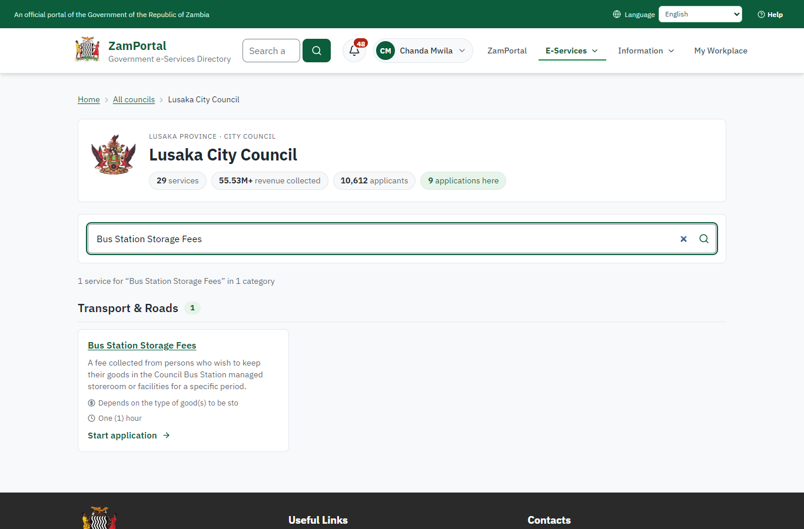 | 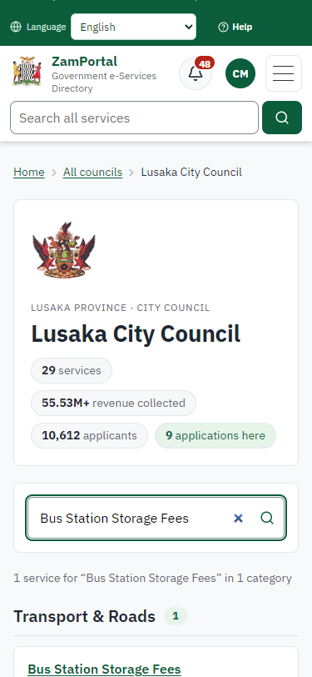
Step 1: Find the service at the council - desktop (left) and a 375 px phone (right).

Step 2. Read the service page
Citizen · National e-Services portal
The service page sets out what the service is for, the fee, how long it takes and the documents to have ready, and names the council the application goes to. "Start application" begins an application at Lusaka City Council (the citizen is signed in with ZamPass).
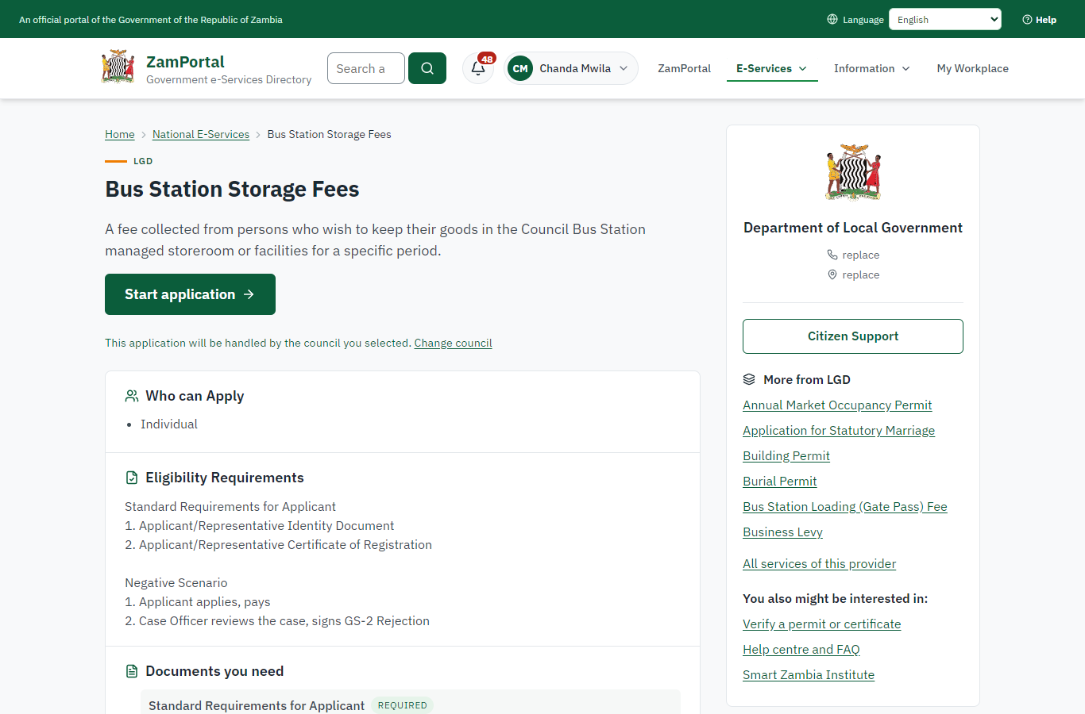 | 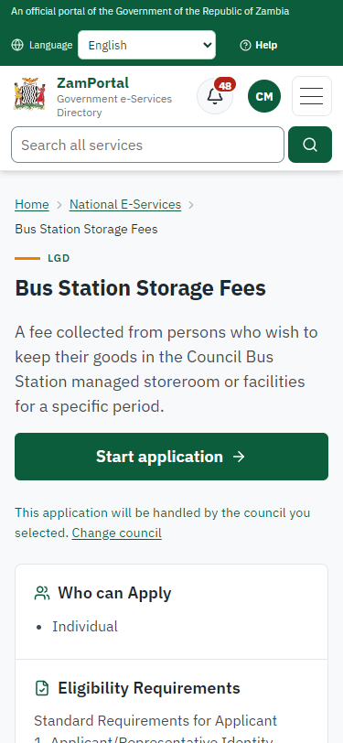
Step 2: Read the service page - desktop (left) and a 375 px phone (right).

Step 3. Confirm the applicant details
Citizen · National e-Services portal
The applicant details are filled in from the citizen's ZamPass account. The citizen says whom they are applying for (themself) and continues with "Proceed to Application".
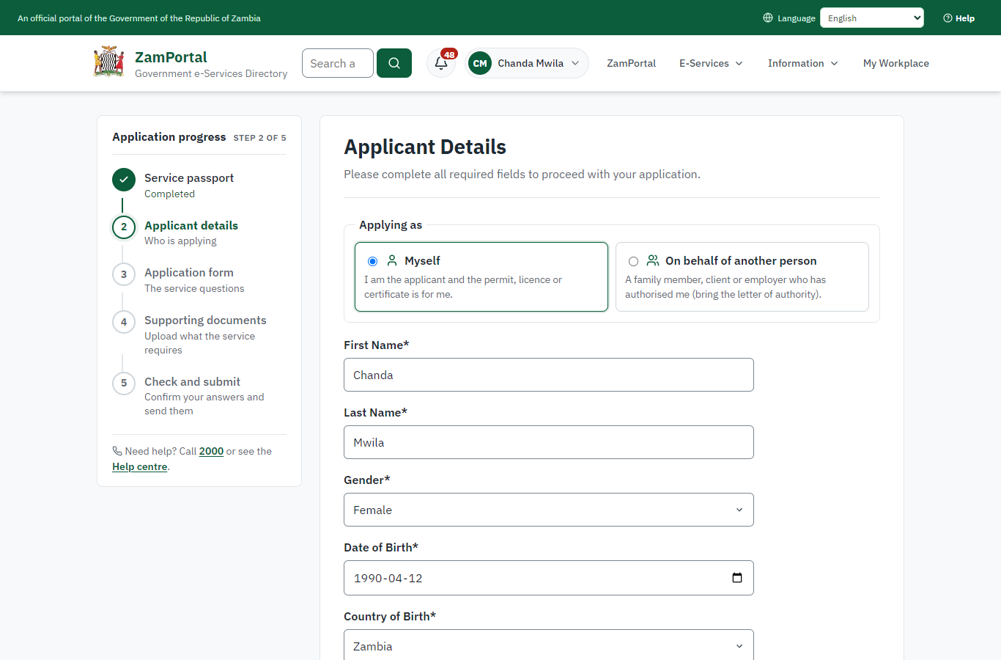 | 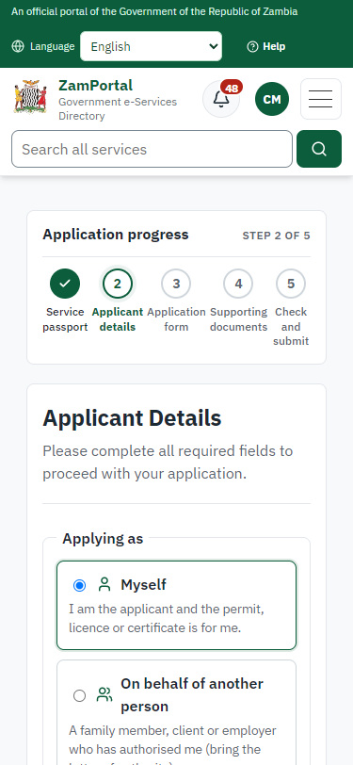
Step 3: Confirm the applicant details - desktop (left) and a 375 px phone (right).

Step 4. Fill in the application form
Citizen · National e-Services portal
The citizen answers the service's own application form, converted from the legacy system (4 answers in this run, all synthetic), for the type of application "New". Questions marked * must be answered; some appear only after an earlier answer. Answers are saved as the citizen types, so an unfinished application can be reopened from My Workplace.
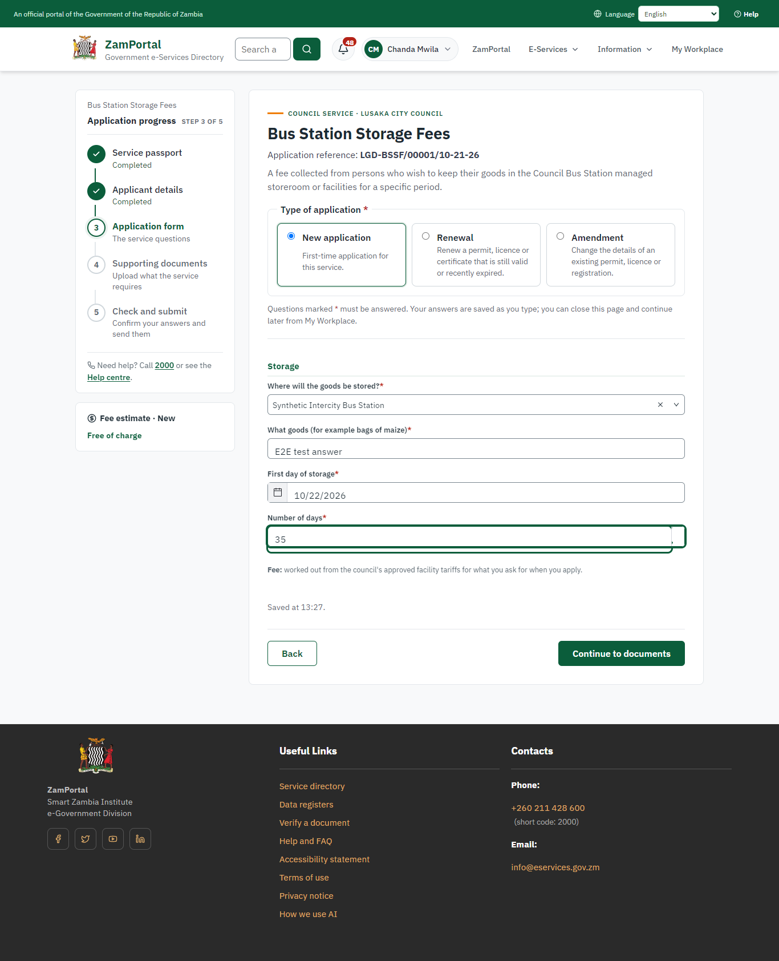 | 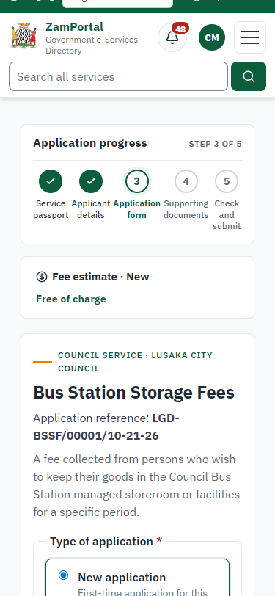
Step 4: Fill in the application form - desktop (left) and a 375 px phone (right).

Step 5. Upload the supporting documents
Citizen · National e-Services portal
Each document the service asks for has its own upload (6 in this run: Standard Requirements for Applicant, Applicant/Representative Identity Document, Applicant/Representative Certificate of Registration, Negative Scenario, Applicant applies, pays, Case Officer reviews the case, signs GS-2 Rejection). The files are checked and stored with the application; the page confirms each upload.
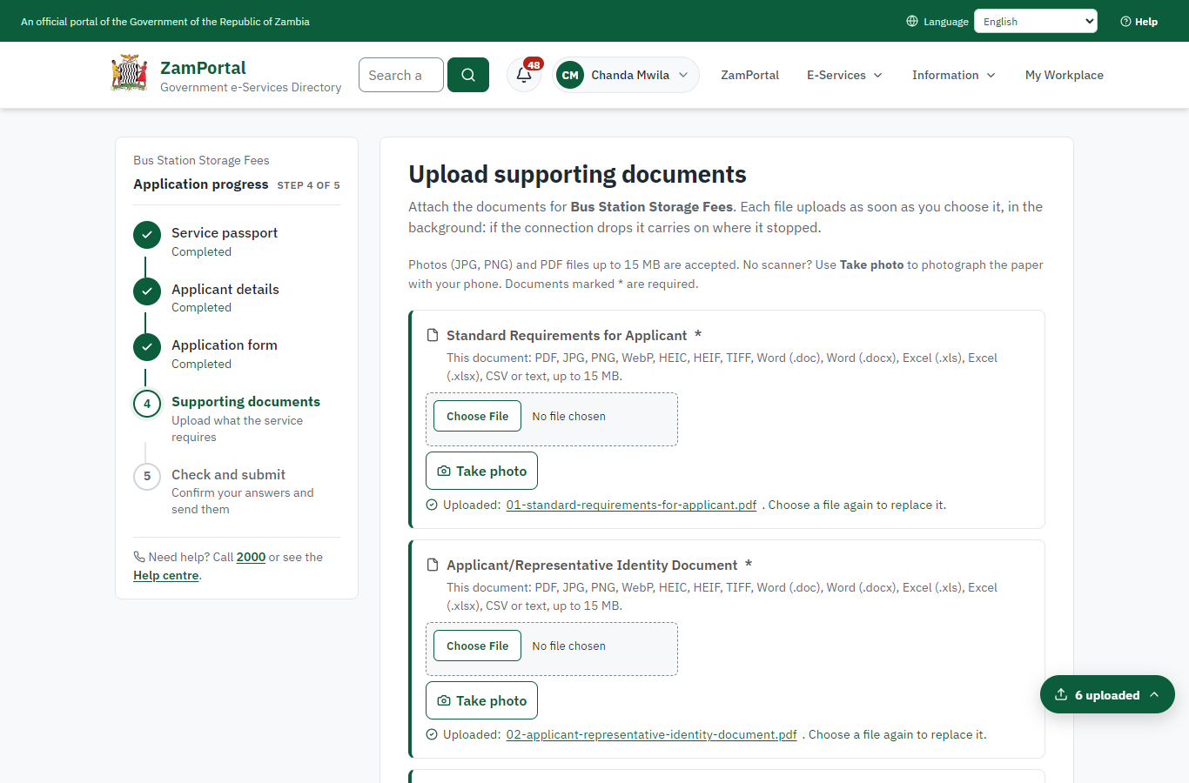 | 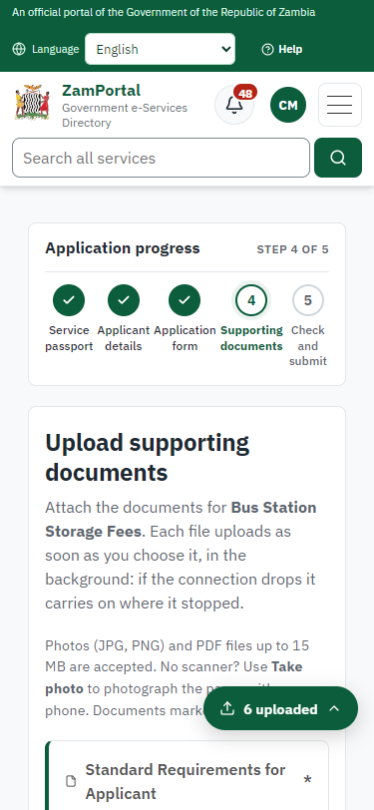
Step 5: Upload the supporting documents - desktop (left) and a 375 px phone (right).

Step 6. Check the answers and confirm the declaration
Citizen · National e-Services portal
Before sending, the citizen sees every answer and document on one page and can go back to change them. The declaration that the information is true and complete must be ticked.
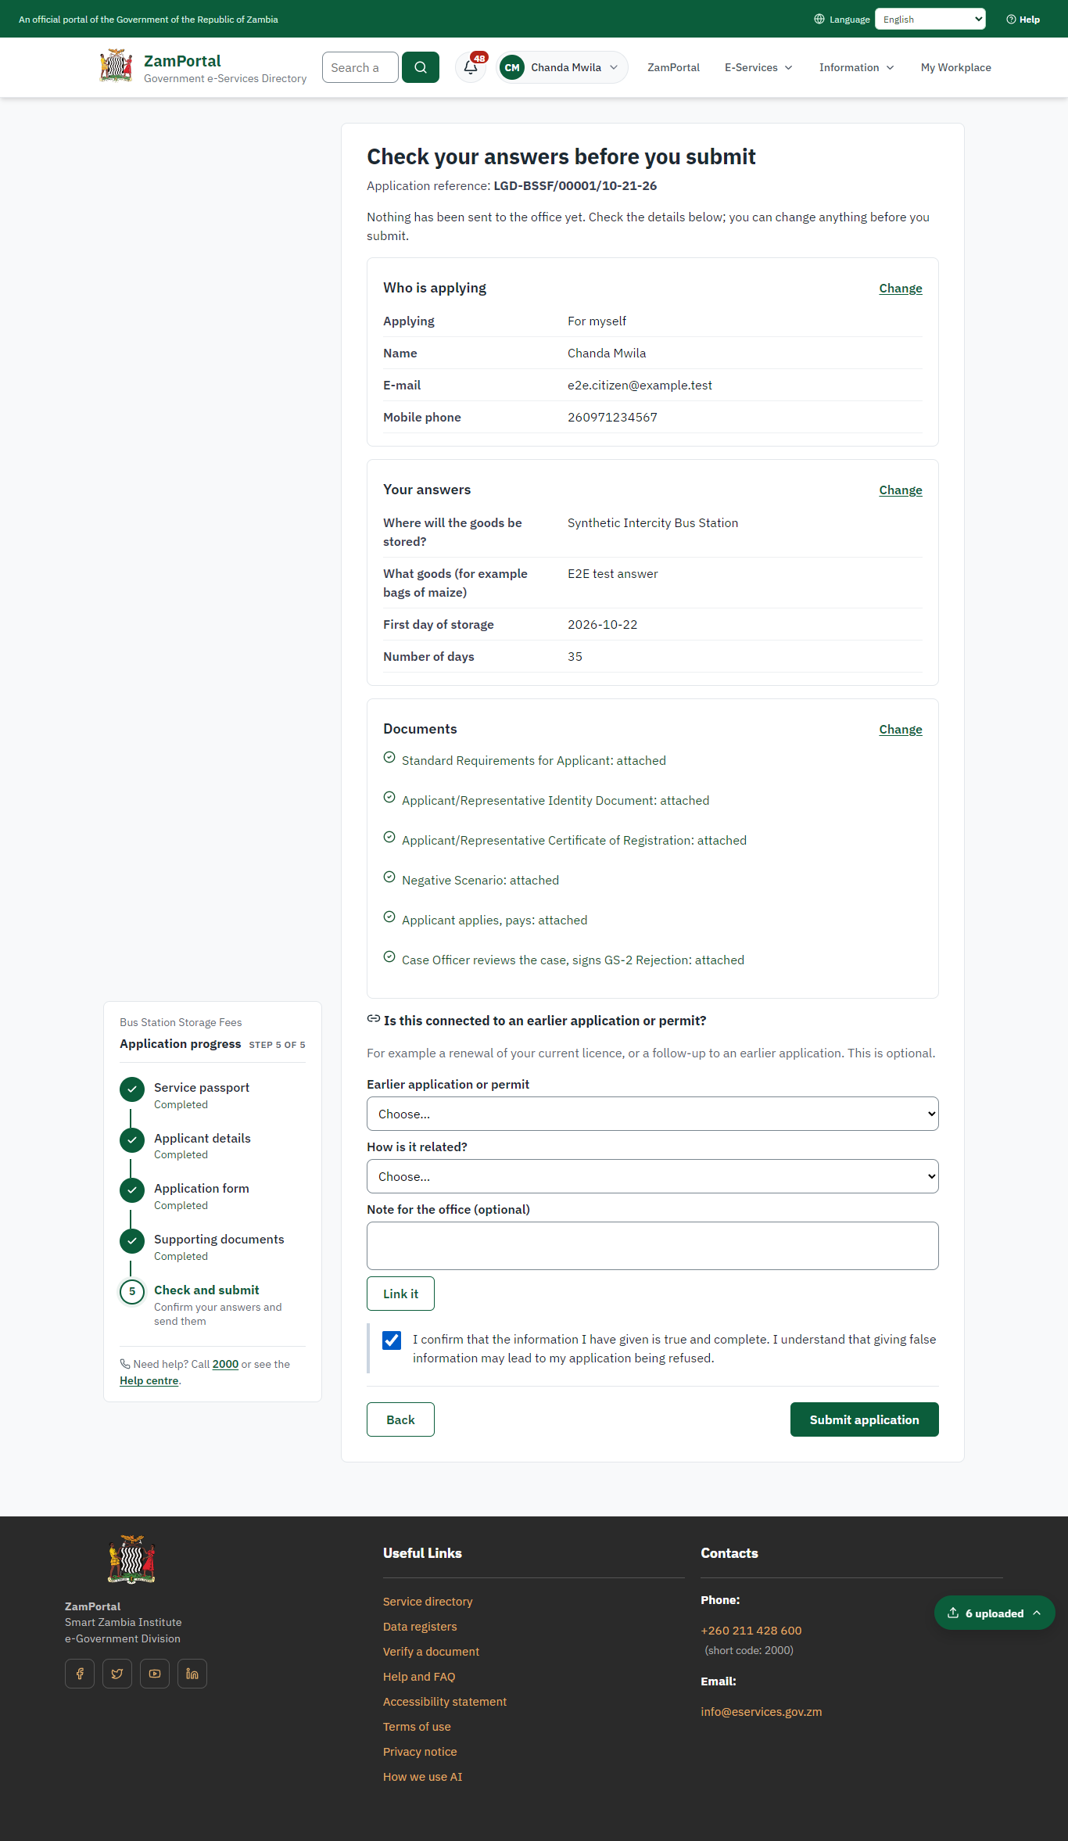 | 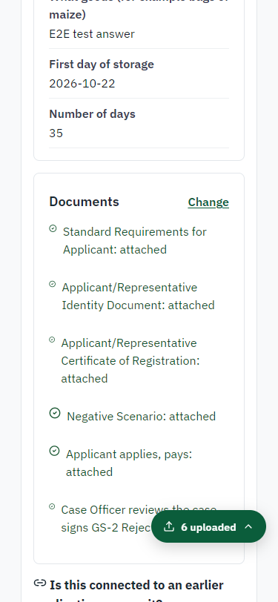
Step 6: Check the answers and confirm the declaration - desktop (left) and a 375 px phone (right).

Step 7. Application sent
Citizen · National e-Services portal
The portal confirms the application with the ministry's reference number (LGD-BSSF/00001/10-21-26 in this run). The fee is due now: it is taken with the application, so the invoice was raised when the application was sent.
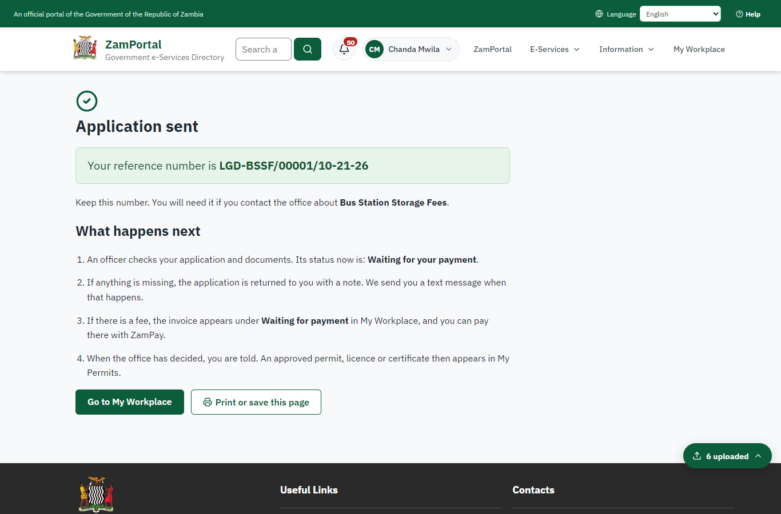 | 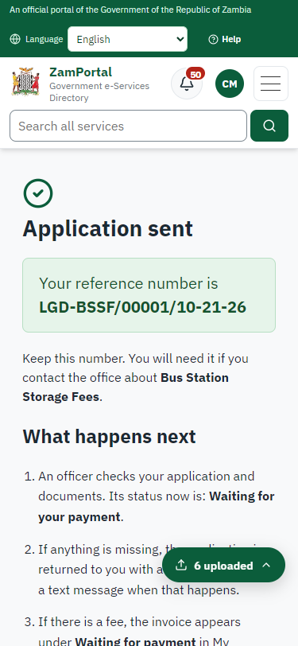
Step 7: Application sent - desktop (left) and a 375 px phone (right).

Step 8. See that the fee is due
Citizen · National e-Services portal
The application shows "Waiting for your payment" in My Workplace with a Pay button (K140.00). The fee is taken with the application; the invoice was raised on ZamPay.
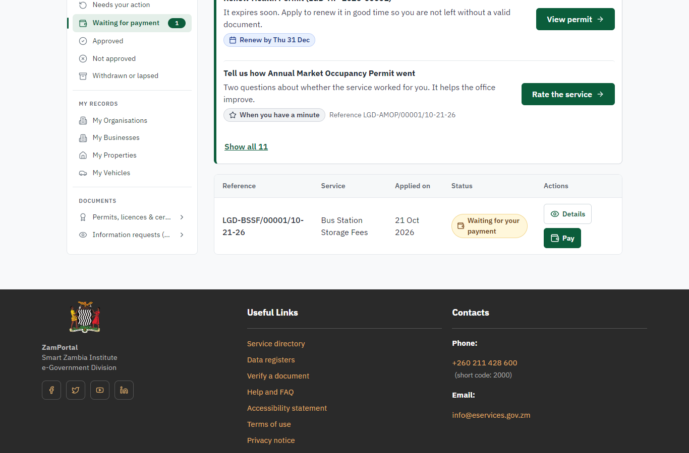 | 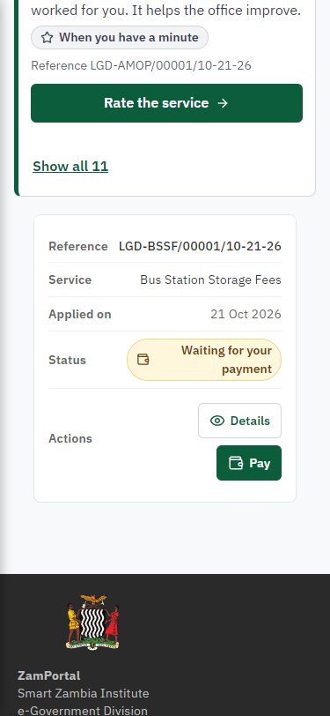
Step 8: See that the fee is due - desktop (left) and a 375 px phone (right).

Step 9. Pay with ZamPay
Citizen · National e-Services portal
Pay opens the invoice (K140.00, the amount set by the platform, never by the page) with its PDF preview; the citizen pays at ZamPay by mobile money or bank card.
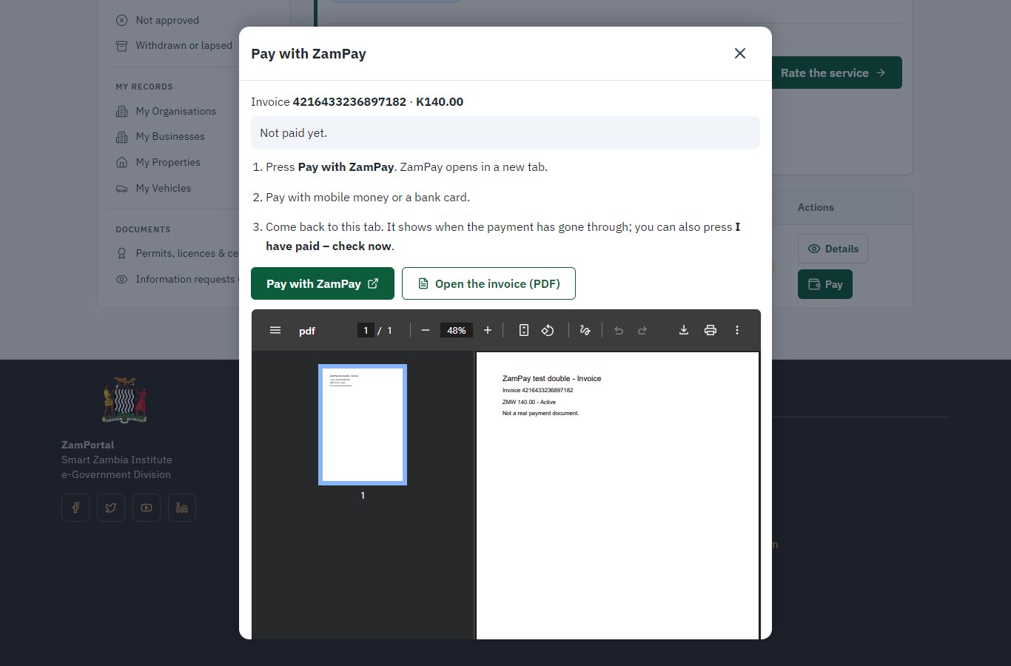 | 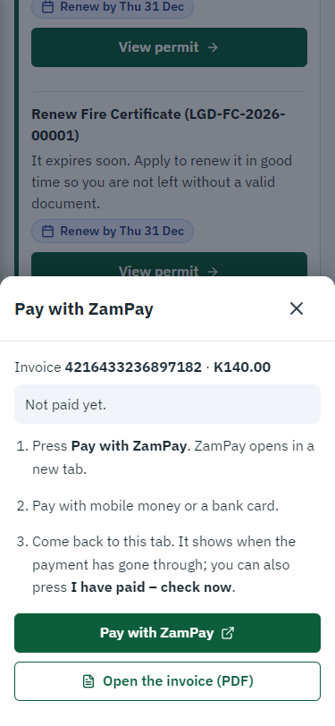
Step 9: Pay with ZamPay - desktop (left) and a 375 px phone (right).

Step 10. Payment received
Citizen · National e-Services portal
ZamPay reports the payment; the dialog says "Paid. Thank you" and the application moves on to the ministry's officers.
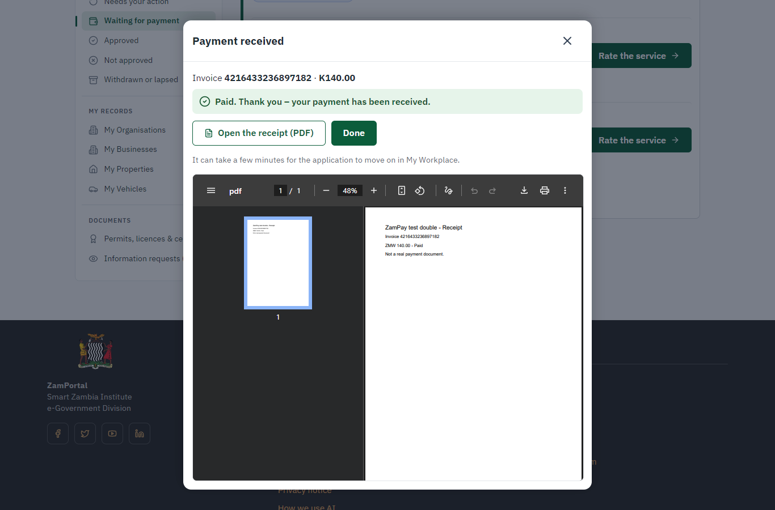 | 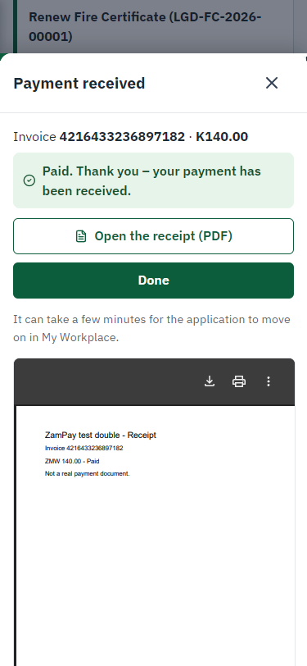
Step 10: Payment received - desktop (left) and a 375 px phone (right).

3. Payment
On screen: step 8 (See that the fee is due), step 9 (Pay with ZamPay), step 10 (Payment received) in section 2.

4. Output documents

GS-2 Notice of Government Action (PDF)
The service grants no certificate, licence or permit: when the case is completed the applicant downloads this notice of the government action from the application in My Workplace.
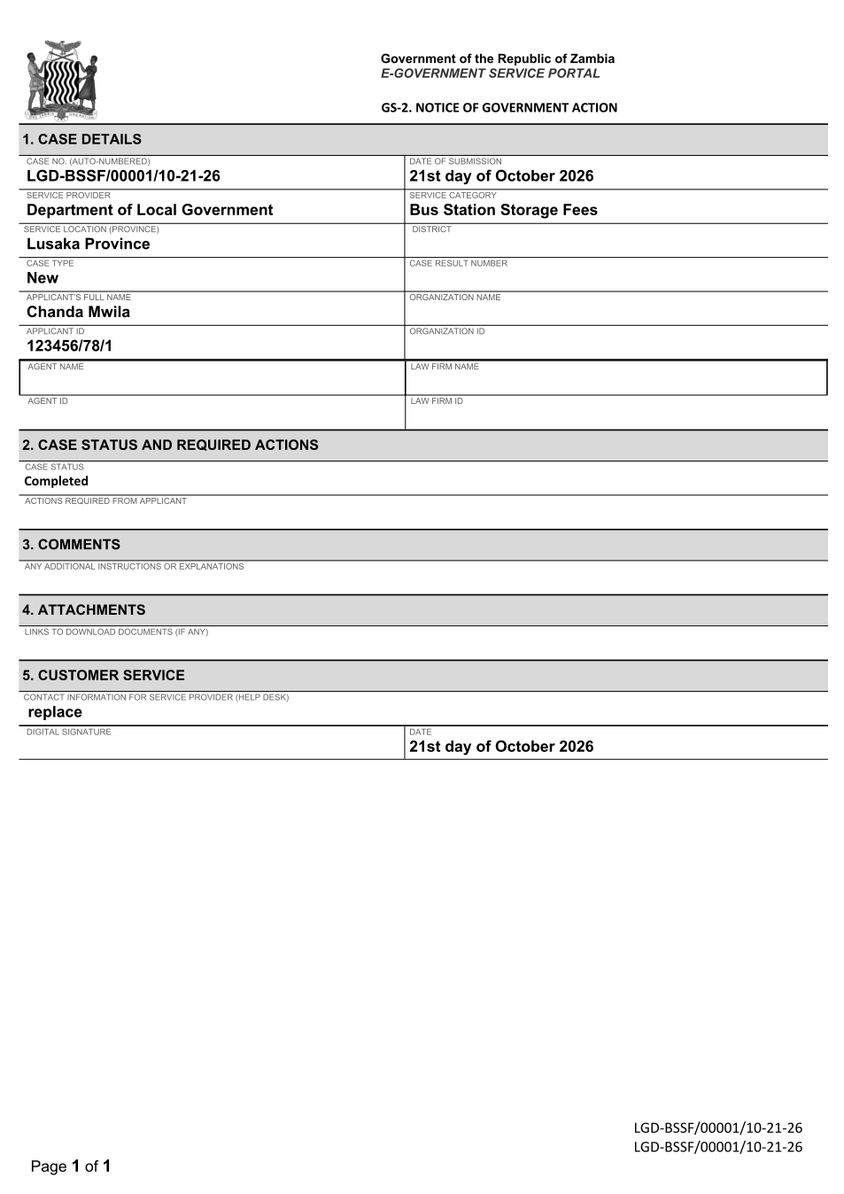
GS-2 Notice of Government Action (PDF) - first of 1 page, as issued in the test run.

Fields
Field | Value in the test run
Line 1 | LGD-BSSF/00001/10-21-26
Line 2 | LGD-BSSF/00001/10-21-26
Line 3 | Page 1 of 1
Line 4 | Government of the Republic of Zambia
Line 5 | E-GOVERNMENT SERVICE PORTAL
Line 6 | GS-2. NOTICE OF GOVERNMENT ACTION
Line 7 | 1. CASE DETAILS
Line 8 | CASE NO. (AUTO-NUMBERED)
Line 9 | LGD-BSSF/00001/10-21-26
Line 10 | DATE OF SUBMISSION
Line 11 | 21st day of October 2026
Line 12 | SERVICE PROVIDER
Line 13 | Department of Local Government
Line 14 | SERVICE CATEGORY

5. Notifications
When | Channel | To | Message | Delivery
Payment due (invoice raised) | in-app (portal bell) | the applicant | Payment due for application LGD-BSSF/00001/10-21-26 - The fee of ZMW 140.00 for Bus Station Storage Fees (LGD-BSSF/00001/10-21-26) is now due. Invoice 4216433236897182. | shown
Application received | in-app (portal bell) | the applicant | Application LGD-BSSF/00001/10-21-26 received - Your application LGD-BSSF/00001/10-21-26 for Bus Station Storage Fees has been received by Department of Local Government. | shown
Invitation to rate the service | in-app (portal bell) | the applicant | How was Bus Station Storage Fees? - How was Bus Station Storage Fees? Tell us in about a minute. | shown
Payment received | in-app (portal bell) | the applicant | Payment received for LGD-BSSF/00001/10-21-26 - Your payment of ZMW 140.00 for LGD-BSSF/00001/10-21-26 (Bus Station Storage Fees) has been received. Receipt: <ZamPay>/pdf?documentType=receipt&invoiceNumber=4216433236897182 | shown
Decision: approved | in-app (portal bell) | the applicant | Application LGD-BSSF/00001/10-21-26 completed - LGD-BSSF/00001/10-21-26 (Bus Station Storage Fees) is complete. Your documents are ready. | shown
Payment due (invoice raised) | sms | +260 97* *** 567 | Fee of ZMW 140.00 due for LGD-BSSF/00001/10-21-26. Invoice 4216433236897182. Pay: <ZamPay>/pay-for-service/get-invoice/4216433236897182 | delivered
Payment due (invoice raised) | email | e2e.c***@example.test | Payment due for application LGD-BSSF/00001/10-21-26 | skipped
Application received | sms | +260 97* *** 567 | Application LGD-BSSF/00001/10-21-26 for Bus Station Storage Fees has been received. Track it: <portal>/my-workplace | delivered
Application received | email | e2e.c***@example.test | Application LGD-BSSF/00001/10-21-26 received | skipped
Invitation to rate the service | sms | +260 97* *** 567 |  | skipped
Invitation to rate the service | email | e2e.c***@example.test | How was Bus Station Storage Fees? | skipped
Payment received | sms | +260 97* *** 567 | Your payment of ZMW 140.00 for application LGD-BSSF/00001/10-21-26 (Bus Station Storage Fees) has been received. Receipt: <ZamPay>/pdf?documentType=receipt&invoiceNumber=4216433236897182 Processing continues. | delivered
Decision: approved | sms | +260 97* *** 567 | LGD-BSSF/00001/10-21-26 (Bus Station Storage Fees) is complete. Download your documents: <portal>/my-workplace | delivered
Decision: approved | email | e2e.c***@example.test | Application LGD-BSSF/00001/10-21-26 completed | skipped
Delivery: shown = in the portal's notification bell; delivered = the SMS gateway (a test double in this run) reported the text delivered; skipped = not sent on that channel (e-mail is not configured on the test installation, and some notices go out on one channel only); sent by the national portal = a ministry node handed the notice to the national portal, which texts and e-mails the citizen under its own name and the citizen's preferences. Addresses written <portal>, <ZamPay> stand for the national portal and ZamPay.

6. Legacy mapping
Replaces | Bus Station Storage Fees in the legacy ZIGS e-Services directory (ZIGS_Services)
Legacy service id | 613
Legacy provider | Department of Local Government (LGD) under Ministry of Local Government and Rural Development
Legacy process | not recorded
Fee in the legacy system | none
Fee taken before submission | yes (as in ZIGS)
Time to issue (legacy) | not recorded
Legacy output templates | GS-1 Application for a Government Service: ZIGS_Forms_ZDA / GS1  GS-2 Notice of Government Action: ZIGS_Forms_Notices / GS-2.NoticeOfAction
Legacy address | https://ecouncils.gsb.gov.zm
How it was brought over | Imported by the platform's legacy catalogue importer (zcm-backend scripts/zigs/importLegacy.js) from the ZIGS snapshot: form, case types, fees, documents, process and output templates, then served by the new platform.

7. Version and date
Document version | service v1, platform 7eecca5c
Generated | 2026-10-21T11:27:50Z (by the end-to-end run, not edited by hand)
Service version | not versioned (configured directly)
Platform snapshot | backend 7eecca5c  portal 72805f0  back office 58e5946
Test suite | e2e 2f82c10; one installation (combined); seed profile mihud
Journeys | 30-catalogue-service.spec.js: citizen finds the service, answers its form, uploads its documents and sends the application - passed  30-catalogue-service.spec.js: the case goes through every step of its process: payments by the citizen, each officer step by its role - passed  30-catalogue-service.spec.js: the grant document is issued, sealed, filled in and verifiable; the citizen has it in My permits - passed
Result | 3 of 3 journey tests passed
Data | Synthetic test data on a local test installation; provider test doubles for ZamPass, ZamPay, SMS and signing.

