Republic of Zambia
GSB e-Services

Boilers and Air Receivers Authorisation
Service documentation
Owner: Minerals Regulation Commission
Service key: MSMS/boilers-and-air-receivers-authorisation
Version: service v1, platform a0a302b8
Date: 2026-10-21
Generated automatically by the service's end-to-end test run. Every screenshot shows synthetic test data on a local test installation, never real personal data.

Contents
- 1. Service summary
- 2. Application process, step by step
- 3. Payment
- 4. Output documents
- 5. Notifications
- 6. Legacy mapping
- 7. Version and date
This document describes the Boilers and Air Receivers Authorisation service of Minerals Regulation Commission as the platform runs it today. It is generated by the service's end-to-end test: every step was performed by the test and every screenshot was taken during that run, with synthetic data. Regenerate it with "npm run docs:services" in the e2e suite; do not edit it by hand.

1. Service summary
Service | Boilers and Air Receivers Authorisation
Owner (MDA) | Minerals Regulation Commission (MSMS)
Purpose | This is an Approval given to a Mining Company/Processing Plants/Explosive Manufacturing Plants authorizing the use of Boilers and Air Receivers
Who can apply | Not set in the service configuration.
How to apply | Online on the national e-Services portal, signed in with ZamPass; pay with ZamPay.
Fees | Not set in the service configuration.
Turnaround | Not set in the service configuration.
Validity of the output | Not applicable
Required documents | None
Output documents | Boilers and Air Receivers Authorisation  Boilers and Air Receivers Authorisation  GS-1 Application for a Government Service  GS-2 Notice of Government Action

2. Application process, step by step

The process as configured
Step | Role | Task | Type
1 | Applicant | Apply | form
2 | System | Generate Document | generate-document
3 | Supervisor | Review | review
4 | Case Officer | Review | review
5 | Case Officer | Review | review
6 | Case Officer | Review | review
7 | Executive | Approve | approve
8 | Case Officer | Review | review
9 | Case Officer | Approve | approve
10 | System | Generate Document | generate-document
11 | System | Notify Client | notify

Step by step
Who takes part in this journey: Citizen, Case Officer, Supervisor, Executive, Anyone (public). Citizen steps are shown on a desktop and on a 375 px phone; back-office steps on a desktop.

Step 1. Find the service
Citizen · National e-Services portal
On the national e-Services portal the citizen opens All Services and searches for the service by name ("Boilers and Air Receivers Authorisation"). Each result names the service and the ministry that provides it.
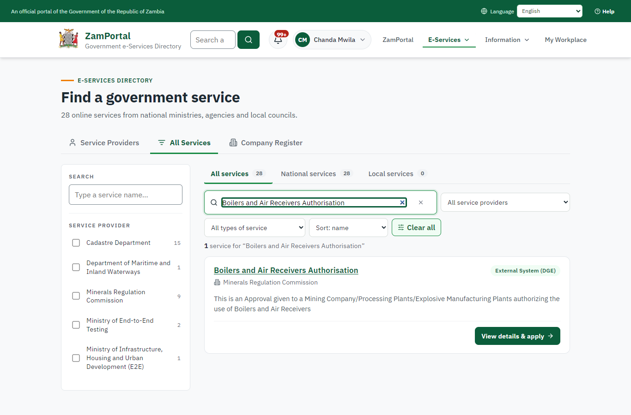 | 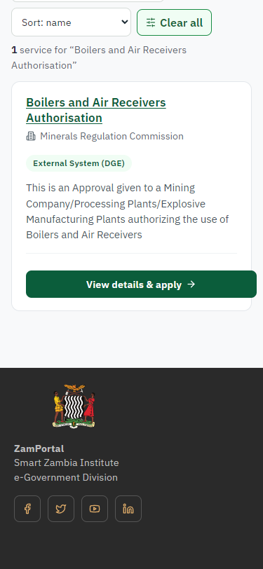
Step 1: Find the service - desktop (left) and a 375 px phone (right).

Step 2. Read the service page
Citizen · National e-Services portal
The service page sets out what the service is for, who provides it, the fee, how long it takes and the documents to have ready. "Start application" begins an application (the citizen is signed in with ZamPass).
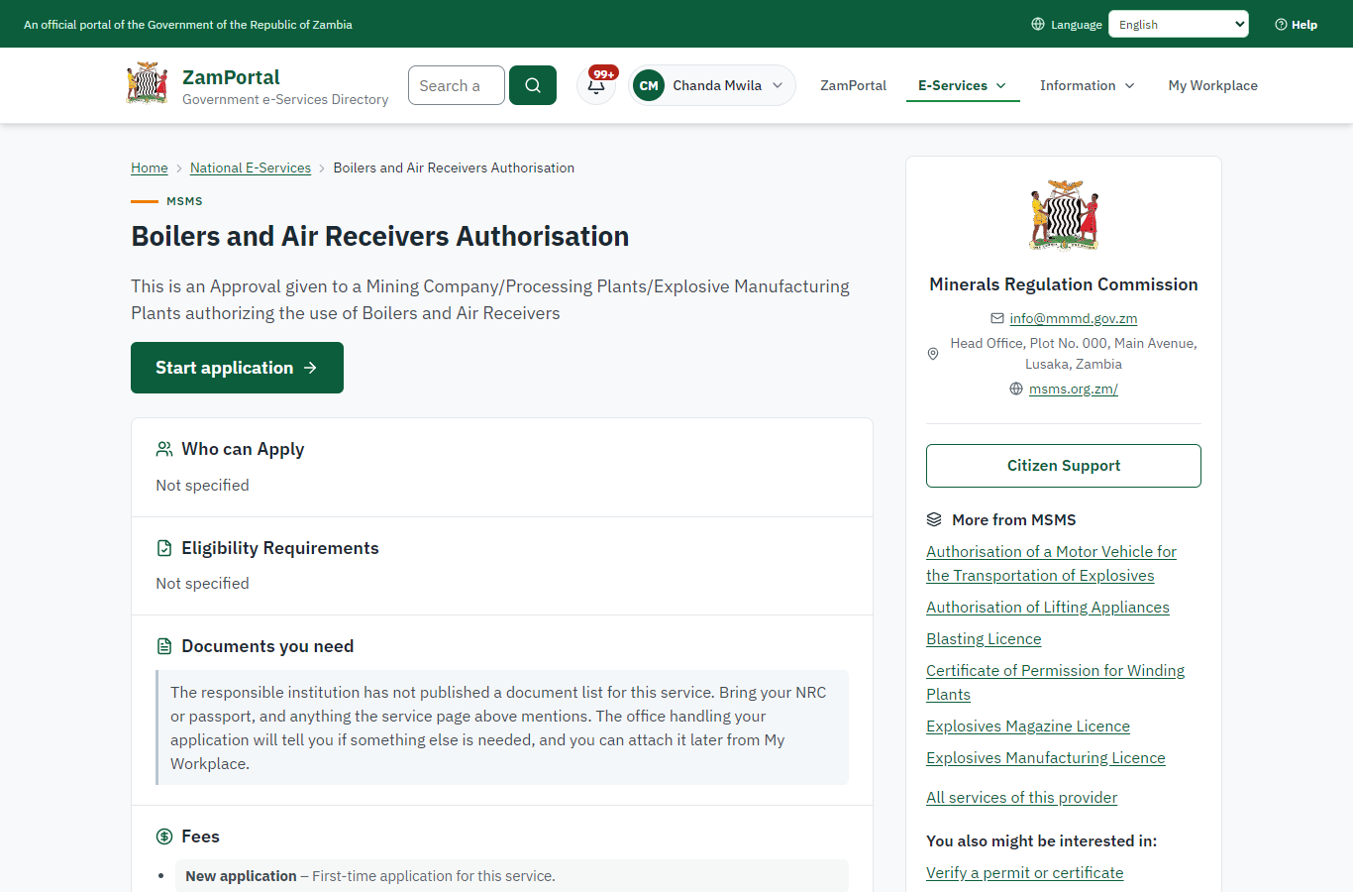 | 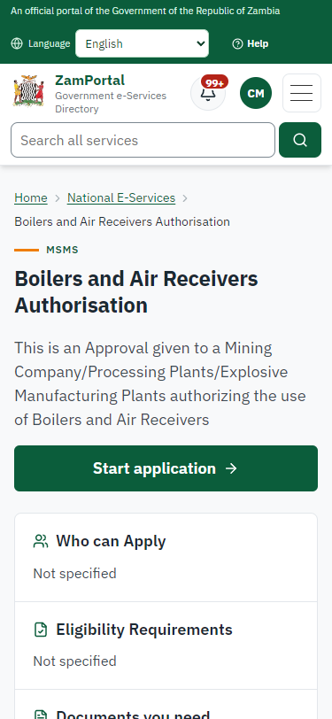
Step 2: Read the service page - desktop (left) and a 375 px phone (right).

Step 3. Confirm the applicant details
Citizen · National e-Services portal
The applicant details are filled in from the citizen's ZamPass account. The citizen says whom they are applying for (themself) and continues with "Proceed to Application".
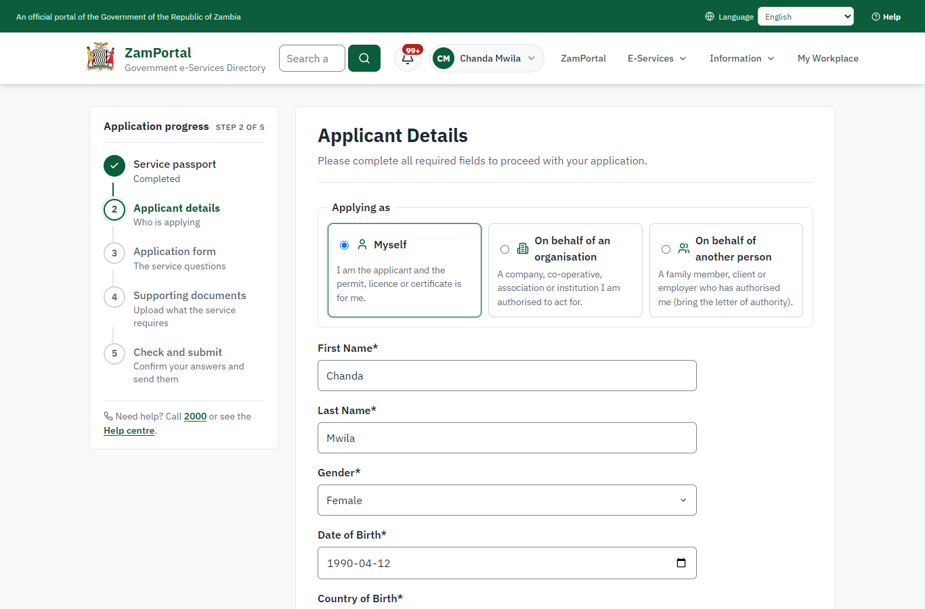 | 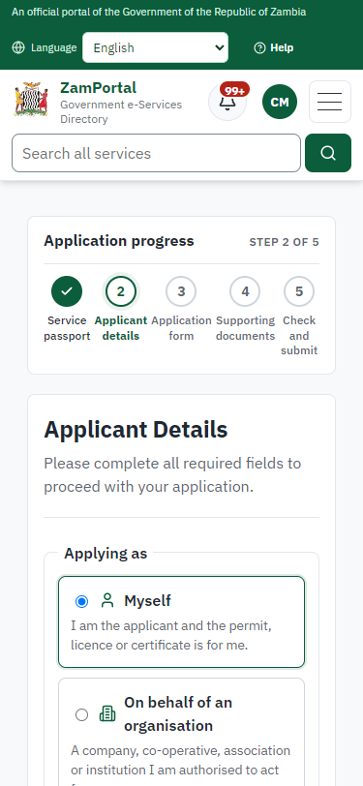
Step 3: Confirm the applicant details - desktop (left) and a 375 px phone (right).

Step 4. Fill in the application form
Citizen · National e-Services portal
The citizen answers the service's own application form, converted from the legacy system (12 answers in this run, all synthetic), for the type of application "New". Questions marked * must be answered; some appear only after an earlier answer. Answers are saved as the citizen types, so an unfinished application can be reopened from My Workplace.
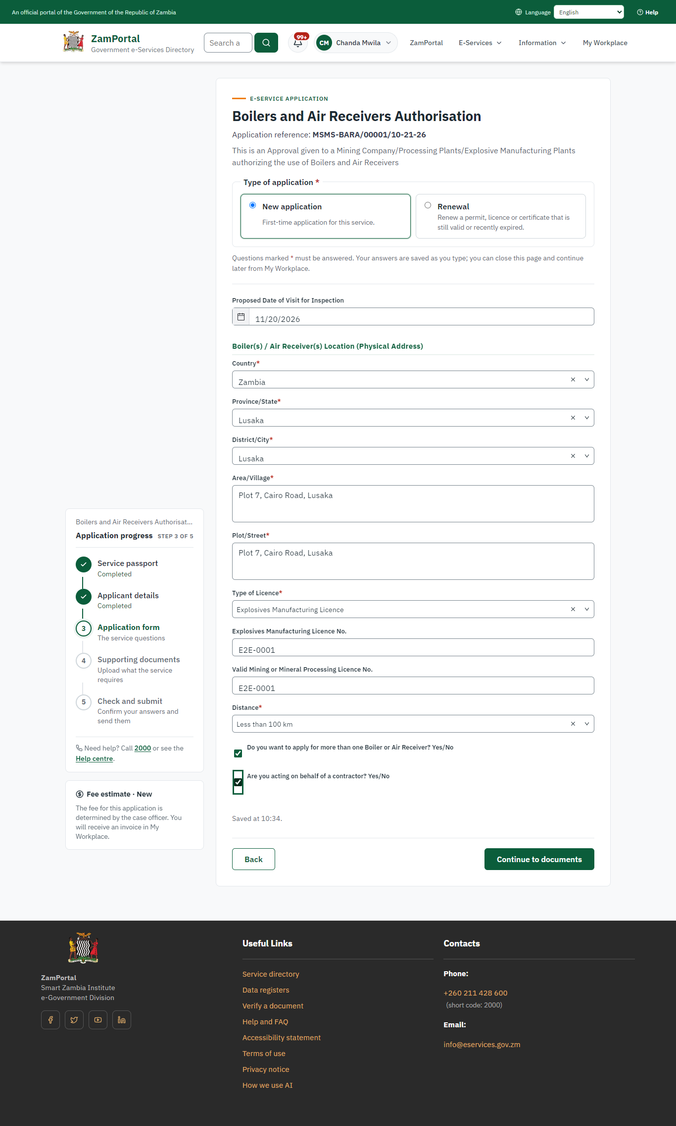 | 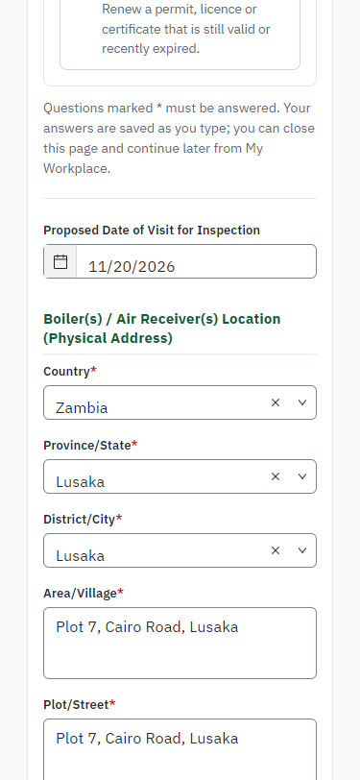
Step 4: Fill in the application form - desktop (left) and a 375 px phone (right).

Step 5. Upload the supporting documents
Citizen · National e-Services portal
The service asks for no supporting documents, so the citizen continues straight to the check of the answers.
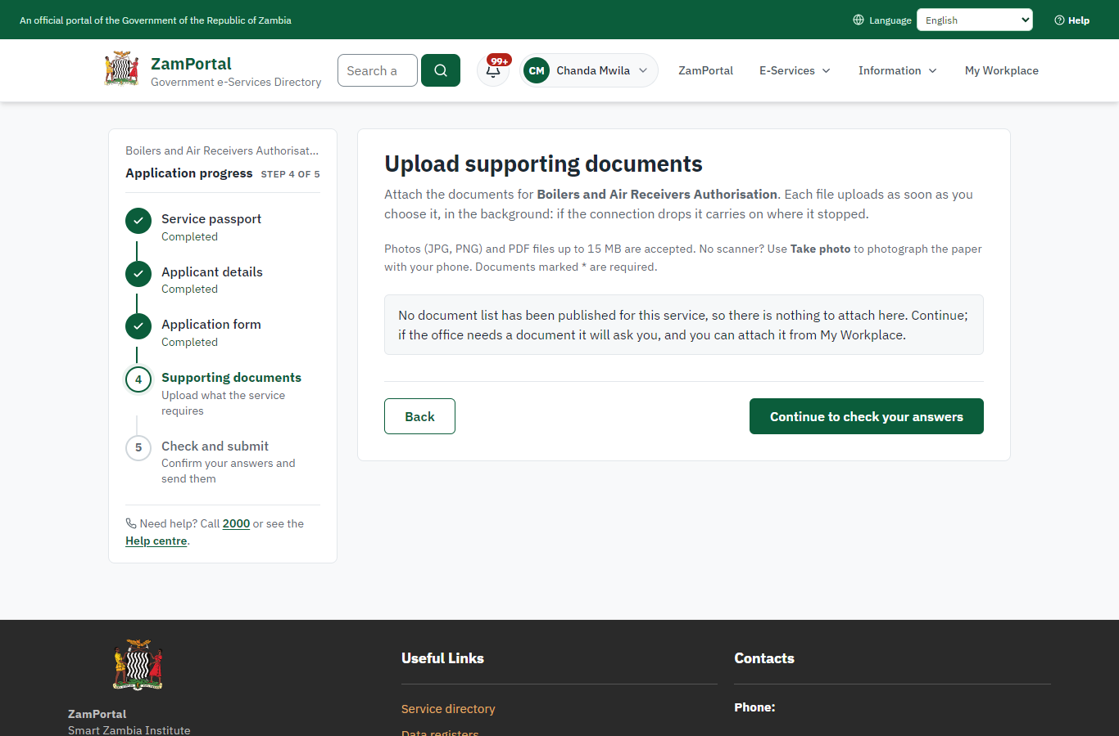 | 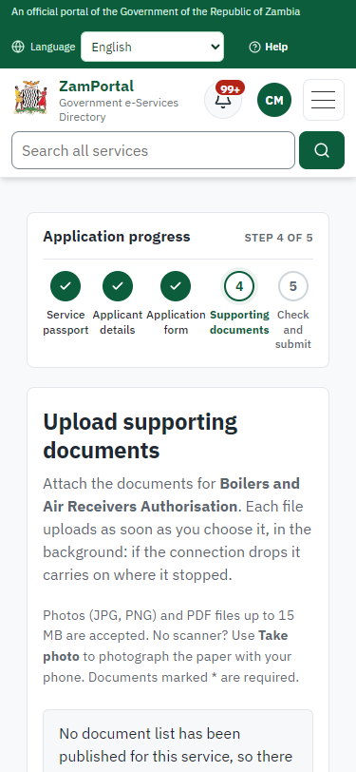
Step 5: Upload the supporting documents - desktop (left) and a 375 px phone (right).

Step 6. Check the answers and confirm the declaration
Citizen · National e-Services portal
Before sending, the citizen sees every answer and document on one page and can go back to change them. The declaration that the information is true and complete must be ticked.
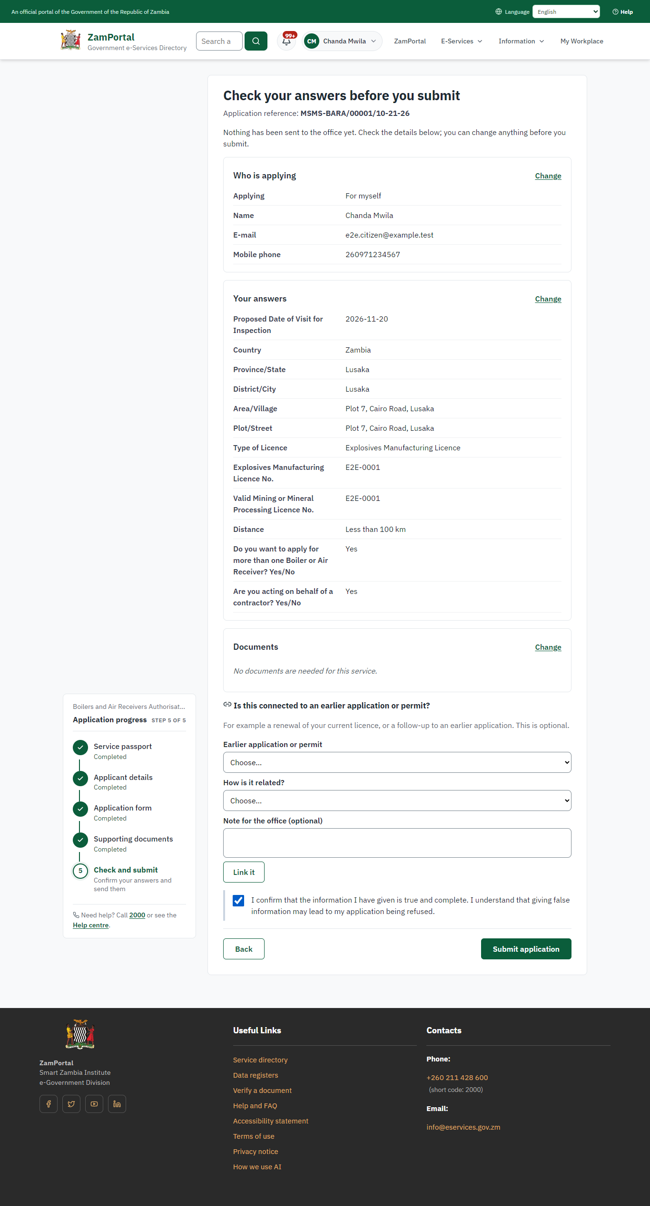 | 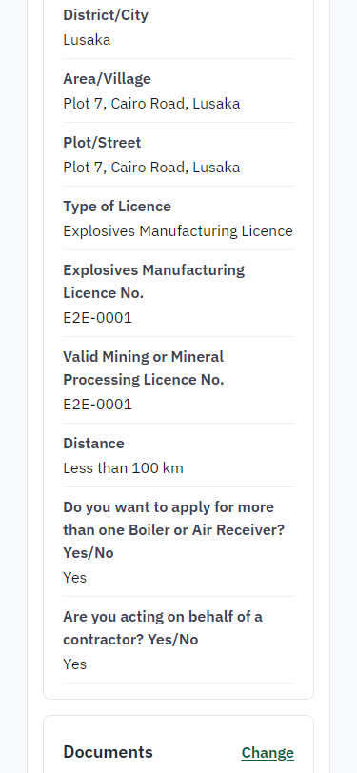
Step 6: Check the answers and confirm the declaration - desktop (left) and a 375 px phone (right).

Step 7. Application sent
Citizen · National e-Services portal
The portal confirms the application with the ministry's reference number (MSMS-BARA/00001/10-21-26 in this run). The application goes to the ministry's officers; the citizen follows it in My Workplace.
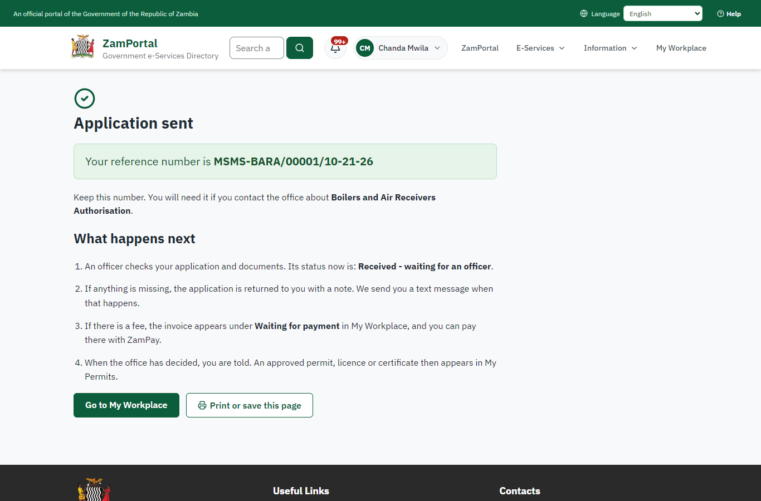 | 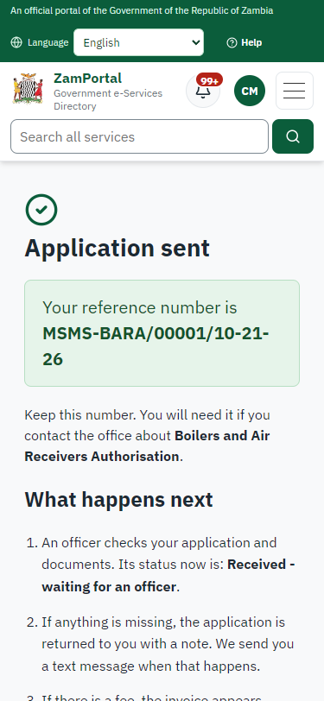
Step 7: Application sent - desktop (left) and a 375 px phone (right).

Step 8. Take the new application on
Case Officer · Back office
The application arrives in the case queue of the ministry that owns the service (Minerals Regulation Commission); only its staff see it. The officer opens it by its reference number - answers, documents and process are on the case - assigns it to themself and takes it on.
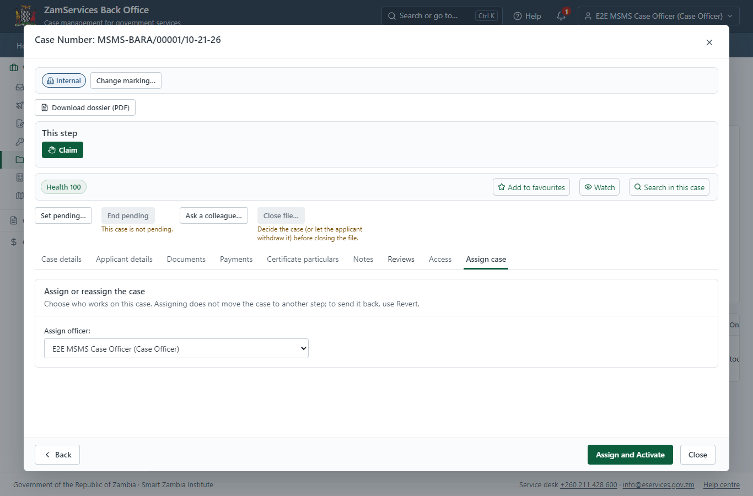
Step 8: Take the new application on.

Step 9. Fill in the certificate particulars
Case Officer · Back office
The issued document prints 14 fields that come from the office rather than from the application (Drawing no, Date examined, Service category, Registered office, Date of manufacture, Hydraulic date test, Air receiver capacity, Equipment manufacturer, Examination conditions, Max operating pressure, Equipment serial number, Hydraulic test pressure, Authorised working pressure, Equipment country of origin). The officer fills them in on the case's "Certificate particulars" tab before the document is issued (synthetic values in this run) and saves; once the document is issued they can no longer change.
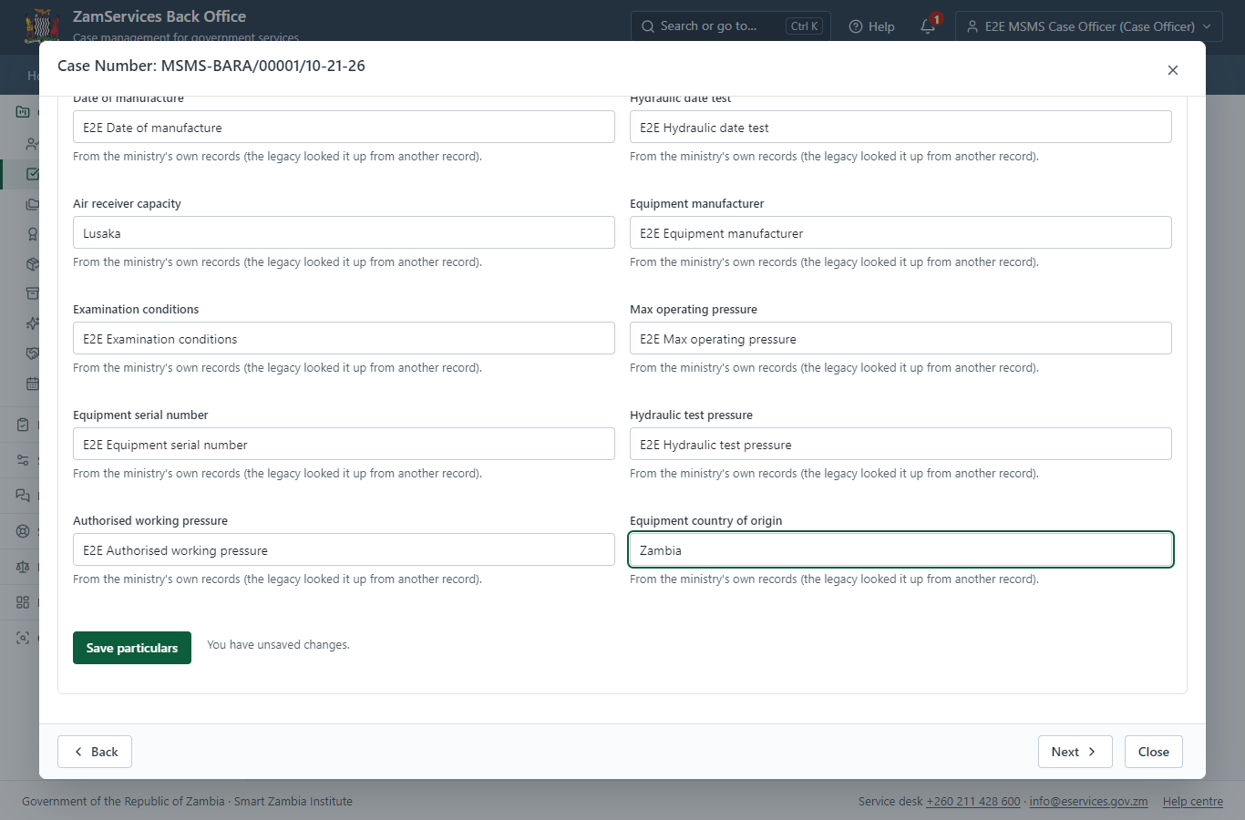
Step 9: Fill in the certificate particulars.

Step 10. Review, Inspect, Assign to Case Officer
Supervisor · Back office
The Supervisor works on "Review, Inspect, Assign to Case Officer" (review in the imported process), checks the application and its documents, and completes the step.
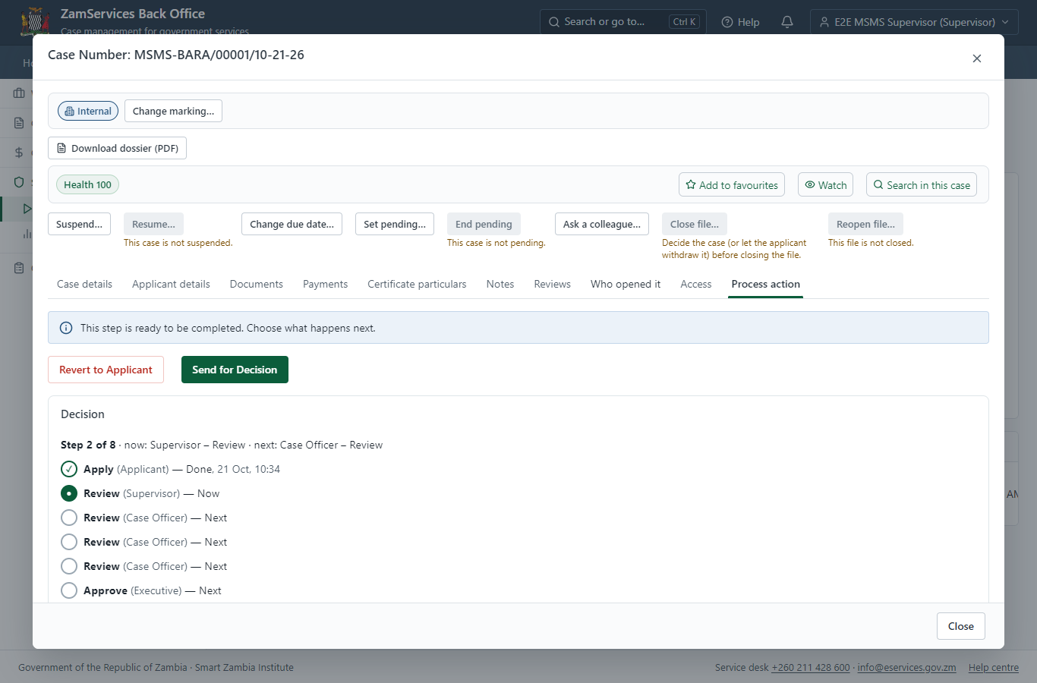
Step 10: Review, Inspect, Assign to Case Officer.

Step 11. Receive, Inspect, Report Findings
Case Officer · Back office
The Case Officer works on "Receive, Inspect, Report Findings" (review in the imported process), checks the application and its documents, and completes the step.
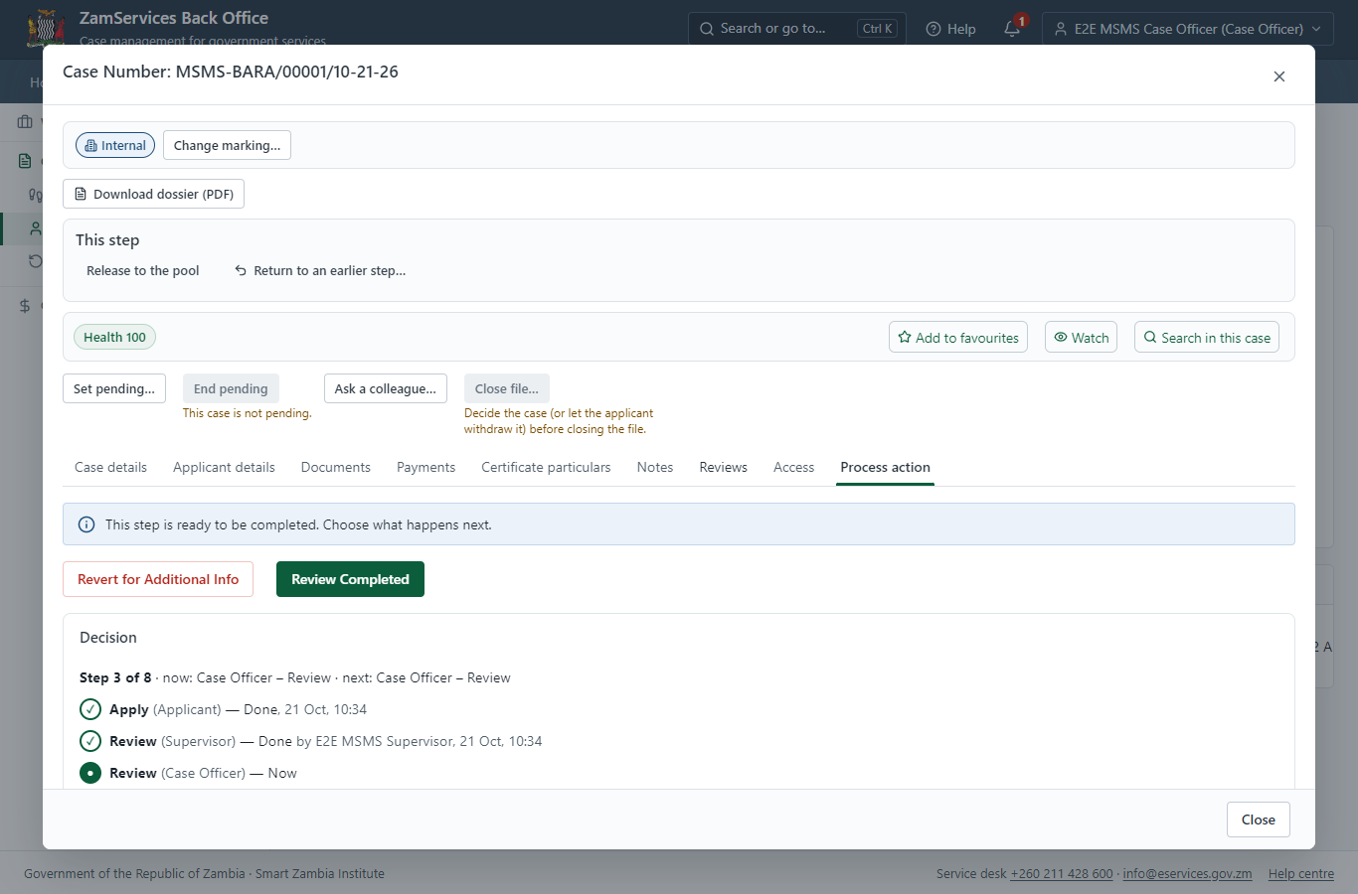
Step 11: Receive, Inspect, Report Findings.

Step 12. Draft Payment
Case Officer · Back office
The Case Officer works on "Draft Payment" (review in the imported process), checks the application and its documents, and completes the step.
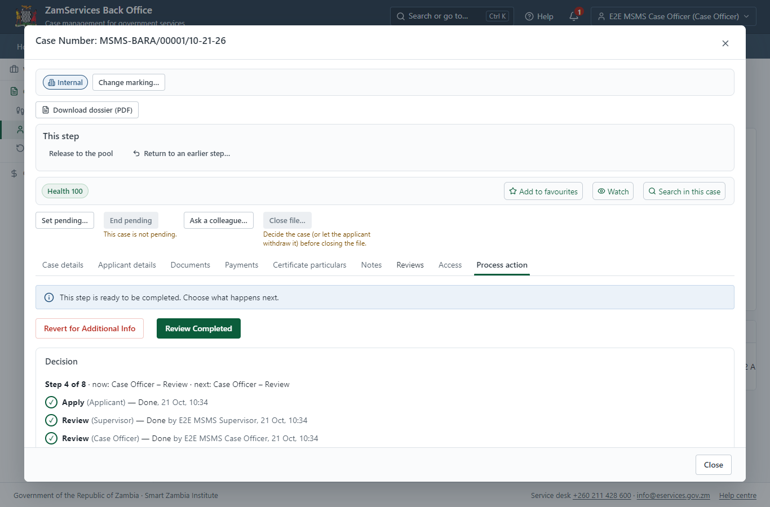
Step 12: Draft Payment.

Step 13. Request Director's Authority to Inspect
Case Officer · Back office
The Case Officer works on "Request Director's Authority to Inspect" (review in the imported process), checks the application and its documents, and completes the step.
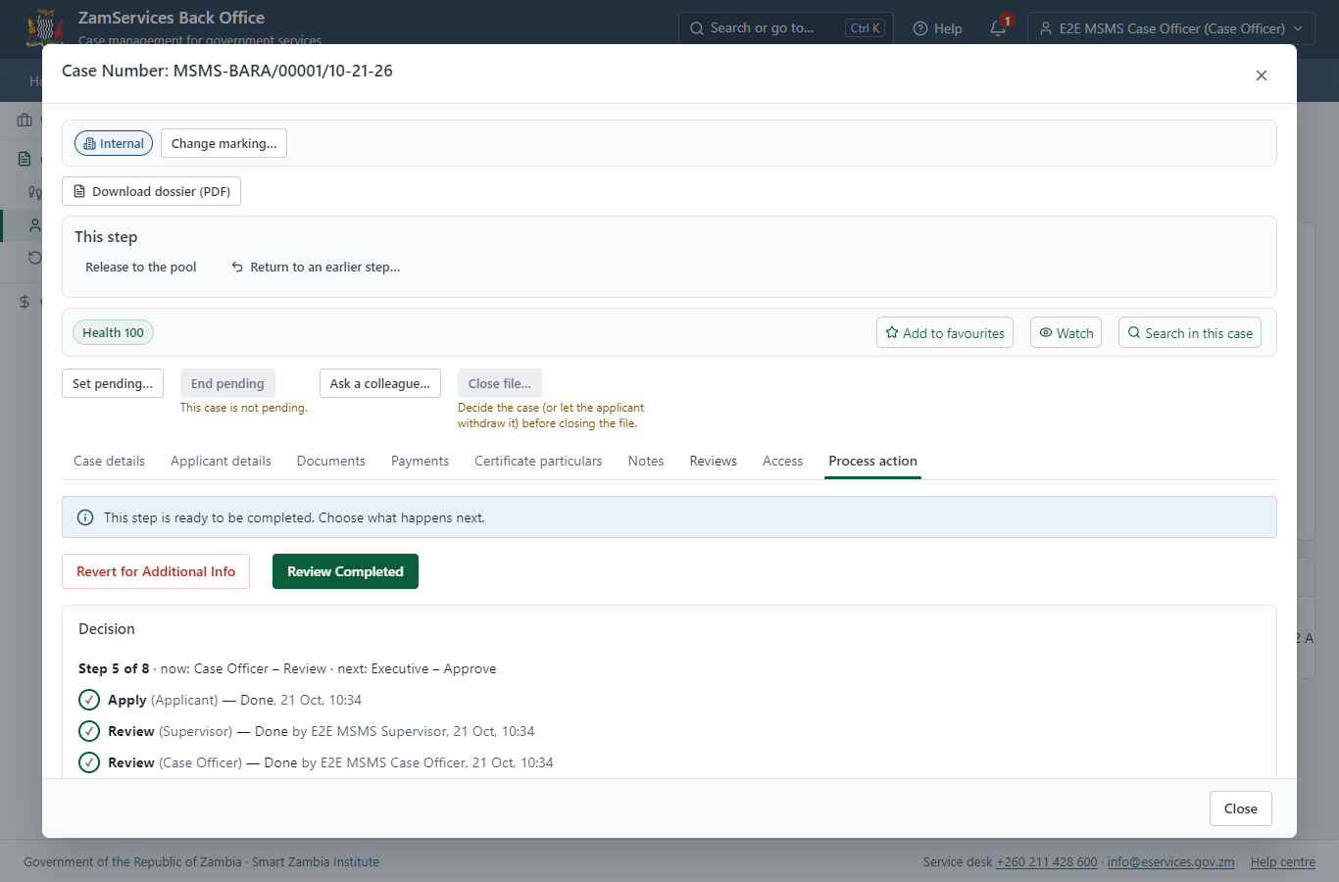
Step 13: Request Director's Authority to Inspect.

Step 14. Decide: Review the request, Approve
Executive · Back office
At "Review the request, Approve" the Executive records the decision: approve, with a comment kept in the case history. Approving moves the case on; the last decision completes it and issues the document.
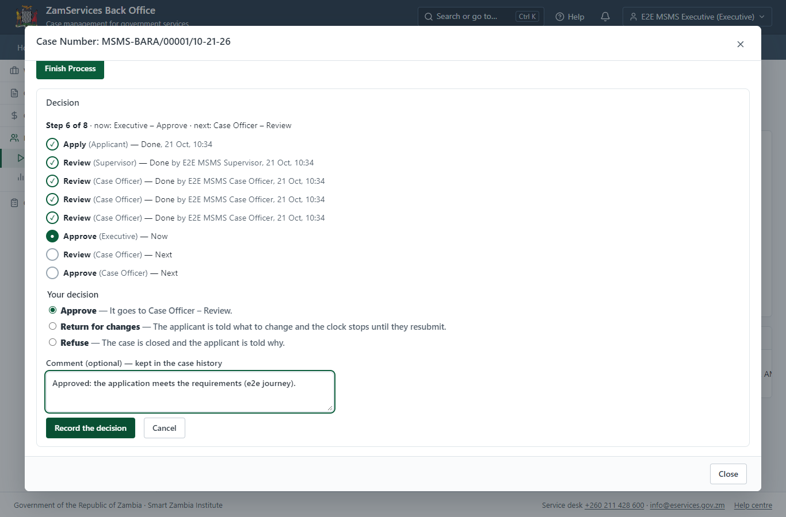
Step 14: Decide: Review the request, Approve.

Step 15. Inspect, Draft Certificate and Conditions, Send for Signature
Case Officer · Back office
The Case Officer works on "Inspect, Draft Certificate and Conditions, Send for Signature" (review in the imported process), checks the application and its documents, and completes the step.
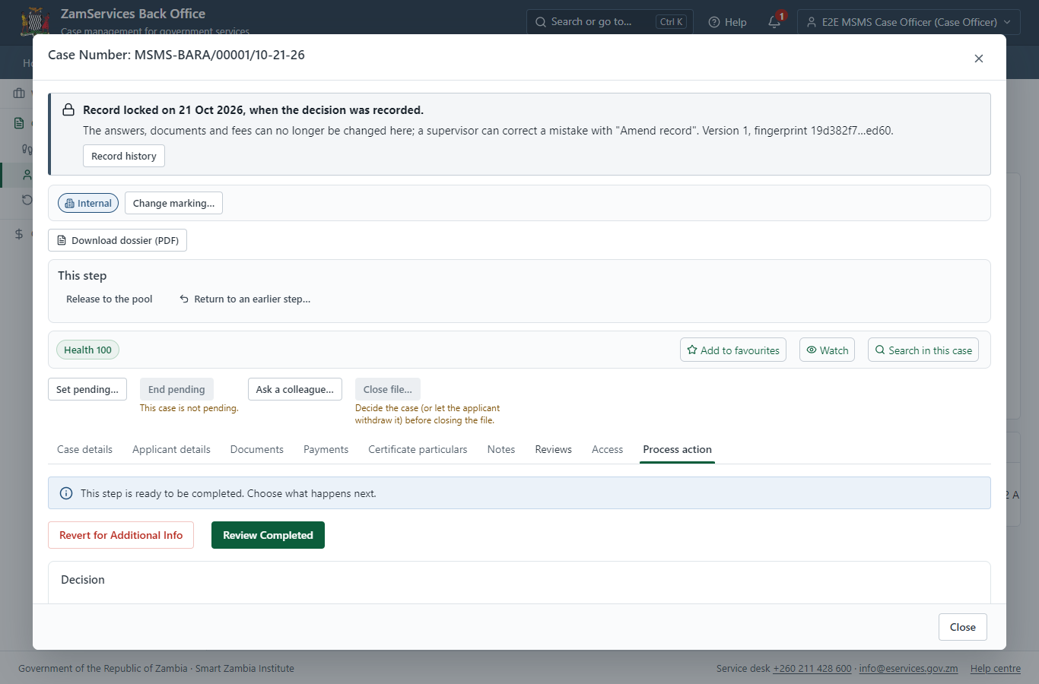
Step 15: Inspect, Draft Certificate and Conditions, Send for Signature.

Step 16. Decide: Review, e-Sign and Complete
Case Officer · Back office
At "Review, e-Sign and Complete" the Case Officer records the decision: approve, with a comment kept in the case history. Approving moves the case on; the last decision completes it and issues the document.
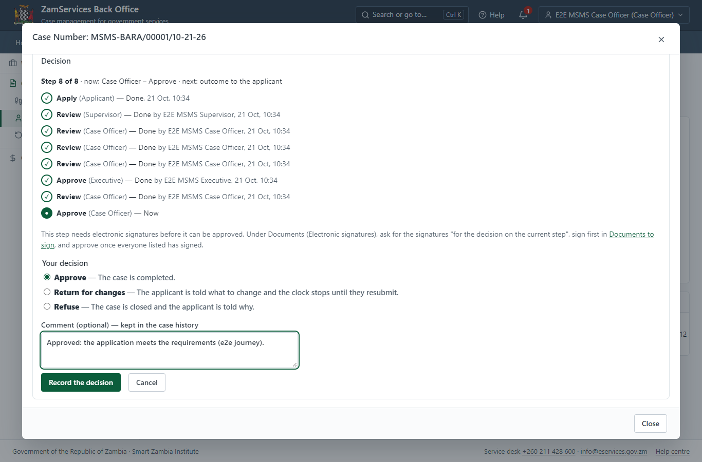
Step 16: Decide: Review, e-Sign and Complete.

Step 17. Issue the document
Case Officer · Back office
The service's validity ("not stated") is not a fixed period, so completing the case does not issue the document by itself: the officer issues it from the completed case ("Issue / check permit"). It is generated from the service's output configuration and sealed.
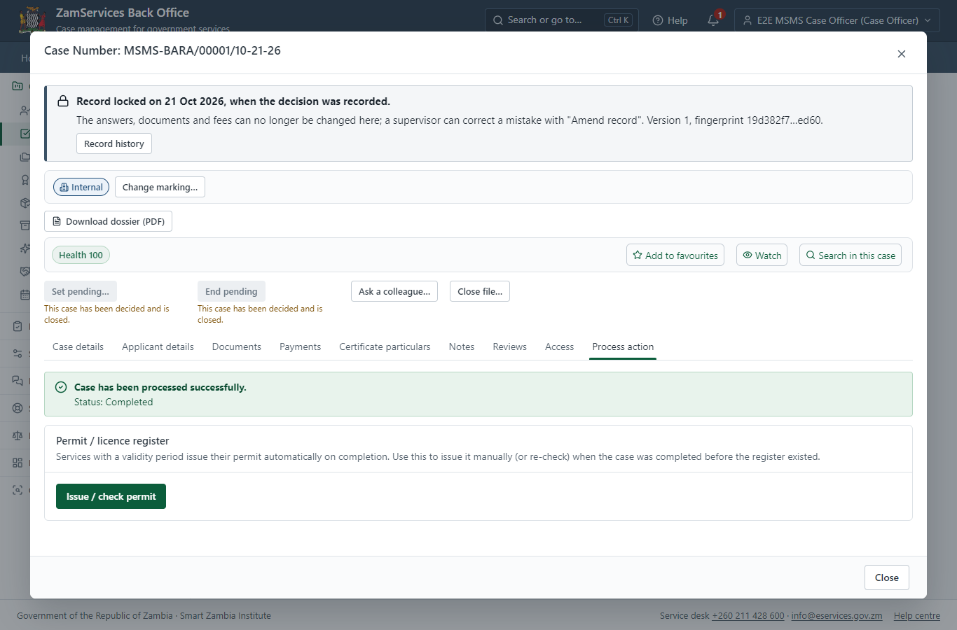
Step 17: Issue the document.

Step 18. The document in My permits
Citizen · National e-Services portal
The issued document (MSMS-BARA-2026-00001 in this run: "Boilers and Air Receivers Authorisation") is listed in "My permits and licences" with its validity and a download of the sealed PDF.
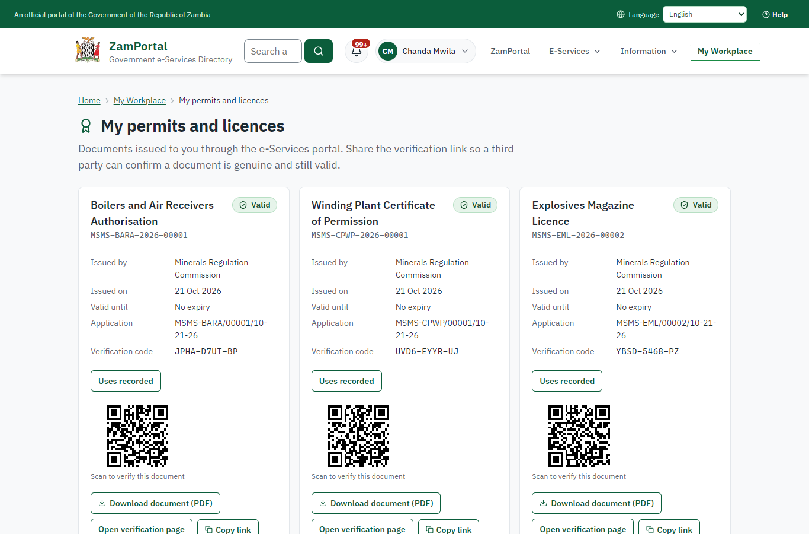 | 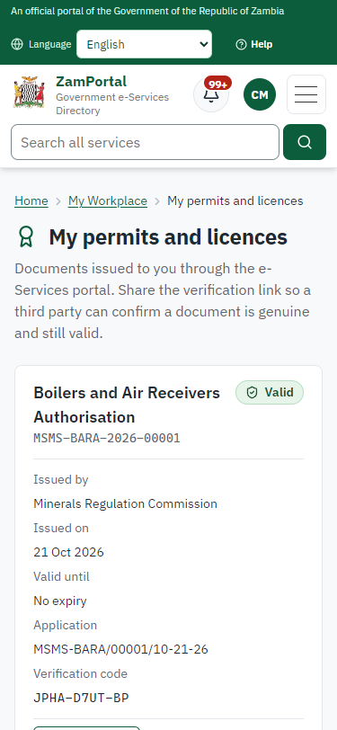
Step 18: The document in My permits - desktop (left) and a 375 px phone (right).

Step 19. Verify the document
Anyone (public) · Public verification page
The QR code on the document opens the public verification page: genuine and current, to whom it was issued, and whether the electronic seal is valid. No sign-in is needed.
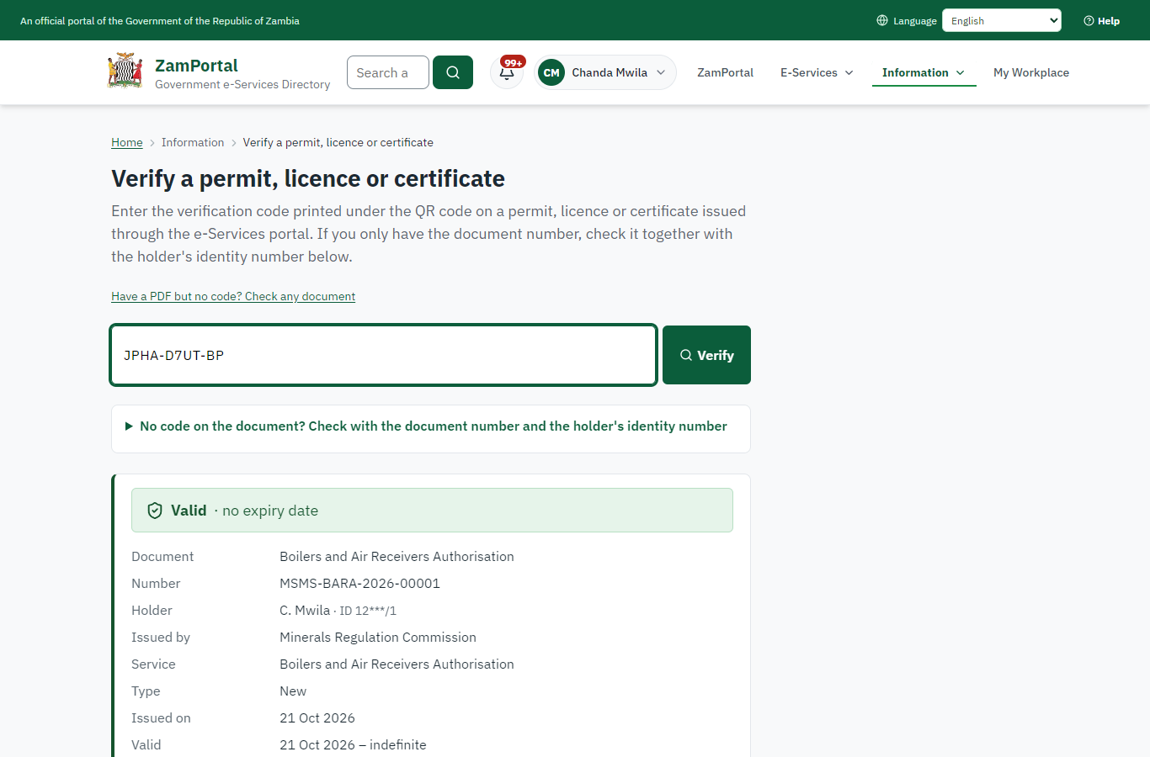 | 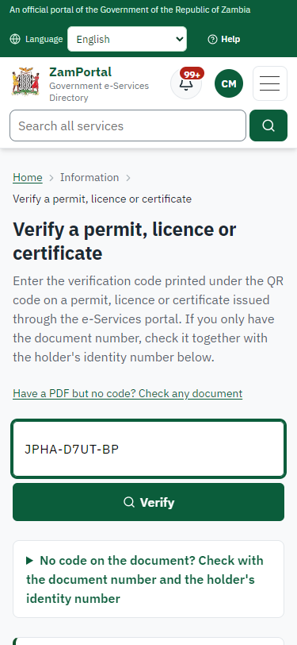
Step 19: Verify the document - desktop (left) and a 375 px phone (right).

3. Payment
Item | In the test run
Fee (as published) | none

4. Output documents

Boilers and Air Receivers Authorisation (sealed PDF)
Issued when the case was approved, from the service's output configuration (service template MSMS.BoilersAirReceiversAuthorisation.Certi), filled from the application and the decision, sealed with the platform's electronic seal and stored as the issued version. The holder downloads it from My permits; the verification page checks it.
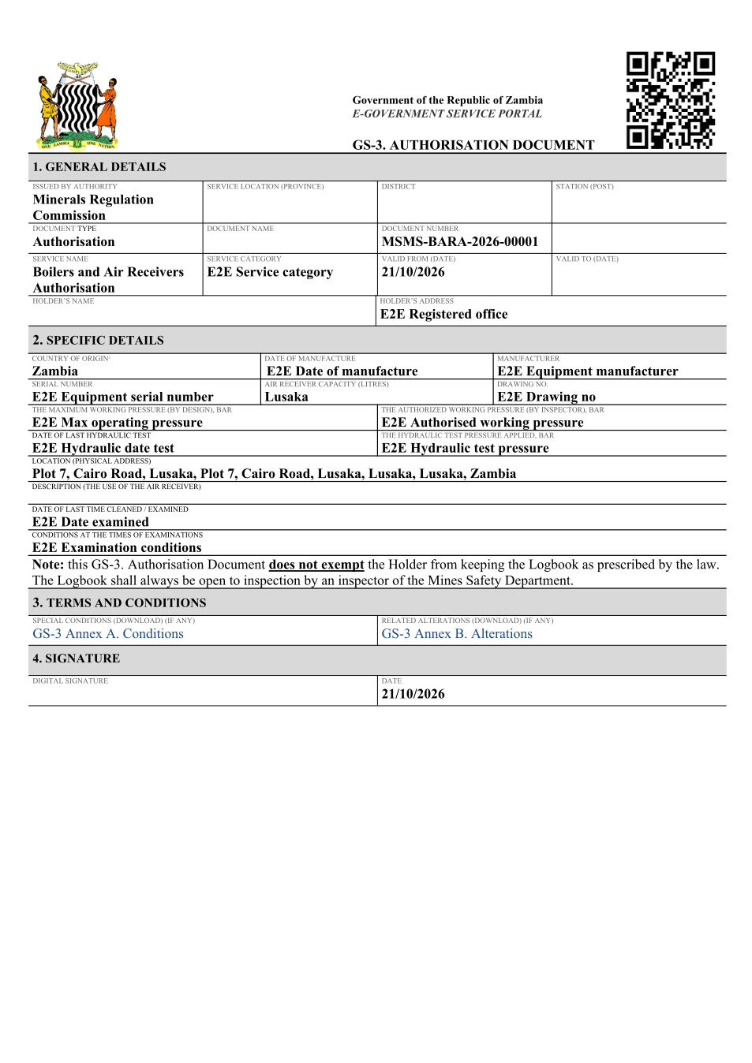
Boilers and Air Receivers Authorisation (sealed PDF) - first of 1 page, as issued in the test run.

Fields
Field | Value in the test run
Document title | Boilers and Air Receivers Authorisation
Permit / licence number | MSMS-BARA-2026-00001
Holder | Chanda Mwila
Valid from | 2026-10-21
Valid until
Status | active
Verification code (printed with a QR code) | JPHA-D7UT-BP

Seal
Seal status | sealed
Signature level | PAdES-B-T
Sealed by | the platform seal (development key in the test run)
Signed at | 2026-10-21T08:35:06.215Z
Trusted time-stamp | 2026-10-21T08:35:06.194Z (time-stamping authority)
Document fingerprint (SHA-256) | 1b35ba5bd27ea452...

Verification
Where | The public verification page of the national portal, <portal>/verify/<verification code>, opened by scanning the QR code on the document.
What it shows | Whether the document is genuine and current, its holder and validity, and whether the electronic seal is valid and who sealed it.
Checking a copy | Anyone can upload a PDF they were given; the page says whether it is exactly the document that was issued. A changed copy is reported as not matching.
On screen: step 17 (Issue the document), step 18 (The document in My permits), step 19 (Verify the document) in section 2.

5. Notifications
When | Channel | To | Message | Delivery
Application received | in-app (portal bell) | the applicant | Application MSMS-BARA/00001/10-21-26 received - Your application MSMS-BARA/00001/10-21-26 for Boilers and Air Receivers Authorisation has been received by Minerals Regulation Commission. | shown
Status changed | in-app (portal bell) | the applicant | Update on application MSMS-BARA/00001/10-21-26 - MSMS-BARA/00001/10-21-26 (Boilers and Air Receivers Authorisation) is now: With the office - being reviewed. | shown
case.approved | in-app (portal bell) | the applicant | Application MSMS-BARA/00001/10-21-26 approved - MSMS-BARA/00001/10-21-26 (Boilers and Air Receivers Authorisation) has been approved. | shown
Invitation to rate the service | in-app (portal bell) | the applicant | How was Boilers and Air Receivers Authorisation? - How was Boilers and Air Receivers Authorisation? Tell us in about a minute. | shown
Decision: approved | in-app (portal bell) | the applicant | Application MSMS-BARA/00001/10-21-26 completed - MSMS-BARA/00001/10-21-26 (Boilers and Air Receivers Authorisation) is complete. Your documents are ready. | shown
Licence / permit issued | in-app (portal bell) | the applicant | Your Boilers and Air Receivers Authorisation document has been issued - MSMS-BARA-2026-00001 has been issued for Boilers and Air Receivers Authorisation. | shown
Application received | email | e2e.c***@example.test | Application MSMS-BARA/00001/10-21-26 received | skipped
Application received | sms | +260 97* *** 567 | Application MSMS-BARA/00001/10-21-26 for Boilers and Air Receivers Authorisation has been received. Track it: <portal>/my-workplace | delivered
Status changed | sms | +260 97* *** 567 |  | delivered
case.approved | sms | +260 97* *** 567 |  | delivered
case.approved | email | e2e.c***@example.test | Application MSMS-BARA/00001/10-21-26 approved | skipped
Invitation to rate the service | sms | +260 97* *** 567 |  | skipped
Invitation to rate the service | email | e2e.c***@example.test | How was Boilers and Air Receivers Authorisation? | skipped
Decision: approved | email | e2e.c***@example.test | Application MSMS-BARA/00001/10-21-26 completed | skipped
Decision: approved | sms | +260 97* *** 567 |  | delivered
Licence / permit issued | sms | +260 97* *** 567 |  | delivered
Licence / permit issued | email | e2e.c***@example.test | Your Boilers and Air Receivers Authorisation document has been issued | skipped
Delivery: shown = in the portal's notification bell; delivered = the SMS gateway (a test double in this run) reported the text delivered; skipped = not sent on that channel (e-mail is not configured on the test installation, and some notices go out on one channel only); sent by the national portal = a ministry node handed the notice to the national portal, which texts and e-mails the citizen under its own name and the citizen's preferences. Addresses written <portal>, <ZamPay> stand for the national portal and ZamPay.

6. Legacy mapping
Replaces | Boilers and Air Receivers Authorisation in the legacy ZIGS e-Services directory (ZIGS_Services)
Legacy service id | 494
Legacy provider | Minerals Regulation Commission (MSMS) under Ministry of Mines and Minerals Development
Legacy process | not recorded
Fee in the legacy system | none
Fee taken before submission | yes (as in ZIGS)
Time to issue (legacy) | not recorded
Legacy output templates | Boilers and Air Receivers Authorisation: ZIGS_Forms_MSMS / MSMS.BoilersAirReceiversAuthorisation.Certificate  Boilers and Air Receivers Authorisation: ZIGS_Forms_MSMS / MSMS.RenewalBoilersAirReceivers.Certificate  GS-1 Application for a Government Service: ZIGS_Forms_ZDA / GS1  GS-2 Notice of Government Action: ZIGS_Forms_Notices / GS-2.NoticeOfAction
Legacy address | https://minessafety.gsb.gov.zm
How it was brought over | Imported by the platform's legacy catalogue importer (zcm-backend scripts/zigs/importLegacy.js) from the ZIGS snapshot: form, case types, fees, documents, process and output templates, then served by the new platform.

7. Version and date
Document version | service v1, platform a0a302b8
Generated | 2026-10-21T08:35:14Z (by the end-to-end run, not edited by hand)
Service version | not versioned (configured directly)
Platform snapshot | backend a0a302b8  portal 72805f0  back office 58e5946
Test suite | e2e 5999d9b; one installation (combined); seed profile mihud
Journeys | 30-catalogue-service.spec.js: citizen finds the service, answers its form, uploads its documents and sends the application - passed  30-catalogue-service.spec.js: the case goes through every step of its process: payments by the citizen, each officer step by its role - passed  30-catalogue-service.spec.js: the grant document is issued, sealed, filled in and verifiable; the citizen has it in My permits - passed
Result | 3 of 3 journey tests passed
Data | Synthetic test data on a local test installation; provider test doubles for ZamPass, ZamPay, SMS and signing.

