Republic of Zambia
GSB e-Services

Aquaculture License
Service documentation
Owner: Department of Fisheries
Service key: MFL/aquaculture-license
Version: service v1, platform 47fe6fa7
Date: 2026-10-22
Generated automatically by the service's end-to-end test run. Every screenshot shows synthetic test data on a local test installation, never real personal data.

Contents
- 1. Service summary
- 2. Application process, step by step
- 3. Payment
- 4. Output documents
- 5. Notifications
- 6. Legacy mapping
- 7. Version and date
This document describes the Aquaculture License service of Department of Fisheries as the platform runs it today. It is generated by the service's end-to-end test: every step was performed by the test and every screenshot was taken during that run, with synthetic data. Regenerate it with "npm run docs:services" in the e2e suite; do not edit it by hand.

1. Service summary
Service | Aquaculture License
Owner (MDA) | Department of Fisheries (MFL)
Purpose | Service offered to individuals or organizations that intend to cultivate, propagate, or farm: fish, aquatic vegetation, from eggs, spawn, spat or seed or by rearing fish lawfully taken from the wild or lawfully imported into the country.
Who can apply | Individual; Organization
How to apply | Online on the national e-Services portal, signed in with ZamPass; pay with ZamPay.
Fees | Ornamental breeding for export: ZMW 6640.00  Angling in dams: ZMW 12.00  Fish Farming License: small pond producing less than 3 tonnes: ZMW 22.00  Fish Farming License: large pond: producing 3 to 5 tonnes: ZMW 66.40  Fish Farming License: large pond: producing 5 to 100 tonnes: ZMW 110.80  Fish Farming License: large pond: producing over 100 tonnes: ZMW 220.00  Fish Farming License: culture of exotic fish (already in production): ZMW 11120.00  Fish Farming License: cage culture/pen culture/re-circulation system: producing less than 1 tonne: ZMW 22.00  Fish Farming License: cage culture/pen culture/re-circulation system: producing 1 to 5 tonnes: ZMW 222.40  Fish Farming License: cage culture/pen culture/re-circulation system: producing 5 to 100 tonnes: ZMW 444.40  Fish Farming License: cage culture/pen culture/re-circulation system: producing over 100 tonnes: ZMW 1110.80  Fish hatchery permits: hatchery producing less than 10,000 fingerlings: ZMW 110.80  Fish hatchery permits: hatchery producing 10 to 50,000 fingerlings: ZMW 222.40  Fish hatchery permits: hatchery producing over 50,000 fingerlings: ZMW 1110.80
Turnaround | Up to 30 days
Validity of the output | 1 year
Required documents | National Registration Card (NRC) (required)  Company Registration Certificate (required)  Water Permit (required)  Environmental Impact Assessment (EIA) or Environment Project Brief (EPB) (required)  Site Inspection Report (required)  Passport (required)
Output documents | Application form  GS-2 Notice of Government Action  GF-1 Treasury Invoice  GF-2 Treasury Receipt  Permit or licence
Legal basis | SI No. 84 of 2019 (https://media.zambialii.org/media/legislation/41877/source_file/368e2a3fae05d60d/zm-act-si-2019-84-publication-document.pdf)  SI No. 17 of 2024 (https://media.zambialii.org/media/legislation/41277/source_file/e2345820a62b692f/zm-act-si-2024-17-publication-document.pdf)

2. Application process, step by step

The process as configured
Step | Role | Task | Type
1 | Applicant | Apply | form
2 | Case Officer | Review | review
3 | Case Officer | Veterinary or fisheries inspection | livestock-fisheries-inspection
4 | Case Officer | Generate Payment | generate-payment
5 | Applicant | Payment | payment
6 | Case Officer | Verify Payment | verify-payment
7 | Case Officer | Review | review
8 | Executive | Decision | decision
9 | System | Generate Document | generate-document
10 | System | Notify Client | notify

Step by step
Who takes part in this journey: Citizen, Case Officer, Inspector, Executive, Supervisor, Anyone (public). Citizen steps are shown on a desktop and on a 375 px phone; back-office steps on a desktop.

Step 1. Find the service and read its page
Citizen · National e-Services portal
The citizen finds "Aquaculture License" in the national directory and opens its page: the authority that decides it, the documents to have ready, the fees and the time it takes.
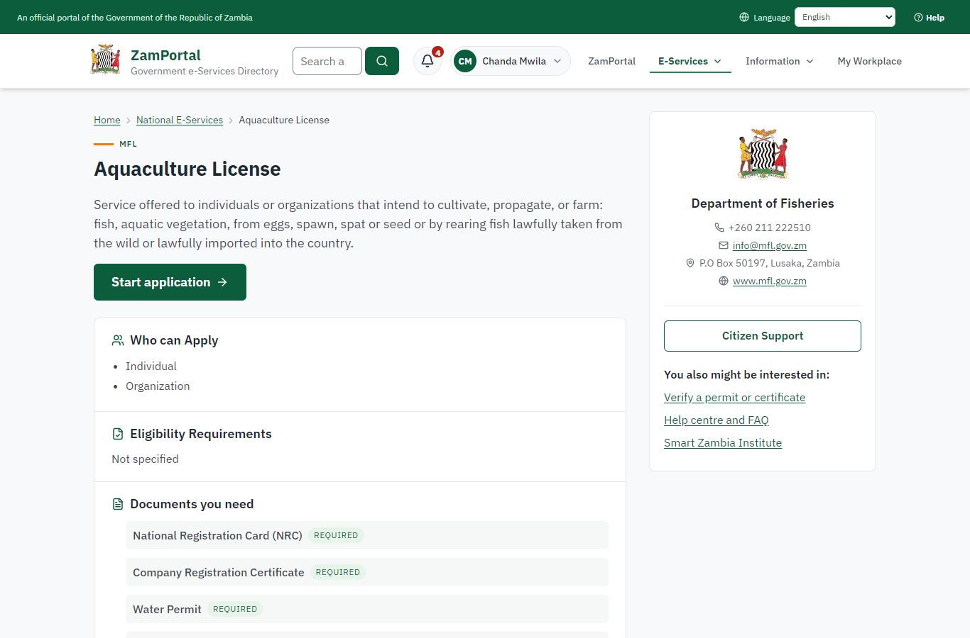 | 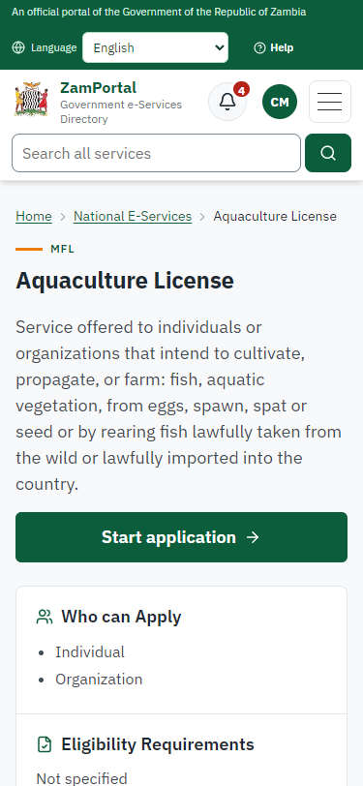
Step 1: Find the service and read its page - desktop (left) and a 375 px phone (right).

Step 2. Apply with the fish farm and its site
Citizen · National e-Services portal (sent through the API the portal uses in the test run: no screenshot)
The citizen names the holder (a company), describes the fish farm - its name, district and address, its outline drawn on the map (about 3.6 hectares), four ponds of 2,400 m2, the species farmed, the water body and the expected production - answers the service's own questions (kind of aquaculture, source of the fish) and uploads the required documents. The fish farm is recorded as FF-2026-00001, proposed, and the application needs an inspection on site.

Step 3. Take the application on
Case Officer · Back office (done through its case API in the test run: no screenshot)
The Case Officer takes the new application on (assigned to them). The case moves from "Submitted" to "CO Review".

Step 4. Check the application against the registers
Case Officer · Back office (done through its case API in the test run: no screenshot)
The Case Officer completes "Check the application against the registers". The case moves from "CO Review" to "CO Review".

Step 5. Plan the inspection on site
Case Officer · Back office
On the licence page (Ministry functions -> Livestock and fisheries -> Permits and licences) the officer plans the inspection and chooses the inspector. It is a core inspection made with the module's fish farm template, which requires the visit proved on site: a GPS-tracked position at the farm and photos taken there. The application's inspection step cannot be left until it is.
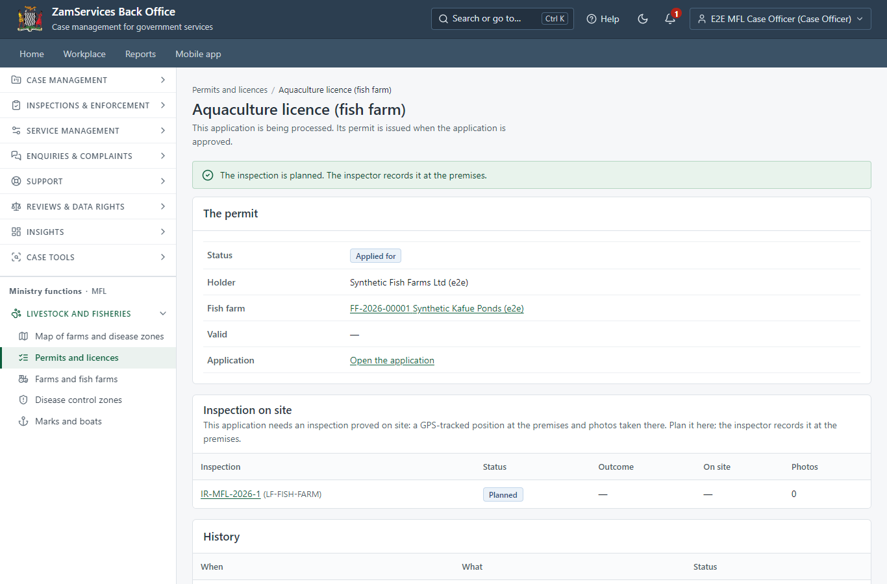
Step 5: Plan the inspection on site.

Step 6. An inspection recorded off site is held
Inspector · Back office
The inspector records the inspection on the GSB-POS terminal from 300 km away: the server compares the walked GPS track and the photos' positions with the fish farm's outline and holds it ("not proved on site"). The licence page says why; the application cannot move on.
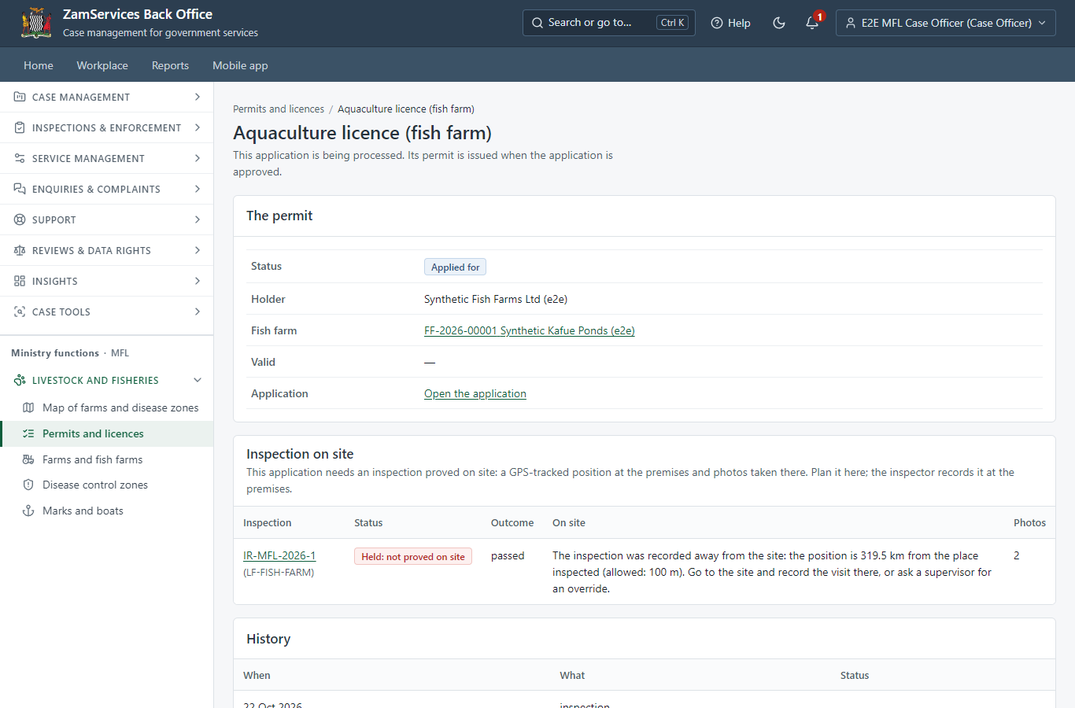
Step 6: An inspection recorded off site is held.

Step 7. The inspection recorded at the farm: verified
Inspector · Back office
At the farm the inspector walks the site with the terminal, takes photos (stamped with their position) and answers the checklist: the farm is where the application says, the ponds are as declared, only the declared species are farmed. The visit is verified on site; the inspector's positions are not shown on the licence page.
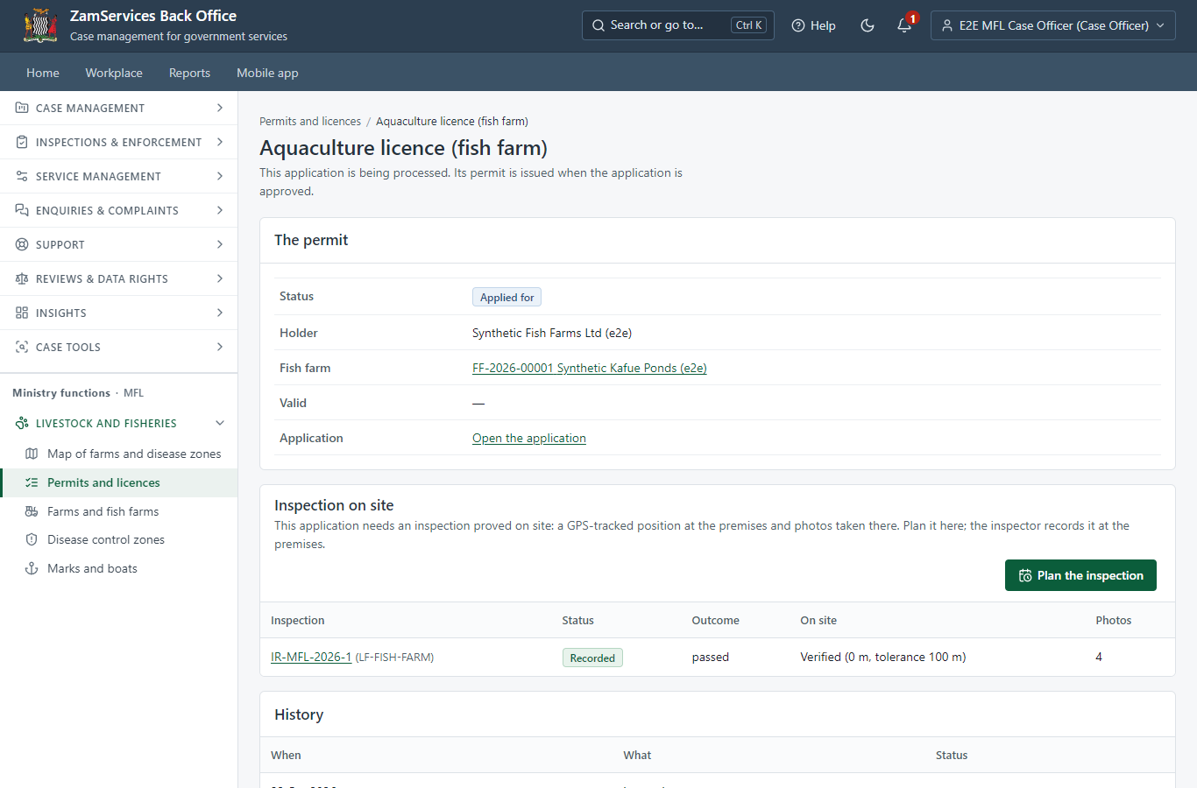
Step 7: The inspection recorded at the farm: verified.

Step 8. Set the fee
Case Officer · Back office (done through its case API in the test run: no screenshot)
The officer sets the fee from the service's fee schedule: Fish Farming License: large pond: producing 5 to 100 tonnes, ZMW 110.80. The applicant is invoiced.

Step 9. Pay the licence fee
Citizen · National e-Services portal
The application waits for the payment in My Workplace, with a Pay button (ZamPay: mobile money or bank card).
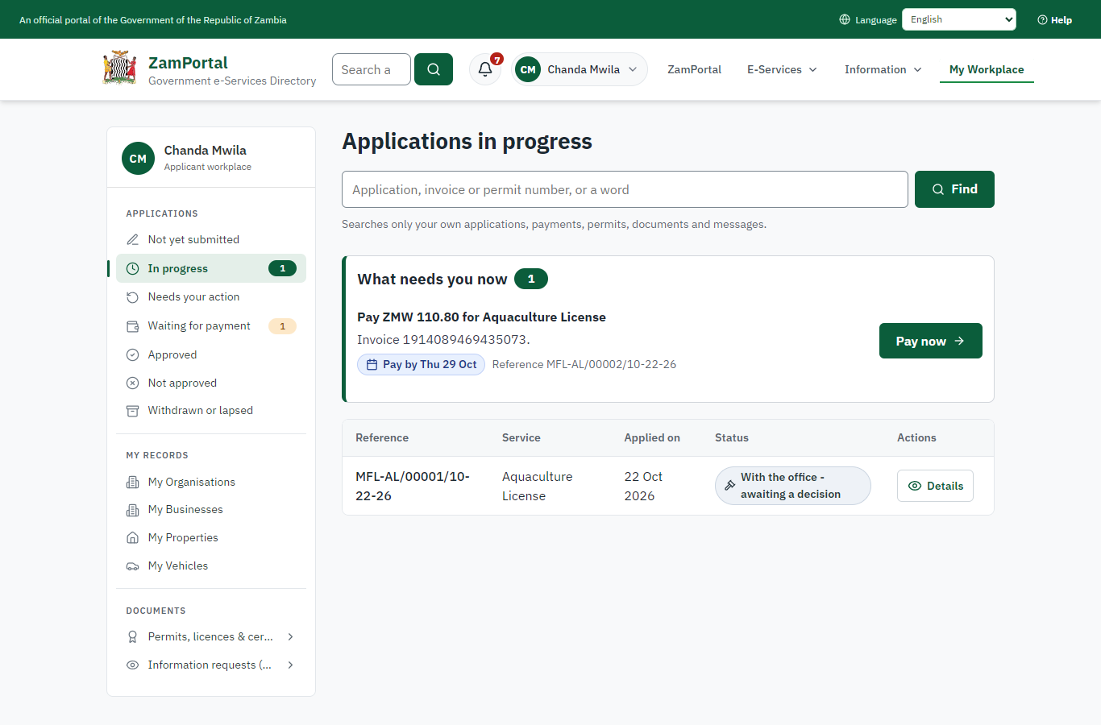 | 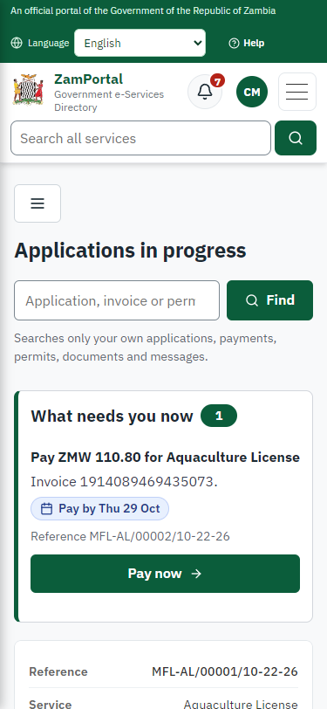
Step 9: Pay the licence fee - desktop (left) and a 375 px phone (right).

Step 10. Verify Payment
Case Officer · Back office (done through its case API in the test run: no screenshot)
The Case Officer completes "Verify Payment". The case moves from "CO Verify Payment" to "CO Review".

Step 11. Draft the decision
Case Officer · Back office (done through its case API in the test run: no screenshot)
The Case Officer completes "Draft the decision". The case moves from "CO Review" to "EX Decision".

Step 12. Decision and signature
Executive · Back office (done through its case API in the test run: no screenshot)
The Executive decides: approve ("Decision and signature"). The case moves from "EX Decision" to "Completed".

Step 13. The fish farm in the register
Supervisor · Back office
Ministry functions -> Livestock and fisheries -> Farms and fish farms: the fish farm, registered, with its ponds, its outline on the map, its licence and its history (proposed with the application, registered at the decision).
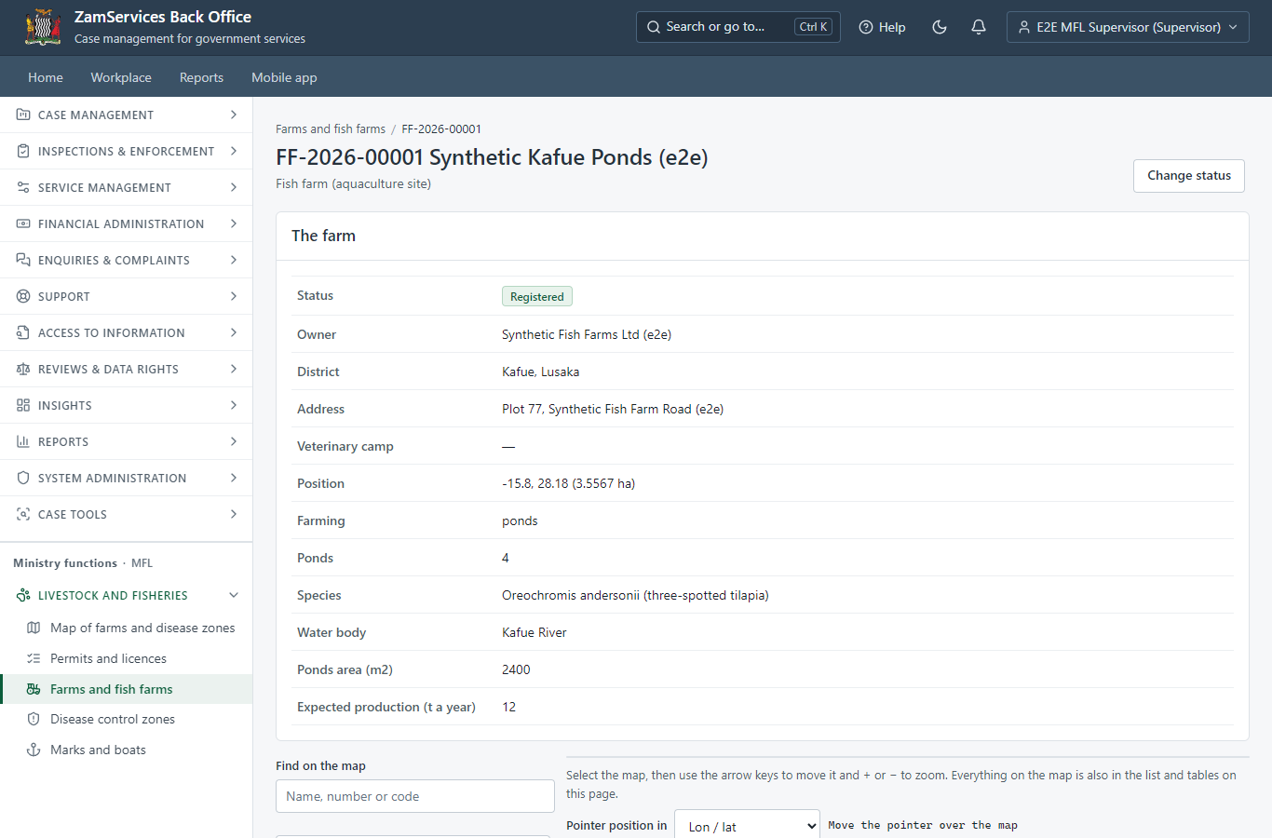
Step 13: The fish farm in the register.

Step 14. The map of farms and disease control zones
Supervisor · Back office
The map shows the disease control zones in force (an infected zone in red), the fish farms with the state of their licence and the livestock farms, with other ministries' published layers. Other ministries see the zones; the farms are this ministry's own and never name a private owner.
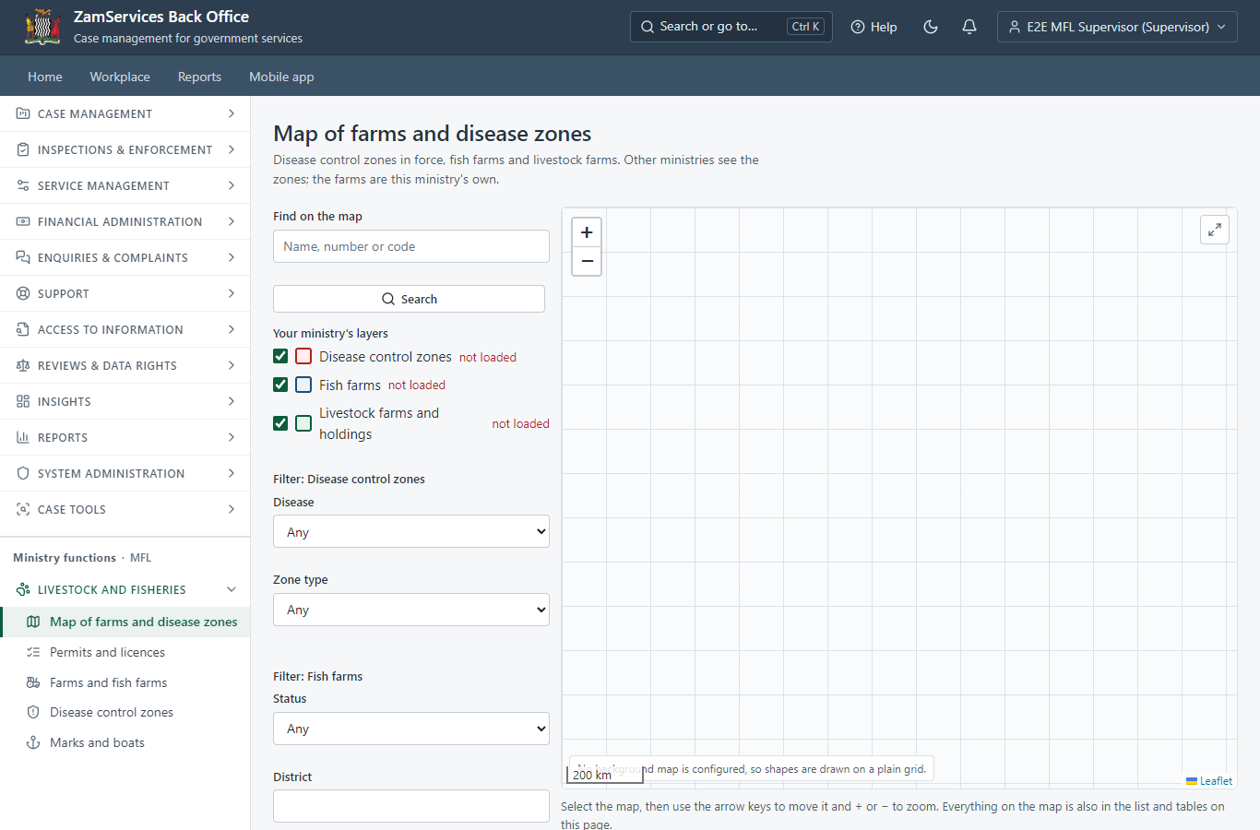
Step 14: The map of farms and disease control zones.

Step 15. The licence in My permits
Citizen · National e-Services portal
The licence is listed in "My permits and licences" with its validity, the fish farm and its outline on a small map (a generic block: any permit can show its particulars and area), and a download of the sealed licence.
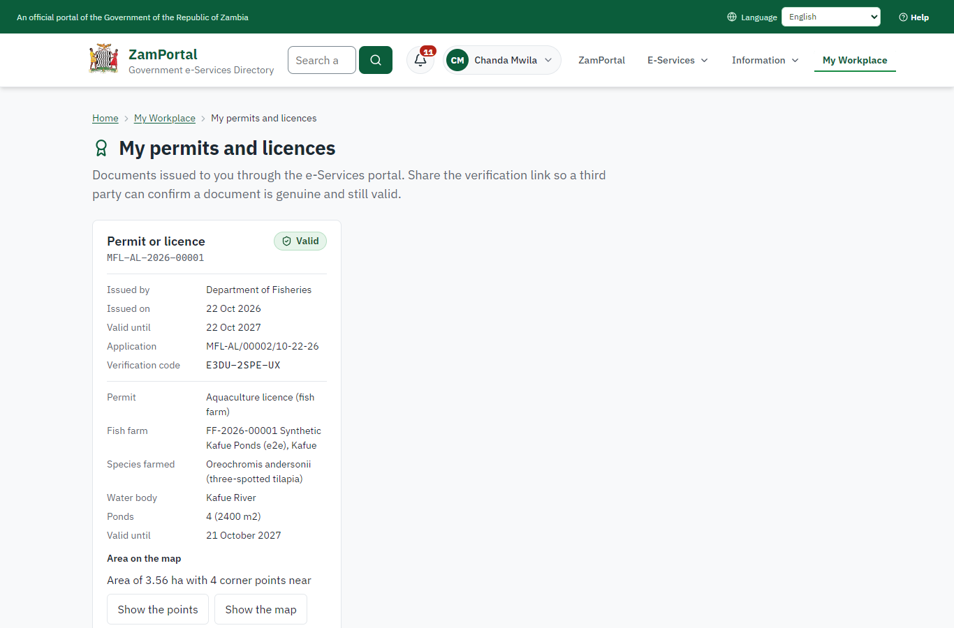 | 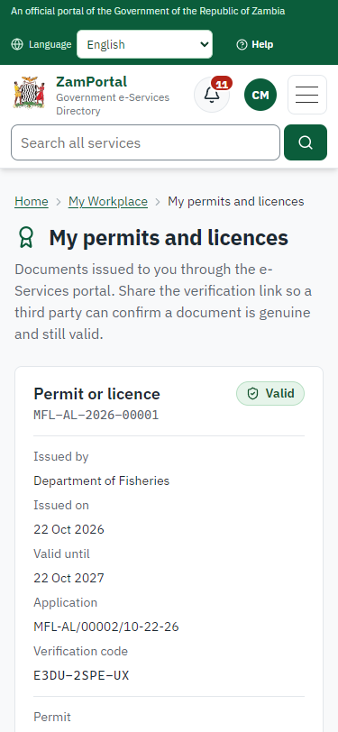
Step 15: The licence in My permits - desktop (left) and a 375 px phone (right).

Step 16. Verify the licence
Anyone (public) · Public verification page
The QR code on the licence opens the public verification page: genuine and current, and whether the electronic seal is valid. No personal details are shown.
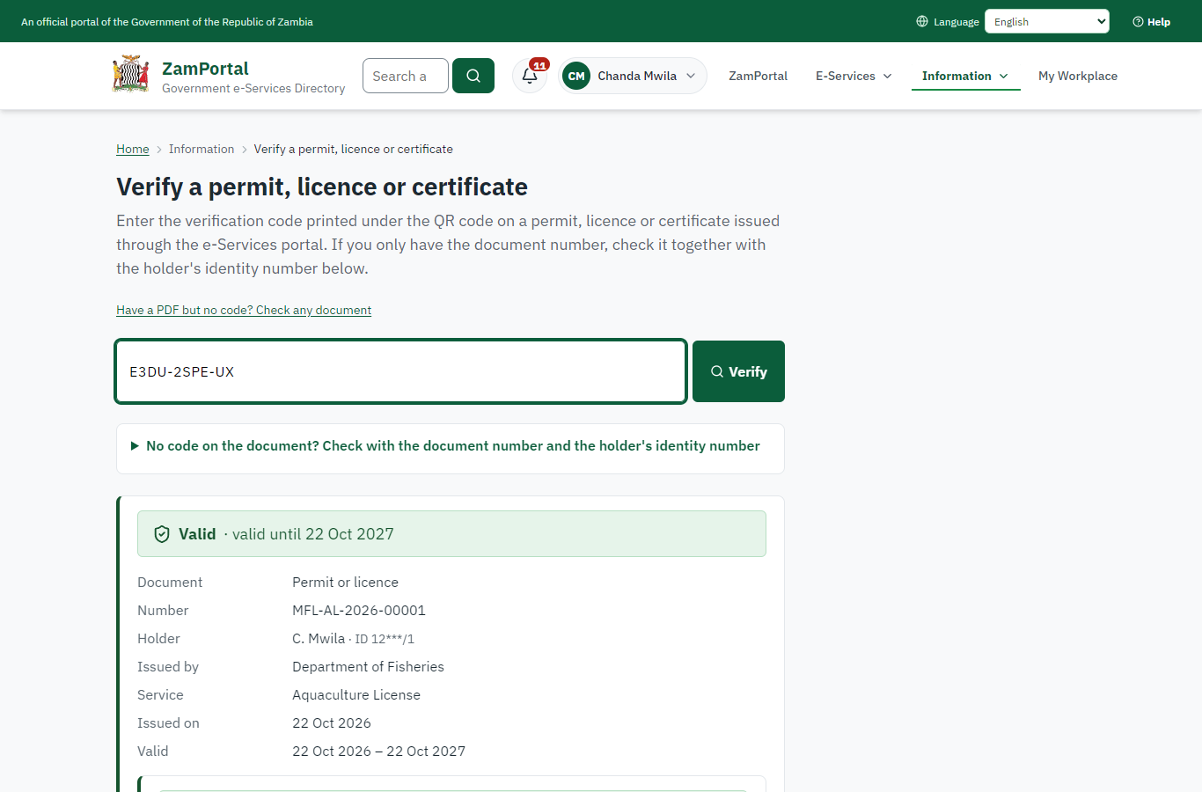 | 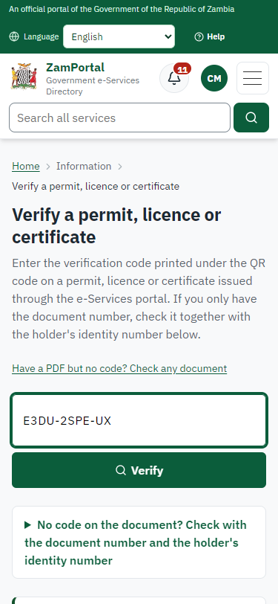
Step 16: Verify the licence - desktop (left) and a 375 px phone (right).

3. Payment
Item | In the test run
Fee | ZMW 110.80: fish farming licence, large pond producing 5 to 100 tonnes (the service's fee schedule)
When it is paid | After the inspection on site, before the decision
Invoice number | 1914089469435073
Paid through | ZamPay (the ZamPay test double in this run)
On screen: step 9 (Pay the licence fee) in section 2.

4. Output documents

Permit or licence (sealed PDF)
The licence issued when the Executive decides: the kind of licence and its number, the holder, the fish farm (reference, name, district), its ponds, species and water body, the validity (12 months), that the farm was inspected on site, sealed with the platform's electronic seal and a QR code for verification.
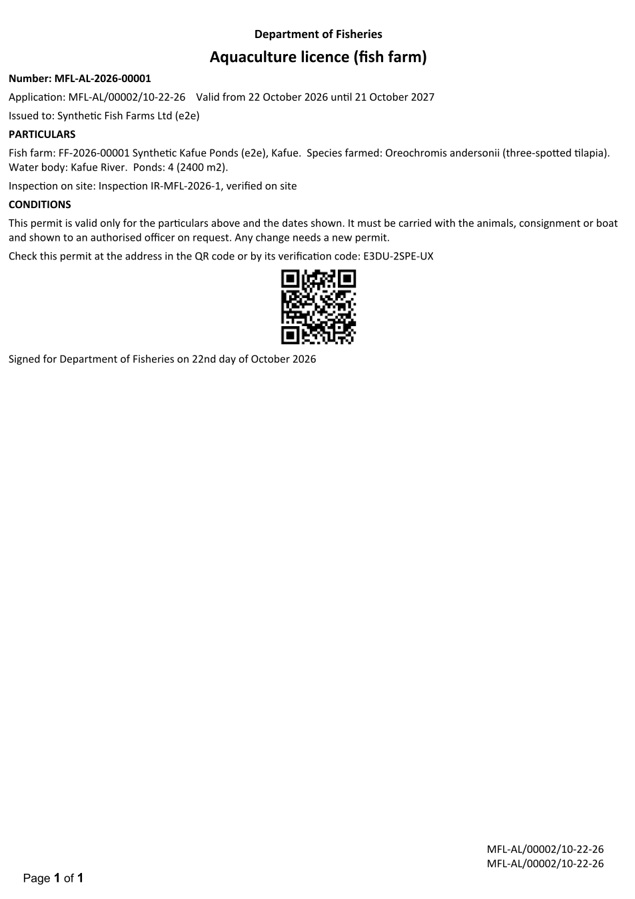
Permit or licence (sealed PDF) - first of 1 page, as issued in the test run.

Fields
Field | Value in the test run
Document title | Permit or licence
Permit / licence number | MFL-AL-2026-00001
Holder | Chanda Mwila
Valid from | 2026-10-22
Valid until | 2027-10-21
Status | active
Verification code (printed with a QR code) | E3DU-2SPE-UX

Seal
Seal status | sealed
Signature level | PAdES-B-T
Sealed by | the platform seal (development key in the test run)
Signed at | 2026-10-22T04:41:43.057Z
Trusted time-stamp | 2026-10-22T04:41:43.047Z (time-stamping authority)
Document fingerprint (SHA-256) | 1807d452cf3f8d2e...

Verification
Where | The public verification page of the national portal, <portal>/verify/<verification code>, opened by scanning the QR code on the document.
What it shows | Whether the document is genuine and current, its holder and validity, and whether the electronic seal is valid and who sealed it.
Checking a copy | Anyone can upload a PDF they were given; the page says whether it is exactly the document that was issued. A changed copy is reported as not matching.
On screen: step 13 (The fish farm in the register), step 14 (The map of farms and disease control zones), step 15 (The licence in My permits), step 16 (Verify the licence) in section 2.

5. Notifications
When | Channel | To | Message | Delivery
Application received | in-app (portal bell) | the applicant | Application MFL-AL/00002/10-22-26 received - Your application MFL-AL/00002/10-22-26 for Aquaculture License has been received by Department of Fisheries. | shown
Status changed | in-app (portal bell) | the applicant | Update on application MFL-AL/00002/10-22-26 - MFL-AL/00002/10-22-26 (Aquaculture License) is now: With the office - being reviewed. | shown
Payment due (invoice raised) | in-app (portal bell) | the applicant | Payment due for application MFL-AL/00002/10-22-26 - The fee of ZMW 110.80 for Aquaculture License (MFL-AL/00002/10-22-26) is now due. Invoice 1914089469435073. | shown
Payment received | in-app (portal bell) | the applicant | Payment received for MFL-AL/00002/10-22-26 - Your payment of ZMW 110.80 for MFL-AL/00002/10-22-26 (Aquaculture License) has been received. Receipt: <ZamPay>/pdf?documentType=receipt&invoiceNumber=1914089469435073 | shown
Invitation to rate the service | in-app (portal bell) | the applicant | How was Aquaculture License? - How was Aquaculture License? Tell us in about a minute. | shown
Licence / permit issued | in-app (portal bell) | the applicant | Your Aquaculture License document has been issued - MFL-AL-2026-00001 has been issued for Aquaculture License and is valid until 22/10/2027. | shown
Decision: approved | in-app (portal bell) | the applicant | Application MFL-AL/00002/10-22-26 completed - MFL-AL/00002/10-22-26 (Aquaculture License) is complete. Your documents are ready. | shown
Application received | email | e2e.c***@example.test | Application MFL-AL/00002/10-22-26 received | skipped
Application received | sms | +260 97* *** 567 | Application MFL-AL/00002/10-22-26 for Aquaculture License has been received. Track it: <portal>/my-workplace | delivered
Status changed | sms | +260 97* *** 567 |  | delivered
Payment due (invoice raised) | email | e2e.c***@example.test | Payment due for application MFL-AL/00002/10-22-26 | skipped
Payment due (invoice raised) | sms | +260 97* *** 567 | Fee of ZMW 110.80 due for MFL-AL/00002/10-22-26. Invoice 1914089469435073. Pay: <ZamPay>/pay-for-service/get-invoice/1914089469435073 | delivered
Payment received | sms | +260 97* *** 567 |  | delivered
Invitation to rate the service | sms | +260 97* *** 567 |  | skipped
Invitation to rate the service | email | e2e.c***@example.test | How was Aquaculture License? | skipped
Licence / permit issued | sms | +260 97* *** 567 |  | delivered
Licence / permit issued | email | e2e.c***@example.test | Your Aquaculture License document has been issued | skipped
Decision: approved | email | e2e.c***@example.test | Application MFL-AL/00002/10-22-26 completed | skipped
Decision: approved | sms | +260 97* *** 567 |  | delivered
Delivery: shown = in the portal's notification bell; delivered = the SMS gateway (a test double in this run) reported the text delivered; skipped = not sent on that channel (e-mail is not configured on the test installation, and some notices go out on one channel only); sent by the national portal = a ministry node handed the notice to the national portal, which texts and e-mails the citizen under its own name and the citizen's preferences. Addresses written <portal>, <ZamPay> stand for the national portal and ZamPay.

6. Legacy mapping
Replaces | Aquaculture License in the legacy ZIGS e-Services directory (ZIGS_Services)
Legacy service id | 371
Legacy provider | Department of Fisheries (MFL) under Ministry of Fisheries and Livestock
Legacy process | FastTrackReview (process 4)
Fee in the legacy system | Ornamental breeding for export: ZMW 6640 (New)  Angling in dams: ZMW 12 (New)  Fish Farming License: small pond producing less than 3 tonnes: ZMW 22 (New)  Fish Farming License: large pond: producing 3 to 5 tonnes: ZMW 66.4 (New)  Fish Farming License: large pond: producing 5 to 100 tonnes: ZMW 110.8 (New)  Fish Farming License: large pond: producing over 100 tonnes: ZMW 220 (New)  Fish Farming License: culture of exotic fish (already in production): ZMW 11120 (New)  Fish Farming License: cage culture/pen culture/re-circulation system: producing less than 1 tonne: ZMW 22 (New)  Fish Farming License: cage culture/pen culture/re-circulation system: producing 1 to 5 tonnes: ZMW 222.4 (New)  Fish Farming License: cage culture/pen culture/re-circulation system: producing 5 to 100 tonnes: ZMW 444.4 (New)  Fish Farming License: cage culture/pen culture/re-circulation system: producing over 100 tonnes: ZMW 1110.8 (New)  Fish hatchery permits: hatchery producing less than 10,000 fingerlings: ZMW 110.8 (New)  Fish hatchery permits: hatchery producing 10 to 50,000 fingerlings: ZMW 222.4 (New)  Fish hatchery permits: hatchery producing over 50,000 fingerlings: ZMW 1110.8 (New)
Fee taken before submission | yes (as in ZIGS)
Time to issue (legacy) | New: 30 calendar days  Renewal: 30 calendar days
Legacy output templates | Application form: ZIGS_Forms_MFL / MFL_AquacultureLicense.Application  GS-2 Notice of Government Action: ZIGS_Forms_Notices / GS-2.NoticeOfAction  GF-1 Treasury Invoice: ZIGS_CustomForms / GF-1 Invoice  GF-2 Treasury Receipt: ZIGS_CustomForms / GF-2 Receipt
Legacy address | none recorded
How it was brought over | Imported by the platform's legacy catalogue importer (zcm-backend scripts/zigs/importLegacy.js) from the ZIGS snapshot: form, case types, fees, documents, process and output templates, then served by the new platform.

7. Version and date
Document version | service v1, platform 47fe6fa7
Generated | 2026-10-22T04:41:50Z (by the end-to-end run, not edited by hand)
Service version | published version 1
Platform snapshot | backend 47fe6fa7  portal 9dadc82  back office f75e95d
Test suite | e2e e42f7f1; one installation (combined); seed profile mihud
Journeys | 44-aquaculture-licence-onsite-inspection.spec.js: citizen: finds the service and applies with the fish farm and its site - passed  44-aquaculture-licence-onsite-inspection.spec.js: officer and inspector: the inspection is planned; off site it is held; at the farm it is verified - passed  44-aquaculture-licence-onsite-inspection.spec.js: citizen pays; the executive decides; the licence is issued and the farm registered - passed  44-aquaculture-licence-onsite-inspection.spec.js: the map: the fish farm next to the disease control zone in force - passed  44-aquaculture-licence-onsite-inspection.spec.js: citizen: the licence in My permits with the farm; sealed; verifies - passed
Result | 5 of 5 journey tests passed
Data | Synthetic test data on a local test installation; provider test doubles for ZamPass, ZamPay, SMS and signing.

