Republic of Zambia
GSB e-Services

Application for Zambian Passport
Service documentation
Owner: Department of National Registration, Passports, and Citizenship (Passport Office)
Service key: DNRPC/application-for-zambian-passport
Version: service v1, platform a0a302b8
Date: 2026-10-21
Generated automatically by the service's end-to-end test run. Every screenshot shows synthetic test data on a local test installation, never real personal data.

Contents
- 1. Service summary
- 2. Application process, step by step
- 3. Payment
- 4. Output documents
- 5. Notifications
- 6. Legacy mapping
- 7. Version and date
This document describes the Application for Zambian Passport service of Department of National Registration, Passports, and Citizenship (Passport Office) as the platform runs it today. It is generated by the service's end-to-end test: every step was performed by the test and every screenshot was taken during that run, with synthetic data. Regenerate it with "npm run docs:services" in the e2e suite; do not edit it by hand.

1. Service summary
Service | Application for Zambian Passport
Owner (MDA) | Department of National Registration, Passports, and Citizenship (Passport Office) (DNRPC)
Purpose | This e-service allows you to apply for a Zambian Passport. Zambian Passports are Travel Documents with five (5) years expiration period for children, due to rapid facial changes, and ten (10) years for adults. They are issued in 32-page and 48-page format, to clients applying for the first time or who are renewing their passports. Applicants for Passports are required to come in person to Passport Offices to be interviewed only and pick up the issued passport. The Applicant must be a bona fide Zambian national.
Who can apply | Individual
How to apply | Online on the national e-Services portal, signed in with ZamPass; pay with ZamPay.
Fees | Travel Passport 32-Page (under 16 years): ZMW 500.00  Travel Passport 48-Page (under 16 years): ZMW 833.00  Travel Passport 32-Page (under 16 years) - Express Issuance: ZMW 833.00  Travel Passport 48-Page (under 16 years) - Express Issuance: ZMW 567.00  Fee for Application Form: ZMW 33.00
Turnaround | Ordinary – 14 working days (Lusaka, Ndola, Livingstone)  Ordinary – 21 working days (Solwezi, Chipata, Kabwe, Mongu, Chinsali, Mansa, Kasama, Choma)  Express – 5 working days (temporarily unavailable)
Validity of the output | Five (5) years for children, due to rapid facial changes.  Ten (10) years for adults.
Required documents | Certified Affidavit form M (Obtained from passport office) (required)  Certified Birth Certificate (required)  Passport-Size Photographs (required)  Certified Copy of Green NRC Guardian(s) (required)  Certified Copy of the Passport of the Guardian if any (required)  Evidence of the legal guardianship (required when the marriage of the parents have been dissolved, or in any case when someone other than the parent signs the application) (required)  Court Order committing the child to a person’s custody (mandatory for persons claiming legal custody over a child during the lifetime of the child's parent) (required)  Child’s Certificate of Naturalisation or Registration (required)
Output documents | Denial of Service  Notice of Approval  Application for Zambian Passport  Application form  GS-2 Notice of Government Action  GF-1 Treasury Invoice  GF-2 Treasury Receipt
Legal basis | Passport Act No. 28 of 2016 (http://www.parliament.gov.zm/sites/default/files/documents/acts/Passport%20Act%20No.%2028%20of%202016%20pmd.pdf)

2. Application process, step by step

The process as configured
Step | Role | Task | Type
1 | Applicant | Apply | form
2 | Case Officer | Generate Payment | generate-payment
3 | Applicant | Payment | payment
4 | System | Generate Document | generate-document
5 | Case Officer | Review | review
6 | Supervisor | Review | review
7 | Executive | Decision | decision
8 | System | Generate Document | generate-document
9 | System | Generate Document | generate-document
10 | Case Officer | Hand Over Document | collection
11 | System | Notify Client | notify

Step by step
Who takes part in this journey: Citizen, Case Officer, Supervisor, Executive, Anyone (public). Citizen steps are shown on a desktop and on a 375 px phone; back-office steps on a desktop.

Step 1. Find the service
Citizen · National e-Services portal
On the national e-Services portal the citizen opens All Services and searches for the service by name ("Application for Zambian Passport"). Each result names the service and the ministry that provides it.
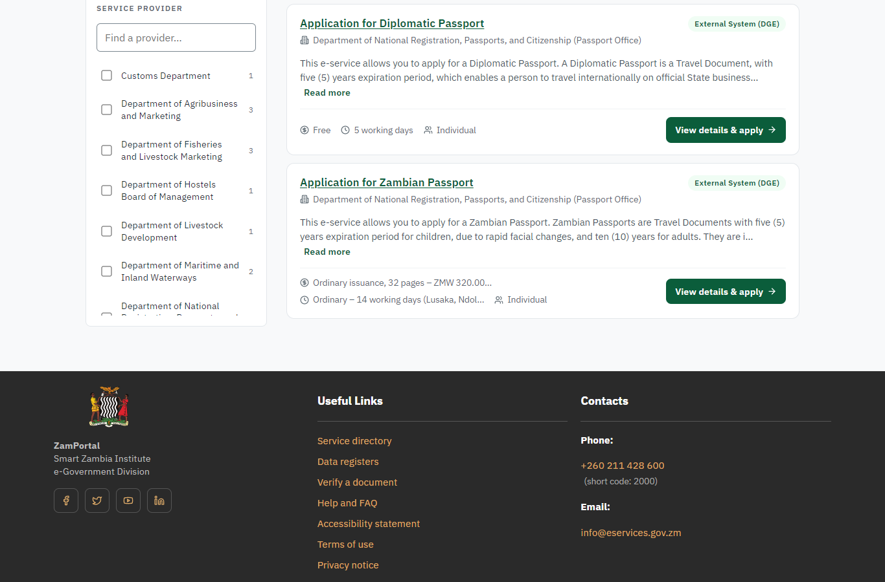 | 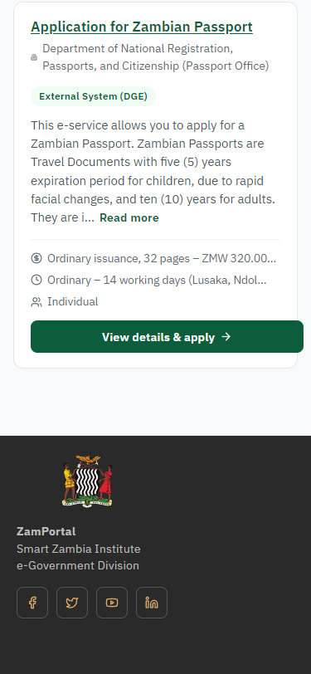
Step 1: Find the service - desktop (left) and a 375 px phone (right).

Step 2. Read the service page
Citizen · National e-Services portal
The service page sets out what the service is for, who provides it, the fee, how long it takes and the documents to have ready. "Start application" begins an application (the citizen is signed in with ZamPass).
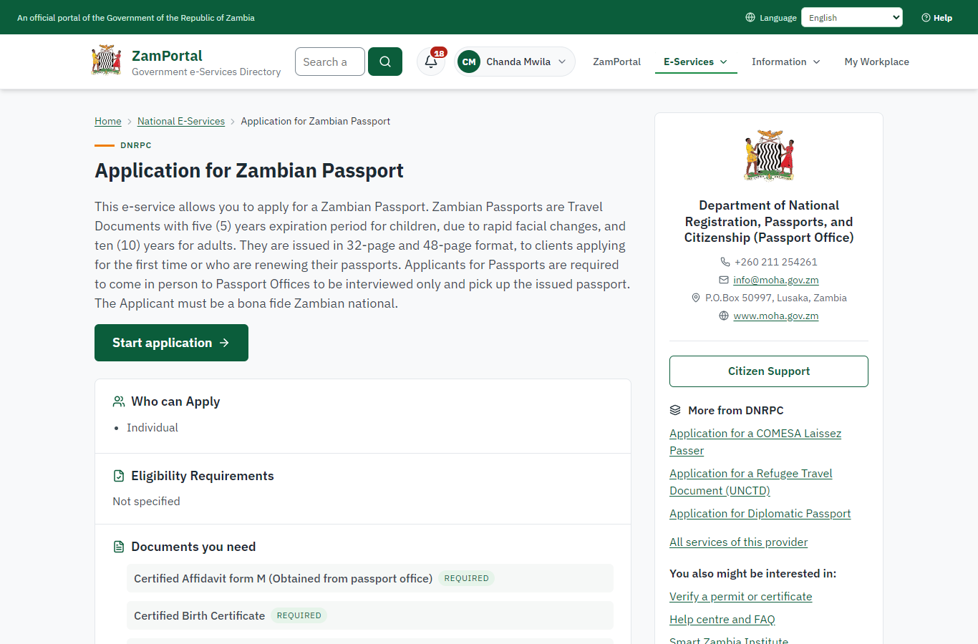 | 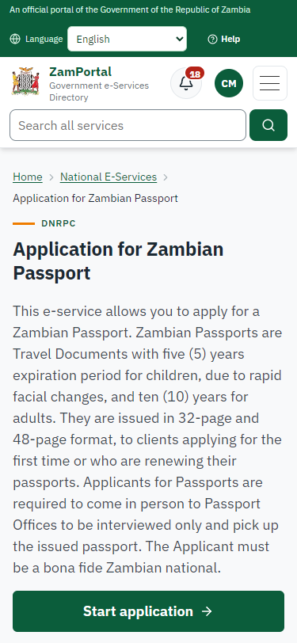
Step 2: Read the service page - desktop (left) and a 375 px phone (right).

Step 3. Confirm the applicant details
Citizen · National e-Services portal
The applicant details are filled in from the citizen's ZamPass account. The citizen says whom they are applying for (themself) and continues with "Proceed to Application".
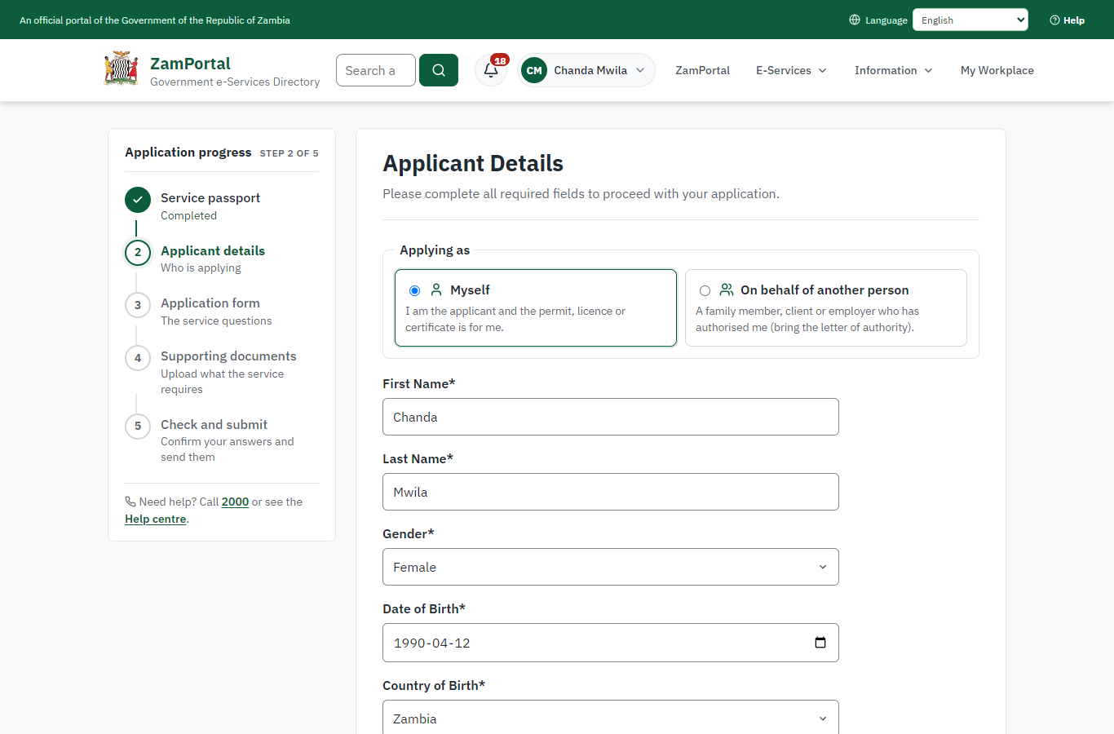 | 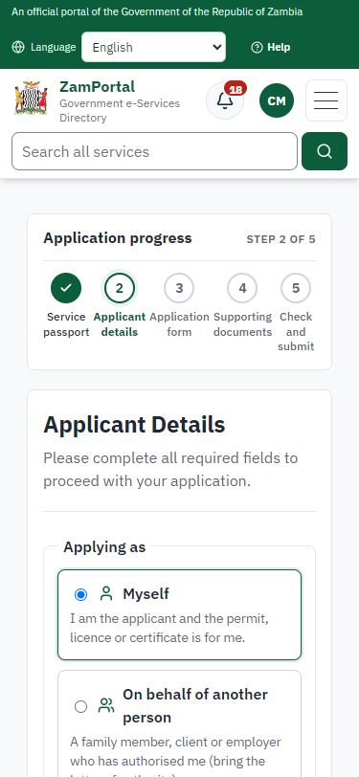
Step 3: Confirm the applicant details - desktop (left) and a 375 px phone (right).

Step 4. Fill in the application form
Citizen · National e-Services portal
The citizen answers the service's own application form, converted from the legacy system (66 answers in this run, all synthetic), for the type of application "New". Questions marked * must be answered; some appear only after an earlier answer. Answers are saved as the citizen types, so an unfinished application can be reopened from My Workplace.
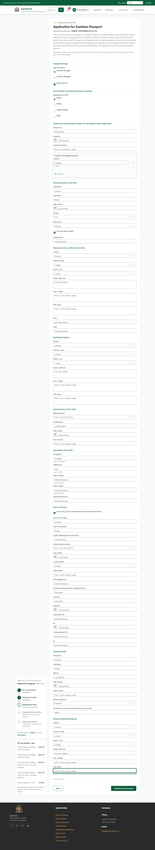 | 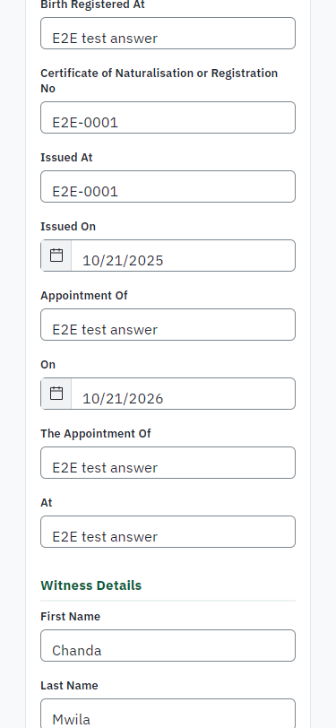
Step 4: Fill in the application form - desktop (left) and a 375 px phone (right).

Step 5. Upload the supporting documents
Citizen · National e-Services portal
Each document the service asks for has its own upload (8 in this run: Certified Affidavit form M (Obtained from passport office), Certified Birth Certificate, Passport-Size Photographs, Certified Copy of Green NRC Guardian(s), Certified Copy of the Passport of the Guardian if any, Evidence of the legal guardianship (required when the marriage of the parents have been dissolved, or in any case when someone other than the parent signs the application), Court Order committing the child to a person’s custody (mandatory for persons claiming legal custody over a child during the lifetime of the child's parent), Child’s Certificate of Naturalisation or Registration). The files are checked and stored with the application; the page confirms each upload.
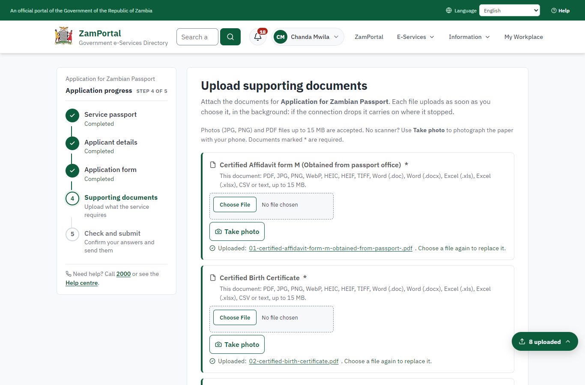 | 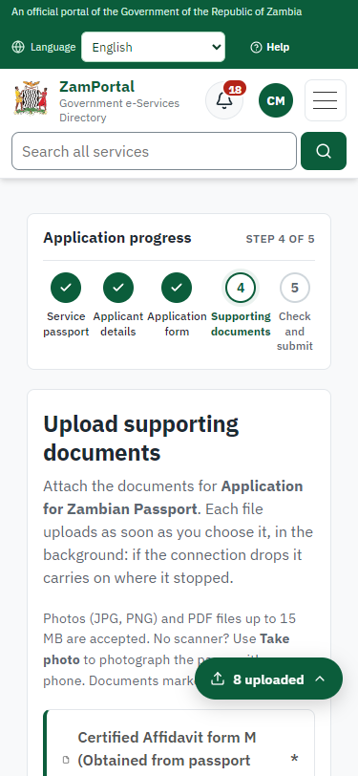
Step 5: Upload the supporting documents - desktop (left) and a 375 px phone (right).

Step 6. Check the answers and confirm the declaration
Citizen · National e-Services portal
Before sending, the citizen sees every answer and document on one page and can go back to change them. The declaration that the information is true and complete must be ticked.
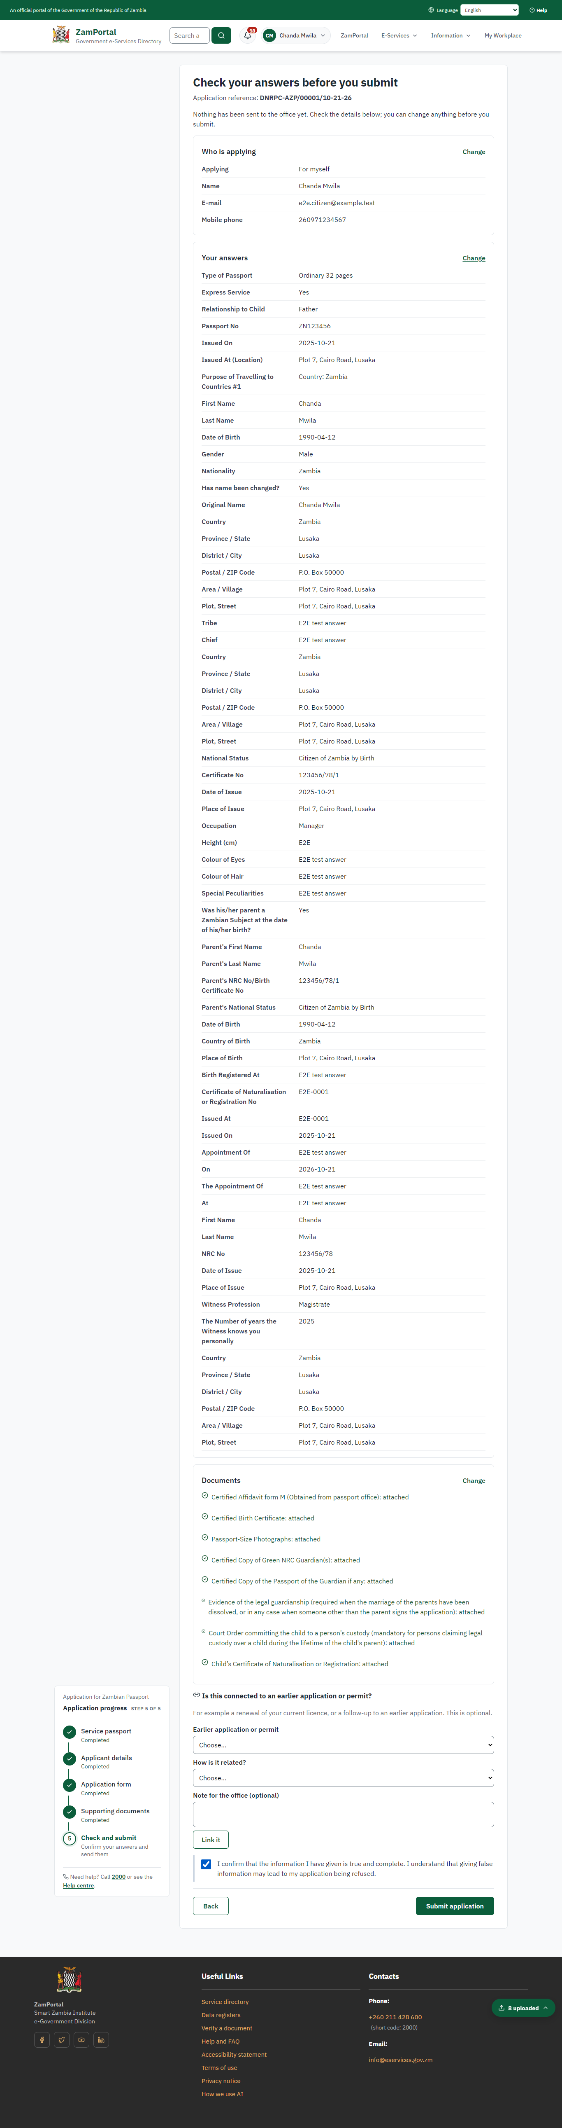 | 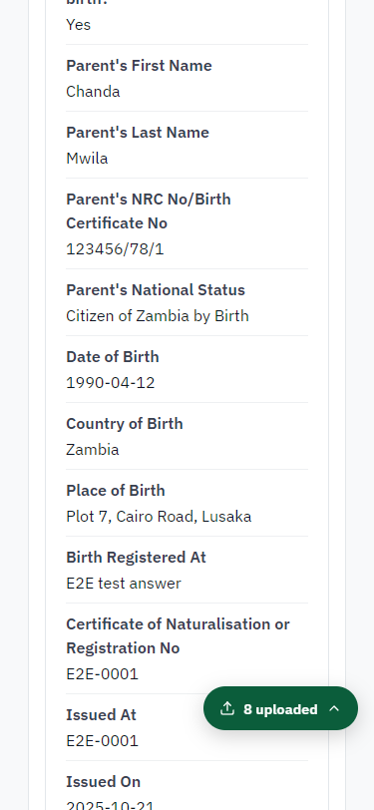
Step 6: Check the answers and confirm the declaration - desktop (left) and a 375 px phone (right).

Step 7. Application sent
Citizen · National e-Services portal
The portal confirms the application with the ministry's reference number (DNRPC-AZP/00001/10-21-26 in this run). The application goes to the ministry's officers; the citizen follows it in My Workplace.
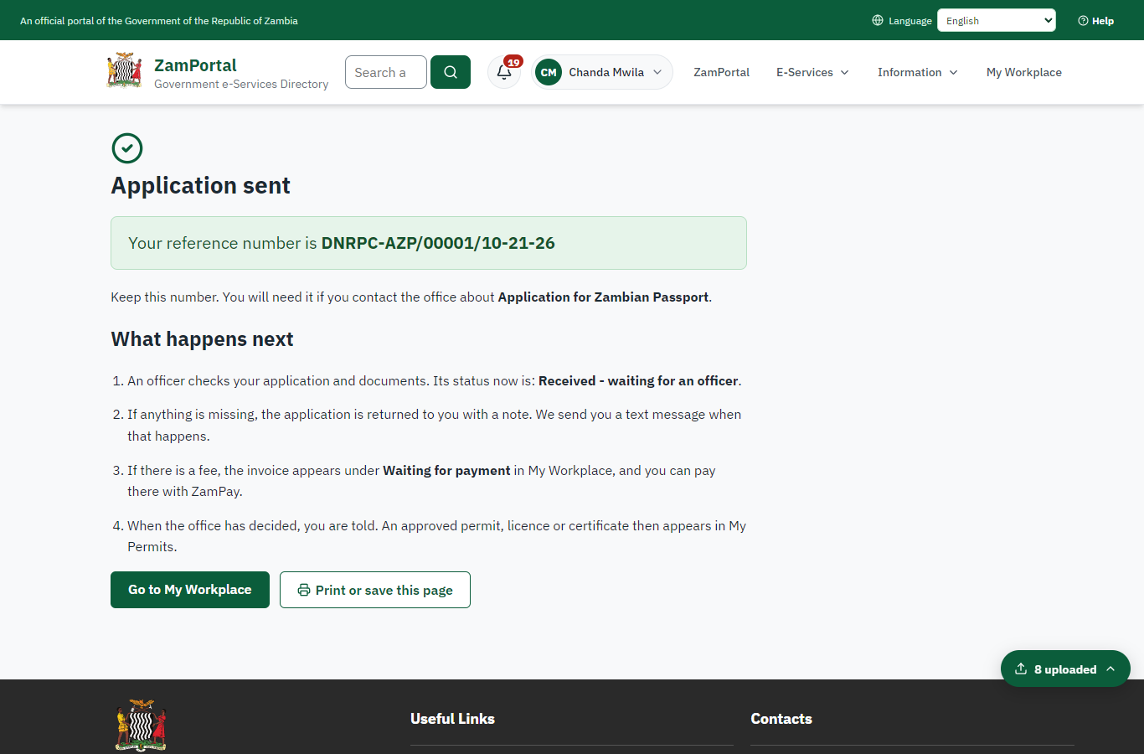 | 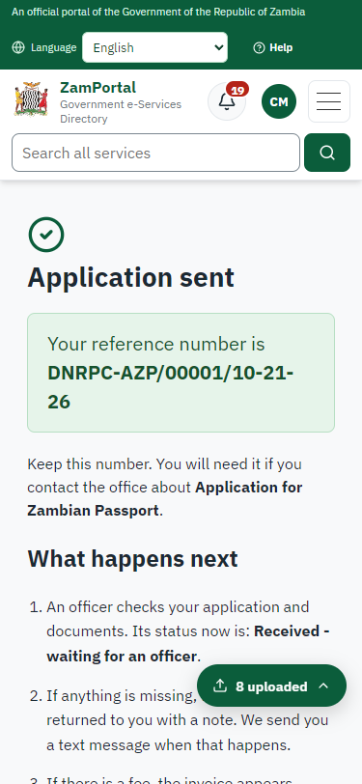
Step 7: Application sent - desktop (left) and a 375 px phone (right).

Step 8. Take the new application on
Case Officer · Back office
The application arrives in the case queue of the ministry that owns the service (Department of National Registration, Passports, and Citizenship (Passport Office)); only its staff see it. The officer opens it by its reference number - answers, documents and process are on the case - assigns it to themself and takes it on.
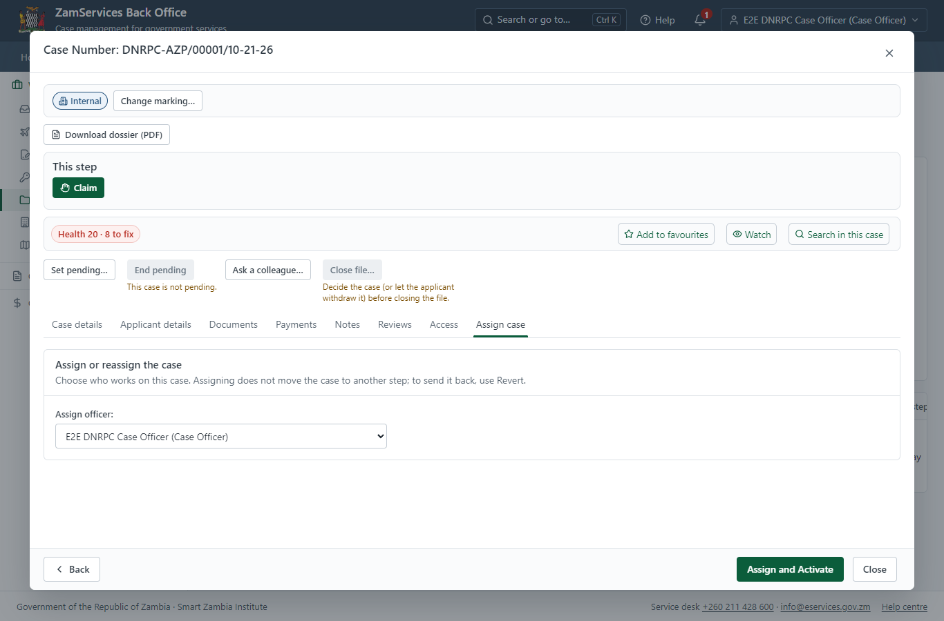
Step 8: Take the new application on.

Step 9. Work out the fee
Case Officer · Back office
The Case Officer works out the fee from the service's imported fee schedule ("Ordinary issuance, 32 pages – ZMW 320.00 Express issuance, 32 pages – ZMW 520.00 Ordinary issuance, 48 pages – ZMW 520.00 Express issuance, 48 pages – ZMW 720.0"). "Submit Fees and Advance" records it, raises a ZamPay invoice for the applicant and moves the case to payment.
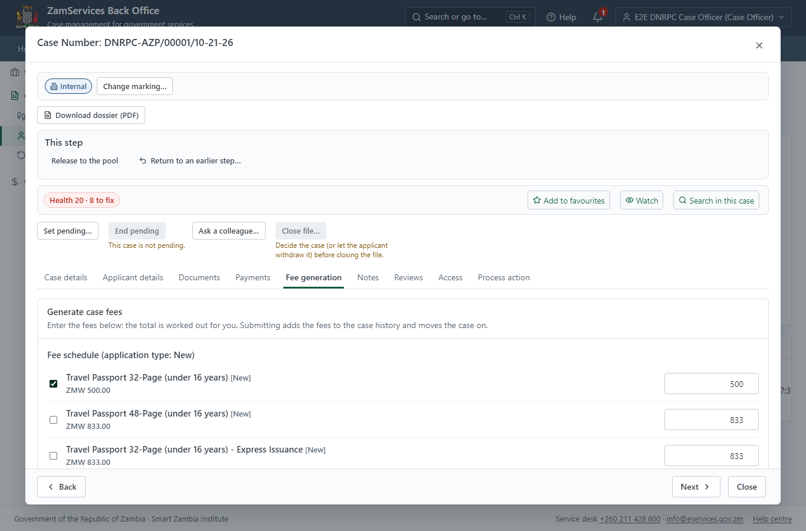
Step 9: Work out the fee.

Step 10. See that the fee is due
Citizen · National e-Services portal
The application shows "Waiting for your payment" in My Workplace with a Pay button (K500.00). The office priced the case; the invoice was raised on ZamPay.
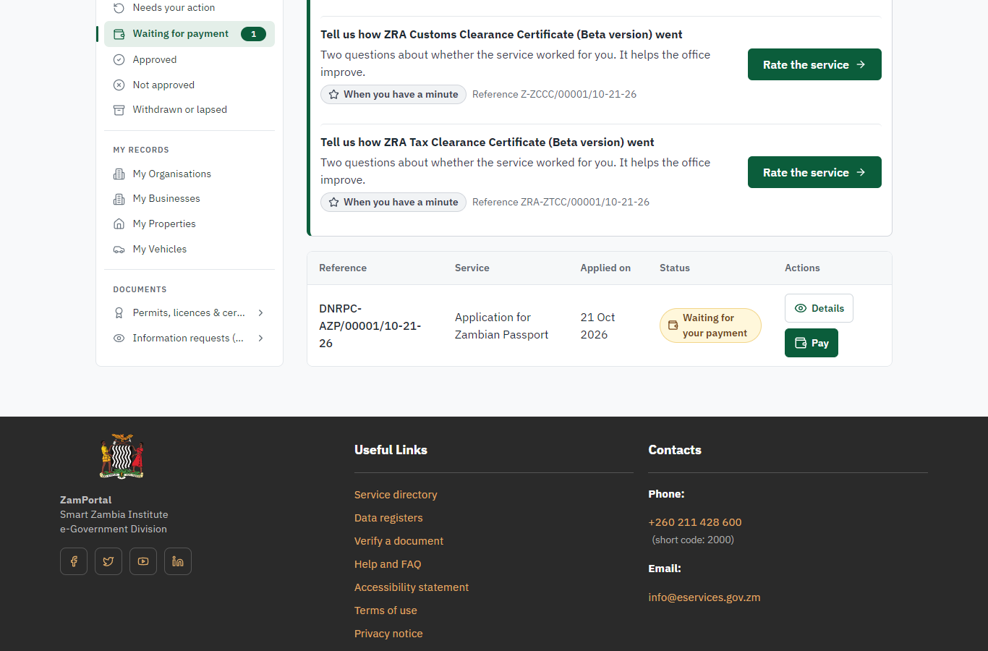 | 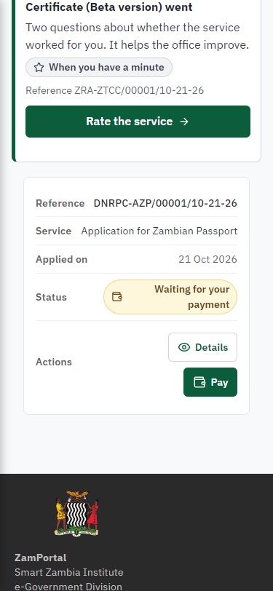
Step 10: See that the fee is due - desktop (left) and a 375 px phone (right).

Step 11. Pay with ZamPay
Citizen · National e-Services portal
Pay opens the invoice (K500.00, the amount set by the platform, never by the page) with its PDF preview; the citizen pays at ZamPay by mobile money or bank card.
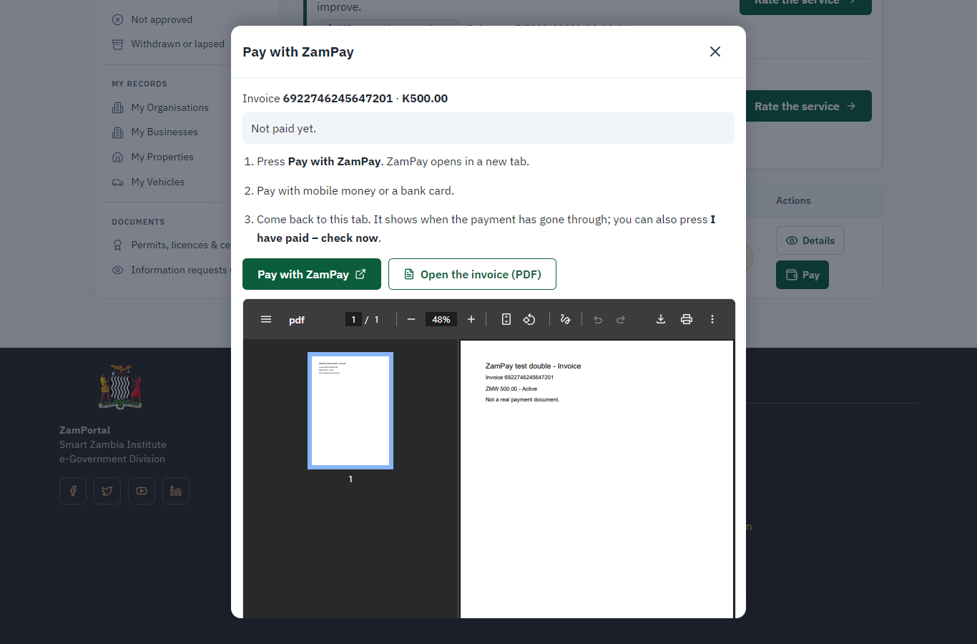 | 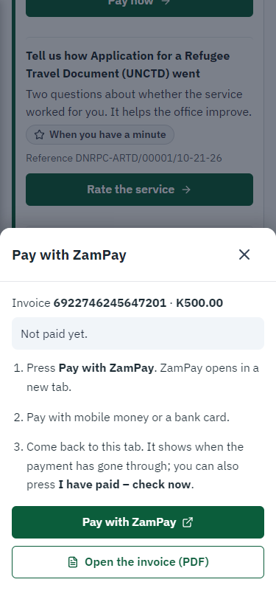
Step 11: Pay with ZamPay - desktop (left) and a 375 px phone (right).

Step 12. Payment received
Citizen · National e-Services portal
ZamPay reports the payment; the dialog says "Paid. Thank you" and the application moves on to the ministry's officers.
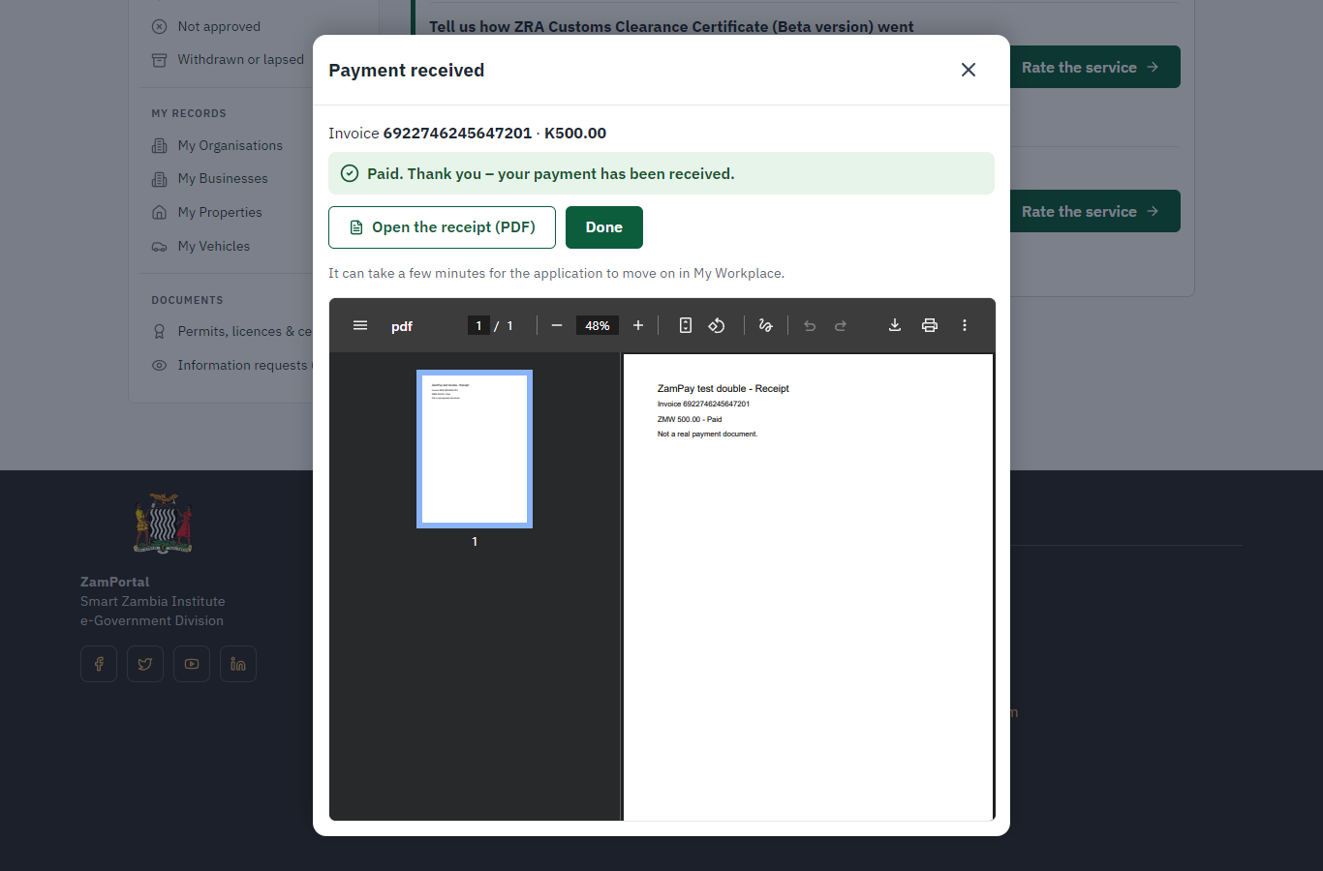 | 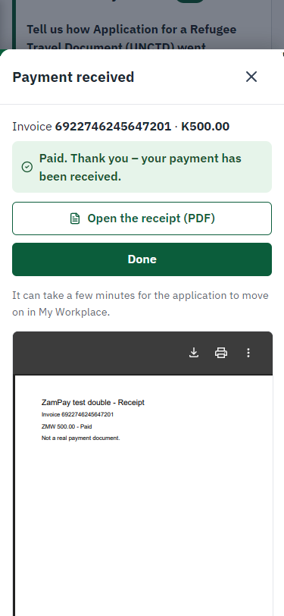
Step 12: Payment received - desktop (left) and a 375 px phone (right).

Step 13. Receive, Inspect
Case Officer · Back office
The Case Officer works on "Receive, Inspect" (review in the imported process), checks the application and its documents, and completes the step.
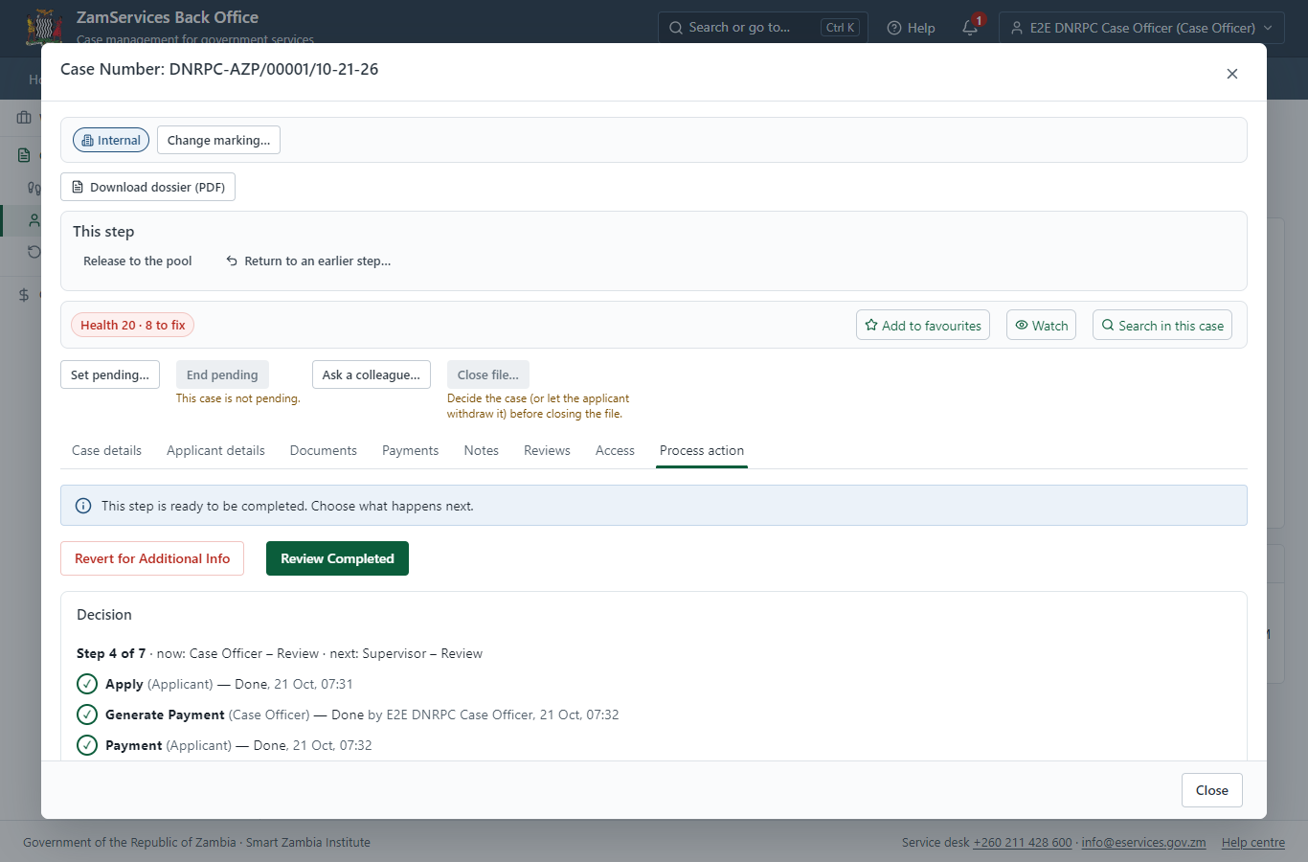
Step 13: Receive, Inspect.

Step 14. Review, Security Vetting
Supervisor · Back office
The Supervisor works on "Review, Security Vetting" (review in the imported process), checks the application and its documents, and completes the step.
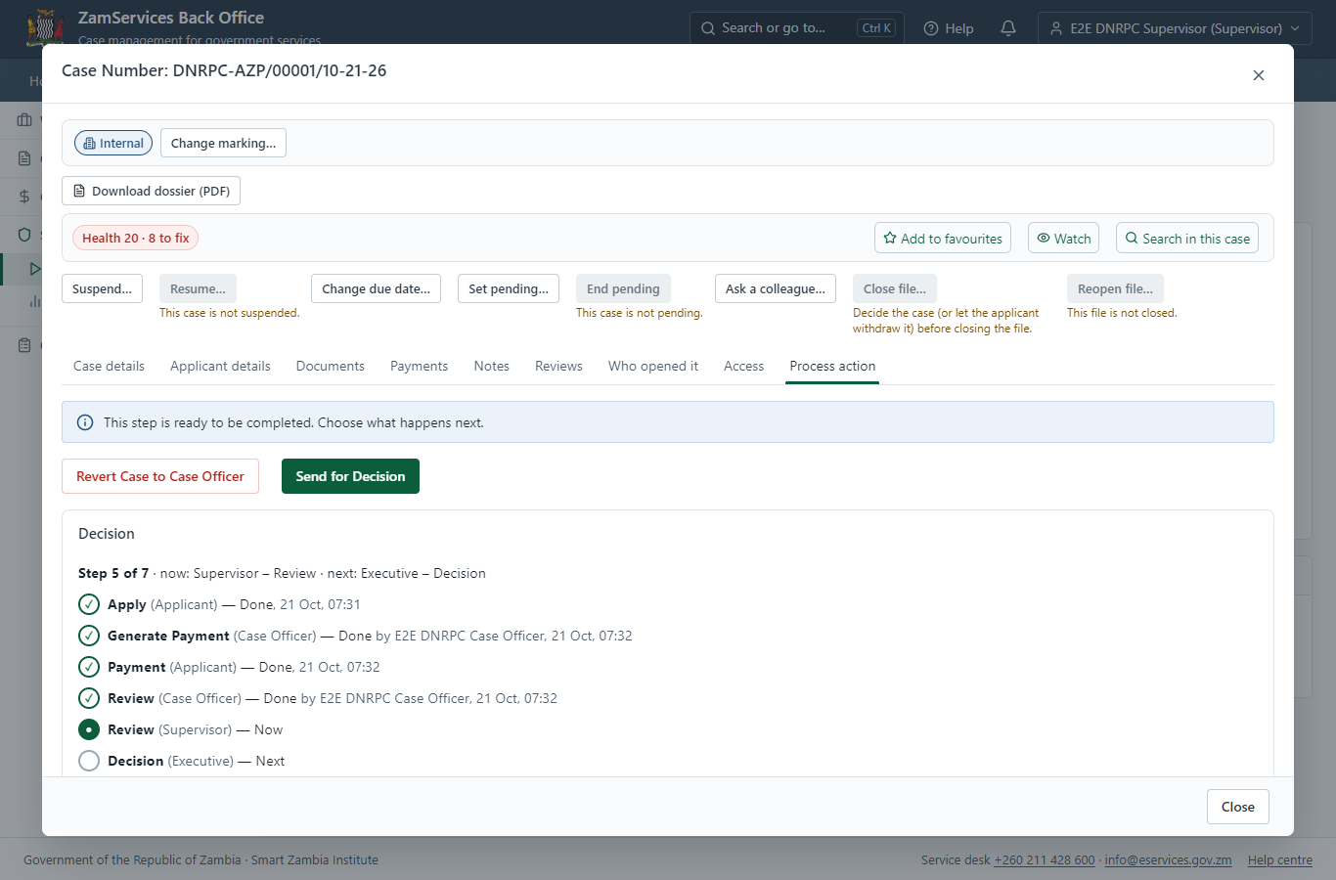
Step 14: Review, Security Vetting.

Step 15. Decide: Review, Authorize
Executive · Back office
At "Review, Authorize" the Executive records the decision: approve, with a comment kept in the case history. Approving moves the case on; the last decision completes it and issues the document.
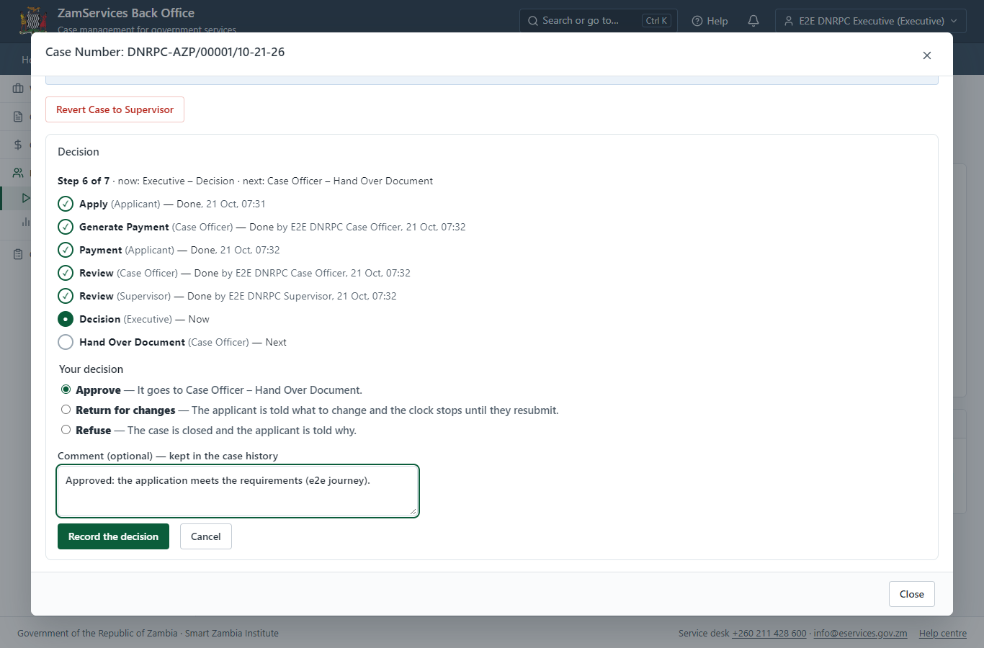
Step 15: Decide: Review, Authorize.

Step 16. Print GS3
Case Officer · Back office
The Case Officer works on "Print GS3" (collection in the imported process), checks the application and its documents, and completes the step.
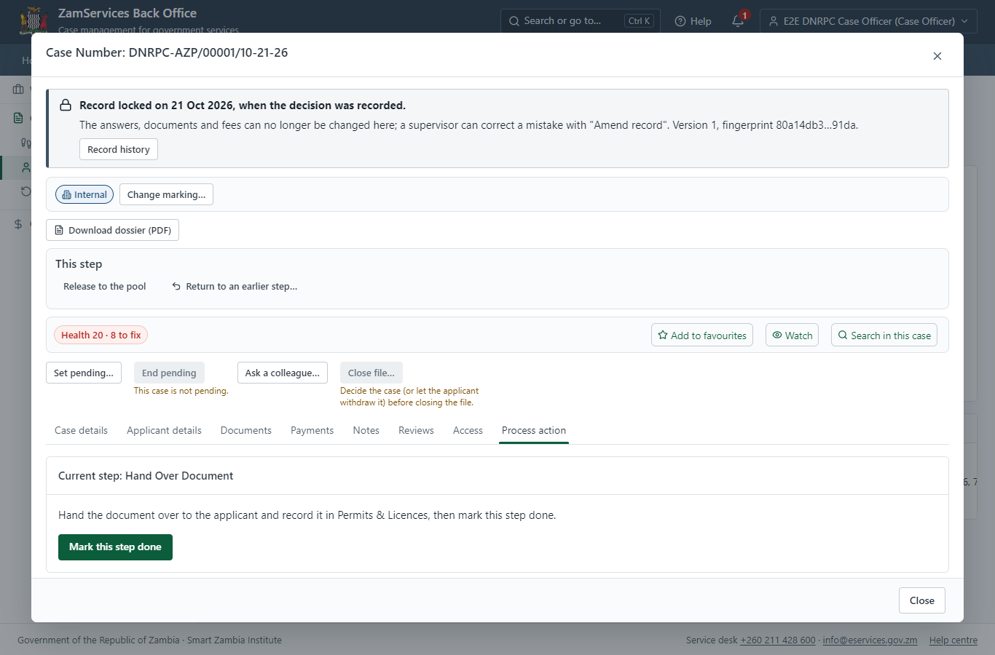
Step 16: Print GS3.

Step 17. The document in My permits
Citizen · National e-Services portal
The issued document (DNRPC-AZP-2026-00001 in this run: "Application for Zambian Passport") is listed in "My permits and licences" with its validity and a download of the sealed PDF.
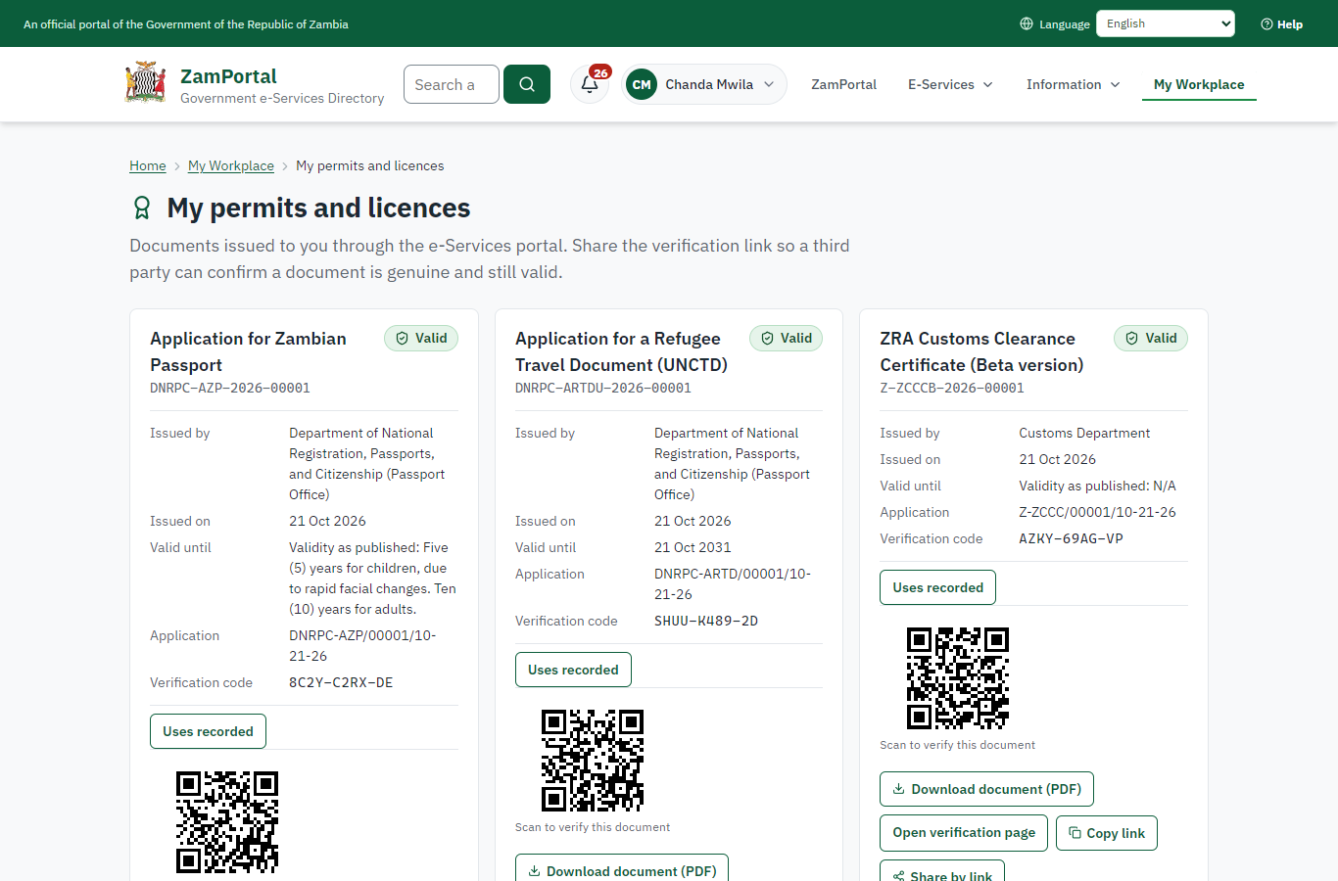 | 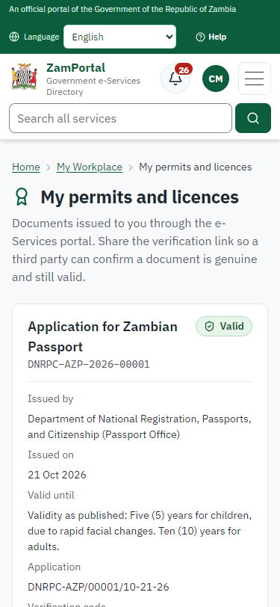
Step 17: The document in My permits - desktop (left) and a 375 px phone (right).

Step 18. Verify the document
Anyone (public) · Public verification page
The QR code on the document opens the public verification page: genuine and current, to whom it was issued, and whether the electronic seal is valid. No sign-in is needed.
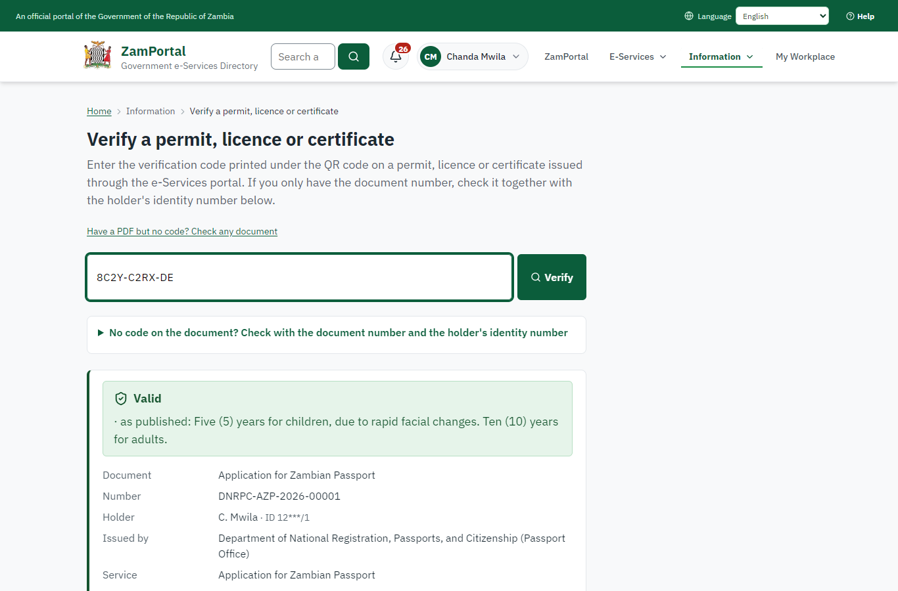 | 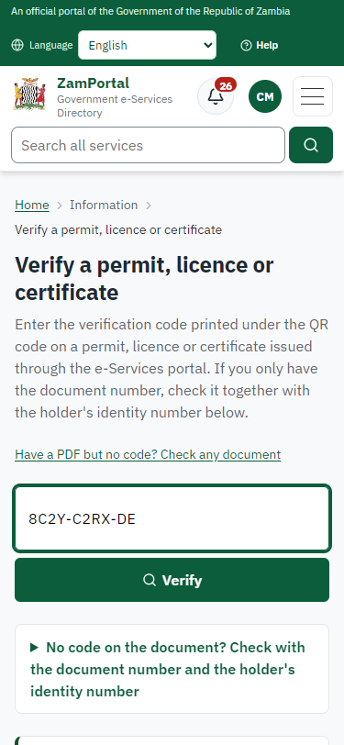
Step 18: Verify the document - desktop (left) and a 375 px phone (right).

3. Payment
Item | In the test run
Fee (as published) | Ordinary issuance, 32 pages – ZMW 320.00 Express issuance, 32 pages – ZMW 520.00 Ordinary issuance, 48 pages – ZMW 520.00 Express issuance, 48 pages – ZMW 720.00 Lost penalty fee – ZMW 100.00
Invoice 1 | 6922746245647201
Amount 1 | ZMW 500.00
Paid at 1 | after "Work out the fee"
On screen: step 9 (Work out the fee), step 10 (See that the fee is due), step 11 (Pay with ZamPay), step 12 (Payment received) in section 2.

4. Output documents

Application for Zambian Passport (sealed PDF)
Issued when the case was approved, from the service's output configuration (service template MOHA_TravelPassportUnder.Certificate.docx), filled from the application and the decision, sealed with the platform's electronic seal and stored as the issued version. The holder downloads it from My permits; the verification page checks it.
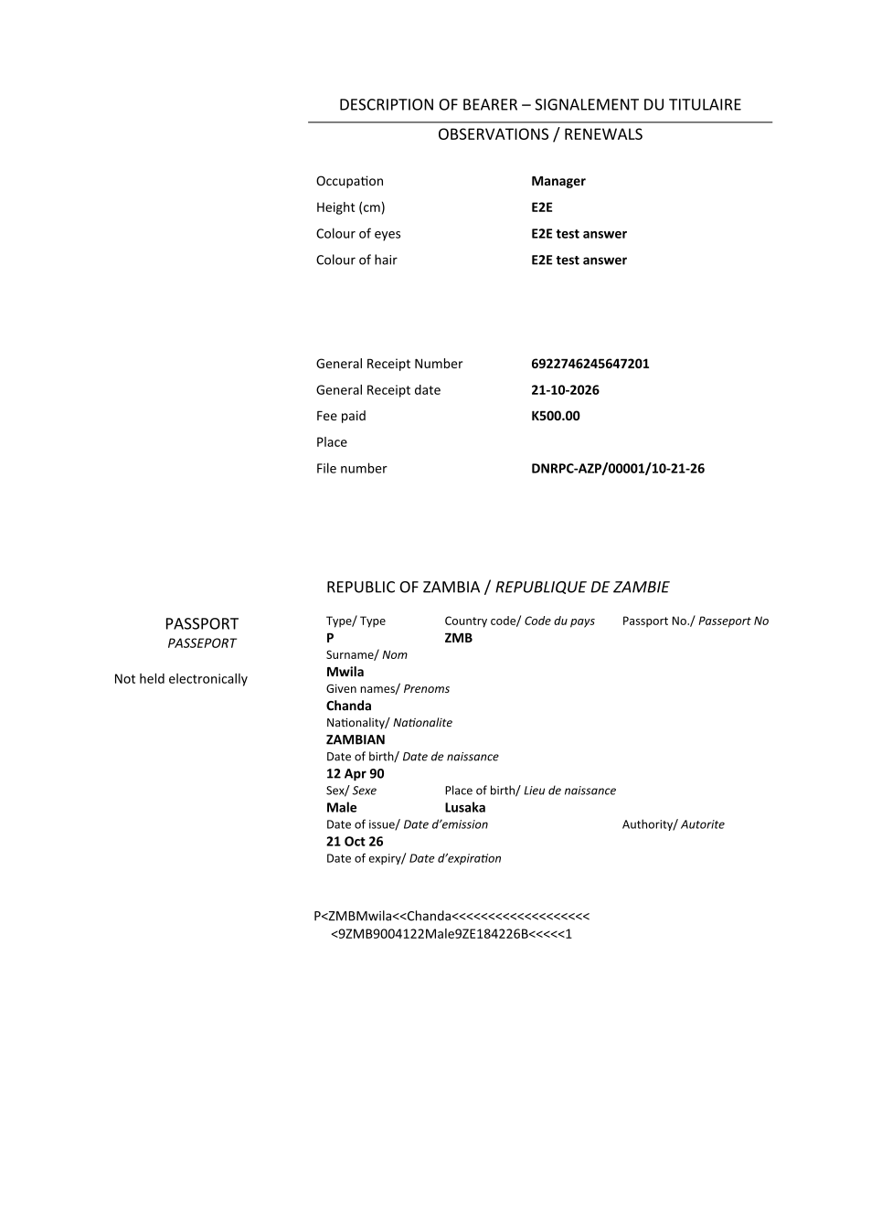
Application for Zambian Passport (sealed PDF) - first of 1 page, as issued in the test run.

Fields
Field | Value in the test run
Document title | Application for Zambian Passport
Permit / licence number | DNRPC-AZP-2026-00001
Holder | Chanda Mwila
Valid from | 2026-10-21
Valid until
Status | active
Verification code (printed with a QR code) | 8C2Y-C2RX-DE

Seal
Seal status | sealed
Signature level | PAdES-B-T
Sealed by | the platform seal (development key in the test run)
Signed at | 2026-10-21T05:32:40.539Z
Trusted time-stamp | 2026-10-21T05:32:40.520Z (time-stamping authority)
Document fingerprint (SHA-256) | 35ff602336c26035...

Verification
Where | The public verification page of the national portal, <portal>/verify/<verification code>, opened by scanning the QR code on the document.
What it shows | Whether the document is genuine and current, its holder and validity, and whether the electronic seal is valid and who sealed it.
Checking a copy | Anyone can upload a PDF they were given; the page says whether it is exactly the document that was issued. A changed copy is reported as not matching.
On screen: step 17 (The document in My permits), step 18 (Verify the document) in section 2.

5. Notifications
When | Channel | To | Message | Delivery
Application received | in-app (portal bell) | the applicant | Application DNRPC-AZP/00001/10-21-26 received - Your application DNRPC-AZP/00001/10-21-26 for Application for Zambian Passport has been received by Department of National Registration, Passports, and Citizenship (Passport Office). | shown
Status changed | in-app (portal bell) | the applicant | Update on application DNRPC-AZP/00001/10-21-26 - DNRPC-AZP/00001/10-21-26 (Application for Zambian Passport) is now: With the office - fees being worked out. | shown
Payment due (invoice raised) | in-app (portal bell) | the applicant | Payment due for application DNRPC-AZP/00001/10-21-26 - The fee of ZMW 500.00 for Application for Zambian Passport (DNRPC-AZP/00001/10-21-26) is now due. Invoice 6922746245647201. | shown
Payment received | in-app (portal bell) | the applicant | Payment received for DNRPC-AZP/00001/10-21-26 - Your payment of ZMW 500.00 for DNRPC-AZP/00001/10-21-26 (Application for Zambian Passport) has been received. Receipt: <ZamPay>/pdf?documentType=receipt&invoiceNumber=6922746245647201 | shown
Licence / permit issued | in-app (portal bell) | the applicant | Your Application for Zambian Passport document has been issued - DNRPC-AZP-2026-00001 has been issued for Application for Zambian Passport. | shown
case.approved | in-app (portal bell) | the applicant | Application DNRPC-AZP/00001/10-21-26 approved - DNRPC-AZP/00001/10-21-26 (Application for Zambian Passport) has been approved. | shown
Decision: approved | in-app (portal bell) | the applicant | Application DNRPC-AZP/00001/10-21-26 completed - DNRPC-AZP/00001/10-21-26 (Application for Zambian Passport) is complete. Your documents are ready. | shown
Invitation to rate the service | in-app (portal bell) | the applicant | How was Application for Zambian Passport? - How was Application for Zambian Passport? Tell us in about a minute. | shown
Application received | email | e2e.c***@example.test | Application DNRPC-AZP/00001/10-21-26 received | skipped
Application received | sms | +260 97* *** 567 | Application DNRPC-AZP/00001/10-21-26 for Application for Zambian Passport has been received. Track it: <portal>/my-workplace | delivered
Status changed | sms | +260 97* *** 567 |  | delivered
Payment due (invoice raised) | email | e2e.c***@example.test | Payment due for application DNRPC-AZP/00001/10-21-26 | skipped
Payment due (invoice raised) | sms | +260 97* *** 567 | Fee of ZMW 500.00 due for DNRPC-AZP/00001/10-21-26. Invoice 6922746245647201. Pay: <ZamPay>/pay-for-service/get-invoice/6922746245647201 | delivered
Payment received | sms | +260 97* *** 567 |  | delivered
Licence / permit issued | email | e2e.c***@example.test | Your Application for Zambian Passport document has been issued | skipped
Licence / permit issued | sms | +260 97* *** 567 |  | delivered
case.approved | sms | +260 97* *** 567 |  | delivered
case.approved | email | e2e.c***@example.test | Application DNRPC-AZP/00001/10-21-26 approved | skipped
Invitation to rate the service | sms | +260 97* *** 567 |  | skipped
Invitation to rate the service | email | e2e.c***@example.test | How was Application for Zambian Passport? | skipped
Decision: approved | email | e2e.c***@example.test | Application DNRPC-AZP/00001/10-21-26 completed | skipped
Decision: approved | sms | +260 97* *** 567 |  | delivered
Delivery: shown = in the portal's notification bell; delivered = the SMS gateway (a test double in this run) reported the text delivered; skipped = not sent on that channel (e-mail is not configured on the test installation, and some notices go out on one channel only); sent by the national portal = a ministry node handed the notice to the national portal, which texts and e-mails the citizen under its own name and the citizen's preferences. Addresses written <portal>, <ZamPay> stand for the national portal and ZamPay.

6. Legacy mapping
Replaces | Application for Zambian Passport in the legacy ZIGS e-Services directory (ZIGS_Services)
Legacy service id | 91
Legacy provider | Department of National Registration, Passports, and Citizenship (Passport Office) (DNRPC) under Ministry of Home Affairs and Internal Security
Legacy process | FullReview (process 3)
Fee in the legacy system | Travel Passport 32-Page (under 16 years): ZMW 500 (New)  Travel Passport 48-Page (under 16 years): ZMW 833 (New)  Travel Passport 32-Page (under 16 years) - Express Issuance: ZMW 833 (New)  Travel Passport 48-Page (under 16 years) - Express Issuance: ZMW 567 (New)  Fee for Application Form: ZMW 33 (New)
Fee taken before submission | yes (as in ZIGS)
Time to issue (legacy) | New: 14 working days
Legacy output templates | Denial of Service: ZIGS_Forms_MOHA / MOHA_TravelPassportUnder.DenialService  Notice of Approval: ZIGS_Forms_MOHA / MOHA_TravelPassportUnder.NoticeApproval  Application for Zambian Passport: ZIGS_Forms_MOHA / MOHA_TravelPassportUnder.Certificate  Application form: ZIGS_Forms_MOHA / MOHA_TravelPassportUnder.Application  GS-2 Notice of Government Action: ZIGS_Forms_Notices / GS-2.NoticeOfAction  GF-1 Treasury Invoice: ZIGS_CustomForms / GF-1 Invoice  GF-2 Treasury Receipt: ZIGS_CustomForms / GF-2 Receipt
Legacy address | https://passports.gsb.gov.zm
How it was brought over | Imported by the platform's legacy catalogue importer (zcm-backend scripts/zigs/importLegacy.js) from the ZIGS snapshot: form, case types, fees, documents, process and output templates, then served by the new platform.

7. Version and date
Document version | service v1, platform a0a302b8
Generated | 2026-10-21T05:32:47Z (by the end-to-end run, not edited by hand)
Service version | not versioned (configured directly)
Platform snapshot | backend a0a302b8  portal 72805f0  back office 58e5946
Test suite | e2e 5999d9b; one installation (combined); seed profile mihud
Journeys | 30-catalogue-service.spec.js: citizen finds the service, answers its form, uploads its documents and sends the application - passed  30-catalogue-service.spec.js: the case goes through every step of its process: payments by the citizen, each officer step by its role - passed  30-catalogue-service.spec.js: the grant document is issued, sealed, filled in and verifiable; the citizen has it in My permits - passed
Result | 3 of 3 journey tests passed
Data | Synthetic test data on a local test installation; provider test doubles for ZamPass, ZamPay, SMS and signing.

