Republic of Zambia
GSB e-Services

Application for Statutory Marriage
Service documentation
Owner: Department of Local Government
Service key: LGD/application-for-statutory-marriage
Version: service v1, platform 39fb88e4
Date: 2026-10-21
Generated automatically by the service's end-to-end test run. Every screenshot shows synthetic test data on a local test installation, never real personal data.

Contents
- 1. Service summary
- 2. Application process, step by step
- 3. Payment
- 4. Output documents
- 5. Notifications
- 6. Legacy mapping
- 7. Version and date
This document describes the Application for Statutory Marriage service of Department of Local Government as the platform runs it today. It is generated by the service's end-to-end test: every step was performed by the test and every screenshot was taken during that run, with synthetic data. Regenerate it with "npm run docs:services" in the e2e suite; do not edit it by hand.

1. Service summary
Service | Application for Statutory Marriage
Owner (MDA) | Department of Local Government (LGD)
Purpose | Every couple intending to marry as a statutory marriage shall register with the local District Registrar to be issued with a marriage certificate as official proof of their union. This service allows couples to submit a statutory marriage notice, pay the applicable fee, and complete the legal steps required for marriage under the Marriage Act. Depending on the selected path, the marriage may be solemnised at the Civic Centre before a Registrar, or under a Special licence for an exceptional venue. It also supports cancellation before the marriage is solemnised.
Who can apply | Individual
How to apply | Online on the national e-Services portal, signed in with ZamPass; pay with ZamPay.
Fees | Marriage fee: (table)  Marriage certificate / Form C fee: (table)  Registration and Form 1 fees: (table)  Special licence (ceremony outside the Civic Centre): (table)  Registrar booking fee: (table)  Weekend / public holiday solemnisation: (table)  Video filming fee: (table)  Photos at the Civic Centre: (table)  Council Chamber hire: (table)  Photo session fee: (table)  Cancellation penalty: (table)
Turnaround | Within 21 or 14 days (or less, if express marriage).
Validity of the output | Three months (valid only for the intended marriage and void if the marriage does not take place within 3 months from the notice date).
Required documents | Applicant/Representative Identity Document (required) - Checked against the national register where available (legacy automatic NRC check).  Husband Identity Document (NRC/Passport) (required) - Checked against the national register where available (legacy automatic NRC check).  Wife Identity Document (NRC/Passport) (required) - Checked against the national register where available (legacy automatic NRC check).  Divorce Certificate of Former Marriage (if applicable) (optional) - Only when it applies to one of the parties.  Death Certificate of Former Spouse (if applicable) (optional) - Only when it applies to one of the parties.  Letter of Non-Impediment to Marriage (first time being married, foreigners) (optional) - Only when it applies to one of the parties.  Parent/Guardian Consent Letter (spouses under 21 years old) (optional) - Only when it applies to one of the parties.  Resident Permit (Non-Zambian) (optional) - Only when it applies to one of the parties.  Applicant/Representative Identity Document (cancellation) (required) - Checked against the national register where available (legacy automatic NRC check).
Output documents | GS-1 Application for a Government Service  GS-2 Notice of Government Action  Notice of Marriage (Form 1)  Certificate of Marriage  Registrar's Certificate (Form C)  Special Licence for Marriage

2. Application process, step by step

The process as configured
Step | Role | Task | Type
1 | Applicant | Apply | form
2 | System | Generate Document | generate-document
3 | Case Officer | Generate Payment | generate-payment
4 | Applicant | Payment | payment
5 | System | Route | gateway
6 | Case Officer | Review | review
7 | System | Generate Document | generate-document
8 | System | Route | gateway
9 | System | Wait | wait
10 | System | Wait | wait
11 | Case Officer | Review | review
12 | Case Officer | Decision | decision
13 | System | Route | gateway
14 | System | Generate Document | generate-document
15 | System | Generate Document | generate-document
16 | System | Generate Document | generate-document
17 | Case Officer | Review | review
18 | Case Officer | Decision | decision
19 | System | Notify Client | notify

Step by step
Who takes part in this journey: Citizen, Case Officer, Anyone (public). Citizen steps are shown on a desktop and on a 375 px phone; back-office steps on a desktop.

Step 1. Find the service at the council
Citizen · National e-Services portal
The service is delivered by the local authorities: on the national e-Services portal the citizen opens Councils, chooses their council (Lusaka City Council in this run) and searches its services ("Application for Statutory Marriage"). The application is then registered with that council and priced with its own fees.
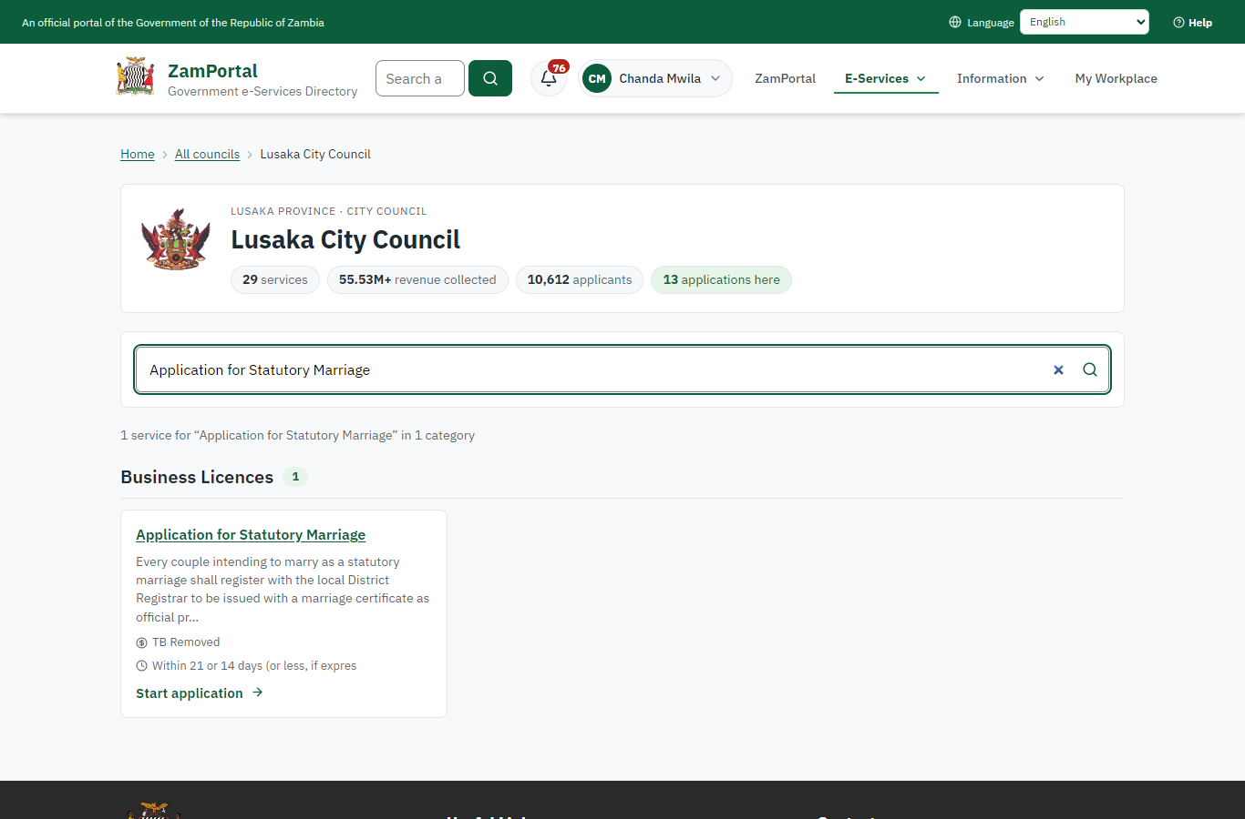 | 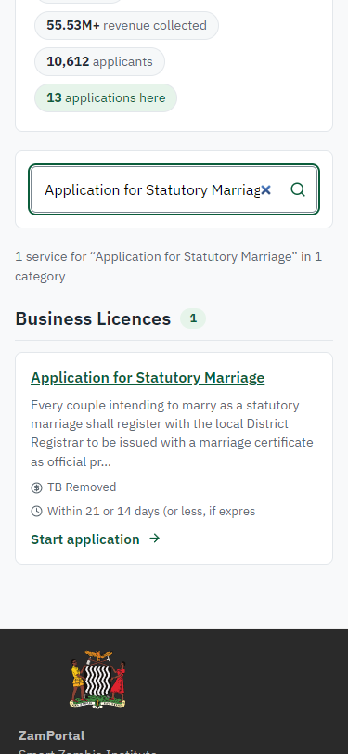
Step 1: Find the service at the council - desktop (left) and a 375 px phone (right).

Step 2. Read the service page
Citizen · National e-Services portal
The service page sets out what the service is for, the fee, how long it takes and the documents to have ready, and names the council the application goes to. "Start application" begins an application at Lusaka City Council (the citizen is signed in with ZamPass).
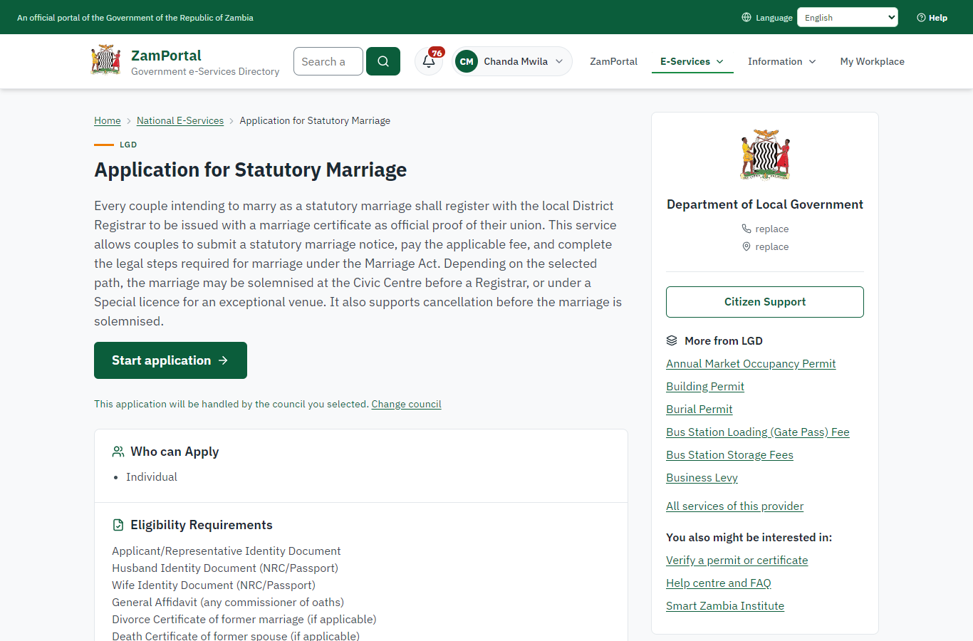 | 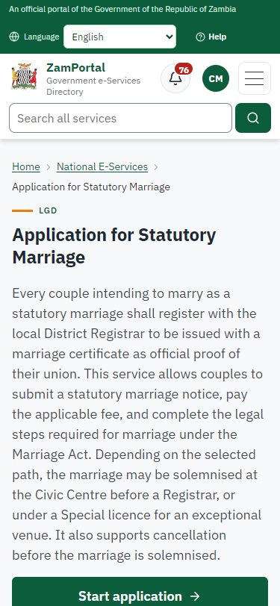
Step 2: Read the service page - desktop (left) and a 375 px phone (right).

Step 3. Confirm the applicant details
Citizen · National e-Services portal
The applicant details are filled in from the citizen's ZamPass account. The citizen says whom they are applying for (themself) and continues with "Proceed to Application".
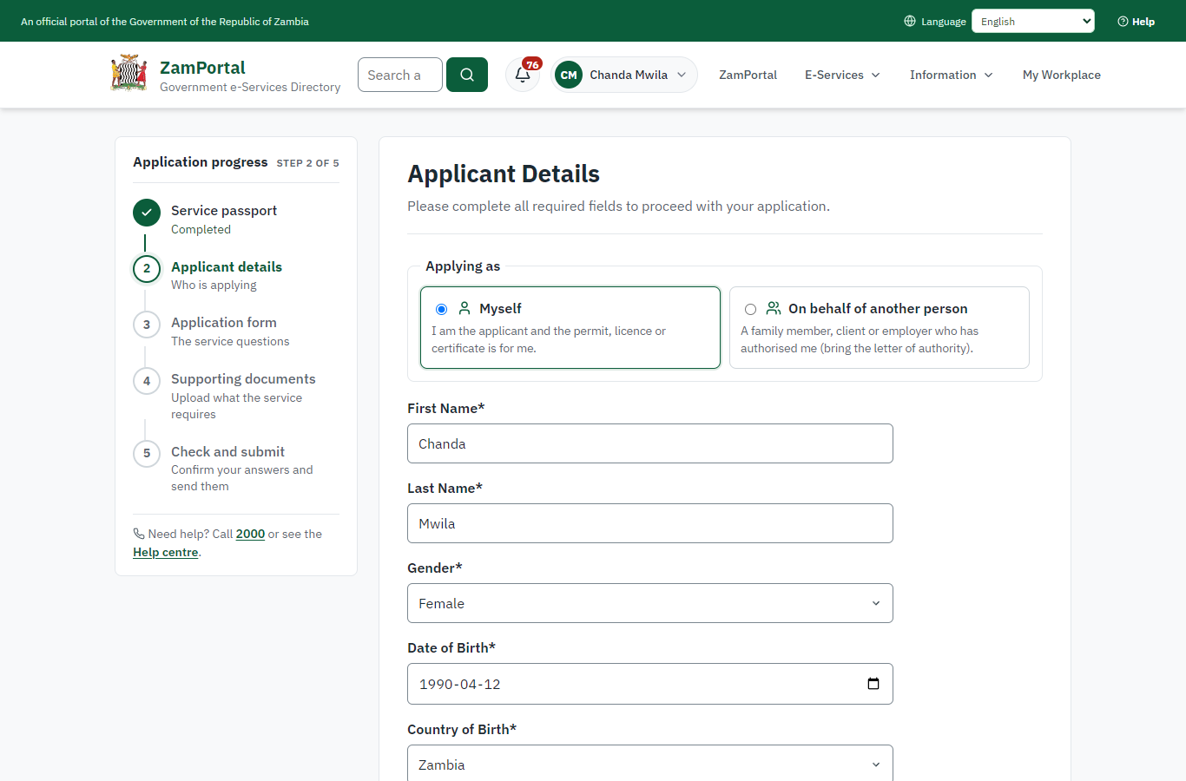 | 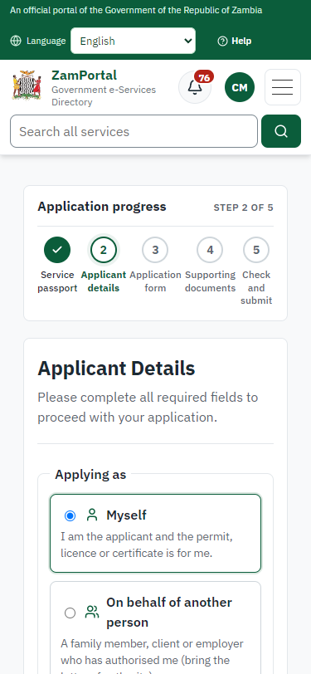
Step 3: Confirm the applicant details - desktop (left) and a 375 px phone (right).

Step 4. Fill in the application form
Citizen · National e-Services portal
The citizen answers the service's own application form, converted from the legacy system (61 answers in this run, all synthetic), for the type of application "New". Questions marked * must be answered; some appear only after an earlier answer. Answers are saved as the citizen types, so an unfinished application can be reopened from My Workplace.
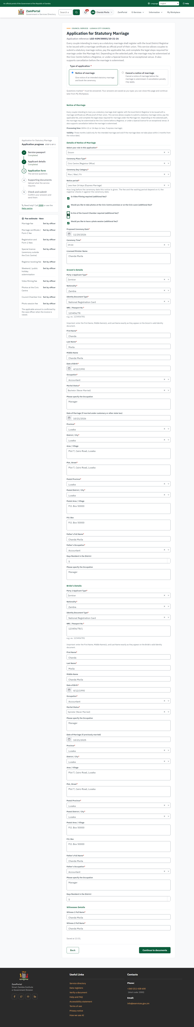 | 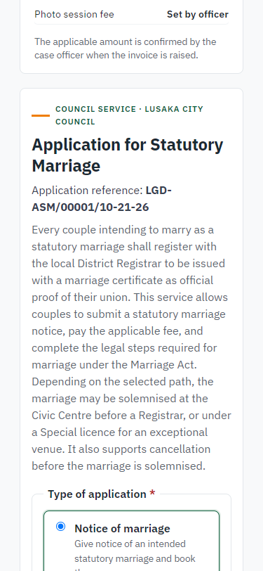
Step 4: Fill in the application form - desktop (left) and a 375 px phone (right).

Step 5. Upload the supporting documents
Citizen · National e-Services portal
Each document the service asks for has its own upload (9 in this run: Applicant/Representative Identity Document, Husband Identity Document (NRC/Passport), Wife Identity Document (NRC/Passport), Divorce Certificate of Former Marriage (if applicable), Death Certificate of Former Spouse (if applicable), Letter of Non-Impediment to Marriage (first time being married, foreigners), Parent/Guardian Consent Letter (spouses under 21 years old), Resident Permit (Non-Zambian), Applicant/Representative Identity Document (cancellation)). The files are checked and stored with the application; the page confirms each upload.
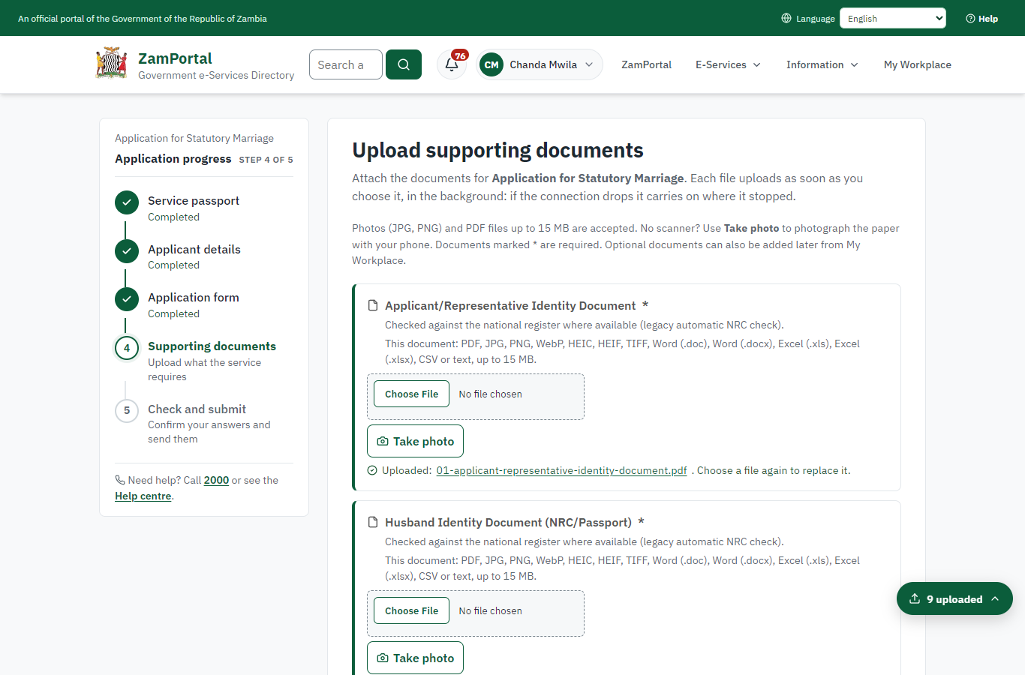 | 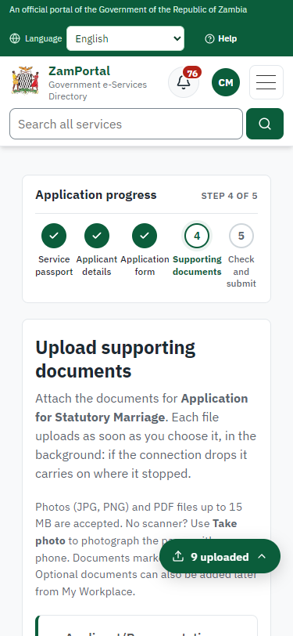
Step 5: Upload the supporting documents - desktop (left) and a 375 px phone (right).

Step 6. Check the answers and confirm the declaration
Citizen · National e-Services portal
Before sending, the citizen sees every answer and document on one page and can go back to change them. The declaration that the information is true and complete must be ticked.
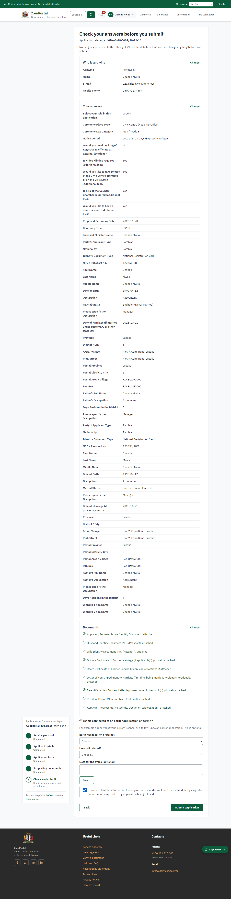 | 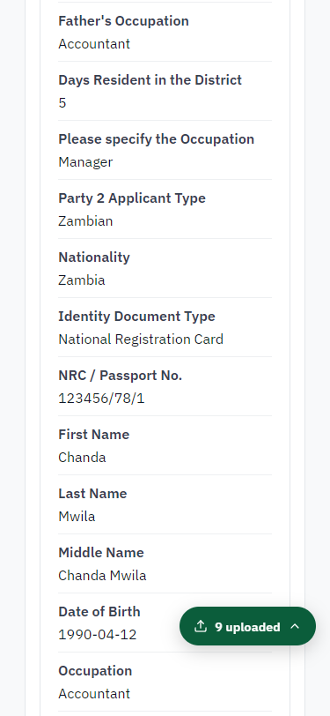
Step 6: Check the answers and confirm the declaration - desktop (left) and a 375 px phone (right).

Step 7. Application sent
Citizen · National e-Services portal
The portal confirms the application with the ministry's reference number (LGD-ASM/00001/10-21-26 in this run). The fee is due now: it is taken with the application, so the invoice was raised when the application was sent.
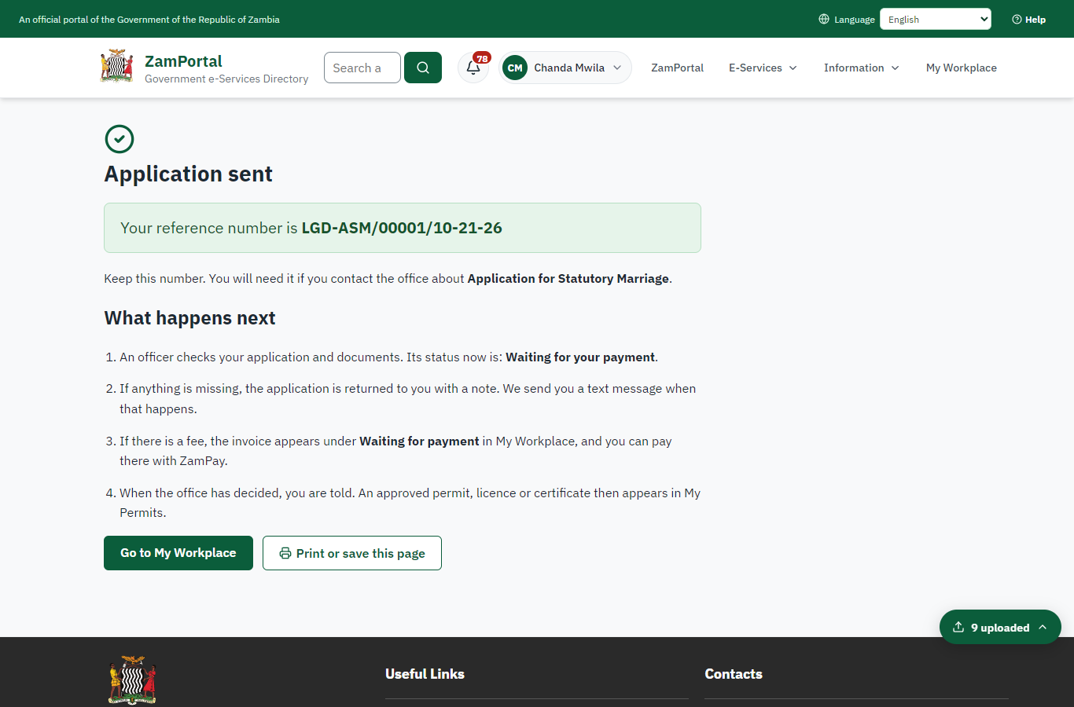 | 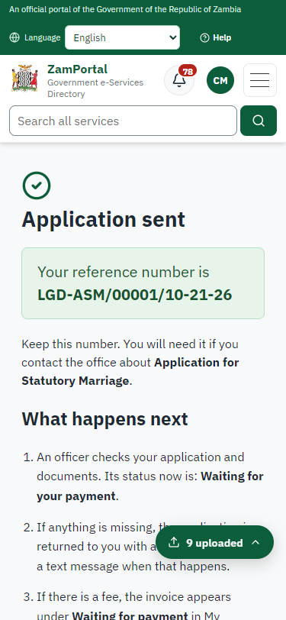
Step 7: Application sent - desktop (left) and a 375 px phone (right).

Step 8. See that the fee is due
Citizen · National e-Services portal
The application shows "Waiting for your payment" in My Workplace with a Pay button (K2,500.00). The fee is taken with the application; the invoice was raised on ZamPay.
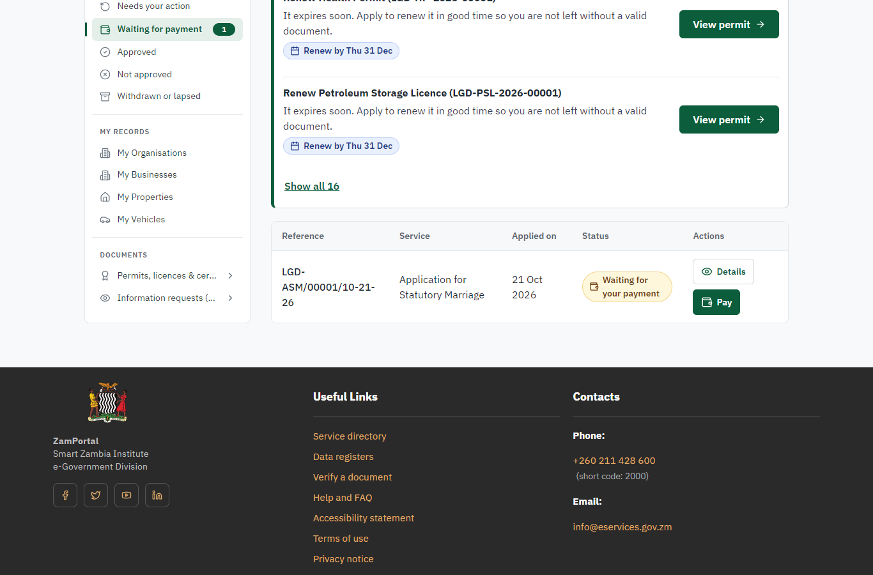 | 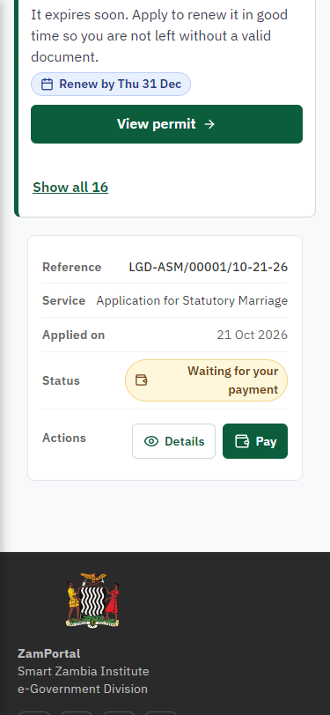
Step 8: See that the fee is due - desktop (left) and a 375 px phone (right).

Step 9. Pay with ZamPay
Citizen · National e-Services portal
Pay opens the invoice (K2,500.00, the amount set by the platform, never by the page) with its PDF preview; the citizen pays at ZamPay by mobile money or bank card.
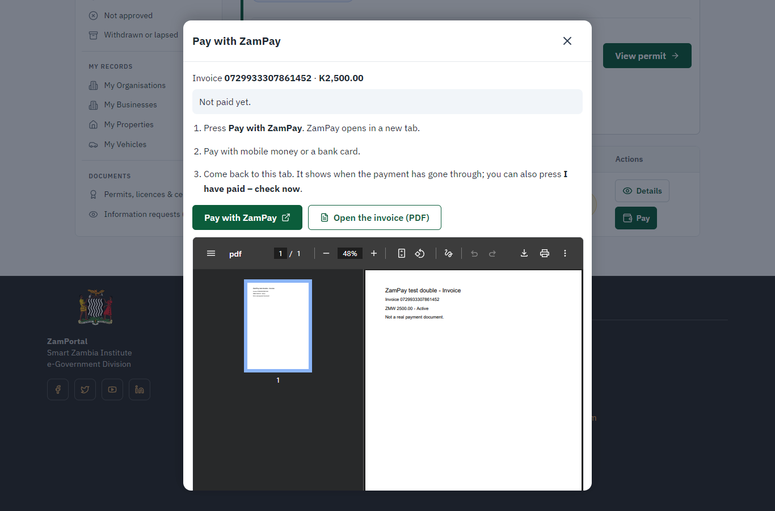 | 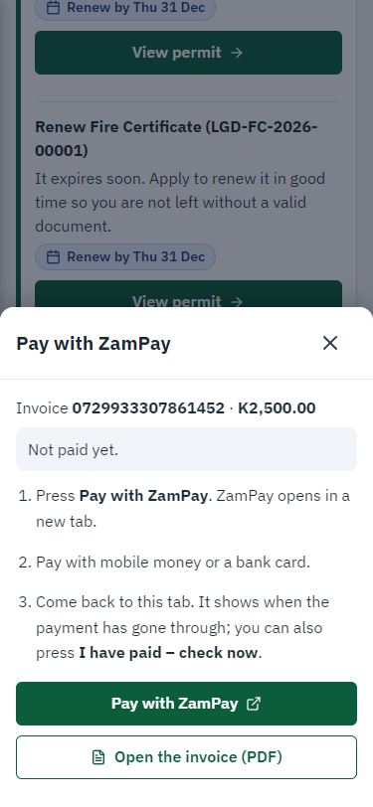
Step 9: Pay with ZamPay - desktop (left) and a 375 px phone (right).

Step 10. Payment received
Citizen · National e-Services portal
ZamPay reports the payment; the dialog says "Paid. Thank you" and the application moves on to the ministry's officers.
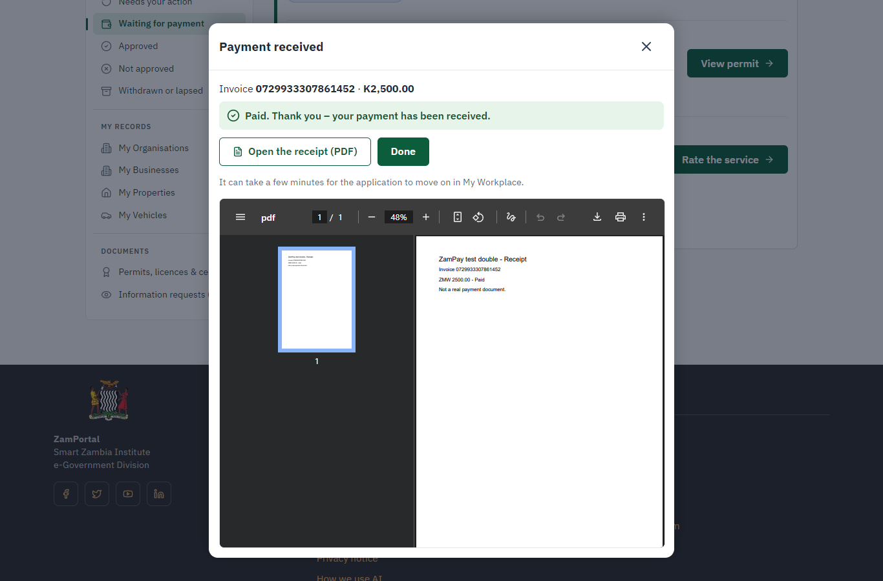 | 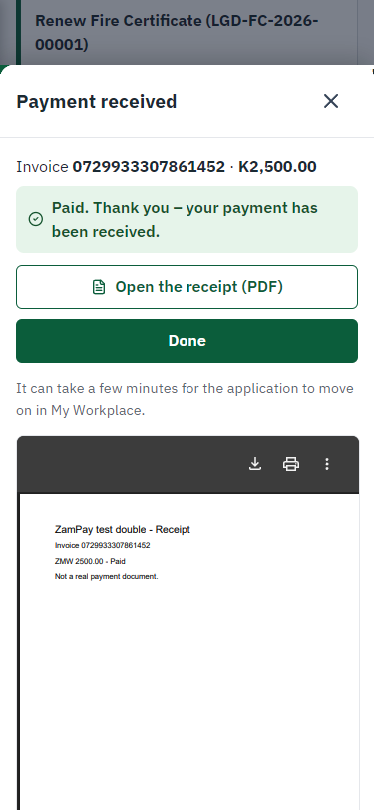
Step 10: Payment received - desktop (left) and a 375 px phone (right).

Step 11. Take the new application on
Case Officer · Back office
The application arrives in the case queue of the ministry that owns the service (Department of Local Government); only its staff see it. The officer opens it by its reference number - answers, documents and process are on the case - assigns it to themself and takes it on.
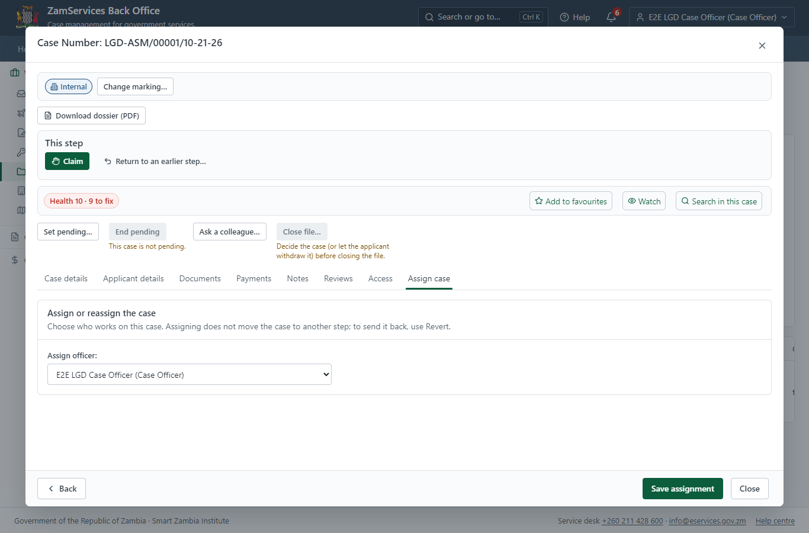
Step 11: Take the new application on.

Step 12. Verify the notice (eligibility, identity and documents of both parties)
Case Officer · Back office
The Case Officer works on "Verify the notice (eligibility, identity and documents of both parties)" (review in the imported process), checks the application and its documents, and completes the step.
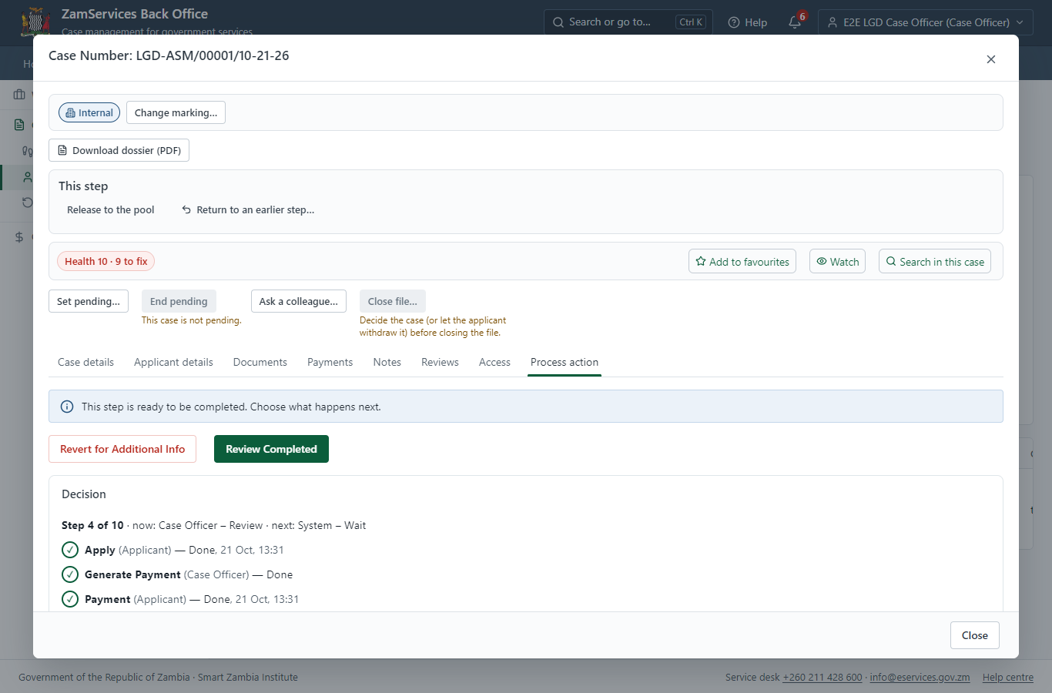
Step 12: Verify the notice (eligibility, identity and documents of both parties).

Step 13. Review, final decision (no caveat lodged, ceremony details confirmed)
Case Officer · Back office
The Case Officer works on "Review, final decision (no caveat lodged, ceremony details confirmed)" (review in the imported process), checks the application and its documents, and completes the step.
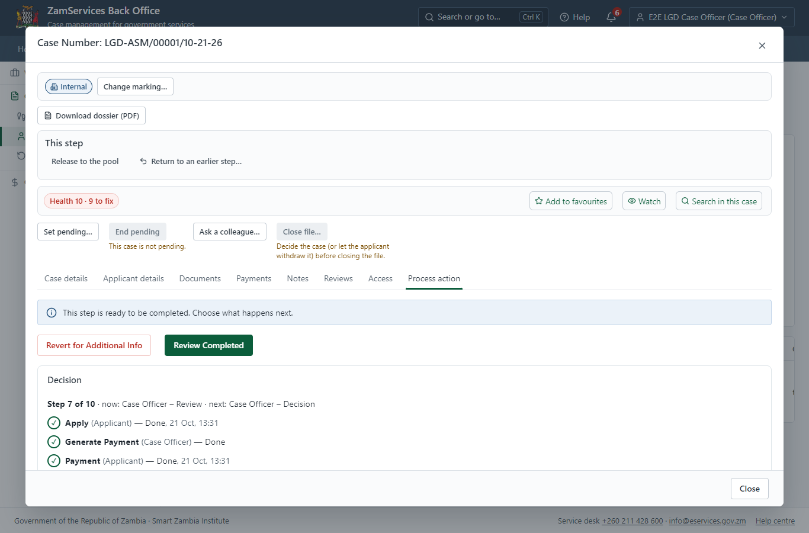
Step 13: Review, final decision (no caveat lodged, ceremony details confirmed).

Step 14. Decide: Registrar decision, e-sign
Case Officer · Back office
At "Registrar decision, e-sign" the Case Officer records the decision: approve, with a comment kept in the case history. Approving moves the case on; the last decision completes it and issues the document.
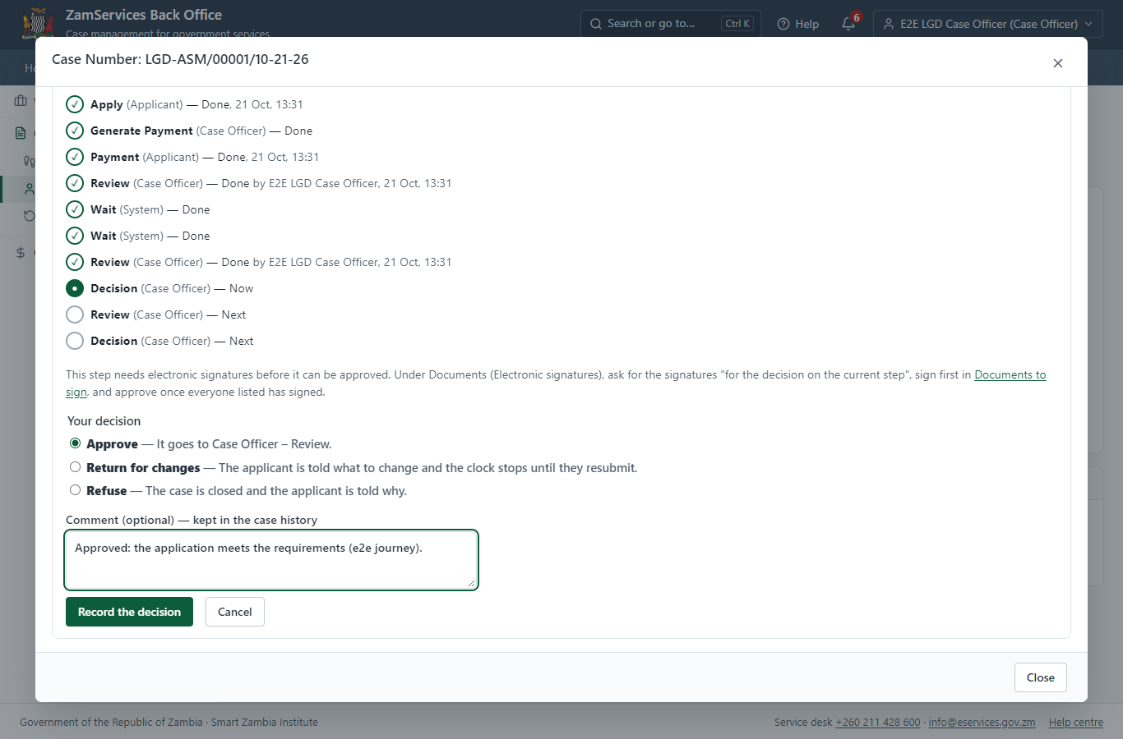
Step 14: Decide: Registrar decision, e-sign.

Step 15. The document in My permits
Citizen · National e-Services portal
The issued document (LGD-ASM-2026-00001 in this run: "Certificate of Marriage") is listed in "My permits and licences" with its validity and a download of the sealed PDF.
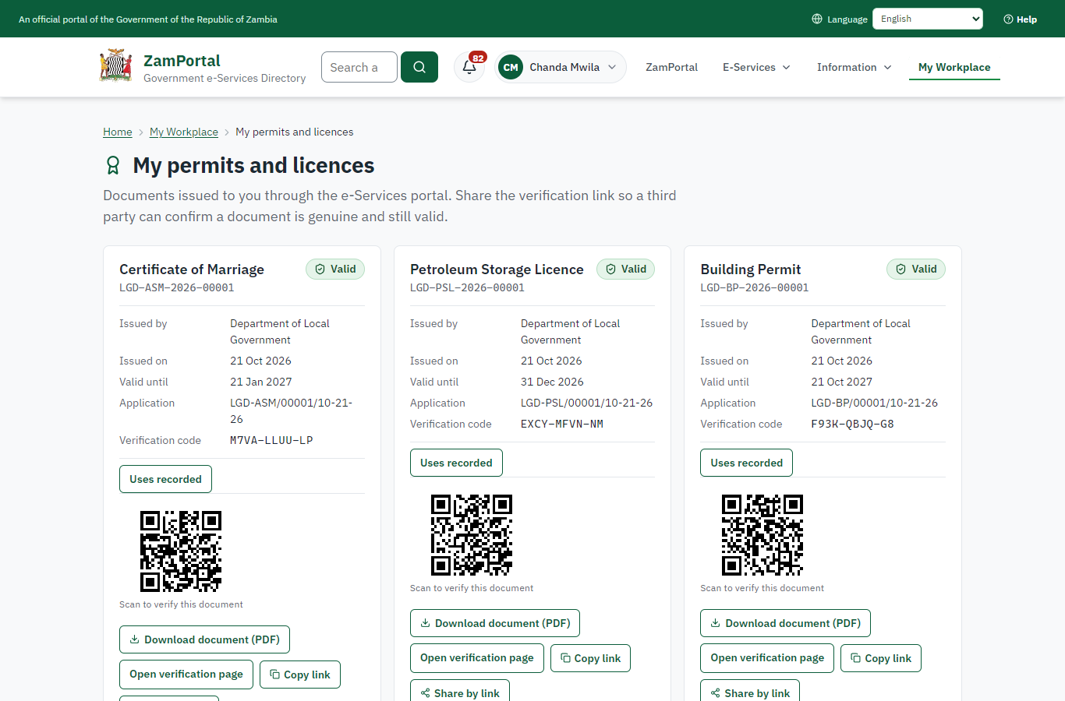 | 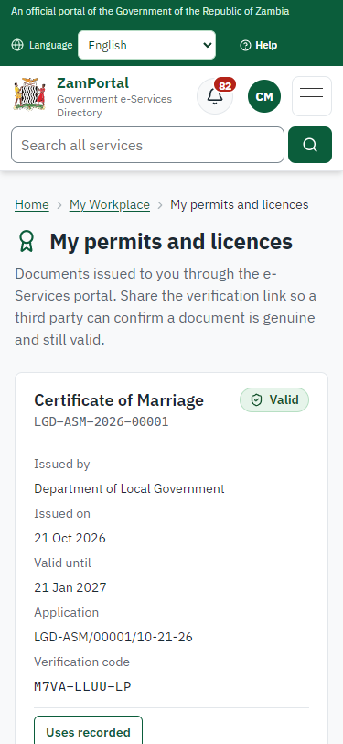
Step 15: The document in My permits - desktop (left) and a 375 px phone (right).

Step 16. Verify the document
Anyone (public) · Public verification page
The QR code on the document opens the public verification page: genuine and current, to whom it was issued, and whether the electronic seal is valid. No sign-in is needed.
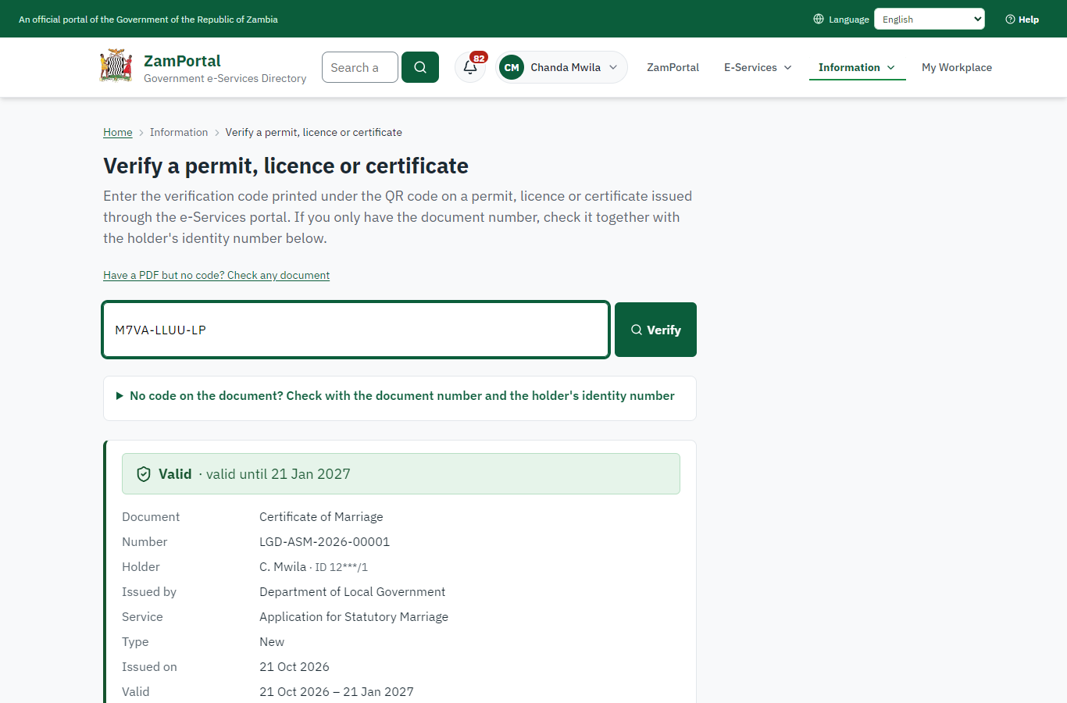 | 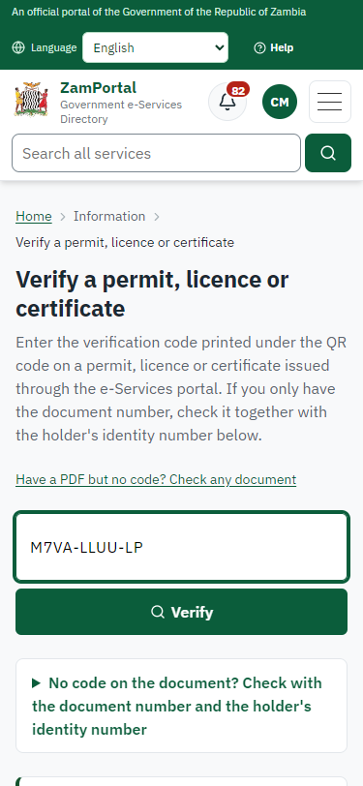
Step 16: Verify the document - desktop (left) and a 375 px phone (right).

3. Payment
Item | In the test run
Fee (as published) | TB Removed
Invoice 1 | 0729933307861452
Amount 1 | ZMW 2500.00
Paid at 1 | with the application
On screen: step 8 (See that the fee is due), step 9 (Pay with ZamPay), step 10 (Payment received) in section 2.

4. Output documents

Certificate of Marriage (sealed PDF)
Issued when the case was approved, from the service's output configuration (service template MarriageNotice.Certificate.docx), filled from the application and the decision, sealed with the platform's electronic seal and stored as the issued version. The holder downloads it from My permits; the verification page checks it.
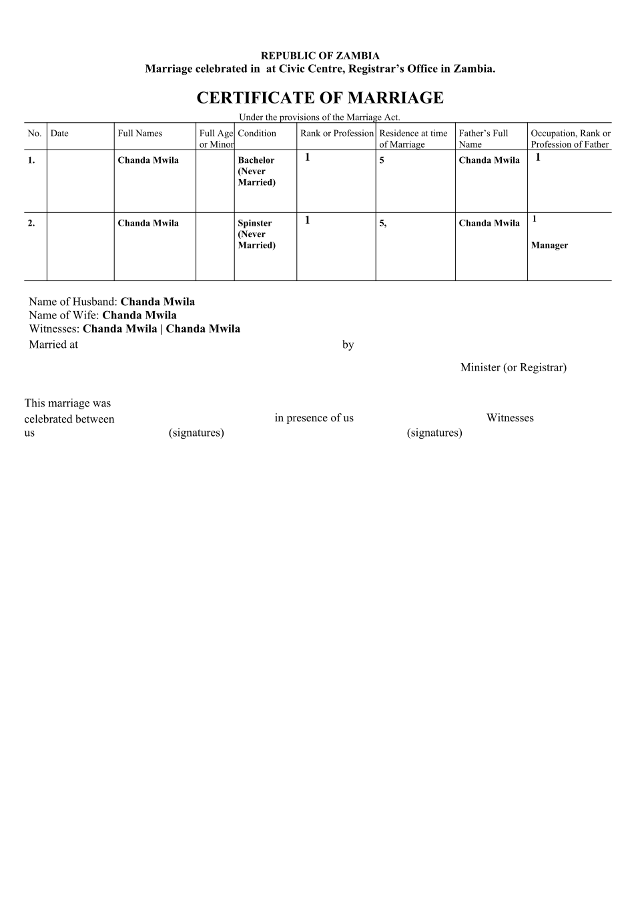
Certificate of Marriage (sealed PDF) - first of 1 page, as issued in the test run.

Fields
Field | Value in the test run
Document title | Certificate of Marriage
Permit / licence number | LGD-ASM-2026-00001
Holder | Chanda Mwila
Valid from | 2026-10-21
Valid until | 2027-01-21
Status | active
Verification code (printed with a QR code) | M7VA-LLUU-LP

Seal
Seal status | sealed
Signature level | PAdES-B-T
Sealed by | the platform seal (development key in the test run)
Signed at | 2026-10-21T11:32:03.883Z
Trusted time-stamp | 2026-10-21T11:32:03.872Z (time-stamping authority)
Document fingerprint (SHA-256) | 91823686b6dfd9b2...

Verification
Where | The public verification page of the national portal, <portal>/verify/<verification code>, opened by scanning the QR code on the document.
What it shows | Whether the document is genuine and current, its holder and validity, and whether the electronic seal is valid and who sealed it.
Checking a copy | Anyone can upload a PDF they were given; the page says whether it is exactly the document that was issued. A changed copy is reported as not matching.
On screen: step 15 (The document in My permits), step 16 (Verify the document) in section 2.

5. Notifications
When | Channel | To | Message | Delivery
Payment due (invoice raised) | in-app (portal bell) | the applicant | Payment due for application LGD-ASM/00001/10-21-26 - The fee of ZMW 2500.00 for Application for Statutory Marriage (LGD-ASM/00001/10-21-26) is now due. Invoice 0729933307861452. | shown
Application received | in-app (portal bell) | the applicant | Application LGD-ASM/00001/10-21-26 received - Your application LGD-ASM/00001/10-21-26 for Application for Statutory Marriage has been received by Department of Local Government. | shown
Payment received | in-app (portal bell) | the applicant | Payment received for LGD-ASM/00001/10-21-26 - Your payment of ZMW 2500.00 for LGD-ASM/00001/10-21-26 (Application for Statutory Marriage) has been received. Receipt: <ZamPay>/pdf?documentType=receipt&invoiceNumber=0729933307861452 | shown
Licence / permit issued | in-app (portal bell) | the applicant | Your Application for Statutory Marriage document has been issued - LGD-ASM-2026-00001 has been issued for Application for Statutory Marriage and is valid until 21/01/2027. | shown
Decision: approved | in-app (portal bell) | the applicant | Application LGD-ASM/00001/10-21-26 completed - LGD-ASM/00001/10-21-26 (Application for Statutory Marriage) is complete. Your documents are ready. | shown
Invitation to rate the service | in-app (portal bell) | the applicant | How was Application for Statutory Marriage? - How was Application for Statutory Marriage? Tell us in about a minute. | shown
Payment due (invoice raised) | email | e2e.c***@example.test | Payment due for application LGD-ASM/00001/10-21-26 | skipped
Application received | email | e2e.c***@example.test | Application LGD-ASM/00001/10-21-26 received | skipped
Payment due (invoice raised) | sms | +260 97* *** 567 | Fee of ZMW 2500.00 due for LGD-ASM/00001/10-21-26. Invoice 0729933307861452. Pay: <ZamPay>/pay-for-service/get-invoice/0729933307861452 | delivered
Application received | sms | +260 97* *** 567 | Application LGD-ASM/00001/10-21-26 for Application for Statutory Marriage has been received. Track it: <portal>/my-workplace | delivered
Payment received | sms | +260 97* *** 567 |  | delivered
Invitation to rate the service | sms | +260 97* *** 567 |  | skipped
Invitation to rate the service | email | e2e.c***@example.test | How was Application for Statutory Marriage? | skipped
Decision: approved | sms | +260 97* *** 567 |  | delivered
Licence / permit issued | sms | +260 97* *** 567 |  | delivered
Decision: approved | email | e2e.c***@example.test | Application LGD-ASM/00001/10-21-26 completed | skipped
Licence / permit issued | email | e2e.c***@example.test | Your Application for Statutory Marriage document has been issued | skipped
Delivery: shown = in the portal's notification bell; delivered = the SMS gateway (a test double in this run) reported the text delivered; skipped = not sent on that channel (e-mail is not configured on the test installation, and some notices go out on one channel only); sent by the national portal = a ministry node handed the notice to the national portal, which texts and e-mails the citizen under its own name and the citizen's preferences. Addresses written <portal>, <ZamPay> stand for the national portal and ZamPay.

6. Legacy mapping
Replaces | Application for Statutory Marriage in the legacy ZIGS e-Services directory (ZIGS_Services)
Legacy service id | 649
Legacy provider | Department of Local Government (LGD) under Ministry of Local Government and Rural Development
Legacy process | not recorded
Fee in the legacy system | none
Fee taken before submission | not recorded
Time to issue (legacy) | not recorded
Legacy output templates | GS-1 Application for a Government Service: ZIGS_Forms_ZDA / GS1  GS-2 Notice of Government Action: ZIGS_Forms_Notices / GS-2.NoticeOfAction  Notice of Marriage (Form 1): / MarriageNotice.Form1  Certificate of Marriage: / MarriageNotice.Certificate  Registrar's Certificate (Form C): / MarriageNotice.FormC  Special Licence for Marriage: / MarriageNotice.SpecialLicence
Legacy address | https://ecouncils.gsb.gov.zm
How it was brought over | Imported by the platform's legacy catalogue importer (zcm-backend scripts/zigs/importLegacy.js) from the ZIGS snapshot: form, case types, fees, documents, process and output templates, then served by the new platform.

7. Version and date
Document version | service v1, platform 39fb88e4
Generated | 2026-10-21T11:32:10Z (by the end-to-end run, not edited by hand)
Service version | not versioned (configured directly)
Platform snapshot | backend 39fb88e4  portal 72805f0  back office 58e5946
Test suite | e2e 2f82c10; one installation (combined); seed profile mihud
Journeys | 30-catalogue-service.spec.js: citizen finds the service, answers its form, uploads its documents and sends the application - passed  30-catalogue-service.spec.js: the case goes through every step of its process: payments by the citizen, each officer step by its role - passed  30-catalogue-service.spec.js: the grant document is issued, sealed, filled in and verifiable; the citizen has it in My permits - passed
Result | 3 of 3 journey tests passed
Data | Synthetic test data on a local test installation; provider test doubles for ZamPass, ZamPay, SMS and signing.

