Republic of Zambia
GSB e-Services

Application for Negative Clearance
Service documentation
Owner: Competition and Consumer Protection Commission
Service key: CCPC/application-for-negative-clearance
Version: service v1, platform a0a302b8
Date: 2026-10-21
Generated automatically by the service's end-to-end test run. Every screenshot shows synthetic test data on a local test installation, never real personal data.

Contents
- 1. Service summary
- 2. Application process, step by step
- 3. Payment
- 4. Output documents
- 5. Notifications
- 6. Legacy mapping
- 7. Version and date
This document describes the Application for Negative Clearance service of Competition and Consumer Protection Commission as the platform runs it today. It is generated by the service's end-to-end test: every step was performed by the test and every screenshot was taken during that run, with synthetic data. Regenerate it with "npm run docs:services" in the e2e suite; do not edit it by hand.

1. Service summary
Service | Application for Negative Clearance
Owner (MDA) | Competition and Consumer Protection Commission (CCPC)
Purpose | This is an application by parties to a merger transaction seeking clarification as to whether the proposed merger requires the authorization of the Commission under Section 26 or is subject to review by the Commission under Section 27. It is a certification by the Commission that otherwise uncompetitive conduct can be allowed under conditions specified by the Commission.
Who can apply | Organization
How to apply | Online on the national e-Services portal, signed in with ZamPass; pay with ZamPay.
Fees | Note: 1 Fee Unit =: ZMW 0.40
Turnaround | Varies from case to case
Validity of the output | It is valid for that transaction.
Required documents | National Registration Card (NRC) (required)  Annual Reports and strategic plans (required)  Latest Audited books of Accounts to check the Annual Turnover or Assets (required)  Board Minutes and resolutions (required)  Motive for the transaction, if not in the strategic plan (optional)  Letter of Power of Attorney where applicable (optional)  A Copy of Agreement or other documents relating to the transaction (required)  Current organogram(s) of the parties operating in Zambia showing full staff and indicating their nationalities/positions (optional)  Proposed Staffing levels and positions post transaction indicating their nationalities/positions (optional)  Other Industry or study reports that support the transaction (optional)  Company Registration details that show the Shareholders and the Directors (optional)
Output documents | Notice of Action  Application form  FormIII
Legal basis | SI. No.97 of 2011 (https://www.ccpc.org.zm/media/guide/Guidelines-For-Merger-Regulations.pdf)  Competition and Consumer Protection Act No. 24 of 2010 as amended by Act No. 21 of 2023 (https://www.ccpc.org.zm/media/policy/CCPC-ACT-2010.pdf)

2. Application process, step by step

The process as configured
Step | Role | Task | Type
1 | Applicant | Apply | form
2 | Case Officer | Generate Payment | generate-payment
3 | Applicant | Payment | payment
4 | System | Generate Document | generate-document
5 | Executive | Approve | approve
6 | Case Officer | Review | review
7 | Case Officer | Review | review
8 | Supervisor | Approve | approve
9 | Case Officer | Review | review
10 | Case Officer | Verify Payment | verify-payment
11 | Supervisor | Review | review
12 | Executive | Decision | decision
13 | System | Generate Document | generate-document
14 | System | Notify Client | notify

Step by step
Who takes part in this journey: Citizen, Case Officer, Executive, Supervisor, Anyone (public). Citizen steps are shown on a desktop and on a 375 px phone; back-office steps on a desktop.

Step 1. Find the service
Citizen · National e-Services portal
On the national e-Services portal the citizen opens All Services and searches for the service by name ("Application for Negative Clearance"). Each result names the service and the ministry that provides it.
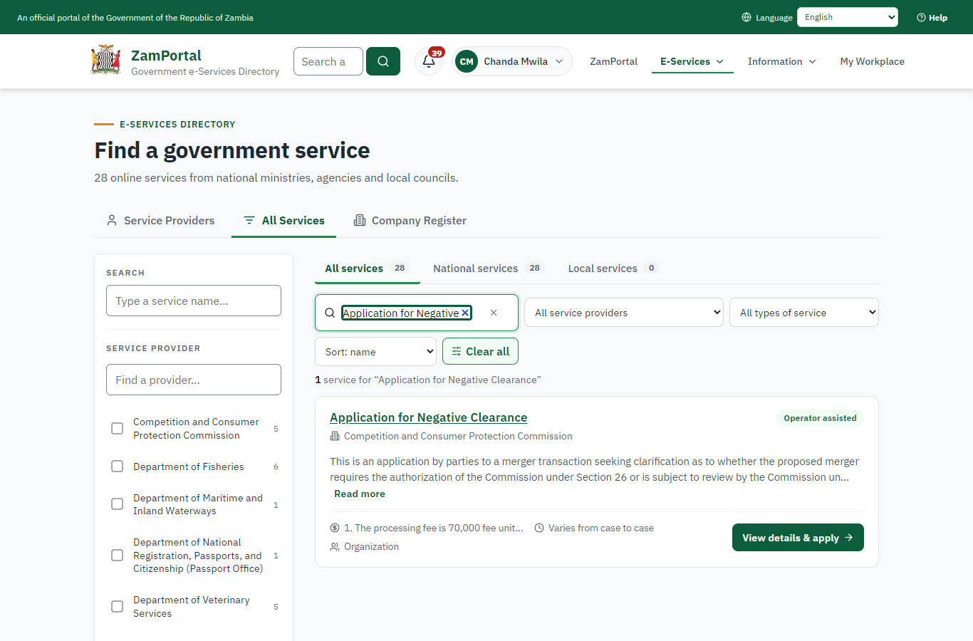 | 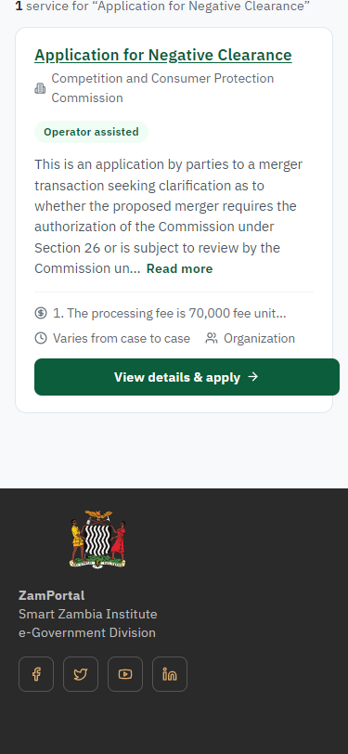
Step 1: Find the service - desktop (left) and a 375 px phone (right).

Step 2. Read the service page
Citizen · National e-Services portal
The service page sets out what the service is for, who provides it, the fee, how long it takes and the documents to have ready. "Start application" begins an application (the citizen is signed in with ZamPass).
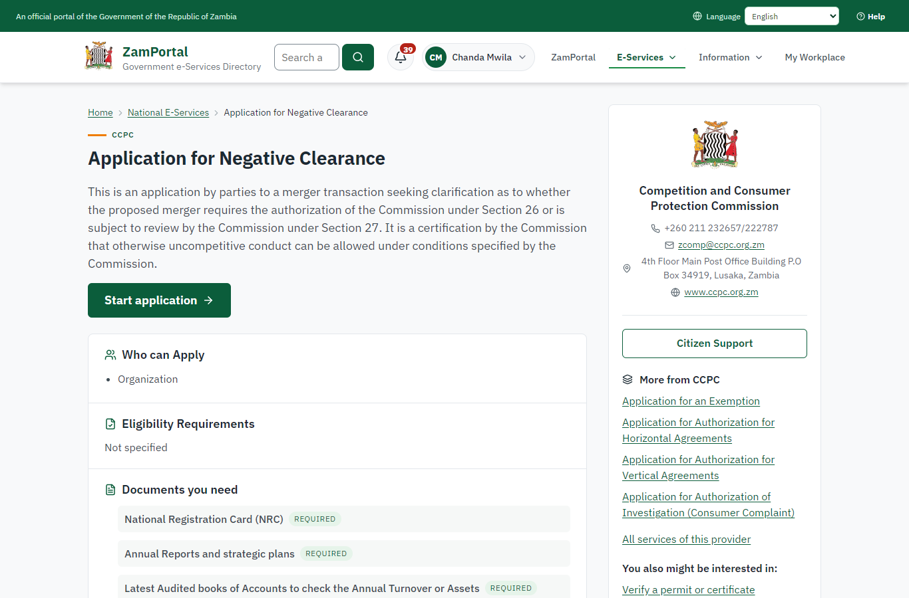 | 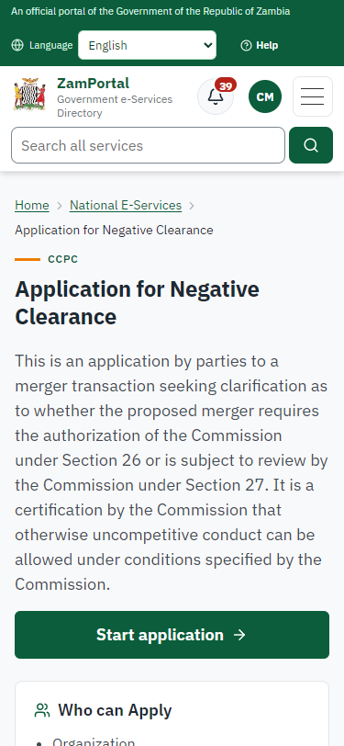
Step 2: Read the service page - desktop (left) and a 375 px phone (right).

Step 3. Confirm the applicant details
Citizen · National e-Services portal
The applicant details are filled in from the citizen's ZamPass account. The citizen says whom they are applying for (an organisation: the service is for organisations only) and continues with "Proceed to Application".
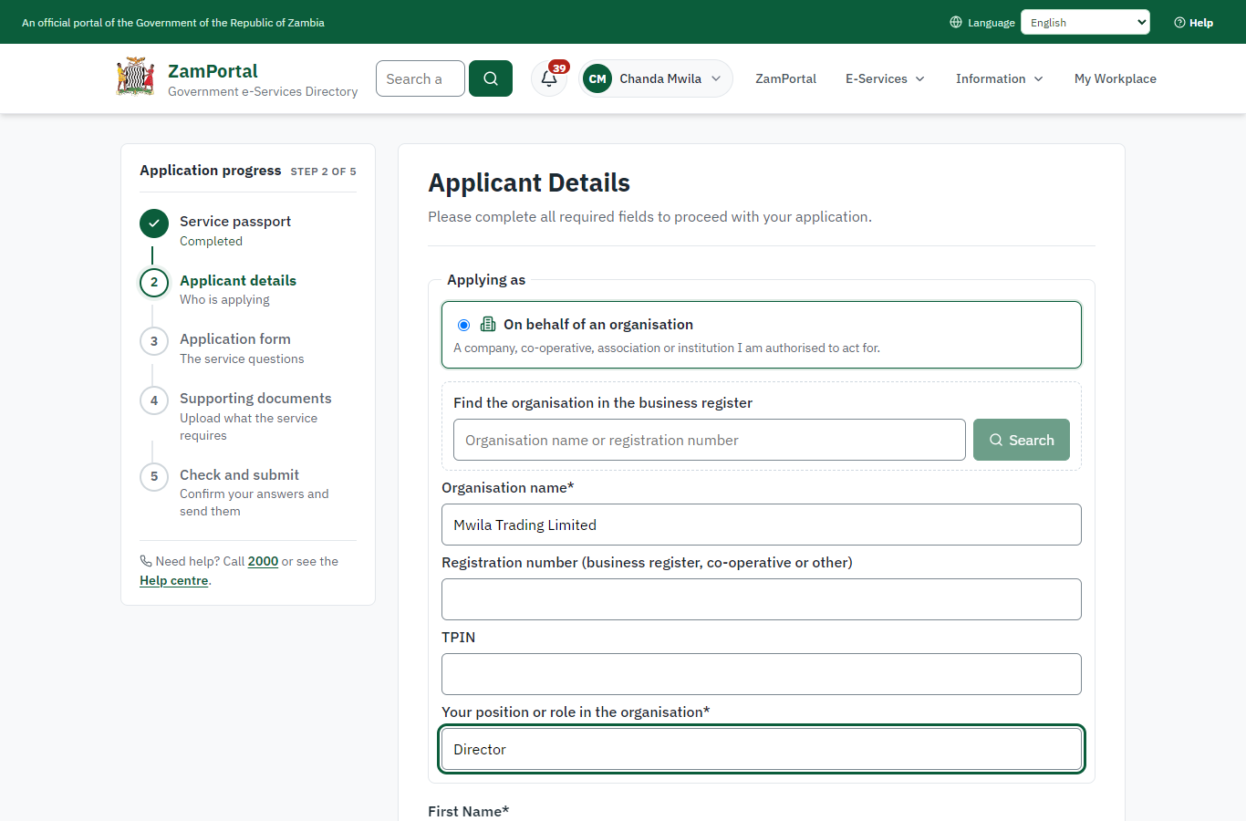 | 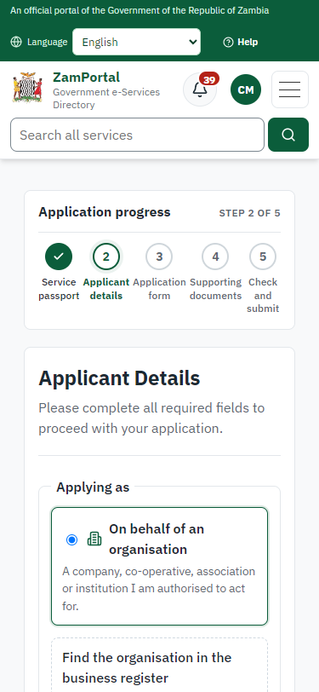
Step 3: Confirm the applicant details - desktop (left) and a 375 px phone (right).

Step 4. Fill in the application form
Citizen · National e-Services portal
The citizen answers the service's own application form, converted from the legacy system (12 answers in this run, all synthetic), for the type of application "New". Questions marked * must be answered; some appear only after an earlier answer. Answers are saved as the citizen types, so an unfinished application can be reopened from My Workplace.
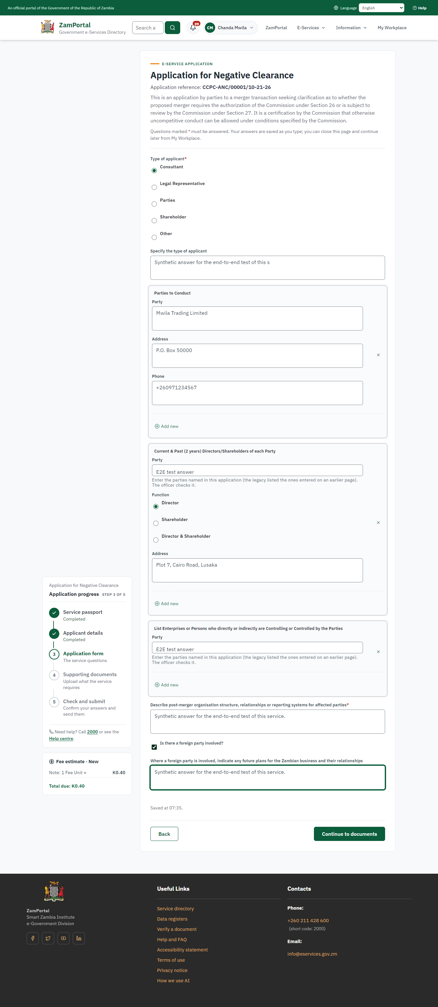 | 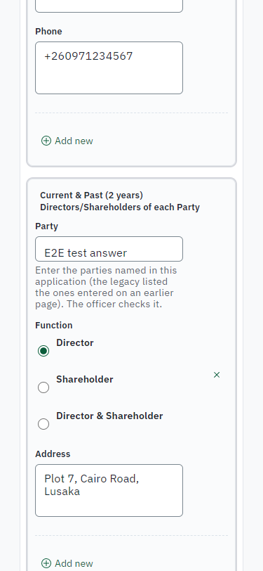
Step 4: Fill in the application form - desktop (left) and a 375 px phone (right).

Step 5. Upload the supporting documents
Citizen · National e-Services portal
Each document the service asks for has its own upload (11 in this run: National Registration Card (NRC), Annual Reports and strategic plans, Latest Audited books of Accounts to check the Annual Turnover or Assets, Board Minutes and resolutions, Motive for the transaction, if not in the strategic plan, Letter of Power of Attorney where applicable, A Copy of Agreement or other documents relating to the transaction, Current organogram(s) of the parties operating in Zambia showing full staff and indicating their nationalities/positions, Proposed Staffing levels and positions post transaction indicating their nationalities/positions, Other Industry or study reports that support the transaction, Company Registration details that show the Shareholders and the Directors). The files are checked and stored with the application; the page confirms each upload.
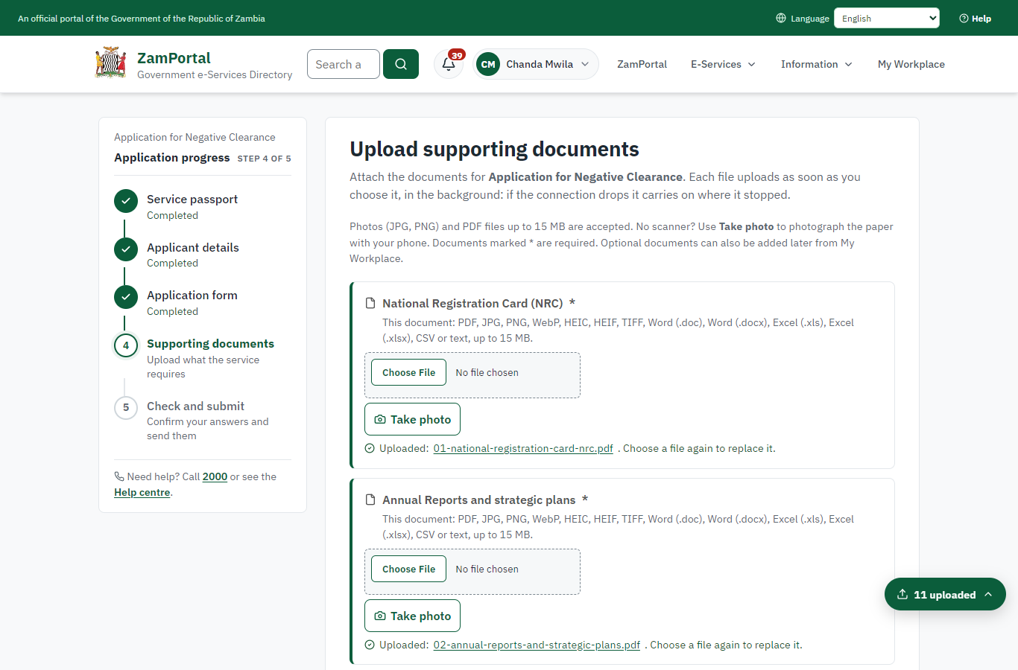 | 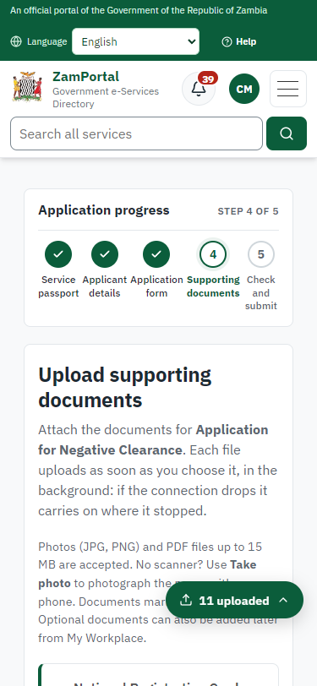
Step 5: Upload the supporting documents - desktop (left) and a 375 px phone (right).

Step 6. Check the answers and confirm the declaration
Citizen · National e-Services portal
Before sending, the citizen sees every answer and document on one page and can go back to change them. The declaration that the information is true and complete must be ticked.
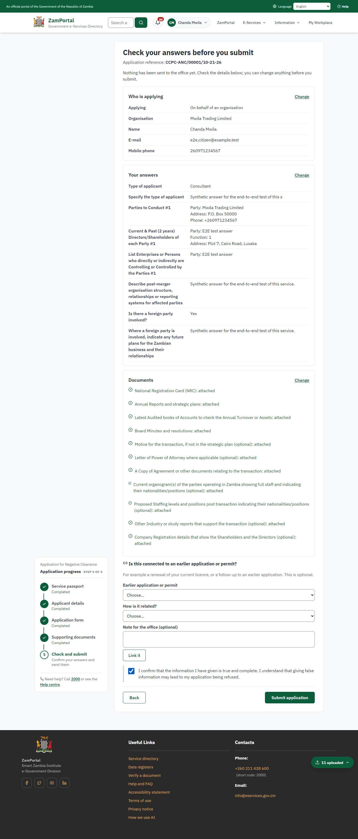 | 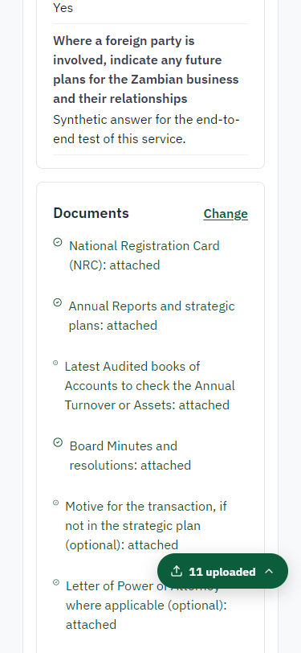
Step 6: Check the answers and confirm the declaration - desktop (left) and a 375 px phone (right).

Step 7. Application sent
Citizen · National e-Services portal
The portal confirms the application with the ministry's reference number (CCPC-ANC/00001/10-21-26 in this run). The application goes to the ministry's officers; the citizen follows it in My Workplace.
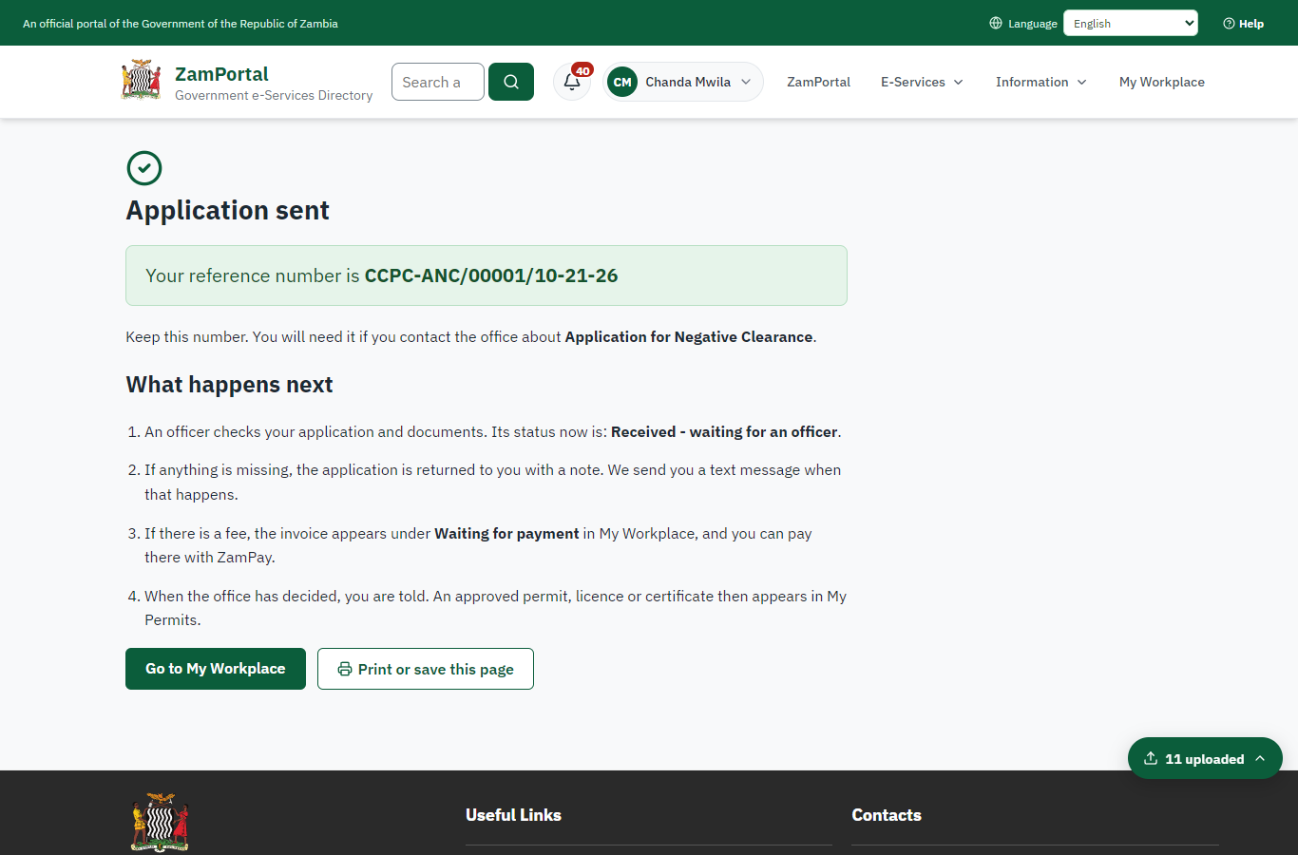 | 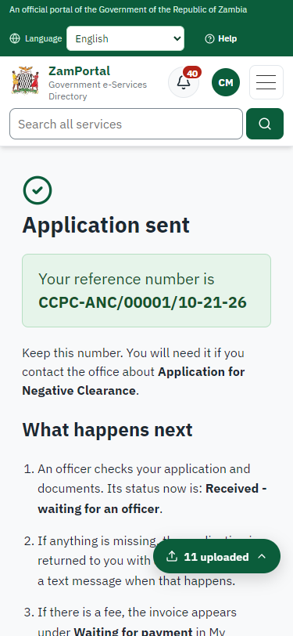
Step 7: Application sent - desktop (left) and a 375 px phone (right).

Step 8. Take the new application on
Case Officer · Back office
The application arrives in the case queue of the ministry that owns the service (Competition and Consumer Protection Commission); only its staff see it. The officer opens it by its reference number - answers, documents and process are on the case - assigns it to themself and takes it on.
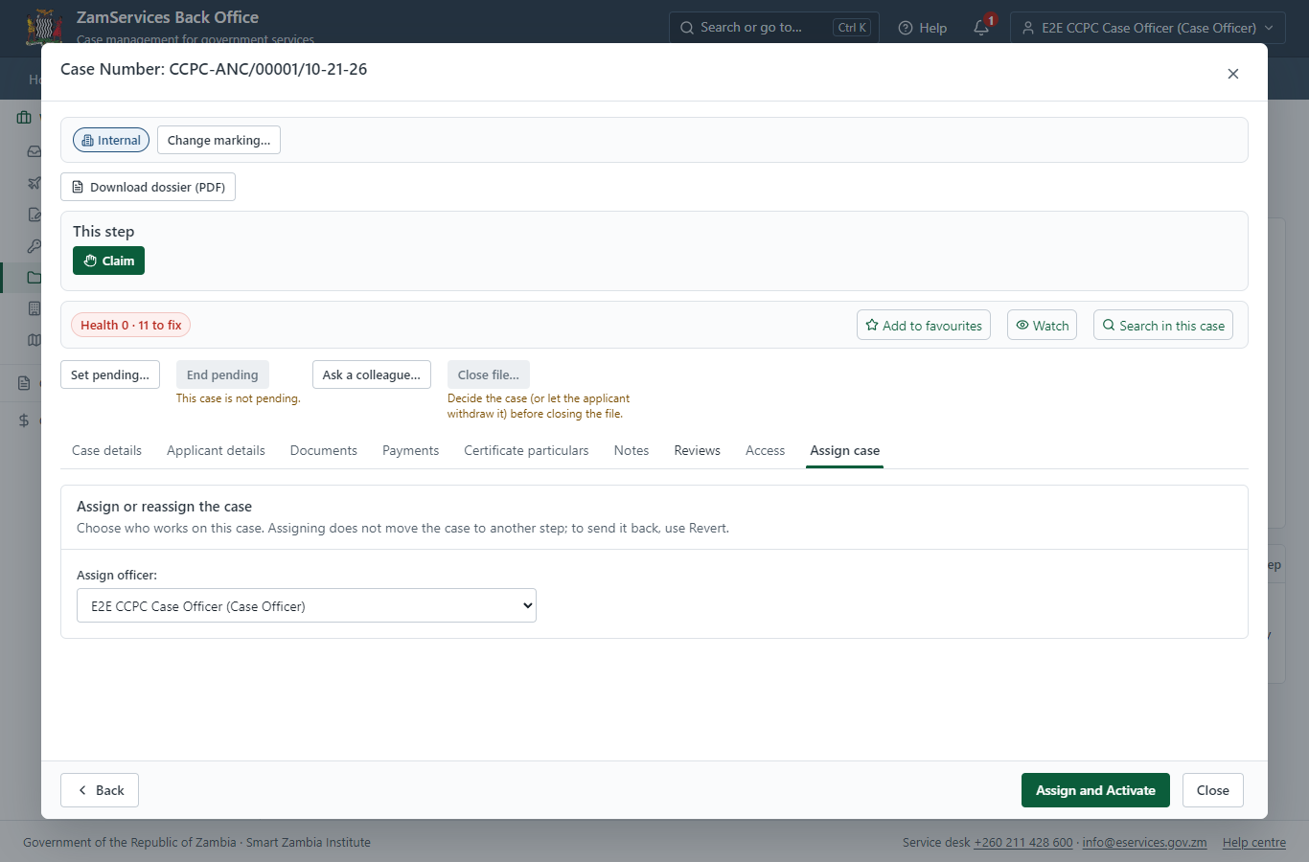
Step 8: Take the new application on.

Step 9. Fill in the certificate particulars
Case Officer · Back office
The issued document prints 3 fields that come from the office rather than from the application (Exemptions, Validity period, Granting Conditions). The officer fills them in on the case's "Certificate particulars" tab before the document is issued (synthetic values in this run) and saves; once the document is issued they can no longer change.
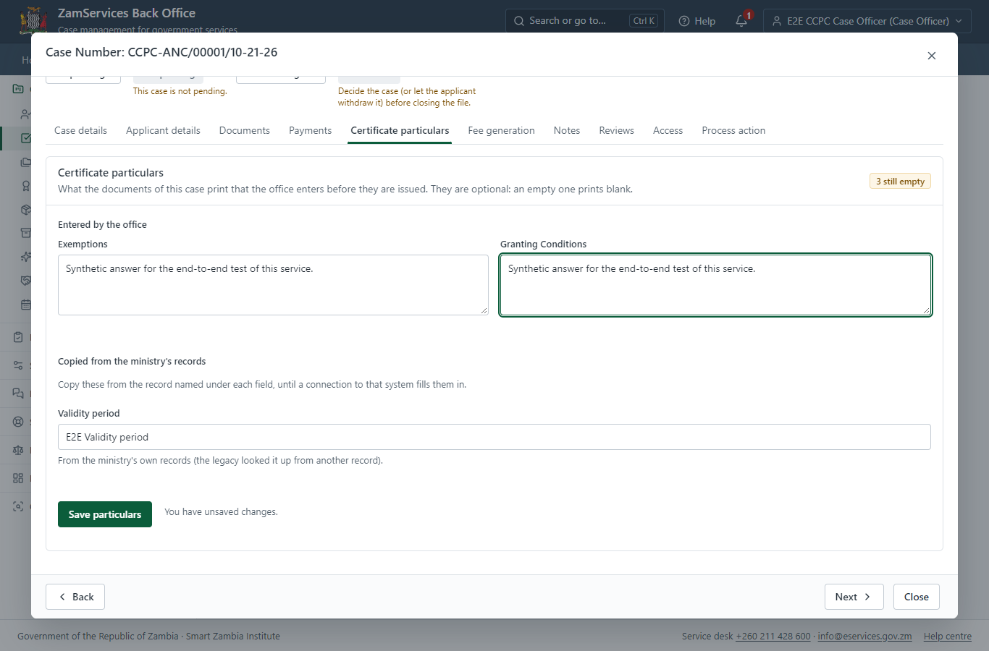
Step 9: Fill in the certificate particulars.

Step 10. Set the fee and raise the invoice
Case Officer · Back office
The Case Officer works out the fee from the service's imported fee schedule ("1. The processing fee is 70,000 fee units for an Applicant with Assets or Turnover below or up to 100,000,000 fee units. 2. The processing fee is 150,000 fee un"). "Submit Fees and Advance" records it, raises a ZamPay invoice for the applicant and moves the case to payment.
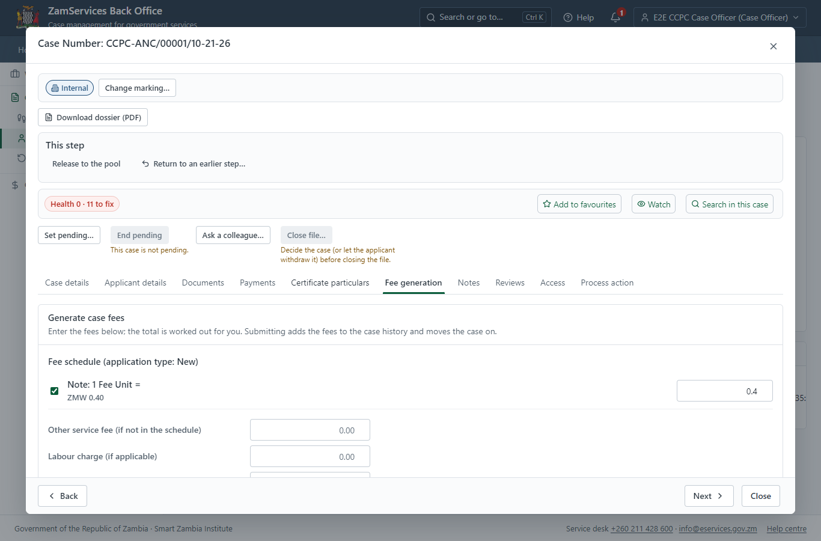
Step 10: Set the fee and raise the invoice.

Step 11. See that the fee is due
Citizen · National e-Services portal
The application shows "Waiting for your payment" in My Workplace with a Pay button (K0.40). The office priced the case; the invoice was raised on ZamPay.
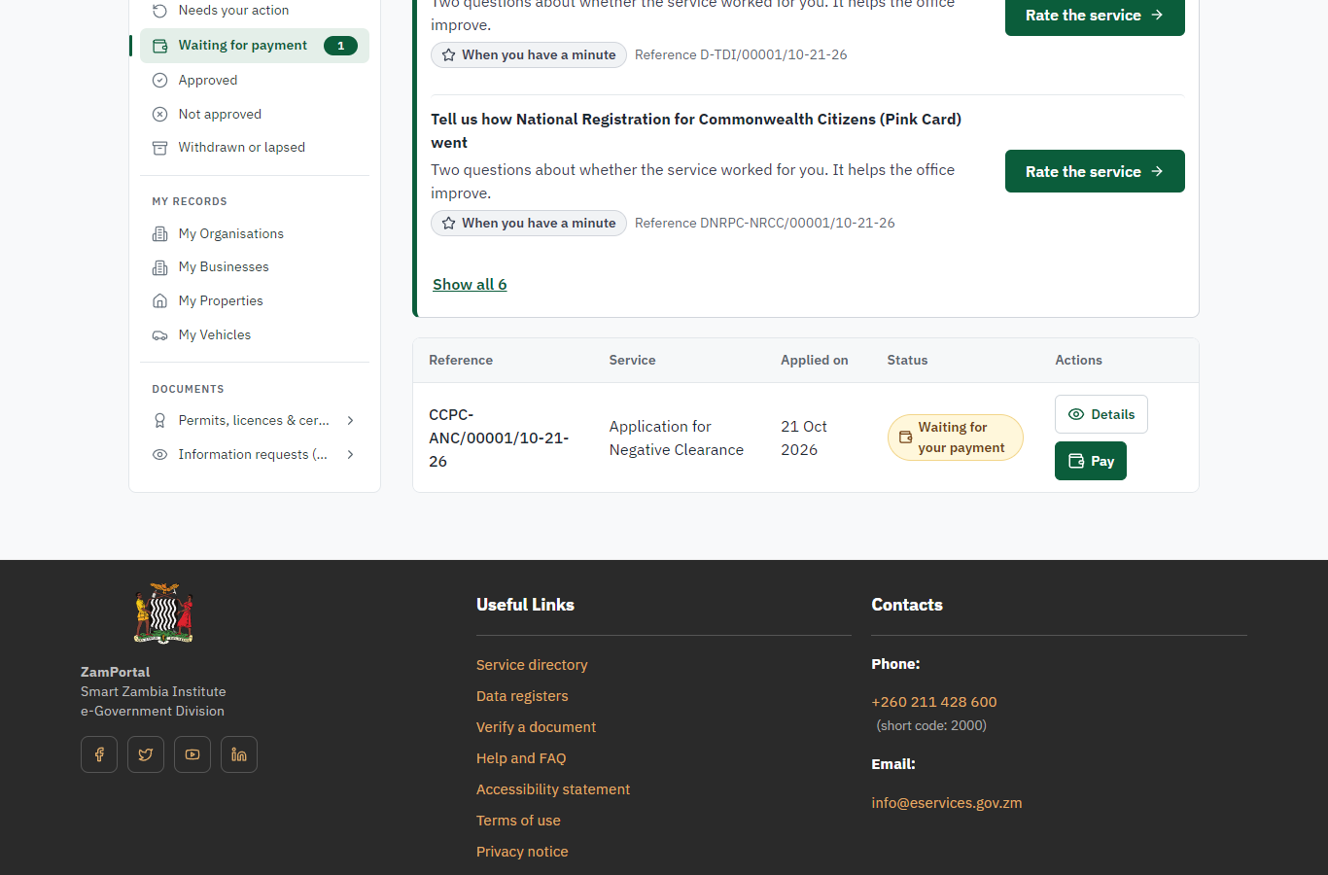 | 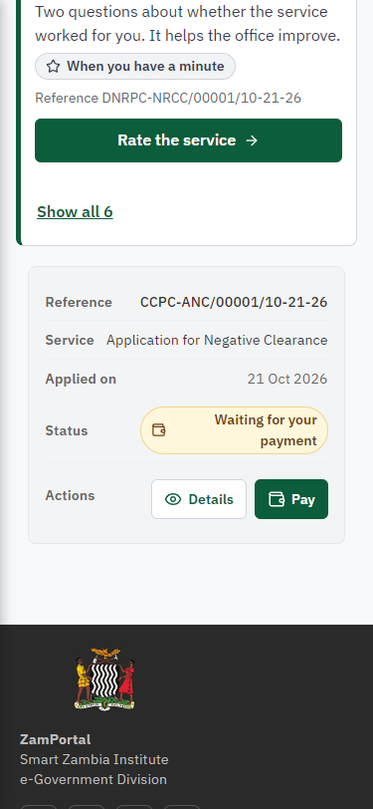
Step 11: See that the fee is due - desktop (left) and a 375 px phone (right).

Step 12. Pay with ZamPay
Citizen · National e-Services portal
Pay opens the invoice (K0.40, the amount set by the platform, never by the page) with its PDF preview; the citizen pays at ZamPay by mobile money or bank card.
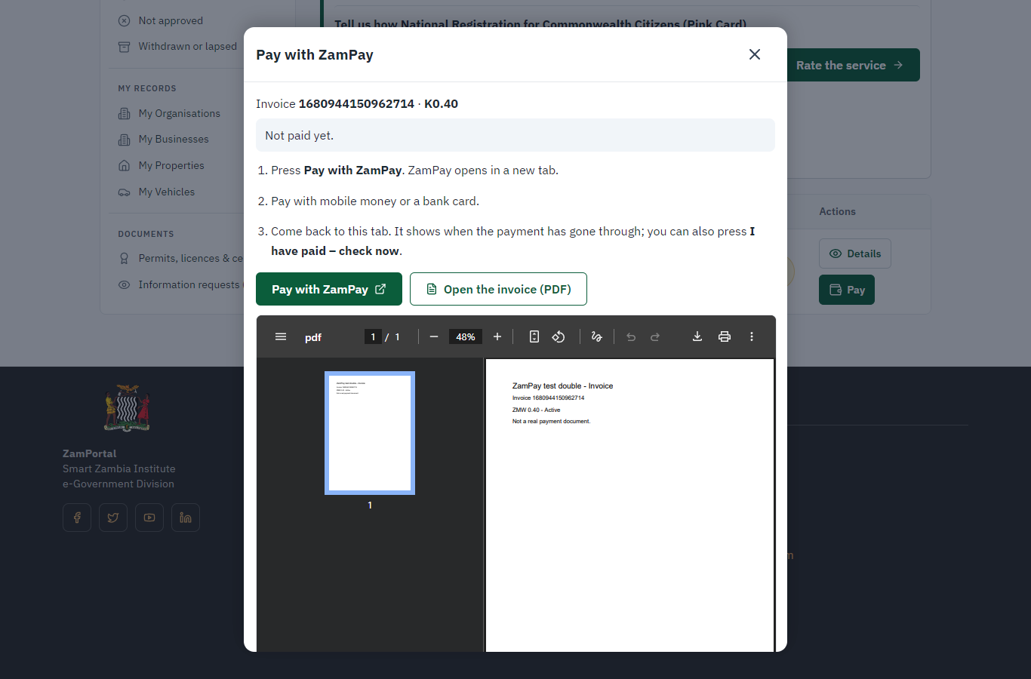 | 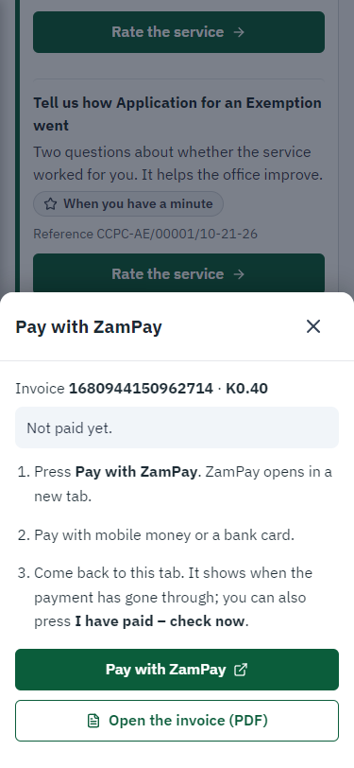
Step 12: Pay with ZamPay - desktop (left) and a 375 px phone (right).

Step 13. Payment received
Citizen · National e-Services portal
ZamPay reports the payment; the dialog says "Paid. Thank you" and the application moves on to the ministry's officers.
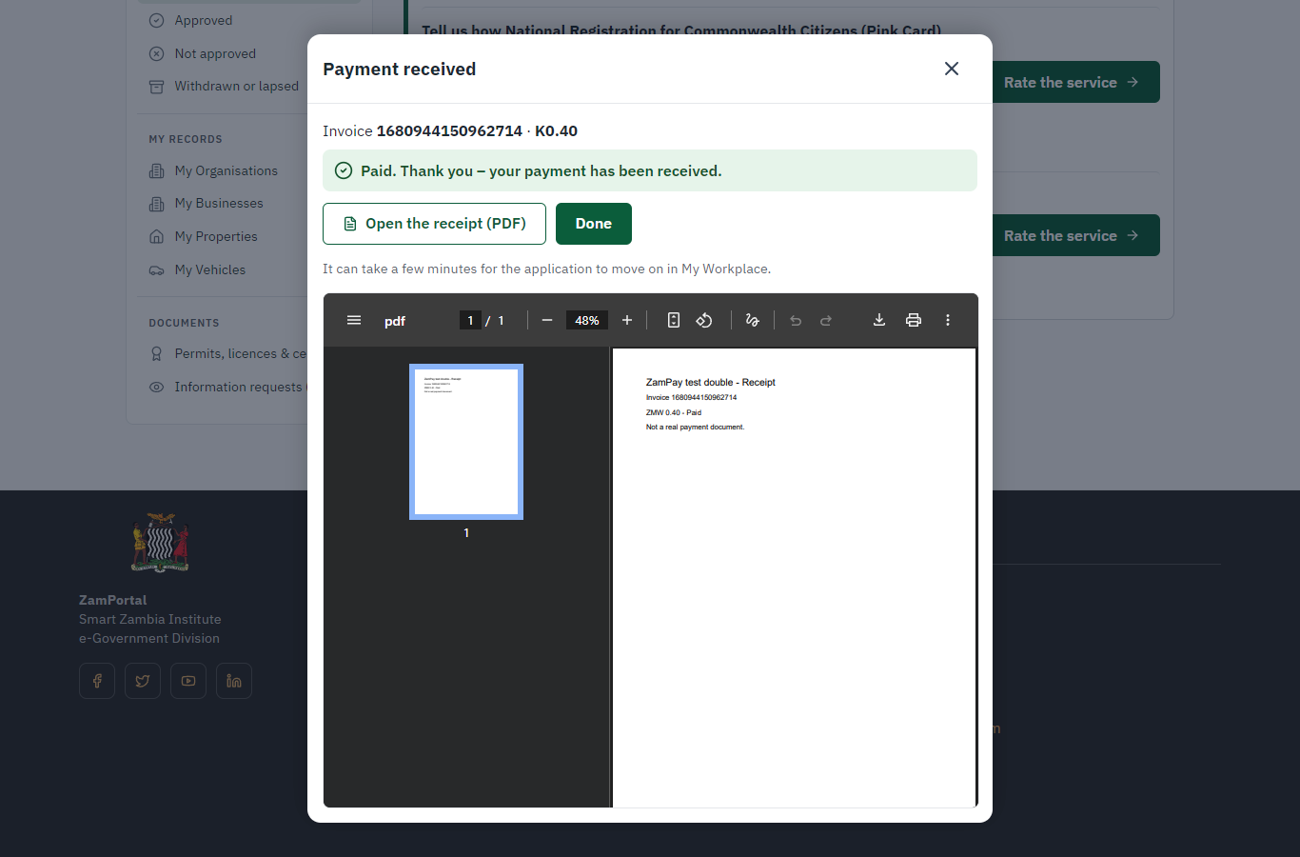 | 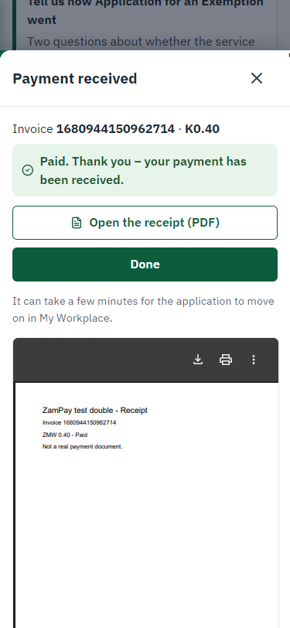
Step 13: Payment received - desktop (left) and a 375 px phone (right).

Step 14. Decide: Review, Inspect, Assign to Case Officer
Executive · Back office
At "Review, Inspect, Assign to Case Officer" the Executive records the decision: approve, with a comment kept in the case history. Approving moves the case on; the last decision completes it and issues the document.
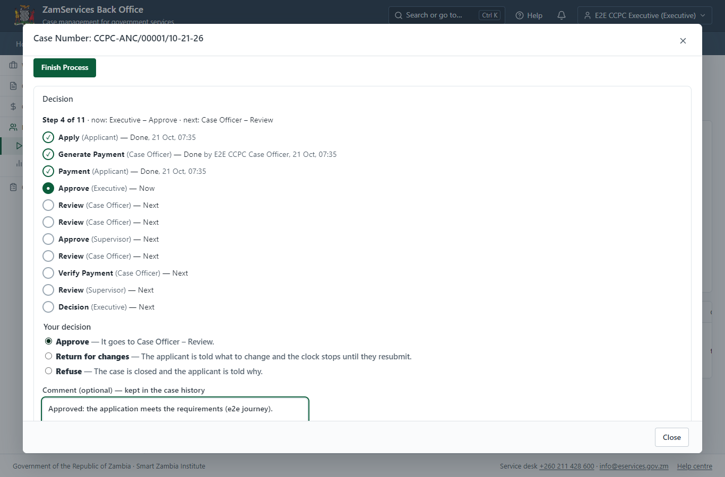
Step 14: Decide: Review, Inspect, Assign to Case Officer.

Step 15. Receive, Inspect, Report Findings
Case Officer · Back office
The Case Officer works on "Receive, Inspect, Report Findings" (review in the imported process), checks the application and its documents, and completes the step.
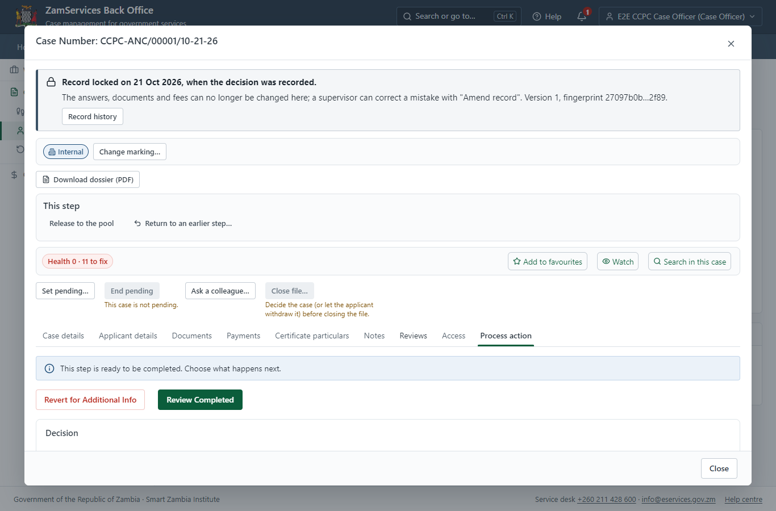
Step 15: Receive, Inspect, Report Findings.

Step 16. Review Audited Financial Reports
Case Officer · Back office
The Case Officer works on "Review Audited Financial Reports" (review in the imported process), checks the application and its documents, and completes the step.
Step 16: Review Audited Financial Reports.

Step 17. Decide: Fee Note Approval
Supervisor · Back office
At "Fee Note Approval" the Supervisor records the decision: approve, with a comment kept in the case history. Approving moves the case on; the last decision completes it and issues the document.
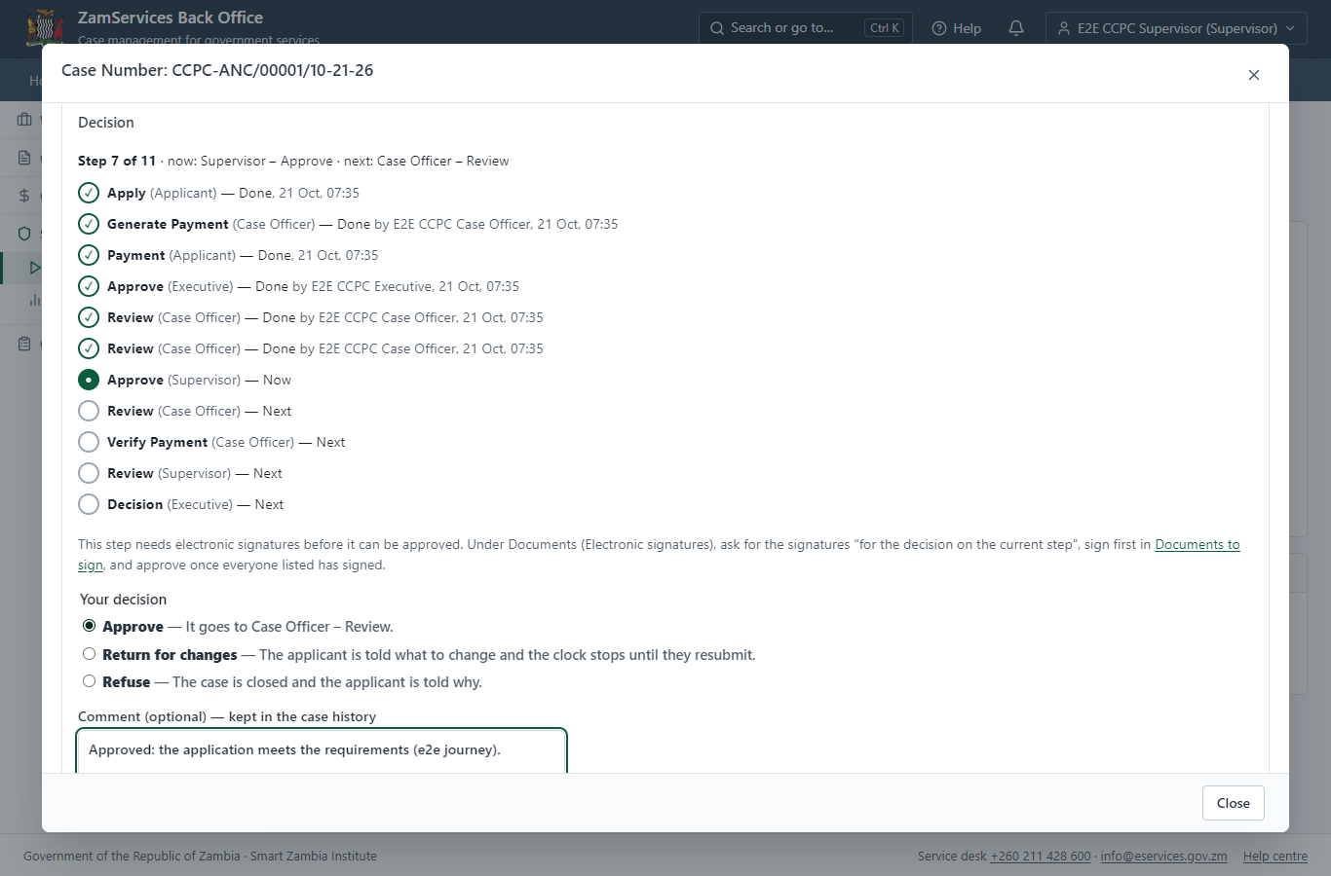
Step 17: Decide: Fee Note Approval.

Step 18. Review & Send Fee Note
Case Officer · Back office
The Case Officer works on "Review & Send Fee Note" (review in the imported process), checks the application and its documents, and completes the step.
Step 18: Review & Send Fee Note.

Step 19. Verify Payment Completion
Case Officer · Back office
The Case Officer works on "Verify Payment Completion" (verify-payment in the imported process), checks the application and its documents, and completes the step.
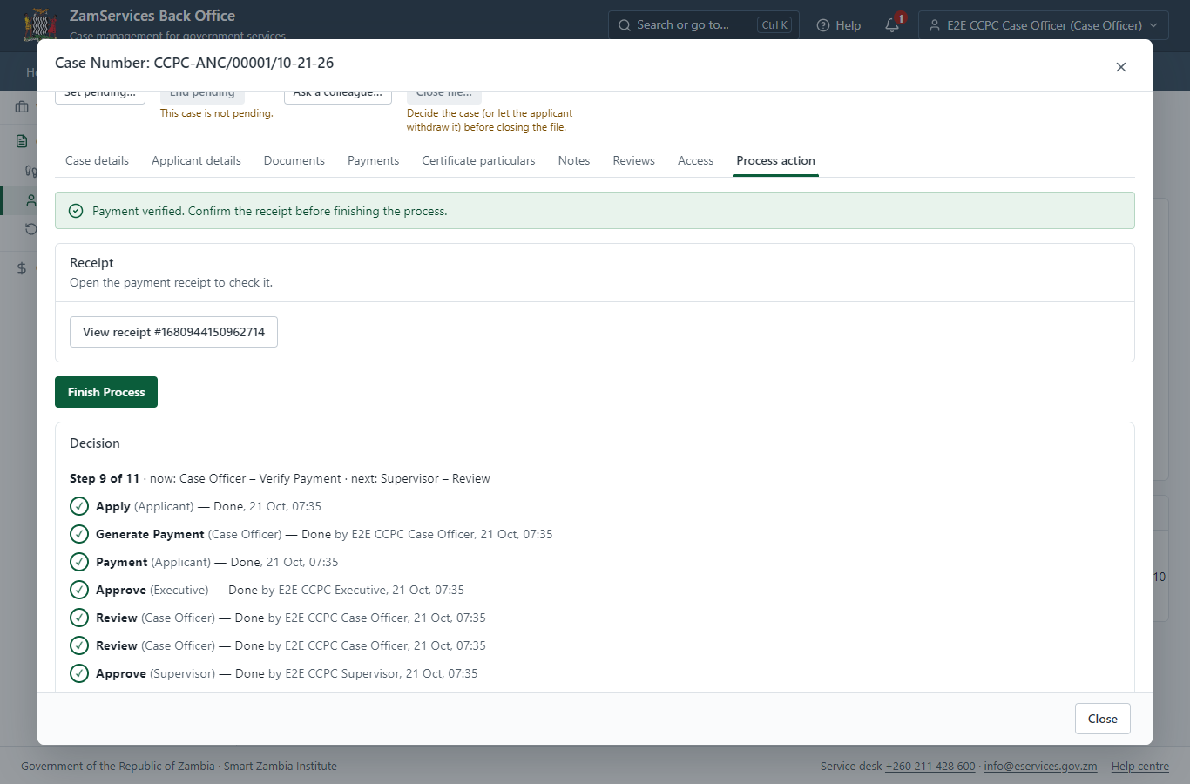
Step 19: Verify Payment Completion.

Step 20. Review, Add Comments, Send for Decision
Supervisor · Back office
The Supervisor works on "Review, Add Comments, Send for Decision" (review in the imported process), checks the application and its documents, and completes the step.
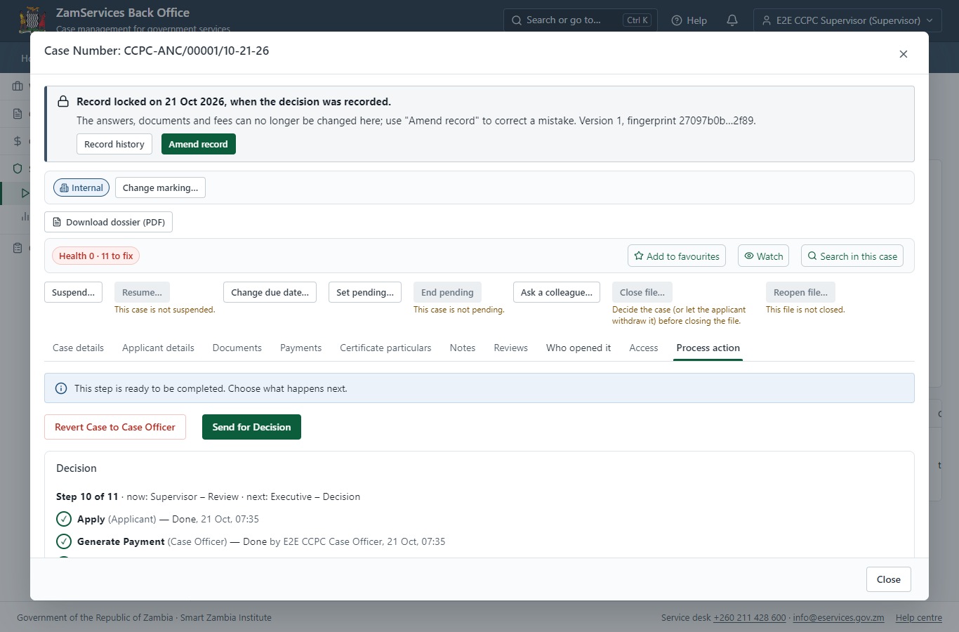
Step 20: Review, Add Comments, Send for Decision.

Step 21. Decide: Review Case, e-Sign output
Executive · Back office
At "Review Case, e-Sign output" the Executive records the decision: approve, with a comment kept in the case history. Approving moves the case on; the last decision completes it and issues the document.
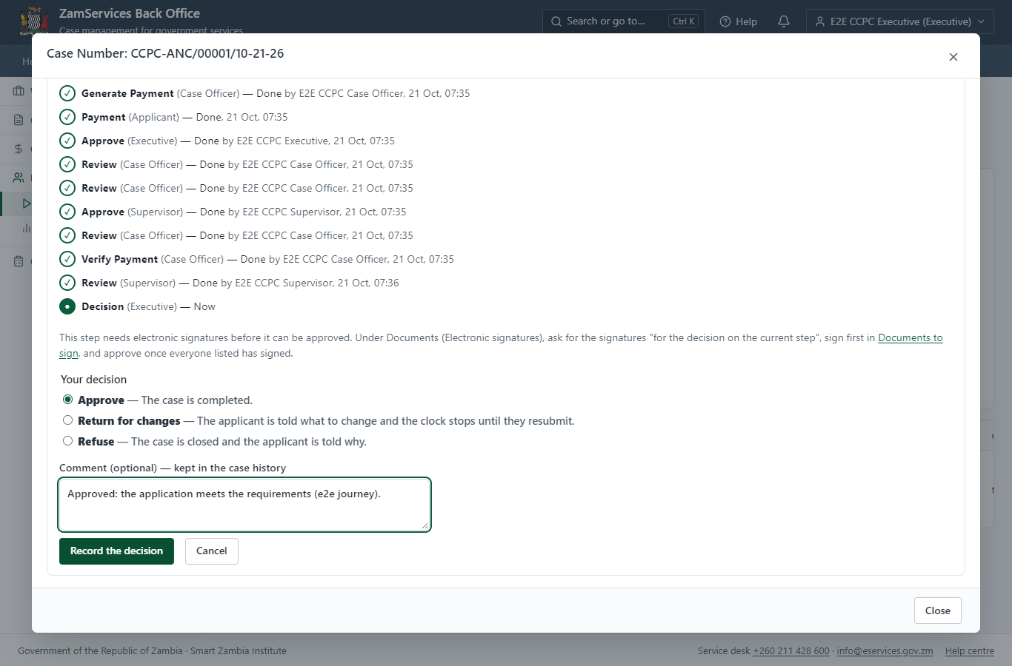
Step 21: Decide: Review Case, e-Sign output.

Step 22. The document in My permits
Citizen · National e-Services portal
The issued document (CCPC-ANC-2026-00001 in this run: "FormIII") is listed in "My permits and licences" with its validity and a download of the sealed PDF.
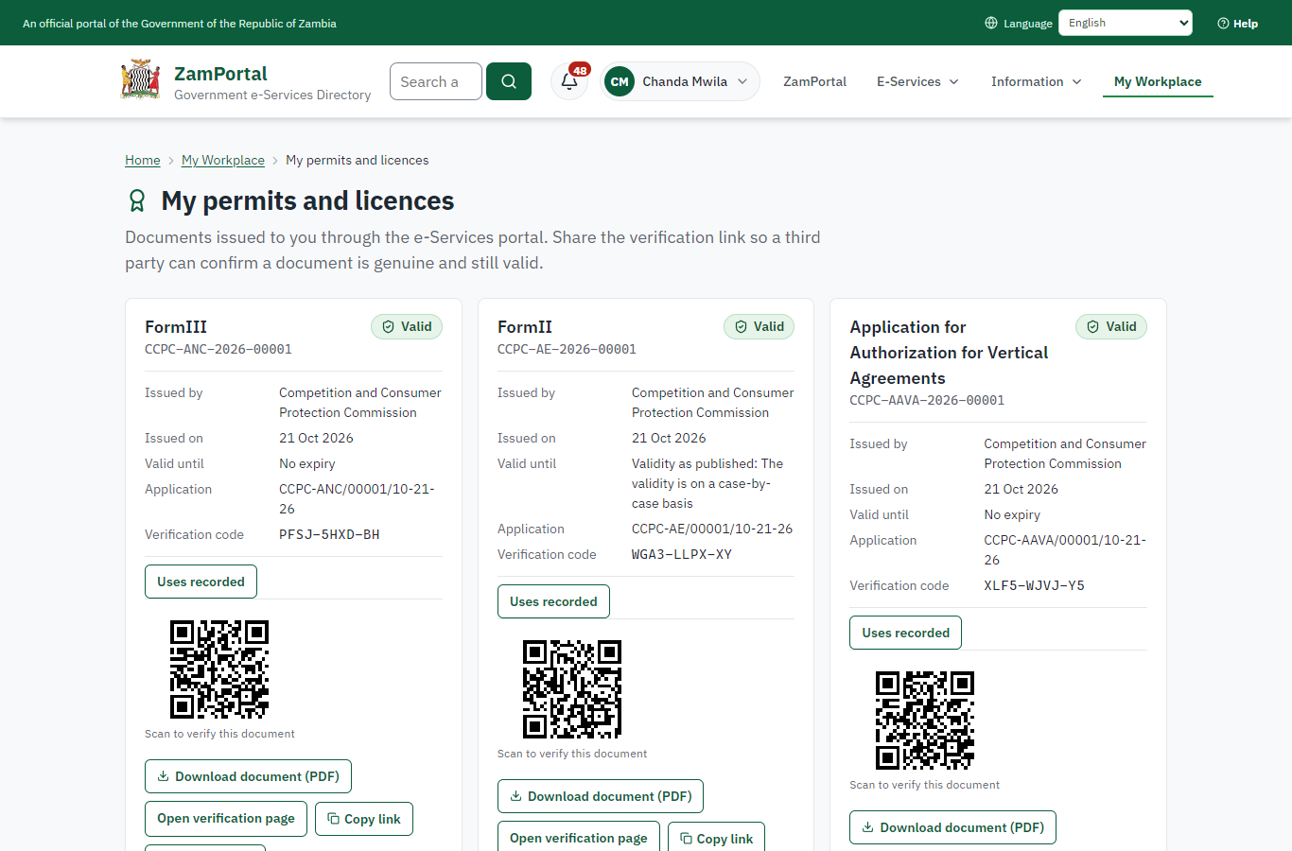 | 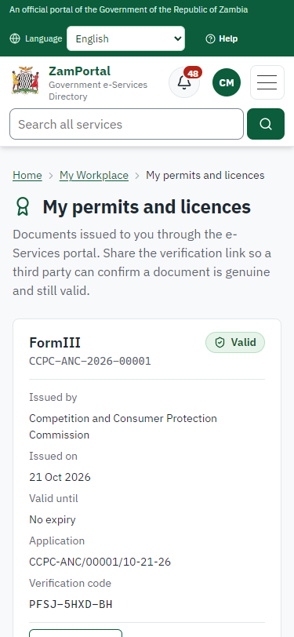
Step 22: The document in My permits - desktop (left) and a 375 px phone (right).

Step 23. Verify the document
Anyone (public) · Public verification page
The QR code on the document opens the public verification page: genuine and current, to whom it was issued, and whether the electronic seal is valid. No sign-in is needed.
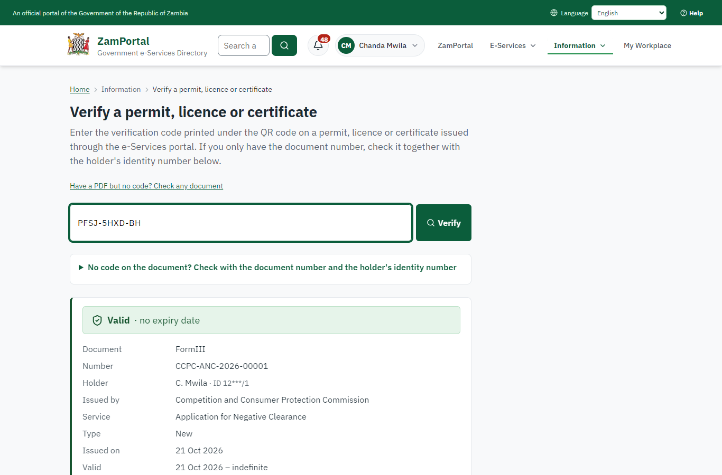 | 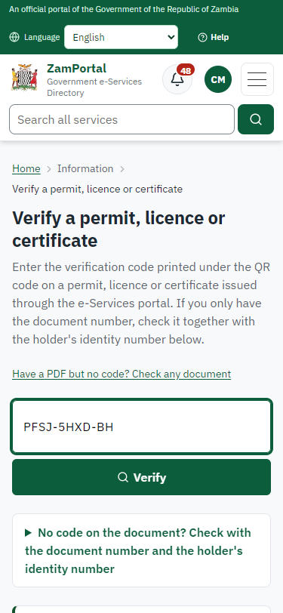
Step 23: Verify the document - desktop (left) and a 375 px phone (right).

3. Payment
Item | In the test run
Fee (as published) | 1. The processing fee is 70,000 fee units for an Applicant with Assets or Turnover below or up to 100,000,000 fee units. 2. The processing fee is 150,000 fee units for an Applicant with Assets or Turnover above 100,000,000 fee units. Note: 1 Fee Unit = 0.40 ZMW.
Invoice 1 | 1680944150962714
Amount 1 | ZMW 0.40
Paid at 1 | after "Generate Payment"
On screen: step 10 (Set the fee and raise the invoice), step 11 (See that the fee is due), step 12 (Pay with ZamPay), step 13 (Payment received) in section 2.

4. Output documents

FormIII (sealed PDF)
Issued when the case was approved, from the service's output configuration (service template CCPC_NegativeClearance.Certificate.docx), filled from the application and the decision, sealed with the platform's electronic seal and stored as the issued version. The holder downloads it from My permits; the verification page checks it.
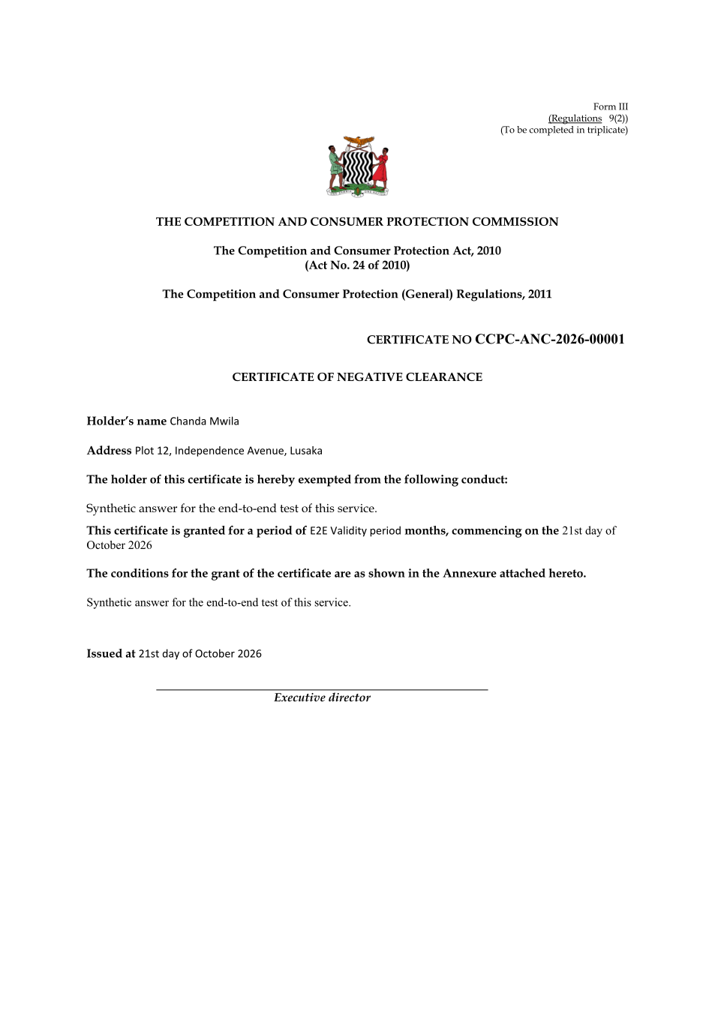
FormIII (sealed PDF) - first of 2 pages, as issued in the test run.

Fields
Field | Value in the test run
Document title | FormIII
Permit / licence number | CCPC-ANC-2026-00001
Holder | Chanda Mwila
Valid from | 2026-10-21
Valid until
Status | active
Verification code (printed with a QR code) | PFSJ-5HXD-BH

Seal
Seal status | sealed
Signature level | PAdES-B-T
Sealed by | the platform seal (development key in the test run)
Signed at | 2026-10-21T05:36:17.289Z
Trusted time-stamp | 2026-10-21T05:36:17.255Z (time-stamping authority)
Document fingerprint (SHA-256) | 1421033e1d19b2dc...

Verification
Where | The public verification page of the national portal, <portal>/verify/<verification code>, opened by scanning the QR code on the document.
What it shows | Whether the document is genuine and current, its holder and validity, and whether the electronic seal is valid and who sealed it.
Checking a copy | Anyone can upload a PDF they were given; the page says whether it is exactly the document that was issued. A changed copy is reported as not matching.
On screen: step 22 (The document in My permits), step 23 (Verify the document) in section 2.

5. Notifications
When | Channel | To | Message | Delivery
Application received | in-app (portal bell) | the applicant | Application CCPC-ANC/00001/10-21-26 received - Your application CCPC-ANC/00001/10-21-26 for Application for Negative Clearance has been received by Competition and Consumer Protection Commission. | shown
Status changed | in-app (portal bell) | the applicant | Update on application CCPC-ANC/00001/10-21-26 - CCPC-ANC/00001/10-21-26 (Application for Negative Clearance) is now: With the office - fees being worked out. | shown
Payment due (invoice raised) | in-app (portal bell) | the applicant | Payment due for application CCPC-ANC/00001/10-21-26 - The fee of ZMW 0.40 for Application for Negative Clearance (CCPC-ANC/00001/10-21-26) is now due. Invoice 1680944150962714. | shown
Payment received | in-app (portal bell) | the applicant | Payment received for CCPC-ANC/00001/10-21-26 - Your payment of ZMW 0.40 for CCPC-ANC/00001/10-21-26 (Application for Negative Clearance) has been received. Receipt: <ZamPay>/pdf?documentType=receipt&invoiceNumber=1680944150962714 | shown
case.approved | in-app (portal bell) | the applicant | Application CCPC-ANC/00001/10-21-26 approved - CCPC-ANC/00001/10-21-26 (Application for Negative Clearance) has been approved. | shown
Licence / permit issued | in-app (portal bell) | the applicant | Your Application for Negative Clearance document has been issued - CCPC-ANC-2026-00001 has been issued for Application for Negative Clearance. | shown
Invitation to rate the service | in-app (portal bell) | the applicant | How was Application for Negative Clearance? - How was Application for Negative Clearance? Tell us in about a minute. | shown
Decision: approved | in-app (portal bell) | the applicant | Application CCPC-ANC/00001/10-21-26 completed - CCPC-ANC/00001/10-21-26 (Application for Negative Clearance) is complete. Your documents are ready. | shown
Application received | sms | +260 97* *** 567 | Application CCPC-ANC/00001/10-21-26 for Application for Negative Clearance has been received. Track it: <portal>/my-workplace | delivered
Application received | email | e2e.c***@example.test | Application CCPC-ANC/00001/10-21-26 received | skipped
Status changed | sms | +260 97* *** 567 |  | delivered
Payment due (invoice raised) | email | e2e.c***@example.test | Payment due for application CCPC-ANC/00001/10-21-26 | skipped
Payment due (invoice raised) | sms | +260 97* *** 567 | Fee of ZMW 0.40 due for CCPC-ANC/00001/10-21-26. Invoice 1680944150962714. Pay: <ZamPay>/pay-for-service/get-invoice/1680944150962714 | delivered
Payment received | sms | +260 97* *** 567 |  | delivered
case.approved | email | e2e.c***@example.test | Application CCPC-ANC/00001/10-21-26 approved | skipped
case.approved | sms | +260 97* *** 567 |  | delivered
Invitation to rate the service | sms | +260 97* *** 567 |  | skipped
Invitation to rate the service | email | e2e.c***@example.test | How was Application for Negative Clearance? | skipped
Licence / permit issued | email | e2e.c***@example.test | Your Application for Negative Clearance document has been issued | skipped
Decision: approved | email | e2e.c***@example.test | Application CCPC-ANC/00001/10-21-26 completed | skipped
Licence / permit issued | sms | +260 97* *** 567 |  | delivered
Decision: approved | sms | +260 97* *** 567 |  | delivered
Delivery: shown = in the portal's notification bell; delivered = the SMS gateway (a test double in this run) reported the text delivered; skipped = not sent on that channel (e-mail is not configured on the test installation, and some notices go out on one channel only); sent by the national portal = a ministry node handed the notice to the national portal, which texts and e-mails the citizen under its own name and the citizen's preferences. Addresses written <portal>, <ZamPay> stand for the national portal and ZamPay.

6. Legacy mapping
Replaces | Application for Negative Clearance in the legacy ZIGS e-Services directory (ZIGS_Services)
Legacy service id | 303
Legacy provider | Competition and Consumer Protection Commission (CCPC) under Ministry of Commerce, Trade and Industry
Legacy process | not recorded
Fee in the legacy system | none
Fee taken before submission | yes (as in ZIGS)
Time to issue (legacy) | not recorded
Legacy output templates | Notice of Action: ZIGS_Forms_Notices / GS-2.NoticeOfAction  Application form: ZIGS_Forms_CCPC / CCPC_FormI.Application  FormIII: ZIGS_Forms_CCPC / CCPC_NegativeClearance.Certificate
Legacy address | none recorded
How it was brought over | Imported by the platform's legacy catalogue importer (zcm-backend scripts/zigs/importLegacy.js) from the ZIGS snapshot: form, case types, fees, documents, process and output templates, then served by the new platform.

7. Version and date
Document version | service v1, platform a0a302b8
Generated | 2026-10-21T05:36:24Z (by the end-to-end run, not edited by hand)
Service version | not versioned (configured directly)
Platform snapshot | backend a0a302b8  portal 72805f0  back office 58e5946
Test suite | e2e 5999d9b; one installation (combined); seed profile mihud
Journeys | 30-catalogue-service.spec.js: citizen finds the service, answers its form, uploads its documents and sends the application - passed  30-catalogue-service.spec.js: the case goes through every step of its process: payments by the citizen, each officer step by its role - passed  30-catalogue-service.spec.js: the grant document is issued, sealed, filled in and verifiable; the citizen has it in My permits - passed
Result | 3 of 3 journey tests passed
Data | Synthetic test data on a local test installation; provider test doubles for ZamPass, ZamPay, SMS and signing.

