Republic of Zambia
GSB e-Services

Application for Marking Off
Service documentation
Owner: Survey Department
Service key: MLNR/application-for-marking-off
Version: service v1, platform a0a302b8
Date: 2026-10-21
Generated automatically by the service's end-to-end test run. Every screenshot shows synthetic test data on a local test installation, never real personal data.

Contents
- 1. Service summary
- 2. Application process, step by step
- 3. Payment
- 4. Output documents
- 5. Notifications
- 6. Legacy mapping
- 7. Version and date
This document describes the Application for Marking Off service of Survey Department as the platform runs it today. It is generated by the service's end-to-end test: every step was performed by the test and every screenshot was taken during that run, with synthetic data. Regenerate it with "npm run docs:services" in the e2e suite; do not edit it by hand.

1. Service summary
Service | Application for Marking Off
Owner (MDA) | Survey Department (MLNR)
Purpose | The service provides marking off the subdivided properties from the parent property. The marking off is necessary for obtaining a new Certificate of Title for subdivided properties or to be able to sell subdivided properties (through the Assignment for subdivision). The property has to be on title. The subdivided properties must be already numbered and surveyed.
Who can apply | Individual; Organization
How to apply | Online on the national e-Services portal, signed in with ZamPass; pay with ZamPay.
Fees | Application for Marking Off: ZMW 333.60
Turnaround | 7 days
Validity of the output | N/A
Required documents | National Registration Card (NRC) (required)  Certificate of Incorporation / ZDA (if company, church, society) (required)  Original Certificate of Title (required)  Numbered Site Plan (optional)  Subdivided Properties Survey Diagrams (required)  Plan X (optional)
Output documents | Notice of Action  Application form  Marking Off Subdivisions  GF-1 Treasury Invoice  GF-2 Treasury Receipt
Legal basis | The Land Survey Act No Chapter 188 of the Laws of Zambia (http://www.parliament.gov.zm/sites/default/files/documents/acts/Land%20Survey%20Act.pdf)

2. Application process, step by step

The process as configured
Step | Role | Task | Type
1 | Applicant | Apply | form
2 | Applicant | Payment | payment
3 | System | Generate Document | generate-document
4 | Case Officer | Review | review
5 | Case Officer | Review | review
6 | Case Officer | Review | review
7 | Supervisor | Verify Payment | verify-payment
8 | Executive | Decision | decision
9 | System | Generate Document | generate-document
10 | System | Notify Client | notify

Step by step
Who takes part in this journey: Citizen, Case Officer, Supervisor, Executive, Anyone (public). Citizen steps are shown on a desktop and on a 375 px phone; back-office steps on a desktop.

Step 1. Find the service
Citizen · National e-Services portal
On the national e-Services portal the citizen opens All Services and searches for the service by name ("Application for Marking Off"). Each result names the service and the ministry that provides it.
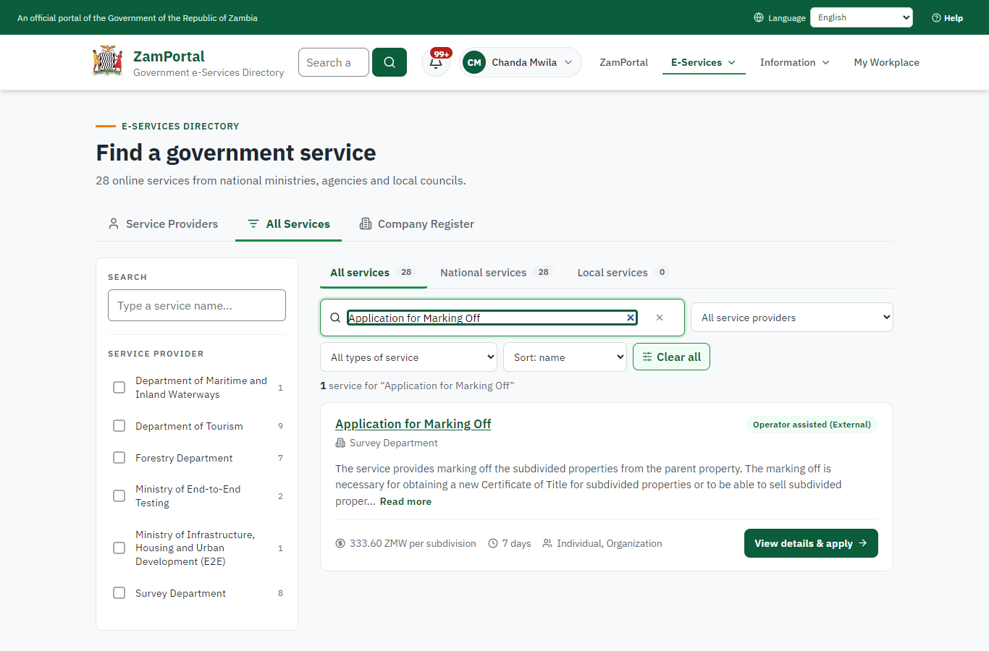 | 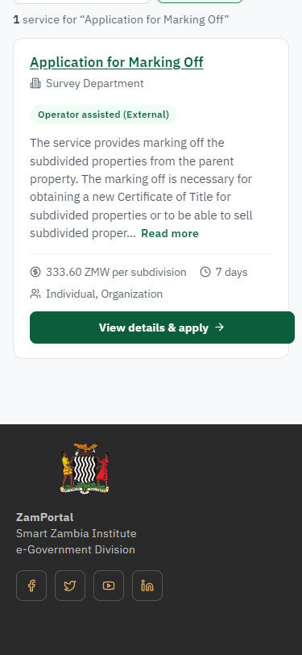
Step 1: Find the service - desktop (left) and a 375 px phone (right).

Step 2. Read the service page
Citizen · National e-Services portal
The service page sets out what the service is for, who provides it, the fee, how long it takes and the documents to have ready. "Start application" begins an application (the citizen is signed in with ZamPass).
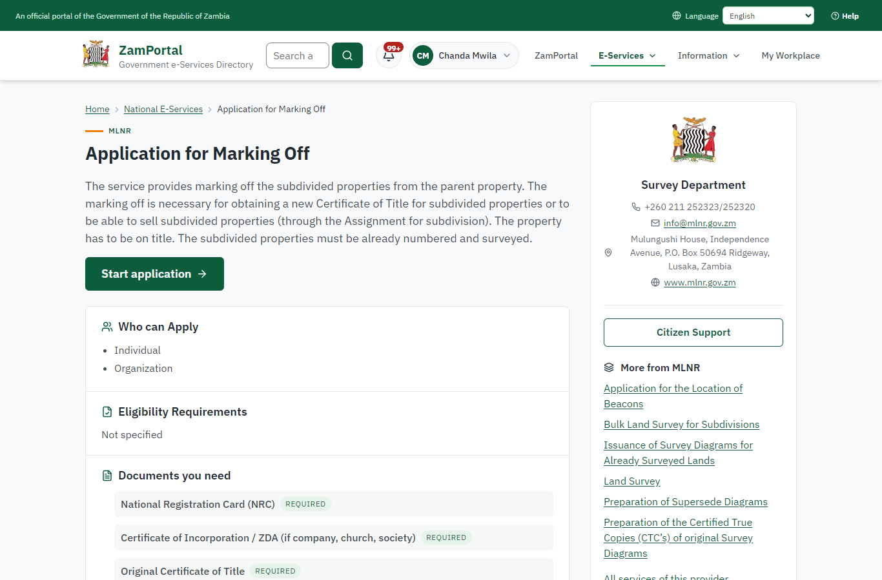 | 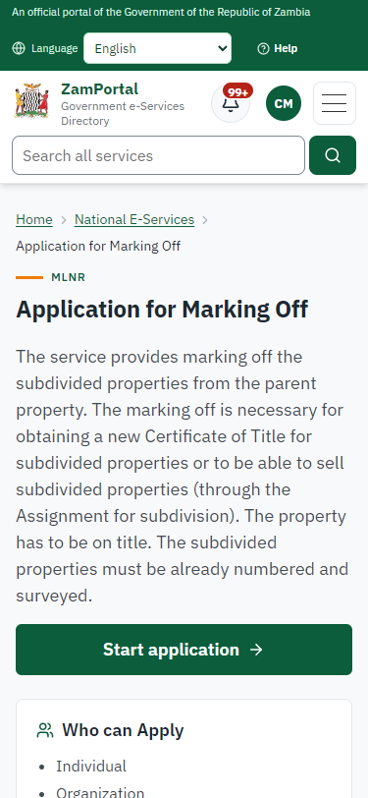
Step 2: Read the service page - desktop (left) and a 375 px phone (right).

Step 3. Confirm the applicant details
Citizen · National e-Services portal
The applicant details are filled in from the citizen's ZamPass account. The citizen says whom they are applying for (themself) and continues with "Proceed to Application".
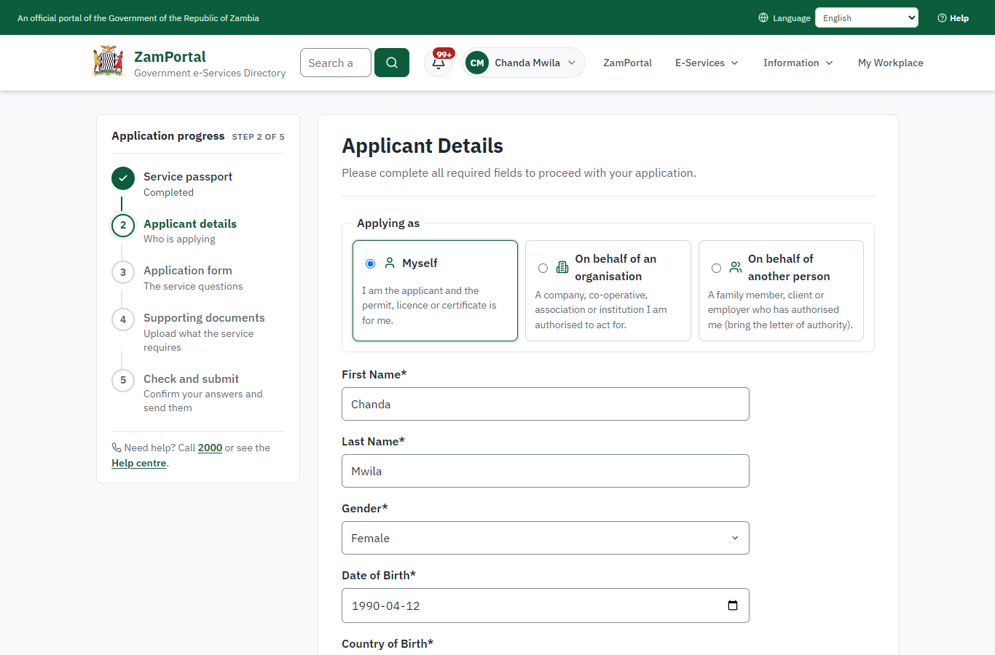 | 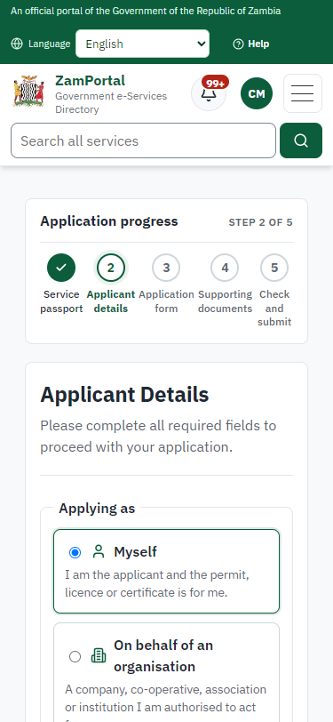
Step 3: Confirm the applicant details - desktop (left) and a 375 px phone (right).

Step 4. Fill in the application form
Citizen · National e-Services portal
The citizen answers the service's own application form, converted from the legacy system (26 answers in this run, all synthetic), for the type of application "New". Questions marked * must be answered; some appear only after an earlier answer. Answers are saved as the citizen types, so an unfinished application can be reopened from My Workplace.
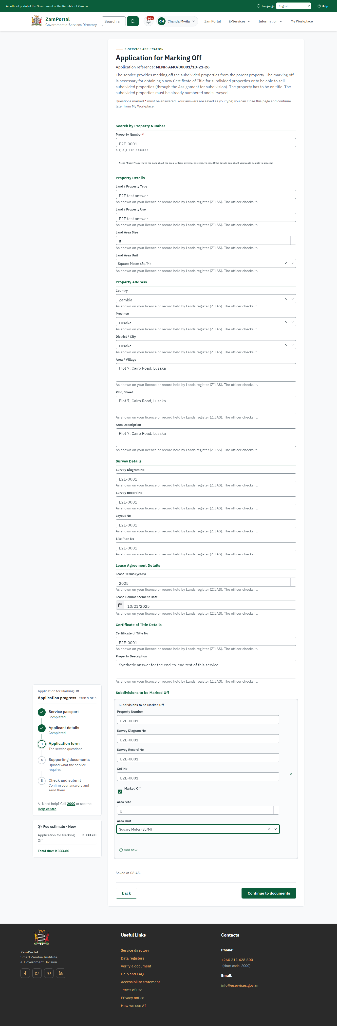 | 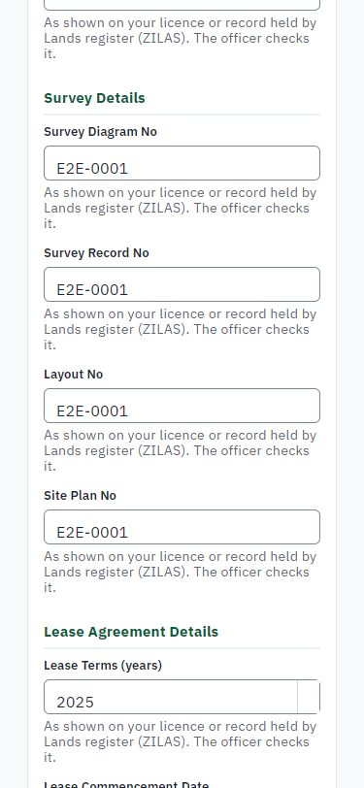
Step 4: Fill in the application form - desktop (left) and a 375 px phone (right).

Step 5. Upload the supporting documents
Citizen · National e-Services portal
Each document the service asks for has its own upload (6 in this run: National Registration Card (NRC), Certificate of Incorporation / ZDA (if company, church, society), Original Certificate of Title, Numbered Site Plan, Subdivided Properties Survey Diagrams, Plan X). The files are checked and stored with the application; the page confirms each upload.
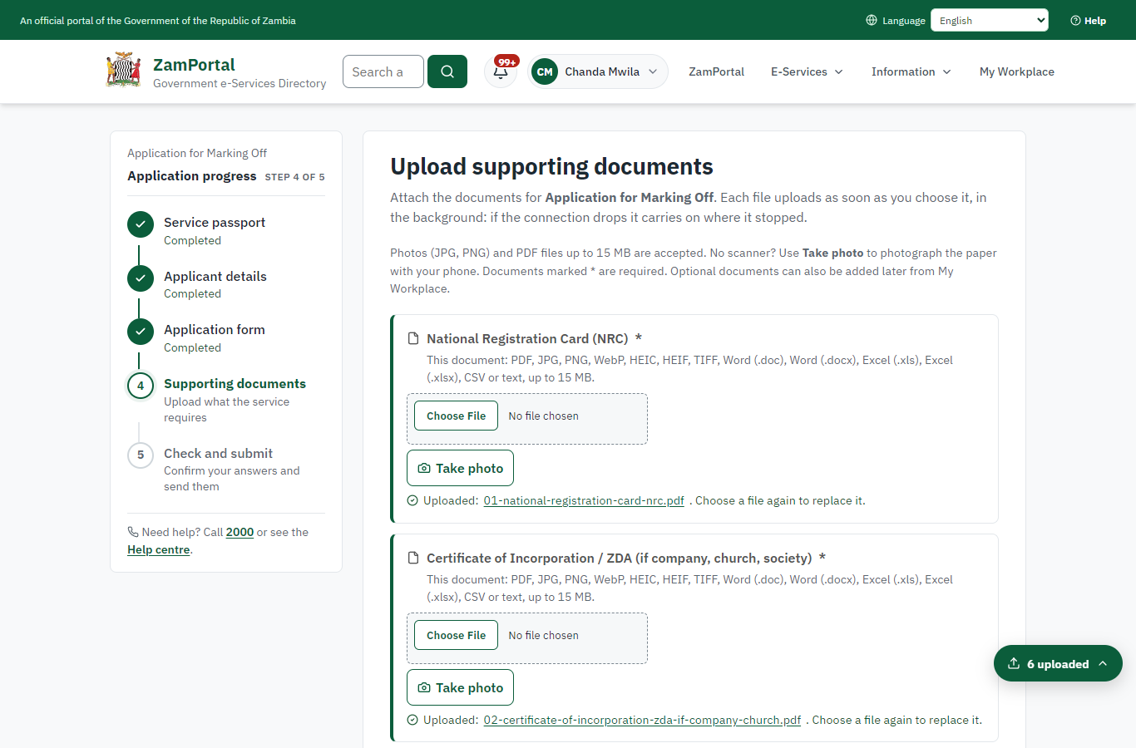 | 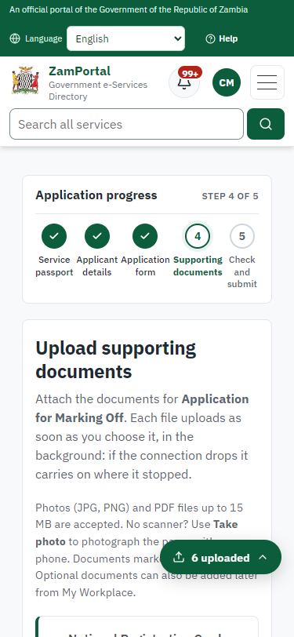
Step 5: Upload the supporting documents - desktop (left) and a 375 px phone (right).

Step 6. Check the answers and confirm the declaration
Citizen · National e-Services portal
Before sending, the citizen sees every answer and document on one page and can go back to change them. The declaration that the information is true and complete must be ticked.
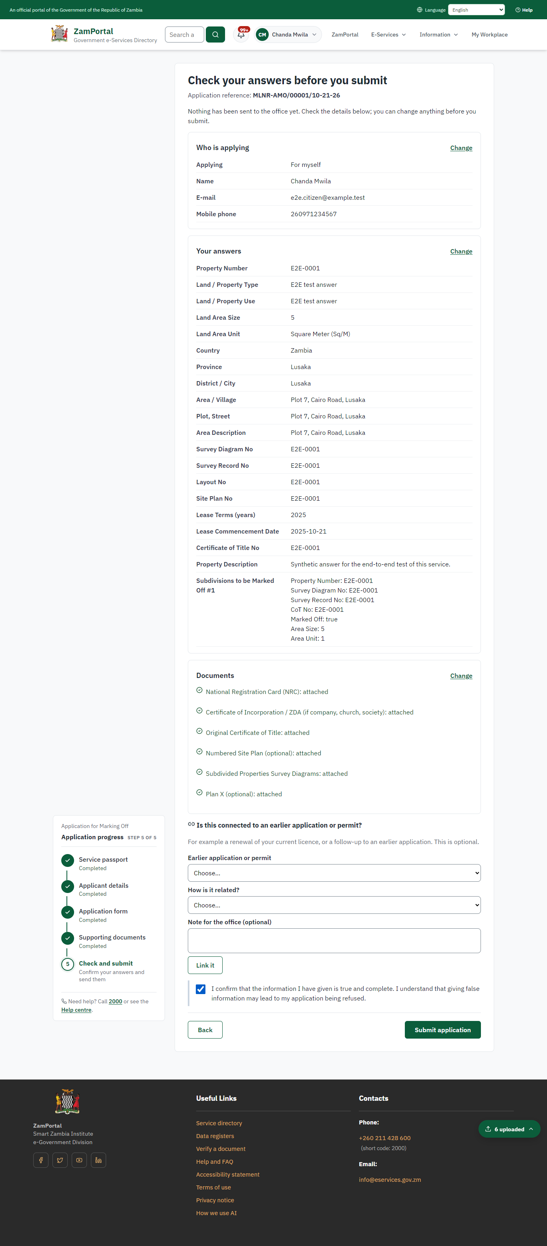 | 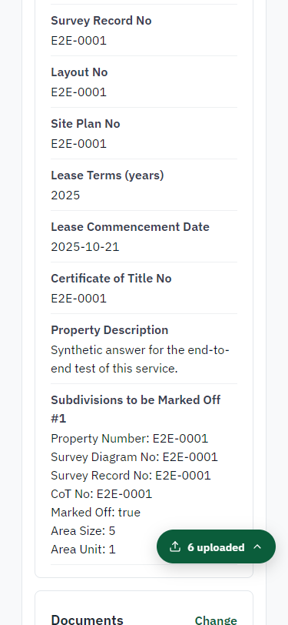
Step 6: Check the answers and confirm the declaration - desktop (left) and a 375 px phone (right).

Step 7. Application sent
Citizen · National e-Services portal
The portal confirms the application with the ministry's reference number (MLNR-AMO/00001/10-21-26 in this run). The fee is due now: it is taken with the application, so the invoice was raised when the application was sent.
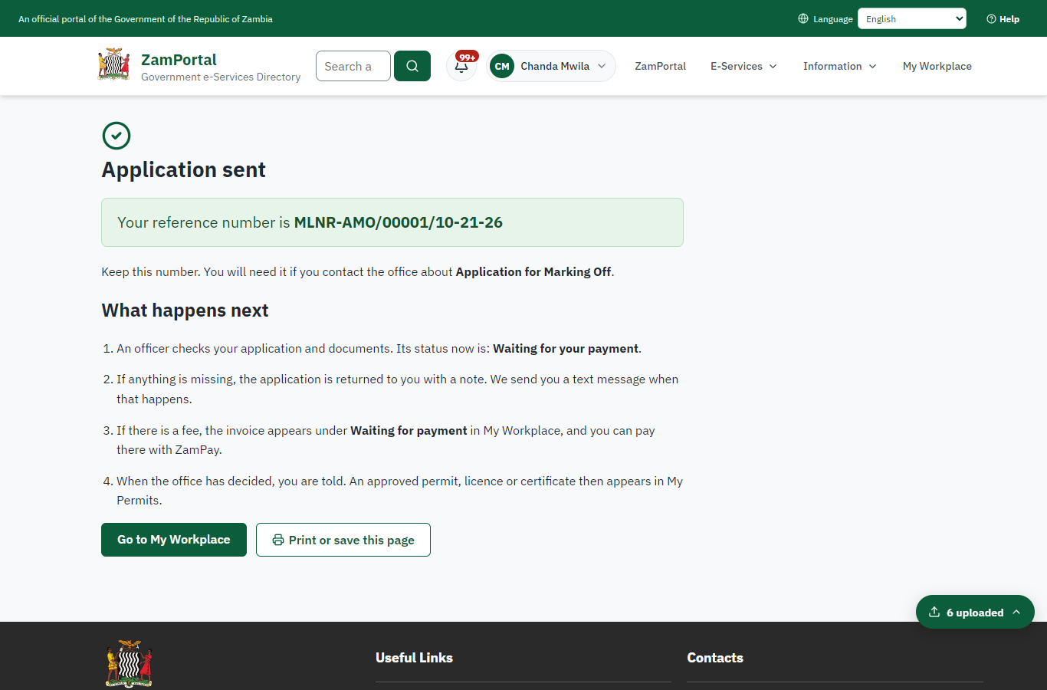 | 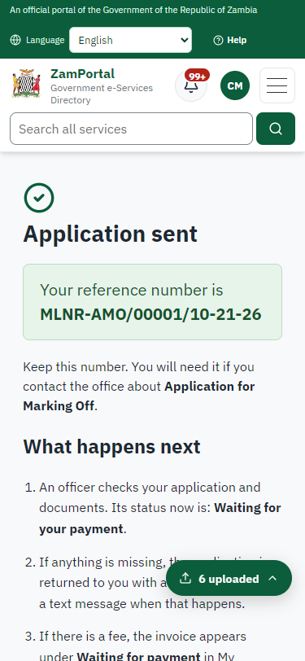
Step 7: Application sent - desktop (left) and a 375 px phone (right).

Step 8. See that the fee is due
Citizen · National e-Services portal
The application shows "Waiting for your payment" in My Workplace with a Pay button (K333.60). The fee is taken with the application; the invoice was raised on ZamPay.
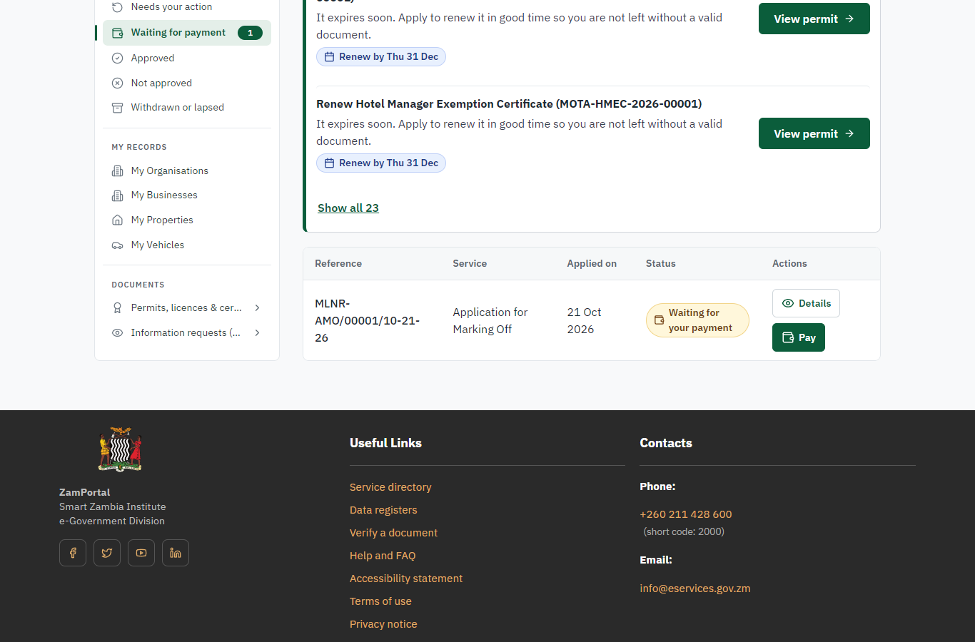 | 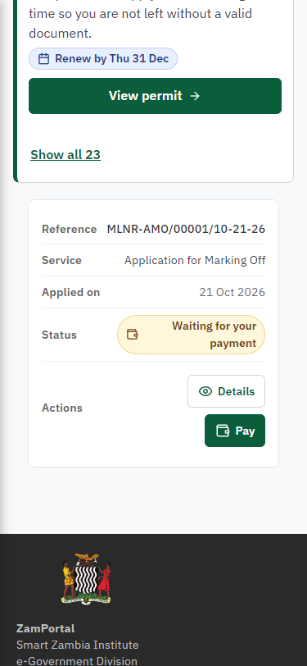
Step 8: See that the fee is due - desktop (left) and a 375 px phone (right).

Step 9. Pay with ZamPay
Citizen · National e-Services portal
Pay opens the invoice (K333.60, the amount set by the platform, never by the page) with its PDF preview; the citizen pays at ZamPay by mobile money or bank card.
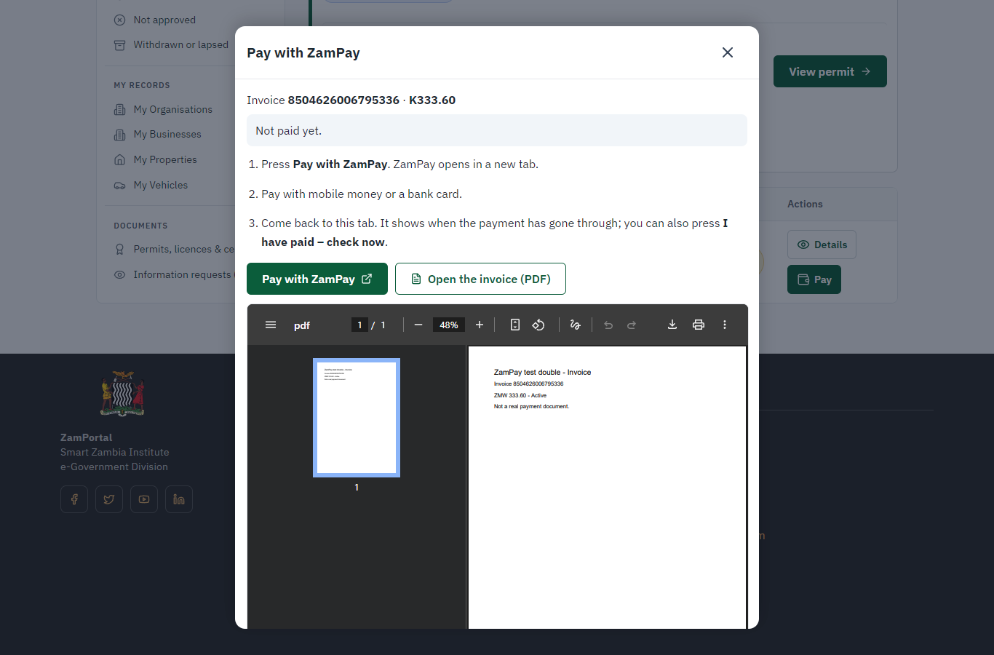 | 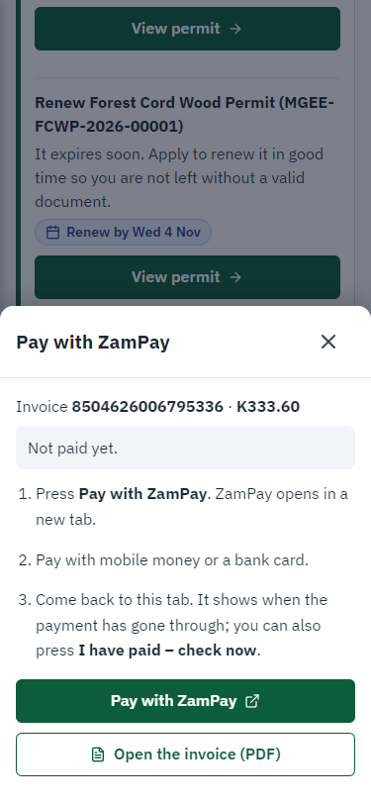
Step 9: Pay with ZamPay - desktop (left) and a 375 px phone (right).

Step 10. Payment received
Citizen · National e-Services portal
ZamPay reports the payment; the dialog says "Paid. Thank you" and the application moves on to the ministry's officers.
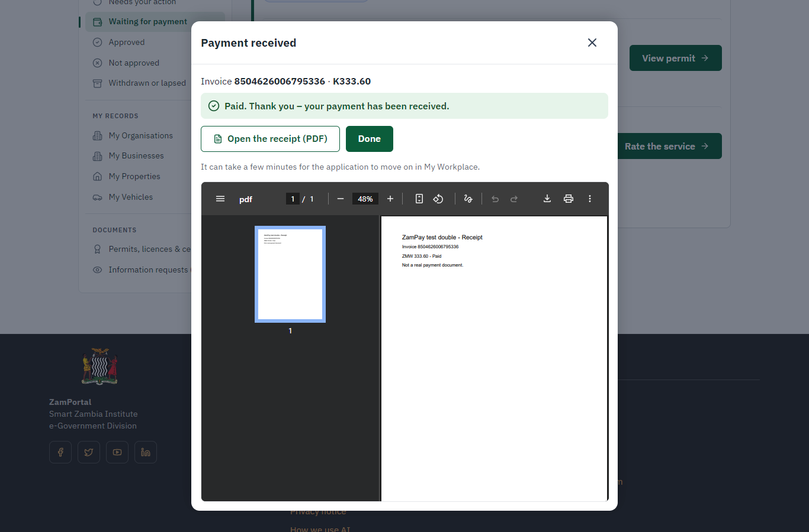 | 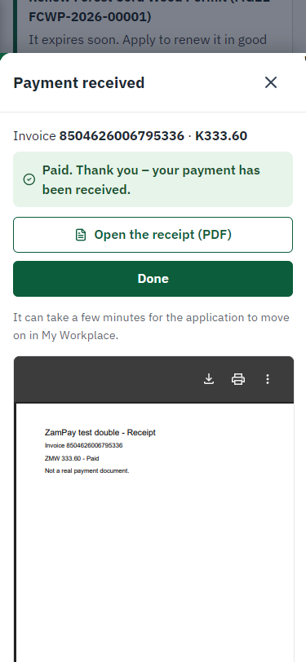
Step 10: Payment received - desktop (left) and a 375 px phone (right).

Step 11. Take the new application on
Case Officer · Back office
The application arrives in the case queue of the ministry that owns the service (Survey Department); only its staff see it. The officer opens it by its reference number - answers, documents and process are on the case - assigns it to themself and takes it on.
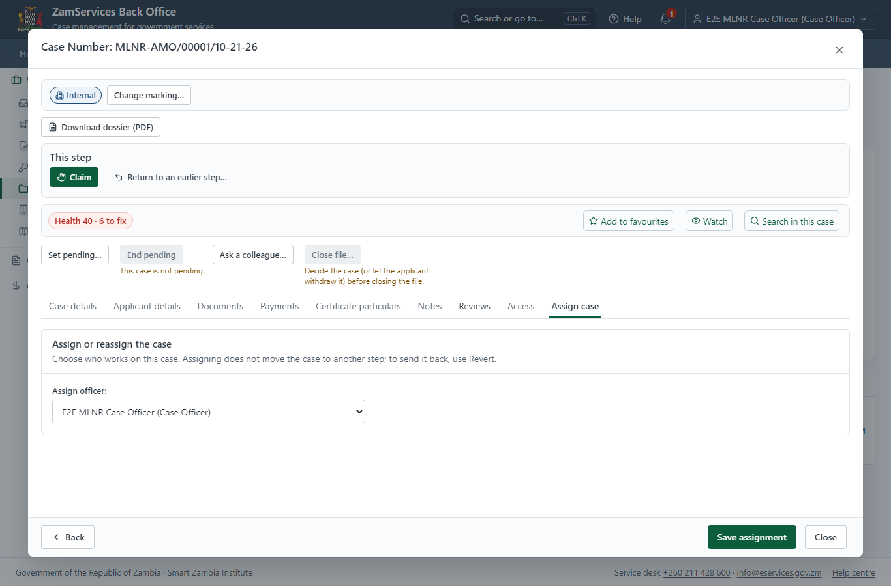
Step 11: Take the new application on.

Step 12. Fill in the certificate particulars
Case Officer · Back office
The issued document prints 10 fields that come from the office rather than from the application (Lot Id, Area size unit, Parent area size, Signed by pattern, Subdivision color, Parent property no, Subdivision letter, Marking off document, Parent area size unit, Vw nlr properties marked off). The officer fills them in on the case's "Certificate particulars" tab before the document is issued (synthetic values in this run) and saves; once the document is issued they can no longer change.
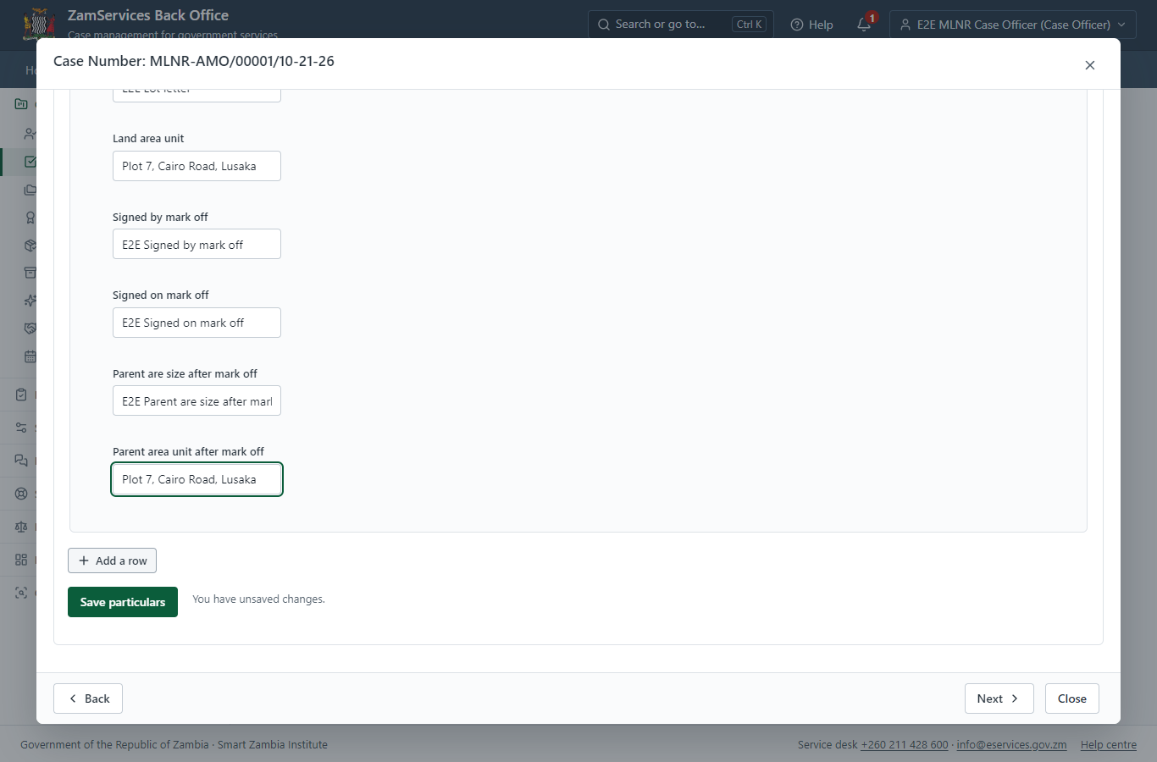
Step 12: Fill in the certificate particulars.

Step 13. Conduct survey, submit report (EXTRANET)
Case Officer · Back office
The Case Officer works on "Conduct survey, submit report (EXTRANET)" (review in the imported process), checks the application and its documents, and completes the step.
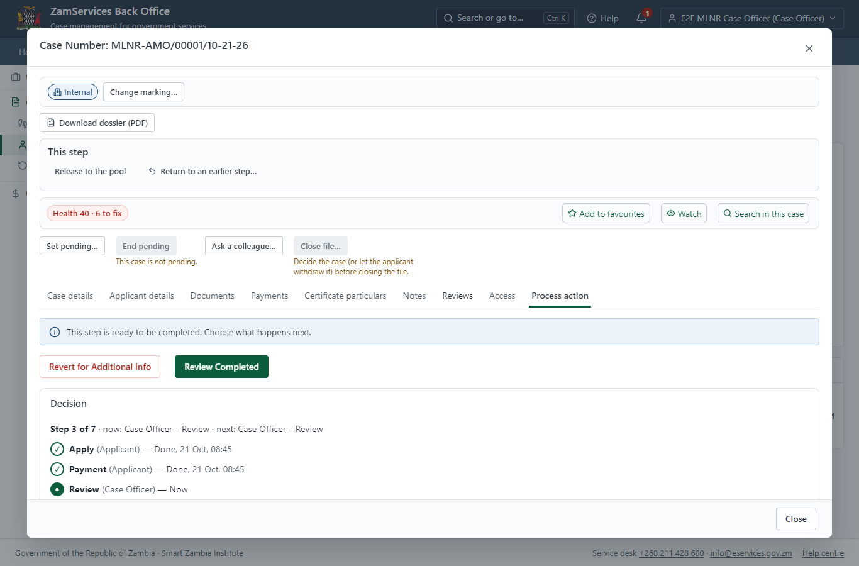
Step 13: Conduct survey, submit report (EXTRANET).

Step 14. Quality control of Survey Documents
Case Officer · Back office
The Case Officer works on "Quality control of Survey Documents" (review in the imported process), checks the application and its documents, and completes the step.
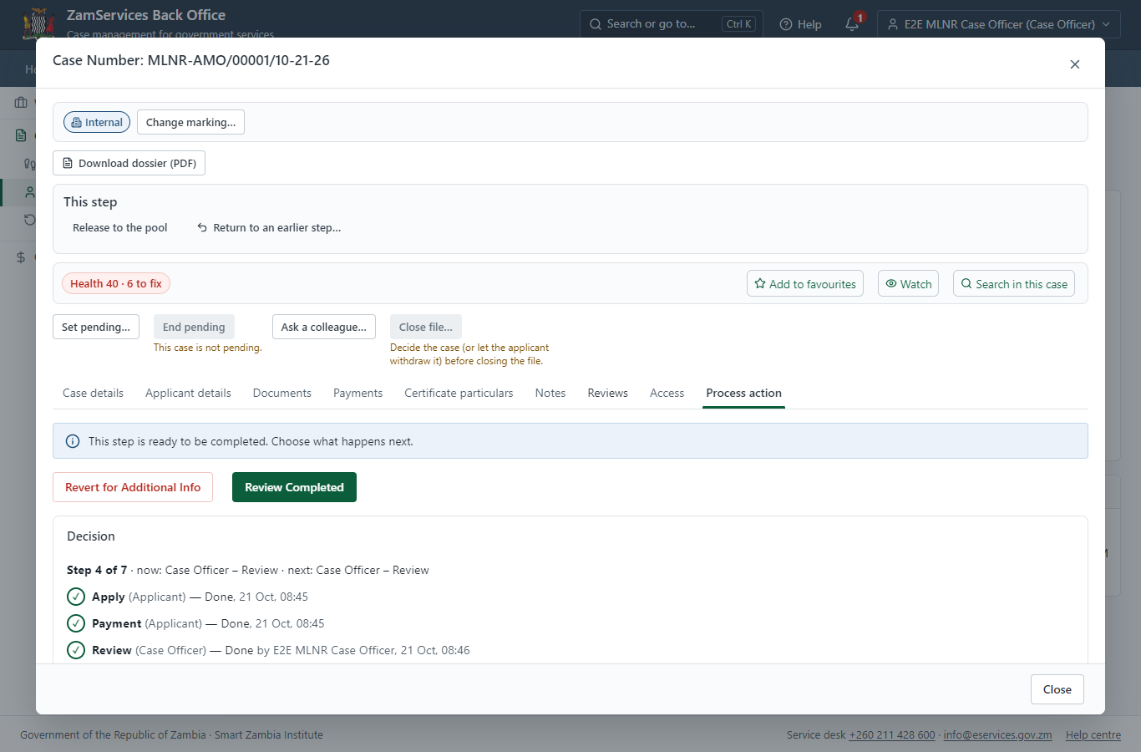
Step 14: Quality control of Survey Documents.

Step 15. Download Survey Documents
Case Officer · Back office
The Case Officer works on "Download Survey Documents" (review in the imported process), checks the application and its documents, and completes the step.
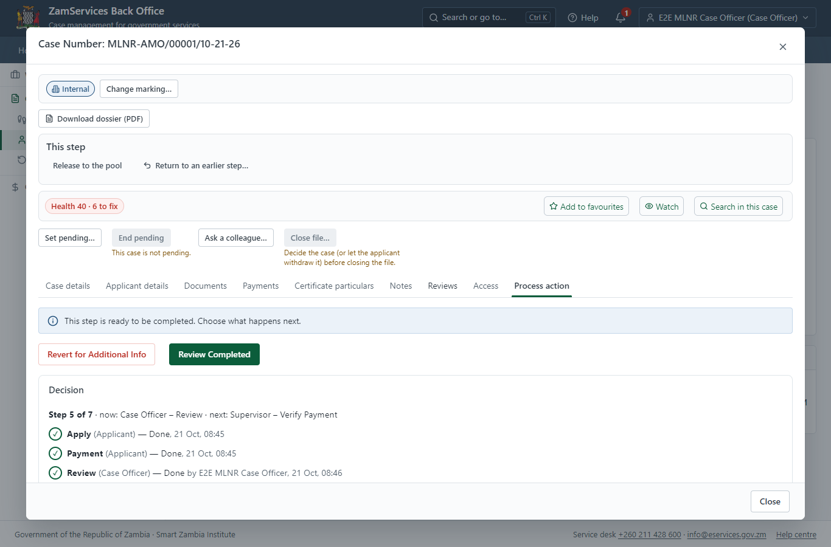
Step 15: Download Survey Documents.

Step 16. Verify Payment Completion, Review Survey Report & Survey Diagram
Supervisor · Back office
The Supervisor works on "Verify Payment Completion, Review Survey Report & Survey Diagram" (verify-payment in the imported process), checks the application and its documents, and completes the step.
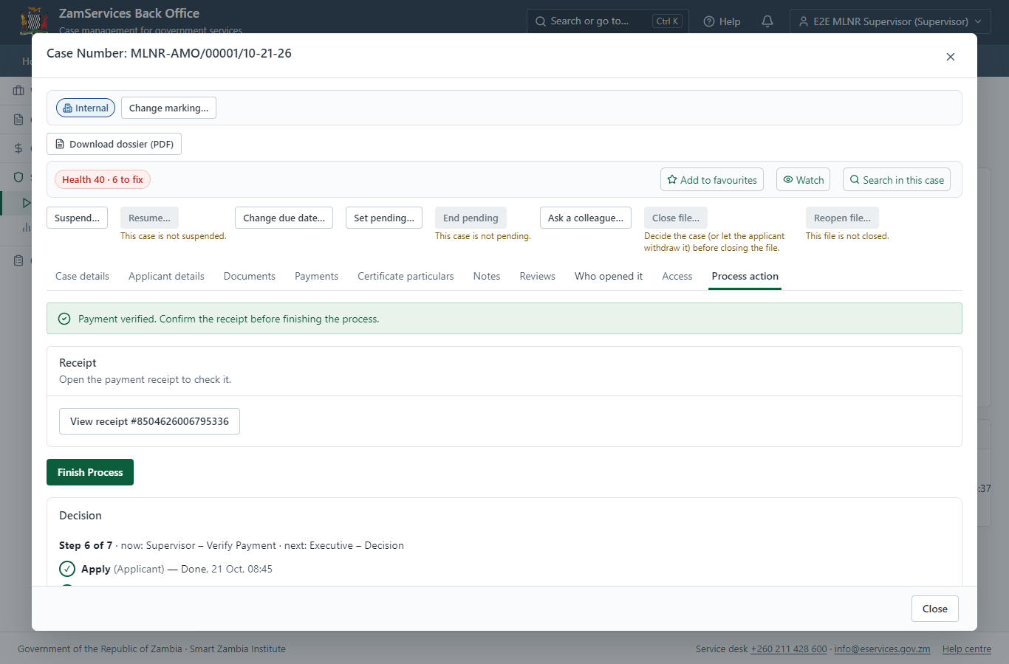
Step 16: Verify Payment Completion, Review Survey Report & Survey Diagram.

Step 17. Decide: Review, Inspect, e-Sign Surveyor General
Executive · Back office
At "Review, Inspect, e-Sign Surveyor General" the Executive records the decision: approve, with a comment kept in the case history. Approving moves the case on; the last decision completes it and issues the document.
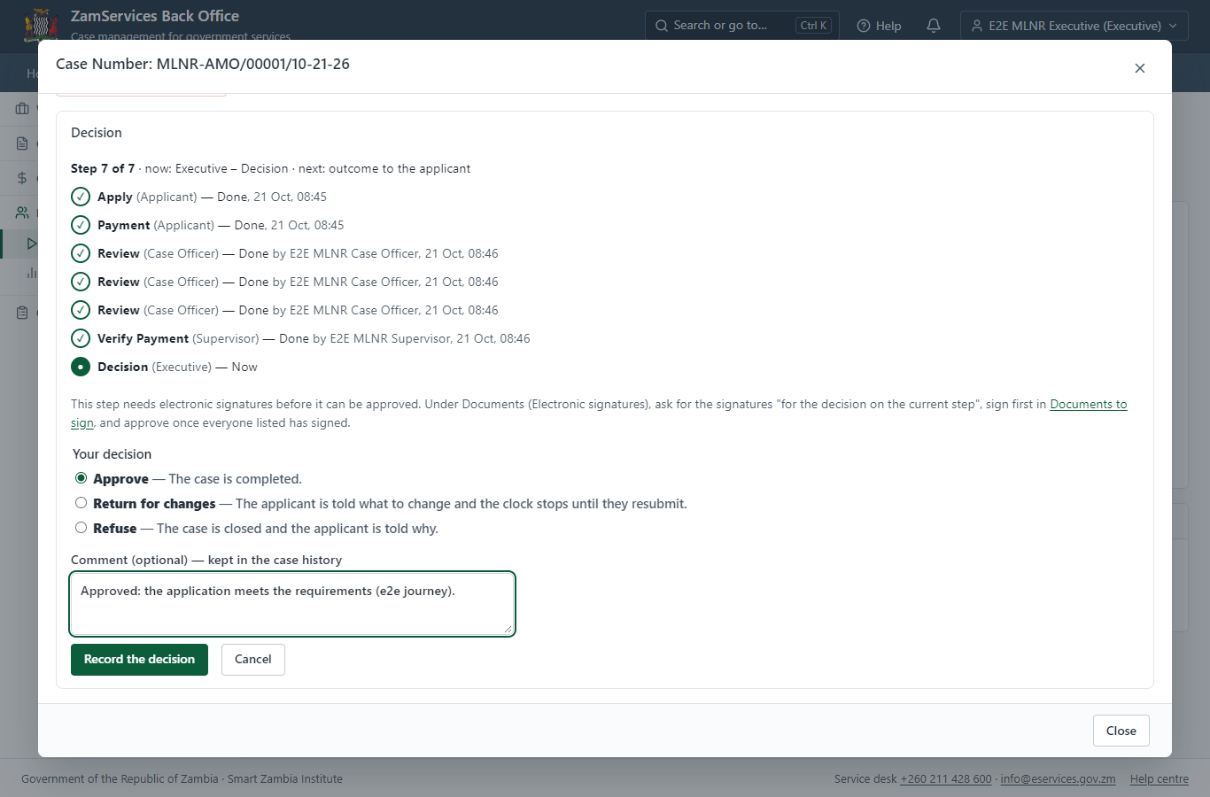
Step 17: Decide: Review, Inspect, e-Sign Surveyor General.

Step 18. Issue the document
Case Officer · Back office
The service's validity ("N/A") is not a fixed period, so completing the case does not issue the document by itself: the officer issues it from the completed case ("Issue / check permit"). It is generated from the service's output configuration and sealed.
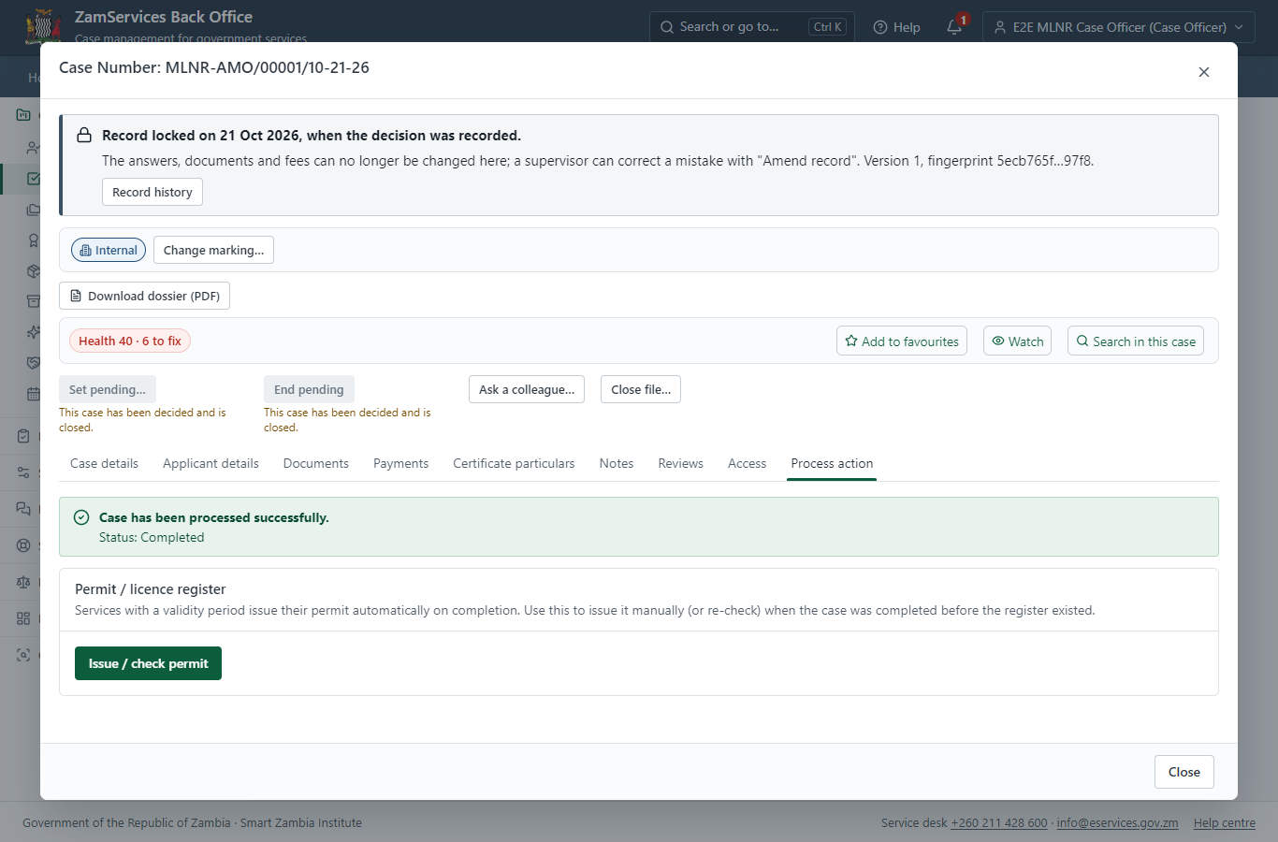
Step 18: Issue the document.

Step 19. The document in My permits
Citizen · National e-Services portal
The issued document (MLNR-AMO-2026-00001 in this run: "Marking Off Subdivisions") is listed in "My permits and licences" with its validity and a download of the sealed PDF.
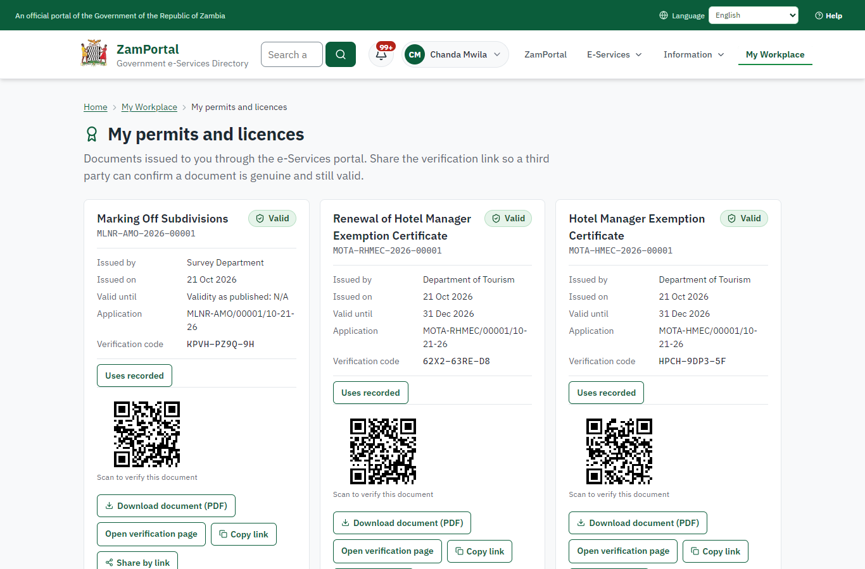 | 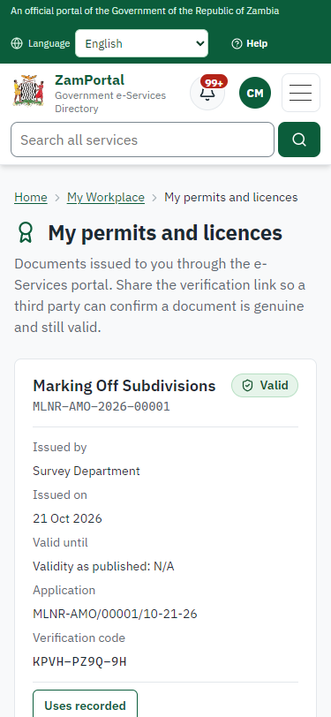
Step 19: The document in My permits - desktop (left) and a 375 px phone (right).

Step 20. Verify the document
Anyone (public) · Public verification page
The QR code on the document opens the public verification page: genuine and current, to whom it was issued, and whether the electronic seal is valid. No sign-in is needed.
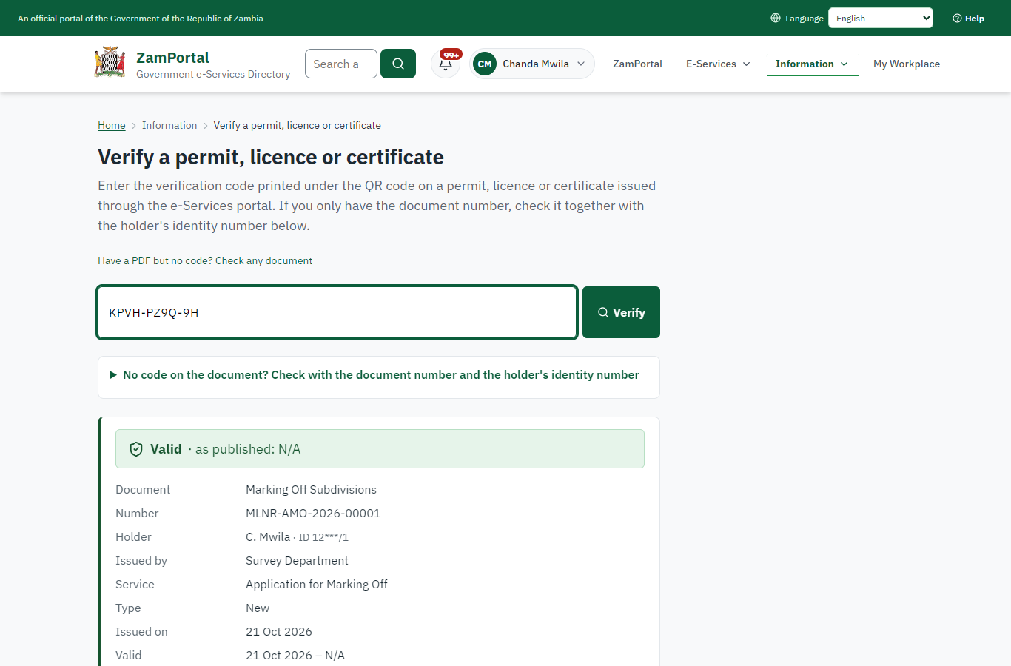 | 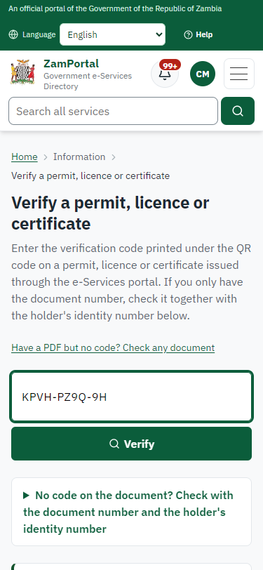
Step 20: Verify the document - desktop (left) and a 375 px phone (right).

3. Payment
Item | In the test run
Fee (as published) | 333.60 ZMW per subdivision
Invoice 1 | 8504626006795336
Amount 1 | ZMW 333.60
Paid at 1 | with the application
On screen: step 8 (See that the fee is due), step 9 (Pay with ZamPay), step 10 (Payment received) in section 2.

4. Output documents

Marking Off Subdivisions (sealed PDF)
Issued when the case was approved, from the service's output configuration (service template MLNR_MarkingOff.Certificate.docx), filled from the application and the decision, sealed with the platform's electronic seal and stored as the issued version. The holder downloads it from My permits; the verification page checks it.

Marking Off Subdivisions (sealed PDF) - first of 1 page, as issued in the test run.

Fields
Field | Value in the test run
Document title | Marking Off Subdivisions
Permit / licence number | MLNR-AMO-2026-00001
Holder | Chanda Mwila
Valid from | 2026-10-21
Valid until
Status | active
Verification code (printed with a QR code) | KPVH-PZ9Q-9H

Seal
Seal status | sealed
Signature level | PAdES-B-T
Sealed by | the platform seal (development key in the test run)
Signed at | 2026-10-21T06:46:40.510Z
Trusted time-stamp | 2026-10-21T06:46:40.486Z (time-stamping authority)
Document fingerprint (SHA-256) | c3701d45545eeefe...

Verification
Where | The public verification page of the national portal, <portal>/verify/<verification code>, opened by scanning the QR code on the document.
What it shows | Whether the document is genuine and current, its holder and validity, and whether the electronic seal is valid and who sealed it.
Checking a copy | Anyone can upload a PDF they were given; the page says whether it is exactly the document that was issued. A changed copy is reported as not matching.
On screen: step 18 (Issue the document), step 19 (The document in My permits), step 20 (Verify the document) in section 2.

5. Notifications
When | Channel | To | Message | Delivery
Payment due (invoice raised) | in-app (portal bell) | the applicant | Payment due for application MLNR-AMO/00001/10-21-26 - The fee of ZMW 333.60 for Application for Marking Off (MLNR-AMO/00001/10-21-26) is now due. Invoice 8504626006795336. | shown
Application received | in-app (portal bell) | the applicant | Application MLNR-AMO/00001/10-21-26 received - Your application MLNR-AMO/00001/10-21-26 for Application for Marking Off has been received by Survey Department. | shown
Payment received | in-app (portal bell) | the applicant | Payment received for MLNR-AMO/00001/10-21-26 - Your payment of ZMW 333.60 for MLNR-AMO/00001/10-21-26 (Application for Marking Off) has been received. Receipt: <ZamPay>/pdf?documentType=receipt&invoiceNumber=8504626006795336 | shown
Invitation to rate the service | in-app (portal bell) | the applicant | How was Application for Marking Off? - How was Application for Marking Off? Tell us in about a minute. | shown
Decision: approved | in-app (portal bell) | the applicant | Application MLNR-AMO/00001/10-21-26 completed - MLNR-AMO/00001/10-21-26 (Application for Marking Off) is complete. Your documents are ready. | shown
Licence / permit issued | in-app (portal bell) | the applicant | Your Application for Marking Off document has been issued - MLNR-AMO-2026-00001 has been issued for Application for Marking Off. | shown
Payment due (invoice raised) | email | e2e.c***@example.test | Payment due for application MLNR-AMO/00001/10-21-26 | skipped
Application received | email | e2e.c***@example.test | Application MLNR-AMO/00001/10-21-26 received | skipped
Payment due (invoice raised) | sms | +260 97* *** 567 | Fee of ZMW 333.60 due for MLNR-AMO/00001/10-21-26. Invoice 8504626006795336. Pay: <ZamPay>/pay-for-service/get-invoice/8504626006795336 | delivered
Application received | sms | +260 97* *** 567 | Application MLNR-AMO/00001/10-21-26 for Application for Marking Off has been received. Track it: <portal>/my-workplace | delivered
Payment received | sms | +260 97* *** 567 |  | delivered
Invitation to rate the service | sms | +260 97* *** 567 |  | skipped
Invitation to rate the service | email | e2e.c***@example.test | How was Application for Marking Off? | skipped
Decision: approved | email | e2e.c***@example.test | Application MLNR-AMO/00001/10-21-26 completed | skipped
Decision: approved | sms | +260 97* *** 567 |  | delivered
Licence / permit issued | sms | +260 97* *** 567 |  | delivered
Licence / permit issued | email | e2e.c***@example.test | Your Application for Marking Off document has been issued | skipped
Delivery: shown = in the portal's notification bell; delivered = the SMS gateway (a test double in this run) reported the text delivered; skipped = not sent on that channel (e-mail is not configured on the test installation, and some notices go out on one channel only); sent by the national portal = a ministry node handed the notice to the national portal, which texts and e-mails the citizen under its own name and the citizen's preferences. Addresses written <portal>, <ZamPay> stand for the national portal and ZamPay.

6. Legacy mapping
Replaces | Application for Marking Off in the legacy ZIGS e-Services directory (ZIGS_Services)
Legacy service id | 361
Legacy provider | Survey Department (MLNR) under Ministry of Lands and Natural Resources
Legacy process | Standard.Review_3Step (process 103)
Fee in the legacy system | Application for Marking Off: ZMW 333.6 (New)
Fee taken before submission | yes (as in ZIGS)
Time to issue (legacy) | New: 7 calendar days
Legacy output templates | Notice of Action: ZIGS_Forms_Notices / GS-2.NoticeOfAction  Application form: ZIGS_Forms_MLNR / MLNR_MarkingOff.Application  Marking Off Subdivisions: ZIGS_Forms_MLNR / MLNR_MarkingOff.Certificate  GF-1 Treasury Invoice: ZIGS_CustomForms / GF-1 Invoice  GF-2 Treasury Receipt: ZIGS_CustomForms / GF-2 Receipt
Legacy address | none recorded
How it was brought over | Imported by the platform's legacy catalogue importer (zcm-backend scripts/zigs/importLegacy.js) from the ZIGS snapshot: form, case types, fees, documents, process and output templates, then served by the new platform.

7. Version and date
Document version | service v1, platform a0a302b8
Generated | 2026-10-21T06:46:49Z (by the end-to-end run, not edited by hand)
Service version | not versioned (configured directly)
Platform snapshot | backend a0a302b8  portal 72805f0  back office 58e5946
Test suite | e2e 5999d9b; one installation (combined); seed profile mihud
Journeys | 30-catalogue-service.spec.js: citizen finds the service, answers its form, uploads its documents and sends the application - passed  30-catalogue-service.spec.js: the case goes through every step of its process: payments by the citizen, each officer step by its role - passed  30-catalogue-service.spec.js: the grant document is issued, sealed, filled in and verifiable; the citizen has it in My permits - passed
Result | 3 of 3 journey tests passed
Data | Synthetic test data on a local test installation; provider test doubles for ZamPass, ZamPay, SMS and signing.

