Republic of Zambia
GSB e-Services

Annual Return
Service documentation
Owner: Department of Registration and Regulation
Service key: DOC/annual-return
Version: service v1, platform 12841b43
Date: 2026-10-22
Generated automatically by the service's end-to-end test run. Every screenshot shows synthetic test data on a local test installation, never real personal data.

Contents
- 1. Service summary
- 2. Application process, step by step
- 3. Payment
- 4. Output documents
- 5. Notifications
- 6. Legacy mapping
- 7. Version and date
This document describes the Annual Return service of Department of Registration and Regulation as the platform runs it today. It is generated by the service's end-to-end test: every step was performed by the test and every screenshot was taken during that run, with synthetic data. Regenerate it with "npm run docs:services" in the e2e suite; do not edit it by hand.

1. Service summary
Service | Annual Return
Owner (MDA) | Department of Registration and Regulation (DOC)
Purpose | A Co-operative Society shall furnish the Registrar with annual returns under the Co-operative Societies Act. Annual returns are due on the registration date of the Co-operative.
Who can apply | Organization
How to apply | Online on the national e-Services portal, signed in with ZamPass; pay with ZamPay.
Fees | Annual return for a primary co-operative: ZMW 133.33  Annual return for a co-operative union: ZMW 200.00  Annual return for a federation: ZMW 266.67
Turnaround | 30 days
Validity of the output | 365 days
Required documents | Minutes of the last Annual General Meeting (required)  Audited Accounts for the Last Financial Year (required)
Output documents | Notice Of Action  Application form  GF-1 Treasury Invoice  GF-2 Treasury Receipt
Legal basis | Co-operative Societies Act, No. 20 of 1998 (https://www.ilo.org/dyn/natlex/docs/ELECTRONIC/53147/111628/F824149747/ZMB53147.pdf)  Co-operative Societies Regulations, SI No. 26 of 1999 (http://extwprlegs1.fao.org/docs/pdf/zam16012.pdf)

2. Application process, step by step

The process as configured
Step | Role | Task | Type
1 | Applicant | Apply | form
2 | Case Officer | Generate Payment | generate-payment
3 | Applicant | Payment | payment
4 | System | Generate Document | generate-document
5 | Case Officer | Review | review
6 | Supervisor | Review | review
7 | Executive | Decision | decision
8 | System | Generate Document | generate-document
9 | System | Notify Client | notify

Step by step
Who takes part in this journey: Citizen, Case Officer, Supervisor, Executive. Citizen steps are shown on a desktop and on a 375 px phone; back-office steps on a desktop.

Step 1. Find the service and read its page
Citizen · National e-Services portal
The society's account opens "Annual Return": a return is due every year on the anniversary of the registration; the fee depends on the kind of society.
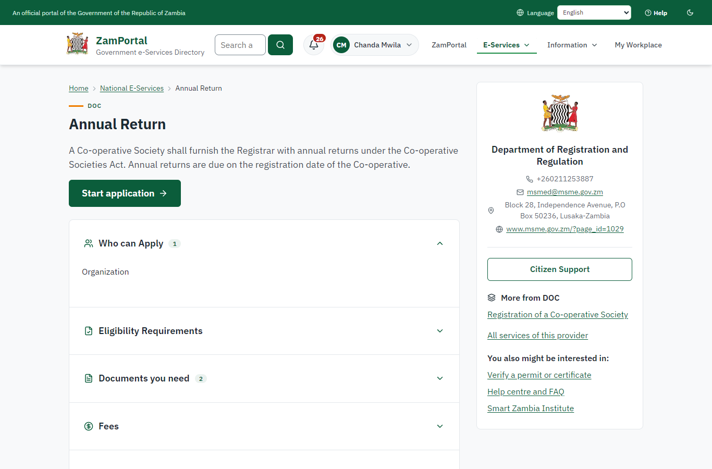 | 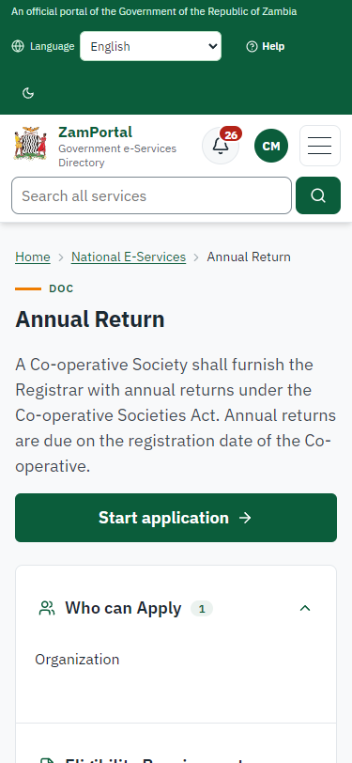
Step 1: Find the service and read its page - desktop (left) and a 375 px phone (right).

Step 2. Inspect the case by Case Officer
Case Officer · Back office (done through its case API in the test run: no screenshot)
The Case Officer completes "Inspect the case by Case Officer". The case moves from "CO Review" to "SV Review".

Step 3. Inspect the case by Supervisor
Supervisor · Back office (done through its case API in the test run: no screenshot)
The Supervisor completes "Inspect the case by Supervisor". The case moves from "SV Review" to "EX Decision".

Step 4. Review, Inspect, e-Sign Executive
Executive · Back office (done through its case API in the test run: no screenshot)
The Executive decides: approve ("Review, Inspect, e-Sign Executive"). The case moves from "EX Decision" to "Completed".

Step 5. The return on the society's record
Supervisor · Back office
The society's record after the approval: the return is filed for the three years, with the two late years shown; the next return is due on the next anniversary.
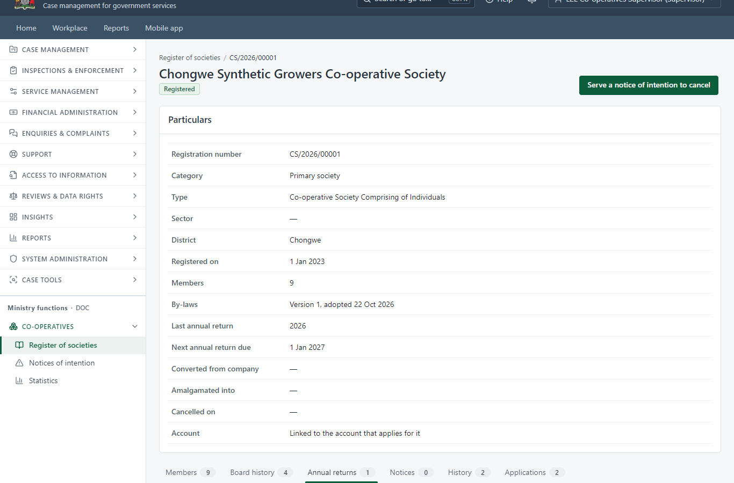
Step 5: The return on the society's record.

Step 6. Board history
Supervisor · Back office
The board named in the return replaces the board on the register: the old chairperson's term ends on the day of the approval and stays in the history.
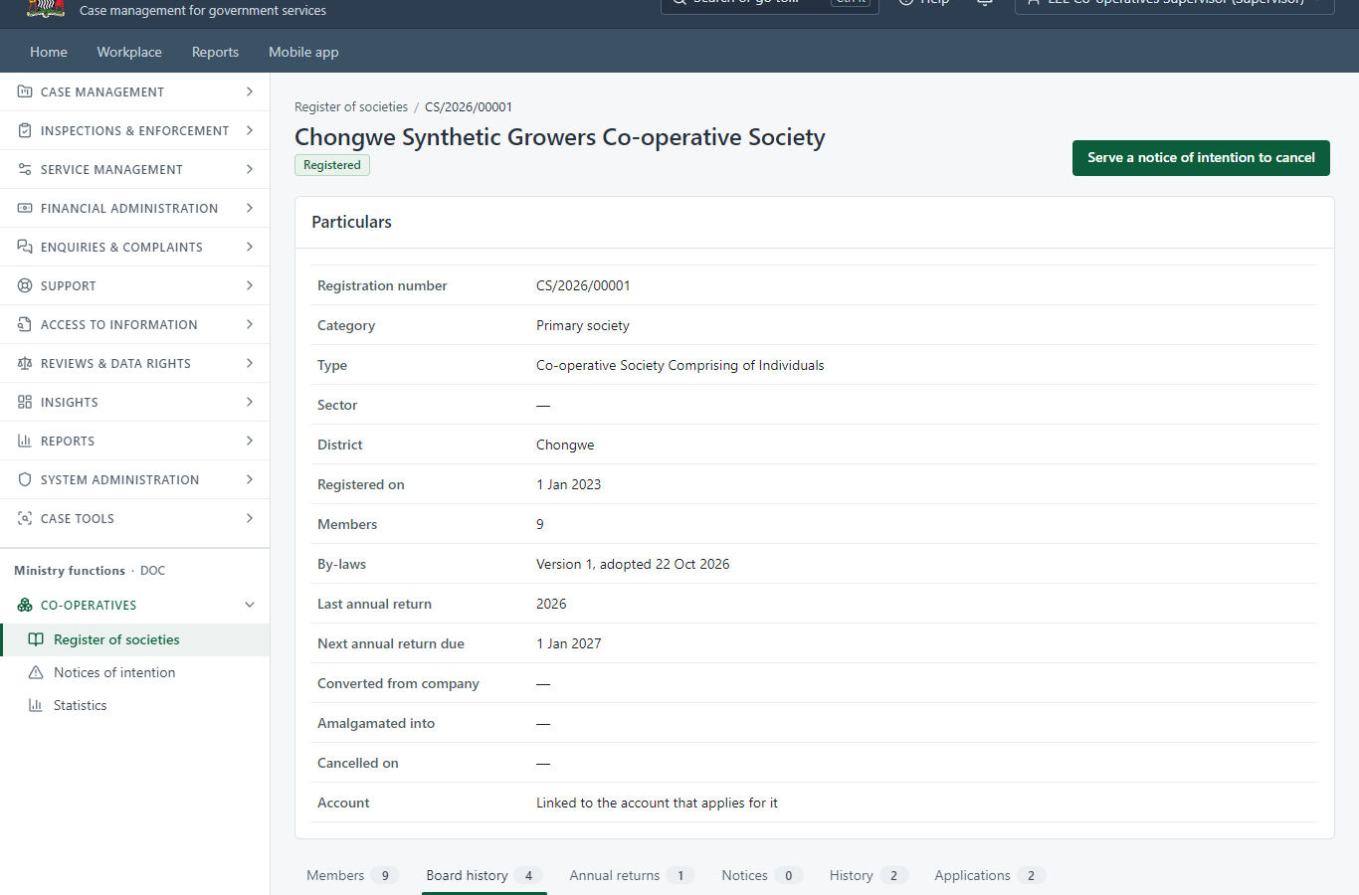
Step 6: Board history.

3. Payment
Item | In the test run
Fee | ZMW 133.33 a year for a primary society (ZMW 200 for a union, ZMW 266.67 for a federation), from the service's fee schedule
Years filed | 2024, 2025, 2026
Late penalty | one year's fee again for each year filed after its year: 2024, 2025
Amount | ZMW 666.65, worked out on the server when the return is sent and fixed then
Invoice number | 4606926190439709
Paid through | ZamPay (the ZamPay test double in this run)

4. Output documents
On screen: step 5 (The return on the society's record), step 6 (Board history) in section 2.

5. Notifications
When | Channel | To | Message | Delivery
Payment due (invoice raised) | in-app (portal bell) | the applicant | Payment due for application DOC-AR/00002/10-22-26 - The fee of ZMW 666.65 for Annual Return (DOC-AR/00002/10-22-26) is now due. Invoice 4606926190439709. | shown
Application received | in-app (portal bell) | the applicant | Application DOC-AR/00002/10-22-26 received - Your application DOC-AR/00002/10-22-26 for Annual Return has been received by Department of Registration and Regulation. | shown
Payment received | in-app (portal bell) | the applicant | Payment received for DOC-AR/00002/10-22-26 - Your payment of ZMW 666.65 for DOC-AR/00002/10-22-26 (Annual Return) has been received. Receipt: <ZamPay>/pdf?documentType=receipt&invoiceNumber=4606926190439709 | shown
Licence / permit issued | in-app (portal bell) | the applicant | Your Annual Return document has been issued - DOC-AR-2026-00002 has been issued for Annual Return and is valid until 22/10/2027. | shown
Invitation to rate the service | in-app (portal bell) | the applicant | How was Annual Return? - How was Annual Return? Tell us in about a minute. | shown
Decision: approved | in-app (portal bell) | the applicant | Application DOC-AR/00002/10-22-26 completed - DOC-AR/00002/10-22-26 (Annual Return) is complete. Your documents are ready. | shown
Payment due (invoice raised) | sms | +260 97* *** 567 | Fee of ZMW 666.65 due for DOC-AR/00002/10-22-26. Invoice 4606926190439709. Pay: <ZamPay>/pay-for-service/get-invoice/4606926190439709 | delivered
Payment due (invoice raised) | email | e2e.c***@example.test | Payment due for application DOC-AR/00002/10-22-26 | skipped
Application received | sms | +260 97* *** 567 | Application DOC-AR/00002/10-22-26 for Annual Return has been received. Track it: <portal>/my-workplace | delivered
Application received | email | e2e.c***@example.test | Application DOC-AR/00002/10-22-26 received | skipped
Payment received | sms | +260 97* *** 567 |  | delivered
Invitation to rate the service | sms | +260 97* *** 567 |  | skipped
Invitation to rate the service | email | e2e.c***@example.test | How was Annual Return? | skipped
Licence / permit issued | sms | +260 97* *** 567 |  | delivered
Licence / permit issued | email | e2e.c***@example.test | Your Annual Return document has been issued | skipped
Decision: approved | sms | +260 97* *** 567 |  | delivered
Decision: approved | email | e2e.c***@example.test | Application DOC-AR/00002/10-22-26 completed | skipped
Delivery: shown = in the portal's notification bell; delivered = the SMS gateway (a test double in this run) reported the text delivered; skipped = not sent on that channel (e-mail is not configured on the test installation, and some notices go out on one channel only); sent by the national portal = a ministry node handed the notice to the national portal, which texts and e-mails the citizen under its own name and the citizen's preferences. Addresses written <portal>, <ZamPay> stand for the national portal and ZamPay.

6. Legacy mapping
Replaces | Annual Return in the legacy ZIGS e-Services directory (ZIGS_Services)
Legacy service id | 317
Legacy provider | Department of Registration and Regulation (DOC) under Ministry of Small and Medium Enterprise Development
Legacy process | Standard.Review_3Step (process 103)
Fee in the legacy system | Annual return for a primary co-operative: ZMW 133.33 (New)  Annual return for a co-operative union: ZMW 200 (New)  Annual return for a federation: ZMW 266.67 (New)
Fee taken before submission | yes (as in ZIGS)
Time to issue (legacy) | New: 30 working days
Legacy output templates | Notice Of Action: ZIGS_Forms_Notices / GS-2.NoticeOfAction  Application form: ZIGS_Forms_DOC / DOC_AnnualReturn.Application  GF-1 Treasury Invoice: ZIGS_CustomForms / GF-1 Invoice  GF-2 Treasury Receipt: ZIGS_CustomForms / GF-2 Receipt
Legacy address | https://cooperatives.gsb.gov.zm
How it was brought over | Imported by the platform's legacy catalogue importer (zcm-backend scripts/zigs/importLegacy.js) from the ZIGS snapshot: form, case types, fees, documents, process and output templates, then served by the new platform.

7. Version and date
Document version | service v1, platform 12841b43
Generated | 2026-10-22T00:53:44Z (by the end-to-end run, not edited by hand)
Service version | published version 1
Platform snapshot | backend 12841b43  portal 8d4a375  back office 8a4ad7a
Test suite | e2e f4407ea; one installation (combined); seed profile mihud
Journeys | 39-cooperative-registration-annual-return.spec.js: citizen: files the annual return; the fee and the late penalty are worked out on the server - passed  39-cooperative-registration-annual-return.spec.js: officers work the steps; the return is filed and the register brought up to date - passed
Result | 2 of 2 journey tests passed
Data | Synthetic test data on a local test installation; provider test doubles for ZamPass, ZamPay, SMS and signing.

