Republic of Zambia
GSB e-Services

Angling License
Service documentation
Owner: Department of Fisheries
Service key: MFL/angling-license
Version: service v1, platform a0a302b8
Date: 2026-10-21
Generated automatically by the service's end-to-end test run. Every screenshot shows synthetic test data on a local test installation, never real personal data.

Contents
- 1. Service summary
- 2. Application process, step by step
- 3. Payment
- 4. Output documents
- 5. Notifications
- 6. Legacy mapping
- 7. Version and date
This document describes the Angling License service of Department of Fisheries as the platform runs it today. It is generated by the service's end-to-end test: every step was performed by the test and every screenshot was taken during that run, with synthetic data. Regenerate it with "npm run docs:services" in the e2e suite; do not edit it by hand.

1. Service summary
Service | Angling License
Owner (MDA) | Department of Fisheries (MFL)
Purpose | Service offered to fishers in any commercial area allowing fishing with a rod and line.
Who can apply | Individual; Organization
How to apply | Online on the national e-Services portal, signed in with ZamPass; pay with ZamPay.
Fees | Sport Fishing Organizers: ZMW 5520.00  Sport Fishing Individual Participants: ZMW 600.00  Recreation Fishing Residents under 18 years: ZMW 55.20  Recreation Fishing Residents under 18 years: ZMW 332.00  Recreation Fishing Residents of 18 years and above: ZMW 112.00  Recreation Fishing Residents of 18 years and above: ZMW 666.40  Recreation Fishing Nonresidents: ZMW 1120.00  Institutional angling permits - Lodges and camps: ZMW 3880.00  Institutional angling permits - Aquaculture facility: ZMW 1120.00  Institutional angling permits for hotels - With a capacity of 20 beds: ZMW 4880.00  Institutional angling permits for hotels - With a capacity of 21 beds or more: ZMW 6080.00  Institutional angling permits for hotels - Fishing competitions: ZMW 1664.00  Rod and Line Fishing in any area: ZMW 44.00
Turnaround | Maximum 2 days
Validity of the output | Varies on the purpose
Required documents | National Registration Card (NRC) (required)  Company Registration Certificate (required)  Passport (required)
Output documents | Application form (New)  Application form (Renewal)  GS-2 Notice of Government Action  Certificate Angling License  GF-1 Treasury Invoice  GF-2 Treasury Receipt
Legal basis | SI No. 84 of 2019 (https://media.zambialii.org/media/legislation/41877/source_file/368e2a3fae05d60d/zm-act-si-2019-84-publication-document.pdf)  SI No. 17 of 2024 (https://media.zambialii.org/media/legislation/41277/source_file/e2345820a62b692f/zm-act-si-2024-17-publication-document.pdf)

2. Application process, step by step

The process as configured
Step | Role | Task | Type
1 | Applicant | Apply | form
2 | Case Officer | Generate Payment | generate-payment
3 | Applicant | Payment | payment
4 | System | Generate Document | generate-document
5 | Case Officer | Review | review
6 | Case Officer | Review | review
7 | Executive | Decision | decision
8 | System | Generate Document | generate-document
9 | System | Notify Client | notify

Step by step
Who takes part in this journey: Citizen, Case Officer, Executive, Anyone (public). Citizen steps are shown on a desktop and on a 375 px phone; back-office steps on a desktop.

Step 1. Find the service
Citizen · National e-Services portal
On the national e-Services portal the citizen opens All Services and searches for the service by name ("Angling License"). Each result names the service and the ministry that provides it.
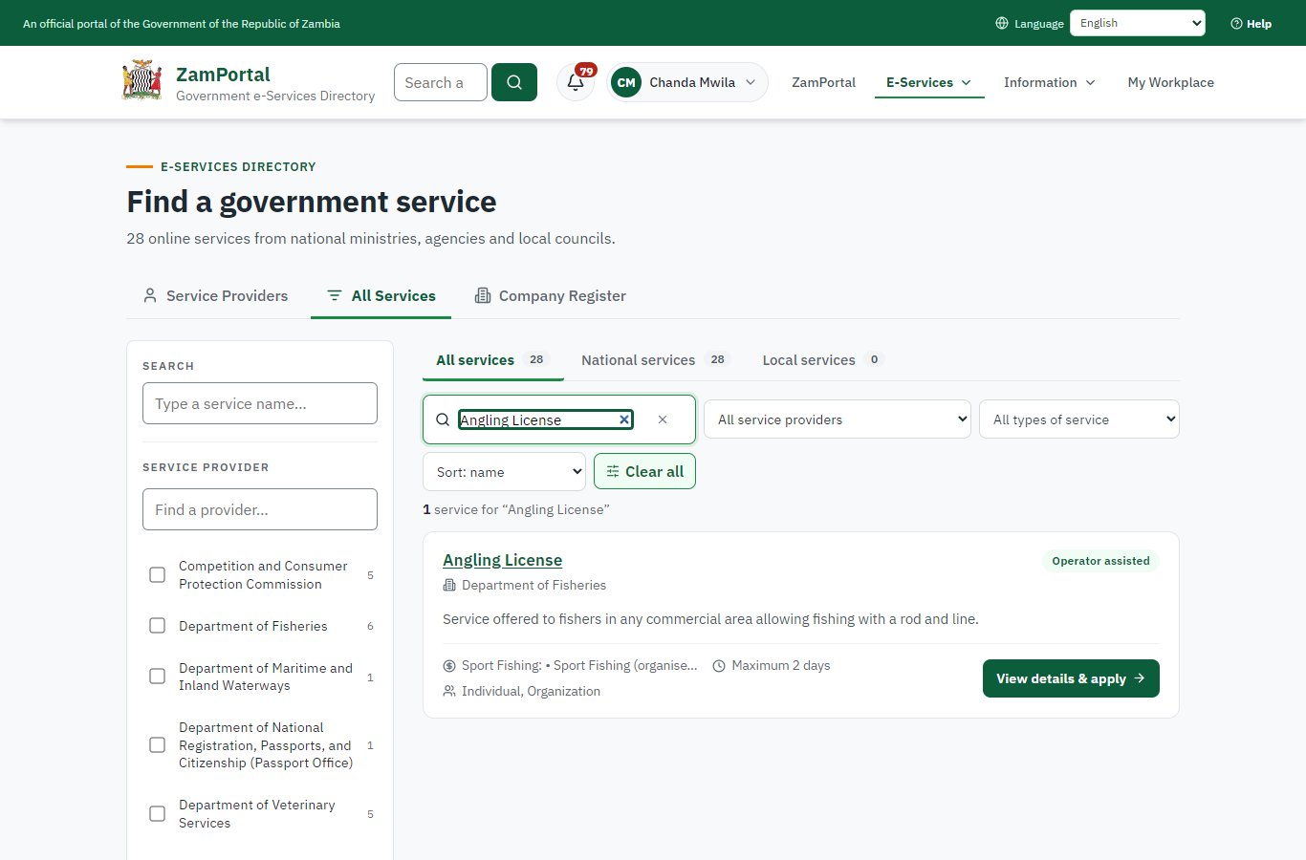 | 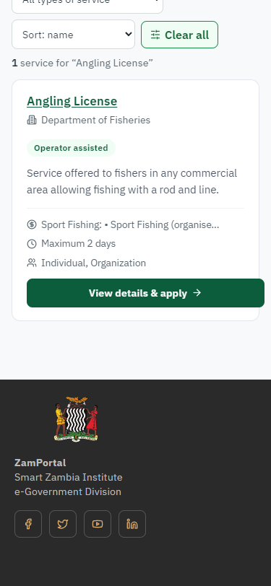
Step 1: Find the service - desktop (left) and a 375 px phone (right).

Step 2. Read the service page
Citizen · National e-Services portal
The service page sets out what the service is for, who provides it, the fee, how long it takes and the documents to have ready. "Start application" begins an application (the citizen is signed in with ZamPass).
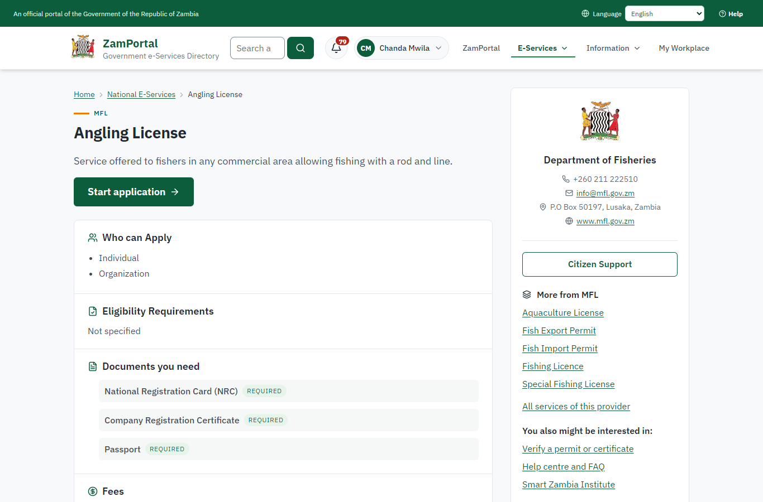 | 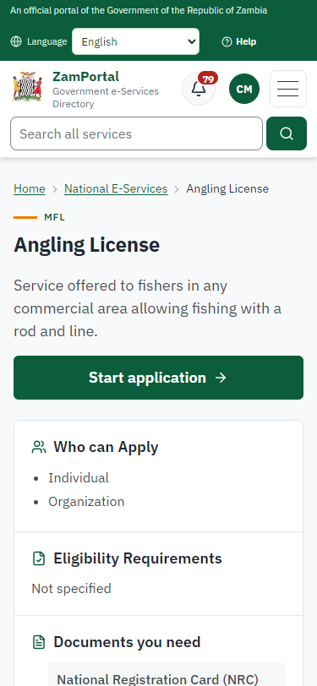
Step 2: Read the service page - desktop (left) and a 375 px phone (right).

Step 3. Confirm the applicant details
Citizen · National e-Services portal
The applicant details are filled in from the citizen's ZamPass account. The citizen says whom they are applying for (themself) and continues with "Proceed to Application".
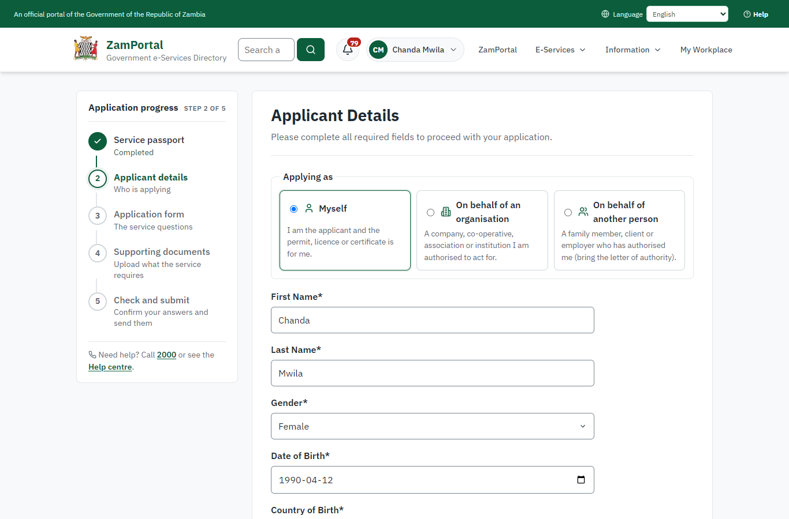 | 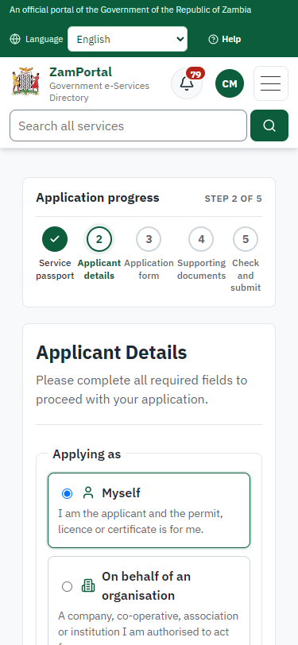
Step 3: Confirm the applicant details - desktop (left) and a 375 px phone (right).

Step 4. Fill in the application form
Citizen · National e-Services portal
The citizen answers the service's own application form, converted from the legacy system (7 answers in this run, all synthetic), for the type of application "New". Questions marked * must be answered; some appear only after an earlier answer. Answers are saved as the citizen types, so an unfinished application can be reopened from My Workplace.
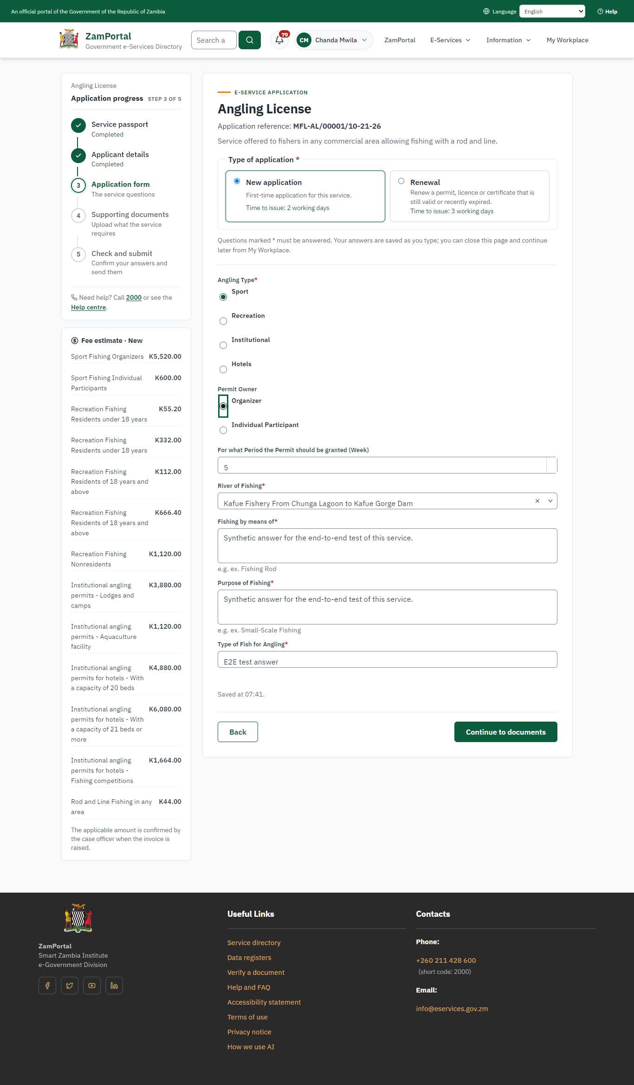 | 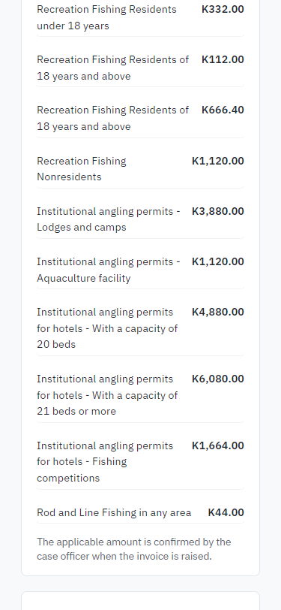
Step 4: Fill in the application form - desktop (left) and a 375 px phone (right).

Step 5. Upload the supporting documents
Citizen · National e-Services portal
Each document the service asks for has its own upload (3 in this run: National Registration Card (NRC), Company Registration Certificate, Passport). The files are checked and stored with the application; the page confirms each upload.
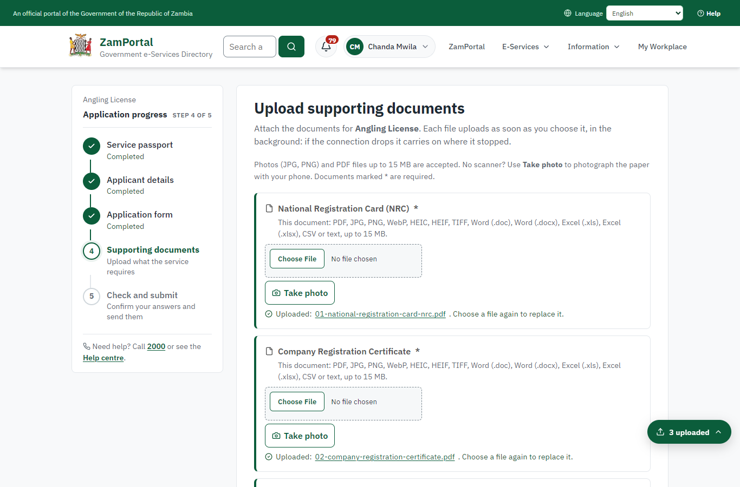 | 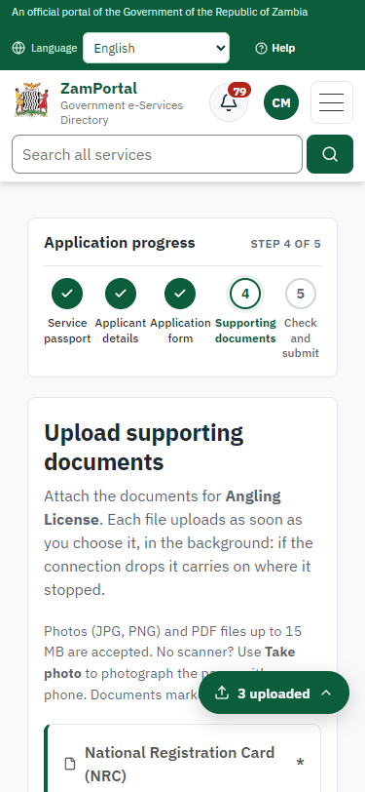
Step 5: Upload the supporting documents - desktop (left) and a 375 px phone (right).

Step 6. Check the answers and confirm the declaration
Citizen · National e-Services portal
Before sending, the citizen sees every answer and document on one page and can go back to change them. The declaration that the information is true and complete must be ticked.
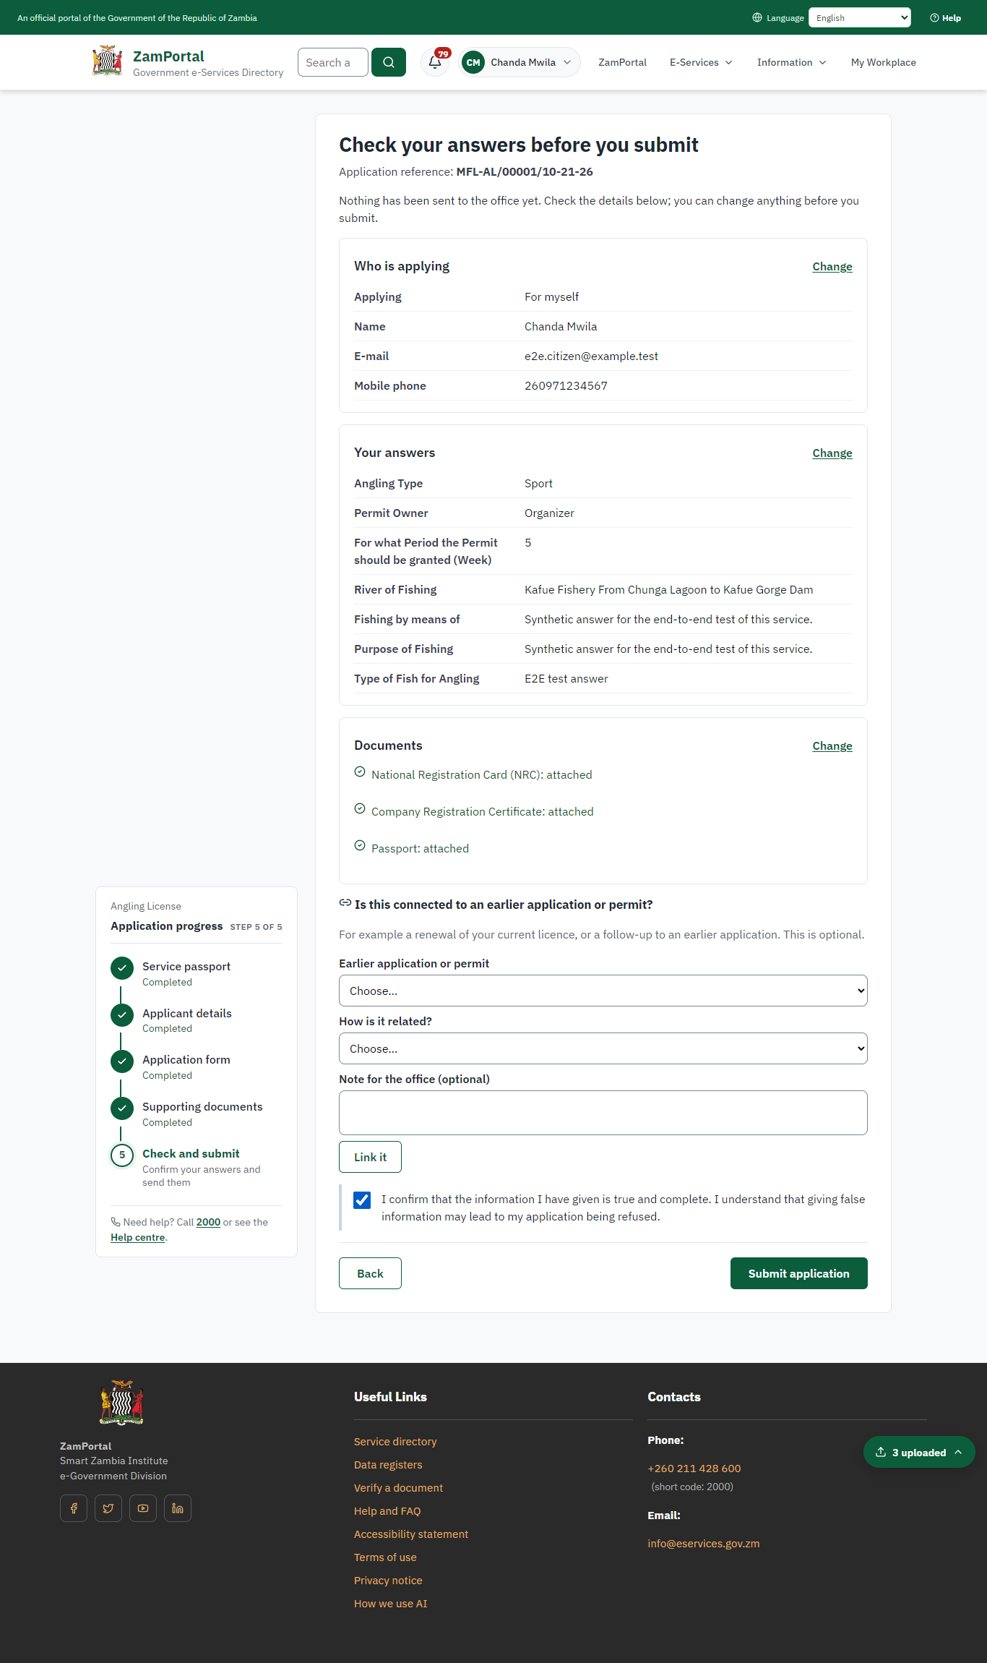 | 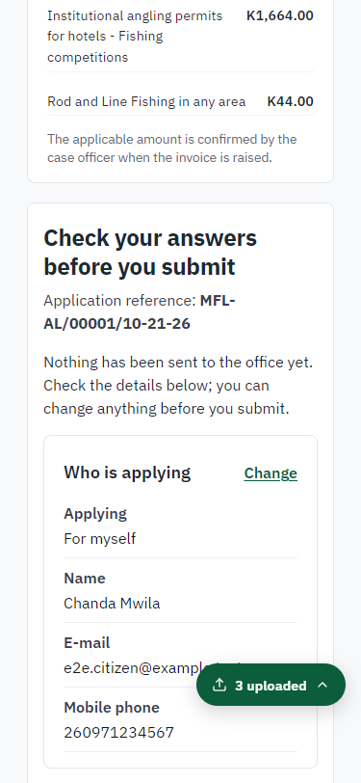
Step 6: Check the answers and confirm the declaration - desktop (left) and a 375 px phone (right).

Step 7. Application sent
Citizen · National e-Services portal
The portal confirms the application with the ministry's reference number (MFL-AL/00001/10-21-26 in this run). The application goes to the ministry's officers; the citizen follows it in My Workplace.
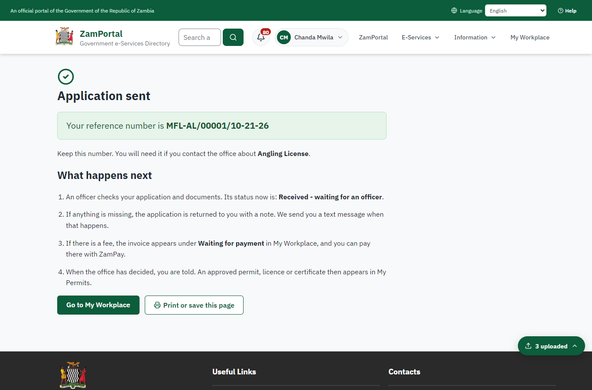 | 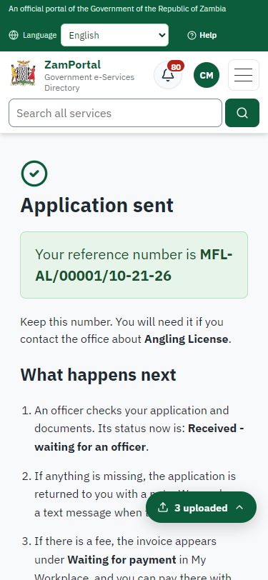
Step 7: Application sent - desktop (left) and a 375 px phone (right).

Step 8. Take the new application on
Case Officer · Back office
The application arrives in the case queue of the ministry that owns the service (Department of Fisheries); only its staff see it. The officer opens it by its reference number - answers, documents and process are on the case - assigns it to themself and takes it on.
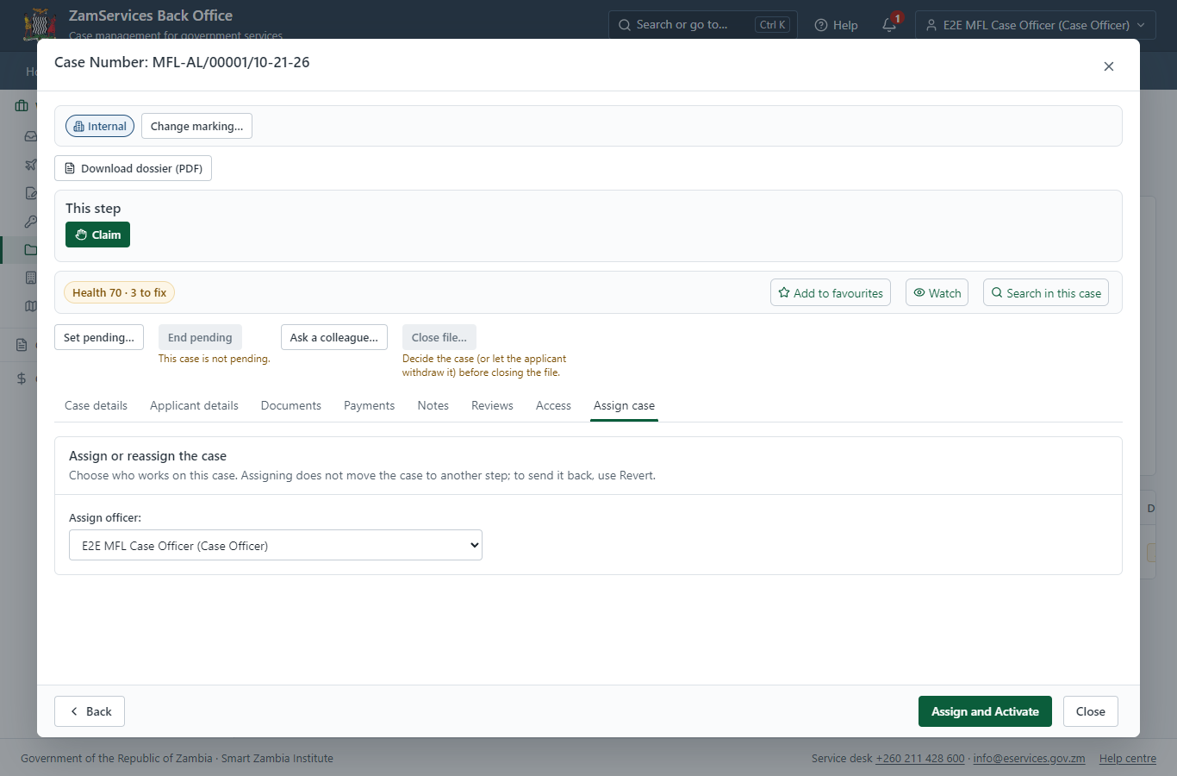
Step 8: Take the new application on.

Step 9. Work out the fee
Case Officer · Back office
The Case Officer works out the fee from the service's imported fee schedule ("Sport Fishing: • Sport Fishing (organisers) - 5555.20 ZMW • Sport Fishing (individual participants) - per event 600.00 ZMW Recreation Fishing: • Persons residen"). "Submit Fees and Advance" records it, raises a ZamPay invoice for the applicant and moves the case to payment.
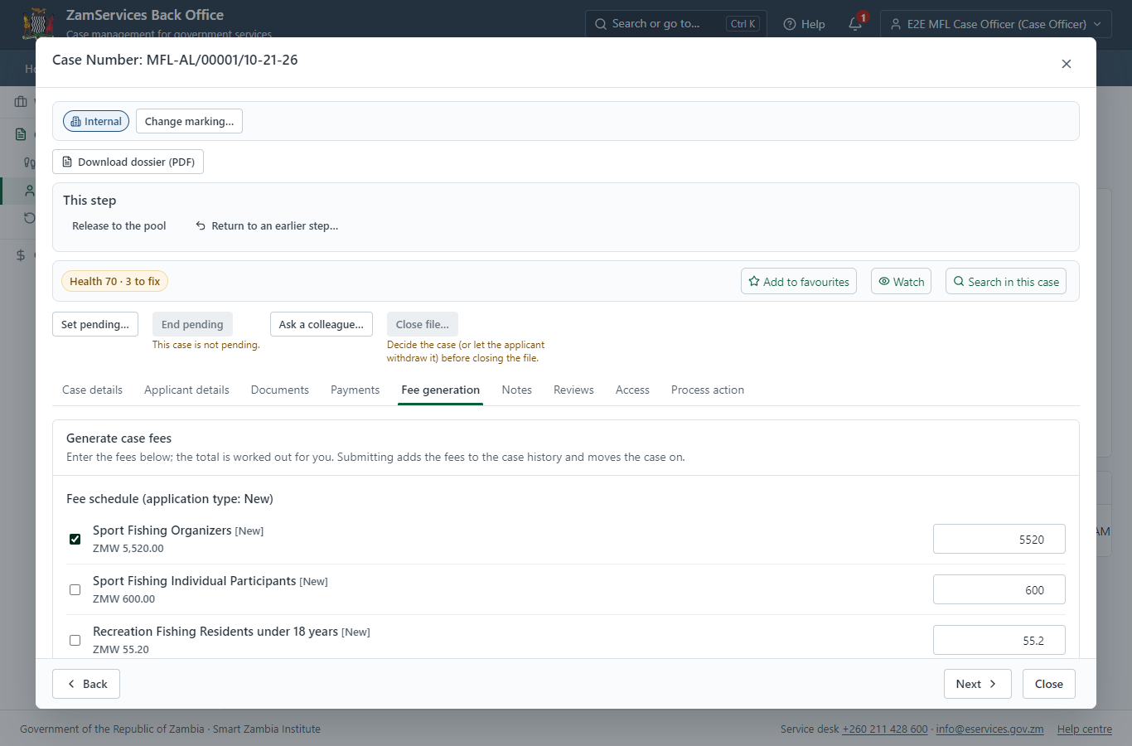
Step 9: Work out the fee.

Step 10. See that the fee is due
Citizen · National e-Services portal
The application shows "Waiting for your payment" in My Workplace with a Pay button (K5,520.00). The office priced the case; the invoice was raised on ZamPay.
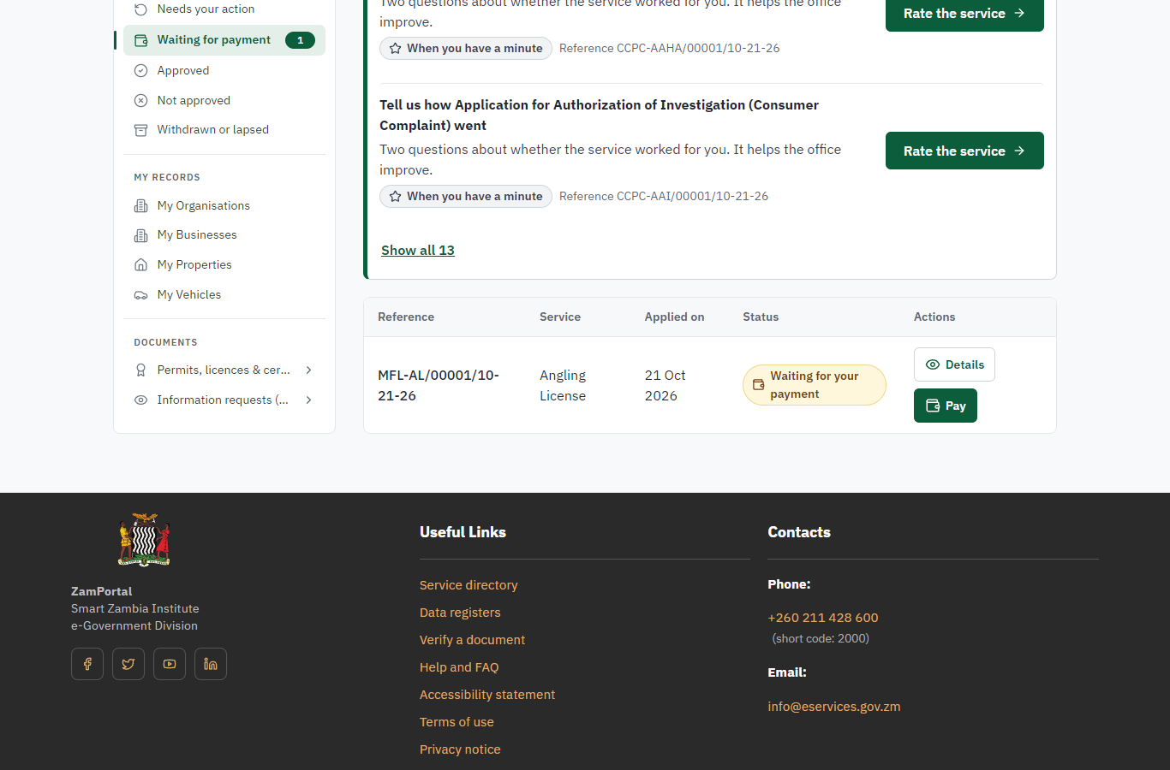 | 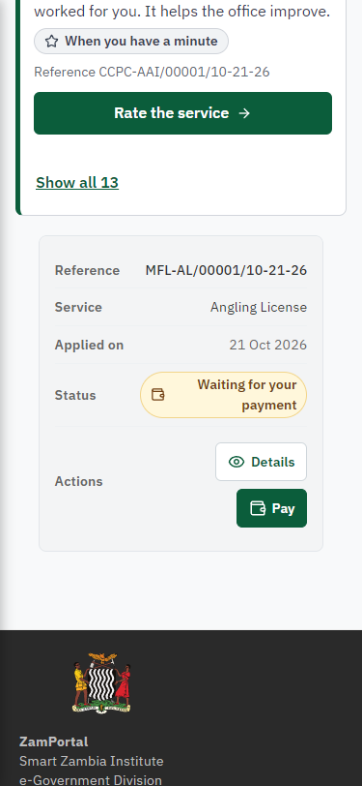
Step 10: See that the fee is due - desktop (left) and a 375 px phone (right).

Step 11. Pay with ZamPay
Citizen · National e-Services portal
Pay opens the invoice (K5,520.00, the amount set by the platform, never by the page) with its PDF preview; the citizen pays at ZamPay by mobile money or bank card.
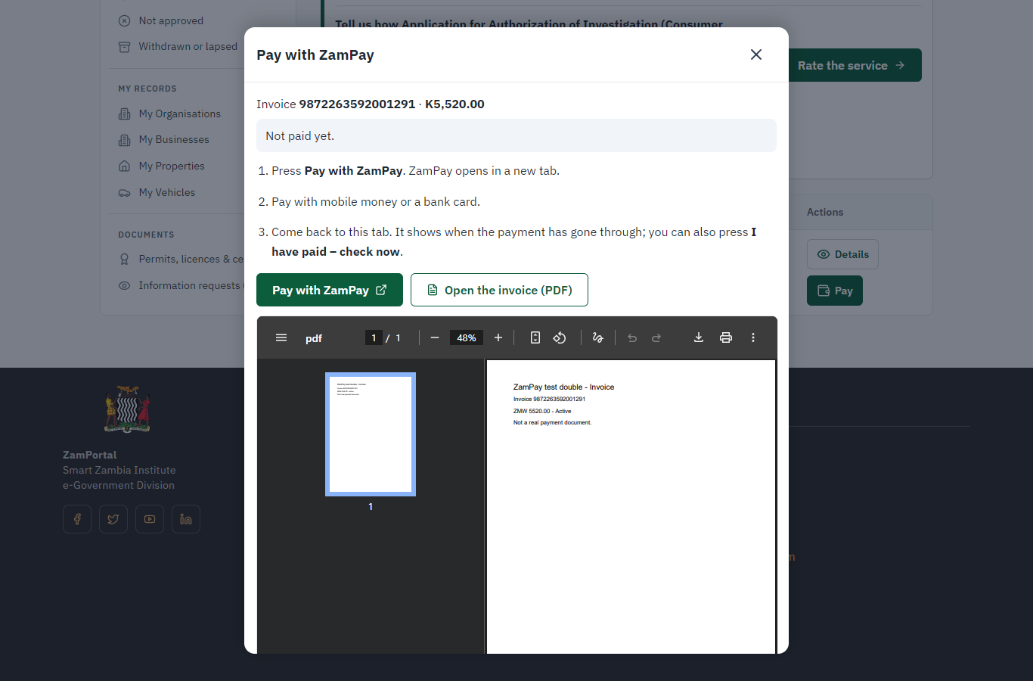 | 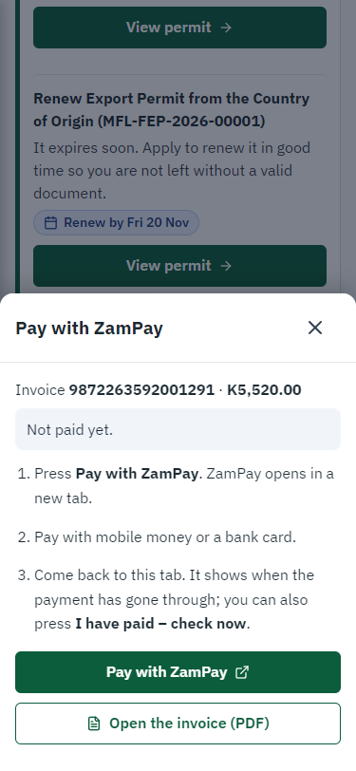
Step 11: Pay with ZamPay - desktop (left) and a 375 px phone (right).

Step 12. Payment received
Citizen · National e-Services portal
ZamPay reports the payment; the dialog says "Paid. Thank you" and the application moves on to the ministry's officers.
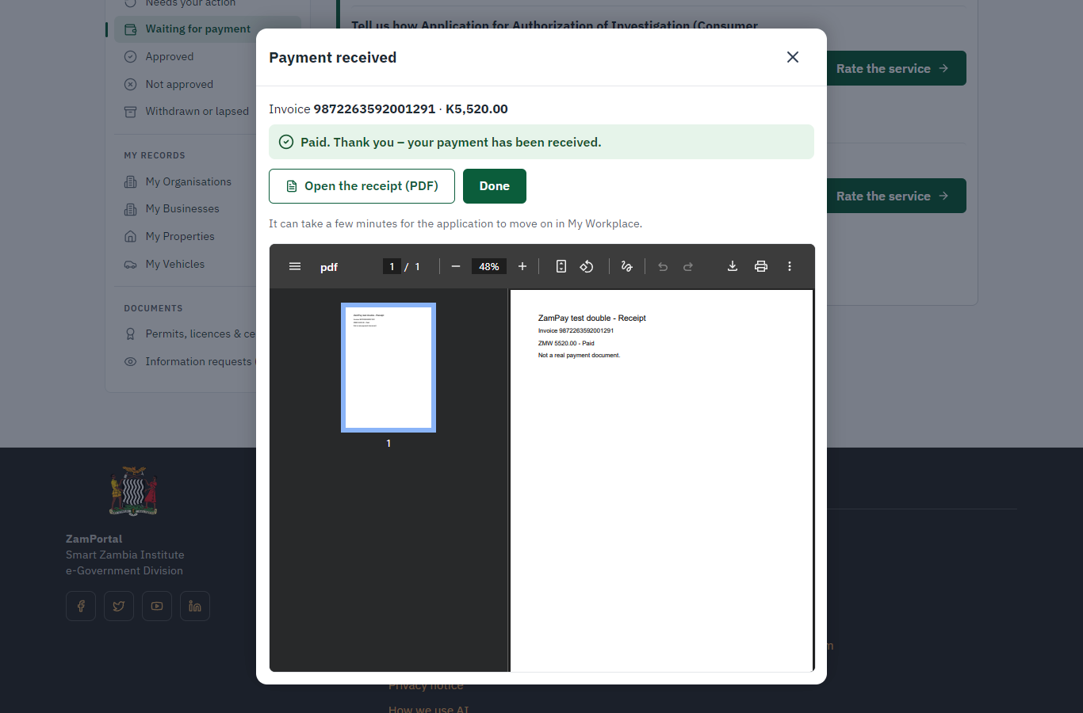 | 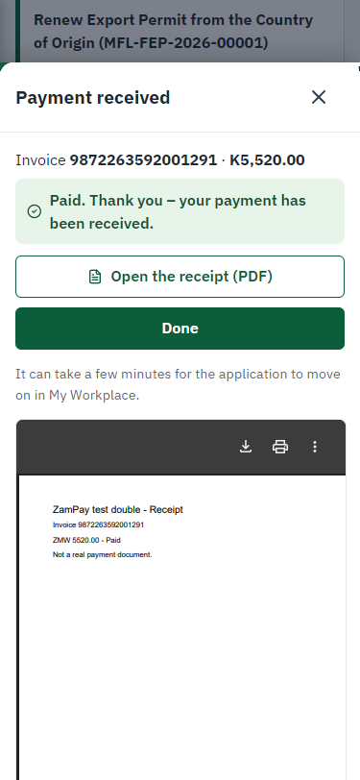
Step 12: Payment received - desktop (left) and a 375 px phone (right).

Step 13. Receive, Inspect, Report Findings
Case Officer · Back office
The Case Officer works on "Receive, Inspect, Report Findings" (review in the imported process), checks the application and its documents, and completes the step.
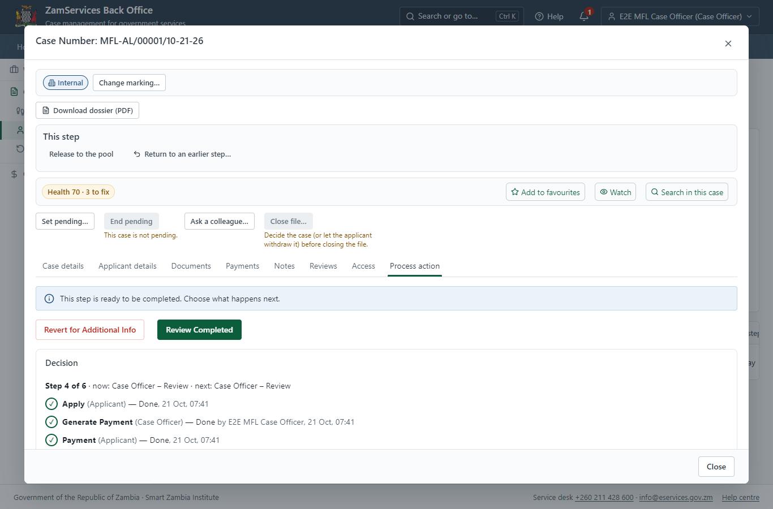
Step 13: Receive, Inspect, Report Findings.

Step 14. Draft Decision, Upload Document
Case Officer · Back office
The Case Officer works on "Draft Decision, Upload Document" (review in the imported process), checks the application and its documents, and completes the step.
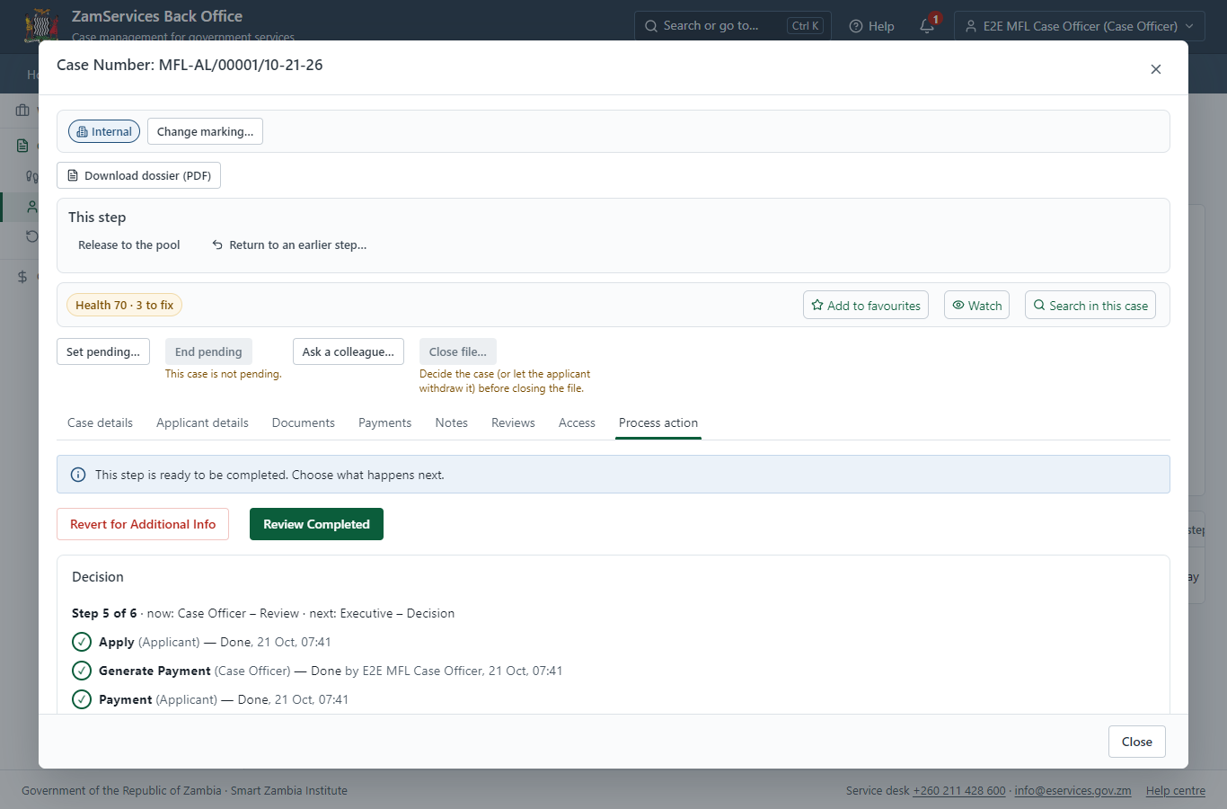
Step 14: Draft Decision, Upload Document.

Step 15. Decide: Review, Inspect, e-Sign
Executive · Back office
At "Review, Inspect, e-Sign" the Executive records the decision: approve, with a comment kept in the case history. Approving moves the case on; the last decision completes it and issues the document.
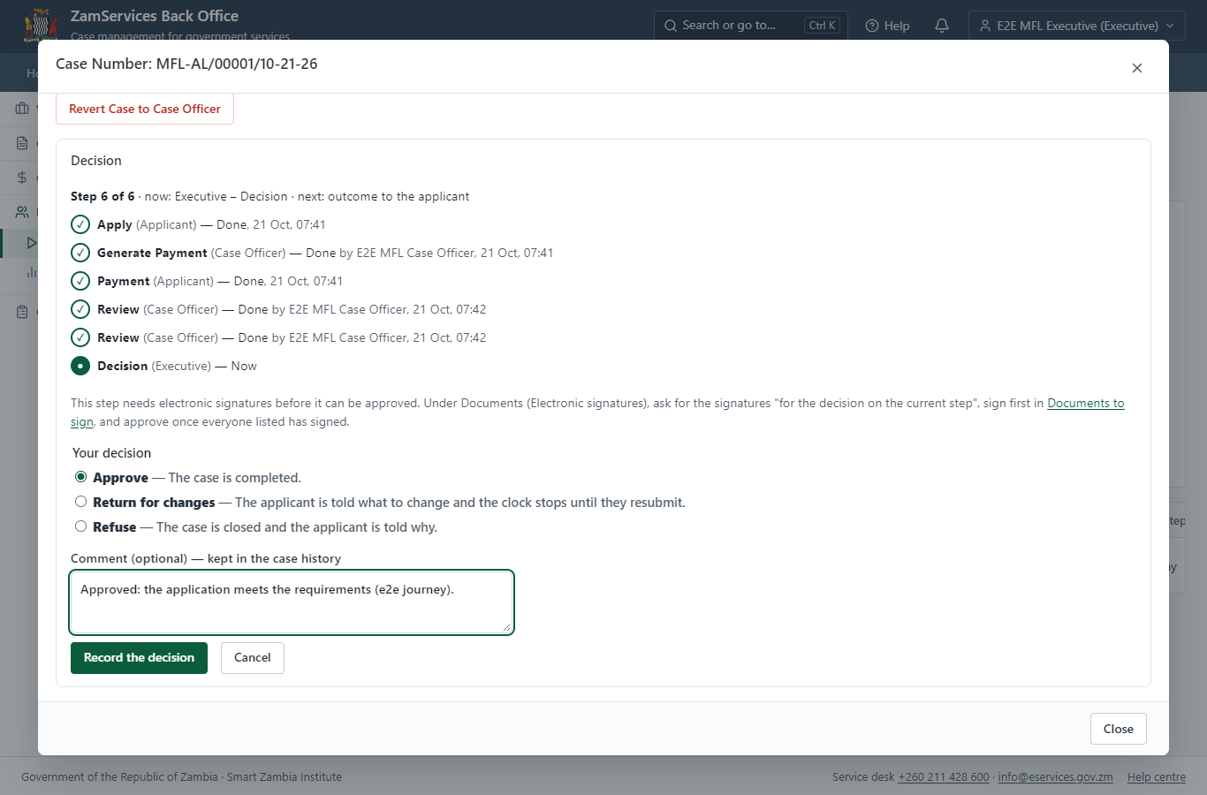
Step 15: Decide: Review, Inspect, e-Sign.

Step 16. Issue the document
Case Officer · Back office
The service's validity ("Varies on the purpose") is not a fixed period, so completing the case does not issue the document by itself: the officer issues it from the completed case ("Issue / check permit"). It is generated from the service's output configuration and sealed.
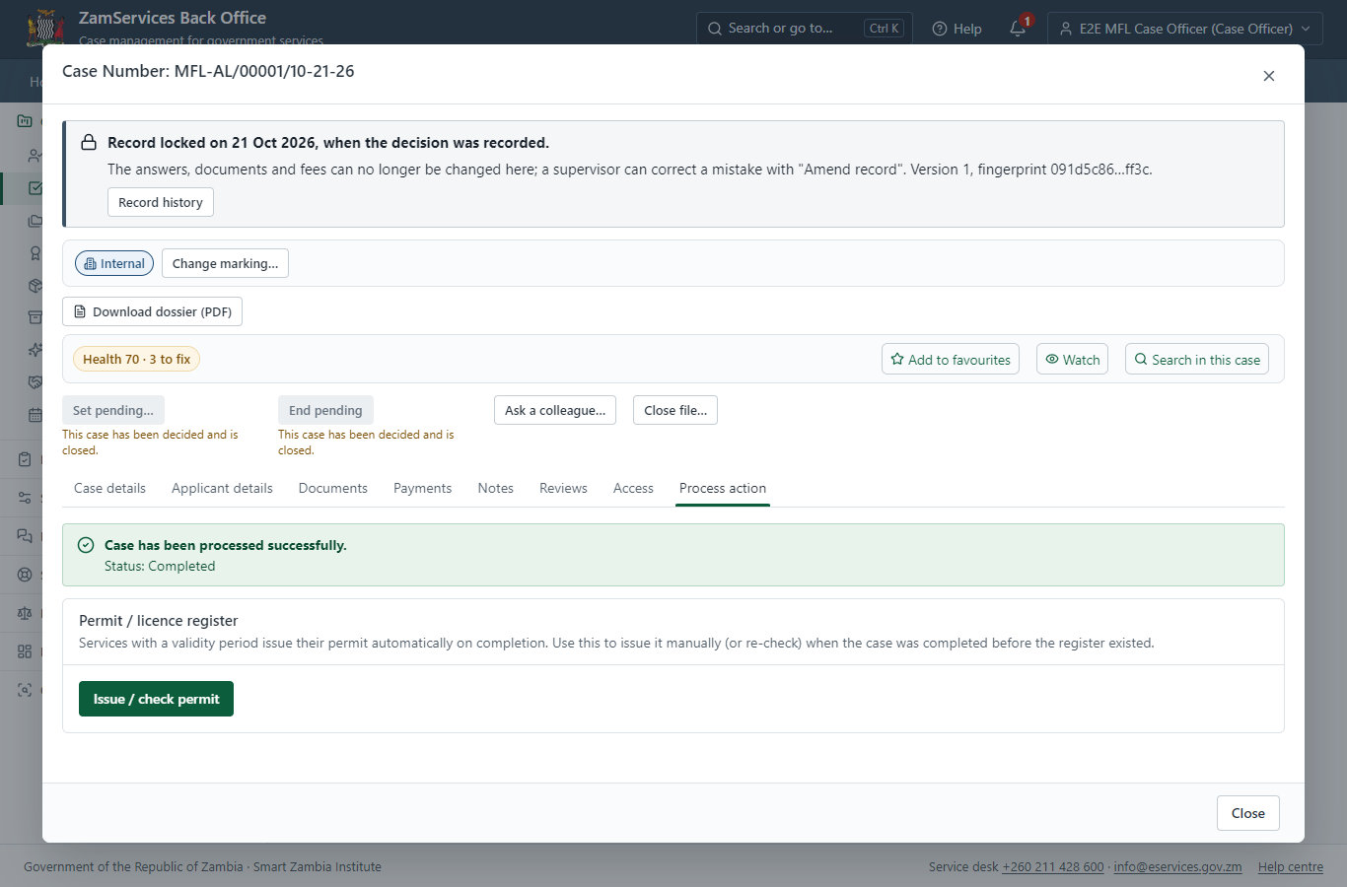
Step 16: Issue the document.

Step 17. The document in My permits
Citizen · National e-Services portal
The issued document (MFL-AL-2026-00001 in this run: "Certificate Angling License") is listed in "My permits and licences" with its validity and a download of the sealed PDF.
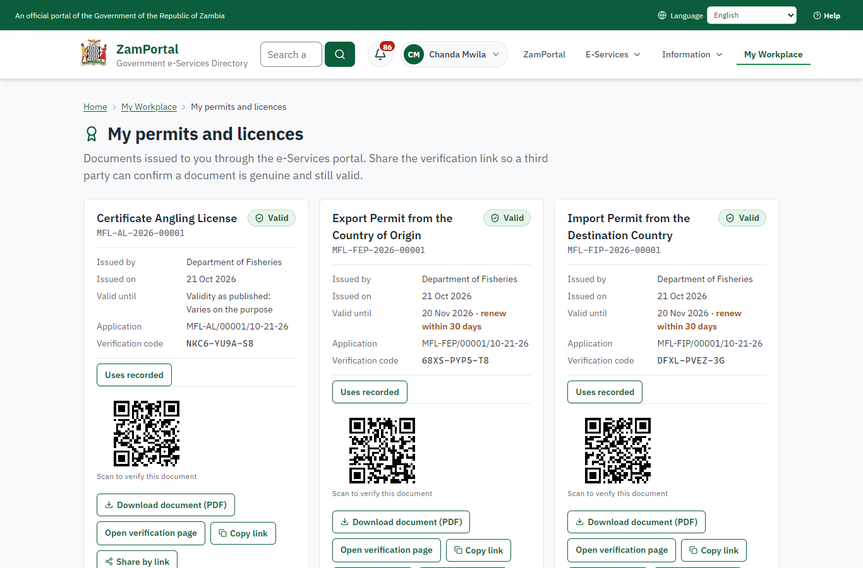 | 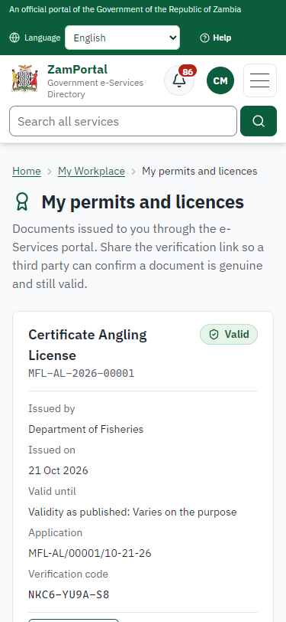
Step 17: The document in My permits - desktop (left) and a 375 px phone (right).

Step 18. Verify the document
Anyone (public) · Public verification page
The QR code on the document opens the public verification page: genuine and current, to whom it was issued, and whether the electronic seal is valid. No sign-in is needed.
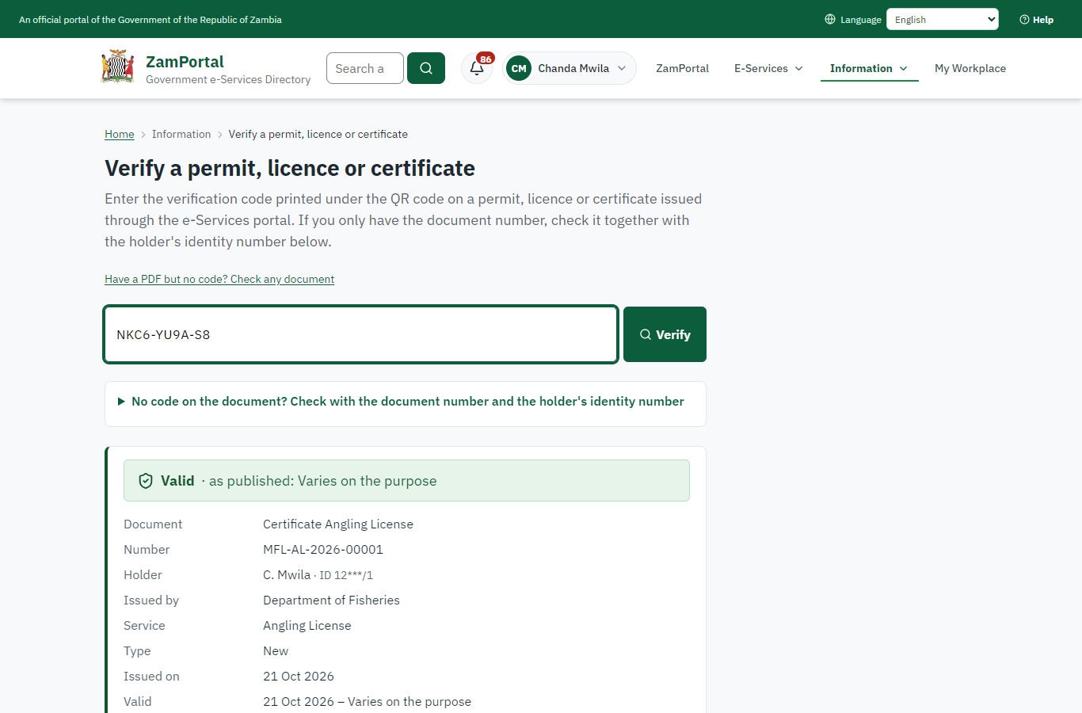 | 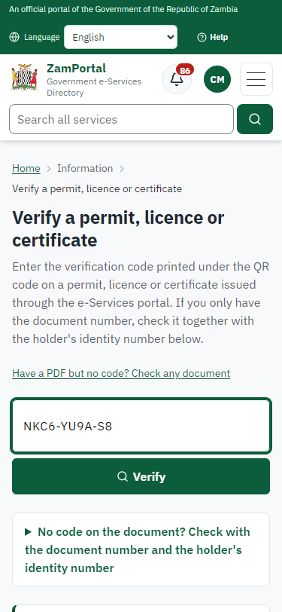
Step 18: Verify the document - desktop (left) and a 375 px phone (right).

3. Payment
Item | In the test run
Fee (as published) | Sport Fishing: • Sport Fishing (organisers) - 5555.20 ZMW • Sport Fishing (individual participants) - per event 600.00 ZMW Recreation Fishing: • Persons resident in Zambia i. Residents under 18 years ZMW 55.20 ii. Residents under 18 years ZMW 332.00 iii. Residents of 18 years and above ZMW 112.00 iv. Residents of 18 years and above ZMW 666.40 • Persons non-resident in Zambia - per month 1,120.00 ZMW Institutional angling permits: • lodges and camps - 3,880.00 ZMW • aquaculture facility - 1,120.00 ZMW Institutional angling permits for a hotel: • With a capacity of 20 beds - 4,880.00 ZMW • With a capacity of 21 beds or more - 6,080.00 ZMW • Fishing competitions - per week 1664.00 ZMW
Invoice 1 | 9872263592001291
Amount 1 | ZMW 5520.00
Paid at 1 | after "Work out the fee"
On screen: step 9 (Work out the fee), step 10 (See that the fee is due), step 11 (Pay with ZamPay), step 12 (Payment received) in section 2.

4. Output documents

Certificate Angling License (sealed PDF)
Issued when the case was approved, from the service's output configuration (service template MFL_AnglingLicense.Certificate.docx), filled from the application and the decision, sealed with the platform's electronic seal and stored as the issued version. The holder downloads it from My permits; the verification page checks it.
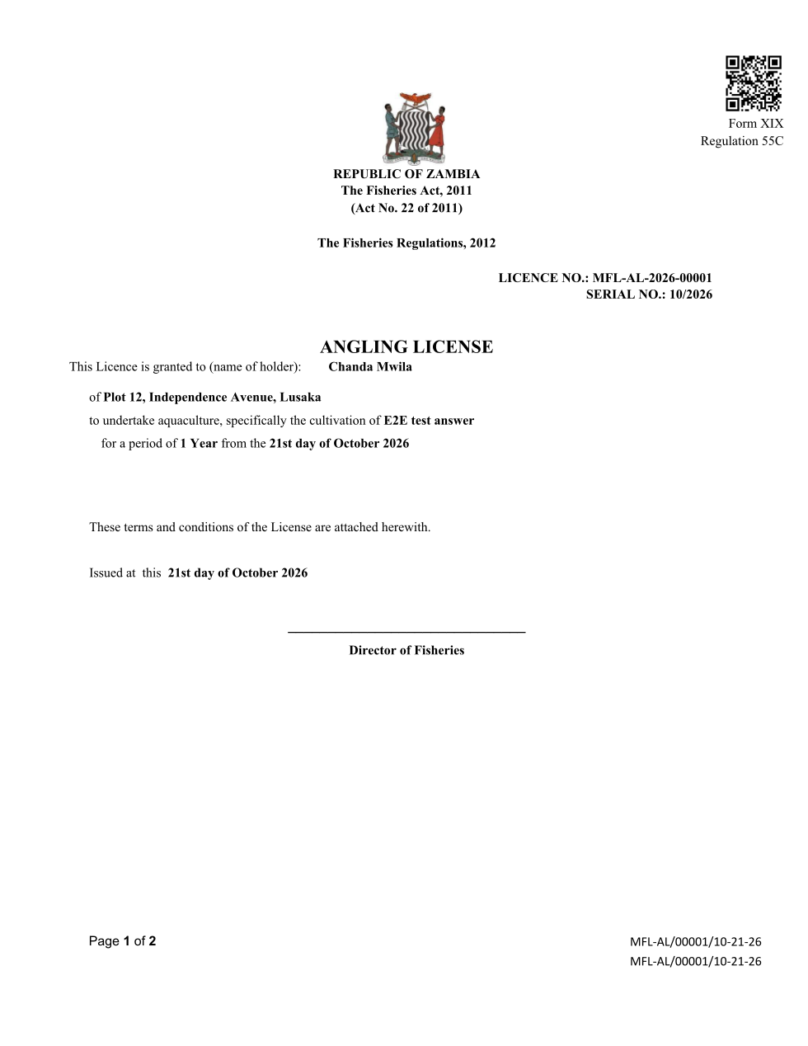
Certificate Angling License (sealed PDF) - first of 2 pages, as issued in the test run.

Fields
Field | Value in the test run
Document title | Certificate Angling License
Permit / licence number | MFL-AL-2026-00001
Holder | Chanda Mwila
Valid from | 2026-10-21
Valid until
Status | active
Verification code (printed with a QR code) | NKC6-YU9A-S8

Seal
Seal status | sealed
Signature level | PAdES-B-T
Sealed by | the platform seal (development key in the test run)
Signed at | 2026-10-21T05:42:43.576Z
Trusted time-stamp | 2026-10-21T05:42:43.549Z (time-stamping authority)
Document fingerprint (SHA-256) | f143cf3d256902e9...

Verification
Where | The public verification page of the national portal, <portal>/verify/<verification code>, opened by scanning the QR code on the document.
What it shows | Whether the document is genuine and current, its holder and validity, and whether the electronic seal is valid and who sealed it.
Checking a copy | Anyone can upload a PDF they were given; the page says whether it is exactly the document that was issued. A changed copy is reported as not matching.
On screen: step 16 (Issue the document), step 17 (The document in My permits), step 18 (Verify the document) in section 2.

5. Notifications
When | Channel | To | Message | Delivery
Application received | in-app (portal bell) | the applicant | Application MFL-AL/00001/10-21-26 received - Your application MFL-AL/00001/10-21-26 for Angling License has been received by Department of Fisheries. | shown
Status changed | in-app (portal bell) | the applicant | Update on application MFL-AL/00001/10-21-26 - MFL-AL/00001/10-21-26 (Angling License) is now: With the office - fees being worked out. | shown
Payment due (invoice raised) | in-app (portal bell) | the applicant | Payment due for application MFL-AL/00001/10-21-26 - The fee of ZMW 5520.00 for Angling License (MFL-AL/00001/10-21-26) is now due. Invoice 9872263592001291. | shown
Payment received | in-app (portal bell) | the applicant | Payment received for MFL-AL/00001/10-21-26 - Your payment of ZMW 5520.00 for MFL-AL/00001/10-21-26 (Angling License) has been received. Receipt: <ZamPay>/pdf?documentType=receipt&invoiceNumber=9872263592001291 | shown
Decision: approved | in-app (portal bell) | the applicant | Application MFL-AL/00001/10-21-26 completed - MFL-AL/00001/10-21-26 (Angling License) is complete. Your documents are ready. | shown
Invitation to rate the service | in-app (portal bell) | the applicant | How was Angling License? - How was Angling License? Tell us in about a minute. | shown
Licence / permit issued | in-app (portal bell) | the applicant | Your Angling License document has been issued - MFL-AL-2026-00001 has been issued for Angling License. | shown
Application received | sms | +260 97* *** 567 | Application MFL-AL/00001/10-21-26 for Angling License has been received. Track it: <portal>/my-workplace | delivered
Application received | email | e2e.c***@example.test | Application MFL-AL/00001/10-21-26 received | skipped
Status changed | sms | +260 97* *** 567 |  | delivered
Payment due (invoice raised) | sms | +260 97* *** 567 | Fee of ZMW 5520.00 due for MFL-AL/00001/10-21-26. Invoice 9872263592001291. Pay: <ZamPay>/pay-for-service/get-invoice/9872263592001291 | delivered
Payment due (invoice raised) | email | e2e.c***@example.test | Payment due for application MFL-AL/00001/10-21-26 | skipped
Payment received | sms | +260 97* *** 567 |  | delivered
Invitation to rate the service | sms | +260 97* *** 567 |  | skipped
Decision: approved | email | e2e.c***@example.test | Application MFL-AL/00001/10-21-26 completed | skipped
Invitation to rate the service | email | e2e.c***@example.test | How was Angling License? | skipped
Decision: approved | sms | +260 97* *** 567 |  | delivered
Licence / permit issued | email | e2e.c***@example.test | Your Angling License document has been issued | skipped
Licence / permit issued | sms | +260 97* *** 567 |  | delivered
Delivery: shown = in the portal's notification bell; delivered = the SMS gateway (a test double in this run) reported the text delivered; skipped = not sent on that channel (e-mail is not configured on the test installation, and some notices go out on one channel only); sent by the national portal = a ministry node handed the notice to the national portal, which texts and e-mails the citizen under its own name and the citizen's preferences. Addresses written <portal>, <ZamPay> stand for the national portal and ZamPay.

6. Legacy mapping
Replaces | Angling License in the legacy ZIGS e-Services directory (ZIGS_Services)
Legacy service id | 368
Legacy provider | Department of Fisheries (MFL) under Ministry of Fisheries and Livestock
Legacy process | FastTrackReview (process 4)
Fee in the legacy system | Sport Fishing Organizers: ZMW 5520 (New)  Sport Fishing Individual Participants: ZMW 600 (New)  Recreation Fishing Residents under 18 years: ZMW 55.2 (New)  Recreation Fishing Residents under 18 years: ZMW 332 (New)  Recreation Fishing Residents of 18 years and above: ZMW 112 (New)  Recreation Fishing Residents of 18 years and above: ZMW 666.4 (New)  Recreation Fishing Nonresidents: ZMW 1120 (New)  Institutional angling permits - Lodges and camps: ZMW 3880 (New)  Institutional angling permits - Aquaculture facility: ZMW 1120 (New)  Institutional angling permits for hotels - With a capacity of 20 beds: ZMW 4880 (New)  Institutional angling permits for hotels - With a capacity of 21 beds or more: ZMW 6080 (New)  Institutional angling permits for hotels - Fishing competitions: ZMW 1664 (New)  Rod and Line Fishing in any area: ZMW 44 (New)
Fee taken before submission | yes (as in ZIGS)
Time to issue (legacy) | New: 2 working days  Renewal: 3 working days
Legacy output templates | Application form (New): ZIGS_Forms_MFL / MFL_AnglingLicense.Application  Application form (Renewal): ZIGS_Forms_MFL / MFL_AnglingLicense_Renewal.Application  GS-2 Notice of Government Action: ZIGS_Forms_Notices / GS-2.NoticeOfAction  Certificate Angling License: ZIGS_Forms_MFL / MFL_AnglingLicense.Certificate  GF-1 Treasury Invoice: ZIGS_CustomForms / GF-1 Invoice  GF-2 Treasury Receipt: ZIGS_CustomForms / GF-2 Receipt
Legacy address | none recorded
How it was brought over | Imported by the platform's legacy catalogue importer (zcm-backend scripts/zigs/importLegacy.js) from the ZIGS snapshot: form, case types, fees, documents, process and output templates, then served by the new platform.

7. Version and date
Document version | service v1, platform a0a302b8
Generated | 2026-10-21T05:42:51Z (by the end-to-end run, not edited by hand)
Service version | not versioned (configured directly)
Platform snapshot | backend a0a302b8  portal 72805f0  back office 58e5946
Test suite | e2e 5999d9b; one installation (combined); seed profile mihud
Journeys | 30-catalogue-service.spec.js: citizen finds the service, answers its form, uploads its documents and sends the application - passed  30-catalogue-service.spec.js: the case goes through every step of its process: payments by the citizen, each officer step by its role - passed  30-catalogue-service.spec.js: the grant document is issued, sealed, filled in and verifiable; the citizen has it in My permits - passed
Result | 3 of 3 journey tests passed
Data | Synthetic test data on a local test installation; provider test doubles for ZamPass, ZamPay, SMS and signing.

