Republic of Zambia
GSB e-Services

Amendment of SEZ Operator Permit
Service documentation
Owner: Zambia Development Agency
Service key: ZDA/amendment-of-sez-operator-permit
Version: service v1, platform 55458ae2
Date: 2026-10-21
Generated automatically by the service's end-to-end test run. Every screenshot shows synthetic test data on a local test installation, never real personal data.

Contents
- 1. Service summary
- 2. Application process, step by step
- 3. Payment
- 4. Output documents
- 5. Notifications
- 6. Legacy mapping
- 7. Version and date
This document describes the Amendment of SEZ Operator Permit service of Zambia Development Agency as the platform runs it today. It is generated by the service's end-to-end test: every step was performed by the test and every screenshot was taken during that run, with synthetic data. Regenerate it with "npm run docs:services" in the e2e suite; do not edit it by hand.

1. Service summary
Service | Amendment of SEZ Operator Permit
Owner (MDA) | Zambia Development Agency (ZDA)
Purpose | This service involves the amendment of investment details. The SEZ Operator Permit is amendable in the following details: Project description/Sub sector, Project location, Company name, Committed investment amount. The Sector is not amendable.  Applicant can also request the conversion of the SEZ Operator Permit to an Investor Certificate. Applications may be submitted while the Permit is still valid.  Original paper Permit (shall be submitted to the selected office after application).
Who can apply | 1. National Registration Card (NRC).  2. Certificate of Incorporation.  3. Proof of Project Location.  4. Proof of Finance.  5. Detailed Business Plan (Using a ZDA prescribed guide).  6. Profiles of Promoters (Business Owners).
How to apply | Online on the national e-Services portal, signed in with ZamPass; pay with ZamPay.
Fees | Application Fee: ZMW 2844.40
Turnaround | 30 working days
Validity of the output | The validity period remains as earlier provided for in the original Permit
Required documents | National Registration Card (NRC). (required)  Certificate of Incorporation. (required)  Proof of Project Location. (required)  Proof of Finance. (required)  Detailed Business Plan (Using a ZDA prescribed guide). (required)  Profiles of Promoters (Business Owners). (required)
Output documents | SEZ Permit  GS3.Authorisation.Document  GS-1 Application for a Government Service  GS-2 Notice of Government Action

2. Application process, step by step

The process as configured
Step | Role | Task | Type
1 | Applicant | Apply | form
2 | Applicant | Payment | payment
3 | System | Generate Document | generate-document
4 | Case Officer | Review | review
5 | Case Officer | Review | review
6 | Supervisor | Review | review
7 | Supervisor | Approve | parallel-approval
8 | Executive | Approve | approve
9 | Executive | Decision | decision
10 | System | Generate Document | generate-document
11 | System | Notify Client | notify

Step by step
Who takes part in this journey: Citizen, Case Officer, Supervisor, Executive, Anyone (public). Citizen steps are shown on a desktop and on a 375 px phone; back-office steps on a desktop.

Step 1. Find the service
Citizen · National e-Services portal
On the national e-Services portal the citizen opens All Services and searches for the service by name ("Amendment of SEZ Operator Permit"). Each result names the service and the ministry that provides it.
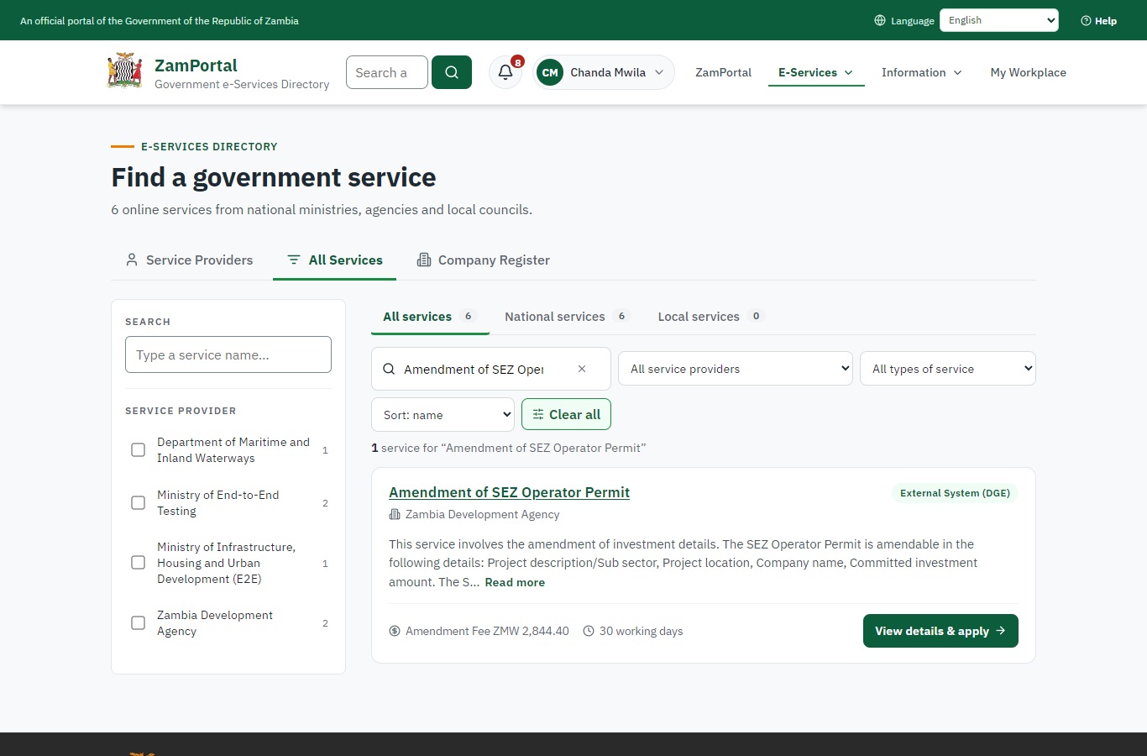 | 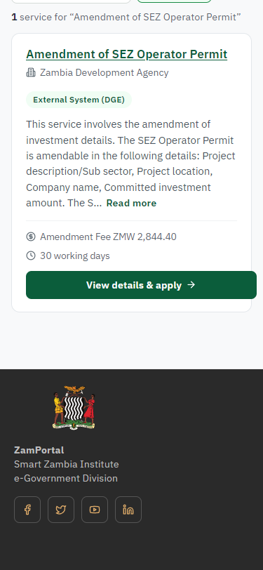
Step 1: Find the service - desktop (left) and a 375 px phone (right).

Step 2. Read the service page
Citizen · National e-Services portal
The service page sets out what the service is for, who provides it, the fee, how long it takes and the documents to have ready. "Start application" begins an application (the citizen is signed in with ZamPass).
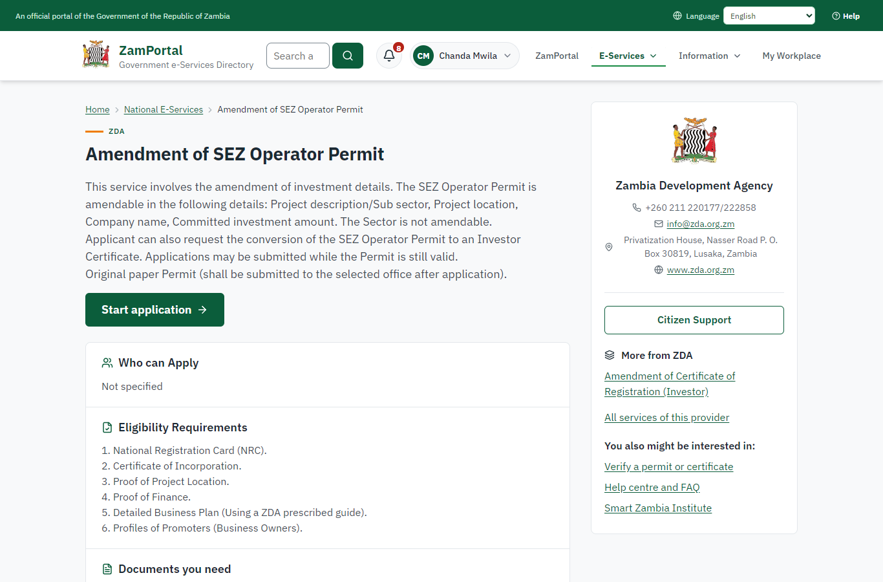 | 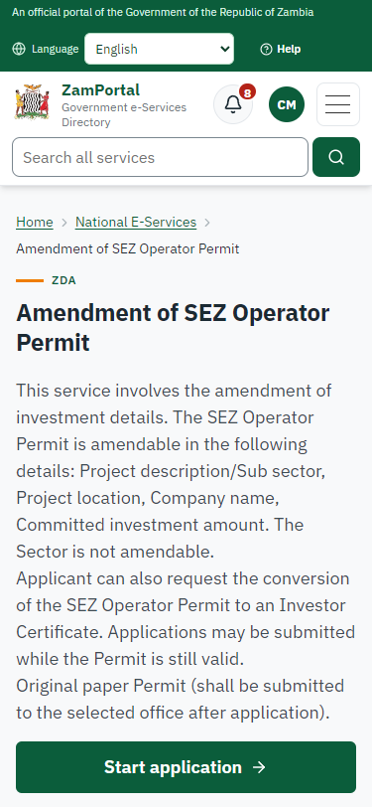
Step 2: Read the service page - desktop (left) and a 375 px phone (right).

Step 3. Confirm the applicant details
Citizen · National e-Services portal
The applicant details are filled in from the citizen's ZamPass account. The citizen says whom they are applying for (themself) and continues with "Proceed to Application".
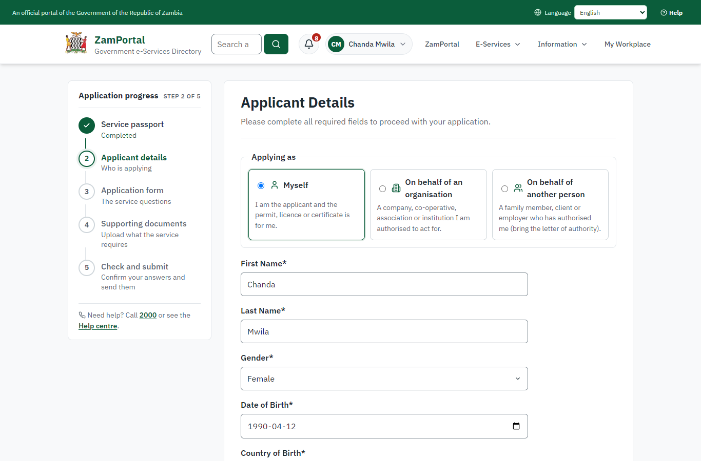 | 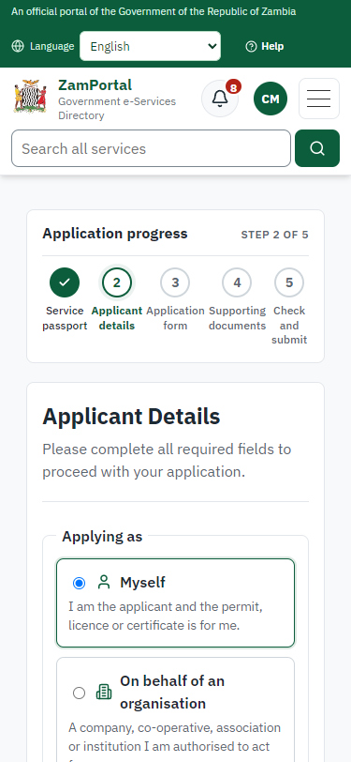
Step 3: Confirm the applicant details - desktop (left) and a 375 px phone (right).

Step 4. Fill in the application form
Citizen · National e-Services portal
The citizen answers the service's own application form, converted from the legacy system (114 answers in this run, all synthetic), for the type of application "Amendment". Questions marked * must be answered; some appear only after an earlier answer. Answers are saved as the citizen types, so an unfinished application can be reopened from My Workplace.
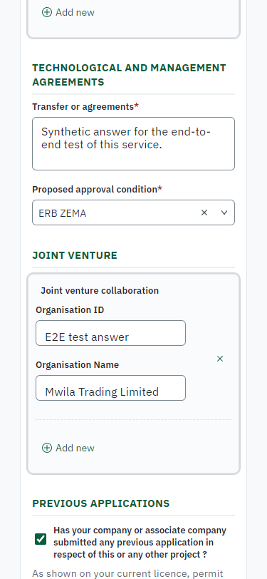
Step 4: Fill in the application form - desktop (left) and a 375 px phone (right).

Step 5. Upload the supporting documents
Citizen · National e-Services portal
Each document the service asks for has its own upload (6 in this run: National Registration Card (NRC)., Certificate of Incorporation., Proof of Project Location., Proof of Finance., Detailed Business Plan (Using a ZDA prescribed guide)., Profiles of Promoters (Business Owners).). The files are checked and stored with the application; the page confirms each upload.
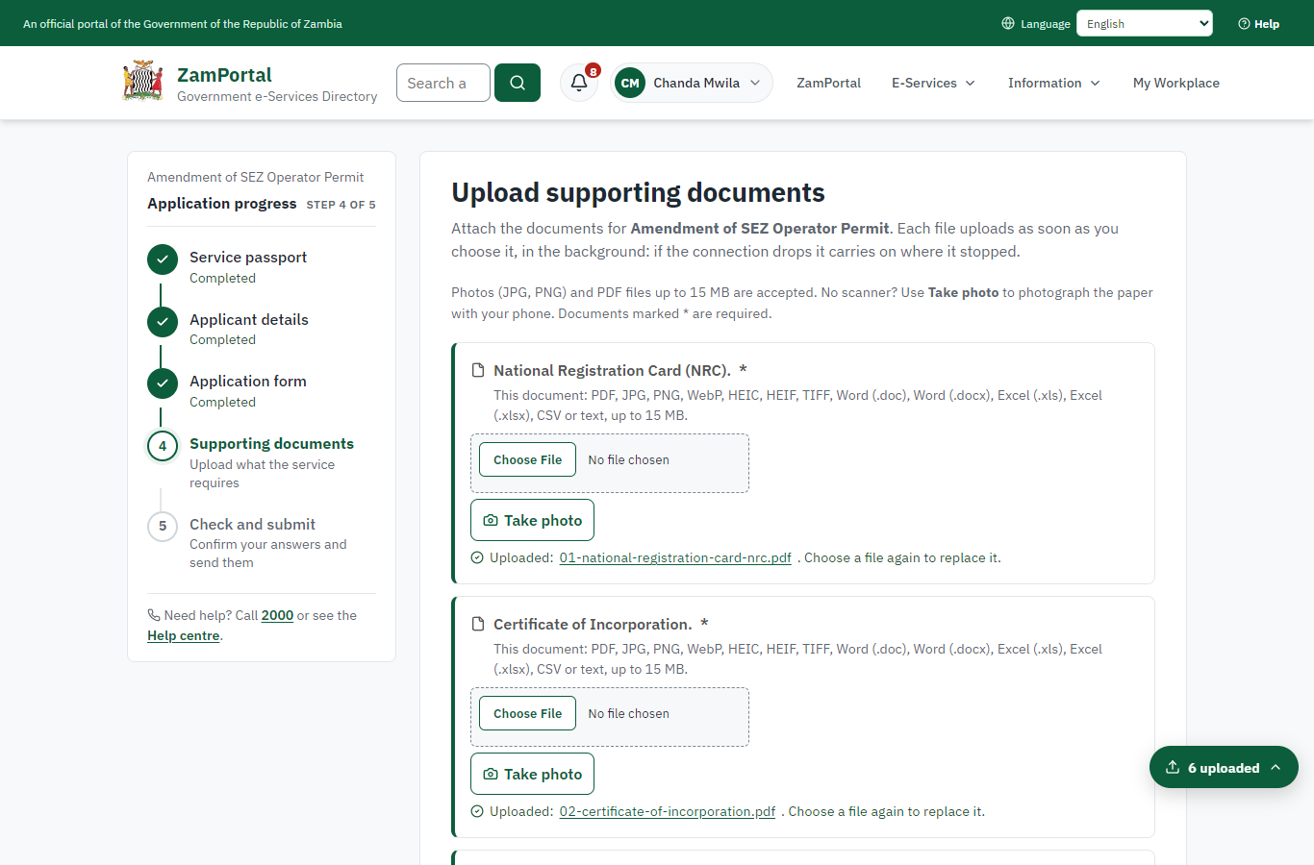 | 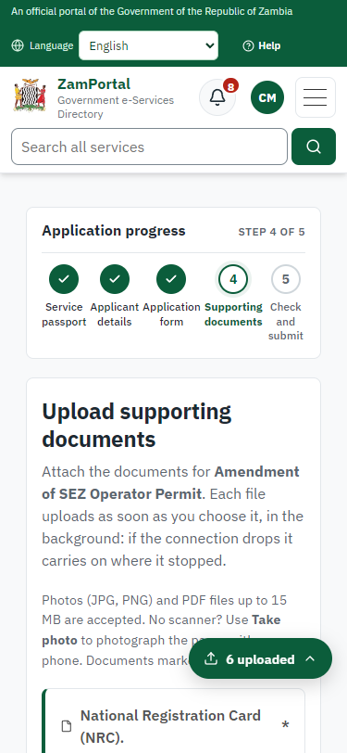
Step 5: Upload the supporting documents - desktop (left) and a 375 px phone (right).

Step 6. Check the answers and confirm the declaration
Citizen · National e-Services portal
Before sending, the citizen sees every answer and document on one page and can go back to change them. The declaration that the information is true and complete must be ticked.
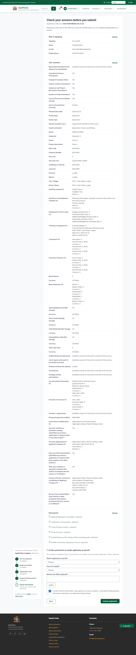 | 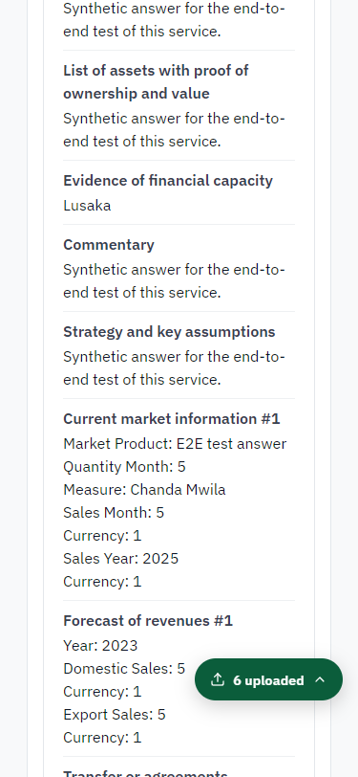
Step 6: Check the answers and confirm the declaration - desktop (left) and a 375 px phone (right).

Step 7. Application sent
Citizen · National e-Services portal
The portal confirms the application with the ministry's reference number (ZDA-ASOP/00001/10-21-26 in this run). The fee is due now: it is taken with the application, so the invoice was raised when the application was sent.
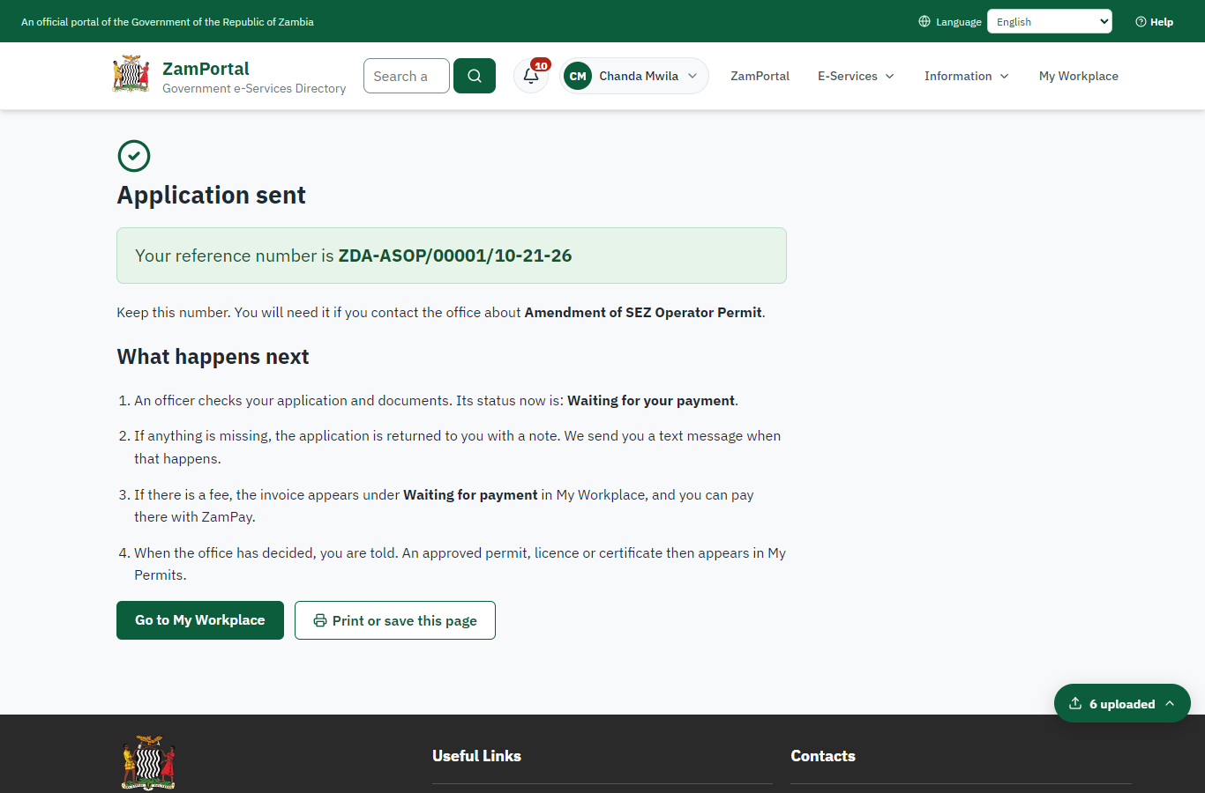 | 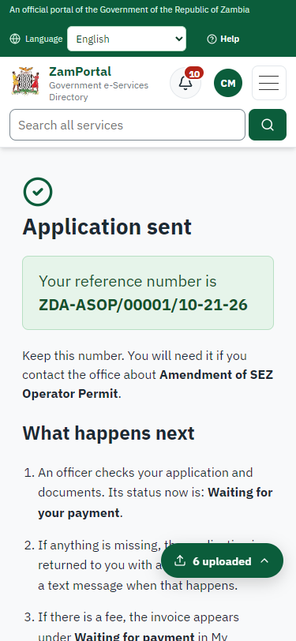
Step 7: Application sent - desktop (left) and a 375 px phone (right).

Step 8. See that the fee is due
Citizen · National e-Services portal
The application shows "Waiting for your payment" in My Workplace with a Pay button (K2,844.40). The fee is taken with the application; the invoice was raised on ZamPay.
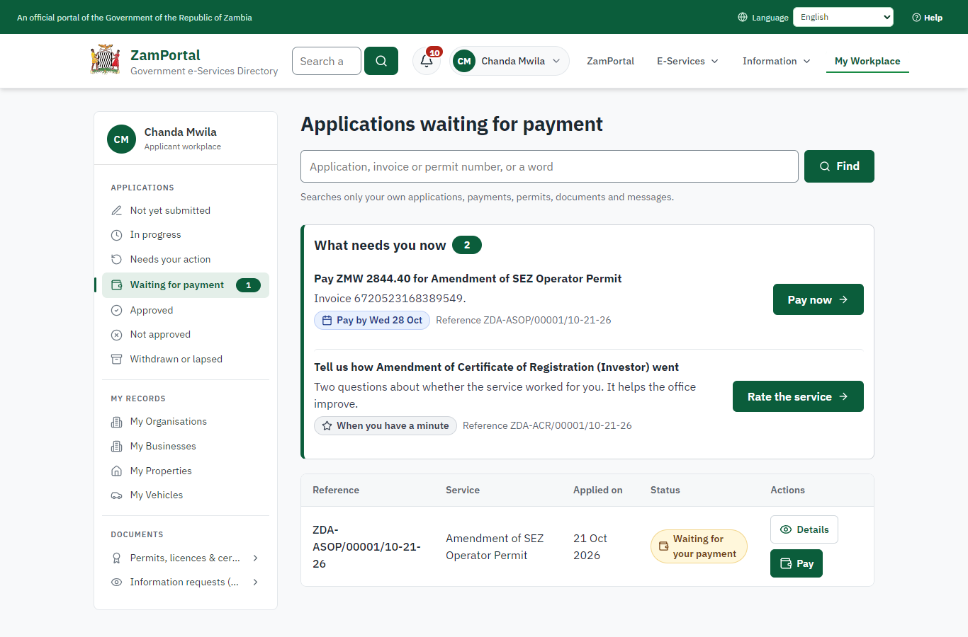 | 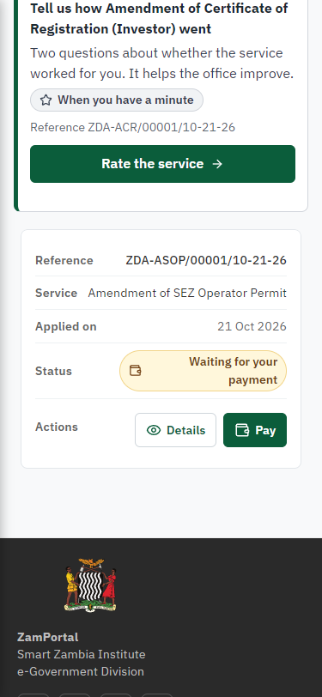
Step 8: See that the fee is due - desktop (left) and a 375 px phone (right).

Step 9. Pay with ZamPay
Citizen · National e-Services portal
Pay opens the invoice (K2,844.40, the amount set by the platform, never by the page) with its PDF preview; the citizen pays at ZamPay by mobile money or bank card.
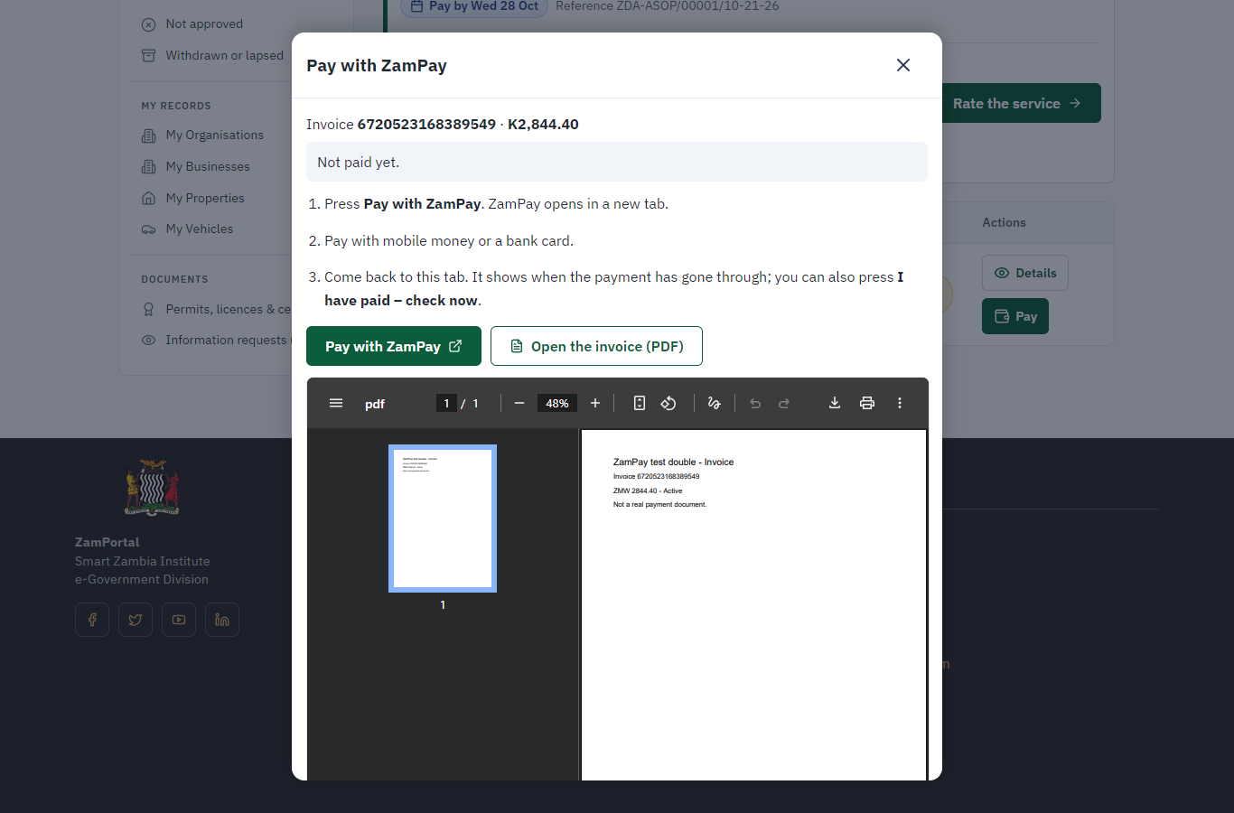 | 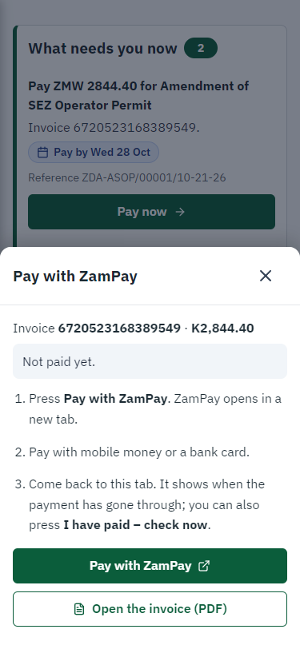
Step 9: Pay with ZamPay - desktop (left) and a 375 px phone (right).

Step 10. Payment received
Citizen · National e-Services portal
ZamPay reports the payment; the dialog says "Paid. Thank you" and the application moves on to the ministry's officers.
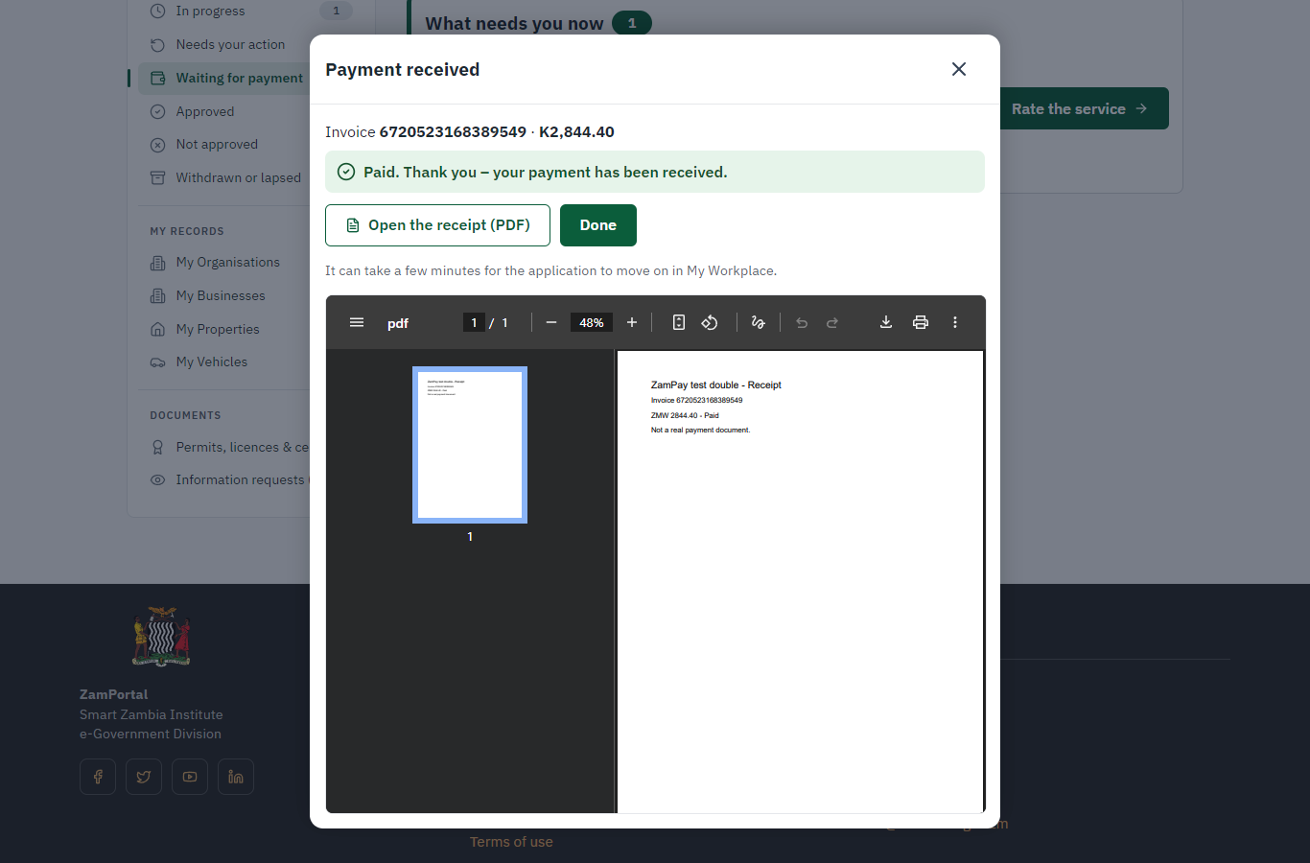 | 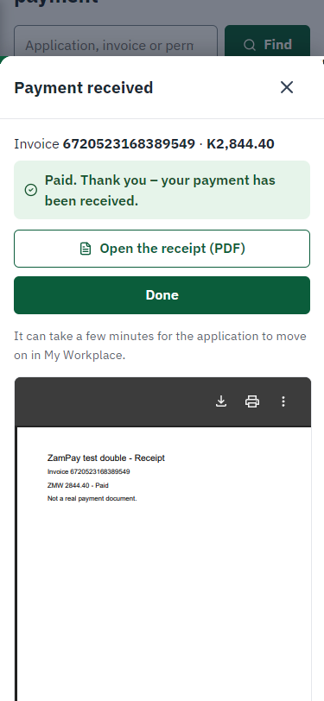
Step 10: Payment received - desktop (left) and a 375 px phone (right).

Step 11. Take the new application on
Case Officer · Back office
The application arrives in the case queue of the ministry that owns the service (Zambia Development Agency); only its staff see it. The officer opens it by its reference number - answers, documents and process are on the case - assigns it to themself and takes it on.
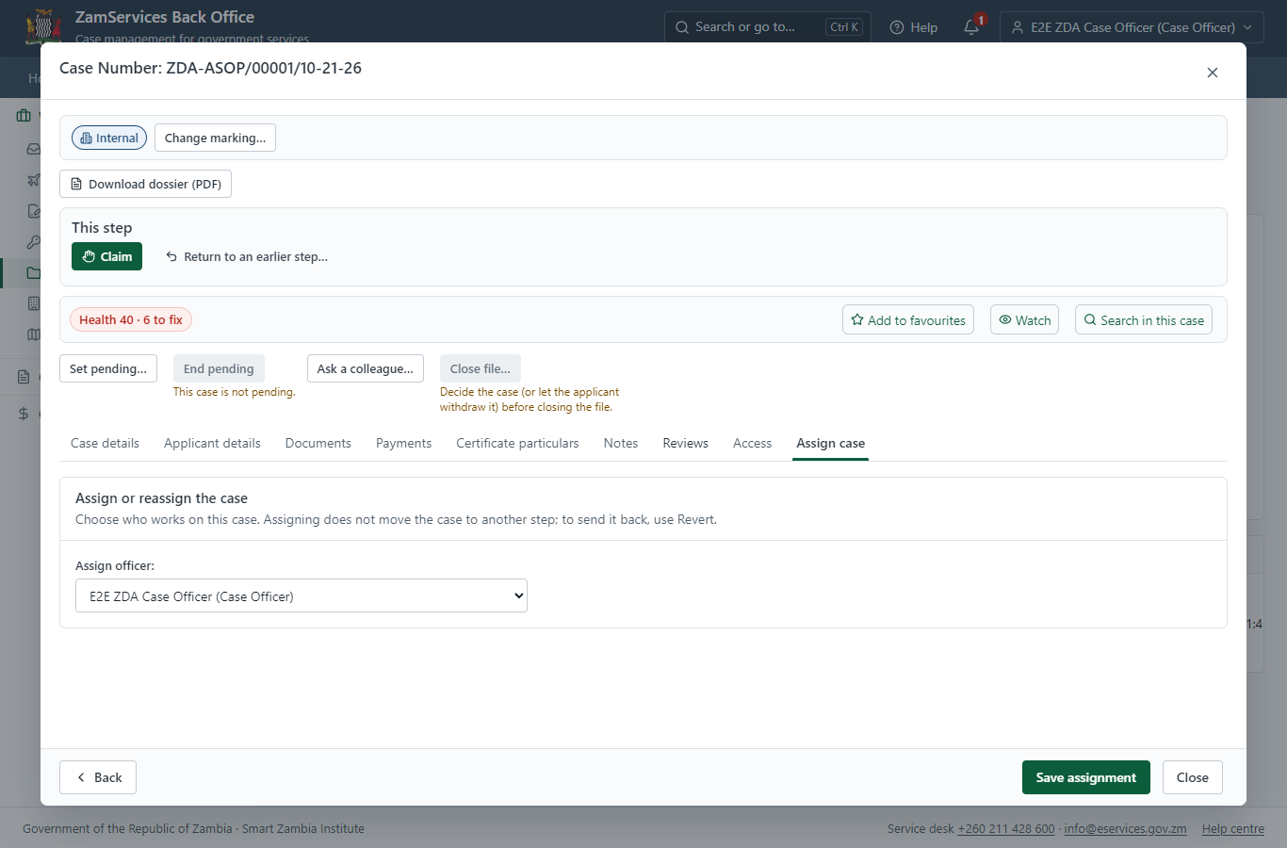
Step 11: Take the new application on.

Step 12. Fill in the certificate particulars
Case Officer · Back office
The issued document prints 5 fields that come from the office rather than from the application (Legal reference, Total project cost, Postal address line, Total project currency, Permit intro text template). The officer fills them in on the case's "Certificate particulars" tab before the document is issued (synthetic values in this run) and saves; once the document is issued they can no longer change.
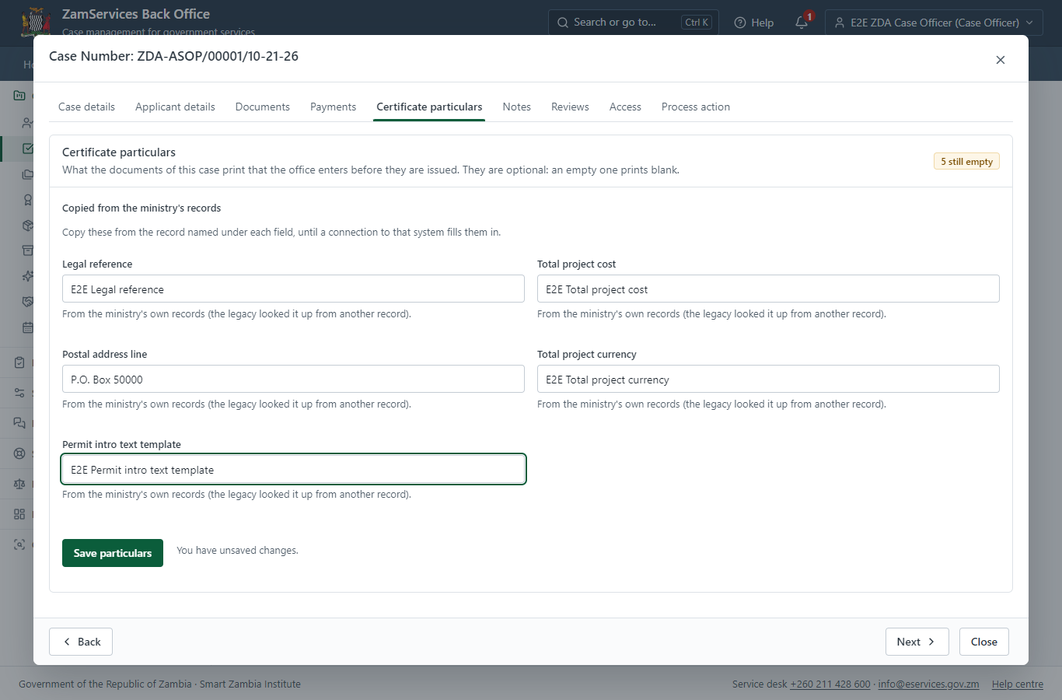
Step 12: Fill in the certificate particulars.

Step 13. Check for Accuracy
Case Officer · Back office
The Case Officer works on "Check for Accuracy" (review in the imported process), checks the application and its documents, and completes the step.
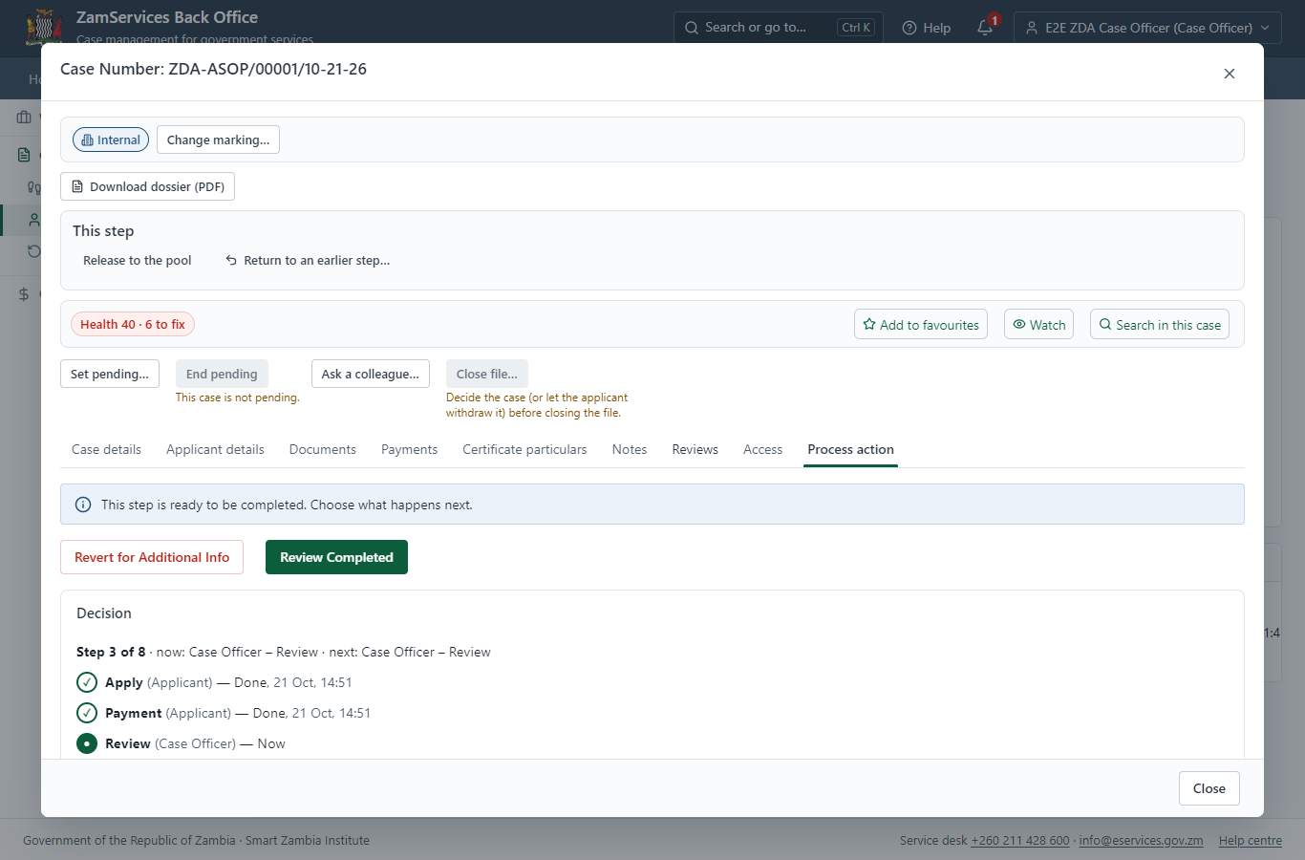
Step 13: Check for Accuracy.

Step 14. Expert consultation: Review Internal Report
Case Officer · Back office
The Case Officer works on "Expert consultation: Review Internal Report" (review in the imported process), checks the application and its documents, and completes the step.
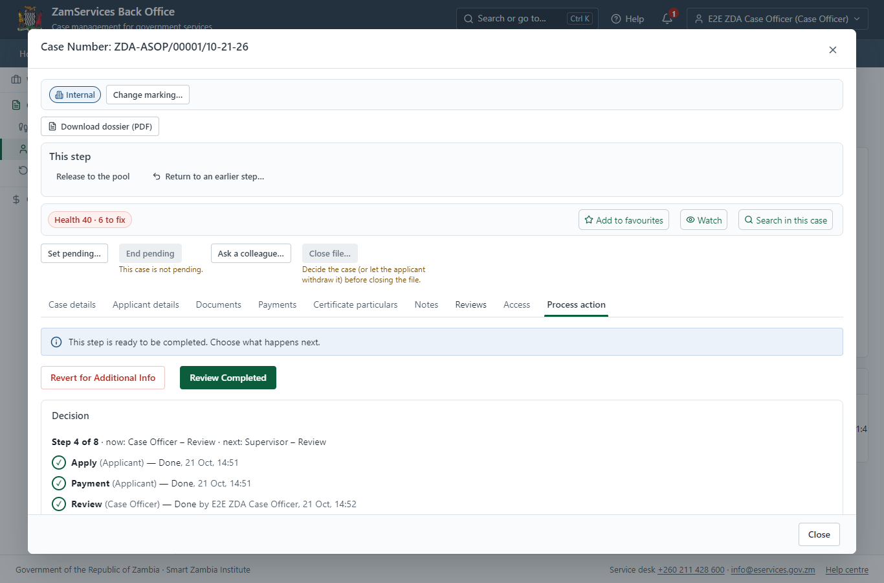
Step 14: Expert consultation: Review Internal Report.

Step 15. Review Internal Report
Supervisor · Back office
The Supervisor works on "Review Internal Report" (review in the imported process), checks the application and its documents, and completes the step.
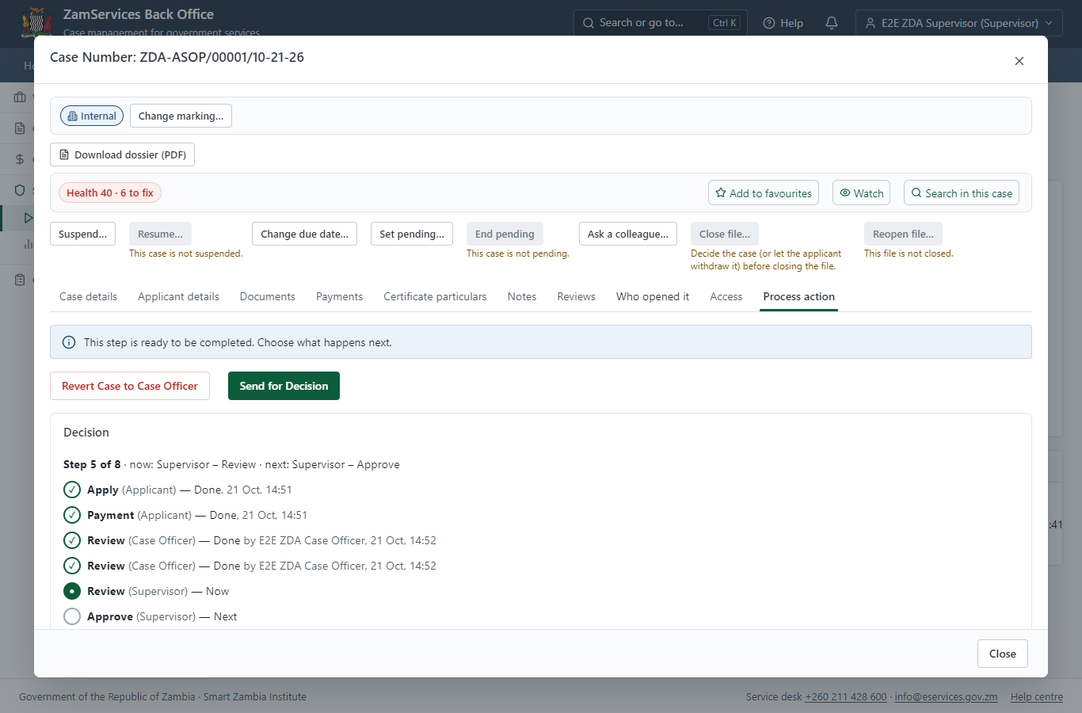
Step 15: Review Internal Report.

Step 16. Committee: Approve & E-sign Internal Report
Supervisor · Back office
"Approve & E-sign Internal Report" is a committee step: the members named by the process (Committee member 1, Committee member 2, Committee member 3) each record a vote on their own task under "This step"; the step completes when its rule (quorum, quorum 2) is met. Each member is a different officer.
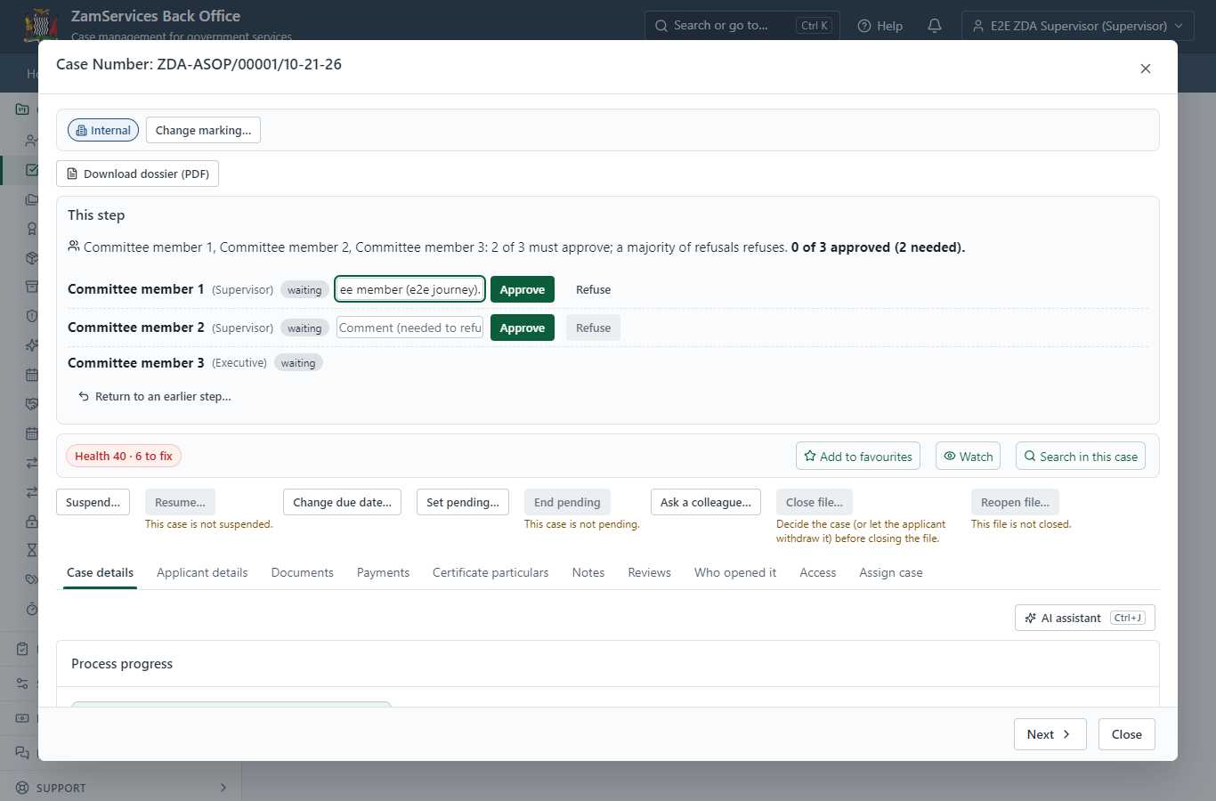
Step 16: Committee: Approve & E-sign Internal Report.

Step 17. Decide: Board Secretary E-sign Generated Document
Executive · Back office
At "Board Secretary E-sign Generated Document" the Executive records the decision: approve, with a comment kept in the case history. Approving moves the case on; the last decision completes it and issues the document.
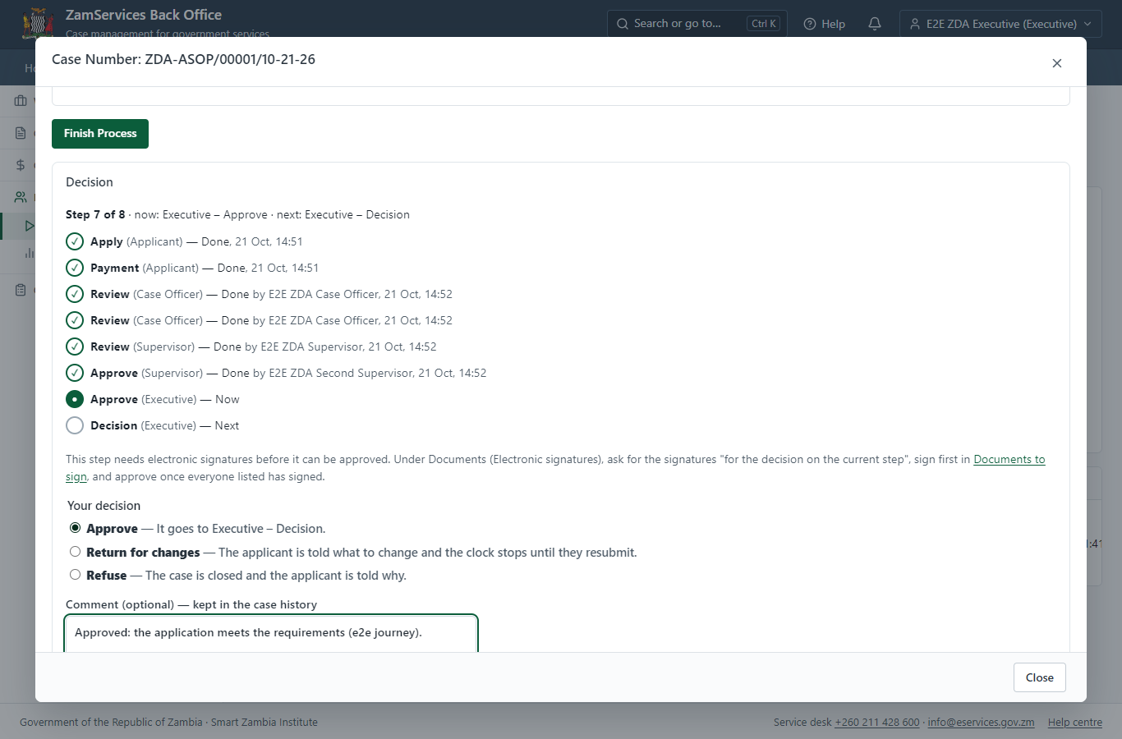
Step 17: Decide: Board Secretary E-sign Generated Document.

Step 18. Decide: Director General E-sign Document
Executive · Back office
At "Director General E-sign Document" the Executive records the decision: approve, with a comment kept in the case history. Approving moves the case on; the last decision completes it and issues the document.
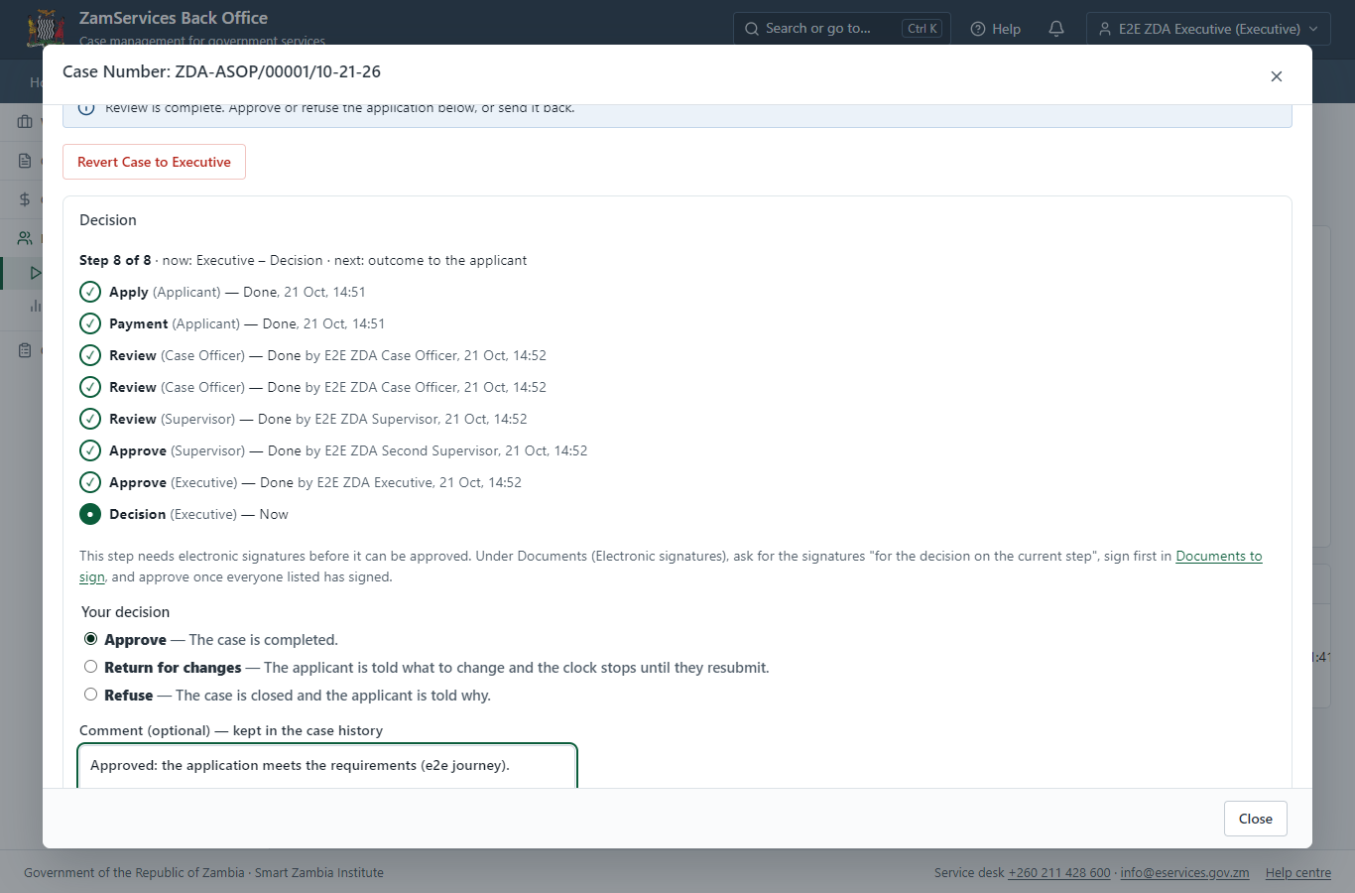
Step 18: Decide: Director General E-sign Document.

Step 19. Issue the document
Case Officer · Back office
The service's validity ("The validity period remains as earlier provided for in the original Permit") is not a fixed period, so completing the case does not issue the document by itself: the officer issues it from the completed case ("Issue / check permit"). It is generated from the service's output configuration and sealed.
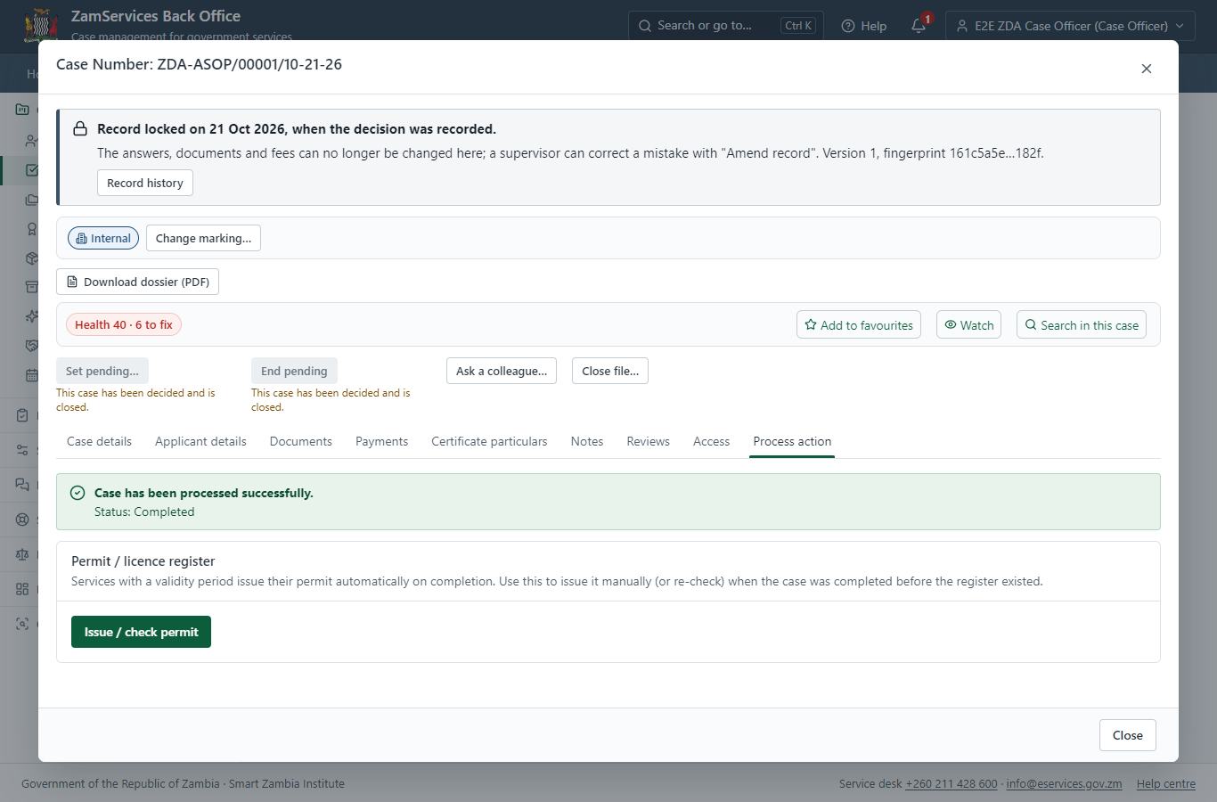
Step 19: Issue the document.

Step 20. The document in My permits
Citizen · National e-Services portal
The issued document (ZDA-ASOP-2026-00001 in this run: "SEZ Permit") is listed in "My permits and licences" with its validity and a download of the sealed PDF.
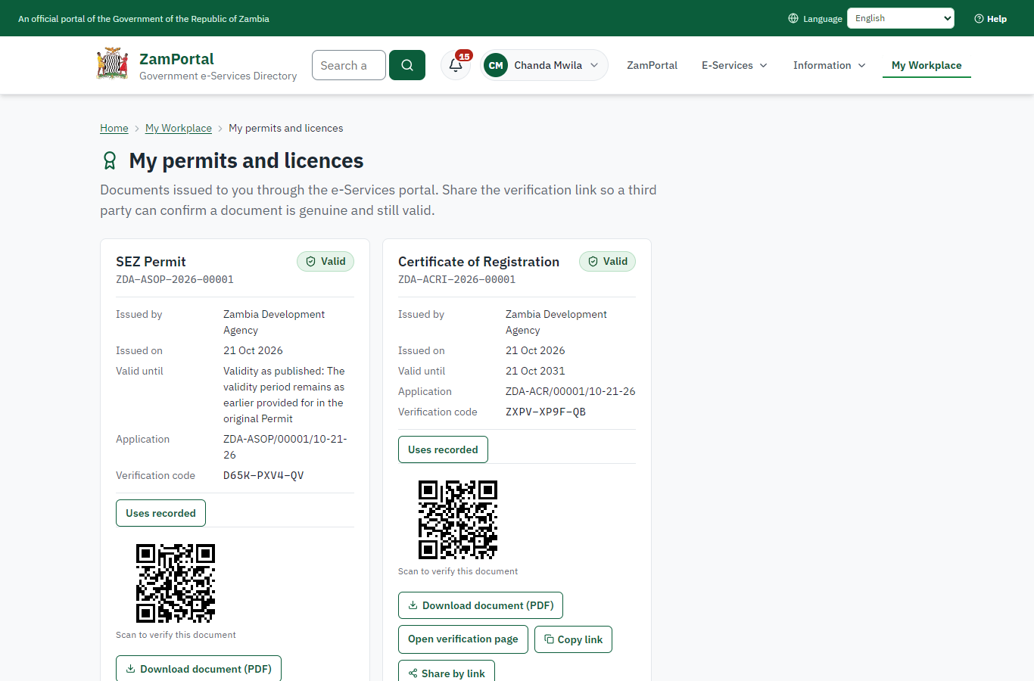 | 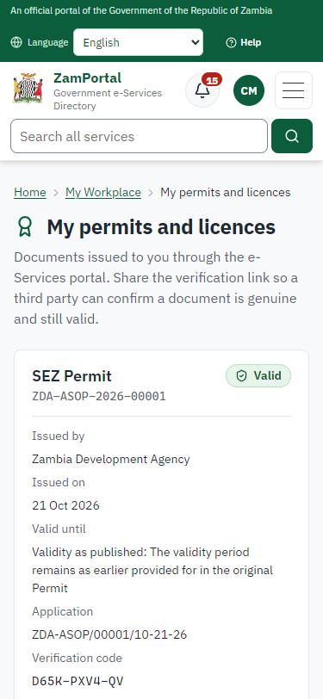
Step 20: The document in My permits - desktop (left) and a 375 px phone (right).

Step 21. Verify the document
Anyone (public) · Public verification page
The QR code on the document opens the public verification page: genuine and current, to whom it was issued, and whether the electronic seal is valid. No sign-in is needed.
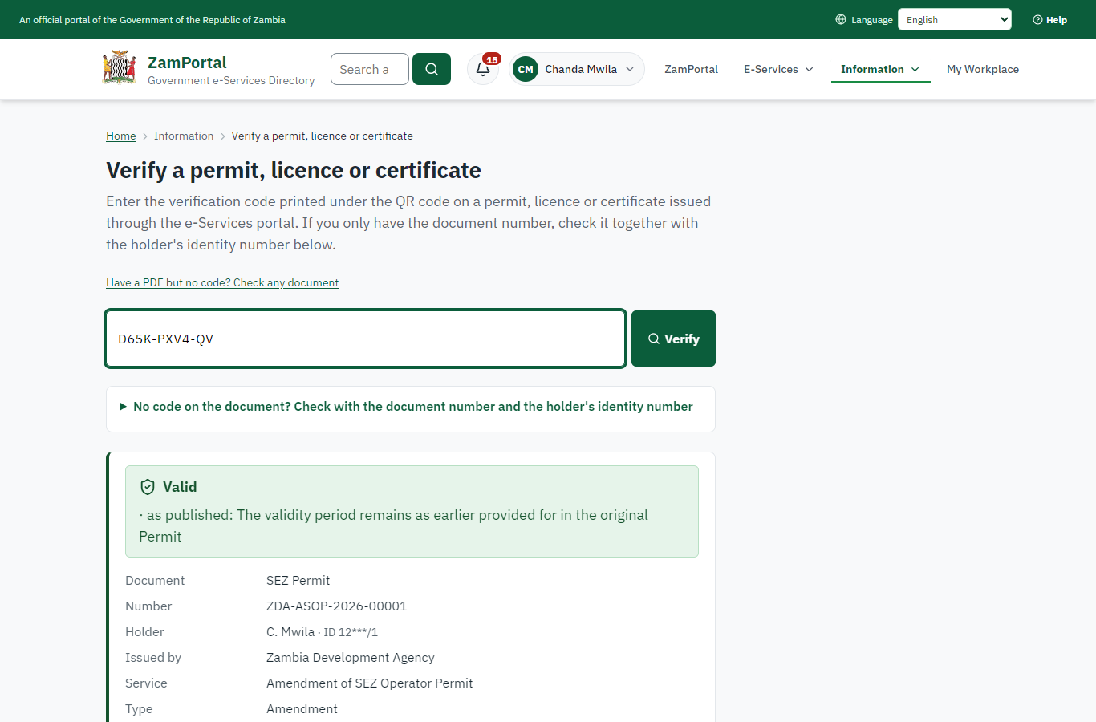 | 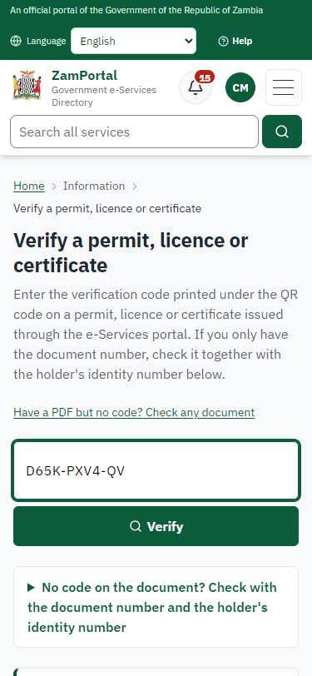
Step 21: Verify the document - desktop (left) and a 375 px phone (right).

3. Payment
Item | In the test run
Fee (as published) | Amendment Fee ZMW 2,844.40
Invoice 1 | 6720523168389549
Amount 1 | ZMW 2844.40
Paid at 1 | with the application
On screen: step 8 (See that the fee is due), step 9 (Pay with ZamPay), step 10 (Payment received) in section 2.

4. Output documents

SEZ Permit (sealed PDF)
Issued when the case was approved, from the service's output configuration (service template Amendment.Certificate.docx), filled from the application and the decision, sealed with the platform's electronic seal and stored as the issued version. The holder downloads it from My permits; the verification page checks it.
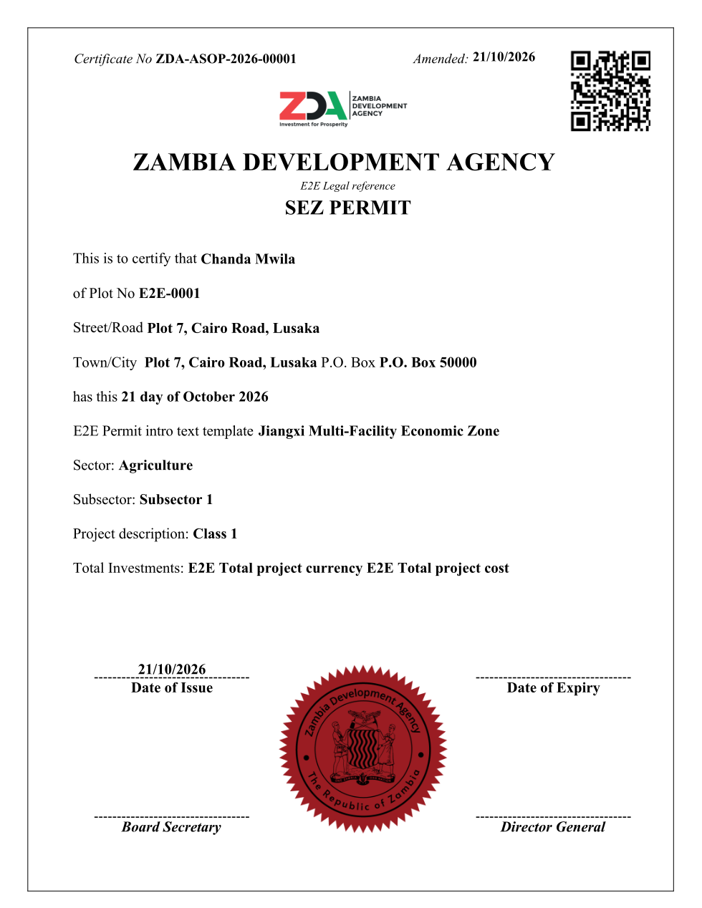
SEZ Permit (sealed PDF) - first of 1 page, as issued in the test run.

Fields
Field | Value in the test run
Document title | SEZ Permit
Permit / licence number | ZDA-ASOP-2026-00001
Holder | Chanda Mwila
Valid from | 2026-10-21
Valid until
Status | active
Verification code (printed with a QR code) | D65K-PXV4-QV

Seal
Seal status | sealed
Signature level | PAdES-B-T
Sealed by | the platform seal (development key in the test run)
Signed at | 2026-10-21T12:52:27.570Z
Trusted time-stamp | 2026-10-21T12:52:27.519Z (time-stamping authority)
Document fingerprint (SHA-256) | 683a4d65566a5b3c...

Verification
Where | The public verification page of the national portal, <portal>/verify/<verification code>, opened by scanning the QR code on the document.
What it shows | Whether the document is genuine and current, its holder and validity, and whether the electronic seal is valid and who sealed it.
Checking a copy | Anyone can upload a PDF they were given; the page says whether it is exactly the document that was issued. A changed copy is reported as not matching.
On screen: step 19 (Issue the document), step 20 (The document in My permits), step 21 (Verify the document) in section 2.

5. Notifications
When | Channel | To | Message | Delivery
Payment due (invoice raised) | in-app (portal bell) | the applicant | Payment due for application ZDA-ASOP/00001/10-21-26 - The fee of ZMW 2844.40 for Amendment of SEZ Operator Permit (ZDA-ASOP/00001/10-21-26) is now due. Invoice 6720523168389549. | shown
Application received | in-app (portal bell) | the applicant | Application ZDA-ASOP/00001/10-21-26 received - Your application ZDA-ASOP/00001/10-21-26 for Amendment of SEZ Operator Permit has been received by Zambia Development Agency. | shown
Payment received | in-app (portal bell) | the applicant | Payment received for ZDA-ASOP/00001/10-21-26 - Your payment of ZMW 2844.40 for ZDA-ASOP/00001/10-21-26 (Amendment of SEZ Operator Permit) has been received. Receipt: <ZamPay>/pdf?documentType=receipt&invoiceNumber=6720523168389549 | shown
case.approved | in-app (portal bell) | the applicant | Application ZDA-ASOP/00001/10-21-26 approved - ZDA-ASOP/00001/10-21-26 (Amendment of SEZ Operator Permit) has been approved. | shown
Invitation to rate the service | in-app (portal bell) | the applicant | How was Amendment of SEZ Operator Permit? - How was Amendment of SEZ Operator Permit? Tell us in about a minute. | shown
Decision: approved | in-app (portal bell) | the applicant | Application ZDA-ASOP/00001/10-21-26 completed - ZDA-ASOP/00001/10-21-26 (Amendment of SEZ Operator Permit) is complete. Your documents are ready. | shown
Licence / permit issued | in-app (portal bell) | the applicant | Your Amendment of SEZ Operator Permit document has been issued - ZDA-ASOP-2026-00001 has been issued for Amendment of SEZ Operator Permit. | shown
Payment due (invoice raised) | sms | +260 97* *** 567 | Fee of ZMW 2844.40 due for ZDA-ASOP/00001/10-21-26. Invoice 6720523168389549. Pay: <ZamPay>/pay-for-service/get-invoice/6720523168389549 | delivered
Payment due (invoice raised) | email | e2e.c***@example.test | Payment due for application ZDA-ASOP/00001/10-21-26 | skipped
Application received | email | e2e.c***@example.test | Application ZDA-ASOP/00001/10-21-26 received | skipped
Application received | sms | +260 97* *** 567 | Application ZDA-ASOP/00001/10-21-26 for Amendment of SEZ Operator Permit has been received. Track it: <portal>/my-workplace | delivered
Payment received | sms | +260 97* *** 567 |  | delivered
case.approved | sms | +260 97* *** 567 |  | delivered
case.approved | email | e2e.c***@example.test | Application ZDA-ASOP/00001/10-21-26 approved | skipped
Invitation to rate the service | sms | +260 97* *** 567 |  | skipped
Invitation to rate the service | email | e2e.c***@example.test | How was Amendment of SEZ Operator Permit? | skipped
Decision: approved | email | e2e.c***@example.test | Application ZDA-ASOP/00001/10-21-26 completed | skipped
Decision: approved | sms | +260 97* *** 567 |  | delivered
Licence / permit issued | sms | +260 97* *** 567 |  | delivered
Licence / permit issued | email | e2e.c***@example.test | Your Amendment of SEZ Operator Permit document has been issued | skipped
Delivery: shown = in the portal's notification bell; delivered = the SMS gateway (a test double in this run) reported the text delivered; skipped = not sent on that channel (e-mail is not configured on the test installation, and some notices go out on one channel only); sent by the national portal = a ministry node handed the notice to the national portal, which texts and e-mails the citizen under its own name and the citizen's preferences. Addresses written <portal>, <ZamPay> stand for the national portal and ZamPay.

6. Legacy mapping
Replaces | Amendment of SEZ Operator Permit in the legacy ZIGS e-Services directory (ZIGS_Services)
Legacy service id | 542
Legacy provider | Zambia Development Agency (ZDA) under Ministry of Commerce, Trade and Industry
Legacy process | not recorded
Fee in the legacy system | none
Fee taken before submission | yes (as in ZIGS)
Time to issue (legacy) | not recorded
Legacy output templates | SEZ Permit: ZIGS_Forms_ZDA / Amendment.Certificate  GS3.Authorisation.Document: ZIGS_Forms_ZDA / GS3.Authorisation.Document  GS-1 Application for a Government Service: ZIGS_Forms_ZDA / GS1  GS-2 Notice of Government Action: ZIGS_Forms_Notices / GS-2.NoticeOfAction
Legacy address | https://development.gsb.gov.zm
How it was brought over | Imported by the platform's legacy catalogue importer (zcm-backend scripts/zigs/importLegacy.js) from the ZIGS snapshot: form, case types, fees, documents, process and output templates, then served by the new platform.

7. Version and date
Document version | service v1, platform 55458ae2
Generated | 2026-10-21T12:52:35Z (by the end-to-end run, not edited by hand)
Service version | not versioned (configured directly)
Platform snapshot | backend 55458ae2  portal 0796e61  back office 58e5946
Test suite | e2e cbc2700; one installation (combined); seed profile mihud
Journeys | 30-catalogue-service.spec.js: citizen finds the service, answers its form, uploads its documents and sends the application - passed  30-catalogue-service.spec.js: the case goes through every step of its process: payments by the citizen, each officer step by its role - passed  30-catalogue-service.spec.js: the grant document is issued, sealed, filled in and verifiable; the citizen has it in My permits - passed
Result | 3 of 3 journey tests passed
Data | Synthetic test data on a local test installation; provider test doubles for ZamPass, ZamPay, SMS and signing.

